An Agentic Multi-Agent System for Realist Evidence Synthesis
Progress report and preliminary results, benchmarked against Richmond et al. (2020)

This report describes where the project stands now. We built a multi-agent system that carries out the analytic steps of a realist systematic review, and we tested it by reproducing a published human review — Richmond et al. (2020), a realist review of educational interventions for clinical reasoning with 28 included papers. We compare what the system produced against the content Richmond's team published, step by step. The numbers in this report were taken from the actual run described here; the system is still being improved, and we say plainly what works and what does not.

1. What we are trying to do
Realist synthesis is a demanding review method. Instead of asking only whether an intervention works, it asks what it is about an intervention that works, for whom, and in what circumstances. The unit of analysis is the Context-Mechanism-Outcome configuration (CMOC): in a given context, an intervention offers a resource, the learner responds to it, and an outcome follows. Building these configurations across many papers and drawing them together into a programme theory is slow, expert work.
Our goal is a system that can do this work with a human kept in charge at every decision point, and that is not tied to one review method. The core of the system is method-agnostic; realist synthesis is implemented as a plug-in on top of it, so the same core can later support other review methods. The measure of success is simple: can the system recover the same contexts, mechanisms, outcomes, and programme-theory that a careful human team published, with every claim traceable to a quote in the source text.

2. Why this architecture and this algorithm
We made a few deliberate choices, each for a concrete reason.
- Multiple specialised agents, not one large prompt. Each analytic step (screening, extraction, checking, synthesis, theory) is a separate agent with a narrow job. Narrow tasks give more faithful output than one agent asked to do everything, and they mirror the division of labour in a real review team.
- A shared database as the single source of truth. Every agent reads and writes the same Postgres store, so the state of the review is always inspectable and auditable, as RAMESES reporting standards require.
- A knowledge graph of big concepts, built by community detection. Rather than fixing every construct in advance, we let the recurring structure of the extracted graph define higher-level concepts: entities are clustered by Leiden community detection (the same method Microsoft GraphRAG uses) and each community is summarised into one big concept. This is how fragments across papers become shared concepts.
- A second, independent checker in a different model family. Extraction is reviewed by a separate model before anything is trusted, echoing Richmond's practice of having a second reviewer check every paper.
- Self-correction before persistence. The extractor drafts, an independent reviewer critiques the draft, and the extractor revises — so obvious coding mistakes are fixed in-run rather than left for a human to clean up.
One finding shaped the design. When we injected the full programme theory into the per-paper extraction prompt, it suppressed how many configurations the extractor found. So the extractor prompt is kept lean and data-driven; the theory steers synthesis and the later refinement, not the first read of each paper.

3. How the system is built and how it runs
The system runs as a pipeline over the shared store. Each stage is one or more agents; a human sign-off sits between the stages that need judgement.
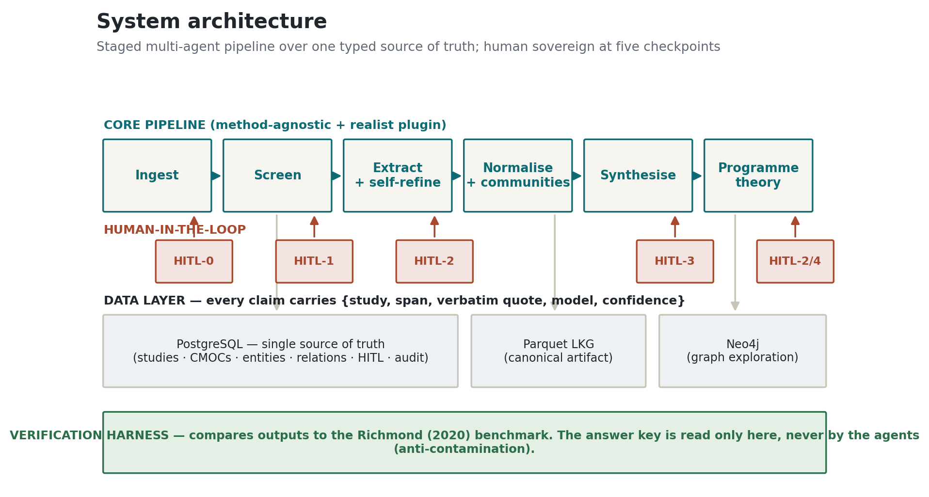
Figure 1. Core-and-plugin architecture with the shared source of truth and human-in-the-loop checkpoints.
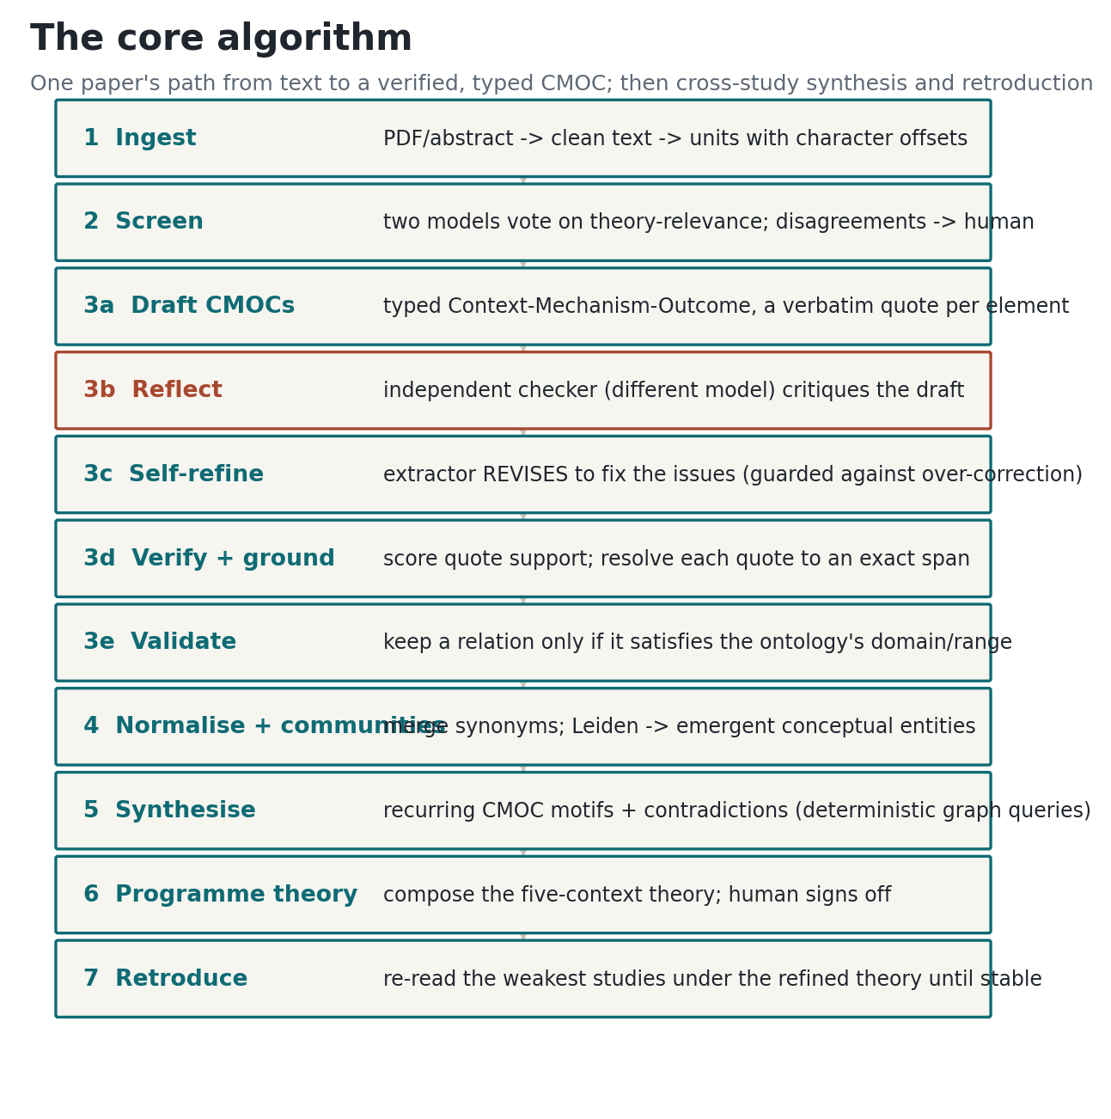
Figure 2. The processing pipeline from ingestion to programme theory and verification.
Ingestion reads the papers and splits them into text units. Screening decides which papers are included, with uncertain cases sent to a human. Extraction turns each included paper into CMOCs, where every element carries a verbatim quote that is resolved to a character span in the source; quotes that cannot be located are flagged, never invented. Normalisation merges synonymous concepts into canonical concepts; community detection groups these into big concepts. Synthesis finds demi-regularities and contradictions and composes the programme theory. Verification, which sits outside the pipeline, compares the result to Richmond's published content.

4. How Richmond's team worked
Richmond and colleagues followed the standard realist review process. They wrote an initial programme theory from existing learning-science theory, searched the literature, screened titles and abstracts and then full texts, and included 28 papers. Two reviewers read the papers and extracted configurations; every paper was checked by a second reviewer for consistency. They grouped their findings by the student context — for example, learners with low prior knowledge versus high prior knowledge, and learners with or without self-efficacy — and for each context they described the mechanism that was triggered and the outcome that followed. Their central conclusion, that the student is the key context that decides whether an intervention helps, is expressed as five context-specific programme-theory chains (their Figures 2 and 3).

5. What our multi-agent system does, step by step
We mapped each part of Richmond's human process onto an agent, so the system carries out the same analytic operations.
Agent | What it does
Protocol & initial theory | Holds the review question and the seed theory that steers synthesis (public theory only, never the benchmark answers).
Screening | Decides inclusion in two stages; uncertain papers go to a human. On this corpus it reproduced the 28-paper inclusion set.
CMOC extraction | Reads each paper and produces typed, quote-grounded configurations, capturing both the pathways that help and the ones that backfire.
Independent checker | A different model family re-checks every paper's coding for consistency, as Richmond's second reviewer did; disagreements are surfaced to the human.
Normalisation & big concepts | Merges synonyms into canonical concepts and clusters them into big concepts by Leiden community detection.
Theory synthesis & refinement | Finds demi-regularities and contradictions and composes the programme theory by student context.
Reporting & audit | Writes the outputs and keeps the provenance trail for RAMESES reporting.

The table below sets Richmond's human workflow beside our system step by step, and records whether the system reproduced that step and what came out of it on this run.
Richmond step (human) | Our agent | Followed? | Result on this run
Write the initial programme theory | Protocol & initial theory agent (public theory seed) | Yes | Seed theory loaded; steers synthesis, not the per-paper read.
Search databases for studies | Search is stubbed for this benchmark (the 28-paper corpus is given) | Partial | Out of scope for the benchmark; the corpus is fixed to Richmond's 28.
Screen titles/abstracts, then full texts | Two-stage screening agent + human on uncertain cases | Yes | Reproduced the inclusion set: 100.0% sensitivity.
Two reviewers extract CMO configurations | CMOC extraction agent with self-refine | Yes | 91 configurations, every element quote-grounded (96.9% of quotes resolve to the source).
Second reviewer checks every paper | Independent checker in a different model family | Yes | Every study re-checked; disagreements surfaced to the human, not overwritten.
Synthesise across studies | Normalisation + Leiden big-concept detection | Yes | 180 canonical concepts, 8 big concepts, 7/14 align with Richmond's mechanisms.
Build programme theory by student context | Theory synthesis & refinement agent | Yes | 7 context sections; correspondence to Richmond's five chains 0.5392 (model-judged, needs human rating).
Report with an audit trail | Reporting & audit agent | Yes | Outputs plus full provenance for RAMESES reporting.

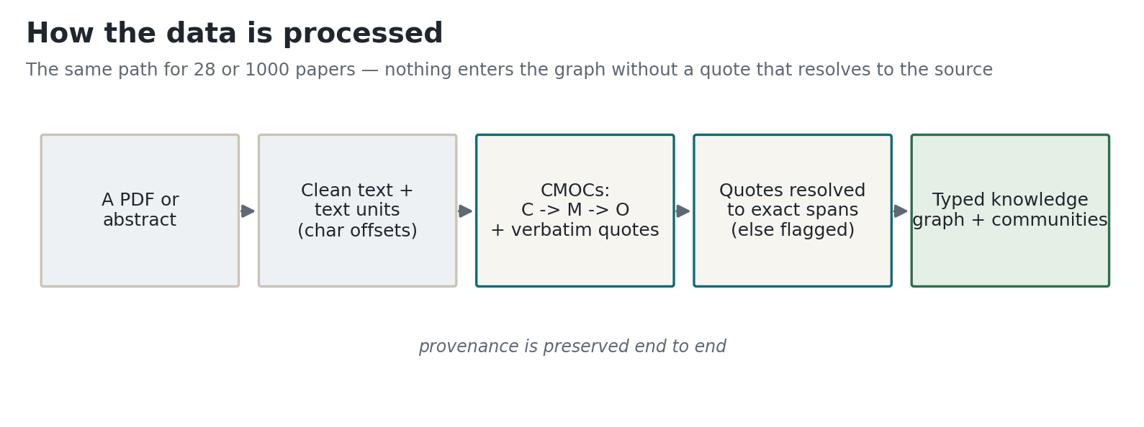
Figure 2b. How a paper becomes CMOCs, concepts, and programme theory as it moves through the agents.
Three mechanisms the professor asked for are now built into the system and are being piloted. First, seed-guided extraction: a few example big concepts from the seed theory are offered to the extractor as naming references. Second, graph-aware extraction: the concepts already in the knowledge graph are retrieved while a new paper is read, so the same idea in different papers gets the same name and the graph stays consistent. Third, a feedback loop: a human correction is stored and replayed to the agent as an example, and the paper is re-read so the correction takes effect. All three are kept deliberately light, because a heavy guidance block was measured to reduce extraction yield.

6. Results of the latest full run
On this run the system screened 28 records, included 28 studies, and extracted 91 configurations from 26 studies (two records are abstract-only and correctly yielded nothing). Normalisation produced 180 canonical concepts and 439 typed causal relations; community detection produced 8 big concepts.
Verification against Richmond's published content:
Measure | Result
Screening sensitivity (after human review of uncertain cases) | 100.0%
Coverage of Richmond's 47 concepts (contexts, interventions, mechanisms, outcomes) | 43/47 (91.5%)
of which same realist role as Richmond / same concept, different role | 37 / 6
Causal relations — pattern level (e.g. Context constrains Outcome) | 39/40 (97.5%)
Causal relations — anchored (one exact endpoint) / concept-exact (both endpoints) | 22/40 / 0/40
Citation faithfulness (quotes that resolve exactly to the source text) | 501/517 (96.9%)
Programme-theory correspondence (model-judged, needs human rating) | 0.5392
Big concepts aligning with Richmond's mechanisms | 7/14 (50.0%)

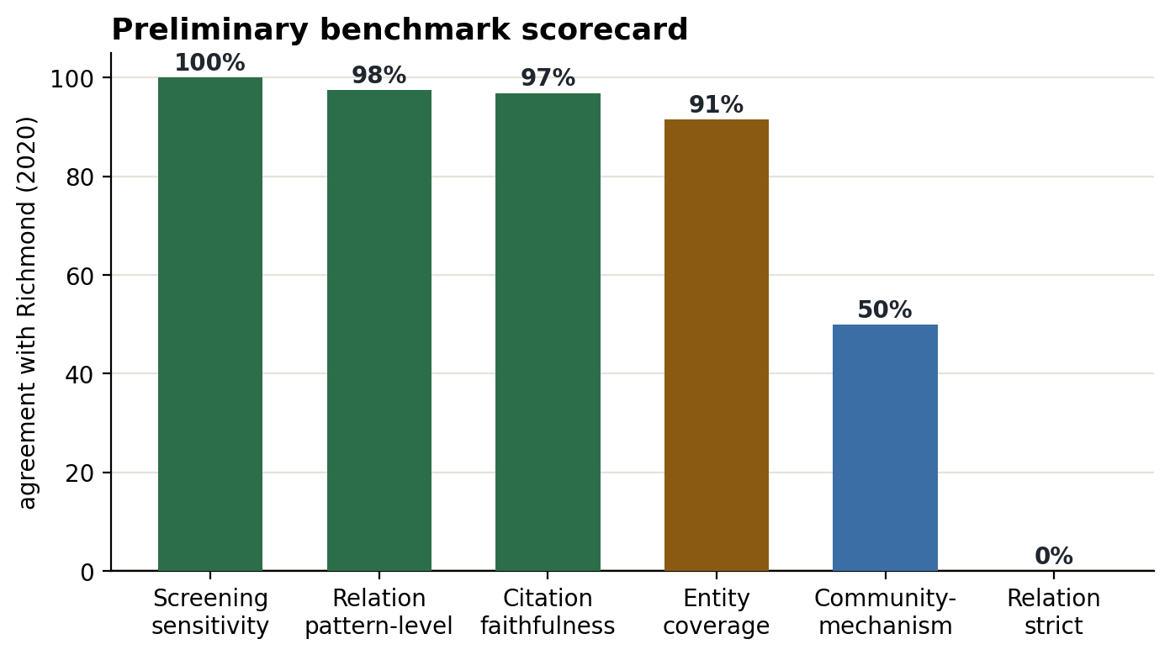
Figure 3. Verification results against the Richmond benchmark.
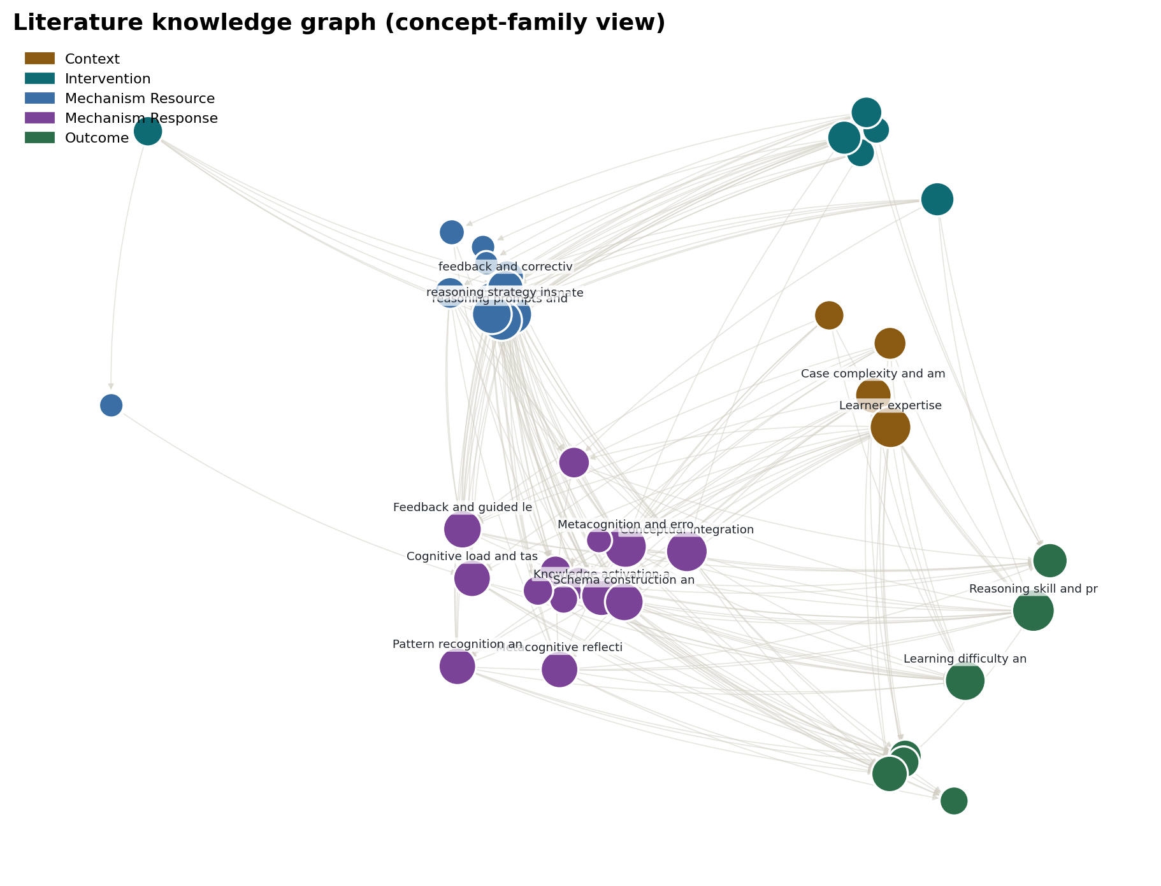
Figure 4. The literature knowledge graph the system built (canonical concepts and their typed relations).
The measure that matters most for a realist review is not a number but the content match, which can be checked directly against Richmond's paper. The companion file Richmond_Correspondence.md lists, for every concept and every programme-theory chain that Richmond published, whether the system recovered it and from which study and quote. Two short examples: Richmond's context 'cognitive load is increased' is recovered as our concept 'cognitive load overwhelm' with the quote about reflection imposing a high cognitive load; Richmond's outcome 'high diagnostic accuracy' is recovered from four studies with the quote reporting the contrastive-learning group performing significantly better.

7. Our honest reading of where this stands
What is working. The system reproduces the inclusion decisions, recovers most of the concepts Richmond described, and — importantly — grounds nearly every element in a verbatim quote, so the output can be audited rather than taken on trust. The causal patterns Richmond asserts are almost all present at the pattern level. The big concepts the graph discovers on its own (for example guided reasoning practice, self-explanation, testing-enhanced study) are recognisably the mechanisms a human would name.
What is not there yet. A small number of Richmond's concepts are still missed — in particular the mixed-knowledge-group context. Concept-exact relation matching is low, because it demands that both endpoints match the exact gold concept; we report it honestly alongside the pattern-level figure, which is the more appropriate one for a realist review. Programme-theory correspondence is judged by a model and still needs a human expert rating before any publication claim. Some semantic matches are generous and are flagged for human review rather than counted silently.
Is the current result good enough to keep going? We think yes. On a genuinely hard, expert task the system already recovers most of a published human review's content with traceable evidence, and the places it falls short are specific and understood rather than diffuse. The three mechanisms above were added precisely to close the remaining gaps, and they are new enough that their effect on a full run is still being measured. The direction is sound and the remaining work is concrete.

8. The system in use
The system has a control room where the graph, the workflow, and each run stage can be inspected. The screenshots below are from the live interface.
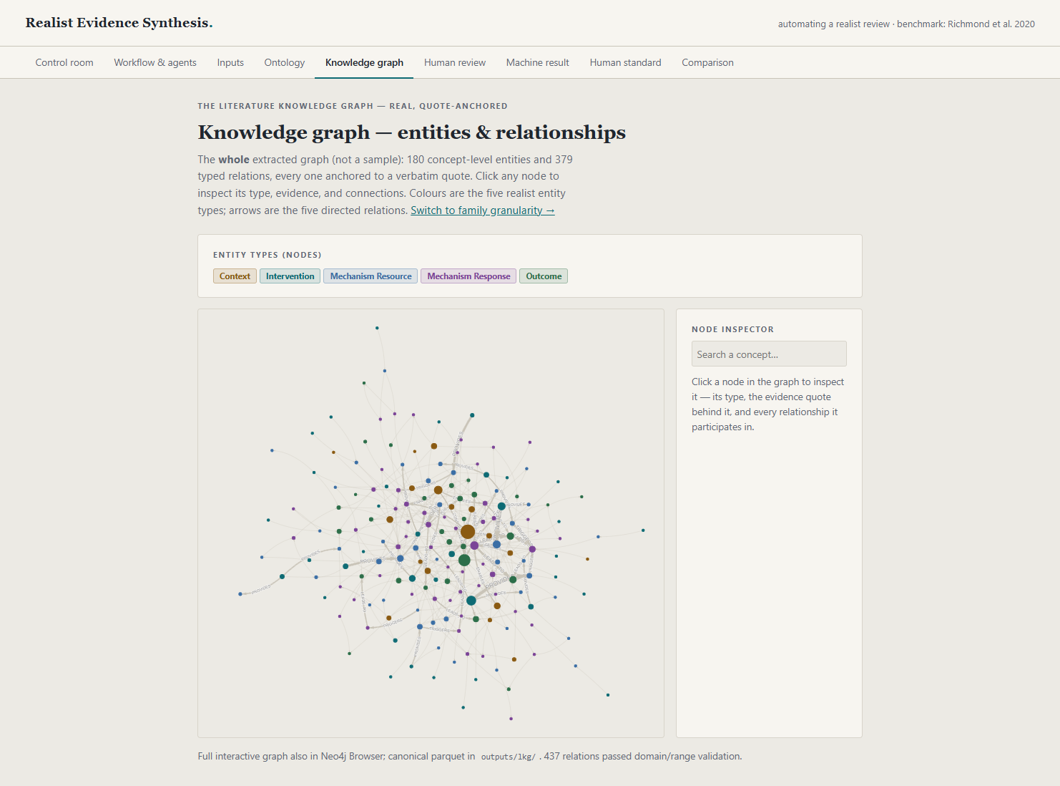
Figure 5. The knowledge-graph view: concepts as nodes, typed causal relations as edges, with a per-node inspector.
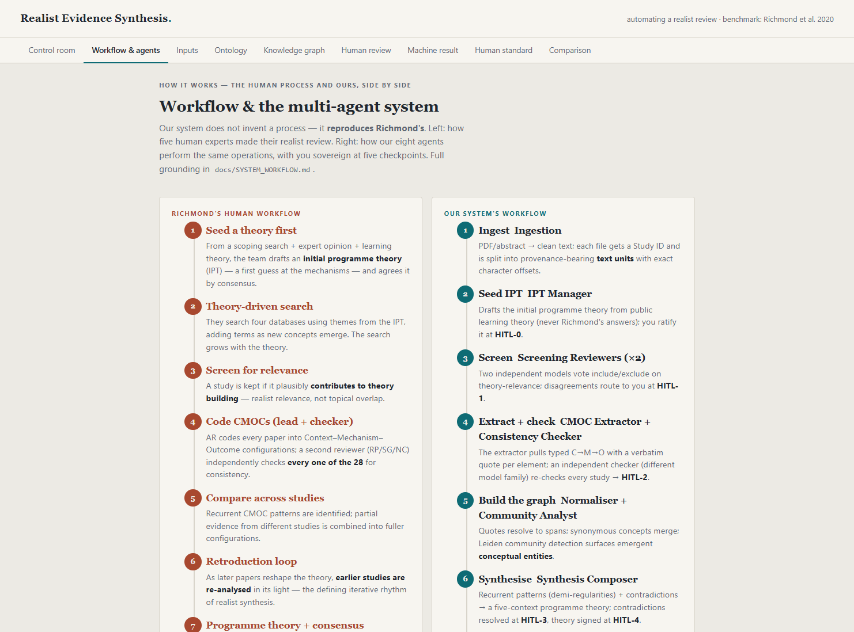
Figure 6. The workflow view: Richmond's human steps beside the system's agents and the human-in-the-loop checkpoints.

Prepared from the run described above. All figures and numbers are generated from the run's own data.

