SAS Sample for IceMelt.csv

**Spring 2022 6371 Analysis Question**



1. A winter storm just hit Dallas which got me thinking, how do they de-ice planes? There are several methods which include magnesium, calcium, potassium and good ole sodium chloride (salt). A study was conducted to test the effectiveness of these methods and the relative magnitude of the difference between them. For each method, the number of seconds it took to totally de-ice a wing was recorded for a random sample of Southwest Airlines jets at 7am on Tuesday Feb 22, 2022 from all over the United States. Please answer the following questions from the Director of Data Science at Southwest Airlines, Doug Gray. The results are in IceMelt.csv. Provide your code in your solution.
2. As an initial test, conduct an ANOVA or Kruskal Wallace test to test if there is a significant difference in mean time to de-ice between any of the four methods. Provide a complete analysis which means: a) State the problem b) address the assumptions, c) Conduct the 6-step test d) pay close attention to the conclusion e) Provide a scope of inference. (12 pts)

**Problem:** We need to test if there is a significant difference in mean time to de-ice between any of the four methods.

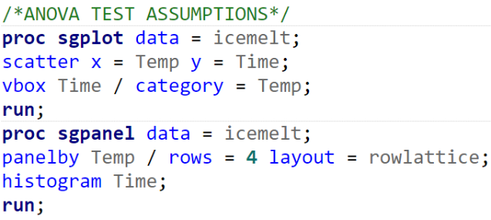**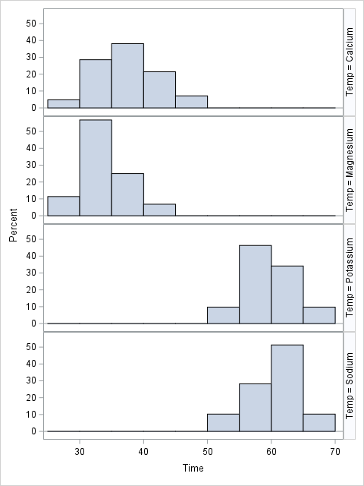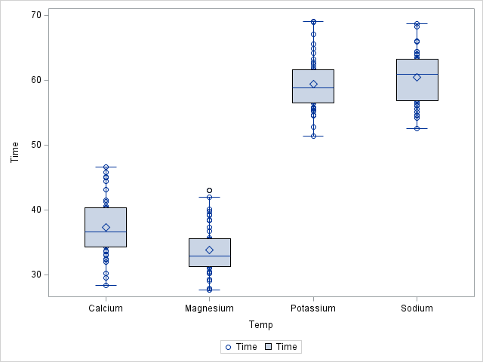Assumptions:** From the histograms and QQ plots below, we can see that all four groups have very rough normality. Therefore, we can proceed with a pure ANOVA.

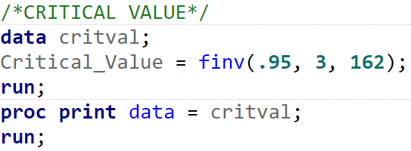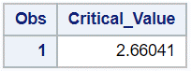**Hypothesis Test (pure ANOVA test):**

$$H0: μ_{Magnesium}=μ_{Calcium}=μ_{Sodium}=μ_{Potassium}$$

$Ha: atleast one mean is different$

$$f-value =489.70$$

$$p-value <0.0001$$

$$α=0.05$$

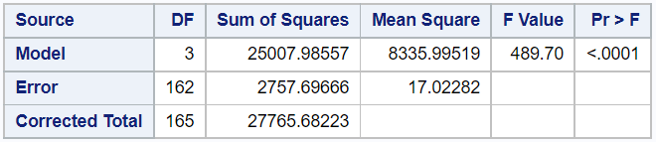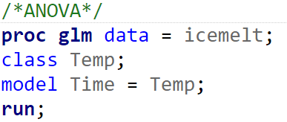Since p-value is less than $α$, we reject the null hypothesis.



**Conclusion:** There is enough evidence to conclude that at the alpha = 0.05 level of significance, at least one of the 4 methods to de-ice produces a significant difference in time (p-value < 0.0001 from a pure ANOVA).

**Scope of Inference:** Since our sample of Southwest Airlines jets were random, we can infer that there is a significant difference among the 4 methods to de-ice for the entire population. Also, the randomized assignment of jets for de-icing was not mentioned, so we cannot make a causal inference.

**Good!**

1. Based on your findings above, use the most powerful test available to test for difference in mean time to melt between the sodium method and the potassium method. Include inference as to the magnitude of the difference, that is provide a 95% confidence interval for the difference in mean time to melt between the two methods. For this question simply provide the 6-step test, you do not need to recheck the assumptions or provide a scope of inference. (10 pts)

**Problem:** We need to test to see there is a difference in mean time to melt ice between the sodium method and the potassium method.

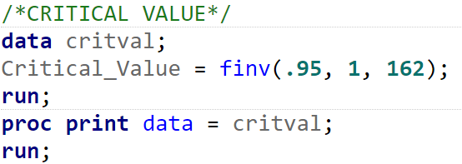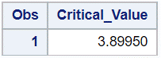**Hypothesis Test (contrast/estimate):**

$$H0: μ_{Sodium}=μ_{Potassium}$$

$Ha: μ_{Sodium}≠μ_{Potassium}$

$$f-value =1.41$$

$$t-value =1.19$$

$$p-value =0.2363$$

$$α=0.05$$

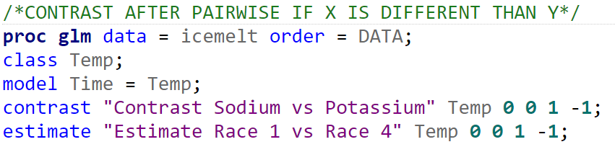Since p-value is more than $α$, we fail to reject the null hypothesis.

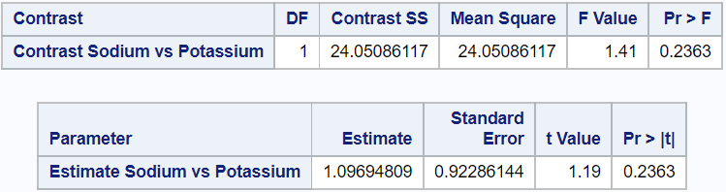



**Conclusion:** There is NOT enough evidence to conclude that at the alpha = 0.05 level of significance, the mean time to melt ice with sodium is different than that of potassium (p-value = 0.2363 from a contrast with 162 degrees of freedom).

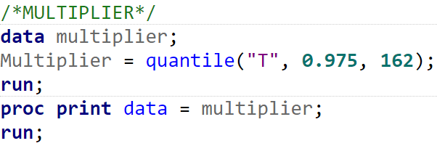**95% Confidence Interval:**

= Estimate ± Multiplier * Standard Error



= 1.10 ± 1.97 * 0.92

= (-0.7124, 2.9124)

We are 95% confident that there is a difference of



-0.7124 to 2.9124 seconds between the mean time to melt ice with sodium and that of potassium. This range includes 0 which suggests that there is not a difference of time to melt ice between using sodium versus using potassium.

**Great work!**

1. Next, we would like to test the mean time to de-ice for the sodium method versus the average of the means of the other three methods. Include inference as to the magnitude of the difference, that is provide a 95% confidence interval for the difference in mean time to melt between sodium and the average of the mean time to melt of the other three methods. Again, for this question simply provide the 6-step test, you do not need to recheck the assumptions or provide a scope of inference. (10 pts)

**Problem:** We need to test to see if there is a difference in mean time to melt between sodium and the average of the mean times to melt of the other three methods.

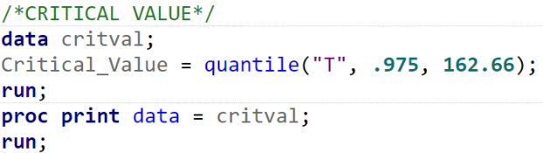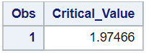**Hypothesis Test (two sample t-test):**

$$H0: μ_{Sodium}=μ_{Group}$$

$Ha: μ_{Sodium}≠μ_{group}$

$$t-value =-13.82$$

$$p-value <0.0001$$

$$α=0.05$$

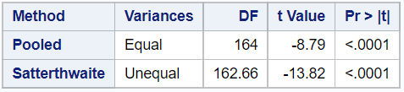Since p-value is less than $α$, we reject the null hypothesis.



**Conclusion:** There is enough evidence to conclude that at the alpha = 0.05 level of significance, the mean melting time using sodium is different than the average of the mean melting times of the other three methods (p-value < 0.0001). We are 95% confident that the mean melting time using sodium is 14.80 to 19.74 seconds higher than the average of the mean times to melt of the other three methods.

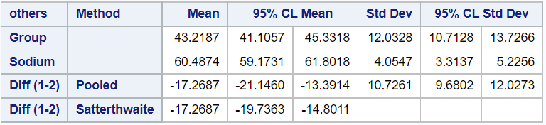



**Good idea but testing sodium versus the group is not the same as testing sodiums mean versus the average of the other 3 means (unless there is the same number of observations in each group.) Good work here… just a bit off… need a contrast. -2**

1. A separate follow up study was conducted to test the effect of sodium versus magnesium specifically. In this study, 13 planes from Dallas Love Field Gates 1 - 13 were selected on a single day at 7 am in the morning and sodium was used to de-ice one of the wings while magnesium was used on the other wing. The time to de-ice was recorded for each wing and the data are recorded in Sodium_v_Magnesium.csv.

Conduct a complete analysis to test for difference in the performance of Sodium versus that of Magnesium on de-icing. (12 pts)

There is strong visual evidence from the above histograms that the distribution of the time to melt sodium and magnesium are both moderately skewed left. However, looking at the x-axis of both we can say that the standard deviations are equal to each other.

As shown in the boxplot, we can say the same assumptions as before, both distributions are not normal and there exists no outliers.



There is not enough evidence to suggest that at least one mean is different (p = 0.3299).



Even with a Wilcoxon Rank Sum, instead of Welch’s, that assumed sample sizes are too small, there is not enough evidence to suggest that at least one mean is different (p = 0.0988).

**These are paired data. Need a paired t-test or a signed rank test. -8**