House Prices Regression Analysis

*Duy Nguyen*

**1 Introduction**

What determines the value of a house? My final project for the Statistical Foundations course in the DataScience@SMU program was to predict the final price of each home in Ames, Iowa, making regression analyses using what we have learned in the course.

**2 Ames, Iowa Housing Data Set**

The data set used in this project describes the sale of individual residential property in Ames, Iowa from 2006 to 2010[1]. It was retrieved from data set hosting website Kaggle, where it is listed as a machine learning competition called *House Prices - Advanced Regression Techniques*[2] . The data involves both a training set and a testing set, which contains 1460 observations with 81 variables and 1459 observations with 80 variables, respectively. The first analysis estimates the sales price of a house (SalePrice) as the response of the square footage of the living area (GrLivArea) of the house and the neighborhood (Neighborhood) where it resides. The second analysis uses several variable selection and elimination techniques to determine a combination of variables that can result in the most desired house price prediction model.

**3 Analysis Question 1**

**3.1 Restatement of Problem**

Century 21 Ames had commissioned a relationship analysis between the sales price of houses in the NAmes, Edwards and BrkSide neighborhoods and the square footage of the living area of such houses, and particularly if the sales price (and its relationship to square footage) depends on which neighborhood that the house is located in.

Provided in this section is the evidence to determine if certain model assumptions are met and methods to deal with potential outliers / influential observations, along with model estimates as well as their confidence intervals. Remarks about the living area will be kept within increments of 100 sq. ft. for purposes of interpretation.

**3.2 Modeling**

The explicit data of both SalesPrice and GrLivArea show evidence of a linear relationship [*see Section 5.1*]. However, improvements can be made such as log-transforming both of our variables of interest as there are numerous outliers that are affecting linearity. A more uniform distribution of points can be seen forming a diagonal line across the graph after the transformation, revealing a stronger relationship between the two variables.

Another improvement can be made by removing highly influential observations that are greater than 0.1 Cook’s D from the model, one by one as well as in combinations while judging for the R2 and adjusted R2, allowing for more validity in our regression analysis. We came to a conclusion that removing observations 131 and 339 resulted in the best R2 and adjusted R2 of 0.443012 and 0.441542, respectively [*see Section 5.2*].

**Model 1**

$$log(SalePrice)={\hat{β}}_{0}+{\hat{β}}_{1}log(GrLivArea)$$

We would like to see if adding Neighborhood into the regression will produce a more significant second model. We first started with an additive model with only Neighborhood added and judged its R2 and adjusted R2, and sequentially an interactive model with an adjusted slope for Neighborhood and log(GrLivArea), as well as one with Neighborhood and GrLivArea. The latter model stands victorious with an R2 and adjusted R2 of 0.531084 and 0.521632, respectively. We then concluded that this model would be our second model, where the Brookside neighborhood was used for reference.

**Model 2**

$$log(SalePrice)={\hat{β}}_{0}+{\hat{β}}_{1}log(GrLivArea)+{\hat{β}}_{2}Edwards+{\hat{β}}_{3}NAmes$$

$+{\hat{β}}_{4}Edwards*GrLivArea+{\hat{β}}_{5}NAmes*GrLivArea$

**3.3 Assumptions**

After the removal of observations 131 and 339, while there is little evidence against normality and skewness from the QQ plot and histogram, there is little evidence of SD from the studentized scatterplots. We are able to see an outlier, observation 135, from the Cook’s D and leverage plots that we can remove from our second model. However, after removing observation 135 and judging the R-Squared and adjusted R-Squared of the model, we concluded that it is best to leave observation 135 in the data. We will assume that the observations are independent [*see Appendix 5.3*].

**3.4 Comparing Competing Models**

An extra sums of square test is conducted to compare the significance between our two models. There is strong evidence suggesting that the second model is more significant (p-value = 1.004e-12).

We also ran a 10-fold cross-validations repeated for 5 times on both models, and have concluded that the second model is more significant, which is consistent with our extra sums of square test [*see Appendix 5.4*].

**3.5 Conclusion**

**Complete Regression Model**

$$log(SalePrice)=5.913+0.82 log(GrLivArea)+1.01 Edwards+2.58 NAmes$$

$-0.146 log(GrLivArea)*Edwards-0.347 log(GrLivArea)*NAmes$

The data suggests that a doubling of the square footage of living area of houses increases the estimated median of its sales price by $2^{.82}-1=76.514\%$. We are 95% confident that the multiplicative increase in median sales price of houses after a doubling of its square footage of living area is ${(2}^{0.681}-1, 2^{0.958}-1)=(60.33\%, 94.26\%)$. Model 2 is a good fit for the data (p-value < 2.2E-16 for F-test with df(5, 375)). It is estimated that the square footage of living area explains about 52.79% of the variation in sales price of houses in Ames, Iowa between 2006 and 2010 [*see Section 5.5*].

The separate equations that represent the model of each neighborhood is below:

$$\{log(SalePrice) | BrkSide\}=5.913+0.82 log( GrLivArea)$$

$$\{log(SalePrice) | Edwards\}=6.923+0.674 log(GrLivArea)$$

$$\{log(SalePrice) | NAmes\}=8.493+0.473 log(GrLivArea)$$

We are 95% confident that for every doubling of the square footage of living area of a house in:

* Brookside, the estimated median sales price increases by $2^{.82}-1=76.51\%$.
* Edwards, the estimated median sales price increases by $2^{.604}-1=56.59\%$.
* North Ames, the estimated median sales price increases by $2^{.473}-1=38.80\%$.

Finally, since this is an observational study, we cannot make any causal inferences. However, we can imply that for the houses in Ames, Iowa during 2006 and 2010, increases in square footage of living area does relate to increases in sales price.

4 **Analysis Question 2**

**4.1 Restatement of Problem**

In this analysis, we are asked to build the most predictive model for sales prices of homes in all neighborhoods of Ames, Iowa, using both the train and test datasets retrieved from the Kaggle website..

Our strategy is to produce four selection models: one from forward selection, one from backwards elimination, one from stepwise selection, and one that is built custom. We will also evaluate the adjusted R-Squared, internal CV Press, and the Kaggle score for each of the said four models.

**4.2 Modeling**

After much discussion amongst our team, we decided to test an initial model with all the available variables, or rather data features, in the Ames, Iowa housing data set which is contained within a text file named [datadescription.txt](https://github.com/epicduy/epicduy.github.io/blob/6942881e1be7914cf327295c9d5989eaf3155916/data_description.txt) retrieved from the Kaggle website. This dataset has a missing values percentage, or in this case Not Available (NA), of 5.88% along with some special cases which will be further discussed below. All of these are deemed crucial to be either removed or adjusted accordingly for our analysis [*see Section 5.6*].

While going down the list of all available variables of the initial model and judging for its R-Squared value, the sequential steps to clean the data consists of the following:

* NA numerical variables are replaced with zeros.
* NA non-numerical variables, or in this case character variables, are replaced with “None” to represent the non-available feature for that variable.
* Character variables are converted into factor variables, which proves to improve our prediction analysis as there is now one reference for each factor variable for RStudio to recognize and use.
* One influential observation, data point 524, was detected with a standout Cook’s D and leverage. We decided to ultimately remove this observation since it may hinder our prediction analysis [*see Appendix 5.7*].
* The variables Id, MSSubClass, MSZoning, Utilities, Condition2, Exterior1st, Exterior2nd, MasVnrType, KitchenQual, Functional, SaleType and PoolQC contain levels in the testing dataset that does not exist in the training dataset. Since those are categorical variables, all of the variables need to be used in the training phase of the model. Hence, since we cannot train for levels not in the training dataset, those variables are not to be used while training the model.
* At this time, the variables OverallQual and OverallCond are converted mistakenly into numeric variables as they appear to be. These two variables actually proved to be more useful for our analysis once they are turned into factor variables to better represent the data.
* SalePrice is log-transformed to be used as the response for our models since previously its data was heavily right skewed [*see Appendix 5.8*].

**4.3 Assumptions**

As mentioned previously, influential observation 524 was removed to clean up some of the noise we were seeing. Our plots suggest that there is minimal evidence against normality when looking at the histograms [*see Appendix 5.9*]. And looking at the QQ plots, there are signs of data that is peaking in the middle of the graph. We will assume that our data is independent.

**4.4 Model Selection**

**Linear Regression Model**

$$log(y)={\hat{β}}_{0}+{\hat{β}}_{1}{(x}_{1})+...+{\hat{β}}_{n-1}x_{n-1}+{\hat{β}}_{n}x_{n}$$

The goal of the forward, backward and stepwise selections is to generate a linear regression model as seen above. A custom model is also included to predict the log-transformed SalePrice. The strategy for this custom model is to start with the predicting variables from both our forward and stepwise selection models, which yielded the highest and identical adjusted R-squares, and adjusting the coefficient of the numerical variables with the Neighborhood factor variable.

**Forward & Stepwise Selection Model**

Since the forward and stepwise selection yielded the same model, consequently they picked the same predictors. The forward selection model was built with a simple model and adding variables as they fit the p-value criteria. This means that variables with a p-value less than 0.01 would enter the final model. The stepwise select uses the steps of the forward and backward selection, where it adds and removes variables according to the p-value criteria. This means that it would add variables with a p-value less than 0.01 and removes those variables with a p-value above 0.01 [*see Appendix 5.10*].

**Backward Selection Model**

The backward selection was built with all of the predictors in it and it removes those that did not meet the p-value criteria. This means that variables with a p-value above 0.01 would be removed from the model.

As mentioned earlier, the custom model utilized the predictors derived from the backward selection and adjusted the coefficients of the numerical variables with the Neighborhood variable [*see Appendix 5.11*].

**4.5 Comparing Competing Models**

|  |  |  |  |
| --- | --- | --- | --- |
| **Predictive Models** | **Adjusted $R^{2}$** | **SSR** | **Kaggle Score** |
| **Forward** | 0.927 | 15.79319 | 0.30336 |
| **Backward** | 0.9267 | 15.89446 | 0.30297 |
| **Stepwise** | 0.927 | 15.79319 | 0.30336 |
| **Custom** | 0.9357 | 10.89817 | 4.50665 |

It is worth noting that the forward and stepwise selection models produced the identical predictors. That is why they have the same scores throughout the table. We would also like to mention that since the stepwise selection had the highest $R^{2}$ and adjusted $R^{2}$, the custom model taking the same predictors used in that model and adding an adjustment to the coefficient of the numerical variables with the Neighborhood categorical variable.

**4.5 Conclusion**

We believe our custom model is a good fit for the data (p-value < 2.2E-16 for F-test with df(396, 1062)). It is estimated that our model explains about 95.32% of the variation in sales price of houses in Ames, Iowa between 2006 and 2010.

Our custom model produced the best scores [*see Appendix 5.12*]. It had the highest $R^{2}$ and ${adjusted R}^{2}$ as well as the lowest sum of squared residuals. Interestingly, however, its kaggle score was much higher than that of any of the models created via a form of selection. The best kaggle score in fact came from the backward selection model, which yielded the lowest highest $R^{2}$ and ${adjusted R}^{2}$ as well as the highest sum of squared residuals.

We believe that the best approach to predicting house prices in this situation is an inspection of multiple selection methods and visualization to remove the appropriate outliers.

Perhaps a different machine learning technique, which we will learn at a later course, can provide us with clearer proofs of effectiveness within the training dataset.

**5 Appendix**

**5.1 Checking for Linearity between SalePrice and GrLivArea**

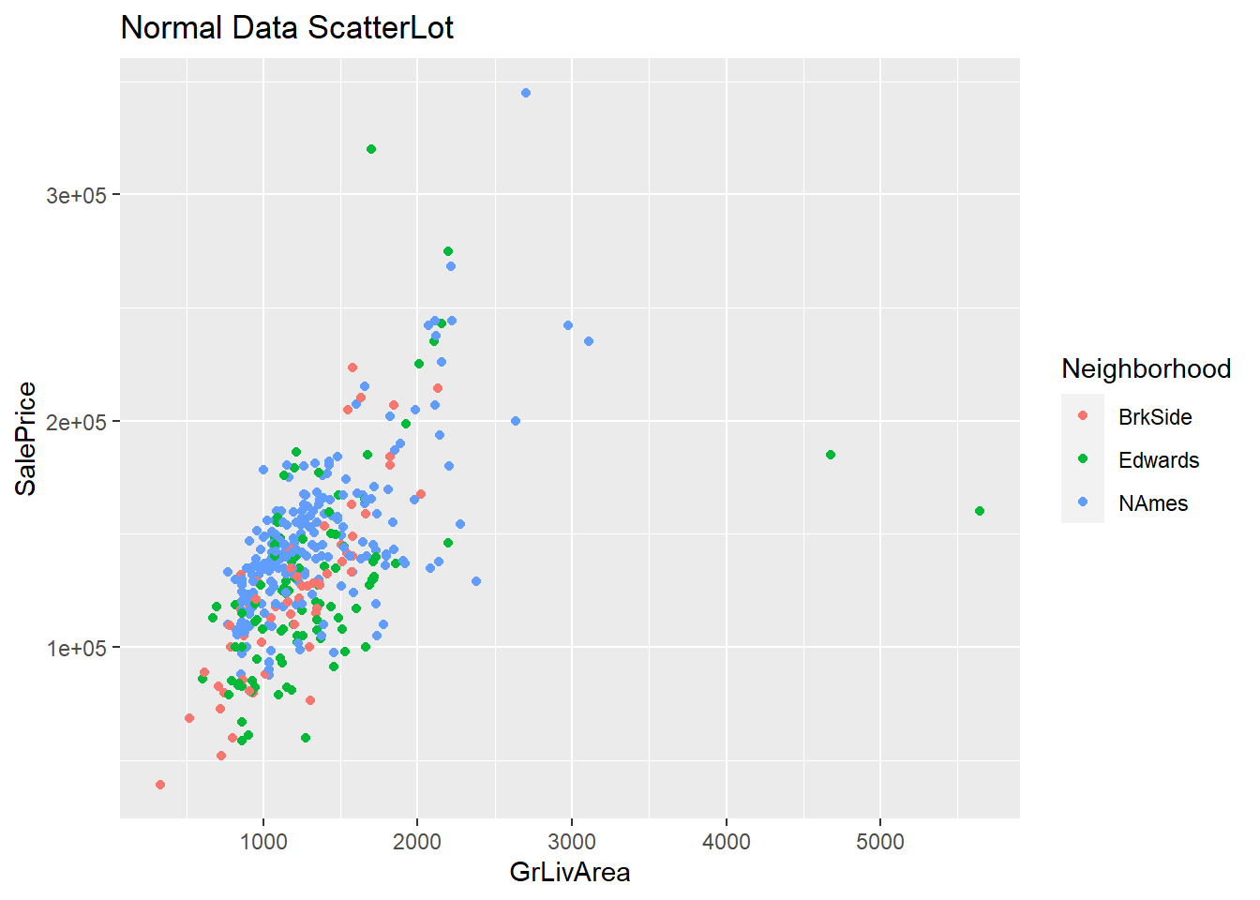

Figure 1

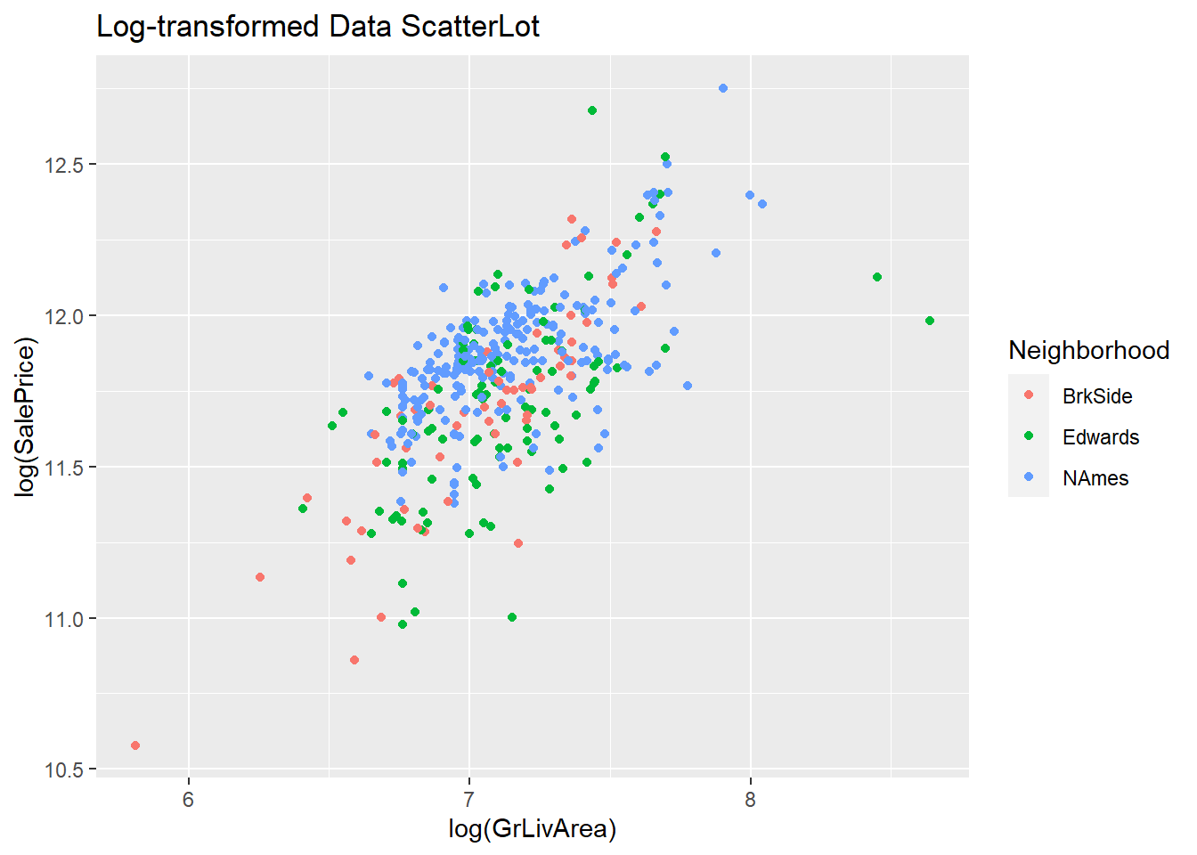

Figure 2

**5.2 Fit Assessment of Model 1**

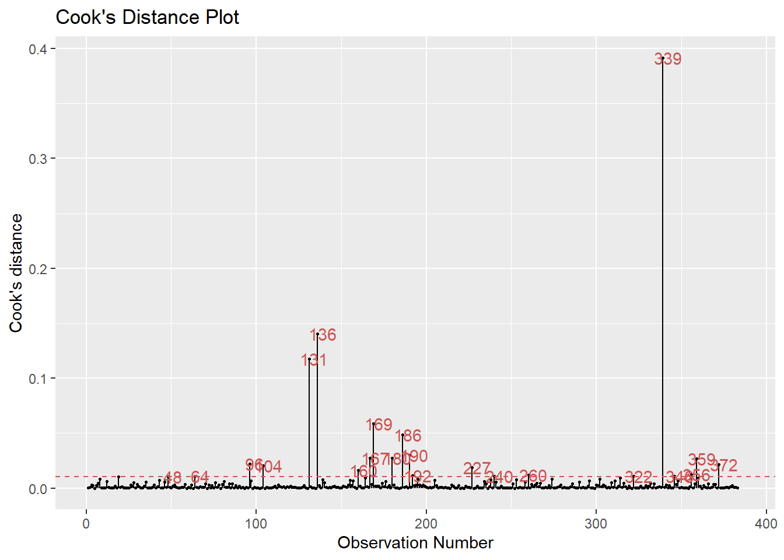

Figure 3

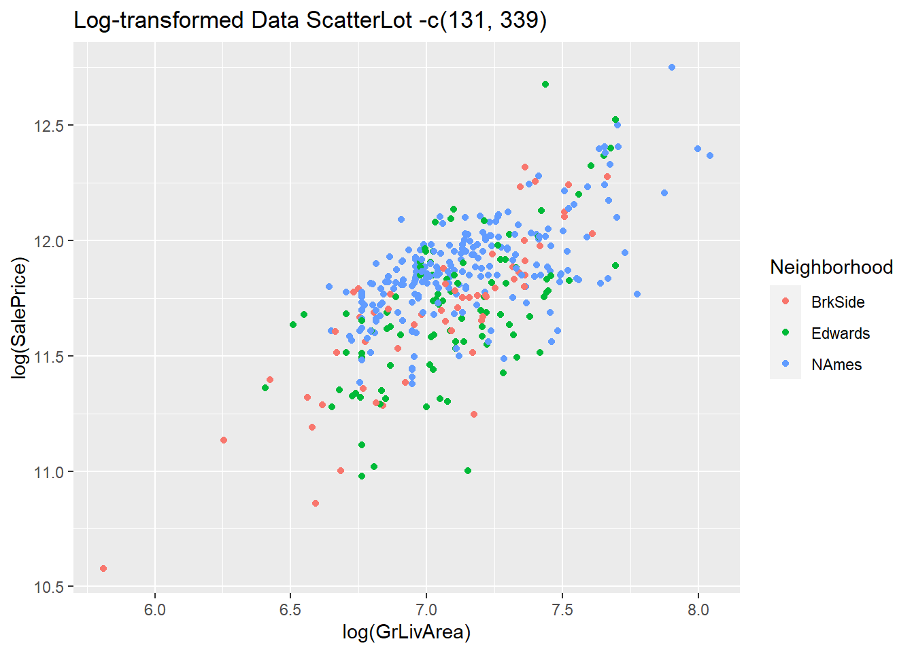

Figure 4

**5.3 Fit Assessment of Model 2**

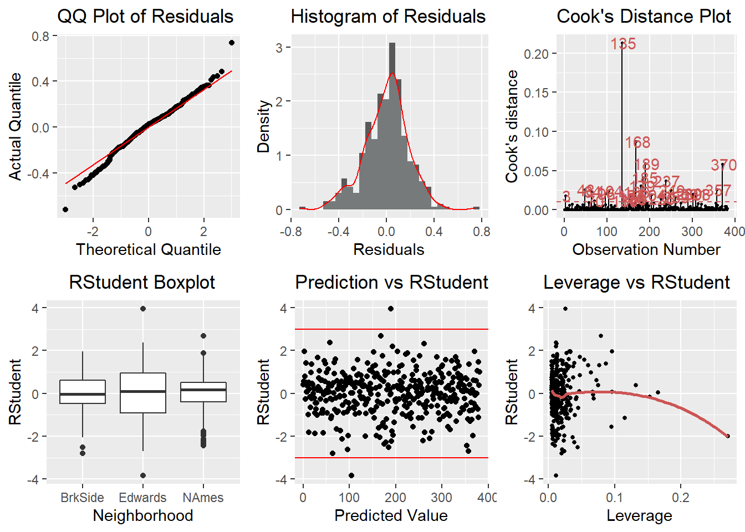

Figure 5

**5.4 Comparing Competing Models**

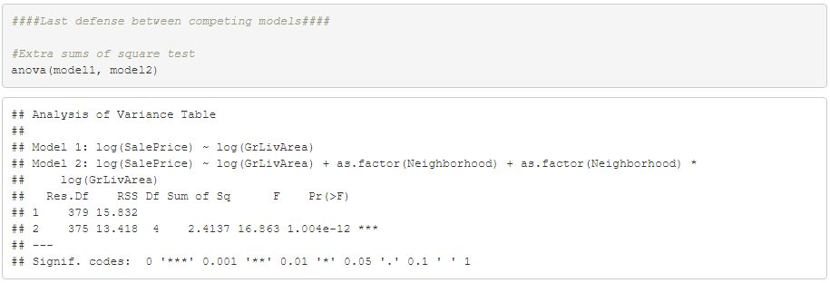

|  |  |  |  |
| --- | --- | --- | --- |
|  | RMSE | R-Squared | CV PRESS |
| Model 1 | 0.2033879 | 0.4454874 | 16.02892 |
| Model 2 | 0.189419 | 0.51558 | 13.94807 |

**5.5 Analysis 1 Conclusion**

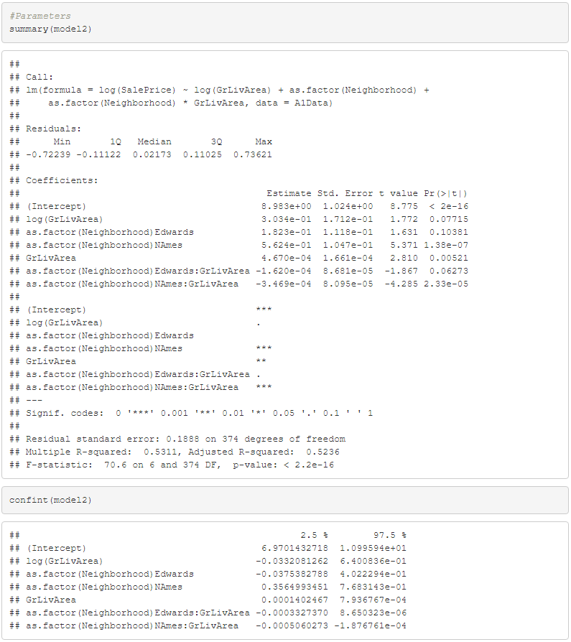

**5.6 Dataset Missing Values**

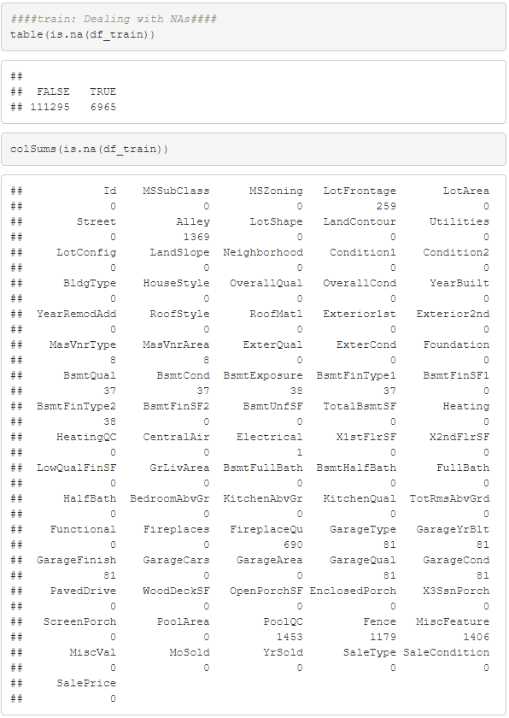

**5.7 Influential Observations**

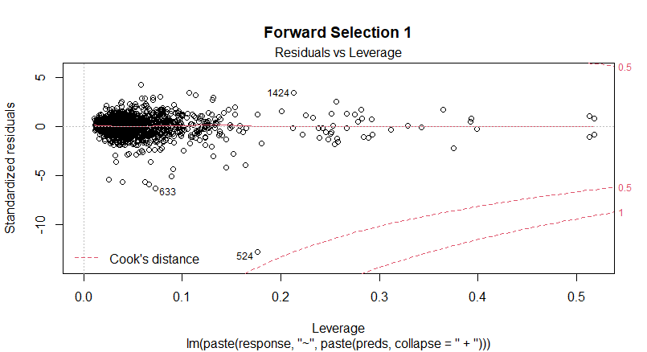

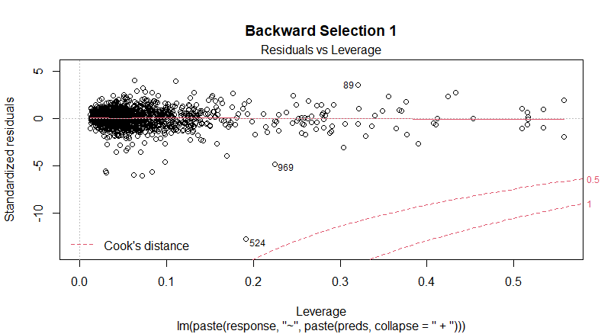

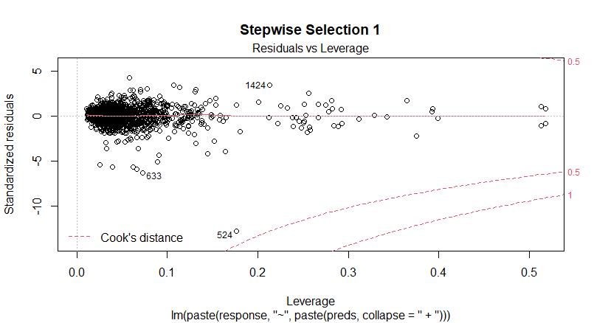

**5.8 Before and After the Log Transformation**

*Before the log, we see the data has a right tail*

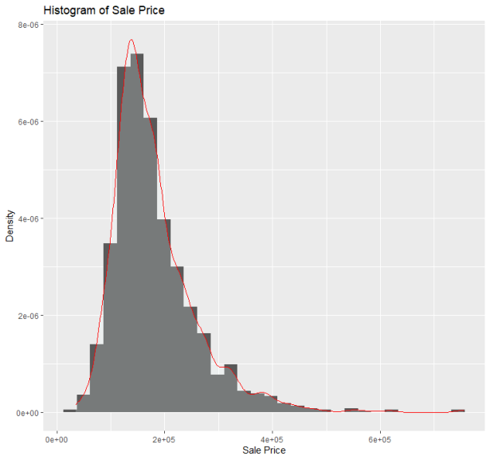

*After the log, we see a much more uniform distribution*

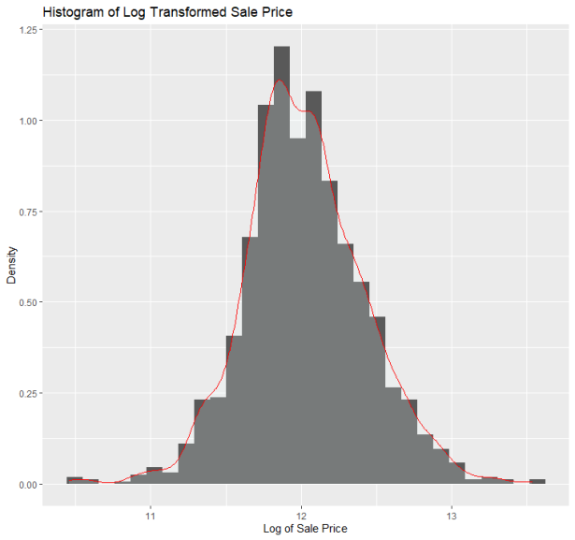

**5.9 Forward, Backward and Stepwise Selection Residual Grid’s**

*Before Transformation*

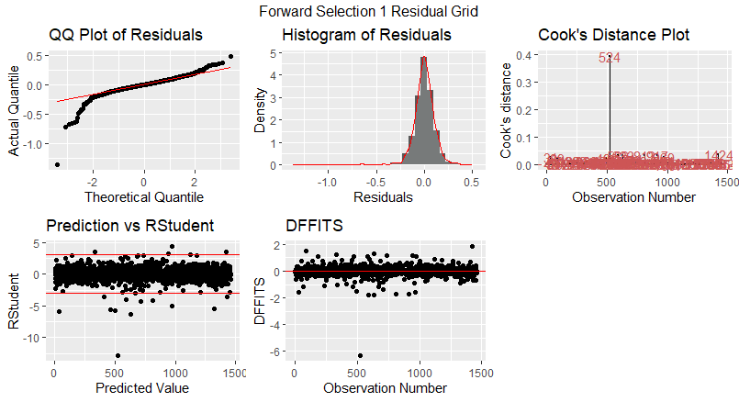

*After Transformation*

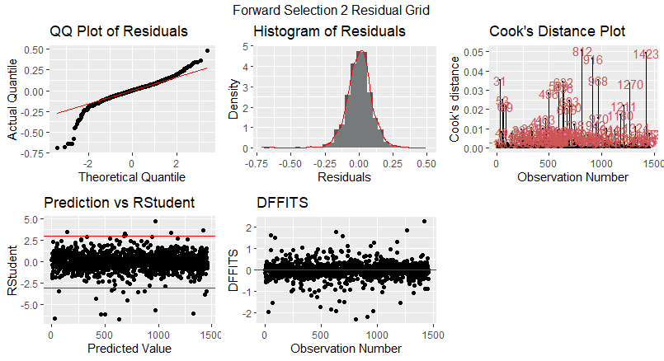

*Before Transformation*

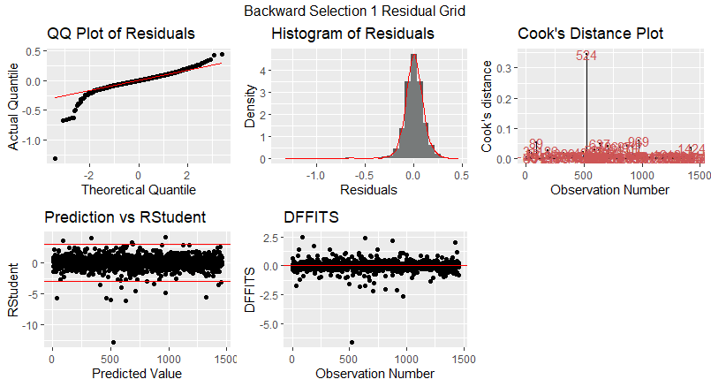

*After Transformation*

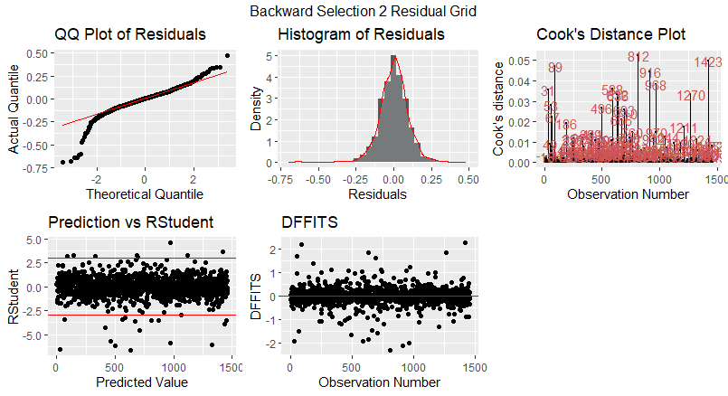

*Before Transformation*

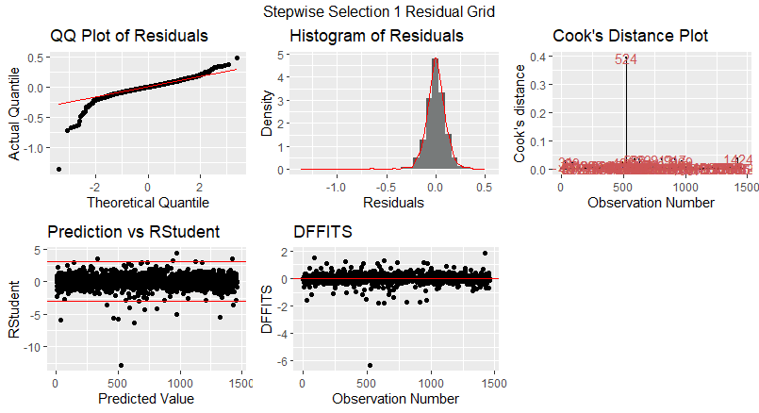

*After Transformation*

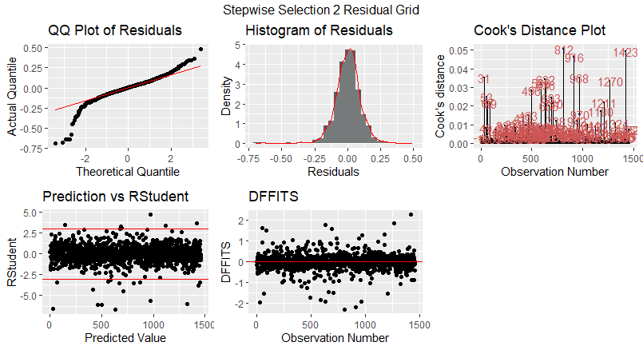

**5.10 Forward & Stepwise Model**

$log(SalePrice)={\hat{β}}_{0}+{\hat{β}}_{1}OverallQual+{\hat{β}}_{2}GrLivArea+{\hat{β}}_{3}Neighborhood+{\hat{β}}_{4}BsmtFinType1+{\hat{β}}_{5}GarageCars+$ ${\hat{β}}_{6}OverallCond+{\hat{β}}_{7}RoofMatl+{\hat{β}}_{8}TotalBsmtSF+{\hat{β}}_{9}YearBuilt+{\hat{β}}_{10}SaleCondition+{\hat{β}}_{11}BsmtUnfSF+{{\hat{β}}_{12}BldgType+\hat{β}}_{13}LotArea+{\hat{β}}_{14}CentralAir+{\hat{β}}_{15}ScreenPorch+{\hat{β}}_{16}Fireplaces+{\hat{β}}_{17}Condition1+{{\hat{β}}_{18}YearRemodAdd+{\hat{β}}_{19}BsmtExposure+\hat{β}}_{20}LandSlope+{\hat{β}}_{21}BsmtFullBath+{\hat{β}}_{22}Street+{\hat{β}}_{23}HalfBath+{\hat{β}}_{24}{GarageQual+{\hat{β}}_{25}Foundation+{\hat{β}}_{26}WoodDeckSF+\hat{β}}_{27}EnclosedPorch+{\hat{β}}_{28}KitchenAbvGr$

**5.11 Backward Model**

$log(SalePrice)={\hat{β}}_{0}+{\hat{β}}_{1}LotArea+{\hat{β}}_{2}Street+{\hat{β}}_{3}LandSlope+{\hat{β}}_{4}Neighborhood+{\hat{β}}_{5}Condition1+$ ${\hat{β}}_{6}BldgType+{\hat{β}}_{7}OverallQual+{\hat{β}}_{8}OverallCond+{\hat{β}}_{9}YearBuilt+{\hat{β}}_{10}YearRemodAdd+{\hat{β}}_{11}RoofMatl+{\hat{β}}_{12}Foundation+{\hat{β}}_{13}BsmtExposure+{\hat{β}}_{14}BsmtFinSF1+{\hat{β}}_{15}BsmtFinSF2+{\hat{β}}_{16}BsmtUnfSF+{\hat{β}}_{17}TotalBsmtSF+{\hat{β}}_{18}CentralAir+{\hat{β}}_{19}X1stFlrSF+{\hat{β}}_{20}X2ndFlrSF+{\hat{β}}_{21}LowQualFinSF+{\hat{β}}_{22}GrLivArea+{\hat{β}}_{23}HalfBath+{\hat{β}}_{24}KitchenAbvGr+{\hat{β}}_{25}Fireplaces+{\hat{β}}_{26}GarageCars+{\hat{β}}_{27}GarageQual+{\hat{β}}_{28}WoodDeckSF+{\hat{β}}_{28}ScreenPorch+{\hat{β}}_{28}SaleCondition$

**5.12 Custom Model**

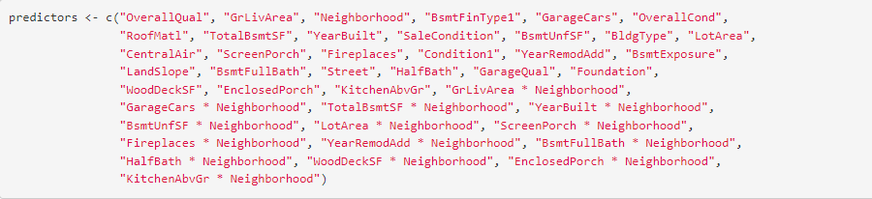

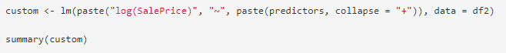

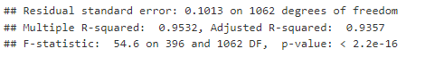

**5.13 Analysis 1 Code**

---

title: "MSDS 6371 Project Analysis 1"

author: "Duy Nguyen"

date: "4/3/2022"

output: html_document

---

```{r setup, include=**FALSE**}

knitr::opts_chunk$set(echo = **TRUE**)

```

```{r, include=**FALSE**}

*####Libaries####*

library(tidyverse)

library(ggplot2)

library(caret) *#createDataPartition*

library(DAAG) *#CVlm*

library(car) *#leverage.plots*

library(lindia) *#gg_cooksd*

library(gridExtra) *#grid.arrange*

library(kableExtra)

library(olsrr) *#ols_step_forward_aic*

```

```{r}

*####Import Data####*

getwd()

train <- read.csv("train.csv")

test <- read.csv("test.csv")

```

```{r}

*####Analysis 1 Wrangle Data####*

df <- dplyr::filter(train, Neighborhood =="Edwards" | Neighborhood =="NAmes" |

Neighborhood == "BrkSide")

df$Neighborhood <- as.factor(df$Neighborhood)

str(df)

```

```{r}

*####Analysis 1 EDA####*

*#Normal Data Scatterplot*

ggplot(df, aes(x = GrLivArea, y = SalePrice, color = Neighborhood)) +

geom_point() +

ggtitle("Normal Data ScatterLot")

*#Log-transformed Data Scatterplot*

ggplot(df, aes(x = log(GrLivArea), y = log(SalePrice), color = Neighborhood)) +

geom_point() +

ggtitle("Log-transformed Data ScatterLot")

```

```{r}

*####Analysis 1 Modeling and Assumptions####*

model0 <- lm(log(SalePrice) ~ log(GrLivArea), data = df)

paste(summary(model0)$r.squared, " | ", summary(model0)$adj.r.squared)

*#0.420370, 0.418849*

library(lindia)

*#Cook's Distance Plot*

gg_cooksd(model0)

*#Identify influential points*

*#From the above graph, those points are greater than 0.1 Cook's D*

as.numeric(names(cooks.distance(model0))[(cooks.distance(model0) > 0.1)])

*#And they are 131, 136, 339*

*#Start removing outliers one by one and a combo of outliers*

*#And find the most desired R-Squared and Adj R-Squared*

A1Data01 = df[-131,]

model01 <- lm(log(SalePrice) ~ log(GrLivArea), data = A1Data01)

paste(summary(model01)$r.squared, " | ", summary(model01)$adj.r.squared)

A1Data02 = df[-136,]

model02 <- lm(log(SalePrice) ~ log(GrLivArea), data = A1Data02)

paste(summary(model02)$r.squared, " | ", summary(model02)$adj.r.squared)

A1Data03 = df[-339,]

model03 <- lm(log(SalePrice) ~ log(GrLivArea), data = A1Data03)

paste(summary(model03)$r.squared, " | ", summary(model03)$adj.r.squared)

A1Data04 = df[-c(131, 136, 339),]

model04 <- lm(log(SalePrice) ~ log(GrLivArea), data = A1Data04)

paste(summary(model04)$r.squared, " | ", summary(model04)$adj.r.squared)

A1Data05 = df[-c(131, 136),]

model05 <- lm(log(SalePrice) ~ log(GrLivArea), data = A1Data05)

paste(summary(model05)$r.squared, " | ", summary(model05)$adj.r.squared)

A1Data06 = df[-c(131, 339),]

model06 <- lm(log(SalePrice) ~ log(GrLivArea), data = A1Data06)

paste(summary(model06)$r.squared, " | ", summary(model06)$adj.r.squared)

*#The most desired is A1Data06 and model06*

A1Data = A1Data06

model1 = model06

str(A1Data)

str(model1)

*#Log-transformed Data Scatterplot without indexes 131 and 339*

ggplot(A1Data, aes(x = log(GrLivArea), y = log(SalePrice), color = Neighborhood)) +

geom_point() +

ggtitle("Log-transformed Data ScatterLot -c(131, 339)")

```

```{r}

*####Model 2 Modeling####*

model21 <- lm(log(SalePrice) ~ log(GrLivArea) + as.factor(Neighborhood), data = A1Data)

paste(summary(model21)$r.squared, " | ", summary(model21)$adj.r.squared)

*#"BrkSide" is read first so it was used as reference*

model22 <- lm(log(SalePrice) ~ log(GrLivArea) + as.factor(Neighborhood) +

as.factor(Neighborhood)*log(GrLivArea), data = A1Data)

paste(summary(model22)$r.squared, " | ", summary(model22)$adj.r.squared)

press(model22)

model23 <- lm(log(SalePrice) ~ log(GrLivArea) * as.factor(Neighborhood), data = A1Data)

paste(summary(model23)$r.squared, " | ", summary(model23)$adj.r.squared)

press(model23)

model24 <- lm(log(SalePrice) ~ log(GrLivArea) + as.factor(Neighborhood), data = A1Data)

paste(summary(model24)$r.squared, " | ", summary(model24)$adj.r.squared)

press(model24)

summary(model24)

*#The most desired is model23*

model2 = model22

paste(summary(model2)$r.squared, " | ", summary(model2)$adj.r.squared)

press(model2)

```

```{r}

*####Model 2 EDA####*

*#Residuals QQ Plot*

residuals = resid(model2)

p1 = ggplot(A1Data, aes(sample = residuals)) +

geom_qq() +

geom_qq_line(color = "red") +

labs(title = "QQ Plot of Residuals", x = "Theoretical Quantile", y = "Actual Quantile")

*#Residuals Histogram*

p2 = ggplot(A1Data, aes(residuals)) +

geom_histogram(aes(y = ..density..)) +

geom_density(alpha = .2, color = "red", fill = "azure") +

labs(title = "Histogram of Residuals", x = "Residuals", y = "Density")

*#Cook's Distance Plot*

library(lindia)

p3 = gg_cooksd(model2)

stdres2 <- rstandard(model2)

*#Neighborhood vs RStudent*

p4 = ggplot(A1Data, aes(as.factor(Neighborhood), stdres2)) +

geom_boxplot() +

labs(title = " RStudent Boxplot", x = "Neighborhood", y = "RStudent")

*#Standardized Residuals Plot*

p5 = ggplot(A1Data, aes(x = seq(stdres2), y = stdres2)) +

geom_point() +

geom_hline(yintercept = 3, color = "red") +

geom_hline(yintercept = -3, color = "red") +

labs(title = "Prediction vs RStudent", x = "Predicted Value", y = "RStudent")

*#Standardized Residuals vs Leverage*

p6 = gg_resleverage(model2, method = "loess", se = **FALSE**, scale.factor = 1) +

labs(title = "Leverage vs RStudent", x = "Leverage", y = "RStudent")

grid.arrange(p1, p2, p3, p4, p5, p6, ncol = 3)

```

```{r}

*####Last defense between competing models####*

*#Extra sums of square test*

anova(model1, model2)

*#Repeated Cross-validation*

set.seed(760397)

train.control <- trainControl(method = "repeatedcv", number = 10, repeats = 5)

*#Train CV model1*

CVModel1 <- train(log(SalePrice) ~ log(GrLivArea),

data = A1Data, method = 'lm',

trControl = train.control)

CVModel1$results$RMSE

CVModel1$results$Rsquared

press(model1)

*#Train CV model1*

CVModel2 <- train(log(SalePrice) ~ log(GrLivArea) + as.factor(Neighborhood) + as.factor(Neighborhood)*log(GrLivArea),

data = A1Data, method = 'lm',

trControl = train.control)

CVModel2$results$RMSE

CVModel2$results$Rsquared

press(model2)

*#Parameters*

summary(model2)

confint(model2)

```

**5.14 Analysis 2 Code**

---

title: "forward selection"

author: "Leonardo Leal Filho"

date: "4/7/2022"

output: html_document

---

```{r TheLibraries, echo=**FALSE**, warning=**FALSE**, include=**FALSE**}

library(tidyverse)

library(ggplot2)

library(plotly)

library(GGally)

library(olsrr)

library(gridExtra)

library(lindia)

```

```{r TheDataSet, echo = **FALSE**}

*# Reading the data*

df <- read.csv("train.csv")

*# This nested loop will take care of the NA values.*

**for**(i **in** names(df)){

**for**(j **in** 1:dim(df)[1]){

**if**(is.na(df[j, i])){

*# Changing the NAs of the categorical features with the string "0"*

**if**(is.character(df[,i])){

df[j,i] <- "0"

}

*# Changing the NAs of the numerical features with the number 0*

**else**{

df[j,i] <- 0

}

}

}

}

*# Making the categorical variables into factors*

**for**(i **in** names(df)){

**if**(is.character(df[, i])){

df[, i] <- as.factor(df[, i])

}

}

df <- subset(df, select = -c(Id, MSSubClass, MSZoning, Utilities, Condition2, Exterior1st,

Exterior2nd, MasVnrType, KitchenQual, Functional, SaleType, PoolQC))

```

*# Adjusting the Levels*

```{r}

*# Adjusting the Levels of condition2*

df$OverallCond <- factor(df$OverallCond, levels = c(1, 2, 3, 4, 5, 6, 7, 8, 9, 10))

*# Adjusting the Levels of BsmtQual*

df$BsmtQual <- factor(df$BsmtQual, levels = c("Ex", "Gd", "TA", "Fa", "Po", "0"))

*# Adjusting the Levels of BsmtCond*

df$BsmtCond <- factor(df$BsmtCond, levels = c("Ex", "Gd", "TA", "Fa", "Po", "0"))

*# Adjusting the Levels of PoolQC*

df$PoolQC <- factor(df$PoolQC, levels = c("Ex", "Gd", "TA", "Fa", "0"))

*# Making OverallCond into factor*

df$OverallCond <- as.factor(df$OverallCond)

*# Making OverallQual into factor*

df$OverallQual <- as.factor(df$OverallQual)

```

```{r}

*# Creating the full model*

price_fit <- lm(log(SalePrice)~., data = df)

```

```{r ForwardSelectionModel1, echo = **FALSE**}

*# Building the forward selection model*

fwm <- ols_step_forward_p(price_fit, penter = 0.01, details = **FALSE**)

*# Summary of the forward model*

summary(fwm$model)

```

```{r ForwardSelectionModelGrid, echo = **FALSE**}

*#Residuals QQ Plot*

residuals = resid(fwm$model)

p1 = ggplot(df, aes(sample = residuals)) +

geom_qq() +

geom_qq_line(color = "red") +

labs(title = "QQ Plot of Residuals", x = "Theoretical Quantile", y = "Actual Quantile")

*#Residuals Histogram*

p2 = ggplot(df, aes(residuals)) +

geom_histogram(aes(y = ..density..), bins = 30) +

geom_density(alpha = .2, color = "red", fill = "azure") +

labs(title = "Histogram of Residuals", x = "Residuals", y = "Density")

*#Cook's Distance Plot*

p3 = gg_cooksd(fwm$model)

stdres2 <- rstandard(fwm$model)

*#Standardized Residuals Plot*

p5 = ggplot(df, aes(x = seq(stdres2), y = stdres2)) +

geom_point() +

geom_hline(yintercept = 3, color = "red") +

geom_hline(yintercept = -3, color = "red") +

labs(title = "Prediction vs RStudent", x = "Predicted Value", y = "RStudent")

*#DFFITS*

p6 = ggplot(df, aes(x = seq(dffits(fwm$model)), y = dffits(fwm$model))) +

geom_point() +

geom_hline(color="red", yintercept=0) +

labs(title = "DFFITS", x = "Observation Number", y = "DFFITS")

ylim(-5,5)

grid.arrange(p1, p2, p3, p5, p6, ncol = 3, top=("Forward Selection 1 Residual Grid"))

*#Standardized Residuals vs Leverage*

plot(fwm$model, which = 5, main = ("Forward Selection 1"))

```

```{r BackwardSelectionModel, echo=**FALSE**}

*# Building the backward selection model*

bwm <- ols_step_backward_p(price_fit, prem = 0.01, details = **FALSE**)

*# Summary of the backward model*

summary(bwm$model)

```

```{r BackwardSelectionModelGrid1, echo = **F**}

*#Residuals QQ Plot*

residuals = resid(bwm$model)

p1 = ggplot(df, aes(sample = residuals)) +

geom_qq() +

geom_qq_line(color = "red") +

labs(title = "QQ Plot of Residuals", x = "Theoretical Quantile", y = "Actual Quantile")

*#Residuals Histogram*

p2 = ggplot(df, aes(residuals)) +

geom_histogram(aes(y = ..density..), bins = 30) +

geom_density(alpha = .2, color = "red", fill = "azure") +

labs(title = "Histogram of Residuals", x = "Residuals", y = "Density")

*#Cook's Distance Plot*

p3 = gg_cooksd(bwm$model)

stdres2 <- rstandard(bwm$model)

*#Standardized Residuals Plot*

p5 = ggplot(df, aes(x = seq(stdres2), y = stdres2)) +

geom_point() +

geom_hline(yintercept = 3, color = "red") +

geom_hline(yintercept = -3, color = "red") +

labs(title = "Prediction vs RStudent", x = "Predicted Value", y = "RStudent")

*#DFFITS*

p6 = ggplot(df, aes(x = seq(dffits(bwm$model)), y = dffits(bwm$model))) +

geom_point() +

geom_hline(color="red", yintercept=0) +

labs(title = "DFFITS", x = "Observation Number", y = "DFFITS")

ylim(-5,5)

grid.arrange(p1, p2, p3, p5, p6, ncol = 3, top=("Backward Selection 1 Residual Grid"))

*#Standardized Residuals vs Leverage*

plot(bwm$model, which = 5, main = ("Backward Selection 1"))

```

```{r StepwiseSelectionModel1, echo=**FALSE**}

*# Building the stepwise selection model*

swm <- ols_step_both_p(price_fit, pent = 0.01, prem = 0.2, details = **FALSE**)

*# Summary of the stepwise model*

summary(swm$model)

```

```{r StepwiseSelectionModelGrid1, echo = **F**}

*#Residuals QQ Plot*

residuals = resid(swm$model)

p1 = ggplot(df, aes(sample = residuals)) +

geom_qq() +

geom_qq_line(color = "red") +

labs(title = "QQ Plot of Residuals", x = "Theoretical Quantile", y = "Actual Quantile")

*#Residuals Histogram*

p2 = ggplot(df, aes(residuals)) +

geom_histogram(aes(y = ..density..), bins = 30) +

geom_density(alpha = .2, color = "red", fill = "azure") +

labs(title = "Histogram of Residuals", x = "Residuals", y = "Density")

*#Cook's Distance Plot*

p3 = gg_cooksd(swm$model)

stdres2 <- rstandard(swm$model)

*#Standardized Residuals Plot*

p5 = ggplot(df, aes(x = seq(stdres2), y = stdres2)) +

geom_point() +

geom_hline(yintercept = 3, color = "red") +

geom_hline(yintercept = -3, color = "red") +

labs(title = "Prediction vs RStudent", x = "Predicted Value", y = "RStudent")

*#DFFITS*

p6 = ggplot(df, aes(x = seq(dffits(swm$model)), y = dffits(swm$model))) +

geom_point() +

geom_hline(color="red", yintercept=0) +

labs(title = "DFFITS", x = "Observation Number", y = "DFFITS")

ylim(-5,5)

grid.arrange(p1, p2, p3, p5, p6, ncol = 3, top=("Stepwise Selection 1 Residual Grid"))

*#Standardized Residuals vs Leverage*

plot(swm$model, which = 5, main = ("Stepwise Selection 1"))

```

*## Initial Thoughts*

When analyzing the models we can see that there are outliers that have a high cooks D and high leverage **for** all three of the models. Because of that we will remove the two datapoints (524 and 826) and redo all three model selections.

```{r}

*# Removing the outliers*

df2 <- df[-c(524),]

*# The new full model*

price_fit2 <- lm(log(SalePrice)~., data = df2)

```

```{r ForwardSelectionModel2, echo = **FALSE**}

*# Building the forward selection model*

fwm2 <- ols_step_forward_p(price_fit2, penter = 0.01, details = **FALSE**)

*# Summary of the forward model*

summary(fwm2$model)

*# The features used for the fwm2 model*

fwm2Predictors <- fwm2$predictors

```

```{r ForwardSelectionModelGrid2, echo = **FALSE**}

*#Residuals QQ Plot*

residuals = resid(fwm2$model)

p1 = ggplot(df2, aes(sample = residuals)) +

geom_qq() +

geom_qq_line(color = "red") +

labs(title = "QQ Plot of Residuals", x = "Theoretical Quantile", y = "Actual Quantile")

*#Residuals Histogram*

p2 = ggplot(df2, aes(residuals)) +

geom_histogram(aes(y = ..density..), bins = 30) +

geom_density(alpha = .2, color = "red", fill = "azure") +

labs(title = "Histogram of Residuals", x = "Residuals", y = "Density")

*#Cook's Distance Plot*

p3 = gg_cooksd(fwm2$model)

stdres2 <- rstandard(fwm2$model)

*#Standardized Residuals Plot*

p5 = ggplot(df2, aes(x = seq(stdres2), y = stdres2)) +

geom_point() +

geom_hline(yintercept = 3, color = "red") +

geom_hline(yintercept = -3, color = "red") +

labs(title = "Prediction vs RStudent", x = "Predicted Value", y = "RStudent")

*#DFFITS*

p6 = ggplot(df2, aes(x = seq(dffits(fwm2$model)), y = dffits(fwm2$model))) +

geom_point() +

geom_hline(color="red", yintercept=0) +

labs(title = "DFFITS", x = "Observation Number", y = "DFFITS")

ylim(-5,5)

grid.arrange(p1, p2, p3, p5, p6, ncol = 3, top=("Forward Selection 2 Residual Grid"))

*#Standardized Residuals vs Leverage*

plot(fwm2$model, which = 5, main = "Forward Selection 2")

```

```{r BackwardSelectionModel2, echo=**FALSE**}

*# Building the backward selection model*

bwm2 <- ols_step_backward_p(price_fit2, prem = 0.01, details = **FALSE**)

*# Summary of the backward model*

summary(bwm2$model)

*# Because the backward selection gives the removed variables, to collect the variables used in the*

*# model I need to first create an empty vector*

bwm2Predictors <- c()

*# Now I add all of the features from the df2 dataframe not included in the removed list from the*

*# bwm2 selection model*

**for**(i **in** names(df2)){

**if**(!i %in% bwm2$removed){

bwm2Predictors <- c(bwm2Predictors, i) *# filling the vector with column names that was not removed*

}

}

```

```{r BackwardSelectionModelGrid2, echo = **F**}

*#Residuals QQ Plot*

residuals = resid(bwm2$model)

p1 = ggplot(df2, aes(sample = residuals)) +

geom_qq() +

geom_qq_line(color = "red") +

labs(title = "QQ Plot of Residuals", x = "Theoretical Quantile", y = "Actual Quantile")

*#Residuals Histogram*

p2 = ggplot(df2, aes(residuals)) +

geom_histogram(aes(y = ..density..), bins = 30) +

geom_density(alpha = .2, color = "red", fill = "azure") +

labs(title = "Histogram of Residuals", x = "Residuals", y = "Density")

*#Cook's Distance Plot*

p3 = gg_cooksd(bwm2$model)

stdres2 <- rstandard(bwm2$model)

*#Standardized Residuals Plot*

p5 = ggplot(df2, aes(x = seq(stdres2), y = stdres2)) +

geom_point() +

geom_hline(yintercept = 3, color = "red") +

geom_hline(yintercept = -3, color = "red") +

labs(title = "Prediction vs RStudent", x = "Predicted Value", y = "RStudent")

*#DFFITS*

p6 = ggplot(df2, aes(x = seq(dffits(bwm2$model)), y = dffits(bwm2$model))) +

geom_point() +

geom_hline(color="red", yintercept=0) +

labs(title = "DFFITS", x = "Observation Number", y = "DFFITS")

ylim(-5,5)

grid.arrange(p1, p2, p3, p5, p6, ncol = 3, top=("Backward Selection 2 Residual Grid"))

*#Standardized Residuals vs Leverage*

plot(bwm2$model, which = 5, main = ("Backward Selection 2"))

```

```{r StepwiseSelectionModel2, echo=**FALSE**}

*# Building the stepwise selection model*

swm2 <- ols_step_both_p(price_fit2, pent = 0.01, prem = 0.2, details = **FALSE**)

*# Summary of the stepwise model*

summary(swm2$model)

```

```{r StepwiseSelectionModelGrid2, echo = **F**}

*#Residuals QQ Plot*

residuals = resid(swm2$model)

p1 = ggplot(df2, aes(sample = residuals)) +

geom_qq() +

geom_qq_line(color = "red") +

labs(title = "QQ Plot of Residuals", x = "Theoretical Quantile", y = "Actual Quantile")

*#Residuals Histogram*

p2 = ggplot(df2, aes(residuals)) +

geom_histogram(aes(y = ..density..), bins = 30) +

geom_density(alpha = .2, color = "red", fill = "azure") +

labs(title = "Histogram of Residuals", x = "Residuals", y = "Density")

*#Cook's Distance Plot*

p3 = gg_cooksd(swm2$model)

stdres2 <- rstandard(swm2$model)

*#Standardized Residuals Plot*

p5 = ggplot(df2, aes(x = seq(stdres2), y = stdres2)) +

geom_point() +

geom_hline(yintercept = 3, color = "red") +

geom_hline(yintercept = -3, color = "red") +

labs(title = "Prediction vs RStudent", x = "Predicted Value", y = "RStudent")

*#DFFITS*

p6 = ggplot(df2, aes(x = seq(dffits(swm2$model)), y = dffits(swm2$model))) +

geom_point() +

geom_hline(color="red", yintercept=0) +

labs(title = "DFFITS", x = "Observation Number", y = "DFFITS")

ylim(-5,5)

grid.arrange(p1, p2, p3, p5, p6, ncol = 3, top=("Stepwise Selection 2 Residual Grid"))

*#Standardized Residuals vs Leverage*

plot(swm2$model, which = 5, main = ("Stepwise Selection 2"))

```

*## Now none of the models seem to have datapoints with a high leverage factor. Cook's D also show that the datapoints that seem high, are actually not that high having a cook's d score of a little above 0.1.*

After deleting the outliers, the forward and stepwise selection have essentially the same model, consequently the exactly same statistics. The Backward model have a higher R-square so thus far it seems to be the best model.

```{r}

*# The swm2 predictors*

swm2Predictors <- swm2$predictors

*# The swm2 dataframe*

dfSwm <- data.frame(lSalePrice = log(df2$SalePrice))

dfSwm[, swm2Predictors] <- df2[, swm2Predictors]

swmFit <- lm(lSalePrice~OverallQual+GrLivArea+Neighborhood+BsmtFinType1+GarageCars+OverallCond+RoofMatl+

TotalBsmtSF+YearBuilt+SaleCondition+BsmtUnfSF+MSZoning+MSSubClass+LotArea+Functional+

CentralAir+ScreenPorch+Condition1+YearRemodAdd+Fireplaces+LandSlope+Exterior1st+BsmtExposure+

Heating+GarageQual+KitchenQual+WoodDeckSF+OpenPorchSF+EnclosedPorch, data = dfSwm)

ols_press(swmFit)

PRESS <- **function**(linear.model) {

*#' calculate the predictive residuals*

pr <- round(residuals(linear.model)/(1-lm.influence(linear.model)$hat), 5)

*#' calculate the PRESS*

PRESS <- sum(pr^2)

**return**(PRESS)

}

PRESS(swmFit)

```

```{r CreatingNewModel, echo = **FALSE**}

*# Selecting the predictors of the stepwise model selection*

predictors <- swm2$predictors

*# Adding the variables that will adjust the coefficient of each numerical variable with the*

*# Neighborhood factor*

**for**(i **in** predictors){

**if**(is.numeric(df2[, i])){

predictors <- c(predictors, paste(i, "*", "Neighborhood")) *# Adding the Adjustment variables*

}

}

*# Creating the regression model*

model12 <- lm(paste("log(SalePrice)", "~",paste(predictors, collapse = "+")), data = df2)

*# Summarizing the model*

summary(model12)

```

```{r PlottingNewModelResiduals}

*#Residuals QQ Plot*

residuals = resid(model12)

p1 = ggplot(df2, aes(sample = residuals)) +

geom_qq() +

geom_qq_line(color = "red") +

labs(title = "QQ Plot of Residuals", x = "Theoretical Quantile", y = "Actual Quantile")

*#Residuals Histogram*

p2 = ggplot(df2, aes(residuals)) +

geom_histogram(aes(y = ..density..), bins = 30) +

geom_density(alpha = .2, color = "red", fill = "azure") +

labs(title = "Histogram of Residuals", x = "Residuals", y = "Density")

*#Cook's Distance Plot*

p3 = gg_cooksd(model12)

stdres2 <- rstandard(model12)

*#Standardized Residuals Plot*

p5 = ggplot(df2, aes(x = seq(stdres2), y = stdres2)) +

geom_point() +

geom_hline(yintercept = 3, color = "red") +

geom_hline(yintercept = -3, color = "red") +

labs(title = "Prediction vs RStudent", x = "Predicted Value", y = "RStudent")

*#DFFITS*

p6 = ggplot(df2, aes(x = seq(dffits(model12)), y = dffits(model12))) +

geom_point() +

geom_hline(color="red", yintercept=0) +

labs(title = "DFFITS", x = "Observation Number", y = "DFFITS")

ylim(-5,5)

grid.arrange(p1, p2, p3, p5, p6, ncol = 3, top=("New Model Residual Grid"))

*#Standardized Residuals vs Leverage*

plot(model12, which = 5, main = ("New Model"))

```

Importing the test set and making the predictions.

```{r}

*#loading the test data*

test <- read.csv("test.csv")

*#Selecting the predictors for the test data*

test2 <- test[, swm2$predictors]

```

```{r}

*# Checking which of the predictors have NA values*

l <- c()

**for**(i **in** names(test2)){

**if**(sum(is.na(test2[, i]))){

l <- c(l, i)

}

}

```

```{r}

*# Taking care of the predictors NA values*

**for**(i **in** l){

**for**(j **in** 1:dim(test2)[1]){

**if**(is.character(test2[,i])){

test2[j, i] <- "0"

}

**else**{

test2[j, i] <- 0

}

}

}

```

```{r}

*# Transforming the character variables into factors*

**for**(i **in** names(test2)){

**if**(is.character(test2[, i])){

test2[, i] <- as.factor(test2[, i])

}

}

```

```{r}

*# Making OverallCond into factor*

test2$OverallCond <- as.factor(test2$OverallCond)

*# Making OverallQual into factor*

test2$OverallQual <- as.factor(test2$OverallQual)

```

```{r ForwardPred}

*# Forward Prediction*

pred <- data.frame(Id = seq(1461, 2919), SalePrice = round(exp(predict(fwm2$model, test2)), 2))

write.csv(pred, "kaggle_forward.csv", row.names = **FALSE**)

```

```{r StepWisePred}

*# Stepward Prediction*

pred <- data.frame(Id = seq(1461, 2919), SalePrice = round(exp(predict(swm2$model, test2)), 2))

write.csv(pred, "kaggle_stepwise.csv", row.names = **FALSE**)

```

```{r CustomPred}

*# Custom Prediction*

pred <- data.frame(Id = seq(1461, 2919), SalePrice = round(exp(predict(model12, test2)), 2))

write.csv(pred, "kaggle_custom.csv", row.names = **FALSE**)

```

```{r}

*# Adapting testing dataset for the backward prediction*

test3 <- test[, predictors1]

```

```{r}

*# Checking which predictors have NA values*

l <- c()

**for**(i **in** names(test3)){

**if**(sum(is.na(test3[, i]))){

l <- c(l, i)

}

}

```

```{r}

*# Taking care of the predictors NA values*

**for**(i **in** l){

**for**(j **in** 1:dim(test3)[1]){

**if**(is.character(test3[,i])){

test3[j, i] <- "0"

}

**else**{

test3[j, i] <- 0

}

}

}

```

```{r}

*# Transforming the necessary variables into factors*

test3$OverallQual <- as.factor(test3$OverallQual)

test3$OverallCond <- as.factor(test3$OverallCond)

```

```{r}

*# Backward Prediction*

pred <- data.frame(Id = seq(1461, 2919), SalePrice = round(exp(predict(bwm2$model, test3)), 2))

write.csv(pred, "kaggle_backward.csv", row.names = **FALSE**)

```

**References**

[1] Cock, D. D. (2011). Ames, Iowa: Alternative to the Boston Housing Data as an End of Semester Regression Project. *Journal of Statistics Education*, from http://jse.amstat.org/v19n3/decock.pdf

[2] Kaggle (2016). *House prices - advanced regression techniques*. Data retrieved April 5, 2022, from https://www.kaggle.com/competitions/house-prices-advanced-regression-techniques/data