
Swinburne University of Technology Hawthorn Campus
Department of Computing Technologies

COS20028 Big Data Architecture and Application
Assignment 2 - Semester 2, 2025

Name: Nguyen Pham Duy
Student ID: 104058375
Submission Date: 30/7/2025

Assignment Task

- Part 1
- Explain how you manage the tool you chose to access multiple files in one go.
Ans: To identify where specific comments appear across multiple files, I used the MapReduce programming. First, I setup the input with “FileInputFormat.addInputPath(job, new Path(args[0]))” to specify a directory in HDFS containing two text sources “ratings_2012.txt” and “ratings_2013.txt”. At runtime, I pass the path to a folder ‘ratings_input’ that contains both two files. Hadoop automatically detects all files in the given directory and assigns each to a Mapper instance. Inside the mapper class, I used “FileSplit”, which gives the name of the current file being processed. I attached this to the output key so that the reducer can track where the sentence appeared. For the output result, the result has the format (key, value) pairs, where the key is the comment (either “Item was defective” or “Shoddy”, and the value is the combination of “filename + location in the file + original line”. Overall, I passed a directory of input files to Hadoop and used “FileSplit” in the mapper class to identify the source of each line, which manage and process multiple files efficiently in one go using a single execution of a MapReduce job.

- Provide the full source code you used for this assignment. The source code must match the design you used for the first task.
You can use free SFTP software such as FileZilla to connect to your virtual machine and transfer the files in and out between your local machine and the virtual machine. After pulling out the source codes, you can open them on your local machine and organise them into the word document or text document for submitting to Turnitin. You don’t need to report the codes in this template.

- Show the screenshot of all locations in your result where the sentence “Item was defective” appears in the sources.
Ans:
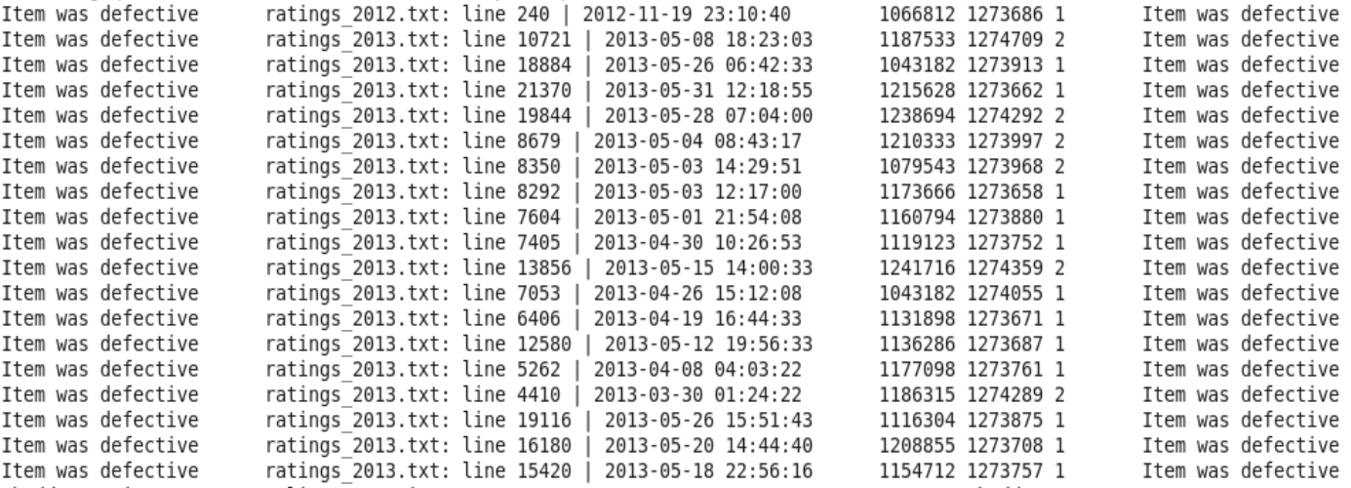
Figure 1. Output for the “Item was defective” appearances.

- Show the screenshot of all locations in your result where the comment with only a single word, “Shoddy”, appears in the sources.
Ans:
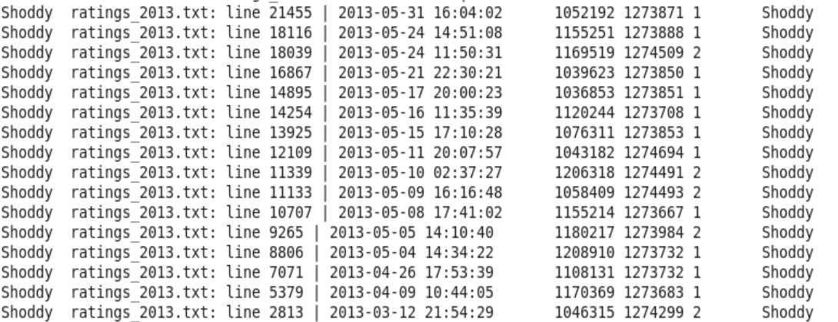
Figure 2. Output for the “Shoddy” appearances.

- Part 2
- Find a way with tools taught in this unit to check whether the language_code attribute in the source data is unique. Note that you cannot eyeball the result. The result should be found by combining valid tools in a sequence.
  - List the sequence of tools you used for finding the answer:
Ans: To find the answer of this task, I used Pig Latin with HDFS.

  - Give a short explanation of which tool did what.
Ans: Pig Latin was used to load the ‘austlang_dataset_nh.txt’ that has been put into HDFS and group rows by the ‘language_code’ field (the first field in the file). In the Pig Latin script, ‘GROUP BY’ and ‘COUNT’ are used to detect whether any ‘language_code’ appears more than once, thus ‘FILTER’ is used to isolate and display only language codes with counts greater than 1. After executing the Pig Latin script, if the result is no ouput, it means all language_code values are unique.

  - List the code/command/statement and the outcome screenshot of the step in the sequence: (Note that only meaningful screenshot is required. For example, the screenshot of the MapReduce execution result is necessary, but the screenshot of the outcome from the “cd ..” command is not meaningful)
[Phase 1 – Store the dataset in the folder ‘assignment2’ in HDFS]
Command:
hdfs dfs -put austlang_dataset_nh.txt assignment2

Outcome:
Figure 3. The source data in the HDFS.

[Phase 2 – Execute the Pig Latin script]
Pig Latin code:
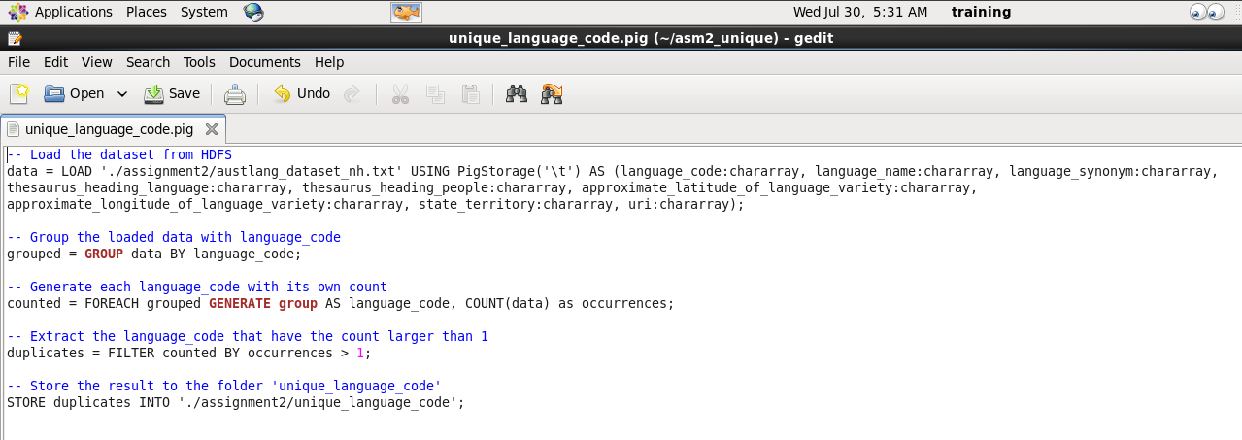
Figure 4. The Pig Latin script.

Outcome:
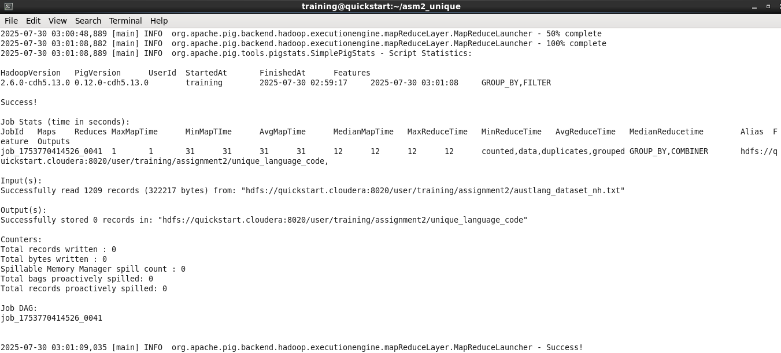
Figure 5. Excute the Pig Latin script successful.

[Phase 3 – Review the result]
If there is no record in the output, it means all the language_code attribute in the source data is unique.
Command:
hdfs dfs -get assignment2/unique_language_code
less unique_language/part-r-00000

Outcome:
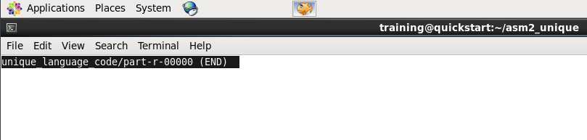
Figure 6. No record in the output, meaning all the language_code attribute in the source data is unique.

- Find a way with tools taught in this unit to list the unique values for all entities (tables with the solid boundary) except lng_id.
  - What is the best tool of choice to perform this task?
Ans: MapReduce is the best choice because it can extract the fields in the dataset and extracts result efficiently via key-based grouping.

  - Assume you choose MapReduce to be the tool. Should it be the Map-only design or the complete MapReduce with mapper and reducer involved in the process?
Ans: The complete MapReduce model with both a Mapper and a Reducer is more approriate, because the Reducer is needed to elimate duplicates and ensure the output is unique values.

  - Assume you choose MapReduce to be the tool. Does the count in the output matter for preparing the data for creating the entities?
Ans: No, the count is not matter. Only the distinct values are needed to populate the entity tables. The reducer simply emits the unique keys without counts.

  - List the code/command/statement and the outcome screenshot of preparing the data for lng_st.
Ans:
MapReduce code for preparing the data for “lng_st”:
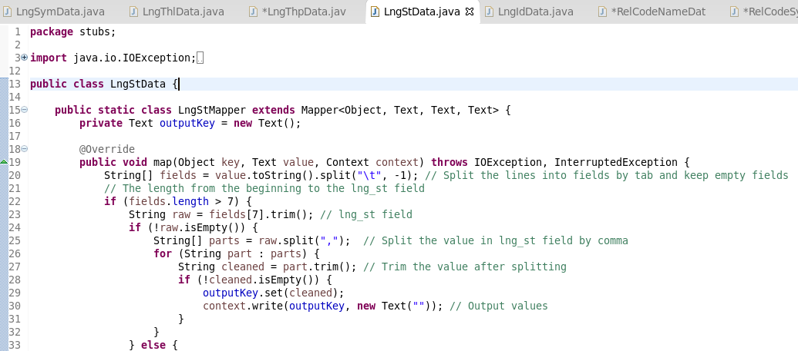
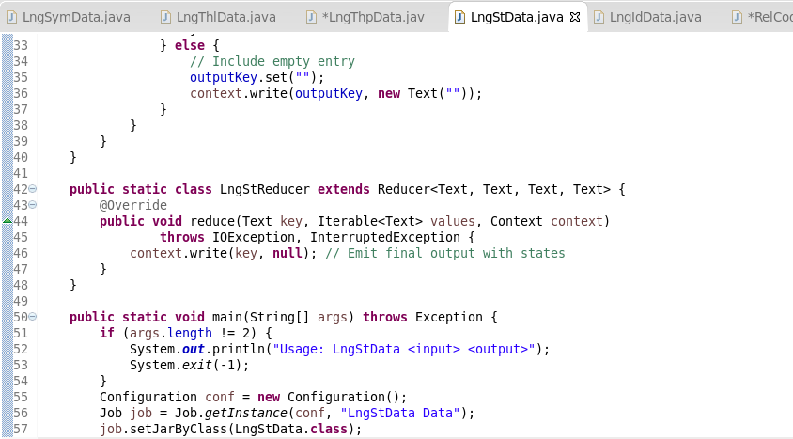
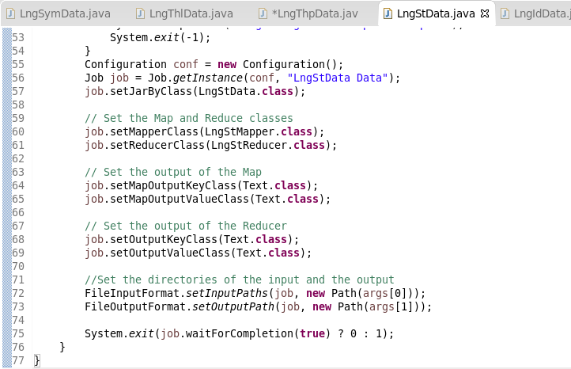
Figure 7. Prepare data for “lng_st” with MapReduce.

Outcome:
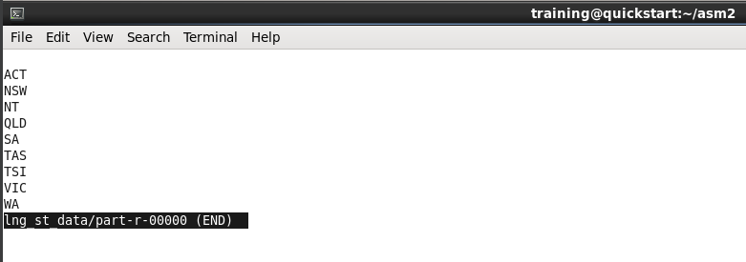
Figure 8. Prepared data for lng_st.

  - How many counts does QLD have?
Ans: There are 347 counts QLD has.

- Find a way with tools taught in this unit to prepare the data for all entities (tables with the solid boundary) for MySQL and Hive.
  - Assume your tool of choice is MapReduce for this task. Will this be a Map-only job or a complete MapReduce job for preparing the desired data?
Ans: This task requires a complete MapReduce job. The mapper extracts the necessary fields from the dataset and emits key-value pairs by fields, while the reducer ensures that each value in fields appears only once, which is essential when multiple rows might contain the same value.

  - List the code/command/statement and the outcome screenshot of preparing the data for lng_id.
Ans:
MapReduce code for preparing the data of lng_id:
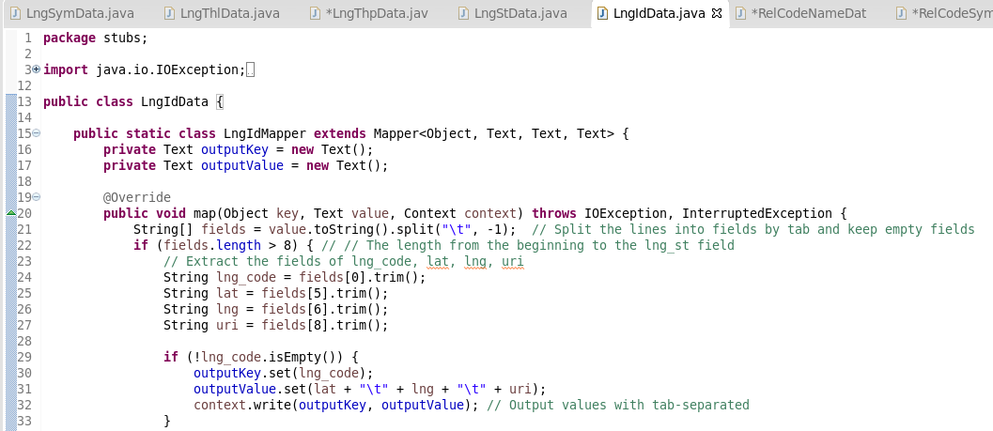
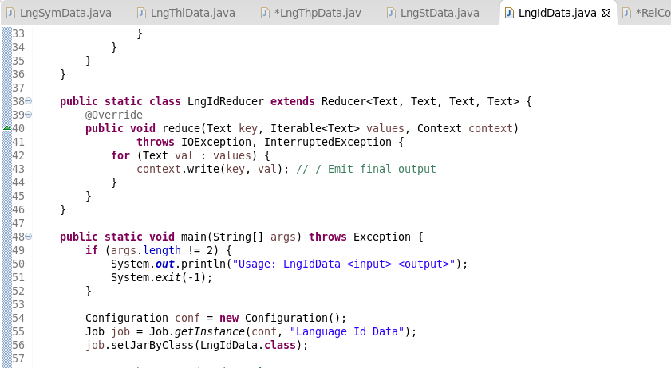
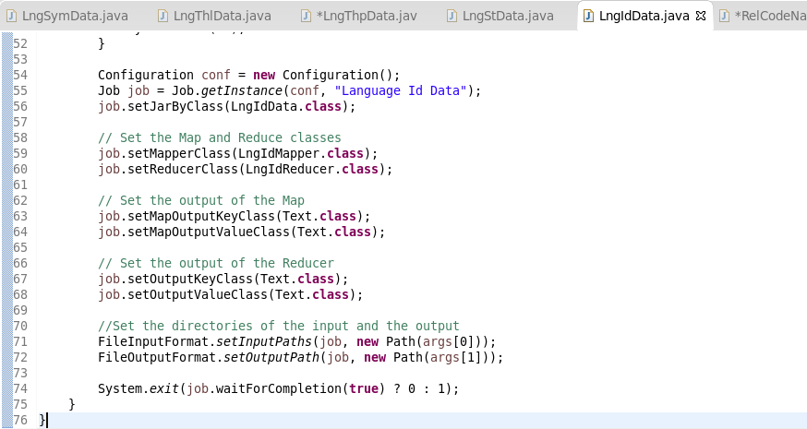
Figure 9. Prepare data for “lng_id” with MapReduce.

Outcome:
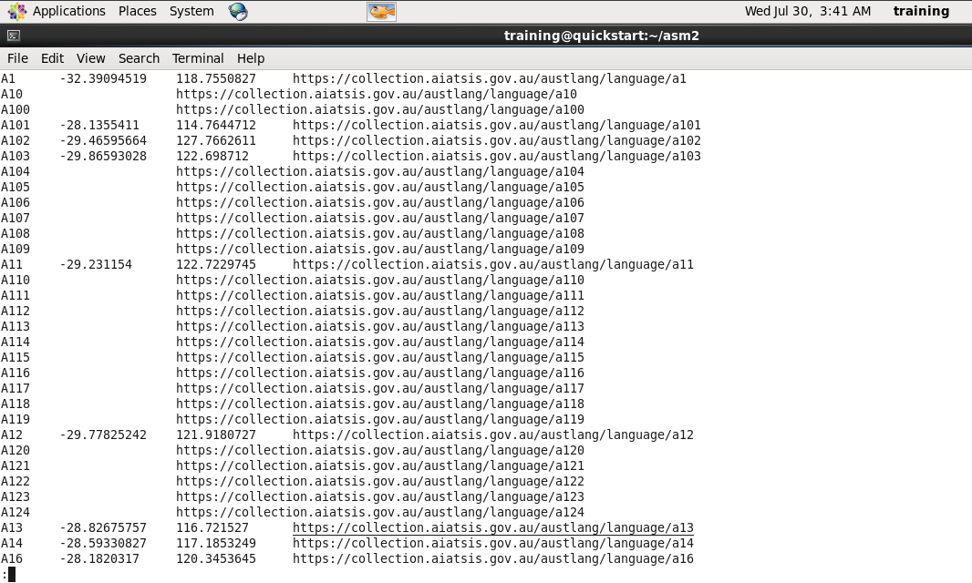
Figure 10. Prepared data for lng_id.

- Find a way with tools taught in this unit to prepare the data for all weak entities (tables with the dashed boundary) for MySQL and Hive.
  - Which tool would be the best choice for handling this task?
Ans: The best tool for preparing data for weak entities is MapReduce, as it allows for controlled extraction and transformation of many-to-many relationships by splitting multi-valued fields and maintaining referential integrity with primary entities.

  - List the code/statement of preparing the data for all weak entities.
Ans:
MapReduce code for preparing the data of rel_code_name:
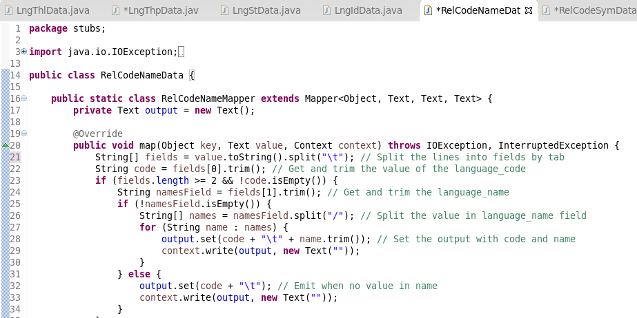
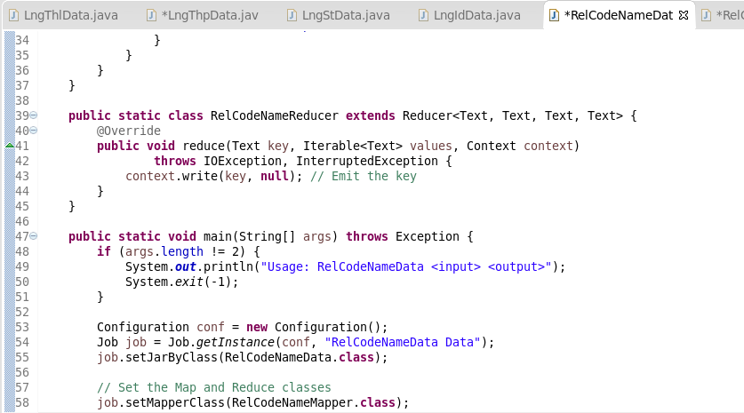
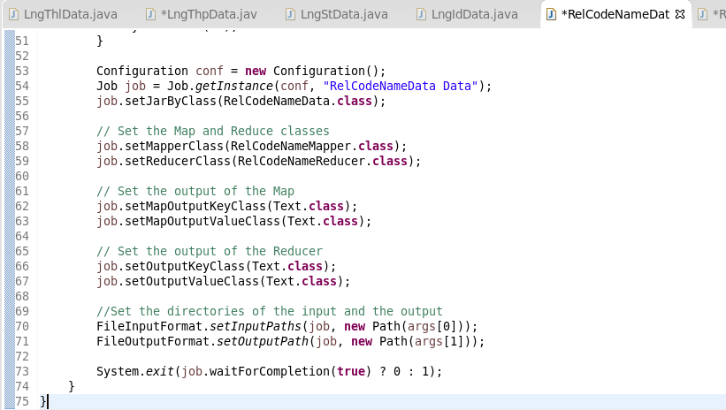
Figure 11. Prepare data for “rel_code_name” with MapReduce.

MapReduce code for preparing the data of rel_code_synonym:
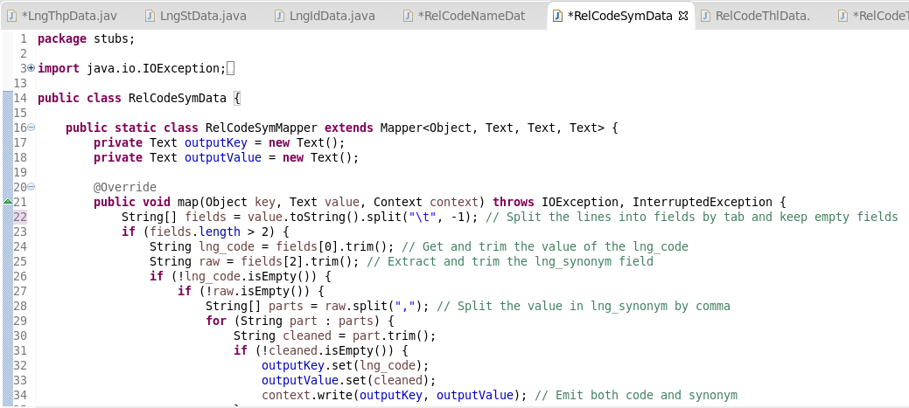
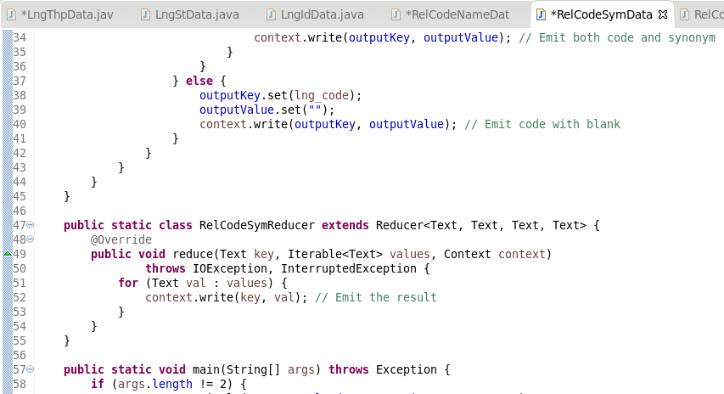
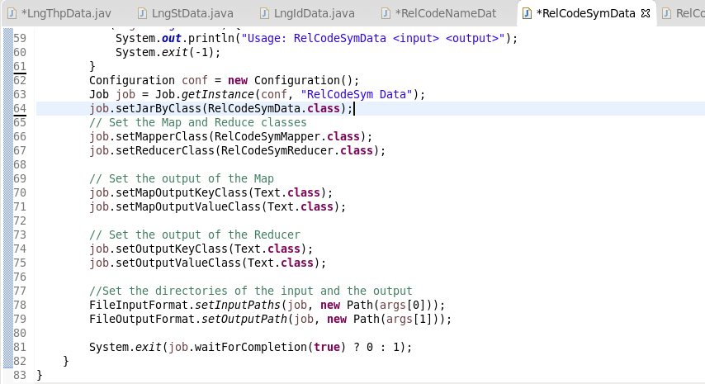
Figure 12. Prepare data for “rel_code_synonym” with MapReduce.

MapReduce code for preparing the data of rel_code_thl:
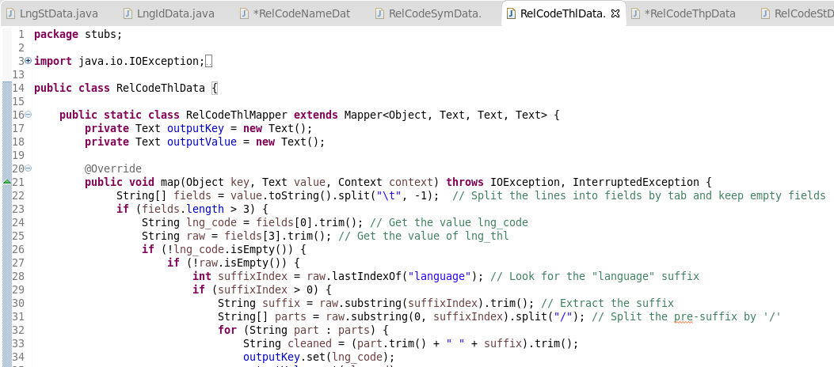
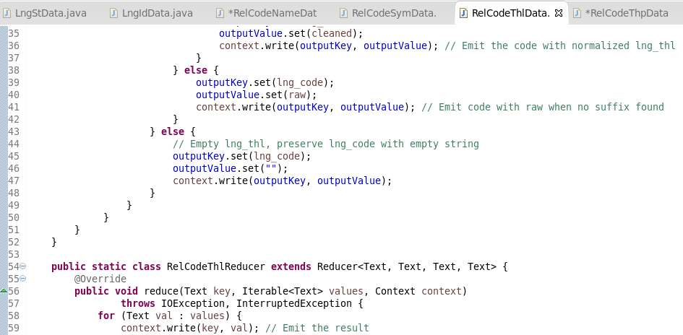
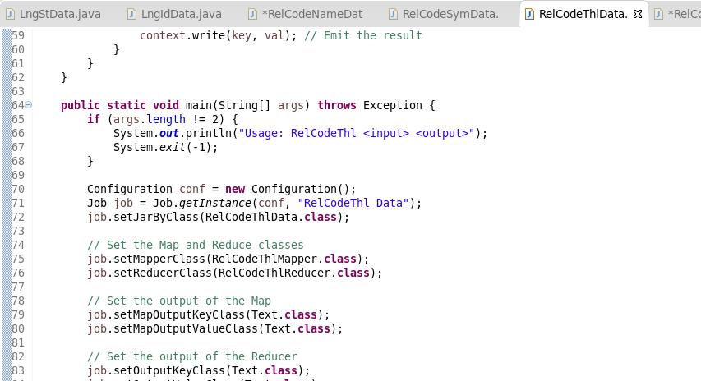
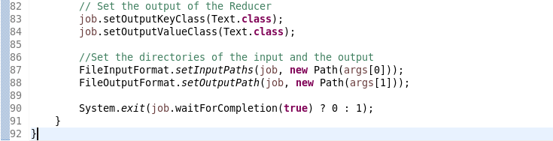
Figure 13. Prepare data for “rel_code_thl” with MapReduce.

MapReduce code for preparing the data of rel_code_thp:
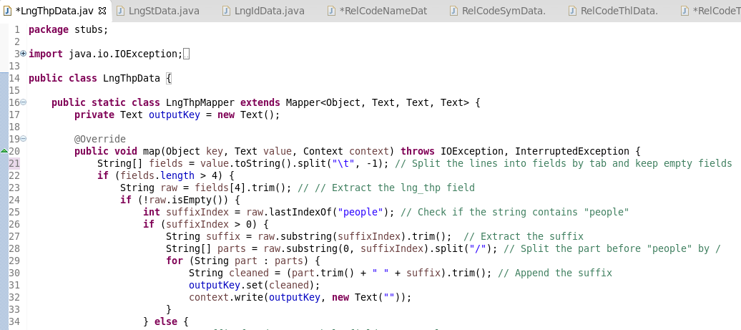
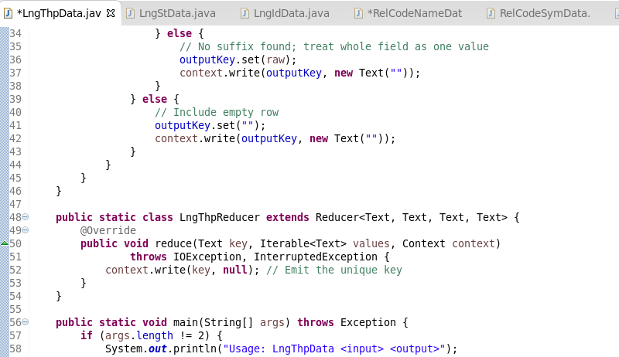
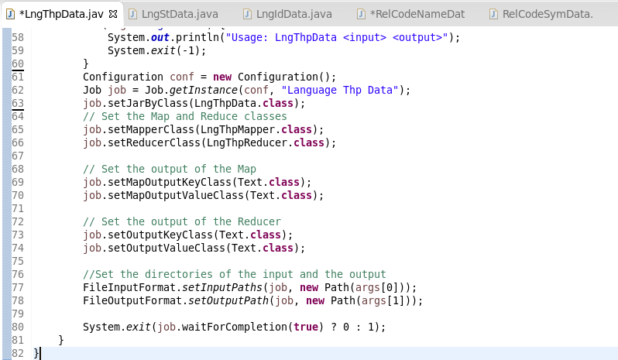
Figure 14. Prepare data for “rel_code_thp” with MapReduce.

MapReduce code for preparing the data of rel_code_st:
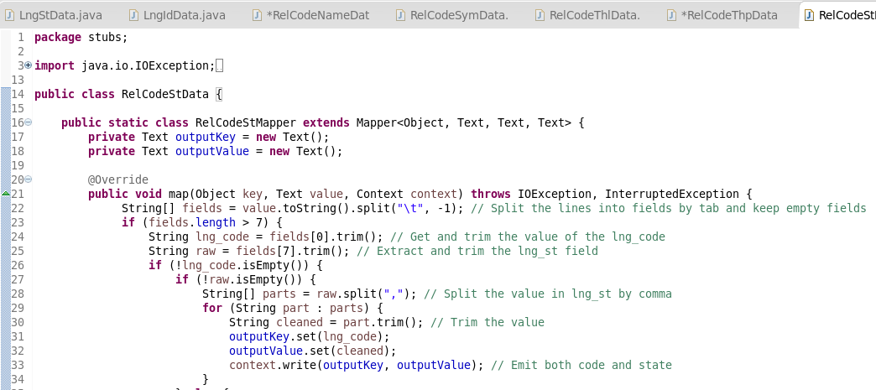
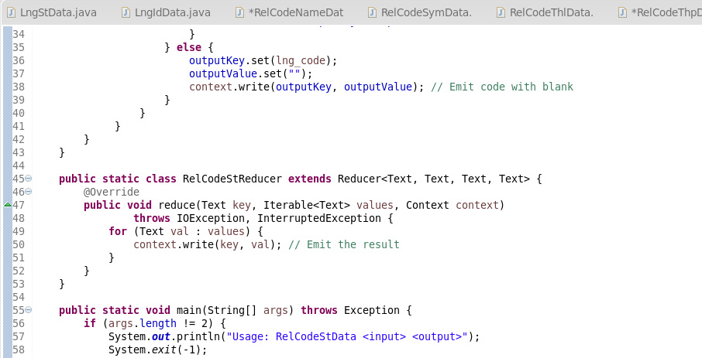
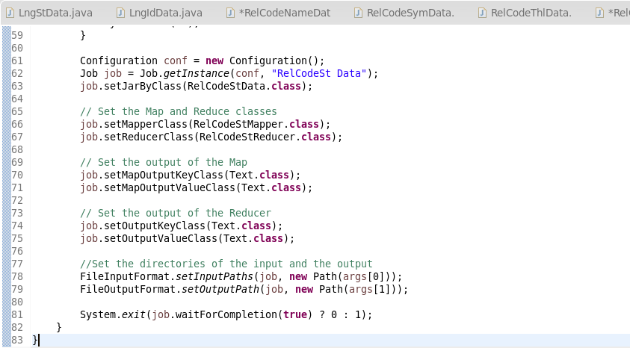
Figure 15. Prepare data for “rel_code_st” with MapReduce.
  - Post the first-page screenshot of the rel_code_name processed result.
Ans:
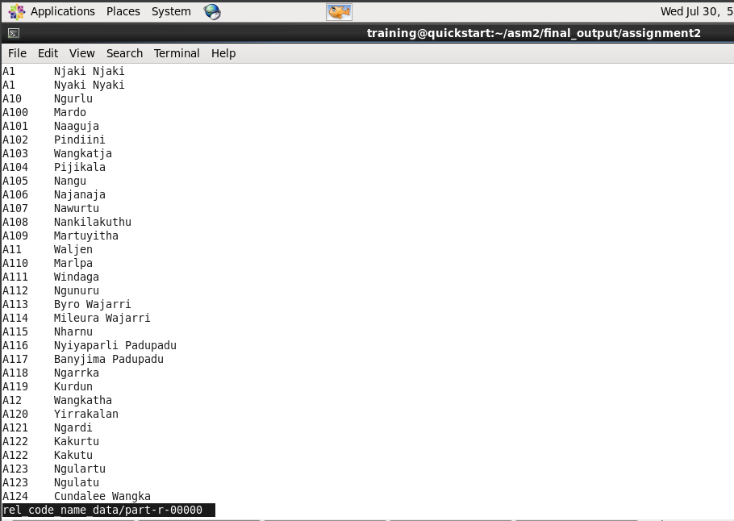
Figure 16. Processed data of the “rel_code_name”.
- Follow the given ERDs, create tables and import data into the created tables. All tables should be put in the database entitled “indigenous”.
  - List all statements of this task for MySQL:
Ans:
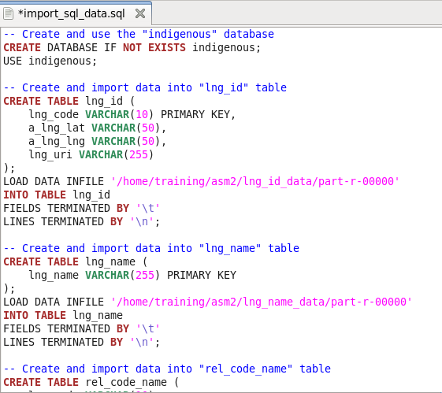
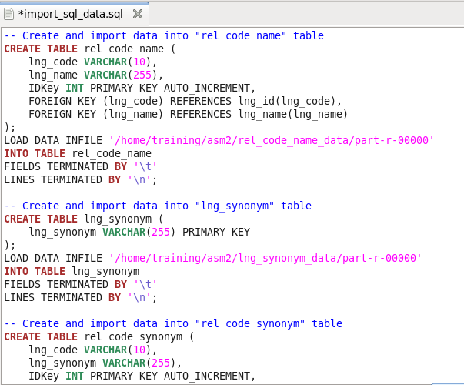
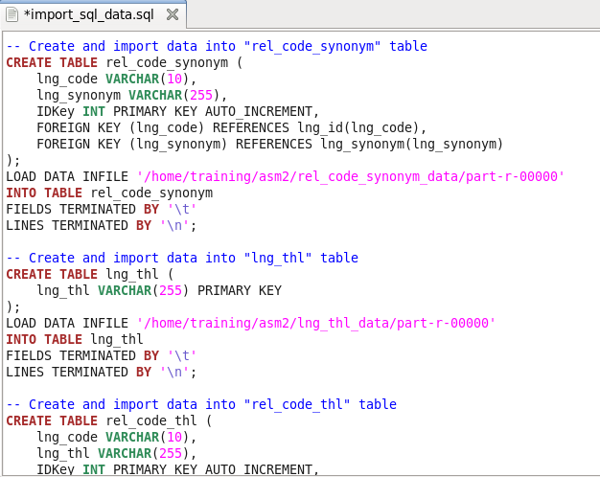
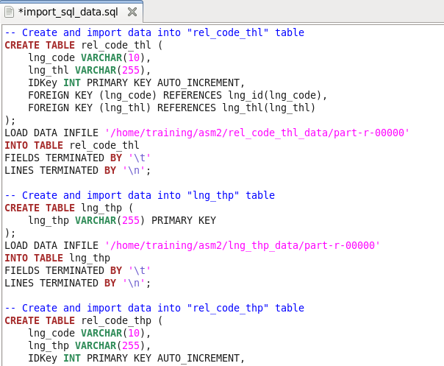
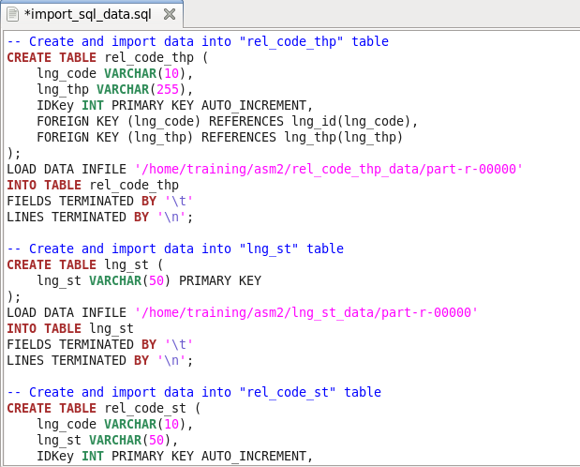
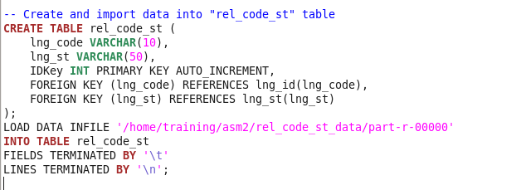
Figure 17. SQL file to create and import data to MySQL.

  - List all statements of this task for Hive:
Ans:
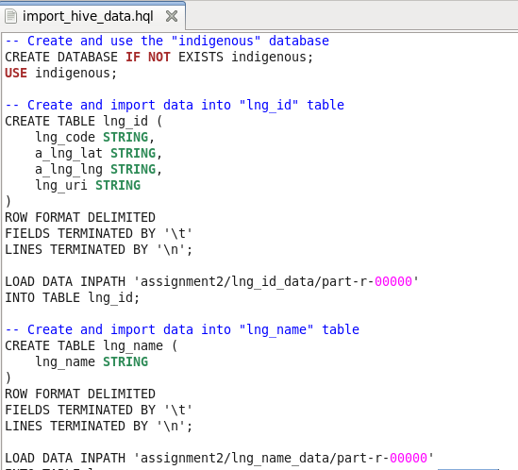
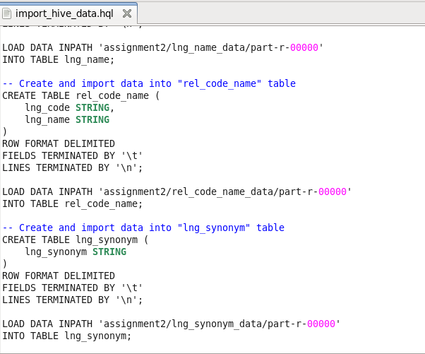
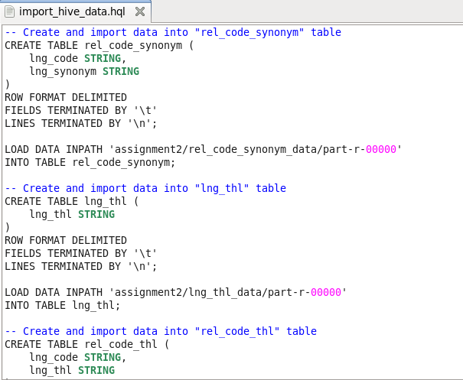
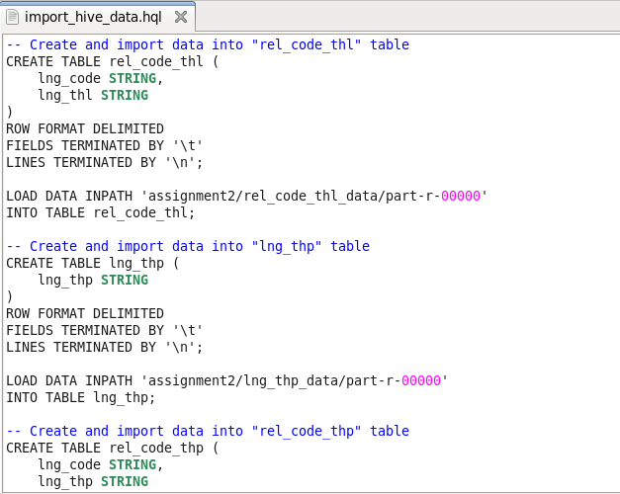
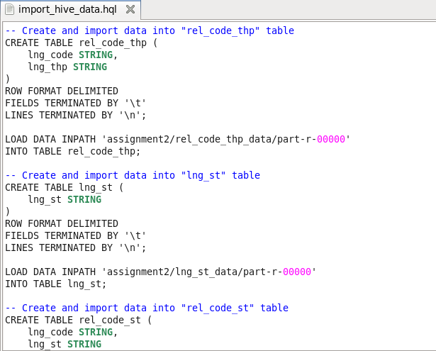
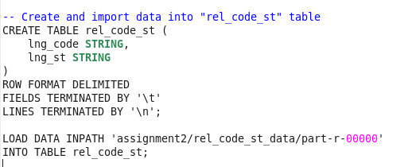
Figure 18. HQL file to create and import data to Hive.

- Show the detailed information of table rel_code_st in MySQL.
  - Statement:
Ans: To show the detailed information of table “rel_code_st” in MySQL, using:
mysql>DESCRIBE rel_code_st;

  - Result screenshot:
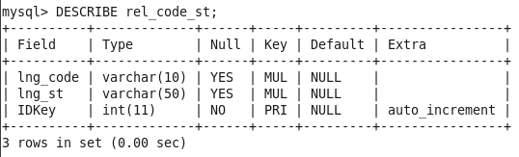
Figure 19. Detailed information of the “rel_code_st” table.
- Collect the results containing “lng_code”, “lng_name”, and “lng_st” of tuples whose lng_name starts with the upper case “D”. Show both statements and the last page screenshot of your query result in MySQL and Hive.
  - MySQL query statement:
Ans:
The MySQL query:
mysql>SELECT l.lng_code, n.lng_name, s.lng_st FROM lng_id l JOIN rel_code_name rcn ON l.lng_code = rcn.lng_code JOIN lng_name n ON rcn.lng_name = n.lng_name JOIN rel_code_st rcs ON l.lng_code = rcs.lng_code JOIN lng_st s ON rcs.lng_st = s.lng_st WHERE n.lng_name LIKE 'D%';

  - MySQL result screenshot:
Ans:
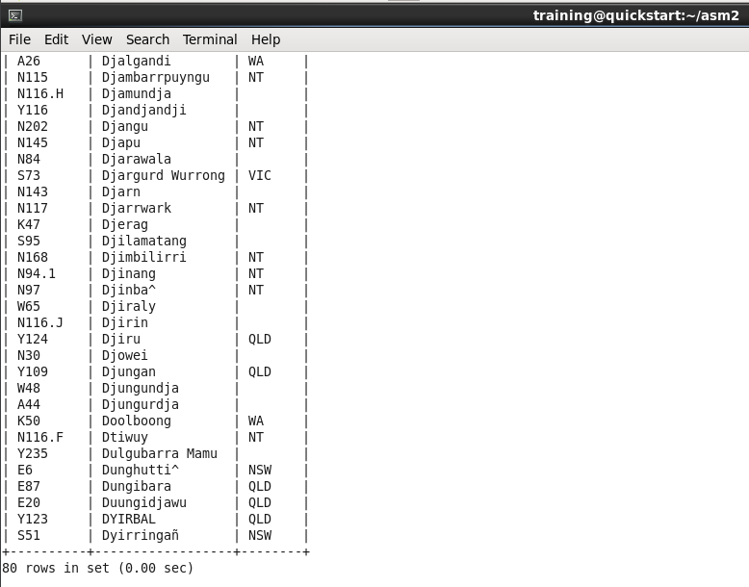
Figure 20. Result in MySQL.
  - Hive query statement:
Ans:
The Hive query:
hive>SELECT l.lng_code, n.lng_name, s.lng_st FROM lng_id l JOIN rel_code_name rcn ON l.lng_code = rcn.lng_code JOIN lng_name n ON rcn.lng_name = n.lng_name JOIN rel_code_st rcs ON l.lng_code = rcs.lng_code JOIN lng_st s ON rcs.lng_st = s.lng_st WHERE n.lng_name LIKE 'D%';

  - Hive result screenshot:
Ans:
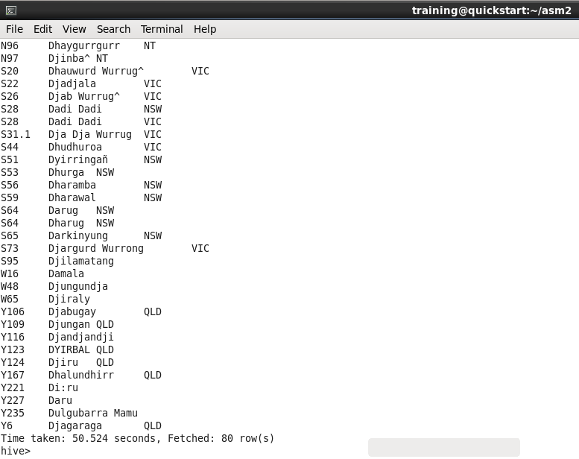
Figure 21. Result in Hive.

- Collect the results containing “lng_code”, “lng_name”, “lng_st”, “a_lng_lat”, and “a_lng_lng” of tuples whose lng_synonym contains “Kerama”. Show both statements and the last page screenshot of your query result in MySQL and Hive.
  - How many tuples are retrieved at the end?
Ans: There are 3 tuples are retrieved at the end for the synonym contains exactly “Kerama”, and there are 9 tuples are retrieved at the end for the synonym contains “Kerama”.

  - MySQL query statement:
Ans:
The SQL statement for containing exactly “Kerama”:
mysql> SELECT l.lng_code, n.lng_name, s.lng_st, l.a_lng_lat, l.a_lng_lng FROM lng_id l JOIN rel_code_synonym rcs ON l.lng_code = rcs.lng_code JOIN lng_synonym syn ON rcs.lng_synonym = syn.lng_synonym JOIN rel_code_name rcn ON l.lng_code = rcn.lng_code JOIN lng_name n ON rcn.lng_name = n.lng_name JOIN rel_code_st r ON l.lng_code = r.lng_code JOIN lng_st s ON r.lng_st = s.lng_st WHERE syn.lng_synonym = 'Kerama';

The SQL statement for containing “Kerama”:
mysql> SELECT l.lng_code, n.lng_name, s.lng_st, l.a_lng_lat, l.a_lng_lng FROM lng_id l JOIN rel_code_synonym rcs ON l.lng_code = rcs.lng_code JOIN lng_synonym syn ON rcs.lng_synonym = syn.lng_synonym JOIN rel_code_name rcn ON l.lng_code = rcn.lng_code JOIN lng_name n ON rcn.lng_name = n.lng_name JOIN rel_code_st r ON l.lng_code = r.lng_code JOIN lng_st s ON r.lng_st = s.lng_st WHERE syn.lng_synonym LIKE '%Kerama%';

  - MySQL result screenshot:
Ans:
The MySQL result screenshot for containing exactly “Kerama”:
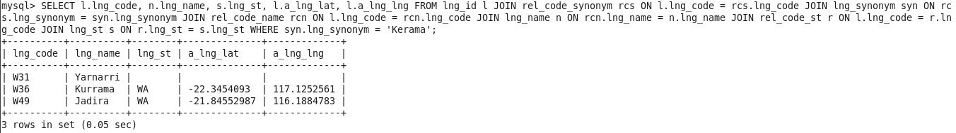
Figure 22. Result in MySQL for containing exactly “Kerama”.

The MySQL result screenshot for containing “Kerama”:
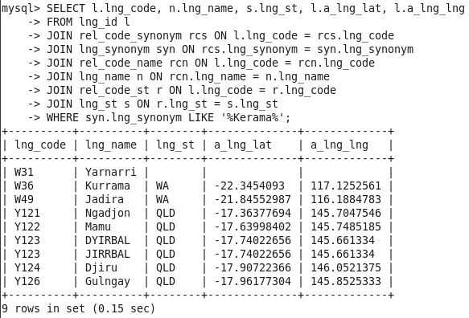
Figure 23. Result in MySQL for containing “Kerama”.

  - Hive query statement:
Ans:
The SQL statement for containing exactly “Kerama”:
hive> SELECT l.lng_code, n.lng_name, s.lng_st, l.a_lng_lat, l.a_lng_lng FROM lng_id l JOIN rel_code_synonym rcs ON l.lng_code = rcs.lng_code JOIN lng_synonym syn ON rcs.lng_synonym = syn.lng_synonym JOIN rel_code_name rcn ON l.lng_code = rcn.lng_code JOIN lng_name n ON rcn.lng_name = n.lng_name JOIN rel_code_st r ON l.lng_code = r.lng_code JOIN lng_st s ON r.lng_st = s.lng_st WHERE syn.lng_synonym = 'Kerama';

The SQL statement for containing “Kerama”:
hive> SELECT l.lng_code, n.lng_name, s.lng_st, l.a_lng_lat, l.a_lng_lng FROM lng_id l JOIN rel_code_synonym rcs ON l.lng_code = rcs.lng_code JOIN lng_synonym syn ON rcs.lng_synonym = syn.lng_synonym JOIN rel_code_name rcn ON l.lng_code = rcn.lng_code JOIN lng_name n ON rcn.lng_name = n.lng_name JOIN rel_code_st r ON l.lng_code = r.lng_code JOIN lng_st s ON r.lng_st = s.lng_st WHERE syn.lng_synonym LIKE '%Kerama%';
  - Hive result screenshot:
Ans:
The Hive result screenshot for containing exactly “Kerama”:
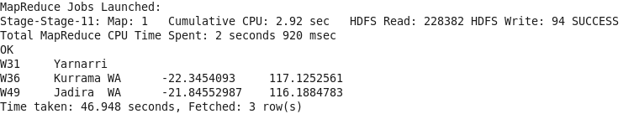
Figure 24. Result in Hive for containing exactly “Kerama”.

The Hive result screenshot for containing “Kerama”:
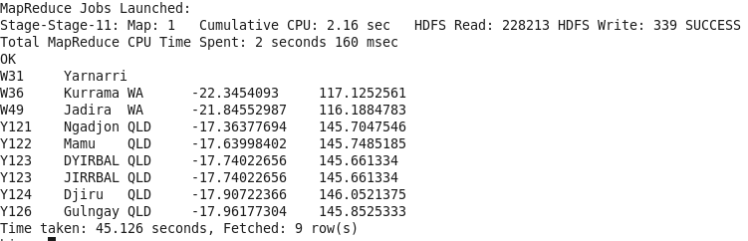
Figure 25. Result in Hive for containing exactly “Kerama”.

