Lab Task 1
Write a MapReduce Program for Finding the Shifted Word Counts
COS20028 – Big data Architecture and Applications
Semester 2, 2024

Name: Nguyen Pham Duy
Student ID: 104058375
Date: 26/05/2025

Project Folder Structure Screenshot
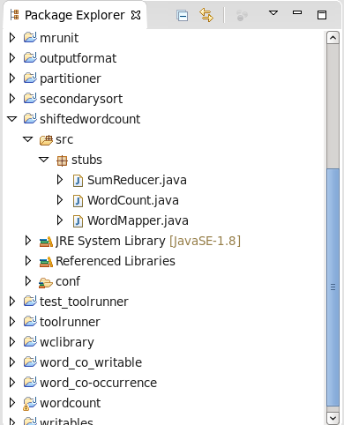

Driver Code
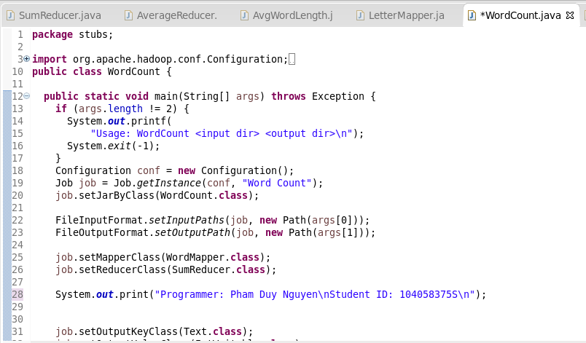
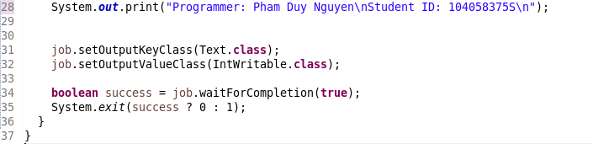

Mapper Code
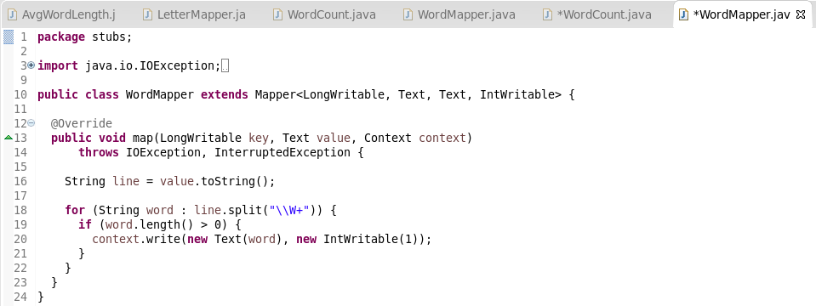

Reducer Code
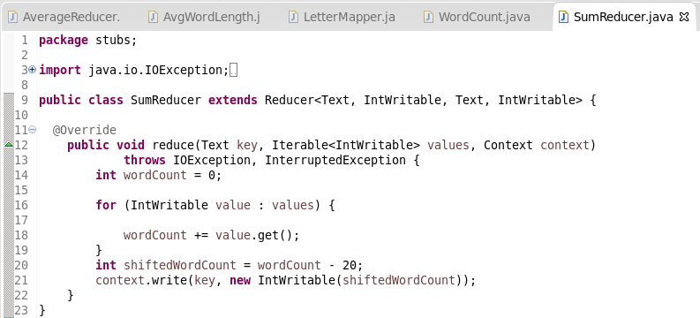

Execution Result
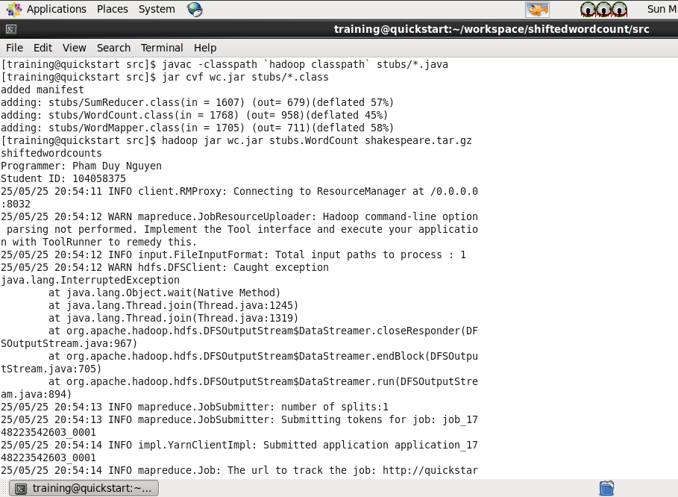

Commands for Retrieving and Displaying Results
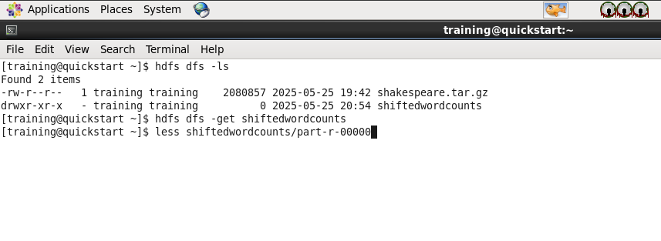
Screenshot of the First Page Result Content
