Lab Task 2
Write a MapReduce Program for Finding the Line Count in the input source
COS20028 – Big data Architecture and Applications
Semester 2, 2025

Name: Nguyen Pham Duy
Student ID: 104058375
Date: 2/6/2025

Project Folder Structure Screenshot

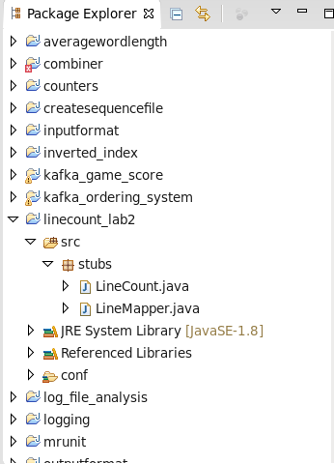

Driver Code
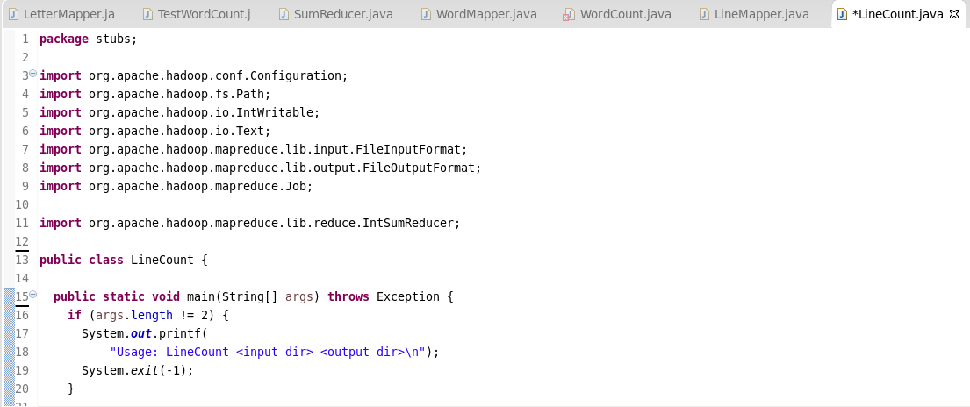
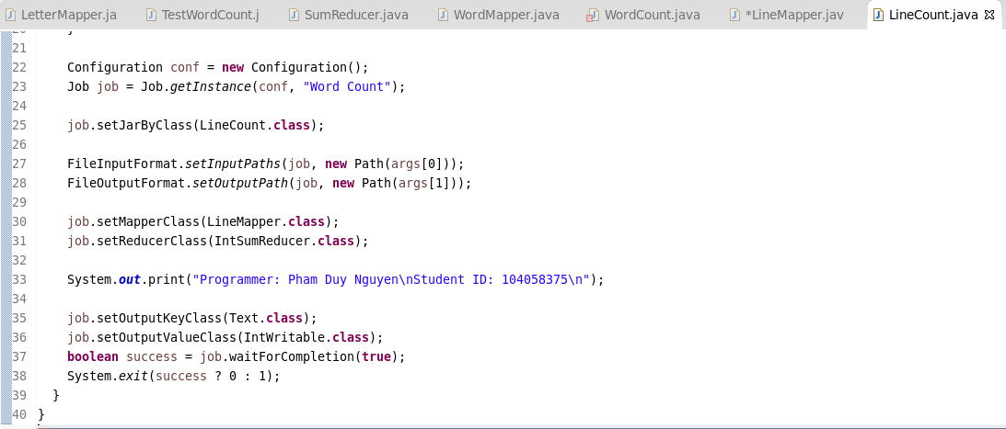

Mapper Code
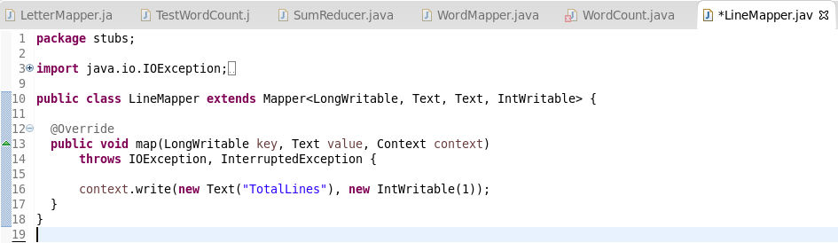

Execution Result

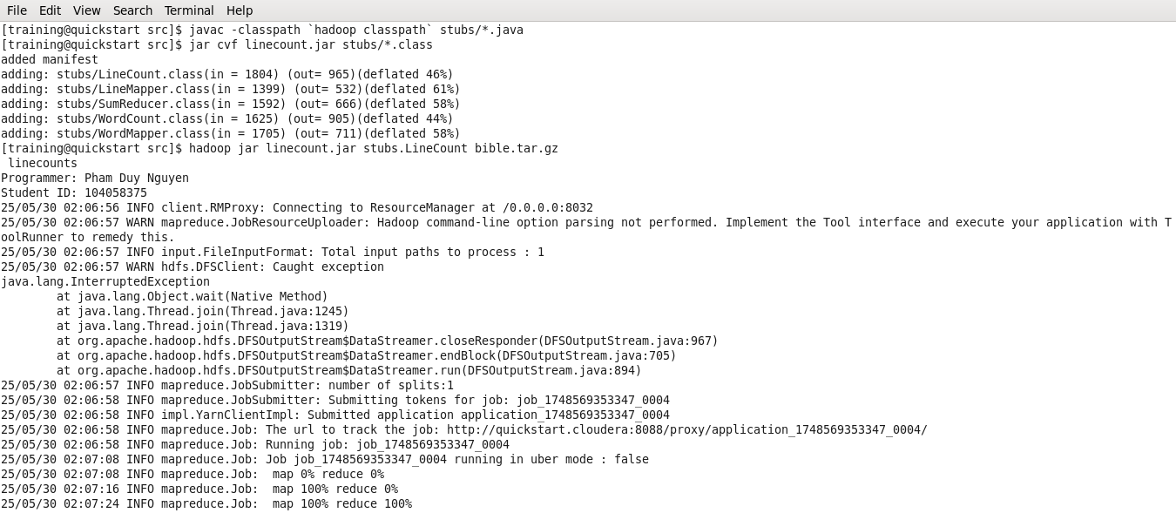

Commands for Retrieving and Displaying Results
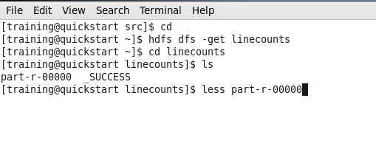
Screenshot of the First Page Result Content

