Lab Task 3
Using Counters and Map-Only Job
COS20028 – Big data Architecture and Applications
Semester 2, 2025

Name: Nguyen Pham Duy
Student ID: 104058375
Date: 11/6/2025

Project Folder Structure Screenshot

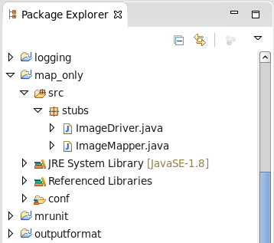

Driver Code
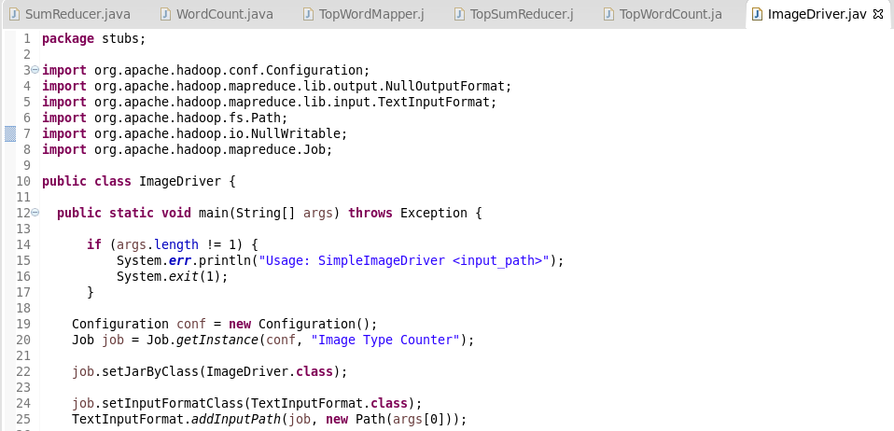
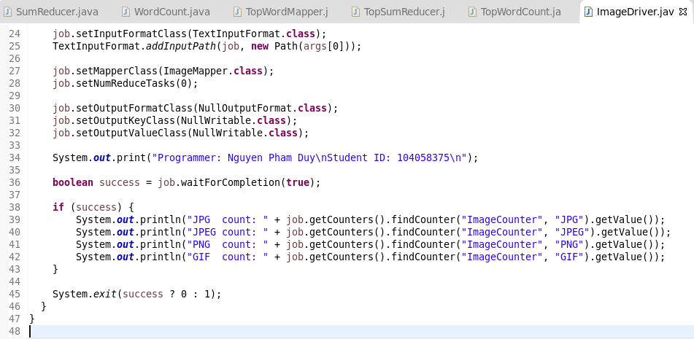

Mapper Code
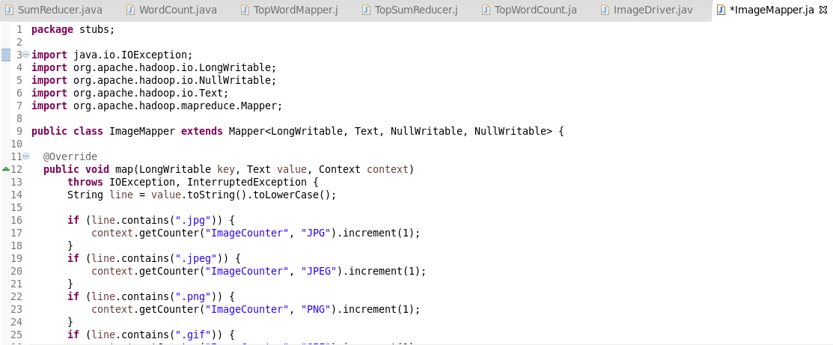
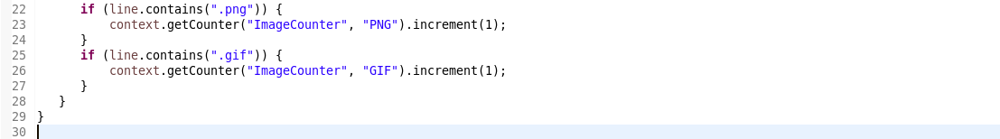

Execution Result

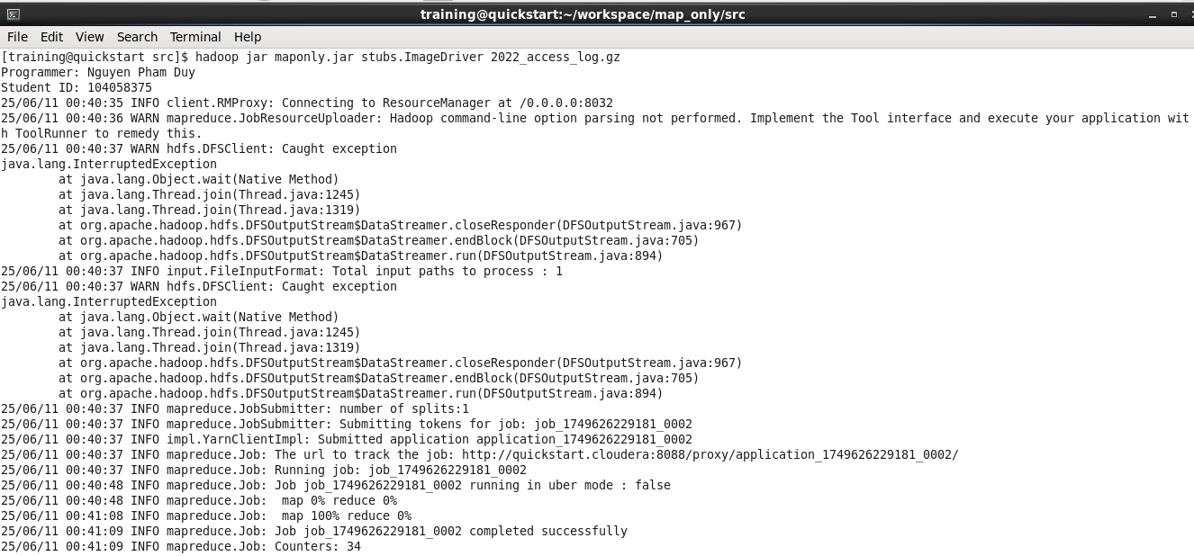
Commands for Retrieving and Displaying Results
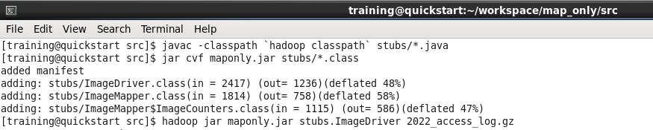

Screenshot of the Result Content

