Lab Task 5
Analysing Ad campaign data with Pig
COS20028 – Big data Architecture and Applications
Semester 2, 2025

Name: Nguyen Pham Duy
Student ID: 104058375
Date: 16/7/2025

Screenshot of the First Page Result Content

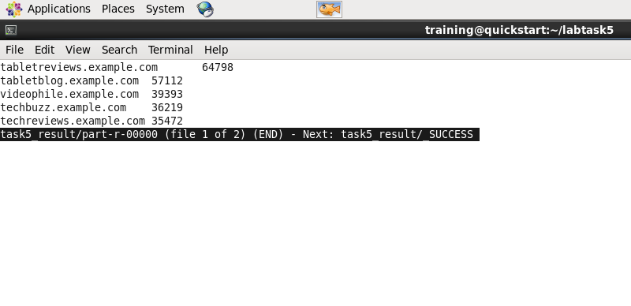

The Code for Processing the First AD:
(The “first_etl.pig” content)
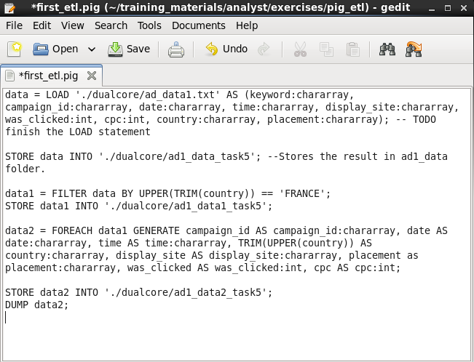

The Code for Processing the Second AD:
(The “second_etl.pig” content)
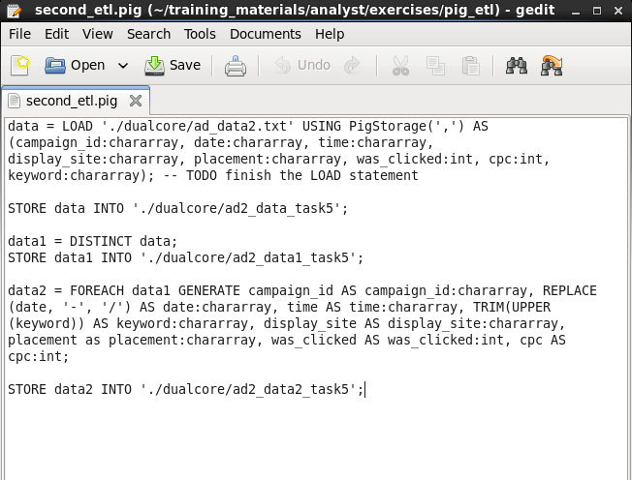

The Code for Merging Multiple Sources and Finding Answers:
(The “high_cost_sites.pig” content)
