Lab Task 6
Analysing Ad campaign data with Pig
COS20028 – Big data Architecture and Applications
Semester 2, 2025

Name: Nguyen Pham Duy
Student ID: 104058375
Date: 23/7/2025

The Code for the first question:
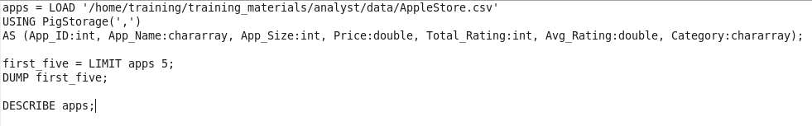

Screenshot of the First Page Result Content

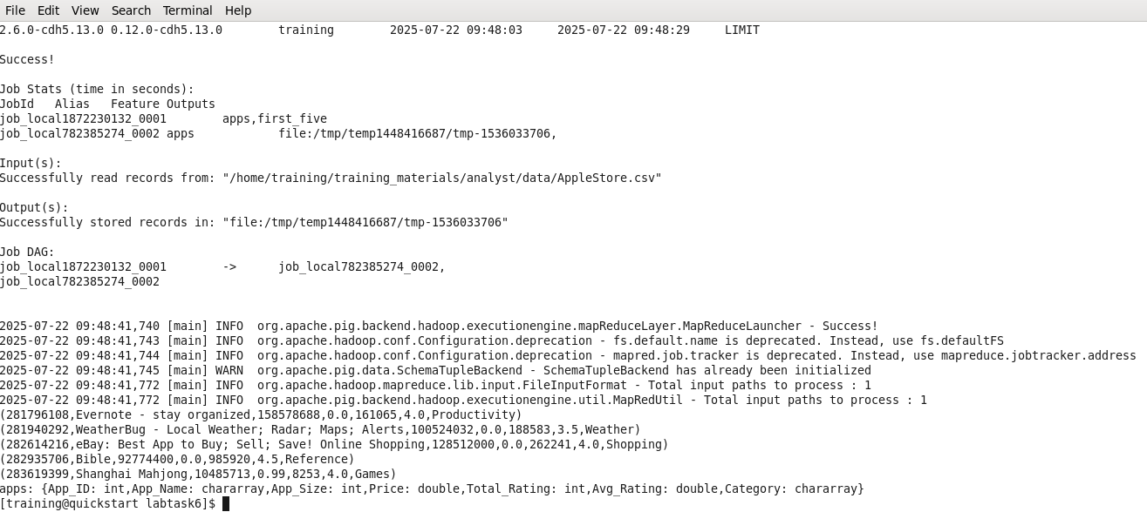

The Code for the second question:
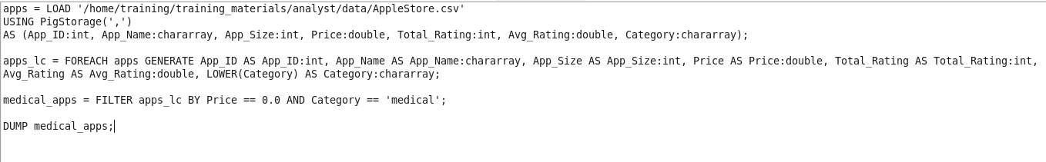

Screenshot of the First Page Result Content
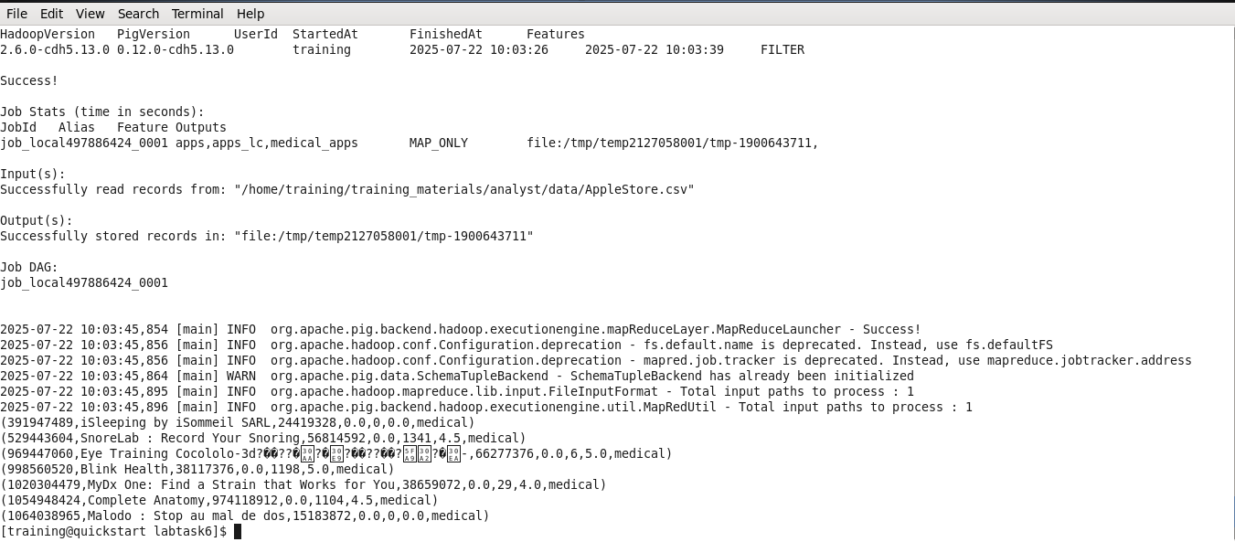

The Code for the third question:
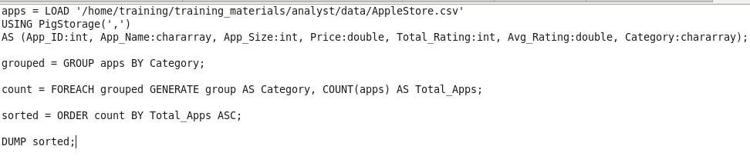

Screenshot of the First Page Result Content
