Lab Task 7
Analysing Ad campaign data with Pig
COS20028 – Big data Architecture and Applications
Semester 2, 2025

Name: Nguyen Pham Duy
Student ID: 104058375
Date: 27/7/2025

Task 1
Answer the question below:
Q: How many tuples are in the austlang table?
A: 1209.

MySQL Statement
(Statement for finding the answer to the above question)
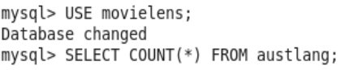

Result Screenshot from MySQL Query
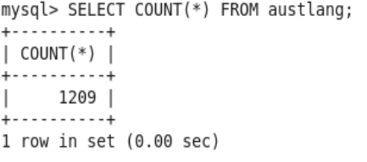

HiveQL Statement
(Statement for finding the answer to the above question)
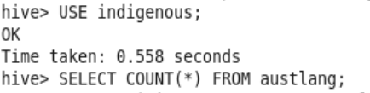

Result Screenshot from HiveQL Query
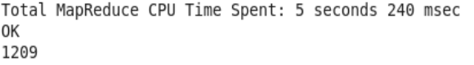

Task 2
Answer the question below:
Q: How many language names appear more than once in the lng_name attribute?
A: 76 in MySQL and 5 in Hive.

MySQL Statement
(Statement for listing the language name and the count that has the count greater than 1.)

Result Screenshot from MySQL Query
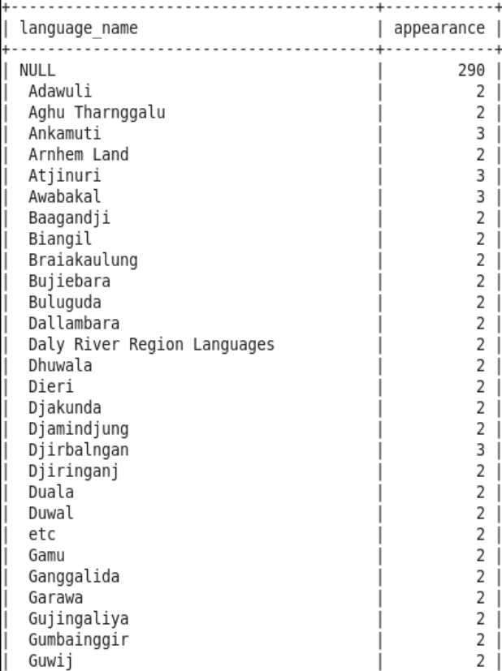

HiveQL Statement
(Statement for listing the language name and the count that has the count greater than 1.)
Result Screenshot from HiveQL Query
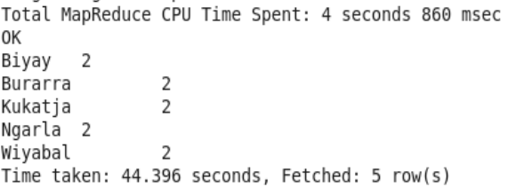

Task 3
MySQL Statement
(Statement for listing the sites and the counts.)

Result Screenshot from MySQL Query
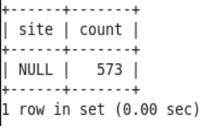

HiveQL Statement
(Statement for listing the sites and the counts.)

Result Screenshot from HiveQL Query

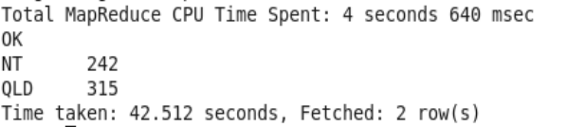
Task 4
Answer the question below:
Q: How many records match the criteria that the location is in the south of latitude -25.12 and the east of longitude 135.36?
A: 0 in MySQL and 256 in Hive.

MySQL Statement
(Statement for finding the answer to the above question)

Result Screenshot from MySQL Query
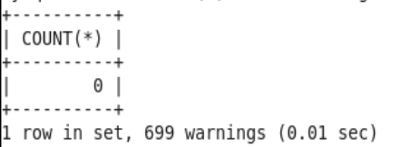

HiveQL Statement
(Statement for finding the answer to the above question)

Result Screenshot from HiveQL Query
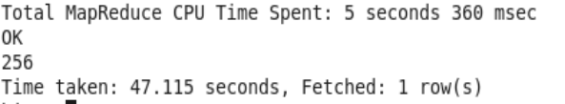

Task 5
Answer the question below:
Q: How many times does “Mardudjara” appear in the lng_synonym attribute?
A: 0 in MySQL and 2 in Hive.

MySQL Statement
(Statement for finding the answer to the above question)

Result Screenshot from MySQL Query

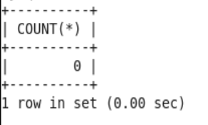

HiveQL Statement
(Statement for finding the answer to the above question)

Result Screenshot from HiveQL Query

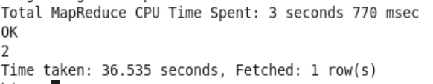

Task 6
Answer the question below:
Q: Does HiveQL return the result faster than MySQL?
A: No, MySQL returns the result faster than HiveQL.

Result Screenshot from MySQL Query
(Screenshot of which contains the answer to the question.)
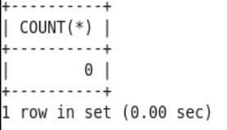
Result Screenshot from HiveQL Query
(Screenshot of which contains the answer to the question.)
