
Swinburne University of Technology Hawthorn Campus
Department of Computing Technologies

COS20028 Big Data Architecture and Application
Assignment 1 - Semester 2, 2025

Student Name: NGUYEN PHAM DUY
Student ID: 104058375
Assessment Title: MapReduce Application.

Assessment Outcome: 20%
Due Date: AEST 23:59 on 11/06/2025.
Assessable Item:
- One (1) piece of a report containing the complete flowchart showing your design idea about how to prepare the data, the tools being used in all steps, and the report for answers to the given questions.
- One (1) piece of a video explaining how you found answers to the question, the challenges you encountered, and how you solved them.

- Correct implementation of the Mapper class(es) with readability and well-structured codes and comments. [20 marks]
“WordMapper” is the mapper for the first MapReduce job. It filters words from the dataset that begin with an uppercase letter from the set {A, C, G, W, Y} and are followed by lowercase letters. It uses the regular expression “\\b[ACGWY][a-z]+\\b” to perform the match and emits each valid word with a count of one.
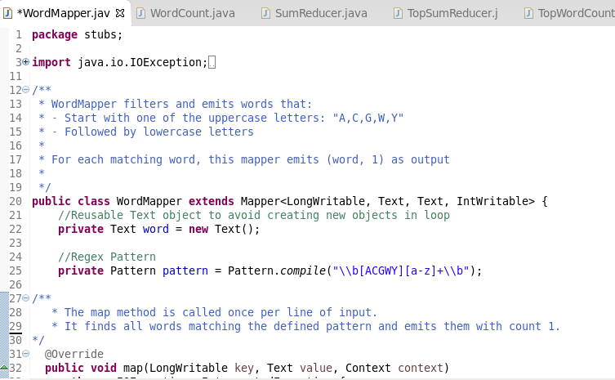
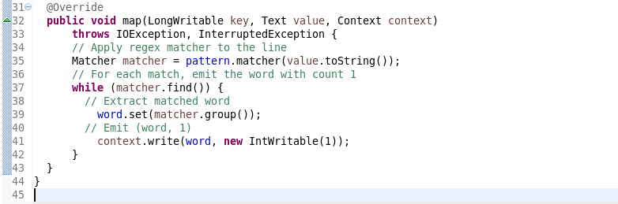
Figure 1. Mapper class for Job 1 – Word Filtering.

“TopWordMapper” is used in the second MapReduce job. It reads the output from the first MapReduce job and switches the key-value pairs from (word, count) to (count, word), enabling sorting to arrange the counts in descending order by multiplying the key (count) by -1.
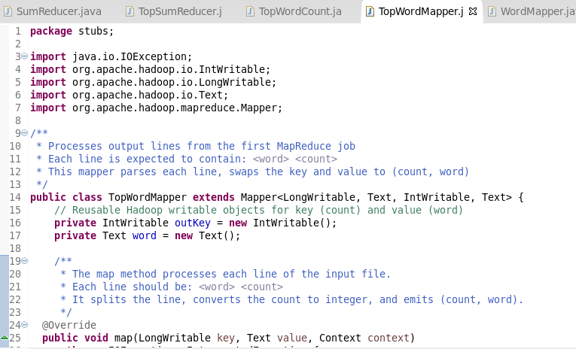
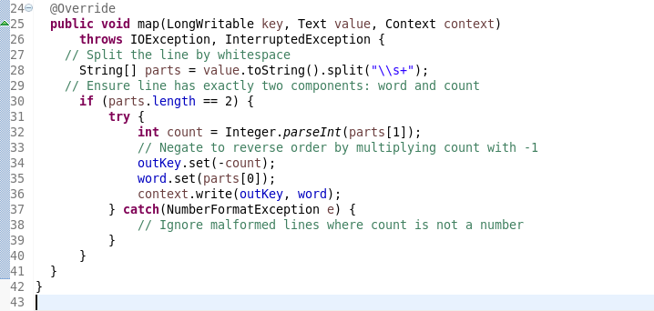
Figure 2. Mapper class for Job 2 – Key-Value Swapping and Sorting Descending Order.

- Correct implementation of the Reducer class(es) with readability and well-structured codes and comments. [20 marks]
“SumReducer” serves as the reducer in the first MapReduce job. It aggregates the values (counts) associated with each word emitted by the mapper and calculates the total frequency of each word.

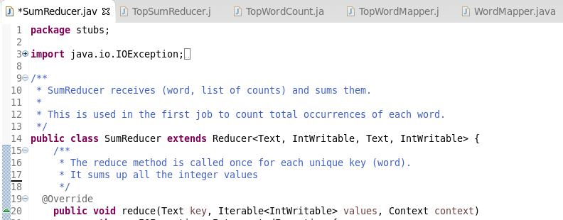
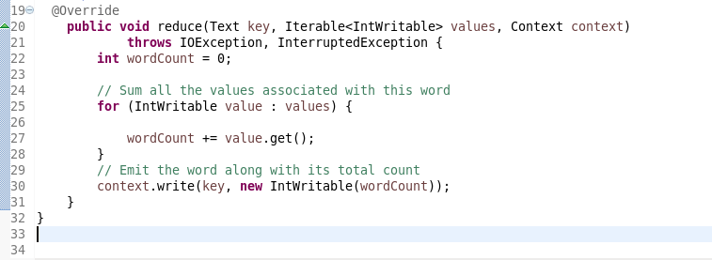
Figure 3. Reducer class for Job 1 – Word Count Aggregation.
“TopSumReducer” class as the reducer in the second job. It receives sorted (count, word) pairs, restores the original positive count, and outputs the two most frequent terms as well as the total number of words that appeared exactly once under the given criteria.

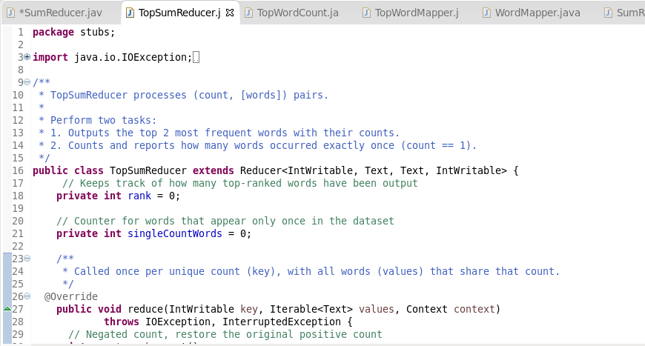
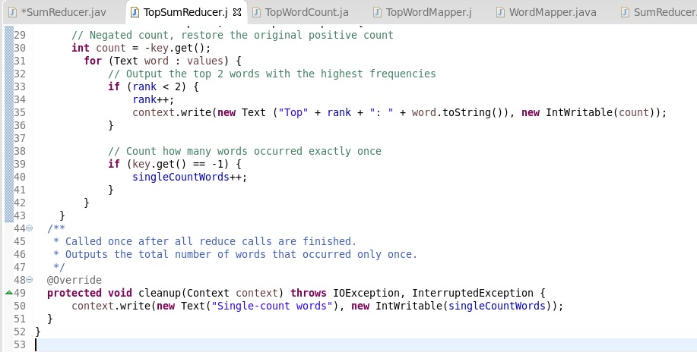
Figure 4. Reducer class for Job 2 – Extract Top Words and Single-Count Terms.

- Correct implementation of the Driver class(es) with readability and well-structured codes and comments. [20 marks]
“WordCount” is the driver class for the first MapReduce job. It sets up the job configuration, invokes the “WordMapper” and “SumReducer” classes, and processes the dataset to produce the word frequency list based on the regex criteria.
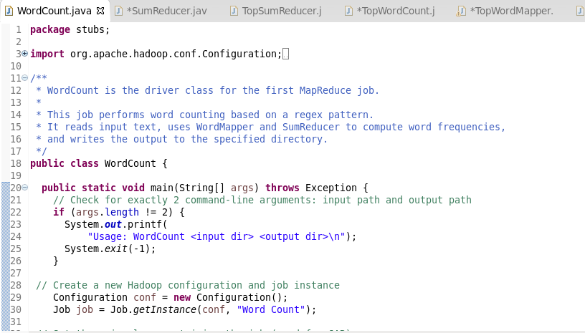
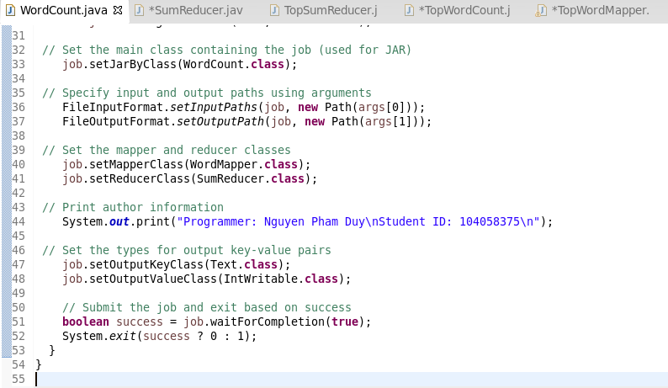
Figure 5. Driver class for Job 1 – Execution setup for filtering and counting.
“TopWordCount” is the driver for the second MapReduce job. It reads the output from the first job, swaps the key-value pair and applies descending sort using “TopWordMapper”, and invokes the reducer to produce the final top-2 and single-count word statistics.
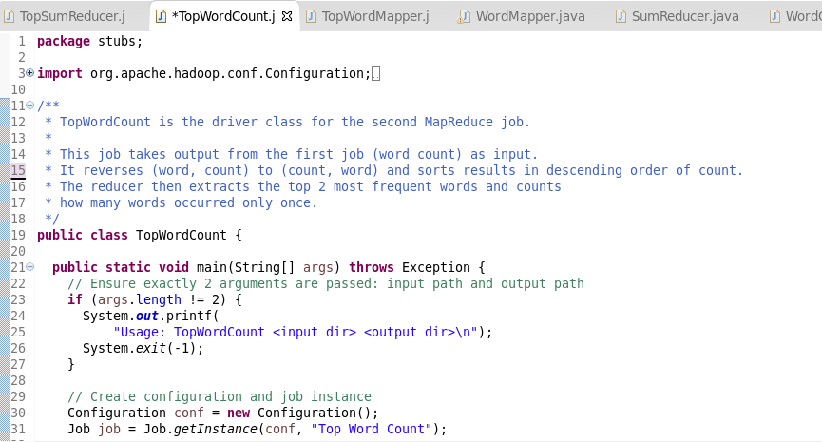
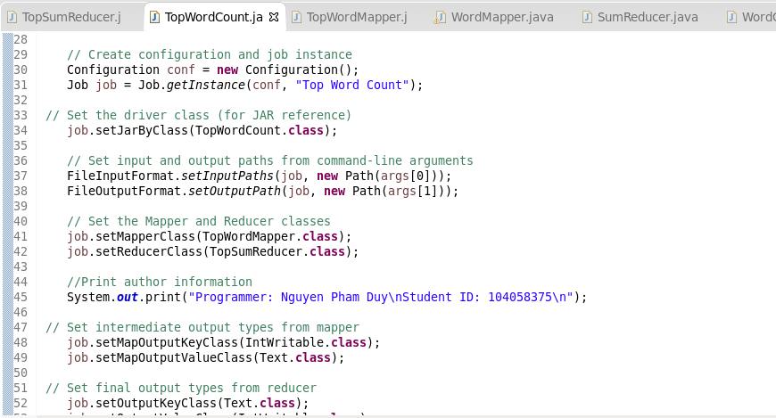
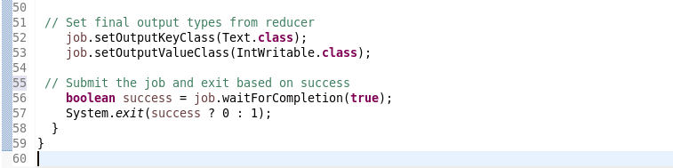
Figure 6. Driver class for Job 2 – Setup for sorting and result extraction.

(*)Additional MapReduce Implementation: Counting Terms that start with all upper-case letters and follow by the lower-case letters Appearing Only Once in the Entire Document:
To handle the task of counting how many terms that start with all upper-case letters and follow by the lower-case letters appear only once in the entire dataset, an additional MapReduce workflow is implemented. This process uses two MapReduce jobs:
First Job: Word Frequency: The first job uses a mapper that emits all words that satisfy the regular expression “\\b[A-Z][a-z]+\\b”. The reducer then sums up the total frequency of each word.
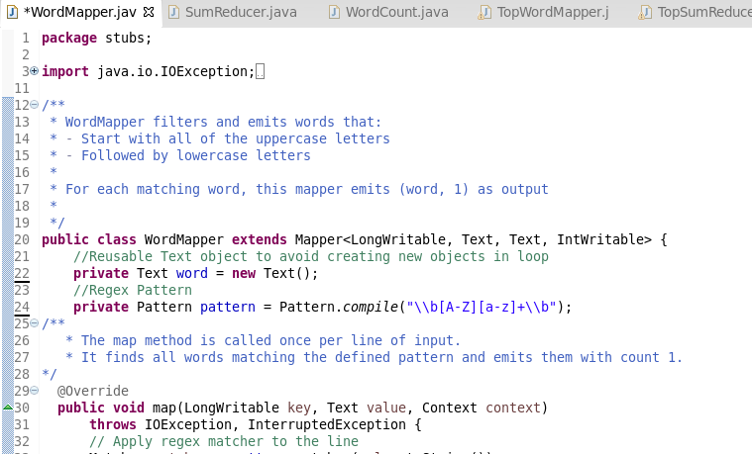
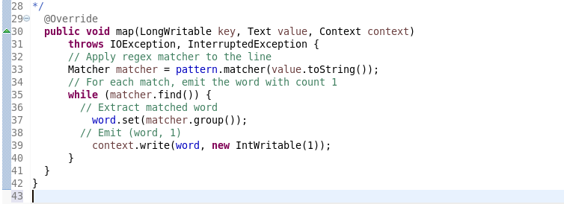
Figure 7. The mapper class for emitting every word in the document with a frequency 1.

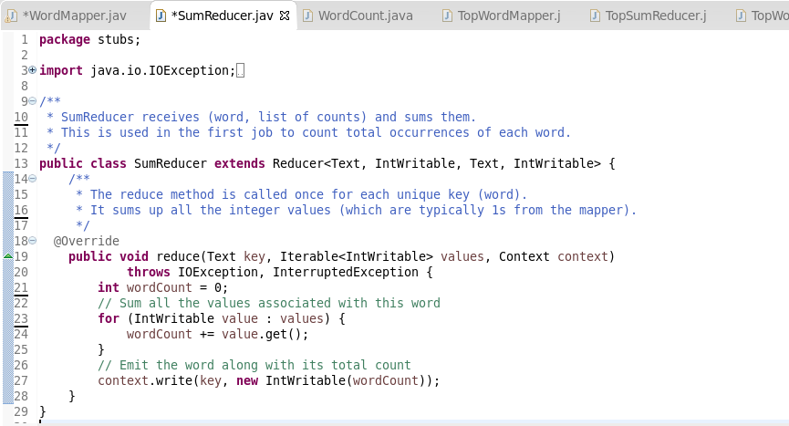
Figure 8. The reducer class for aggregating word counts from the first job.
Second Job: Counting Single-Occurrence Terms: The second job reads the output of the first and emits (count, 1) pairs. The reducer filters for count == 1 and sums the total number of unique words that appeared exactly once.
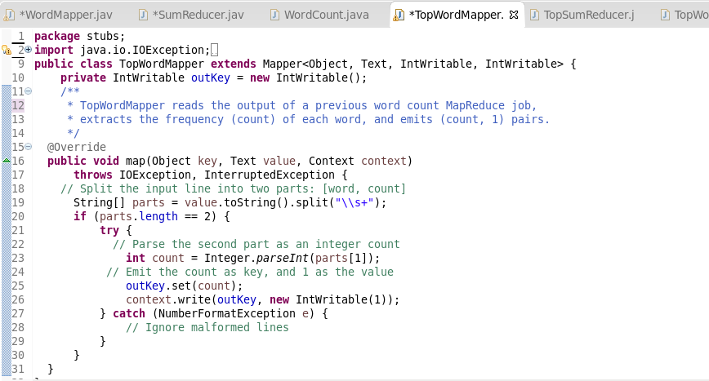
Figure 9. The mapper class for parsing (word, count) lines and emits (count, 1).

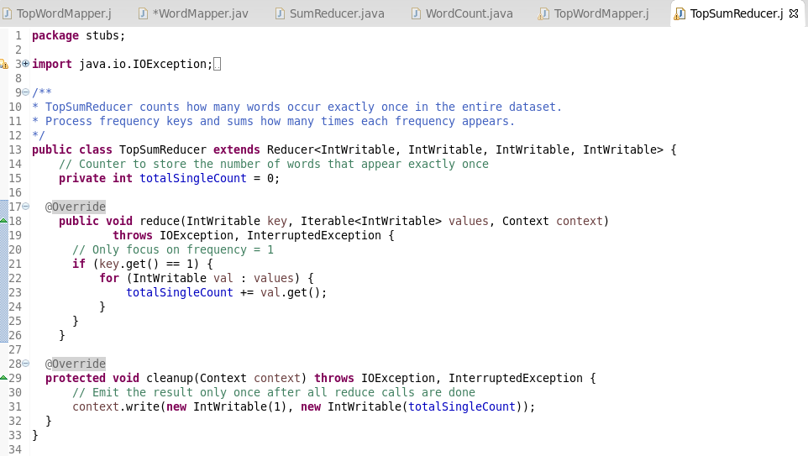
Figure 10. The reducer class to sum up the number of words with count = 1.

- List all commands used in this assignment in order, as well as readable execution screenshots with your name and student ID printed from the driver code. [15 mark]
To begin, the Java classes are compiled by first navigating to their directory using the command “cd workspace/Assignment1/src/stubs”. The command “ls -alh” is then used to verify that the required Java files are present in the directory. After confirming, the command “cd ../” is executed to return to the parent folder in preparation for the compilation step.
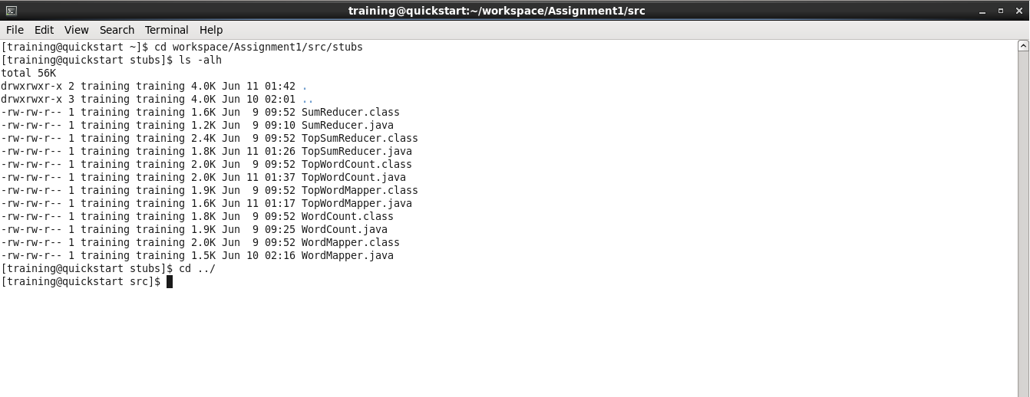
Figure 11. The commands for navigating and checking the Java classes.
Once inside the correct directory, the Java classes located in the “stubs” folder are compiled using the command “javac -classpath `hadoop classpath` stubs/*.java”.
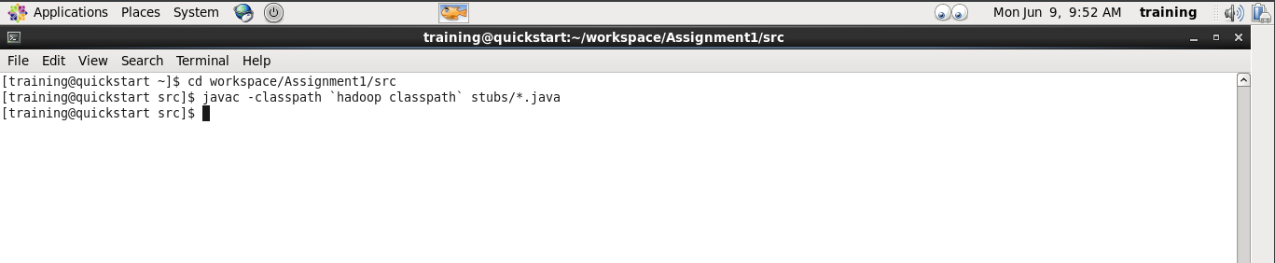
Figure 12. The command for compiling the Java classes.
After successful compilation, the command “jar cvf wca1.jar stubs/*.class” is used to package all the compiled Java class files from the “stubs” folder into a JAR file named “wca1.jar”.
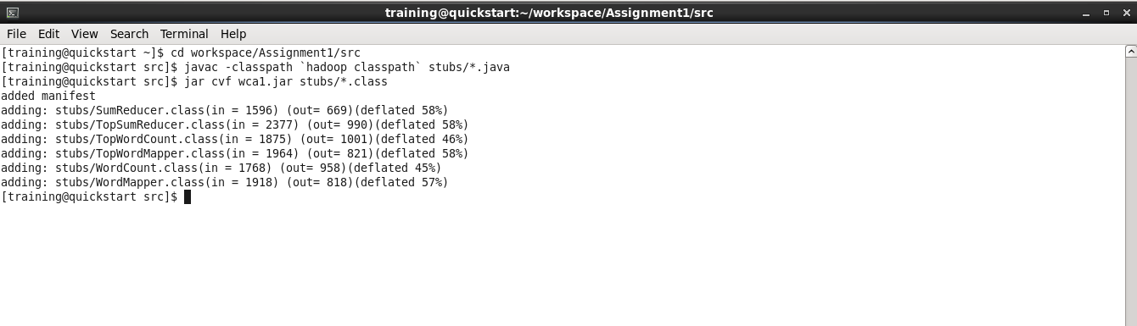
Figure 13. The command for collecting compiled Java files into a JAR file.
Prior to running the MapReduce job, the dataset needs to be uploaded to HDFS. This is done by first navigating to the directory containing the dataset using the command “cd workspace/2025_assignment1”, and then executing “hdfs dfs -put austlang_dataset.csv” to transfer the dataset into the HDFS.
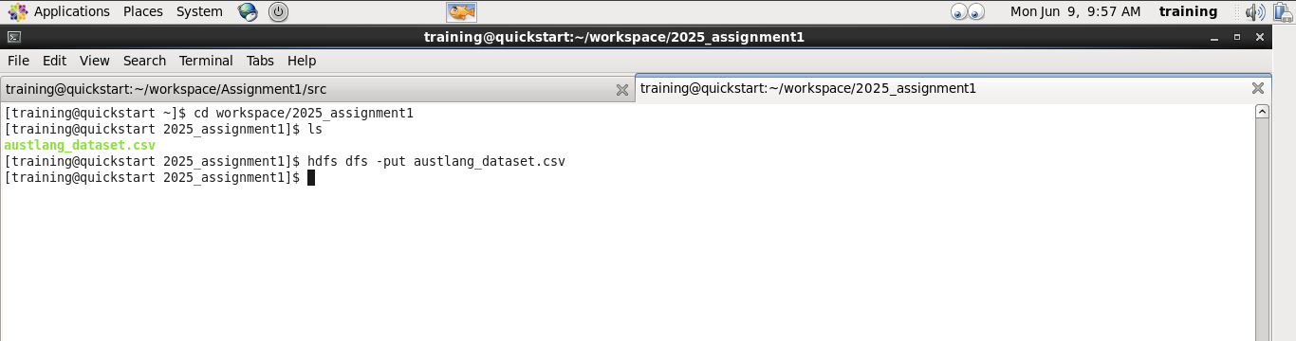
Figure 14. The commands for putting the dataset into HDFS.
Once the dataset has been successfully uploaded to HDFS, navigate back to the directory containing the previously created JAR file. Then, initiate the first MapReduce job “WordCount” using the uploaded dataset as input and specify “wordcountsa1” as the name of the output directory.
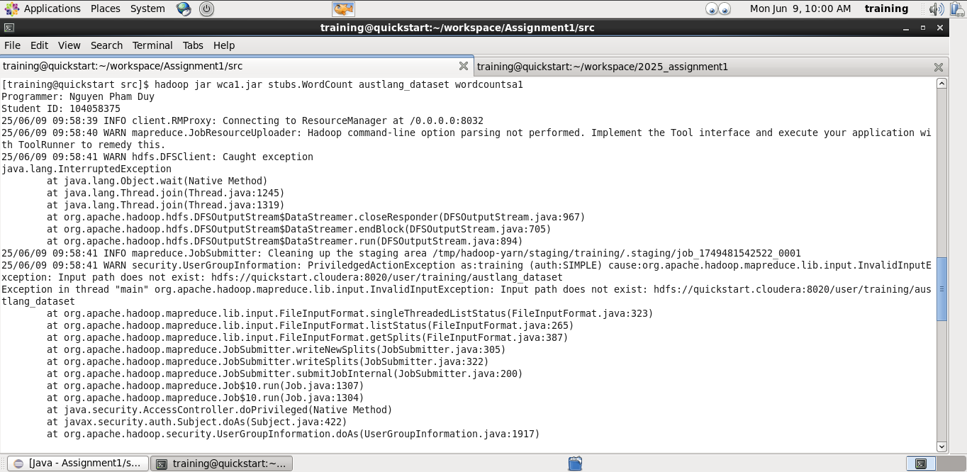
Figure 15. The command for executing the first MapReduce job.
After the execution is complete, retrieve the output using the command “hdfs dfs -get wordcountsa1”, and then examine the results of the first MapReduce job by running “less wordcountsa1/part-r-00000”.
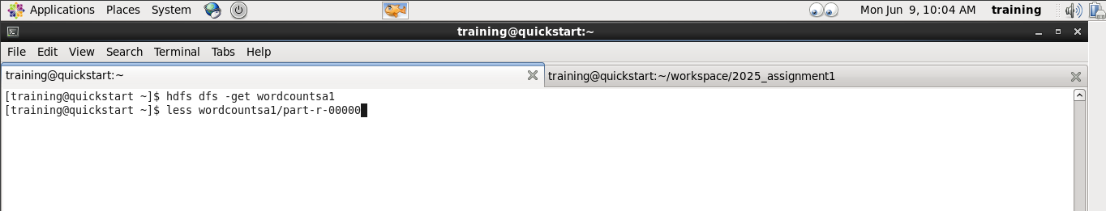
Figure 16. The commands for harvesting and checking the result of the first MapReduce job.

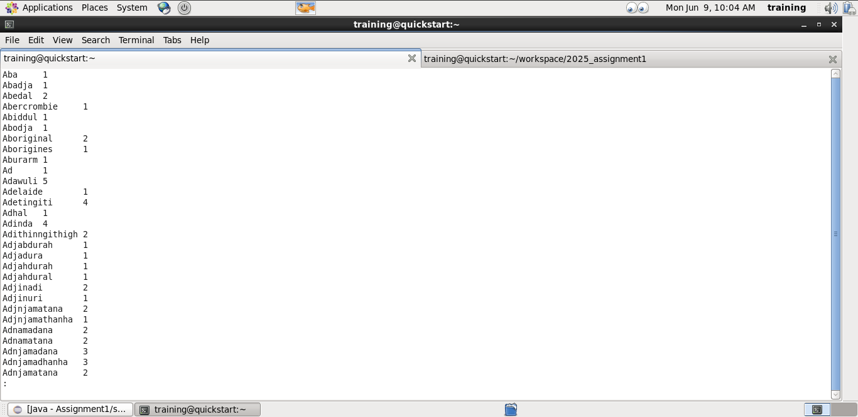
Figure 17. The result of the first MapReduce job.
Similar to the first MapReduce job, the second job is executed using the command “hadoop jar wca1.jar stubs/TopWordCount wordcounta1/part-r-00000 topwordcountsa1”. This runs the “TopWordCount” program, using the output from the first job (wordcounta1/part-r-00000) as input, and stores the results in a new output directory named “topwordcountsa1”.

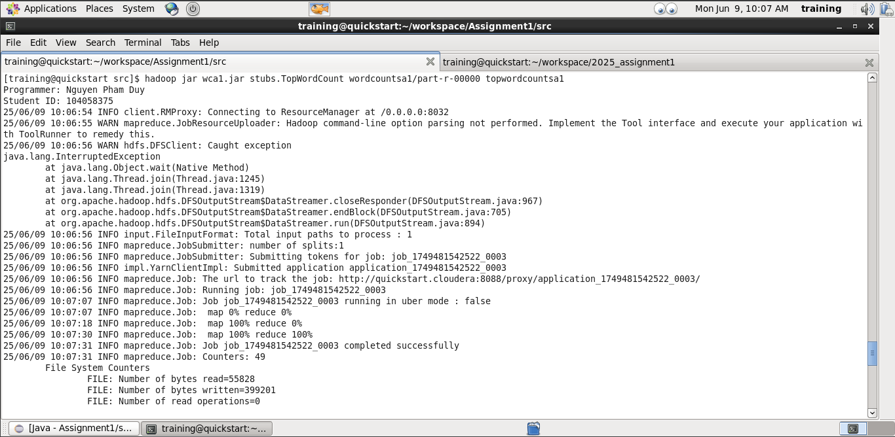
Figure 18. The command for executing the second MapReduce job.
Once the second MapReduce job has completed successfully, retrieve the output using the command “hdfs dfs -get topwordcountsa1”, and view the results by running “less topwordcountsa1/part-r-00000”.
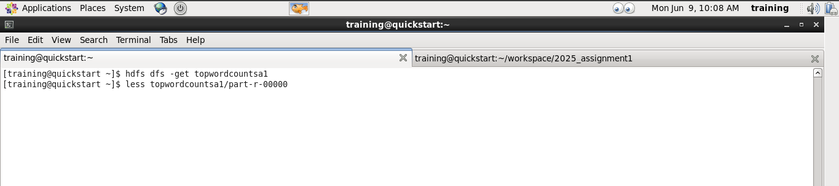
Figure 19. The commands for harvesting and collecting the result of the second MapReduce job.

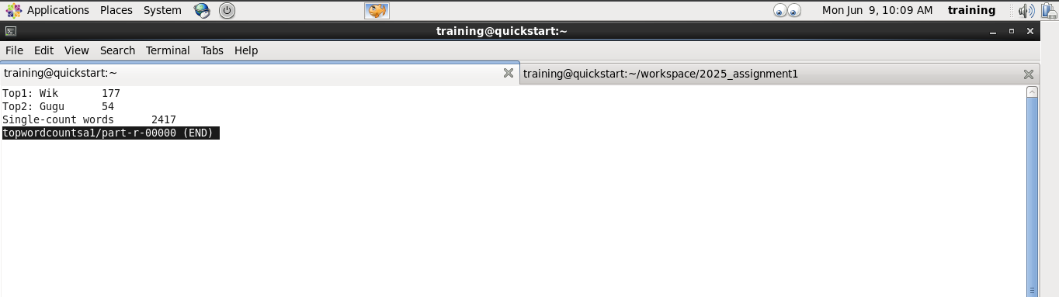
Figure 20. The result of the second MapReduce job.

(*)Additional MapReduce Implementation: Counting Terms that start with all upper-case letters and follow by the lower-case letters Appearing Only Once in the Entire Document:
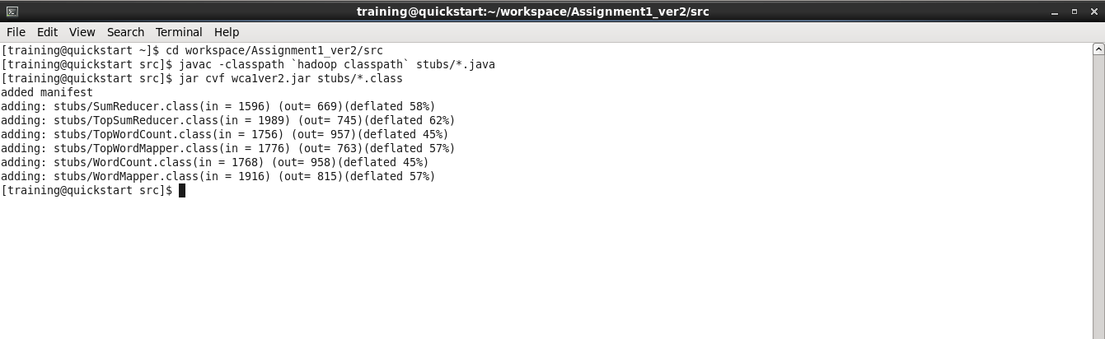
Figure 21. The commands to compile and collect the compiled Java files into a JAR file.

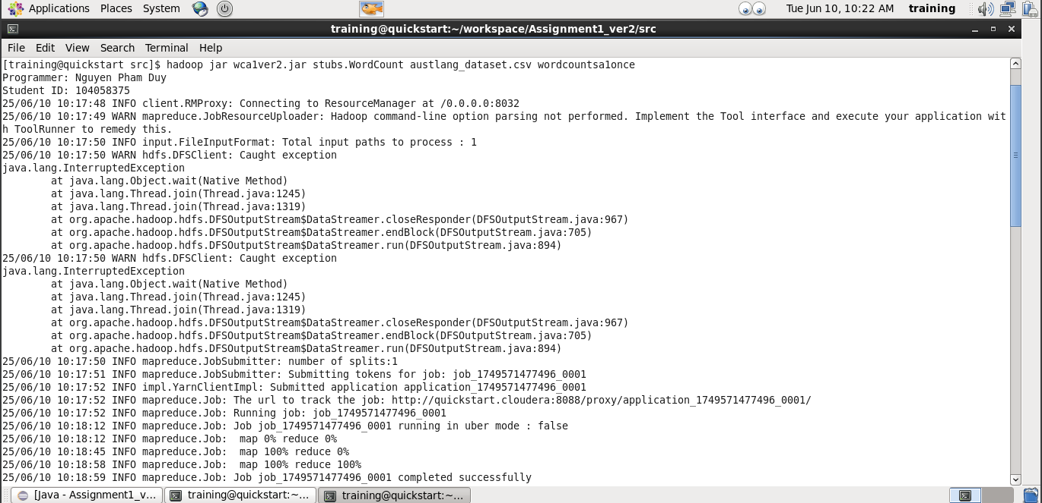
Figure 22. The command for executing the first MapReduce on Hadoop.

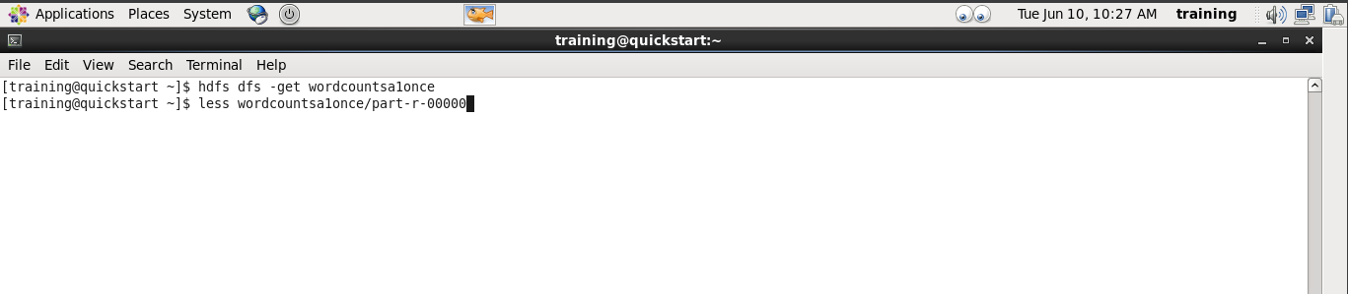
Figure 23. The commands for harvesting and checking the result of the first MapReduce.
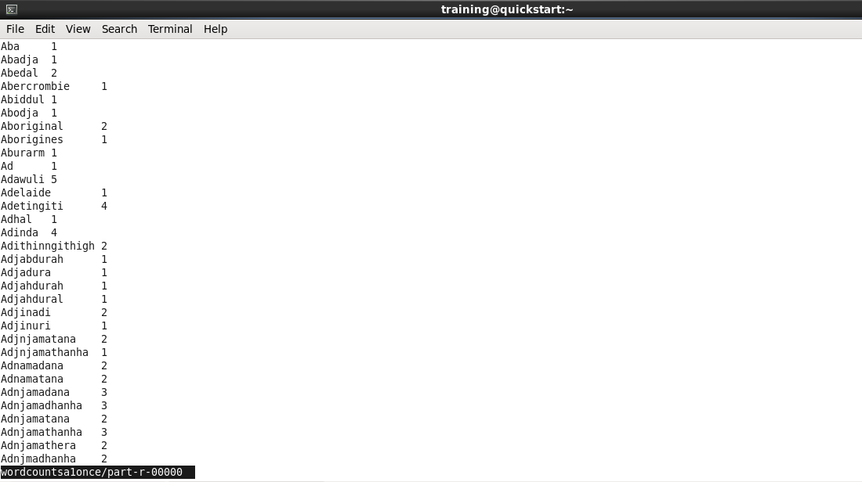
Figure 24. The result of the first MapReduce.

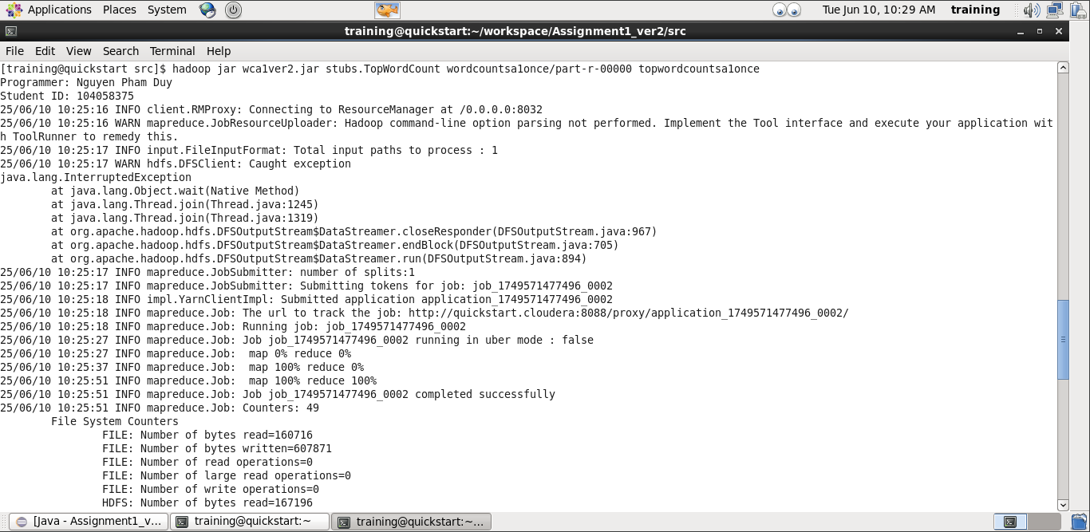
Figure 25. The command for executing the second MapReduce on Hadoop.

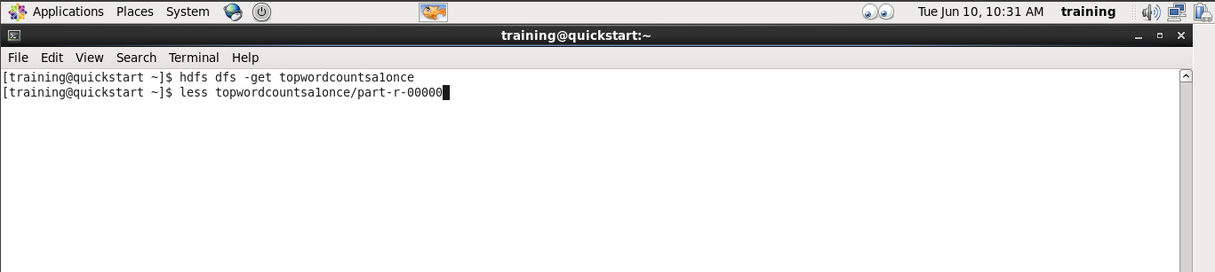
Figure 26. The commands for harvesting and checking the result of the second MapReduce.

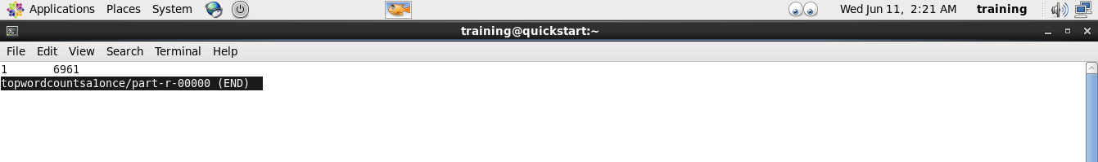
Figure 27. The result of the second MapReduce.

- You are assigned to find the word counts of any terms in the given dataset starting with the upper-case letter "A," "C," "G," "W," or "Y," followed by lowercase letters regardless of the length. Answering the questions:
  - What is the term under the given criteria with the highest appearance count, and what is its count? [10 marks]
The term is “Wik”, and its appearance count is 177 .

  - What is the term under the given criteria for the second high appearance count, and what is its count? [10 marks]
The term is “Gugu”, and its appearance count is 54 .

  - How many terms only have a single count in the document? [5 marks]
There are 2417 terms that have a single count in the document under the given criteria, and there are 6961 terms only have a single count for all words start with a upper-case letter and follow by the lower-case letters in the whole document.

- Video presentation with the required content. [Pass/Fail]
The video needs to be submitted independently on Canvas.

