
SOFTWARE DESIGN SPECIFICATION
CafeChain Management System (SWP391 - Group 4)
Software Engineering Capstone
Hanoi, July 2026

Table of Contents
I. Record of Changes 3
II. Software Design Document 4
1. High Level Design 4
1.1 Software Architecture 4
1.2 Package Diagram and Conventions 5
1.3 Database Design 6
2. State Transition Diagrams 9
2.1 Order Item / KDS Lifecycle 9
2.2 Payment and Session Lifecycle 10
2.3 Receipt and Ledger Lifecycle 10
3. Detailed Design 11
3.1 Order-to-Fulfillment Design 11
3.2 Checkout, Voucher, and Payment 14
3.3 Inventory, Prep, and Waste 15
3.4 Authentication, Branch Scope, and HR 16
Appendix A. Database Data Dictionary 17
Appendix B. Route and Component Catalogue 39
Document scope: This SDS is a design baseline derived from the current CafeChain source code, database migration, and deployed route structure on 22 July 2026. It describes implemented behavior; it does not treat historical plan entries as the source of truth.

I. Record of Changes
Change notation: A = Added, M = Modified, D = Deleted. This issue establishes a complete implementation-aligned SDS for the CafeChain Management System.
Date | A/M/D | In charge | Change description
22/07/2026 | A | SWP391 Group 4 | Initial professional SDS compiled from the current Java/JSP implementation, SQL Server schema, route catalogue, core business services, and operational workflows.
22/07/2026 | M | SWP391 Group 4 | Added complete high-level architecture, package conventions, state-transition flows, detailed order/payment/inventory/HR design, database catalogue, and route traceability.

II. Software Design Document

1. High Level Design
CafeChain is a server-rendered, dine-in cafe-chain management system. It supports Admin, Branch Manager, Cashier, Barista, and anonymous QR-table customer journeys. The system is packaged as a Maven WAR and runs on Apache Tomcat 10+ with Java 17, Jakarta Servlet/JSP, JSTL, HikariCP, and Microsoft SQL Server.

1.1 Software Architecture
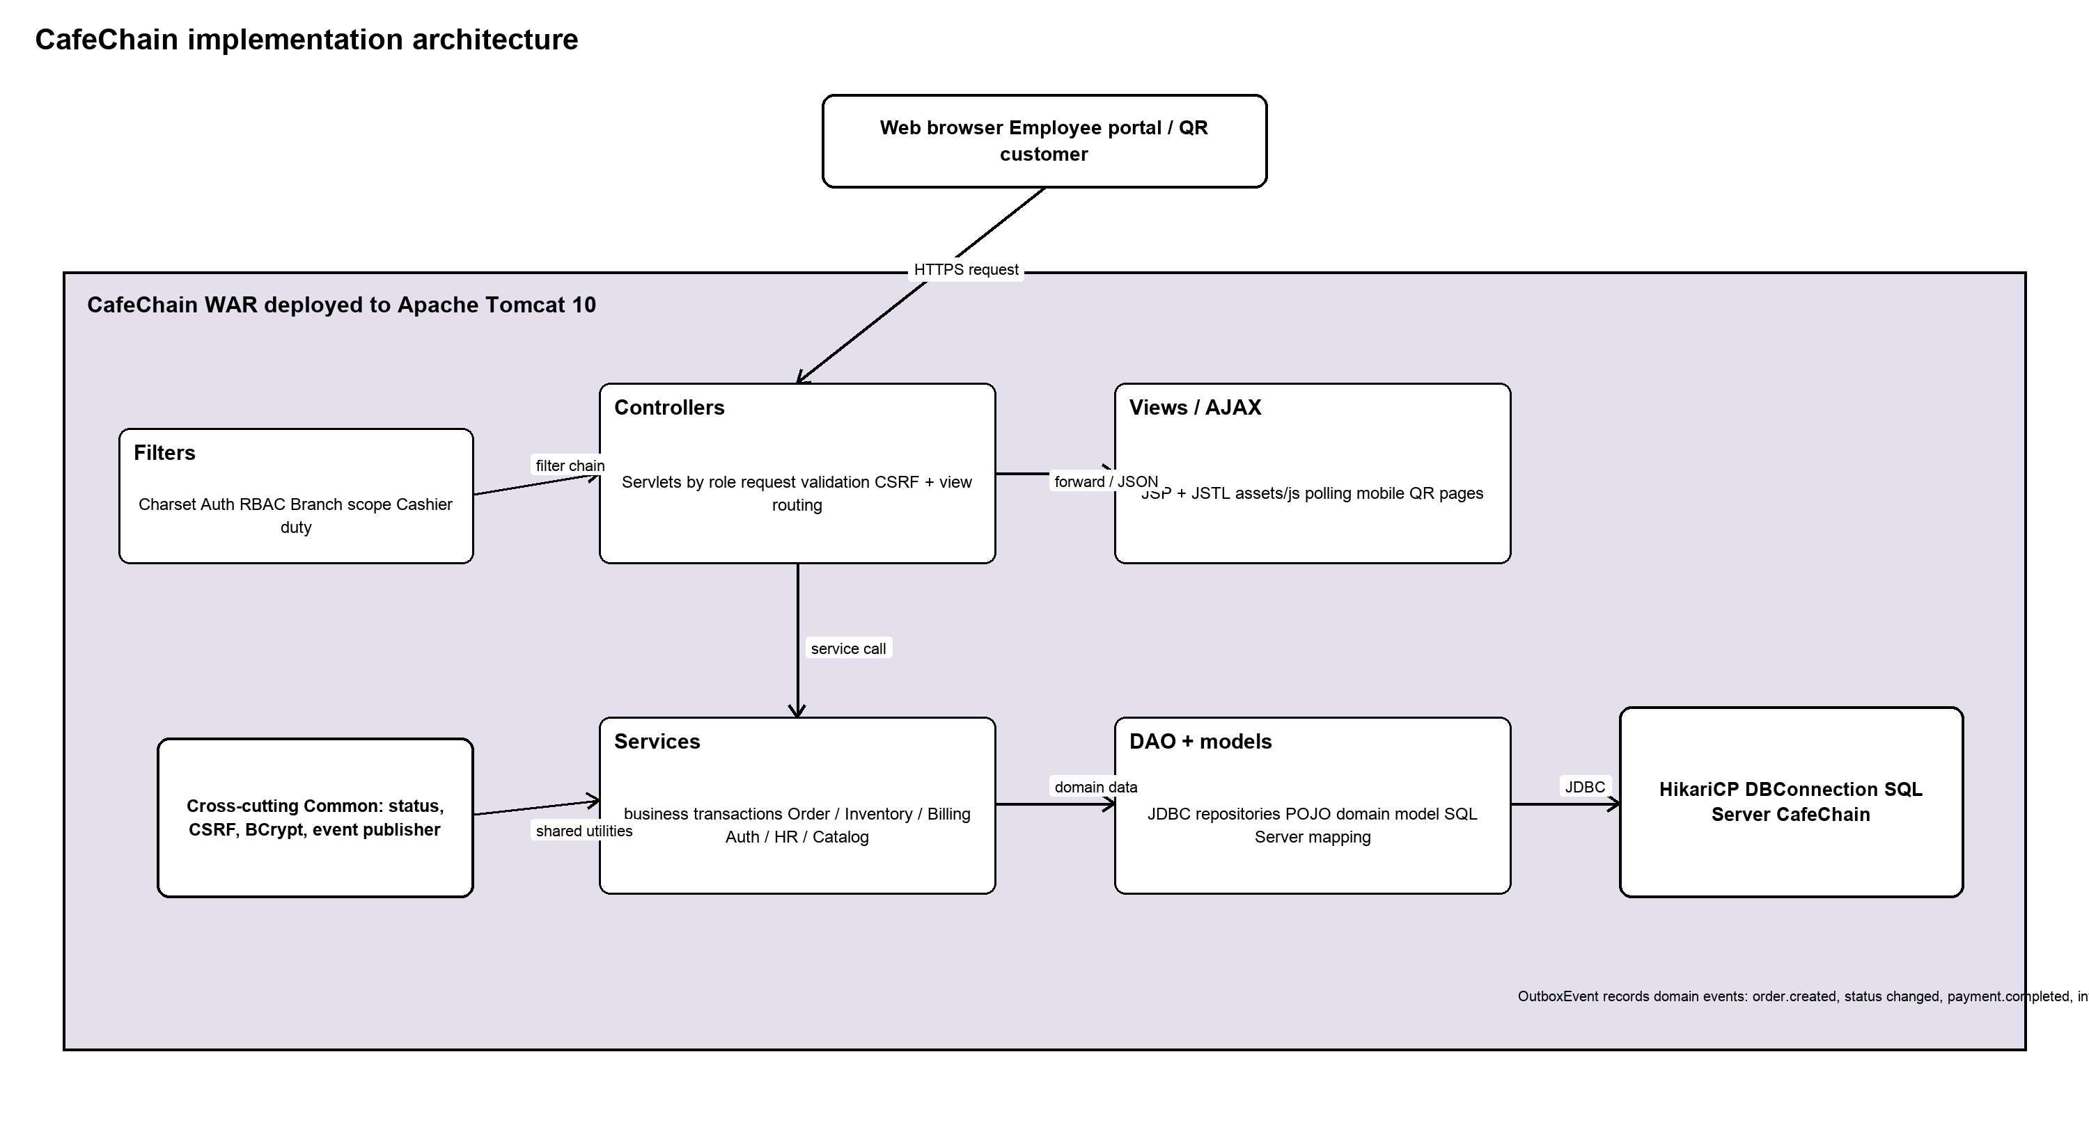
Figure 1. Layered architecture implemented by the CafeChain WAR.
The browser communicates with servlet routes over HTTP. Staff portals are server-rendered JSP pages; QR and KDS views also use AJAX polling for lightweight status/card refreshes. The server remains the authority for validation, authorization, branch scope, transactions, and all inventory and payment mutations.
Component | Implementation | Responsibility
Presentation | JSP + JSTL, CSS, JavaScript | Renders staff and mobile QR views. JSP uses EL/JSTL; the design avoids scriptlets.
Request guards | CharsetFilter, AuthFilter, RbacFilter, BranchScopeFilter, CashierDutyGuardFilter | Normalizes encoding; enforces authenticated access, role prefixes, branch context, CSRF-dependent write flows, and cashier duty prerequisite.
Controller | Servlet classes under com.cafe.controller | Dispatches GET/POST actions, validates request shape, invokes services, sets view data, and returns JSP, redirect, or JSON.
Service | Domain service classes | Owns business rules and transaction boundaries. Core examples are OrderService, InventoryService, BillingService, VoucherService, and AttendanceService.
Data access | JDBC DAO classes | Executes SQL through caller-provided Connection objects and maps rows to model objects.
Persistence | HikariCP + SQL Server CafeChain | HikariCP supplies connections. SQL Server stores 49 tables in iam, org, catalog, inventory, hr, sales, payment, and ops schemas.
Operational events | EventPublisher -> ops.OutboxEvent | Persists domain events inside business transactions, including order.created, order.status_changed, payment.completed, inventory.deducted, and stock.low.

Critical contracts: (1) COUNTER and QR orders share sales.Orders and OrderService. (2) Every stock change goes through InventoryService.applyTxn and inventory.InventoryTransaction; business features do not directly mutate QuantityOnHand. (3) READY is the order-item inventory commit boundary. (4) RAW is consumed by prep; PREPPED is consumed when the drink is made, preventing double deduction.

1.2 Package Diagram and Conventions
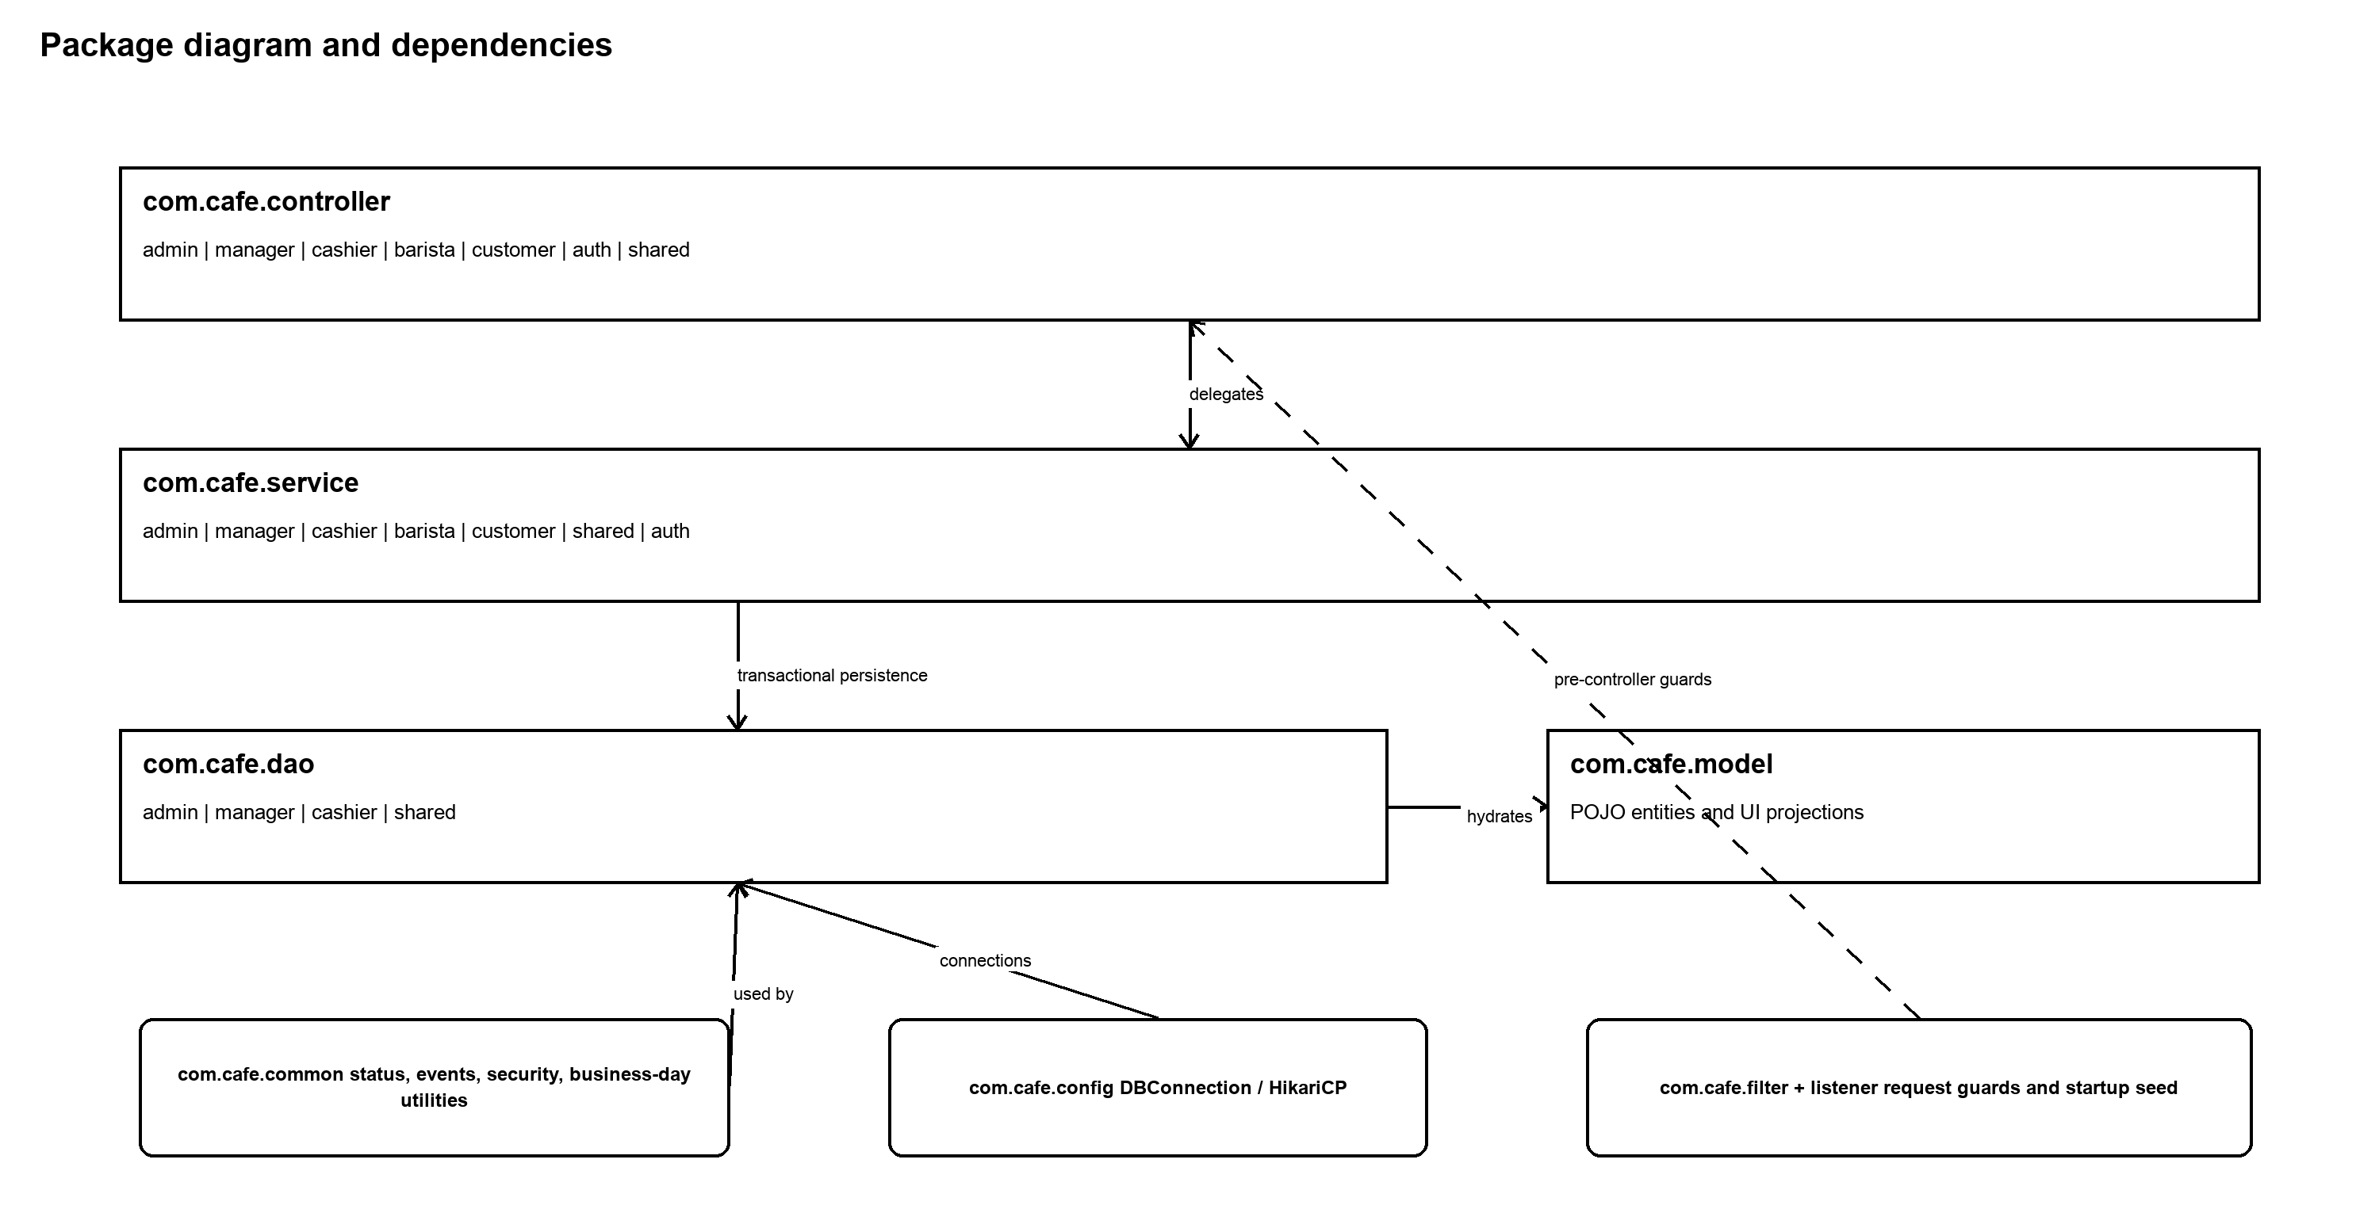
Figure 2. Package dependency direction and shared infrastructure.
Naming and dependency rules are deliberately simple: {Feature}Servlet receives web input; {Domain}Service contains business behavior and transactions; {Entity}Dao performs persistence; models are singular nouns. Controllers never contain SQL. DAO methods receive an existing Connection when participating in a service transaction. Services may depend on DAO/model/common/config; reverse dependencies are avoided.
No. | Package | Description
01 | com.cafe.config | Database bootstrap and HikariCP datasource configuration.
02 | com.cafe.common | Shared status enums, CSRF/session/password utilities, business-day calculations, calculators, events, and domain exceptions.
03 | com.cafe.model | POJO entities and read models used between DAO, service, controller, and JSP.
04 | com.cafe.dao.{admin|manager|cashier|shared} | JDBC persistence components aligned to database entities and role-owned aggregates.
05 | com.cafe.service.{admin|manager|cashier|barista|customer|shared|auth} | Business behavior, validation, orchestration, and transaction management.
06 | com.cafe.controller.{admin|manager|cashier|barista|customer|auth|shared} | Servlet endpoints grouped by portal or public/health concerns.
07 | com.cafe.filter and com.cafe.listener | Cross-cutting request controls and startup lifecycle actions.
08 | src/main/webapp/WEB-INF/views | JSP views grouped by role, with shared layout fragments and a single cafe-theme.css design system.

1.3 Database Design
The authoritative database definition is sql/database.sql. It is an idempotent SQL Server migration/seed script for database CafeChain. It creates 49 tables, required constraints and indexes, operational views, and controlled demo data when explicitly enabled. The application configures HikariCP via src/main/resources/db.properties; environment-specific secrets are not part of this SDS.
Schema | Tables | Design responsibility
iam | 4 | Roles, staff users, optional customer identity, and reserved refresh-token persistence.
org | 1 | Branch master, manager link, and branch-level operating/KDS configuration.
catalog | 12 | Products, ingredients, recipes, modifiers, public home configuration, branch menu, and temporary menu-block workflow.
inventory | 11 | Supplier/receipt flow, materialized balances, immutable stock ledger, prep, waste, audit, and review controls.
hr | 8 | Shift planning, attendance approval, payroll, and shift-handover workflow.
sales | 5 | Dine-in tables/sessions, unified orders, item status, and modifier snapshots.
payment | 5 | Cashier shifts, vouchers, split/merge bill persistence, and voucher redemption.
ops | 3 | Transactional outbox, order-item action audit, and schema-version tracking.

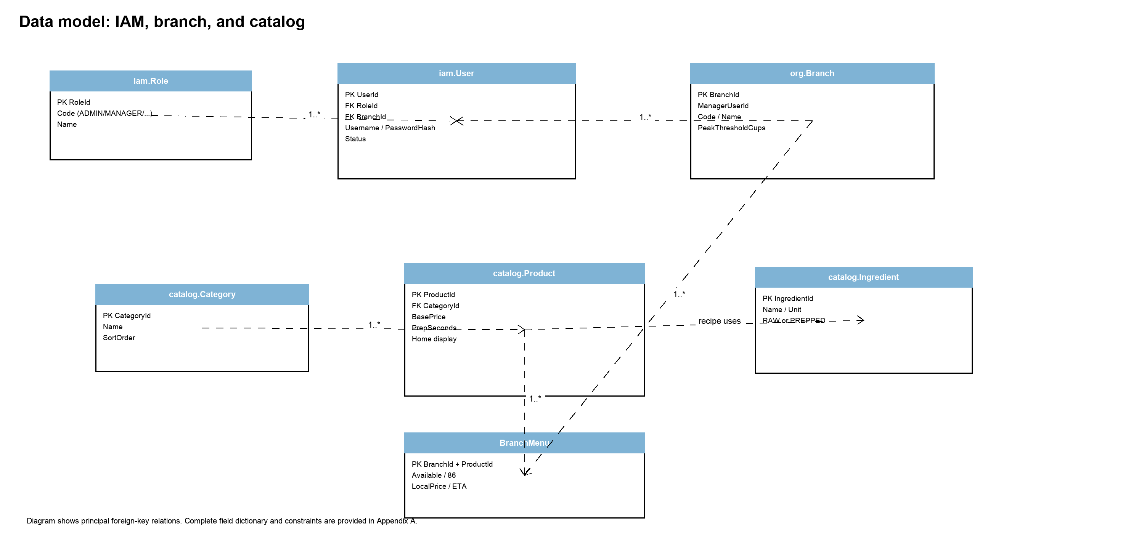
Figure 3. Principal IAM, organization, and catalog relationships.
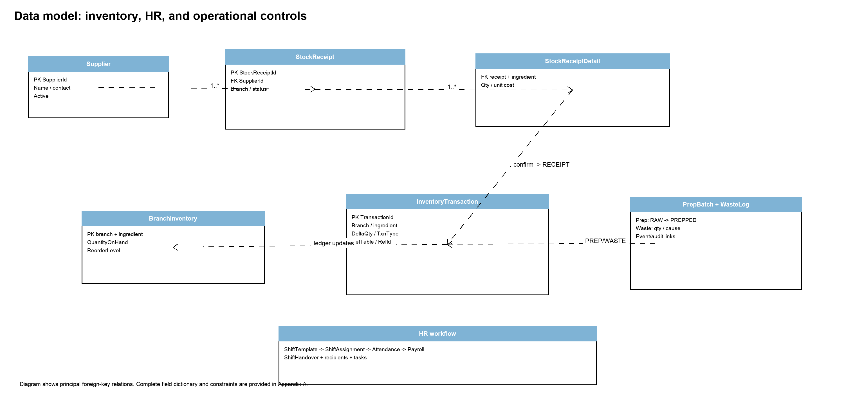
Figure 4. Principal inventory, receipt, prep/waste, and HR relationships.
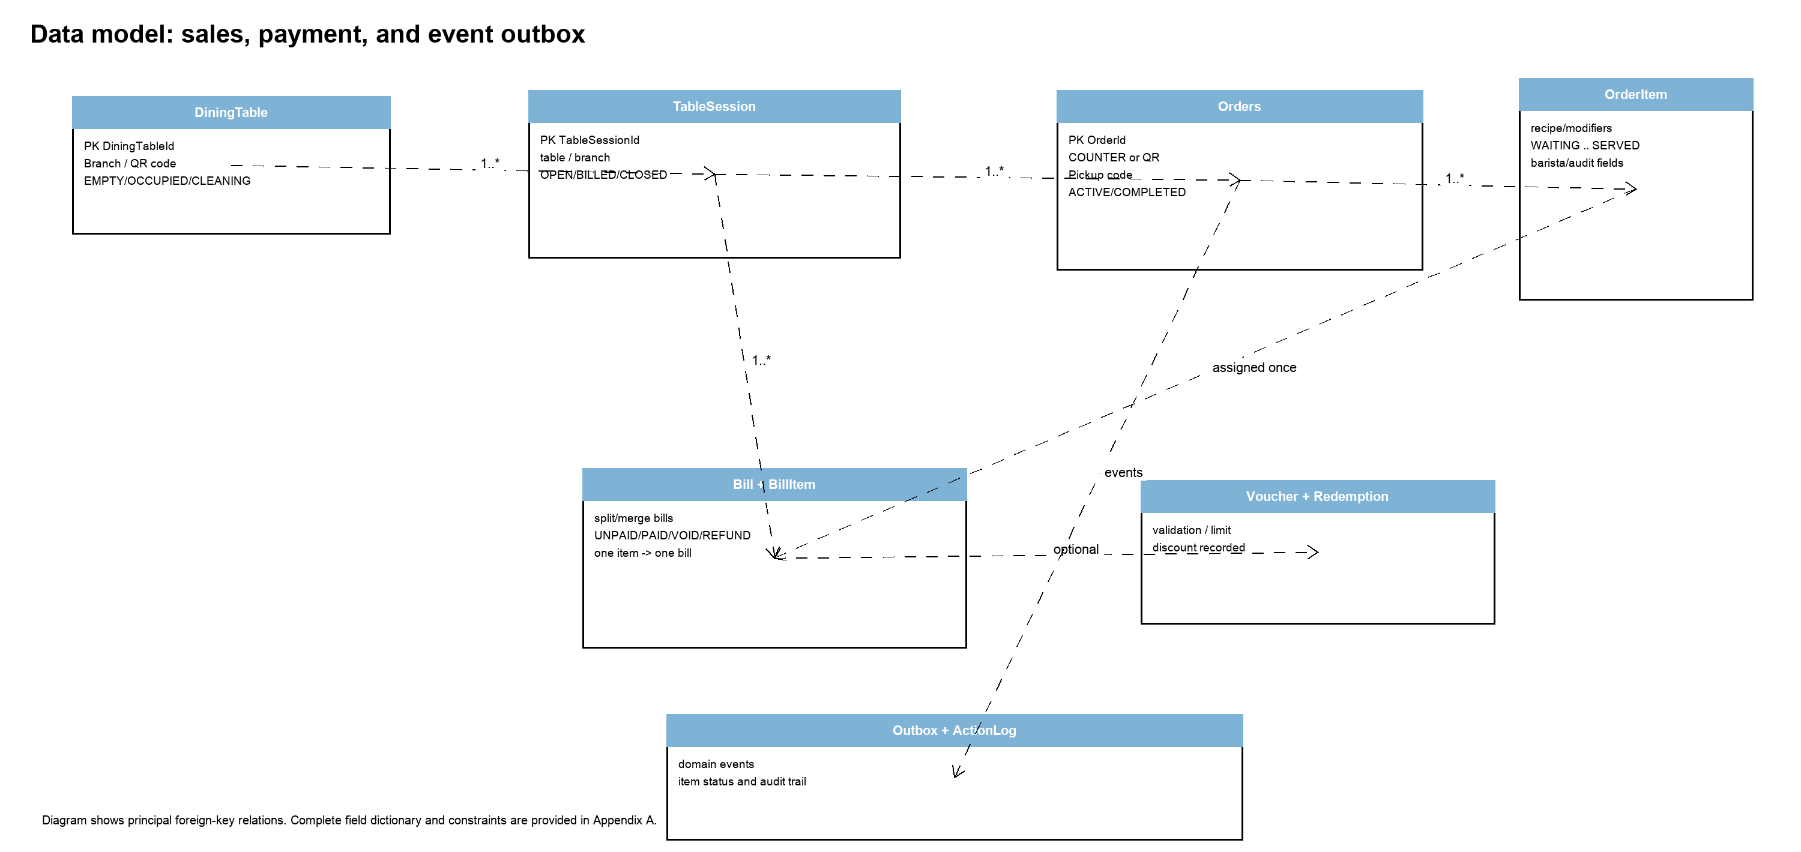
Figure 5. Principal sales, payment, and operational-event relationships.
Ledger invariant: inventory.BranchInventory is a materialized balance, not a source of truth for mutation. InventoryService.applyTxn inserts the corresponding InventoryTransaction and updates BranchInventory in the same transaction. Reports and diagnostics can reconcile the balance to the ledger sum.

2. State Transition Diagrams
State diagrams below define the stored lifecycles and the business actions that trigger transitions. Guards shown in the notes are server-side service/DAO guards; UI controls do not authorize a transition by themselves.

2.1 Order Item / KDS Lifecycle
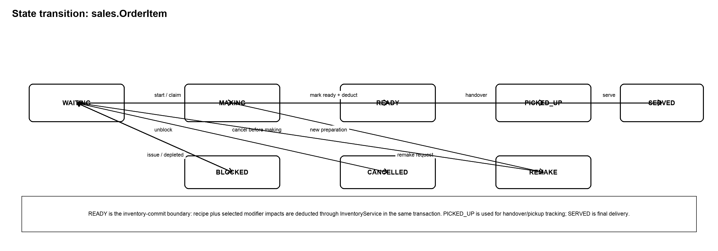
Figure 6. sales.OrderItem operational state machine.
Transition | Trigger | Guard / transaction effect
WAITING -> MAKING | Barista starts an item | Item is claimed for the active barista/branch; StartedAt and action log are recorded.
MAKING -> READY | Barista marks preparation ready | Product recipe plus modifier impacts are computed; ledger deductions and status/DoneAt update commit atomically.
READY -> PICKED_UP -> SERVED | Pickup/handover then serve | Pickup location/person/time and later served time are written for traceability.
WAITING <-> BLOCKED | Issue/depleted ingredient and resolution | Item is removed from active work until a permitted unblock action returns it to the queue.
WAITING -> CANCELLED | Cashier/customer cancellation | Cancellation is guarded to prevent cancellation after preparation begins.
MAKING -> REMAKE -> WAITING | Remake workflow | A remake is audited and routed back to preparation under the waste/remake controls.

2.2 Payment and Session Lifecycle
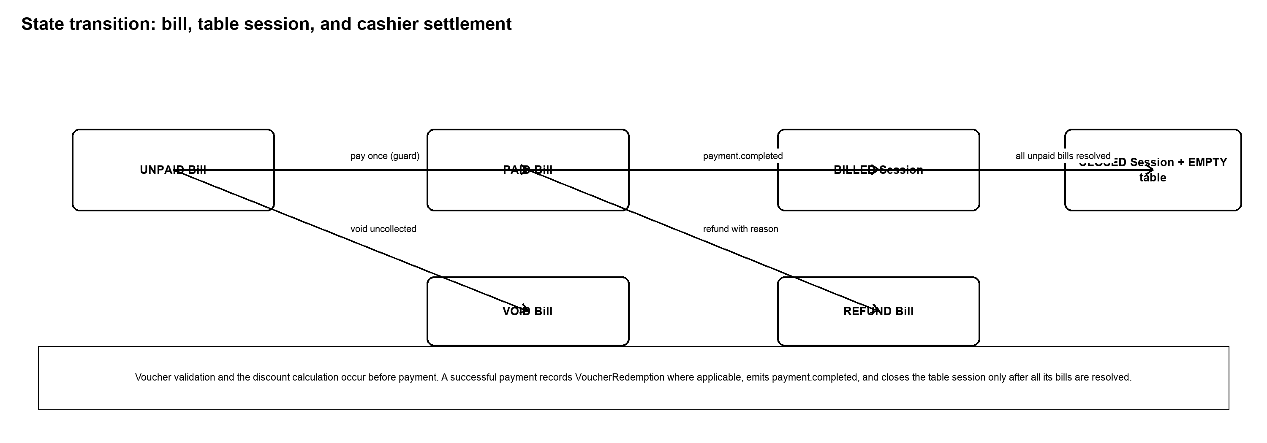
Figure 7. payment.Bill and sales.TableSession lifecycle.

2.3 Receipt and Ledger Lifecycle
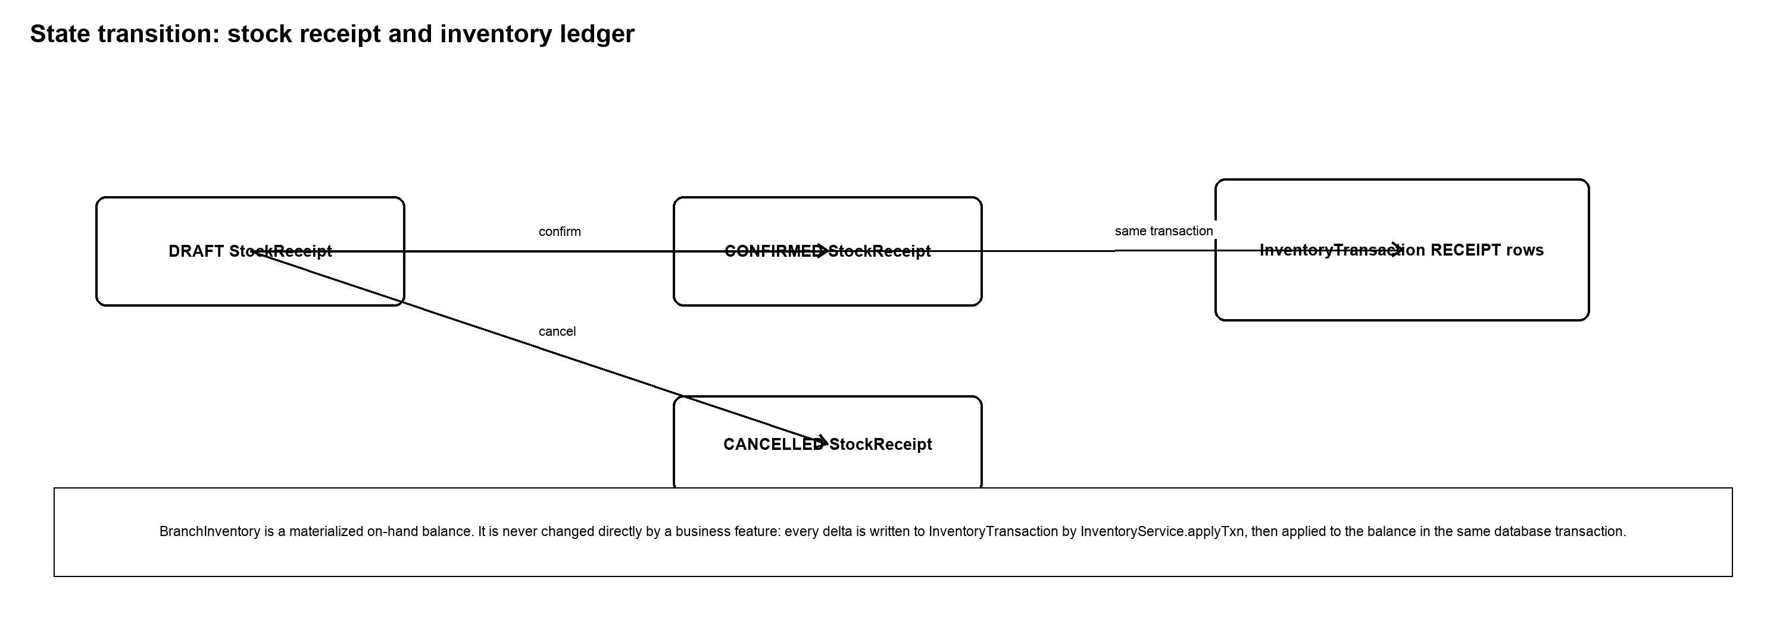
Figure 8. inventory.StockReceipt confirmation flow.

3. Detailed Design
This section traces the main end-to-end business flows through concrete controller, service, DAO, and database responsibilities. It covers the operational workflows that carry the highest consistency risk: order creation, modifier-aware deduction, checkout/payment, inventory receipt, and scoped staff access.

3.1 Order-to-Fulfillment Design

3.1.1 Class Diagram
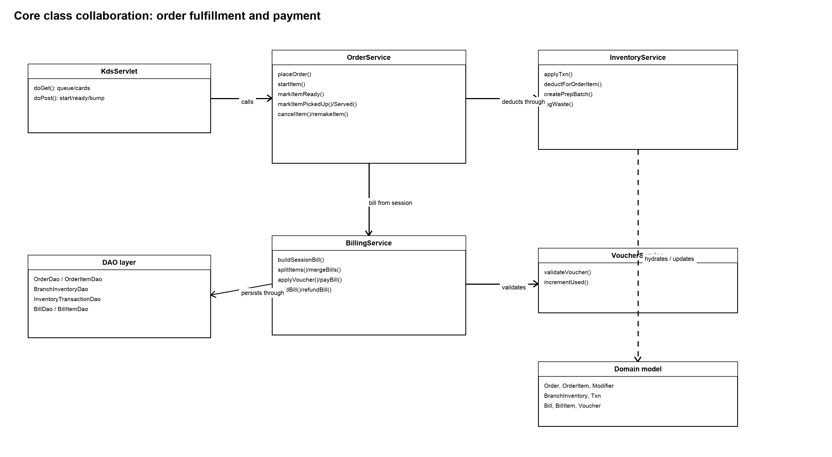
Figure 9. Core classes for order fulfillment, inventory, and payment collaboration.
OrderService is the shared backbone for cashier POS and customer QR orders. It creates an Order, OrderItem rows, and modifier snapshots in one transaction, then publishes order.created. Barista operations call the same service state transitions. InventoryService receives the completed item only at READY, reads ProductRecipe and ModifierIngredientImpact, and applies the resulting ledger entries without any direct stock update in controller or DAO code.

3.1.2 Sequence Diagram - POS/QR Order Placement
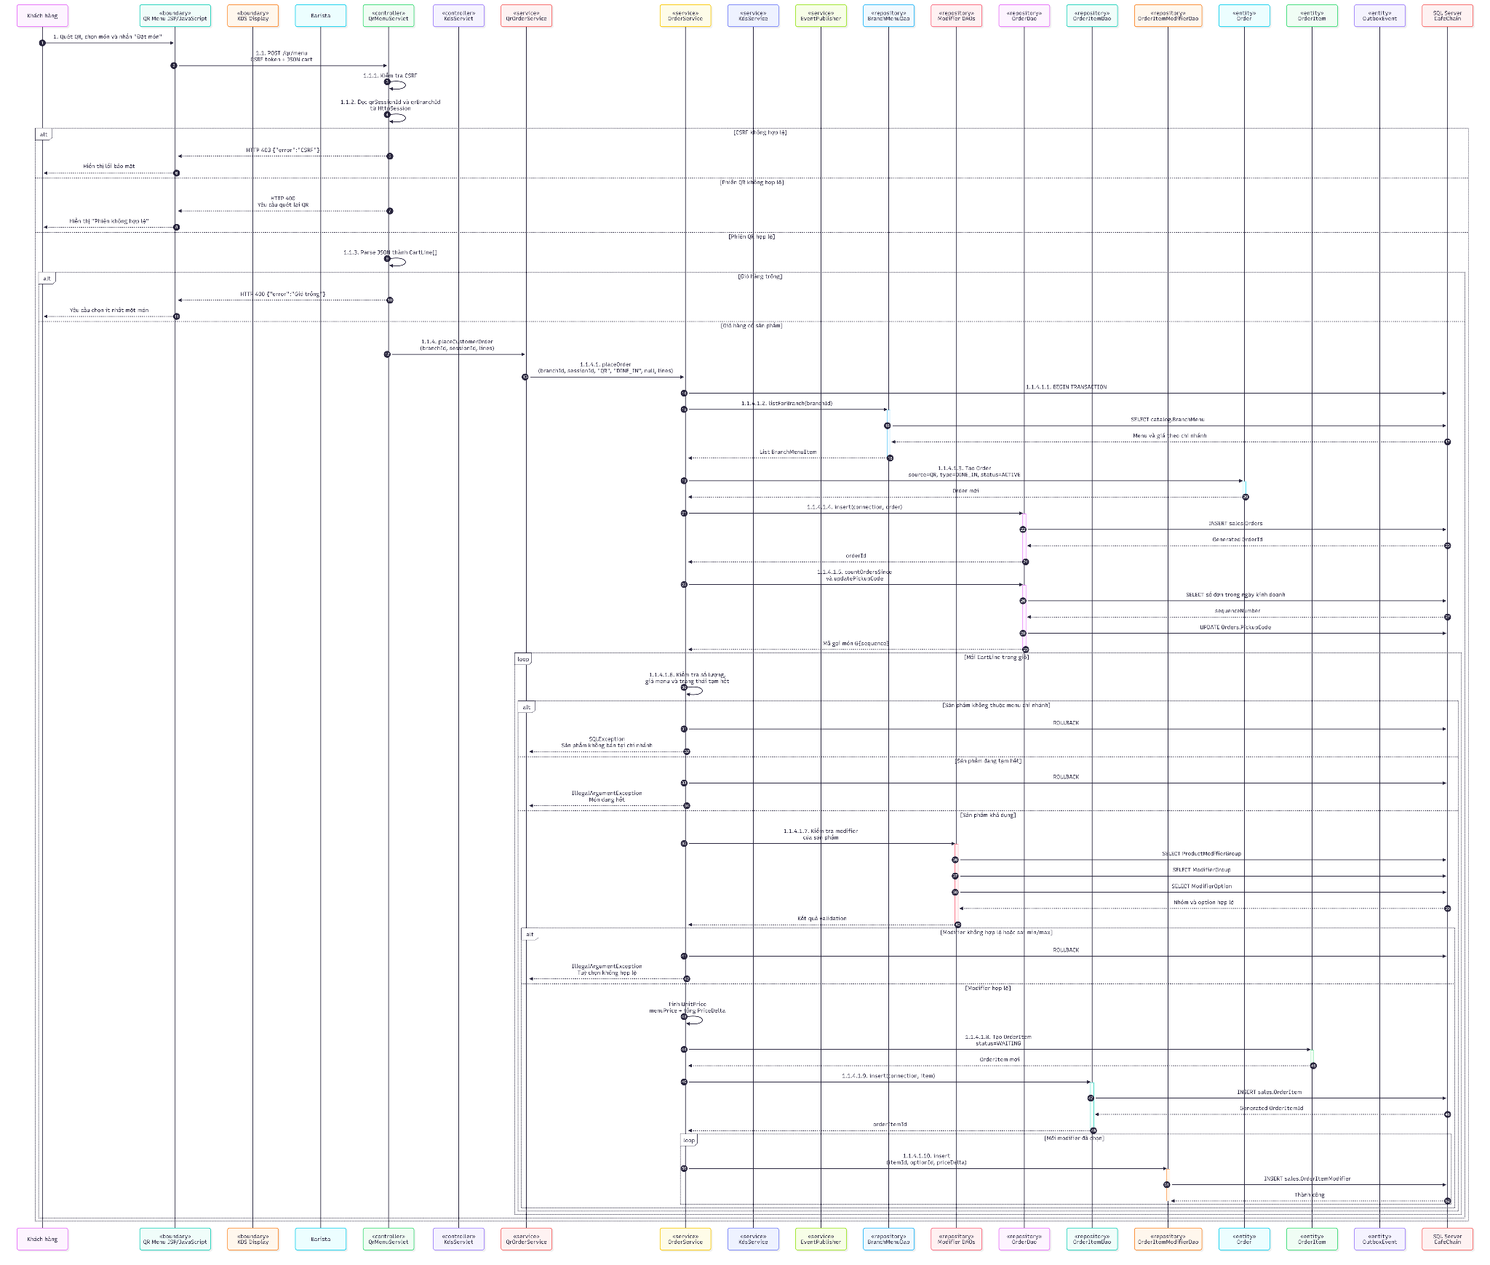
Figure 10. Project flow: QR scan and order placement.
Step | Primary implementation | Control point
1 | PosServlet or QrMenuServlet | Validates CSRF and parses selected product IDs, quantities, notes, and modifier options.
2 | OrderService.placeOrder | Validates source/order type and menu availability for the current branch; prices are frozen from branch menu plus selected modifier deltas.
3 | OrderDao / OrderItemDao / OrderItemModifierDao | Creates header, line items, and modifier snapshots inside one transaction.
4 | EventPublisher | Records order.created in ops.OutboxEvent before transaction completion.

3.1.3 Sequence Diagram - KDS Preparation and Handover
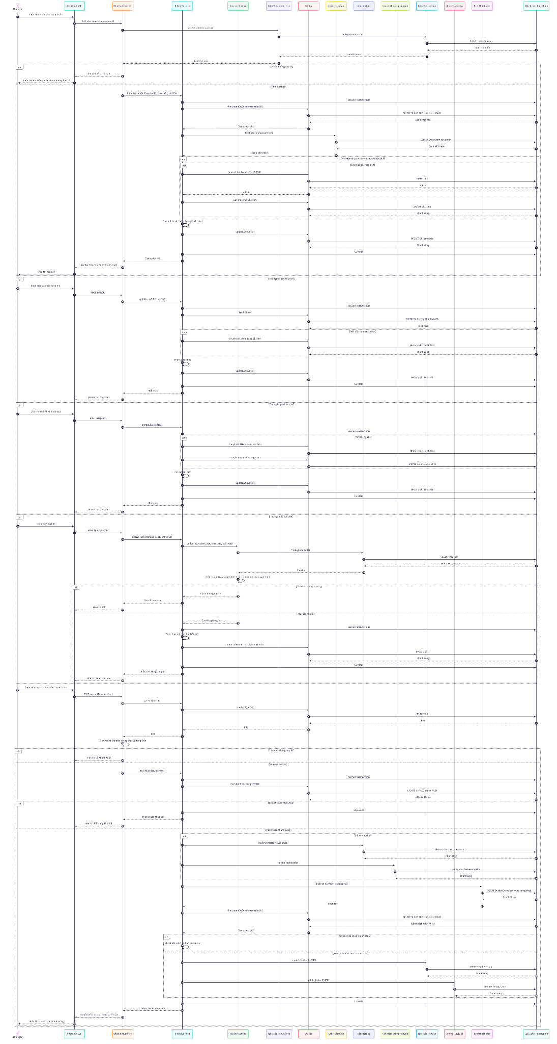
Figure 11. Project flow: beverage preparation and handover.
PREPPED rule: For a product whose recipe consumes a PREPPED ingredient, the READY transition deducts that PREPPED inventory only. Raw ingredients were consumed earlier when PrepService/InventoryService created the PrepBatch, so the system does not double-deduct raw stock.

3.2 Checkout, Voucher, and Payment

3.2.1 Detailed Flow
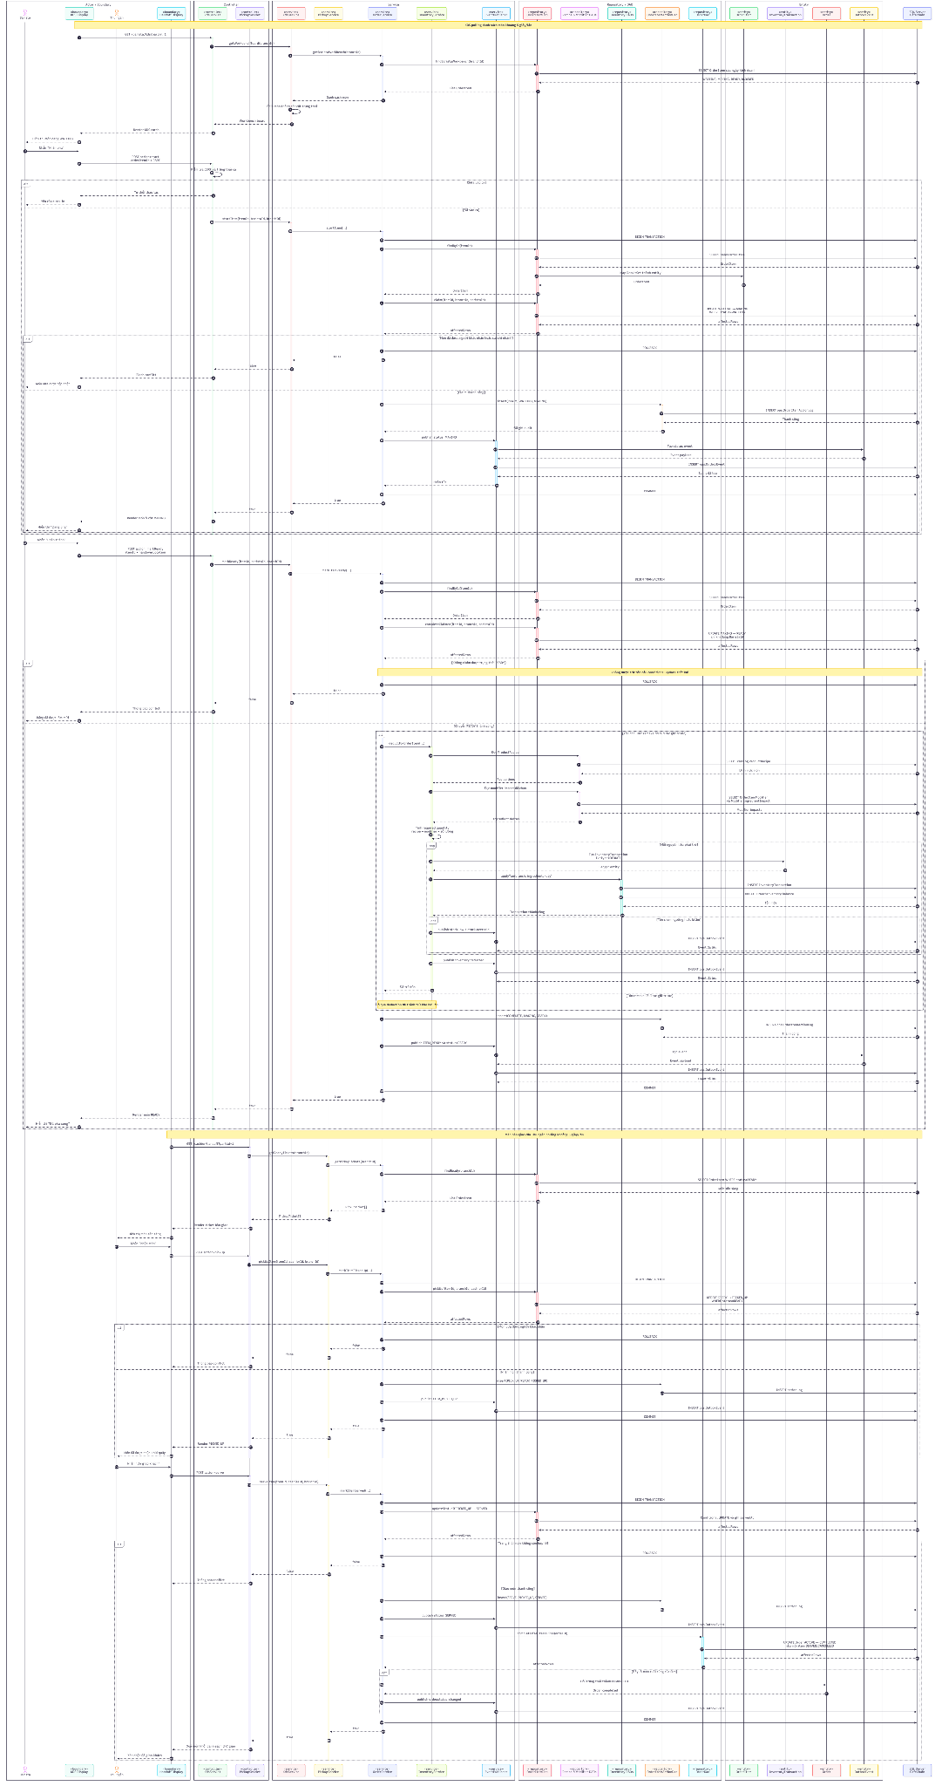
Figure 12. Project flow: checkout and voucher processing.
Operation | Service responsibility | Consistency rule
Build bill | BillingService.buildSessionBill | Moves eligible unbilled OrderItem rows into one or more UNPAID bills for the table session.
Split / merge | BillingService.splitItems / mergeBills | Each OrderItem remains associated with at most one BillItem through the unique order-item constraint.
Voucher | VoucherService.validateVoucher + BillCalculator | Checks active date/scope/limit/minimum then clamps discount and calculates VAT from the net amount.
Pay | BillingService.payBill | Uses a WHERE Status='UNPAID' guard to prevent duplicate payment; records voucher redemption and payment.completed atomically.
Close session | TableSessionService | The session/table closes only when no unresolved unpaid bills remain.

3.3 Inventory, Prep, and Waste

3.3.1 Receipt Confirmation
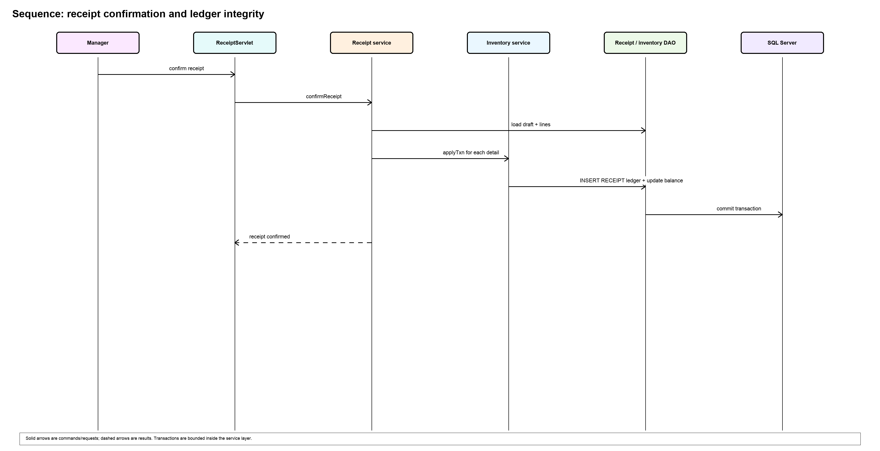
Figure 13. Stock receipt confirmation creates ledger entries and updates the materialized balance atomically.
InventoryService applies the same ledger pattern for stock receipt, adjustment, order deduction, prep out/prep in, and waste. Stock receipt confirmation is one transaction: the DRAFT receipt becomes CONFIRMED only when every detail has generated its RECEIPT ledger effect. Waste and remake operations additionally create event-level and audit records so managers can review negative or late corrections.

3.3.2 Prep and Waste Controls
Flow | Database effect | Operational safeguard
Prep batch | PREP_OUT rows for RAW inputs; PREP_IN row for the PREPPED output | Yield-based consumption uses PrepRecipe and preserves the RAW/PREPPED boundary.
Manual ingredient waste | WasteEvent, WasteLog, WASTE ledger rows, WasteAuditLog | CSRF/request validation, reason/cost capture, and later void/review traceability.
Product remake | REMAKE WasteEvent plus action history and item workflow | Links the remake to its order item, cause, user, branch, and inventory reservation controls.
Physical reconciliation | StockAdjustment and ADJUST ledger row | Manager records only the delta between counted stock and on-hand balance.

3.4 Authentication, Branch Scope, and HR

3.4.1 Authentication and Authorization Flow
AuthServlet authenticates a staff account through AuthService using BCrypt. On successful login it invalidates the previous HTTP session to limit session fixation, establishes the current-user session attribute, and redirects to the role-aware /dashboard router. AuthFilter permits public assets, health, home, and QR routes while redirecting protected traffic to login. RbacFilter enforces role-prefix access; BranchScopeFilter makes the current branch available to controllers/services; CashierDutyGuardFilter blocks cashier write operations until a duty/shift is active.
Role | Primary portal | Scoped responsibilities
ADMIN | /admin/* and /dashboard | Cross-branch master data, catalog/recipe/modifier/voucher/branch settings, users, home content, and chain reporting/export.
BRANCH_MANAGER | /manager/* | Branch stock, receipts, reconciliation, suppliers, local menu settings, shifts, attendance, payroll, menu-block review, and waste reporting.
CASHIER | /cashier/* | Duty/shift, floor sessions, POS, incoming QR order handling, checkout, bill history, void/refund within role controls.
BARISTA | /barista/* | KDS queue, pickup, 86 requests, prep, waste/remake, recipe lookup, and handover/clock flow.
ANONYMOUS CUSTOMER | /qr/* and /home | Scan table QR, browse branch menu, place QR order, track items, request staff/bill, and cancel only when server guard allows.

3.4.2 HR and Handover Flow
ShiftService prevents overlapping staff assignments with the pure ShiftConflict calculation before persistence. AttendanceService records clock-in/out against the branch/user assignment and supplies a manager approval lifecycle. PayrollService aggregates approved monthly work. HandoverService creates a shift handover with recipients and tasks, supports acknowledgement and task progression, and exposes operational KPIs/history for the next barista or manager fallback.

Appendix A. Database Data Dictionary
This appendix is generated from the current sql/database.sql definitions, including idempotent schema upgrades for ShiftHandover and WasteLog. PK = primary key; FK = foreign key; UN = unique; NN = NOT NULL. Field types are SQL Server types as declared.

A.1 iam schema

A.1 iam.Role
Reference list of the four application roles used by RBAC.
No | Field / Type | PK | FK | UN | NN | Description
01 | RoleId  INT IDENTITY | Y |  |  |  | Role identifier.
02 | Code  VARCHAR(30) |  |  | Y | Y | ADMIN / BRANCH_MANAGER / CASHIER / BARISTA.
03 | Name  NVARCHAR(80) |  |  |  | Y | Human-readable name.

A.2 iam.User
Staff identity, role assignment, branch scope, and authentication state.
No | Field / Type | PK | FK | UN | NN | Description
01 | UserId  INT IDENTITY | Y |  |  |  | Staff account identifier.
02 | Username  VARCHAR(60) |  |  | Y | Y | Business attribute defined by this entity.
03 | PasswordHash  VARCHAR(255) |  |  |  | Y | Bcrypt/Argon2.
04 | FullName  NVARCHAR(120) |  |  |  | Y | Business attribute defined by this entity.
05 | Email  VARCHAR(120) |  |  |  |  | Business attribute defined by this entity.
06 | Phone  VARCHAR(20) |  |  |  |  | Business attribute defined by this entity.
07 | RoleId  INT |  | iam.Role |  | Y | Role identifier.
08 | BranchId  INT |  | org.Branch |  |  | NULL với Admin (toàn chuỗi).
09 | Status  VARCHAR(10) |  |  |  | Y | Lifecycle status constrained by the table rule.
10 | CreatedAt  DATETIME |  |  |  | Y | UTC creation timestamp.

A.3 iam.RefreshToken
Reserved persistence for refresh-token lifecycle; session authentication is currently used by the web application.
No | Field / Type | PK | FK | UN | NN | Description
01 | TokenId  BIGINT IDENTITY | Y |  |  |  | Identifier for Token entity.
02 | UserId  INT |  | iam.User |  | Y | Staff account identifier.
03 | TokenHash  VARCHAR(255) |  |  |  | Y | Business attribute defined by this entity.
04 | ExpiresAt  DATETIME |  |  |  | Y | Date/time business record.
05 | RevokedAt  DATETIME |  |  |  |  | Date/time business record.
06 | CreatedAt  DATETIME |  |  |  | Y | UTC creation timestamp.

A.4 iam.Customer
Optional customer identity record associated with orders.
No | Field / Type | PK | FK | UN | NN | Description
01 | CustomerId  INT IDENTITY | Y |  |  |  | Identifier for Customer entity.
02 | Phone  VARCHAR(20) |  |  | Y |  | Business attribute defined by this entity.
03 | FullName  NVARCHAR(120) |  |  |  |  | Business attribute defined by this entity.
04 | CreatedAt  DATETIME |  |  |  | Y | UTC creation timestamp.

A.2 org schema

A.5 org.Branch
Cafe branch master data and locally configured KDS peak threshold.
No | Field / Type | PK | FK | UN | NN | Description
01 | BranchId  INT IDENTITY | Y |  |  |  | Branch identifier/reference.
02 | Code  VARCHAR(20) |  |  | Y | Y | Business code; uniqueness is enforced where declared.
03 | Name  NVARCHAR(150) |  |  |  | Y | Human-readable name.
04 | Address  NVARCHAR(255) |  |  |  |  | Optional descriptive business text.
05 | Phone  VARCHAR(20) |  |  |  |  | Business attribute defined by this entity.
06 | OpenTime  TIME |  |  |  |  | Business attribute defined by this entity.
07 | CloseTime  TIME |  |  |  |  | Business attribute defined by this entity.
08 | ManagerUserId  INT |  |  |  |  | FK thêm sau (ALTER).
09 | IsActive  BIT |  |  |  | Y | Soft-active flag.
10 | PeakThresholdCups  INT |  |  |  | Y | Business attribute defined by this entity.
11 | CreatedAt  DATETIME |  |  |  | Y | UTC creation timestamp.

A.3 catalog schema

A.6 catalog.Category
Product grouping displayed in administration, POS, QR, and public menu pages.
No | Field / Type | PK | FK | UN | NN | Description
01 | CategoryId  INT IDENTITY | Y |  |  |  | Identifier for Category entity.
02 | Name  NVARCHAR(100) |  |  |  | Y | Human-readable name.
03 | SortOrder  INT |  |  |  | Y | Business attribute defined by this entity.
04 | IsActive  BIT |  |  |  | Y | Soft-active flag.

A.7 catalog.Product
Sellable product master, base price, home visibility, and standard preparation time.
No | Field / Type | PK | FK | UN | NN | Description
01 | ProductId  INT IDENTITY | Y |  |  |  | Product identifier/reference.
02 | CategoryId  INT |  | catalog.Category |  | Y | Reference to catalog.Category.
03 | Name  NVARCHAR(150) |  |  |  | Y | Human-readable name.
04 | BasePrice  DECIMAL(12,2) |  |  |  | Y | Monetary amount or price snapshot.
05 | ImageUrl  VARCHAR(255) |  |  |  |  | Business attribute defined by this entity.
06 | IsActive  BIT |  |  |  | Y | Soft-active flag.
07 | ShowOnHome  BIT |  |  |  | Y | hiển thị trên trang Home công khai (Admin chỉnh).
08 | HomeSortOrder  INT |  |  |  | Y | thứ tự ưu tiên trong danh mục trên Home (nhỏ = trước).
09 | PrepSeconds  INT |  |  |  | Y | Business attribute defined by this entity.

A.8 catalog.HomeSetting
Singleton content for the public home page hero.
No | Field / Type | PK | FK | UN | NN | Description
01 | Id  INT | Y |  |  | Y | Identifier for entity.
02 | HeroEyebrow  NVARCHAR(150) |  |  |  |  | Business attribute defined by this entity.
03 | HeroTitle  NVARCHAR(200) |  |  |  |  | Business attribute defined by this entity.
04 | HeroSubtitle  NVARCHAR(500) |  |  |  |  | Business attribute defined by this entity.
05 | HeroImageUrl  VARCHAR(500) |  |  |  |  | Business attribute defined by this entity.
06 | UpdatedAt  DATETIME |  |  |  | Y | UTC last-update timestamp.

A.9 catalog.Ingredient
Ingredient master, including RAW/PREPPED type used by deduction rules.
No | Field / Type | PK | FK | UN | NN | Description
01 | IngredientId  INT IDENTITY | Y |  |  |  | Ingredient identifier/reference.
02 | Name  NVARCHAR(120) |  |  |  | Y | Human-readable name.
03 | Unit  NVARCHAR(20) |  |  |  | Y | g, ml, cái, kg, L.
04 | IngredientType  VARCHAR(10) |  |  |  | Y | Business attribute defined by this entity.
05 | IsActive  BIT |  |  |  | Y | Soft-active flag.

A.10 catalog.ProductRecipe
Bill of materials for a sellable product.
No | Field / Type | PK | FK | UN | NN | Description
01 | ProductRecipeId  INT IDENTITY | Y |  |  |  | Identifier for ProductRecipe entity.
02 | ProductId  INT |  | catalog.Product | Y | Y | Product identifier/reference.
03 | IngredientId  INT |  | catalog.Ingredient | Y | Y | Ingredient identifier/reference.
04 | Quantity  DECIMAL(12,3) |  |  |  | Y | Business quantity in the stated unit.

A.11 catalog.PrepRecipe
Conversion recipe from RAW ingredients to a PREPPED ingredient and yield.
No | Field / Type | PK | FK | UN | NN | Description
01 | PrepRecipeId  INT IDENTITY | Y |  |  |  | Identifier for PrepRecipe entity.
02 | PreppedIngredientId  INT |  | catalog.Ingredient | Y | Y | phải là Ingredient type PREPPED.
03 | RawIngredientId  INT |  | catalog.Ingredient | Y | Y | phải là Ingredient type RAW.
04 | Quantity  DECIMAL(12,3) |  |  |  | Y | Business quantity in the stated unit.
05 | YieldQty  DECIMAL(12,3) |  |  |  | Y | 1 mẻ ra bao nhiêu PREPPED.

A.12 catalog.ModifierGroup
Selectable modifier group and its selection constraints.
No | Field / Type | PK | FK | UN | NN | Description
01 | ModifierGroupId  INT IDENTITY | Y |  |  |  | Identifier for ModifierGroup entity.
02 | Name  NVARCHAR(80) |  |  |  | Y | Human-readable name.
03 | IsRequired  BIT |  |  |  | Y | Boolean control flag.
04 | MinSelect  INT |  |  |  | Y | Business attribute defined by this entity.
05 | MaxSelect  INT |  |  |  | Y | Business attribute defined by this entity.

A.13 catalog.ModifierOption
Option in a modifier group, including price delta.
No | Field / Type | PK | FK | UN | NN | Description
01 | ModifierOptionId  INT IDENTITY | Y |  |  |  | Identifier for ModifierOption entity.
02 | ModifierGroupId  INT |  | catalog.ModifierGroup |  | Y | Reference to catalog.ModifierGroup.
03 | Name  NVARCHAR(80) |  |  |  | Y | Size L, Oat milk, Extra shot.
04 | PriceDelta  DECIMAL(12,2) |  |  |  | Y | Monetary amount or price snapshot.
05 | IsActive  BIT |  |  |  | Y | Soft-active flag.

A.14 catalog.ProductModifierGroup
Association specifying which modifier groups apply to a product.
No | Field / Type | PK | FK | UN | NN | Description
01 | ProductId  INT | Y | catalog.Product |  | Y | Product identifier/reference.
02 | ModifierGroupId  INT | Y | catalog.ModifierGroup |  | Y | Reference to catalog.ModifierGroup.

A.15 catalog.ModifierIngredientImpact
Ingredient quantity delta caused by a selected modifier option.
No | Field / Type | PK | FK | UN | NN | Description
01 | ImpactId  INT IDENTITY | Y |  |  |  | Identifier for Impact entity.
02 | ModifierOptionId  INT |  | catalog.ModifierOption | Y | Y | Reference to catalog.ModifierOption.
03 | IngredientId  INT |  | catalog.Ingredient | Y | Y | Ingredient identifier/reference.
04 | QtyDelta  DECIMAL(12,3) |  |  |  | Y | +18g cà phê (extra shot), -200ml sữa bò + 200ml oat.

A.16 catalog.BranchMenu
Branch-specific availability, local price, and temporary 86 status for products.
No | Field / Type | PK | FK | UN | NN | Description
01 | BranchId  INT | Y | org.Branch |  | Y | Branch identifier/reference.
02 | ProductId  INT | Y | catalog.Product |  | Y | Product identifier/reference.
03 | IsAvailable  BIT |  |  |  | Y | Boolean control flag.
04 | LocalPrice  DECIMAL(12,2) |  |  |  |  | NULL = dùng BasePrice.
05 | Is86  BIT |  |  |  | Y | hết tạm thời (Barista toggle).
06 | BackInEta  DATETIME |  |  |  |  | Business attribute defined by this entity.

A.17 catalog.MenuBlockRequest
Barista-to-manager request and review workflow for temporary menu blocking.
No | Field / Type | PK | FK | UN | NN | Description
01 | RequestId  INT IDENTITY | Y |  |  |  | Identifier for Request entity.
02 | BranchId  INT |  | org.Branch |  | Y | Branch identifier/reference.
03 | ProductId  INT |  | catalog.Product |  | Y | Product identifier/reference.
04 | Reason  VARCHAR(20) |  |  |  | Y | Optional descriptive business text.
05 | Note  NVARCHAR(255) |  |  |  |  | Optional descriptive business text.
06 | BackInEta  DATETIME |  |  |  |  | tuỳ chọn: 86 sự cố (máy hỏng...) thường bất định thời gian có lại.
07 | RequestedBy  INT |  | iam.User |  | Y | Business attribute defined by this entity.
08 | RequestedAt  DATETIME |  |  |  | Y | Date/time business record.
09 | ReopenRequestedAt  DATETIME |  |  |  |  | Date/time business record.
10 | Status  VARCHAR(10) |  |  |  | Y | Lifecycle status constrained by the table rule.
11 | ReviewedBy  INT |  | iam.User |  |  | Business attribute defined by this entity.
12 | ReviewedAt  DATETIME |  |  |  |  | Date/time business record.
13 | ReviewNote  NVARCHAR(255) |  |  |  |  | Business attribute defined by this entity.
14 | ClosedAt  DATETIME |  |  |  |  | Date/time business record.

A.4 inventory schema

A.18 inventory.Supplier
Supplier master data for receipts.
No | Field / Type | PK | FK | UN | NN | Description
01 | SupplierId  INT IDENTITY | Y |  |  |  | Identifier for Supplier entity.
02 | Name  NVARCHAR(150) |  |  |  | Y | Human-readable name.
03 | Phone  VARCHAR(20) |  |  |  |  | Business attribute defined by this entity.
04 | Address  NVARCHAR(255) |  |  |  |  | Optional descriptive business text.
05 | IsActive  BIT |  |  |  | Y | Soft-active flag.

A.19 inventory.BranchInventory
Current materialized quantity on hand by branch and ingredient; backed by the ledger.
No | Field / Type | PK | FK | UN | NN | Description
01 | BranchId  INT | Y | org.Branch |  | Y | Branch identifier/reference.
02 | IngredientId  INT | Y | catalog.Ingredient |  | Y | Ingredient identifier/reference.
03 | QuantityOnHand  DECIMAL(12,3) |  |  |  | Y | Inventory quantity/balance value.
04 | MinThreshold  DECIMAL(12,3) |  |  |  | Y | ngưỡng cảnh báo min-stock.
05 | UpdatedAt  DATETIME |  |  |  | Y | UTC last-update timestamp.

A.20 inventory.StockReceipt
Purchase/stock receipt header with DRAFT, CONFIRMED, or CANCELLED state.
No | Field / Type | PK | FK | UN | NN | Description
01 | StockReceiptId  INT IDENTITY | Y |  |  |  | Identifier for StockReceipt entity.
02 | BranchId  INT |  | org.Branch |  | Y | Branch identifier/reference.
03 | SupplierId  INT |  | inventory.Supplier |  |  | Reference to inventory.Supplier.
04 | ReceivedBy  INT |  | iam.User |  | Y | User (Manager).
05 | ReceiptDate  DATETIME |  |  |  | Y | Date/time business record.
06 | Status  VARCHAR(12) |  |  |  | Y | Lifecycle status constrained by the table rule.
07 | TotalCost  DECIMAL(14,2) |  |  |  | Y | Monetary amount or price snapshot.
08 | Note  NVARCHAR(255) |  |  |  |  | Optional descriptive business text.

A.21 inventory.StockReceiptDetail
Ingredient line of a stock receipt.
No | Field / Type | PK | FK | UN | NN | Description
01 | StockReceiptDetailId  INT IDENTITY | Y |  |  |  | Identifier for StockReceiptDetail entity.
02 | StockReceiptId  INT |  | inventory.StockReceipt |  | Y | Reference to inventory.StockReceipt.
03 | IngredientId  INT |  | catalog.Ingredient |  | Y | Ingredient identifier/reference.
04 | Quantity  DECIMAL(12,3) |  |  |  | Y | Business quantity in the stated unit.
05 | UnitCost  DECIMAL(12,2) |  |  |  | Y | Monetary amount or price snapshot.
06 | Unit  NVARCHAR(20) |  |  |  |  | đơn vị nhập per-line (vd "Túi"); NULL = dùng đơn vị gốc nguyên liệu.

A.22 inventory.PrepBatch
Production batch that consumes RAW and creates PREPPED stock.
No | Field / Type | PK | FK | UN | NN | Description
01 | PrepBatchId  INT IDENTITY | Y |  |  |  | Identifier for PrepBatch entity.
02 | BranchId  INT |  | org.Branch |  | Y | Branch identifier/reference.
03 | PreppedIngredientId  INT |  | catalog.Ingredient |  | Y | Ingredient type PREPPED.
04 | QuantityProduced  DECIMAL(12,3) |  |  |  | Y | Business attribute defined by this entity.
05 | MadeBy  INT |  | iam.User |  | Y | User (Barista).
06 | MadeAt  DATETIME |  |  |  | Y | Date/time business record.
07 | ExpiresAt  DATETIME |  |  |  |  | Date/time business record.
08 | Status  VARCHAR(10) |  |  |  | Y | huỷ mẻ = ghi txn bù + đánh dấu CANCELLED (không hard-delete).
09 | VoidedAt  DATETIME |  |  |  |  | Date/time business record.

A.23 inventory.WasteLog
Line-level waste log, including cost snapshot and event link.
No | Field / Type | PK | FK | UN | NN | Description
01 | WasteLogId  INT IDENTITY | Y |  |  |  | Identifier for WasteLog entity.
02 | BranchId  INT |  | org.Branch |  | Y | Branch identifier/reference.
03 | IngredientId  INT |  | catalog.Ingredient |  | Y | Ingredient identifier/reference.
04 | Quantity  DECIMAL(12,3) |  |  |  | Y | Business quantity in the stated unit.
05 | WasteType  VARCHAR(12) |  |  |  | Y | Business attribute defined by this entity.
06 | Reason  NVARCHAR(255) |  |  |  |  | Optional descriptive business text.
07 | LoggedBy  INT |  | iam.User |  | Y | Business attribute defined by this entity.
08 | LoggedAt  DATETIME |  |  |  | Y | Date/time business record.
09 | Status  VARCHAR(10) |  |  |  | Y | huỷ = ghi txn bù (hoàn kho) + đánh dấu VOIDED (không hard-delete).
10 | VoidedAt  DATETIME |  |  |  |  | Date/time business record.
11 | WasteEventId  BIGINT |  |  |  |  | gắn dòng hao hụt vào event audit (FK_WL_Event thêm sau khi WasteEvent tồn tại).
12 | UnitCostAtLog  DECIMAL(12,2) |  |  |  |  | snapshot đơn giá nguyên liệu lúc ghi (không phụ thuộc giá đổi về sau).
13 | CostBasis  VARCHAR(20) |  |  |  |  | căn cứ chi phí của snapshot.

A.24 inventory.StockAdjustment
Recorded physical-count adjustment request/history.
No | Field / Type | PK | FK | UN | NN | Description
01 | StockAdjustmentId  INT IDENTITY | Y |  |  |  | Identifier for StockAdjustment entity.
02 | BranchId  INT |  | org.Branch |  | Y | Branch identifier/reference.
03 | IngredientId  INT |  | catalog.Ingredient |  | Y | Ingredient identifier/reference.
04 | SystemQty  DECIMAL(12,3) |  |  |  | Y | Business attribute defined by this entity.
05 | ActualQty  DECIMAL(12,3) |  |  |  | Y | Business attribute defined by this entity.
06 | DiffQty  AS |  |  |  |  | Business attribute defined by this entity.
07 | Reason  NVARCHAR(255) |  |  |  |  | Optional descriptive business text.
08 | Unit  NVARCHAR(20) |  |  |  |  | đơn vị đếm per-line (vd "Túi"); NULL = dùng đơn vị gốc nguyên liệu.
09 | AdjustedBy  INT |  | iam.User |  | Y | Business attribute defined by this entity.
10 | AdjustedAt  DATETIME |  |  |  | Y | Date/time business record.

A.25 inventory.InventoryTransaction
Immutable inventory ledger used for every stock delta.
No | Field / Type | PK | FK | UN | NN | Description
01 | InventoryTxnId  BIGINT IDENTITY | Y |  |  |  | Identifier for InventoryTxn entity.
02 | BranchId  INT |  | org.Branch |  | Y | Branch identifier/reference.
03 | IngredientId  INT |  | catalog.Ingredient |  | Y | Ingredient identifier/reference.
04 | ChangeQty  DECIMAL(12,3) |  |  |  | Y | dương: cộng; âm: trừ.
05 | TxnType  VARCHAR(12) |  |  |  | Y | Business attribute defined by this entity.
06 | RefTable  VARCHAR(40) |  |  |  |  | bảng nguồn (StockReceipt, OrderItem, PrepBatch...).
07 | RefId  BIGINT |  |  |  |  | id bản ghi nguồn.
08 | CreatedBy  INT |  | iam.User |  |  | Business attribute defined by this entity.
09 | CreatedAt  DATETIME |  |  |  | Y | UTC creation timestamp.

A.26 inventory.WasteEvent
Event-level source of a manual waste or KDS remake operation.
No | Field / Type | PK | FK | UN | NN | Description
01 | WasteEventId  BIGINT IDENTITY | Y |  |  |  | Identifier for WasteEvent entity.
02 | BranchId  INT |  | org.Branch |  | Y | Branch identifier/reference.
03 | EventKind  VARCHAR(20) |  |  |  | Y | Business attribute defined by this entity.
04 | Source  VARCHAR(12) |  |  |  | Y | Business attribute defined by this entity.
05 | ProductId  INT |  | catalog.Product |  |  | Product identifier/reference.
06 | OrderItemId  INT |  | sales.OrderItem |  |  | Order item identifier/reference.
07 | CupQuantity  INT |  |  |  |  | Business attribute defined by this entity.
08 | CauseCode  VARCHAR(24) |  |  |  | Y | Business attribute defined by this entity.
09 | CauseDetail  NVARCHAR(255) |  |  |  |  | Business attribute defined by this entity.
10 | ShiftAssignmentId  INT |  | hr.ShiftAssignment |  |  | Reference to hr.ShiftAssignment.
11 | CreatedBy  INT |  | iam.User |  | Y | Business attribute defined by this entity.
12 | CreatedAt  DATETIME |  |  |  | Y | UTC creation timestamp.
13 | ClientRequestId  VARCHAR(64) |  |  |  |  | chống double-submit (idempotency theo chi nhánh).

A.27 inventory.WasteAuditLog
Before/after audit history for waste create, edit, void, and review actions.
No | Field / Type | PK | FK | UN | NN | Description
01 | WasteAuditLogId  BIGINT IDENTITY | Y |  |  |  | Identifier for WasteAuditLog entity.
02 | WasteLogId  INT |  | inventory.WasteLog |  |  | Reference to inventory.WasteLog.
03 | WasteEventId  BIGINT |  | inventory.WasteEvent |  |  | Reference to inventory.WasteEvent.
04 | ActionType  VARCHAR(20) |  |  |  | Y | Business attribute defined by this entity.
05 | BeforeValue  NVARCHAR(1000) |  |  |  |  | Business attribute defined by this entity.
06 | AfterValue  NVARCHAR(1000) |  |  |  |  | Business attribute defined by this entity.
07 | Reason  NVARCHAR(255) |  |  |  |  | Optional descriptive business text.
08 | PerformedBy  INT |  | iam.User |  | Y | Business attribute defined by this entity.
09 | PerformedAt  DATETIME |  |  |  | Y | Date/time business record.

A.28 inventory.WasteReview
Manager reconciliation queue for negative/corrective waste effects.
No | Field / Type | PK | FK | UN | NN | Description
01 | WasteReviewId  BIGINT IDENTITY | Y |  |  |  | Identifier for WasteReview entity.
02 | WasteEventId  BIGINT |  | inventory.WasteEvent |  | Y | Reference to inventory.WasteEvent.
03 | IngredientId  INT |  | catalog.Ingredient |  | Y | Ingredient identifier/reference.
04 | ReviewType  VARCHAR(20) |  |  |  | Y | Business attribute defined by this entity.
05 | QtyBefore  DECIMAL(12,3) |  |  |  | Y | Business attribute defined by this entity.
06 | QtyAfter  DECIMAL(12,3) |  |  |  | Y | Business attribute defined by this entity.
07 | Status  VARCHAR(16) |  |  |  | Y | Lifecycle status constrained by the table rule.
08 | Note  NVARCHAR(255) |  |  |  |  | Optional descriptive business text.
09 | CreatedAt  DATETIME |  |  |  | Y | UTC creation timestamp.
10 | ResolvedBy  INT |  | iam.User |  |  | Business attribute defined by this entity.
11 | ResolvedAt  DATETIME |  |  |  |  | Date/time business record.
12 | ResolutionNote  NVARCHAR(255) |  |  |  |  | Business attribute defined by this entity.

A.5 hr schema

A.29 hr.ShiftTemplate
Reusable named shift time template.
No | Field / Type | PK | FK | UN | NN | Description
01 | ShiftTemplateId  INT IDENTITY | Y |  |  |  | Identifier for ShiftTemplate entity.
02 | BranchId  INT |  | org.Branch |  | Y | Branch identifier/reference.
03 | Name  NVARCHAR(60) |  |  |  | Y | Ca sáng / chiều / tối.
04 | StartTime  TIME |  |  |  | Y | Business attribute defined by this entity.
05 | EndTime  TIME |  |  |  | Y | Business attribute defined by this entity.

A.30 hr.ShiftAssignment
Staff-to-shift assignment used for scheduling and attendance.
No | Field / Type | PK | FK | UN | NN | Description
01 | ShiftAssignmentId  INT IDENTITY | Y |  |  |  | Identifier for ShiftAssignment entity.
02 | ShiftTemplateId  INT |  | hr.ShiftTemplate | Y | Y | Reference to hr.ShiftTemplate.
03 | UserId  INT |  | iam.User | Y | Y | Staff account identifier.
04 | WorkDate  DATE |  |  | Y | Y | Date/time business record.

A.31 hr.Attendance
Clock-in/out and manager approval record.
No | Field / Type | PK | FK | UN | NN | Description
01 | AttendanceId  INT IDENTITY | Y |  |  |  | Identifier for Attendance entity.
02 | ShiftAssignmentId  INT |  | hr.ShiftAssignment | Y | Y | Reference to hr.ShiftAssignment.
03 | Status  VARCHAR(10) |  |  |  | Y | Lifecycle status constrained by the table rule.
04 | ApprovedBy  INT |  | iam.User |  |  | Business attribute defined by this entity.

A.32 hr.AttendanceDuplicateArchive
Archive used by attendance integrity migration/control.
No | Field / Type | PK | FK | UN | NN | Description
01 | AttendanceDuplicateArchiveId  INT IDENTITY | Y |  |  |  | Identifier for AttendanceDuplicateArchive entity.
02 | SourceAttendanceId  INT |  |  |  | Y | Identifier for SourceAttendance entity.
03 | ShiftAssignmentId  INT |  |  |  | Y | Identifier for ShiftAssignment entity.
04 | Status  VARCHAR(10) |  |  |  | Y | Lifecycle status constrained by the table rule.
05 | ApprovedBy  INT |  |  |  |  | Business attribute defined by this entity.
06 | ArchivedAt  DATETIME |  |  |  | Y | Date/time business record.
07 | ArchiveReason  NVARCHAR(300) |  |  |  | Y | Business attribute defined by this entity.

A.33 hr.Payroll
Monthly payroll calculation and saved approval data.
No | Field / Type | PK | FK | UN | NN | Description
01 | PayrollId  INT IDENTITY | Y |  |  |  | Identifier for Payroll entity.
02 | BranchId  INT |  | org.Branch |  | Y | Branch identifier/reference.
03 | UserId  INT |  | iam.User | Y | Y | Staff account identifier.
04 | PayMonth  CHAR(7) |  |  | Y | Y | 'yyyy-MM'.
05 | WorkedHours  DECIMAL(10,2) |  |  |  | Y | Business attribute defined by this entity.
06 | HourlyRate  DECIMAL(12,2) |  |  |  | Y | Business attribute defined by this entity.
07 | UpdatedBy  INT |  | iam.User |  |  | Business attribute defined by this entity.
08 | UpdatedAt  DATETIME |  |  |  | Y | UTC last-update timestamp.

A.34 hr.ShiftHandover
Barista shift handover record and overall receipt workflow.
No | Field / Type | PK | FK | UN | NN | Description
01 | ShiftHandoverId  INT IDENTITY | Y |  |  |  | Identifier for ShiftHandover entity.
02 | BranchId  INT |  | org.Branch |  | Y | Branch identifier/reference.
03 | Note  NVARCHAR(1000) |  |  |  | Y | Optional descriptive business text.
04 | CreatedBy  INT |  | iam.User |  | Y | Business attribute defined by this entity.
05 | SourceShiftAssignmentId  INT |  | hr.ShiftAssignment |  |  | Reference to hr.ShiftAssignment.
06 | OverallStatus  VARCHAR(20) |  |  |  | Y | Business attribute defined by this entity.
07 | CreatedAt  DATETIME |  |  |  | Y | UTC creation timestamp.

A.35 hr.ShiftHandoverRecipient
Recipient acknowledgement for a handover.
No | Field / Type | PK | FK | UN | NN | Description
01 | ShiftHandoverRecipientId  INT IDENTITY | Y |  |  |  | Identifier for ShiftHandoverRecipient entity.
02 | ShiftHandoverId  INT |  | hr.ShiftHandover | Y | Y | Reference to hr.ShiftHandover.
03 | RecipientUserId  INT |  | iam.User | Y | Y | Reference to iam.User.
04 | RecipientShiftAssignmentId  INT |  | hr.ShiftAssignment |  |  | Reference to hr.ShiftAssignment.
05 | RecipientType  VARCHAR(20) |  |  |  | Y | Business attribute defined by this entity.
06 | AcknowledgedAt  DATETIME |  |  |  |  | Date/time business record.

A.36 hr.ShiftHandoverTask
Actionable task carried in a handover.
No | Field / Type | PK | FK | UN | NN | Description
01 | ShiftHandoverTaskId  INT IDENTITY | Y |  |  |  | Identifier for ShiftHandoverTask entity.
02 | ShiftHandoverId  INT |  | hr.ShiftHandover |  | Y | Reference to hr.ShiftHandover.
03 | Content  NVARCHAR(500) |  |  |  | Y | Business attribute defined by this entity.
04 | Status  VARCHAR(15) |  |  |  | Y | Lifecycle status constrained by the table rule.
05 | UpdatedBy  INT |  | iam.User |  |  | Business attribute defined by this entity.
06 | UpdatedAt  DATETIME |  |  |  |  | UTC last-update timestamp.

A.6 sales schema

A.37 sales.DiningTable
Physical table and QR code at a branch.
No | Field / Type | PK | FK | UN | NN | Description
01 | DiningTableId  INT IDENTITY | Y |  |  |  | Dining table identifier/reference.
02 | BranchId  INT |  | org.Branch | Y | Y | Branch identifier/reference.
03 | TableNumber  NVARCHAR(20) |  |  | Y | Y | Business attribute defined by this entity.
04 | QrCode  VARCHAR(80) |  |  | Y |  | mã QR dán tại bàn.
05 | Status  VARCHAR(10) |  |  |  | Y | Lifecycle status constrained by the table rule.

A.38 sales.TableSession
Dine-in tab/session; the backbone to which orders and bills are attached.
No | Field / Type | PK | FK | UN | NN | Description
01 | TableSessionId  INT IDENTITY | Y |  |  |  | Dine-in table session identifier/reference.
02 | BranchId  INT |  | org.Branch |  | Y | Branch identifier/reference.
03 | DiningTableId  INT |  | sales.DiningTable |  | Y | Dining table identifier/reference.
04 | OpenedBy  INT |  | iam.User |  |  | Cashier mở; NULL nếu khách tự mở qua QR.
05 | OpenedAt  DATETIME |  |  |  | Y | Date/time business record.
06 | ClosedAt  DATETIME |  |  |  |  | Date/time business record.
07 | Status  VARCHAR(10) |  |  |  | Y | Lifecycle status constrained by the table rule.

A.39 sales.Orders
Unified COUNTER and QR order header.
No | Field / Type | PK | FK | UN | NN | Description
01 | OrderId  INT IDENTITY | Y |  |  |  | Order identifier/reference.
02 | BranchId  INT |  | org.Branch |  | Y | Branch identifier/reference.
03 | TableSessionId  INT |  | sales.TableSession |  |  | NULL nếu takeaway tại quầy.
04 | CustomerId  INT |  | iam.Customer |  |  | Reference to iam.Customer.
05 | Source  VARCHAR(8) |  |  |  | Y | Business attribute defined by this entity.
06 | OrderType  VARCHAR(16) |  |  |  | Y | Business attribute defined by this entity.
07 | Status  VARCHAR(12) |  |  |  | Y | Lifecycle status constrained by the table rule.
08 | CreatedBy  INT |  | iam.User |  |  | User (Cashier) nếu đơn quầy.
09 | PickupCode  VARCHAR(8) |  |  |  |  | Business attribute defined by this entity.
10 | CreatedAt  DATETIME |  |  |  | Y | UTC creation timestamp.

A.40 sales.OrderItem
Order line and common KDS/customer status state machine.
No | Field / Type | PK | FK | UN | NN | Description
01 | OrderItemId  INT IDENTITY | Y |  |  |  | Order item identifier/reference.
02 | OrderId  INT |  | sales.Orders |  | Y | Order identifier/reference.
03 | ProductId  INT |  | catalog.Product |  | Y | Product identifier/reference.
04 | Quantity  INT |  |  |  | Y | Business quantity in the stated unit.
05 | UnitPrice  DECIMAL(12,2) |  |  |  | Y | giá tại thời điểm đặt (đã gồm modifier).
06 | Note  NVARCHAR(255) |  |  |  |  | Optional descriptive business text.
07 | Status  VARCHAR(16) |  |  |  | Y | Lifecycle status constrained by the table rule.
08 | Priority  INT |  |  |  | Y | KDS bump: đẩy đơn quá giờ lên đầu (cao = ưu tiên).
09 | StartedAt  DATETIME |  |  |  |  | để tính lead time.
10 | DoneAt  DATETIME |  |  |  |  | mốc pha xong (→READY).
11 | BaristaId  INT |  | iam.User |  |  | người nhận pha (khóa claim).
12 | PreparedBy  INT |  | iam.User |  |  | barista bấm READY, dùng cho KPI cá nhân.
13 | HasIssue  BIT |  |  |  | Y | Boolean control flag.
14 | IssueReason  NVARCHAR(255) |  |  |  |  | Boolean control flag.
15 | IssueReportedBy  INT |  | iam.User |  |  | Boolean control flag.
16 | IssueReportedAt  DATETIME |  |  |  |  | Boolean control flag.
17 | RemakeCount  INT |  |  |  | Y | Business attribute defined by this entity.
18 | RemakeInventoryReserved  BIT |  |  |  | Y | Business attribute defined by this entity.
19 | HandoverLocation  NVARCHAR(80) |  |  |  |  | Business attribute defined by this entity.
20 | PickedUpBy  INT |  | iam.User |  |  | Business attribute defined by this entity.
21 | PickedUpAt  DATETIME |  |  |  |  | Date/time business record.
22 | ServedAt  DATETIME |  |  |  |  | mốc giao khách (→SERVED); NULL khi hoàn tác giao.

A.41 sales.OrderItemModifier
Modifier selections frozen with their price delta at order time.
No | Field / Type | PK | FK | UN | NN | Description
01 | OrderItemModifierId  INT IDENTITY | Y |  |  |  | Identifier for OrderItemModifier entity.
02 | OrderItemId  INT |  | sales.OrderItem |  | Y | Order item identifier/reference.
03 | ModifierOptionId  INT |  | catalog.ModifierOption |  | Y | Reference to catalog.ModifierOption.
04 | PriceDelta  DECIMAL(12,2) |  |  |  | Y | Monetary amount or price snapshot.

A.7 payment schema

A.42 payment.CashierShift
Cashier drawer opening and closing amounts.
No | Field / Type | PK | FK | UN | NN | Description
01 | CashierShiftId  INT IDENTITY | Y |  |  |  | Identifier for CashierShift entity.
02 | BranchId  INT |  | org.Branch |  | Y | Branch identifier/reference.
03 | CashierId  INT |  | iam.User |  | Y | Reference to iam.User.
04 | OpeningCash  DECIMAL(14,2) |  |  |  | Y | Business attribute defined by this entity.
05 | ClosingCash  DECIMAL(14,2) |  |  |  |  | Business attribute defined by this entity.
06 | OpenedAt  DATETIME |  |  |  | Y | Date/time business record.
07 | ClosedAt  DATETIME |  |  |  |  | Date/time business record.

A.43 payment.Voucher
Central voucher definition and usage limit.
No | Field / Type | PK | FK | UN | NN | Description
01 | VoucherId  INT IDENTITY | Y |  |  |  | Voucher identifier/reference.
02 | Code  VARCHAR(40) |  |  | Y | Y | Business code; uniqueness is enforced where declared.
03 | DiscountType  VARCHAR(8) |  |  |  | Y | Business attribute defined by this entity.
04 | DiscountValue  DECIMAL(12,2) |  |  |  | Y | Business attribute defined by this entity.
05 | MinOrderAmount  DECIMAL(12,2) |  |  |  | Y | Monetary amount or price snapshot.
06 | Scope  VARCHAR(8) |  |  |  | Y | Business attribute defined by this entity.
07 | BranchId  INT |  | org.Branch |  |  | chỉ dùng khi Scope = BRANCH.
08 | StartDate  DATETIME |  |  |  |  | Date/time business record.
09 | EndDate  DATETIME |  |  |  |  | Date/time business record.
10 | UsageLimit  INT |  |  |  |  | NULL = không giới hạn.
11 | UsedCount  INT |  |  |  | Y | Business attribute defined by this entity.
12 | IsActive  BIT |  |  |  | Y | Soft-active flag.

A.44 payment.Bill
Bill header supporting split/merge, payment, void, and refund.
No | Field / Type | PK | FK | UN | NN | Description
01 | BillId  INT IDENTITY | Y |  |  |  | Bill identifier/reference.
02 | BranchId  INT |  | org.Branch |  | Y | Branch identifier/reference.
03 | TableSessionId  INT |  | sales.TableSession |  |  | NULL nếu takeaway.
04 | CashierShiftId  INT |  | payment.CashierShift |  |  | Reference to payment.CashierShift.
05 | Subtotal  DECIMAL(14,2) |  |  |  | Y | Business attribute defined by this entity.
06 | VatAmount  DECIMAL(14,2) |  |  |  | Y | Monetary amount or price snapshot.
07 | DiscountAmount  DECIMAL(14,2) |  |  |  | Y | Monetary amount or price snapshot.
08 | TotalAmount  DECIMAL(14,2) |  |  |  | Y | Monetary amount or price snapshot.
09 | VoucherId  INT |  | payment.Voucher |  |  | Voucher identifier/reference.
10 | PaymentMethod  VARCHAR(10) |  |  |  |  | Business attribute defined by this entity.
11 | Status  VARCHAR(8) |  |  |  | Y | Lifecycle status constrained by the table rule.
12 | PaidAt  DATETIME |  |  |  |  | Date/time business record.
13 | CreatedAt  DATETIME |  |  |  | Y | UTC creation timestamp.

A.45 payment.BillItem
Assignment of an order item to exactly one bill.
No | Field / Type | PK | FK | UN | NN | Description
01 | BillItemId  INT IDENTITY | Y |  |  |  | Identifier for BillItem entity.
02 | BillId  INT |  | payment.Bill |  | Y | Bill identifier/reference.
03 | OrderItemId  INT |  | sales.OrderItem | Y | Y | Order item identifier/reference.
04 | Amount  DECIMAL(12,2) |  |  |  | Y | Monetary amount or price snapshot.

A.46 payment.VoucherRedemption
Voucher discount recorded when a bill is paid.
No | Field / Type | PK | FK | UN | NN | Description
01 | RedemptionId  INT IDENTITY | Y |  |  |  | Identifier for Redemption entity.
02 | VoucherId  INT |  | payment.Voucher |  | Y | Voucher identifier/reference.
03 | BillId  INT |  | payment.Bill |  | Y | Bill identifier/reference.
04 | DiscountApplied  DECIMAL(12,2) |  |  |  | Y | Business attribute defined by this entity.
05 | RedeemedAt  DATETIME |  |  |  | Y | Date/time business record.

A.8 ops schema

A.47 ops.OutboxEvent
Transactional outbox for domain events consumed by polling/operational concerns.
No | Field / Type | PK | FK | UN | NN | Description
01 | EventId  BIGINT IDENTITY | Y |  |  |  | Identifier for Event entity.
02 | EventType  VARCHAR(50) |  |  |  | Y | order.created, order.status_changed,.
03 | AggregateId  VARCHAR(50) |  |  |  |  | id thực thể liên quan (OrderId, BillId...).
04 | BranchId  INT |  | org.Branch |  |  | Branch identifier/reference.
05 | Payload  NVARCHAR(MAX) |  |  |  |  | JSON.
06 | CreatedAt  DATETIME |  |  |  | Y | UTC creation timestamp.
07 | ProcessedAt  DATETIME |  |  |  |  | Date/time business record.

A.48 ops.OrderItemActionLog
Traceable operational audit history for order-item actions.
No | Field / Type | PK | FK | UN | NN | Description
01 | OrderItemActionLogId  BIGINT IDENTITY | Y |  |  |  | Identifier for OrderItemActionLog entity.
02 | OrderItemId  INT |  | sales.OrderItem |  | Y | Order item identifier/reference.
03 | BranchId  INT |  | org.Branch |  | Y | Branch identifier/reference.
04 | ActionType  VARCHAR(24) |  |  |  | Y | Business attribute defined by this entity.
05 | FromStatus  VARCHAR(16) |  |  |  |  | Business attribute defined by this entity.
06 | ToStatus  VARCHAR(16) |  |  |  |  | Business attribute defined by this entity.
07 | Reason  NVARCHAR(255) |  |  |  |  | Optional descriptive business text.
08 | PerformedBy  INT |  | iam.User |  |  | Business attribute defined by this entity.
09 | CreatedAt  DATETIME |  |  |  | Y | UTC creation timestamp.

A.49 ops.SchemaVersion
Idempotent migration version history.
No | Field / Type | PK | FK | UN | NN | Description
01 | VersionCode  VARCHAR(64) | Y |  |  | Y | Business attribute defined by this entity.
02 | AppliedAt  DATETIME |  |  |  | Y | Date/time business record.
03 | Description  NVARCHAR(255) |  |  |  | Y | Optional descriptive business text.

Appendix B. Route and Component Catalogue
The route catalogue is extracted from @WebServlet annotations in the implementation. Prefix, rather than only controller package, determines the principal user role; /qr and /home are intentionally public and are whitelisted by AuthFilter.
Route(s) | Servlet | Package area | Purpose
/admin/branch-menu | BranchMenuServlet | admin | Administration/master data
/admin/branch | BranchServlet | admin | Administration/master data
/admin/category | CategoryServlet | admin | Administration/master data
/dashboard | DashboardServlet | admin | Role-aware dashboard router
/admin/home | HomeAdminServlet | admin | Administration/master data
/admin/ingredient | IngredientServlet | admin | Administration/master data
/admin/modifier | ModifierServlet | admin | Administration/master data
/admin/product | ProductServlet | admin | Administration/master data
/admin/recipe | RecipeServlet | admin | Administration/master data
/admin/report | ReportServlet | admin | Administration/master data
/admin/user | UserServlet | admin | Administration/master data
/admin/voucher | VoucherServlet | admin | Administration/master data
/auth/login, /auth/logout, /auth/forgot | AuthServlet | auth | Authentication
/barista/dashboard | BaristaDashboardServlet | barista | Barista/KDS operations
/barista/eightysix | EightySixServlet | barista | Barista/KDS operations
/barista/kds | KdsServlet | barista | Barista/KDS operations
/barista/shift | MyShiftServlet | barista | Barista/KDS operations
/cashier/handoff | PickupServlet | barista | Cashier/POS/payment
/barista/prep | PrepServlet | barista | Barista/KDS operations
/barista/recipe | RecipeLookupServlet | barista | Barista/KDS operations
/barista/handover | ShiftHandoverServlet | barista | Barista/KDS operations
/barista/waste | WasteServlet | barista | Barista/KDS operations
/cashier/history | BillHistoryServlet | cashier | Cashier/POS/payment
/cashier/dashboard | CashierDashboardServlet | cashier | Cashier/POS/payment
/cashier/shift | CashierShiftServlet | cashier | Cashier/POS/payment
/cashier/checkout | CheckoutServlet | cashier | Cashier/POS/payment
/cashier/inbox | OrderInboxServlet | cashier | Cashier/POS/payment
/cashier/pos | PosServlet | cashier | Cashier/POS/payment
/cashier/table | TableServlet | cashier | Cashier/POS/payment
/home | HomeServlet | customer | Public home
/qr/menu | QrMenuServlet | customer | Anonymous QR customer
/qr/track | QrTrackServlet | customer | Anonymous QR customer
/manager/attendance | AttendanceServlet | manager | Branch management
/manager/branch-settings | BranchSettingsServlet | manager | Branch management
/manager/inventory | InventoryDashboardServlet | manager | Branch management
/manager/dashboard | ManagerDashboardServlet | manager | Branch management
/manager/handover | ManagerHandoverServlet | manager | Branch management
/manager/menu | ManagerMenuServlet | manager | Branch management
/manager/menu-block | MenuBlockServlet | manager | Branch management
/manager/payroll | PayrollServlet | manager | Branch management
/manager/reconciliation | ReconciliationServlet | manager | Branch management
/manager/shift | ShiftServlet | manager | Branch management
/manager/receipt | StockReceiptServlet | manager | Branch management
/manager/supplier | SupplierServlet | manager | Branch management
/manager/waste | WasteReportServlet | manager | Branch management
/health | HealthServlet | shared | Health check

B.1 Verification Baseline
Check | Result / evidence
Build and unit tests | mvn clean test compiles the Java 17 WAR sources and executes the project test suite. The current baseline contains unit coverage for calculators, menu-86 validation, business-day handling, KDS/workbench rules, waste summary/scope, attendance/payroll, handover, and DAO lookup behavior.
Coding architecture | Controllers, service transactions, DAO JDBC boundaries, JSP/JSTL views, filter chain, HikariCP configuration, and SQL schema are aligned with the codebase and the design rules in CLAUDE.md.
Core invariants | The SDS explicitly traces shared OrderService placement, READY-time deduction, the inventory ledger, payment double-pay guard, and table-session closure rule because these are the primary cross-module consistency points.

