**HOMEWORK 1**

**Section 1.1:**

*#6)* The cube root of any negative real number is negative.

a. Given any negative real number s, the cube root of _s_is_negative__.

b. For any real number s, if s is _negative_, then its cube root is also negative.

c. If a real number s is negative, then cube root of s is also negative.

#11) Every positive number has a positive square root.

a. All positive numbers have one positive square root .

b. For every positive number e, there is a positive square root for e.

c. For every positive number e, there is a positive number r such that r = .

**Section 1.2:**

*#8)* Let A = {c, d, f, g}, B = {f, j}, and C = {d, g}. Answer each of the following questions. Give reasons for your answers:

b. Is C ⸦ A?

b is true, since both two elements (d and g) of the set C are in the set A.

c. Is C ⸦ C?

c is true, because for any set, it is a subset of itself, but not a proper subset.

*#9)*  c. Is {2} € {1, 2}?

c is false, since {2} is a set. The element 2 is contained in {1, 2}, but {2} is not.

d. Is {3} € {1, {2}, {3}}?

d is true, because {3} is an element of {1, {2}, {3}}.

e. Is 1 € {1}?

e is true, because 1 is an element of the set {1}.

*#14)* Let R = {a}, S = {x, y}, and T = {p, q, r}. Find each of the following sets.

1. R X (S X T)

= {(a, (x, p)), (a, (x, q)), (a, (x, r)), (a, (y, p)), (a, (y, q)), (a, (y, r))}

1. (R X S) X T

= {((a, x), p), ((a, x), q), ((a, x), r), ((a, y), p), ((a, y), q), ((a, y), r)}

1. R X S X T

= {(a, x, p), (a, x, q), (a, x, r), (a, y, p), (a, y, q), (a, y, r)}

**Section 1.3:**

*#2)* Let C = D = {-3, -2, -1, 1, 2, 3} and define a relation S from C to D as follows: For every (x, y) € C X D,

(x, y) € S means that - is an integer.

a. Is 2 S 2? Is -1 S -1? Is (3, 3) € S? Is (3, -3) € S?

b. Write S as a set of ordered pairs.

c. Write the domain and co-domain of S.

d. Draw an arrow diagram for S.

Sol: a. 2 S 2 is true, since - = 0 (an integer).

-1 S -1 is true, since - = 0 (an integer).

(3, 3) € S because - = 0 (an integer).

(3, -3) € S is false, because - = , not an integer.

b. S = {(-3, -3), (-2, -2), (-2, 2), (-1, -1), (-1, 1), (1, -1), (1, 1), (2, -2), (2, 2), (3, 3)}

c. The domain of S is the set C, and the co-domain of S is the set D.

d.

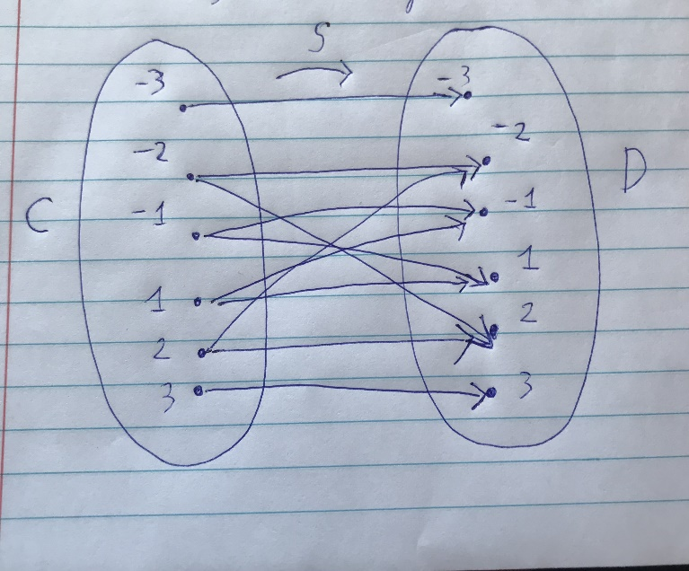

*#15)* Let X = {2, 4, 5} and Y = {1, 2, 4, 6}. Which of the following arrow diagrams determine functions from X to Y?

c) This arrow diagram does not determine a function from X to Y, since it does not satisfy the property 2 (F(4) = 1 and F(4) = 2).

d) This arrow diagram determines a function from X to Y, since it satisfies both property 1 and 2.

e) This arrow diagram does not determine a function from X to Y, since it does not satisfy the property 1 (no value for F(2)).

**Section 1.4:**

*#7)* In graph 7, show that the two drawings represent the same graph by labeling the vertices and edges of the right-hand drawing to correspond to those of the left-hand drawing.

Solution:

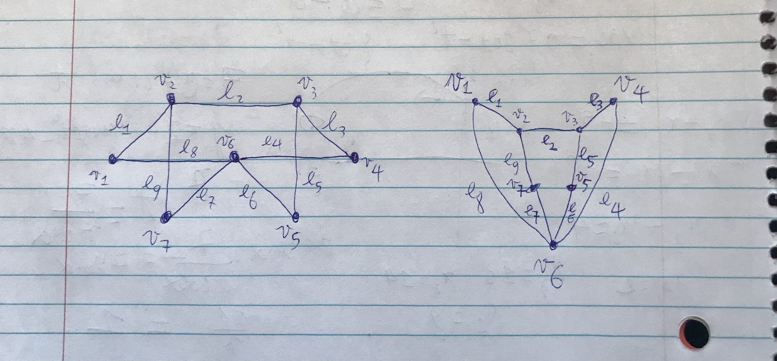

*#9)*

(i) Find all edges that are incident on v1.

(ii) Find all vertices that are adjacent to v3.

(iii) Find all edges that are adjacent to e1.

(iv) Find all loops.

(v) Find all parallel edges.

(vi) Find all isolated vertices.

(vii) Find the degree of v3.

Solution:

1. {e1, e2, e7}.
2. {v1, v2}.
3. {e2, e7}.
4. {e1, e3}.
5. {e4, e5}.
6. {v4}.
7. deg(v3) = 2.

*#17)* A department wants to schedule final exams so that no student has more than one exam on any given day. The vertices of the graph below show the courses that are being taken by more than one student, with an edge connecting two vertices if there is a student in both courses. Find a way to color the vertices of the graph with only four colors so that no two adjacent vertices have the same color and explain how to use the result to schedule the final exams.

Solution:

