HOMEWORK #2

*Section 2.1:*

#7) Write the statement in symbolic form:

Juan is a math major but not a computer science major. (m = “Juan is a math major,” c = “Juan is a computer science major”)

Answer: m ∧ ~c

#22) Determine whether the statement form is logically equivalent. Construct a truth table and include a sentence justifying your answer. Your sentence should show that you understand the meaning of logical equivalence.

p ∧ (q ∨ r) and (p ∧ q) ∨ (p ∧ r)

Solution:

The statement form is logically equivalent.

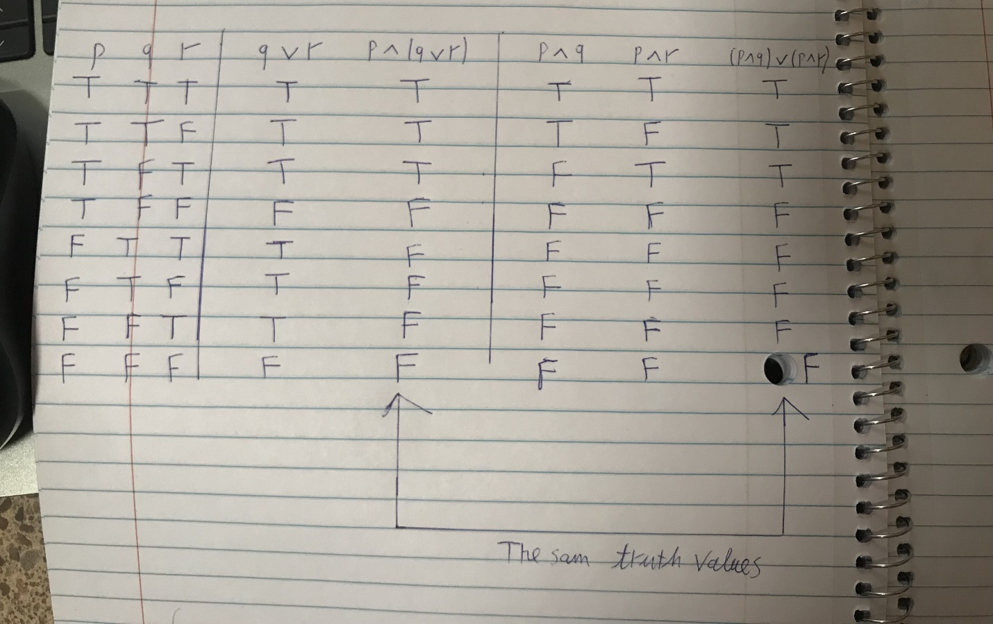

In each row the truth value of p ∧ (q ∨ r) is the same as the truth value of (p ∧ q) ∨ (p ∧ r), thus they are logically equivalent.

#28) Use De Morgan’s laws to write negations for the statement.

The train is late or my watch is fast.

Answer: The train is not late and my watch is not fast.

#52) Use Theorem 2.1.1 to verify the logical equivalences. Supply a reason for each step.

~(p ∨ ~q) ∨ (~p ∧ ~q) ≡ ~p

Solution:

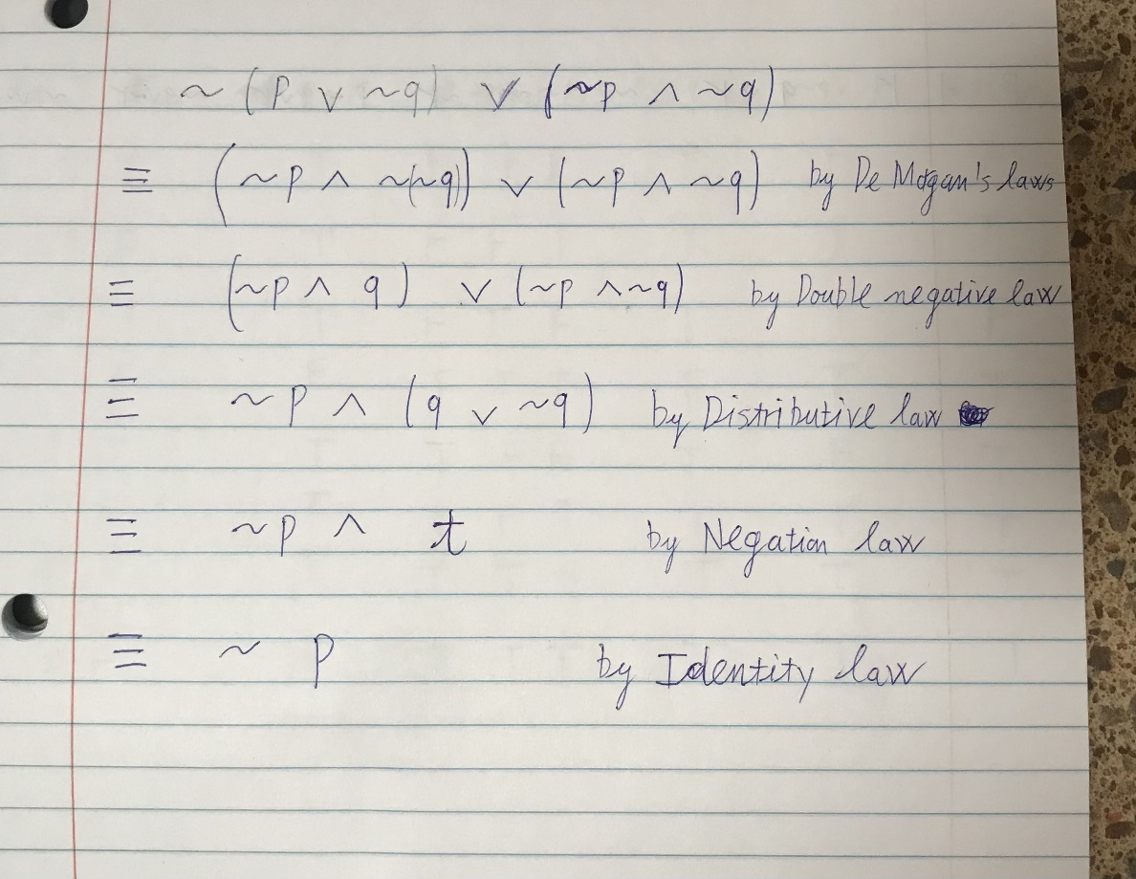

*Section 2.2:*

#13b) Use truth tables to verify the following logical equivalences. Include a few words of explanation with your answers.

~(p → q) ≡ p ∧ ~q

Solution:

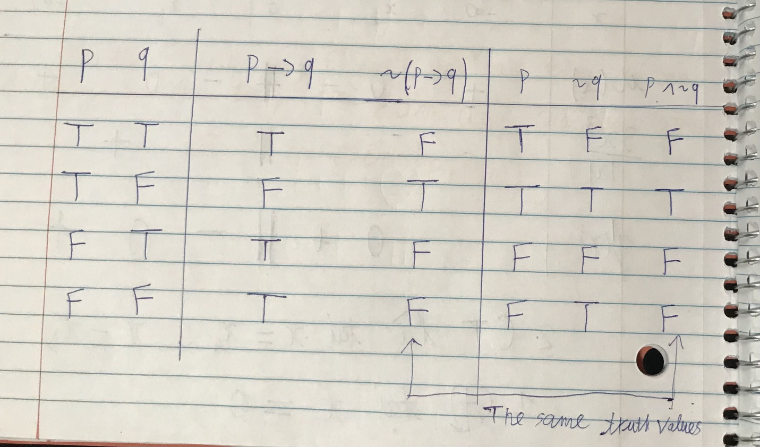

In each row the truth value of ~(p → q) is the same as the truth value of p ∧ ~q, thus they are logically equivalent.

#20g) Write negations for the following statement. (Assume that all variables represent fixed quantities or entities, as appropriate.)

If n is divisible by 6, then n is divisible by 2 and n is divisible by 3.

Answer:

n is divisible by 6 and n is not divisible by 2 or n is not divisible by 3.

#22g) Write contrapositives for the statement of exercise 20g.

Answer: If n is not divisible by 2 or n is not divisible by 3, then n is not divisible by 6.

#23g) Write the converse and inverse for the statement

of exercise 20g.

Answer:

Converse:

If n is divisible by 2 and n is divisible by 3, then n is divisible by 6.

Inverse:

If n is not divisible by 6, then n is not divisible by 2 or n is not divisible by 3.

*Section 2.3:*

#4) If this graph can be colored with three colors, then it can colored with four colors. This graph cannot be colored with four colors

Answer: ∴ This graph cannot be colored with three colors.

#11) Use truth tables to determine whether the argument form is valid. Indicate which columns represent the premises and which represent the conclusion, and include a sentence explaining how the truth table supports your answer. Your explanation should show that you understand what it means for a form of argument to be valid or invalid.

p → q ∨ r

~q ∨ ~r

∴~p ∨ ~r

Solution:

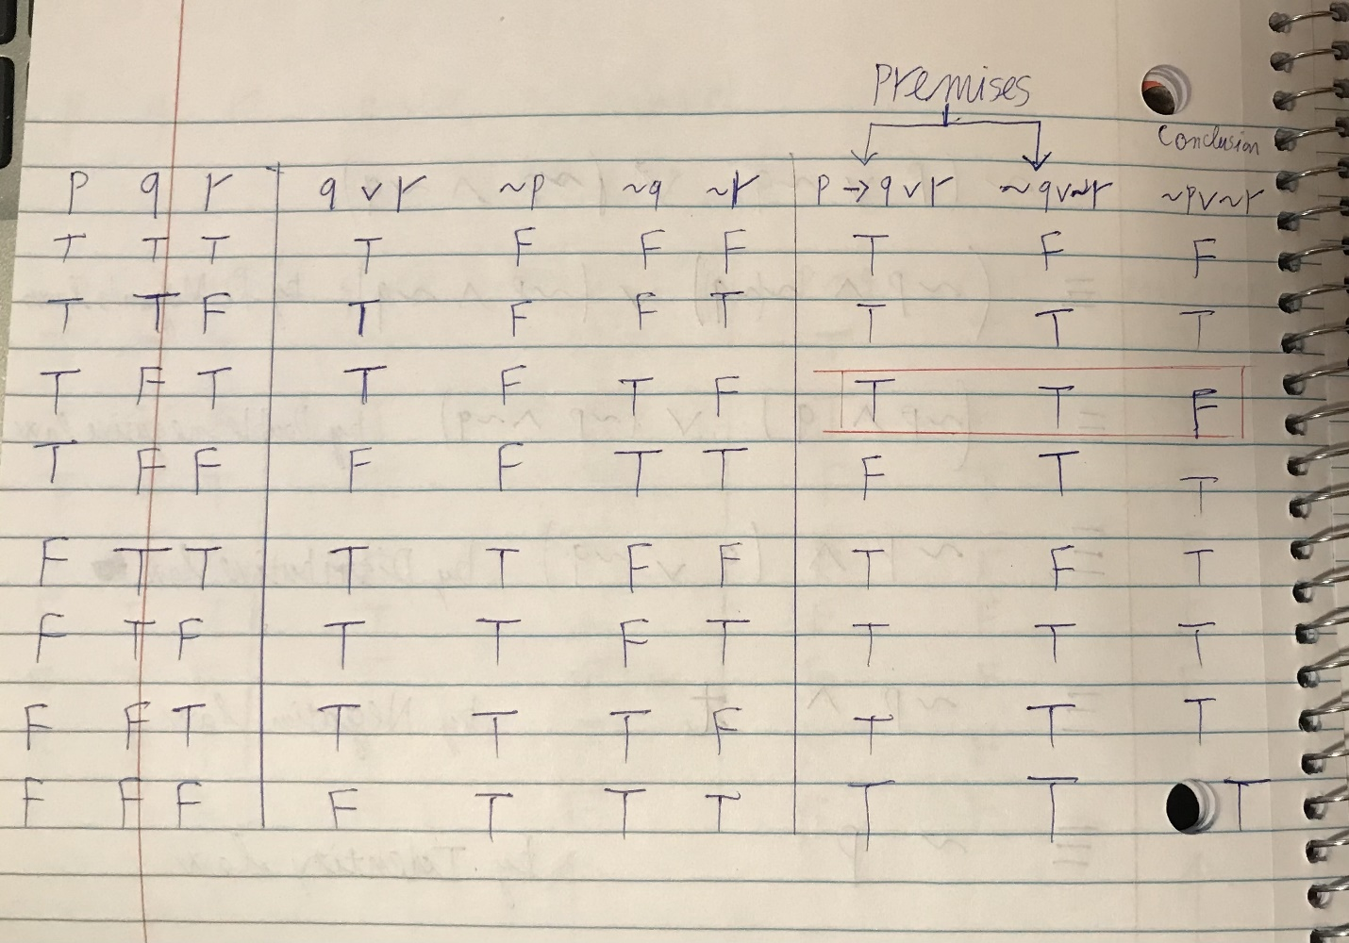

Because as we can see on the row marked red, the conclusion is false while all the premises are true. So this argument is invalid, since an argument is valid if and only if it is impossible for the premises to be true while the conclusion is false.

#29) If at least one of these two numbers is divisible by 6, then the product of these two numbers is divisible by 6.

Neither of these two numbers is divisible by 6.

∴ The product of these two numbers is not divisible by 6.

Solution:

Suppose p: At least one of these two numbers is divisible by 6.

q: The product of these two numbers is divisible by 6.

Logical form:

p→q

~p

∴~q

It is an invalid argument. And this is an inverse error.

*Section 3.1:*

#12) Find counterexamples to show that the statement is false

∀ real numbers x and y, = +

Solution:

Let x = 9 and y = 16, x and y are real numbers; however, = 5 and + = 3 + 4 = 7, which are not equal.

#17b)

Rewrite each of the following in the form “∃ x ___ such that ______”.

Some real numbers are rational.

Solution: ∃ x ∈ R such that x is rational.

#22b) Rewrite each of the following statement in the form “∀____ x, if ____then_____.”

Any valid argument with true premises has a true conclusion.

Solution:

∀valid argument x, if its premises are true then its conclusion is true.

*Section 3.2:*

#3) Write a formal negation for each of the following statements.

b) ∀ computer c, c has a CPU.

d) ∃ a band b such that b has won at least 10 Grammy awards.

Solution:

b) ∃ a computer c such that c does not have any CPU.

d) ∀ band b, b has won less than 10 Grammy awards.

#4) Write a informal negation for each of the following statements.

b) All graphs are connected.

d) Some estimates are accurate.

Solution:

b) There exists at least a disconnected graph.

d) All estimates are not accurate.

#19) Write a negation for the statement:

∀n ∈ Z, if n is prime then n is odd or n = 2.

Answer: ∃n ∈ Z, if n is prime then n is even and n ≠ 2.

#29) Write the contrapositive, converse, and inverse for the statement. Indicate as best as you can which of these statements are true and which are false. Give a counterexample for each that is false.

∀n ∈ Z, if n is prime then n is odd or n = 2.

Solution:

-Contrapositive:

∀n ∈ Z, if n is even and n ≠ 2 then n is not prime.

This statement is true, since number 2 is the unique even prime. Each even integer number that greater than 2, has at least three different factors which are 1, 2 and itself. Therefore, it cannot be a prime number.

- Converse:

∀n ∈ Z, if n is odd or n = 2 then n is prime.

This statement is false. A counterexample for each is that n = 9, then n is odd, but n is not a prime because n has more than two factors such as 1, 3 and 9.

-Inverse:

∀n ∈ Z, if n is not prime then n is even and n ≠ 2.

This statement is false. A counterexample for each is that n = 9, then n is not prime, but n is odd.