**HOMEWORK 3**

Section 3.3:

11b) Every student in my school, has seen the movie Star Wars.

12) Let D = E = {-2, -1, 0, 1, 2}. Write negations for each of the following statements and determine which is true, the given statement or its negation.

c) ∀x in D, ∃y in E such that xy ≥ y.

d) ∃x in D such that ∀y in E, x ≤ y.

Answer: c) The negation: ∃x in D such that ∀y in E, xy < y.

The statement is true and its negation is false.

We prove the statement true:

Since ∀x in D:

If x ≥ 1, then we choose y = 1 (in E). So xy = x ≥ 1 (= y). (Satisfy)

If x < 1, then we choose y ≤ 0 (in E).

y ≤ 0, x – 1 < 0, so y(x – 1) ≥ 0. Therefore, xy ≥ y.

d) The negation: ∀x in D, ∃y in E such that x > y.

The statement is true and its negation is false.

We prove the statement true:

Assume we choose x = -2 (in D), then all of elements in E are equal or greater than x.

16) Statement: There is a real number that does not make any real number changed by multiplying with it.

Negation: Any real number can change some real number’s value by multiplying with it.

47) There is a triangle x such that for every circle y, x is above y.

Solution:

1. True. The triangle a lies above all the circles.
2. ∃x (Triangle(x) ∧ (∀y (Circle(y) → Above(x, y))))
3. Negation:

~(∃x (Triangle(x) ∧ (∀y (Circle(y) → Above(x, y)))))

≡ ∀x(~(Triangle(x) ∧ (∀y (Circle(y) → Above(x, y)))))

≡ ∀x(~Triangle(x) ∨ ~(∀y (Circle(y) → Above(x, y))))

≡ ∀x(~Triangle(x) ∨ ∃y (Circle(y) ∧ ~Above(x, y)))

50) For every object x, if x is a triangle then there is a square y such that y is below x.

Solution:

1. True. Because the square j lies below all the triangles, the statement is true.
2. ∀x (Triangle(x) → ∃y(Square(y) ∧ Below(y, x)))
3. Negation:

~(∀x (Triangle(x) → ∃y(Square(y) ∧ Below(y, x))))

≡ ∃x (~(Triangle(x) → ∃y(Square(y) ∧ Below(y, x))))

≡ ∃x (Triangle(x) ∧ ~(∃y(Square(y) ∧ Below(y, x))))

≡ ∃x (Triangle(x) ∧ ∀y(~Square(y) ∨ ~Below(y, x)))

Section 3.4:

14) If compilation of a computer program produces error messages, then the program is not correct. Compilation of this program does not produce error messages.

∴This program is correct

Answer: This is invalid. (Inverse error)

15) Any sum of two rational numbers is rational. The sum r + s is rational.

∴The numbers r and s are both rational.

Answer: This is invalid. (Converse error)

24) No vegetarians eat meat.

All vegans are vegetarian.

∴No vegans eat meat.

Answer: This is valid.

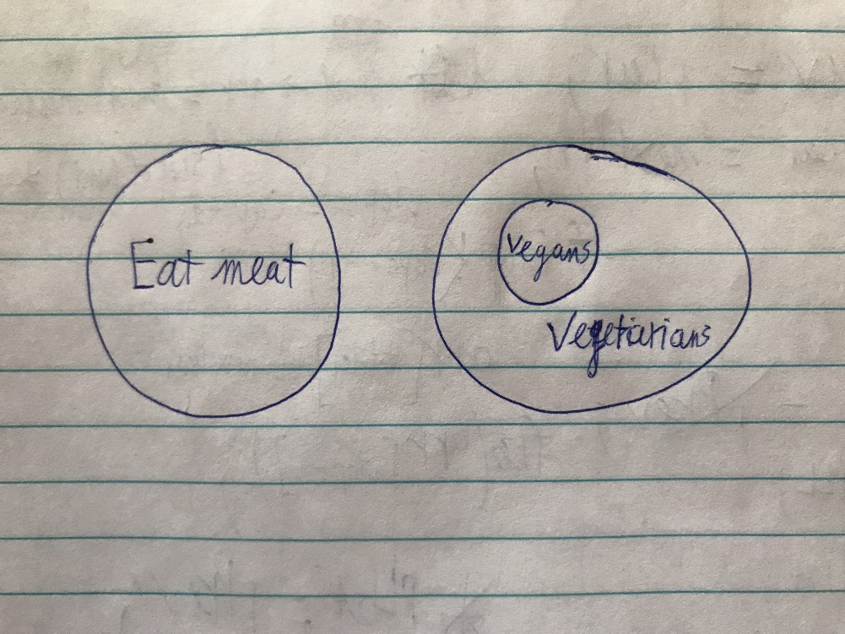

26) All polynomial functions are differentiable.

All differentiable functions are continuous.

∴All polynomial functions are continuous.

Answer: This is valid.

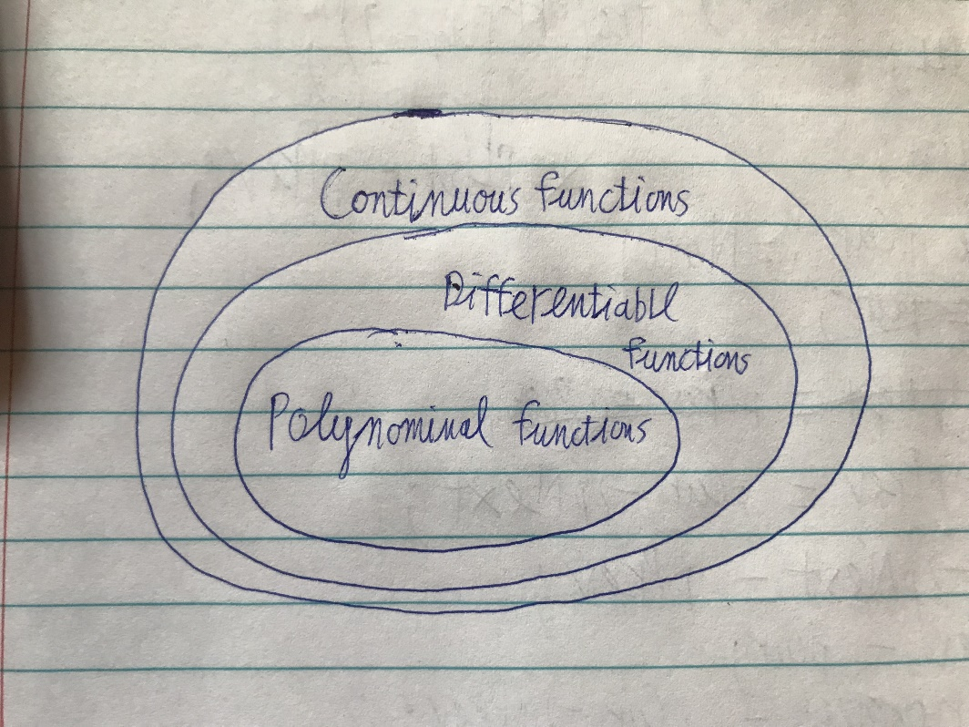

Section 4.1:

7) Prove that there are real numbers a and b such that $\sqrt{a+b}= \sqrt{a}+ \sqrt{b}$

Solution: The statement is true. For example, let a = 0 and b = 1:

= = 1

=

So

9) Prove that there is a real number x such that x > 1 and 2x > x10.

Solution: For example, let x = 60:

2x = 260 = (26)10 = 6410  > 6010 (1)

x10 = 6010  (2)

From (1) and (2), we have: 2x > x10.

15) Disprove the statement in 14–16 by giving a counterexample:

For every integer p, if p is prime then p2 – 1 is even.

Solution:

An counterexample is the case p = 2.

p = 2, then p is a prime; however, p2 – 1 = 22 – 1 = 3 is odd.

31) Theorem: Whenever n is an odd integer, 5n2 + 7 is even.

Rewrite:

* ∀n, if n is an odd integer, then 5n2 + 7 is even.
* ∀odd integer n, 5n2 + 7 is even.
* If n is an odd integer, 5n2 + 7 is even.

Proof: Suppose n is any [particular but arbitrarily chosen] odd integer.

We must show that 5n2 + 7 is even.

By definition of odd, n = (a) for some integer k.

Then

5n2 + 7 = (b)

= 5(4k2 + 4k + 1) + 7

= 20k2 + 20k + 12

= 2(10k2 + 10k + 6)

Let t = (c). Then t is an integer because prodoucts and sums of integers are integers.

Hence 5n2 + 7 = 2t, where t is an integer, and thus (d) by definition of even [as was to be shown].

(a): 2k + 1

(b): 5(2k + 1)2 + 7

(c): 10k2 + 10k + 6

(d): 5n2 + 7 is even