**Problem Set 9**

**Part 1 (one point total).** *For the following English argument provide a translation into PL, using the following translation key (ignore issue of tense and you may use parentheses dropping and quantifier conventions)*:

*Hx*: x is a human

*Fx*: *x* is fish

*Mx*: *x* is meat

*Vx* : *x* is a vegan

*Px*: *x* is a pescatarian

*Exy*: *x* eats *y*

*Cx*: *x* is a canibal

1. Any human who’s eaten a human is a cannibal.
2. Pescatarians eat meat, but only if the meat is fish.
3. Vegans don’t eat meat.
4. Humans are meat and they are not fishes.

Therefore, there are no vegan cannibals, and there are no pescatarian cannibals.

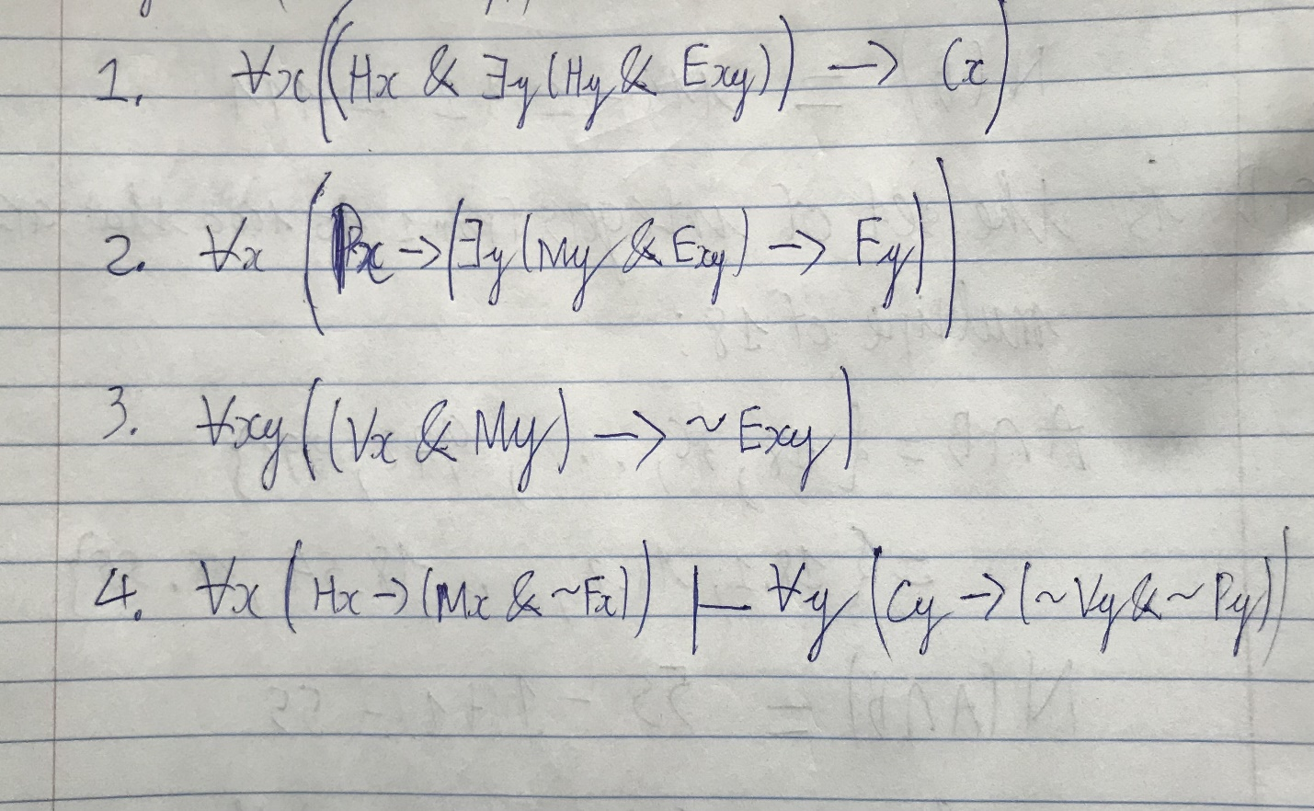

**Part 2 (one point total).** *Provide the expansions for each of the following formulae in PL, using the following universe of discourse:* {a,b,c}.

*Example*:

1. ∀*xPx*

(Pa & Pb) & Pc

1. ∀*x*(*Fx*→*Gx*)
2. ∃*x*(*Fx*&*Gx*)
3. ∀*xFx*→∃*xGx*
4. ∀*x*∃*yLxy*

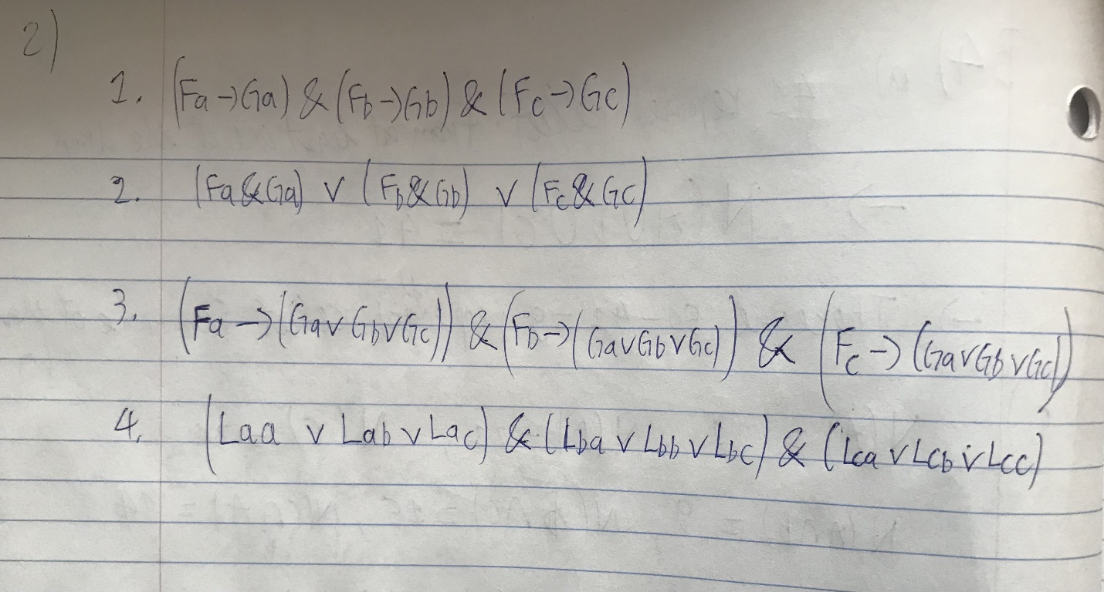

**Part 3 (One point total).** *For each of the following formulae in PL, provide an interpretation (model) that makes them true and an interpretation (model) that makes them false (remember that you need to provide a universe of discourse (U) and an extension for each of the predicates*:

*Example*:

1. ∀*xPx*

True

U:{a}

P:{a]

False

U:{a,b}

P:{a}

1. ∀*x*(*Fx*↔*Gx*)
2. ∃*x*(*Bx*&∀z(*Az*→*Bz*&z≠x))
3. ∀*x*(*Px*→∃*y*((*Py*&*x*≠*y*)&*Lxy*))
4. ∀*xyz*((*Gxy*&*Gyz*)→(*Gxz*&~*Gzx*))

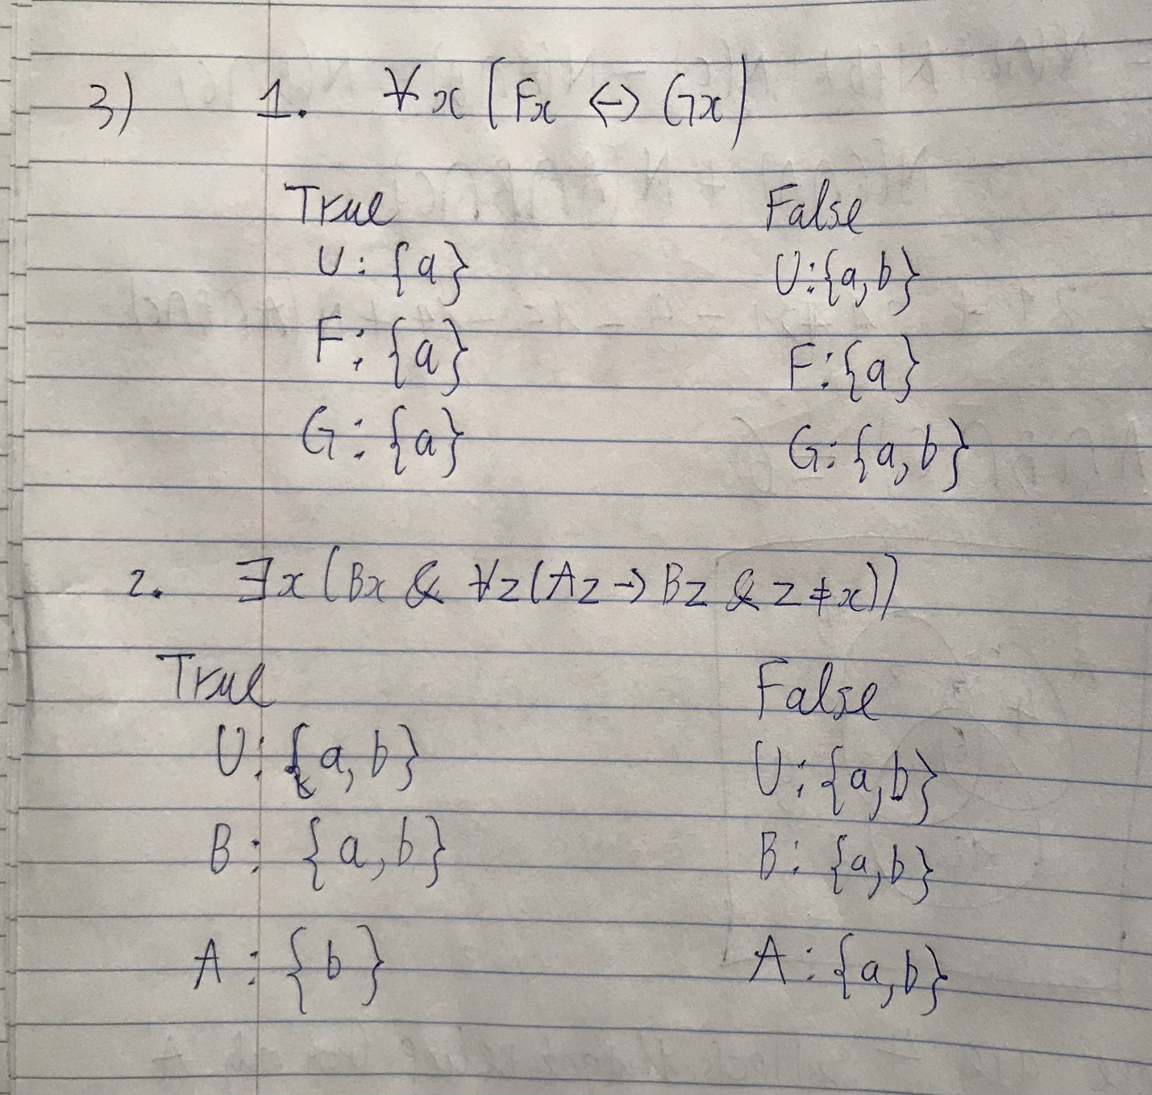

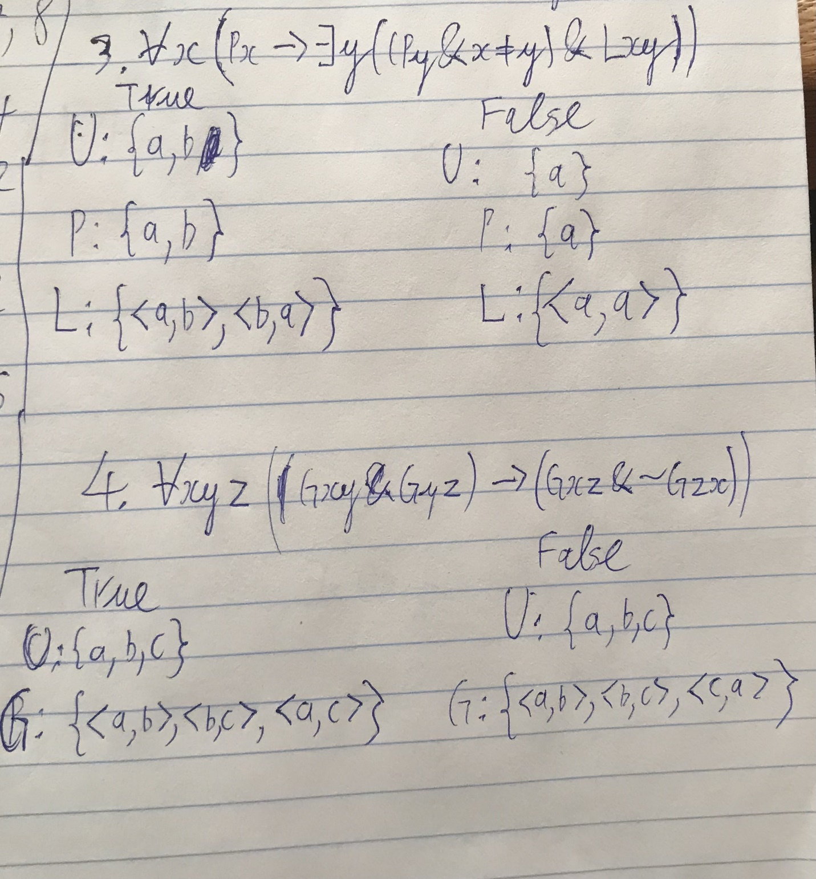

**Part 4 (one point total).** *For each of the following sequents provide a countermodel*.

*Example*:

1. ∀*x*(Px→*Qx*)├ ∃*xQx*

U:{a,b}

P:{ }

Q:{ }

1. ∀*x*(*Fx*→*Gx*), ∃*xGx*├∃*x*(*Fx*&*Gx*)
2. ∀*x*∃*yLxy*├∃*y*∀*xLxy*
3. ∃*xy*(*Ex*&*Oy*)├∃*x*(*Ex*&~*Ox*)&∃*y*(*Oy*&~*Ey*)
4. ∀*x*(*Ex*→~*O*x), ∃*xEx*, ∃*xOx* ├ ~∃*x*~(*Ex*∨*Ox*)

