**Problem Set 8**

**Part 1 (one point total).** *For each of the following English sentences provide a translation into PL, using the following translation key (ignore issue of tense and you may use parentheses dropping and quantifier conventions)*:

*Px*: *x* is a person

*Tx*: *x* is a thing

*Bxy*: *x* belongs to *y*

*Jxy*: *x* brings joy to *y*

*Kxy*: *x* should keep *y*

*Vx*: *x* has value

*Rx*: *x* is a robot

*Mx*: *x* is morally considerable

1. There is a person.
2. There is a person who has a thing.
3. There is a person who has a thing, but that thing does not bring the person joy.
4. There is a person who has a thing, and that thing does not bring that person joy but that person should not keep it.
5. For any person and anything, that person should keep that thing only if that thing brings that person joy.
6. A thing has value if and only if there exists a person to whom the thing brings joy.
7. It is not the case that a thing has value only if there exists a person to whom the thing brings joy.
8. There exists a robot, who is a thing and a person, and that robot has value.
9. All things that are persons and have value are morally considerable.
10. No person has no value, and all persons are morally considerable.

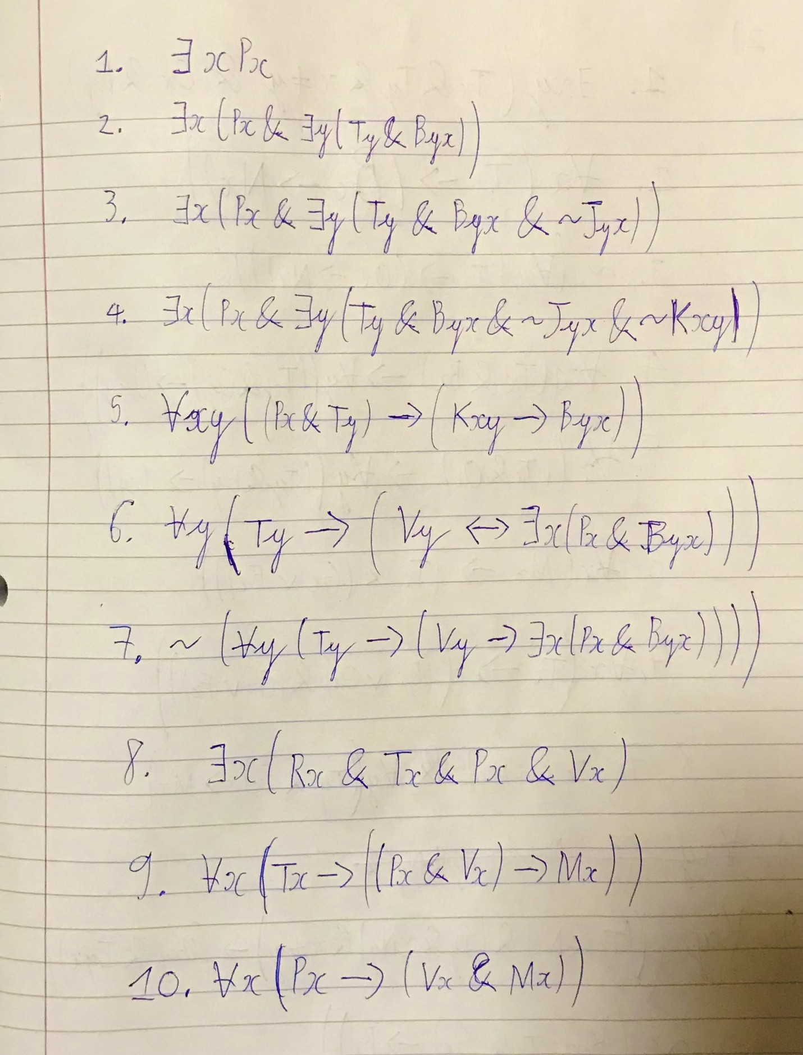

**Part 2 (One point total).** *For each of the following English sentences provide a translation into PL, using the following translation key (ignore issue of tense and you may use parentheses dropping and quantifier conventions)*:

*Tx*: *x* is a troll

*Bx*: *x* lives under a bridge

*Ox*: *x* lives online

*Nx*: *x* is Norse

*Ixy*: *x* is more irritating than *y*

*Uxy*: *x* is uglier than *y*

*Mx*: *x* is a menace

*Fx*: *x* starts flame wars

*Gx*: *x* eats goats

1. Some trolls live online and some trolls live under bridges.
2. All trolls that live under bridges are Norse.
3. Not every troll that lives online is Norse.
4. Trolls that live under bridges are uglier than trolls that live online.
5. Trolls that live online are more irritating than trolls that live under bridges.
6. A menace is a troll that eats goats or starts flame wars.
7. A troll is someone who lives under a bridge or lives online and who eats goats or starts flame wars.
8. Some trolls are not menaces, but every troll who starts a flame war is a menace.
9. Norse trolls are uglier than non-Norse trolls, but non-Norse trolls are more irritating.
10. Not every troll who eats goats lives under a bridge.

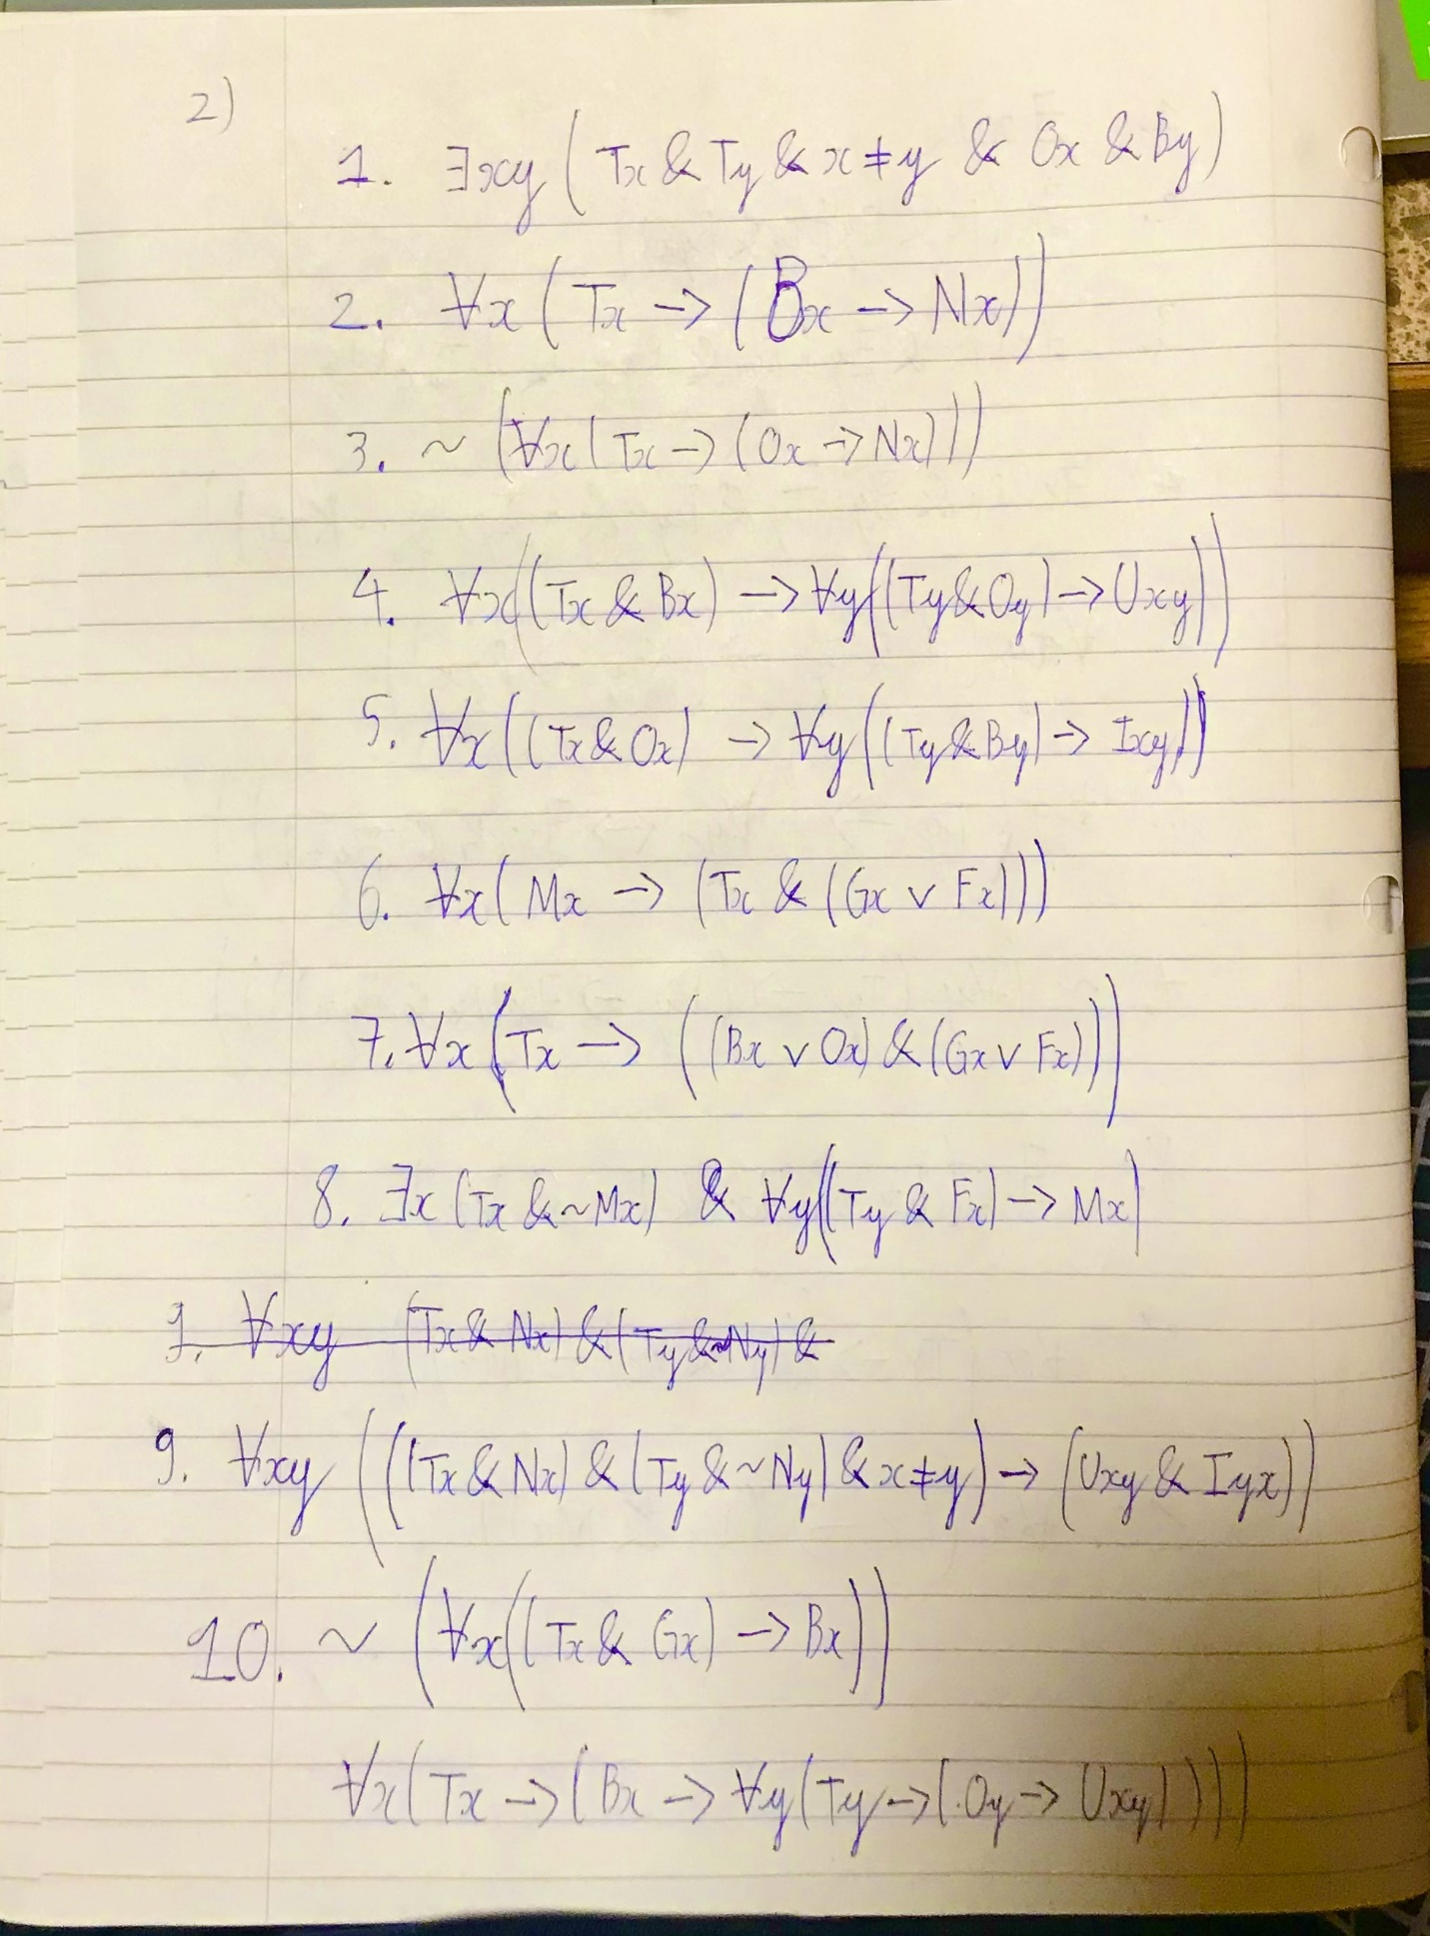

**Part 3 (One point total).** *For each of the following English sentences provide a translation into PL, using the following translation key (ignore issue of tense and you may use parentheses dropping and quantifier conventions)*:

*Gx*: *x* is a grizzly

*Lxy*: *x* lives at *y*

m: Mike

w: WSU

1. There is at least one grizzly.
2. At least one grizzly lives at WSU.
3. There are at least three grizzlies.
4. At least three grizzlies live at WSU.
5. There are at most three grizzlies.
6. At most two grizzlies live at WSU.
7. There are exactly two grizzlies.
8. Exactly two grizzlies live at WSU.
9. If exactly two grizzlies live at WSU, then Mike does not live at WSU.
10. Exactly two grizzlies and Mike live at WSU.

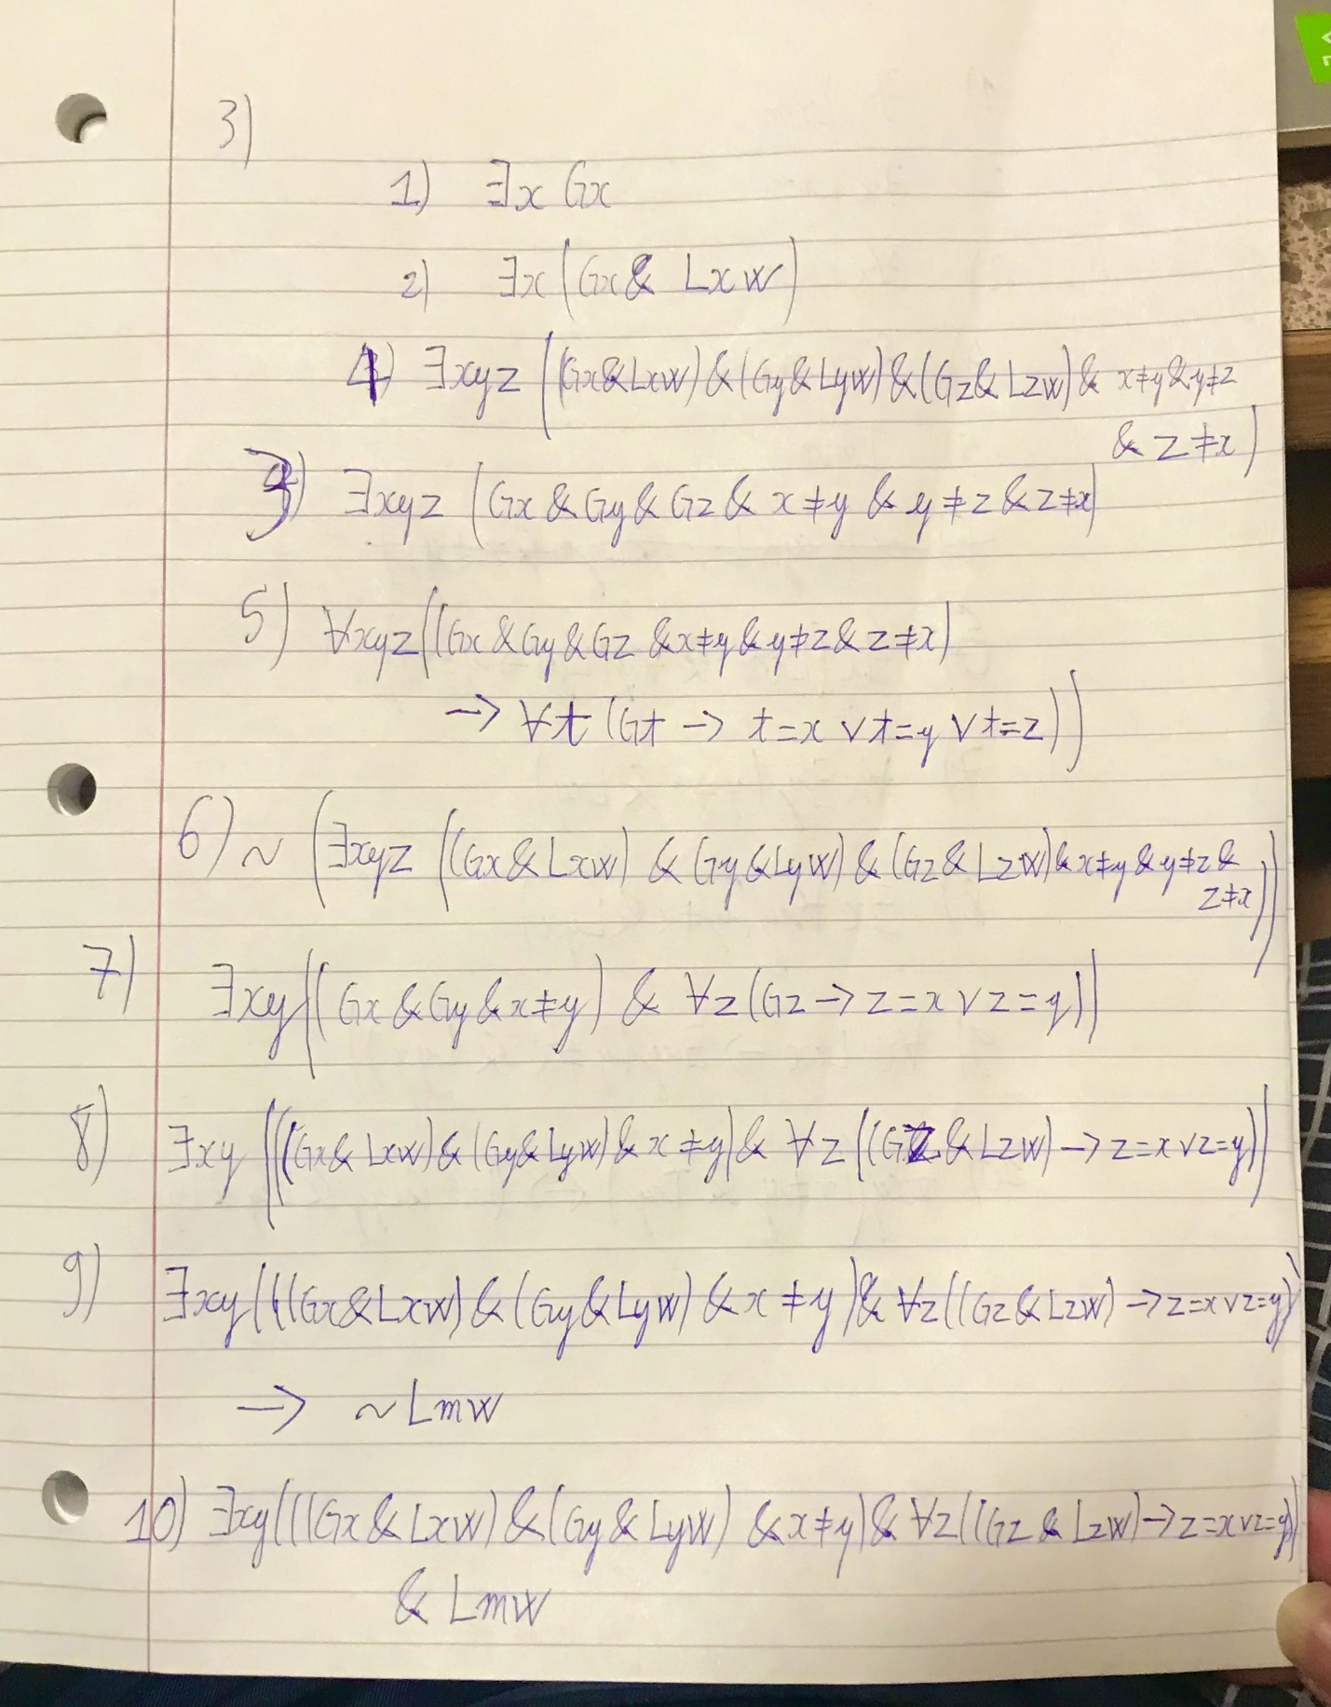

**Part 4 (One point total).** *For each of the following English sentences provide a translation into PL, using the following translation key (ignore issue of tense and you may use parentheses dropping and quantifier conventions)*: (you may assume that the universe of discourse is persons)

*Lxy*: *x* loves *y*

*Txy*: the love between *x* and *y* is true.

m: Marvin

1. Someone loves Marvin.
2. Marvin loves someone.
3. Everybody loves Marvin.
4. Marvin loves everyone.
5. Marvin loves himself.
6. Exactly one person loves Marvin.
7. Everybody has someone they love.
8. There is someone who everyone loves.
9. If one loves oneself, then there is someone who loves them.
10. Two people have true love if and only if each loves themselves and they both love each other.

