NUS Technology

NUS GUI Standard Specification
Created by: | Binh Nguyen-Thanh
Effective date: | N/A
Version: | 0.6

BA/QC Department

This document contains confidential and proprietary information which may not disclosed without prior written consent from NUS Software Technology Corporation.

Document Control
Version | Change description | Changed by | Date
0.1 | Creation | Binh Nguyen-Thanh | November 11, 2013
0.2 | Update Authentication for project “I Want Motivation” | Thuy Le-Thi-Thanh | November 25, 2013
0.3 | Updated | Binh Nguyen-Thanh | September 17, 2014
0.4 | Updated after distribution meeting | Binh Nguyen-Thanh | December 05, 2014
0.5 | Add notes for common sense | Binh Nguyen-Thanh | June 20, 2016
0.6 | Update content | Ha Trinh-Thanh | November 17, 2017

Table of Contents
1. Introduction 5
2. GUI Rules / Specification Standard 5
2.1. Overall GUI Specification 5
2.2. Min-max length 6
2.3. Format 7
2.4. Common Elements 9
2.5. Some Special Elements 13

Index of Tables
Table 1: Overall GUI Specialization 6
Table 2: Min-max length 7
Table 3: Format 9
Table 4: Common Rules 13
Table 5: Input Controls 17
Table 6: Navigational Components 18
Table 7: Informational Components 19

Index of Illustration

Introduction
This document is to describe UI standard specification for some common controls/elements.
This UI standard will be applied in all projects of NUS Technology. If there is any specific rules from customer and they are conflict with the rules in this file, the specific rules from customer will be applied for customer's product.

Note:
Common sense rules: learn by heart
Other rules: can be referred from this file

GUI Rules / Specification Standard

Overall GUI Specification
Item | Rules | Notes
Required field and Optional field | - Use text “(Optional)” at the end of placeholder for optional fields
Placeholder | - In-context descriptions or hints can help to clarify what goes inside each form field, and therefore improve completion and conversion rates.  - This is what placeholders should be placed (inside the form field)  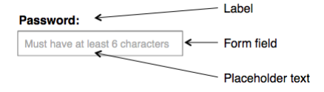  - Placeholder in a form field:  - Additional hint  - Description  - Example of field required  - Placeholders should not used as a replacement for field label  - Adaptive placeholder could be considered | Ref: https://www.nngroup.com/articles/form-design-placeholders/
Menu | - Menu should be placed in a familiar position (Ex: Left rails, Top of the screen)  - Make menu look clickable (Ex: By using shadow, using contrast color, etc)  - Types of menu:    - Navigation Bar  - Hamburger menu/Side view/Navigation Drawer (usually used in responsive view)  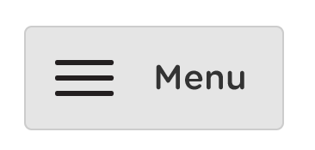 | Ref: https://www.nngroup.com/articles/menu-design/  & https://www.nngroup.com/articles/support-mobile-navigation/
Use Profile Bar | - Always have greeting bar for logged user (Ex: change profile picture, show icons where users can log out)  
Footer | - Have footer for page  - Exception: there's no footer for page with infinity paging  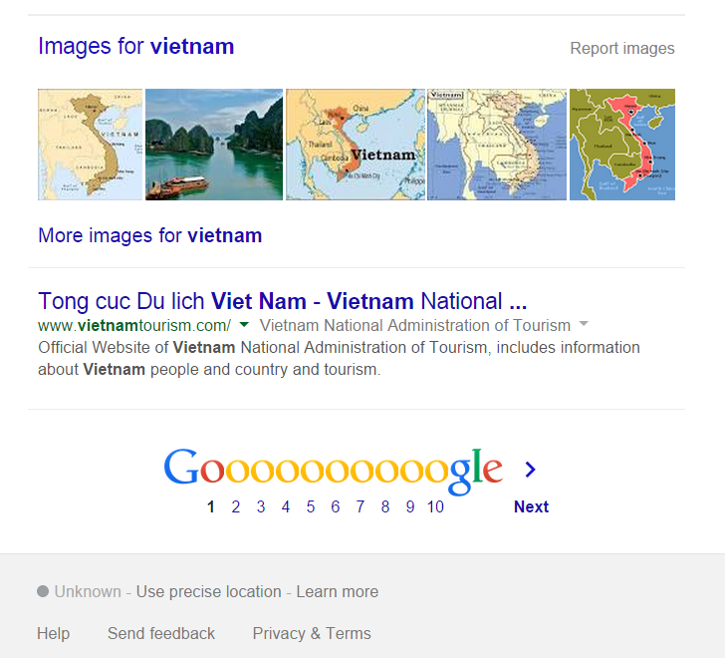 | Ref: https://www.orbitmedia.com/blog/website-footer-design-best-practices/
Auto Focus | - Auto focus is how the cursor is placed automatically in field when arriving a page  - Must have default focus on input form (can be typed)  - Focus on the first input field as default  - Or focus on the first meaningful input  - There's no auto focus in mobile/tablet (because the keyboard is automatically opened whenever putting a cursor) | Button focus
Tab | - Tab: Using Tab on keyboard to move from fields to fields  - Default sequence: from left to right, from top to bottom  - Must have meaningful sequence | Tab key
Enter key | - Effect on Main Action button
Table 1: Overall GUI Specialization

Min-max length
Notes:
- c: character
- d: digit
- n: numeric
- l: letter
Item | Min | Max | Default Value | Notes
Email |  | 256 c
Skype ID | 6c | 32 c
Facebook username |  | 50 c
Username | 6 c | 32 c |  | No special character; and number and hyphen, underscore
Password | 6 c |  |  | Allow to insert spaces in password. Do not allow a password with all spaces
Full name | 2 c | 256 c
Subdomain | 1 c | 255 c |  | Use only letters, numbers, or hyphen ("-")
Link |  | 2048 c
Company name | 2 c | 256 c
Area code |  | 16 c
Primary code |  | 16 c
Street address |  | 256 c
Mobile phone |  | 16 c
Short description |  | 1,000 c
Description |  | 10,000 c
Comment | 2 c | 10,000 c
Family name | 2 c | 100 c
Given name | 2 c | 100 c
Street | 2 c | 94 c
Prefecture / State | 2 c | 10 c
Postal code | 1 c | 20 c | 10-digit: numeric; alphanumeric (i.e. use both letters and digits) and space
City | 2 c | 54 c
Table 2: Min-max length

Format
Item | Rules | Notes
Date and Time | - Default format:  - Month: MMM: Jan Feb … Nov Dec  - Quarter: Q: 1 2 3 4  - Day of week: ddd: Mon … Fri Sat Sun  - Hour: HH: 00 … 23  - Minutes: MM: 00 59  - Second: SS: 59  - Fractional second: SS 0 … 99  - Timezone: z: GMT-07:00 GMT-06:00 … GMT+06:00 GMT+07:00  - Time: LT: 8:30 PM  - Month name, day of month, year: ll: Sep 04, 2014  - Input: MM/DD/YYYY : 09/04/2014  - lll: Sep 04, 2014 8:30 PM  - Week of year: W: 1..53  - Year: YYYY: 2014  - AM/PM: A: AM/PM
Currency | - US Dollar  - 10 USD  - $10 (default)  - US$10, $ 10, US $10  - Japanese Yen  - 10 Yen  - ¥5,980 (default)  - Singapore Dollar  - 10 SGD  - S$10 (default), S$ 10  - Euro  - 10 EUR  - €10 (default), € 10  - British Pound (Sterling)  - 10 GBP  - £10(default), £ 10 | Ref: http://www.thefinancials.com/Default.aspx?SubSectionID=curformat
Percentage | Example: 90%; 90.14% (default)
Number | Example: 1,234.00 | As requirement
Color | - Color meaning:  - Red: danger  - Yellow: warning  - Green: success  - Cyan: primary  - Blue: info  - Grey: default  - Black: inverse | Default color from Bootstrap theme: http://getbootstrap.com/docs/4.0/utilities/colors/
Table 3: Format

Common Elements
Item | Rules | Notes
Text in Forms | - Capitalize the first character of label  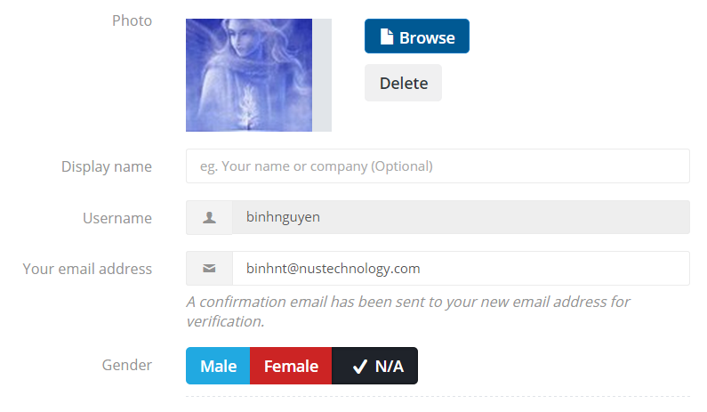 | As requirement
Buttons | - Capitalize all first character of each main word  - Color of primary button must be different from the others.Another button could be a button-link  - Size must fit the text or the same size with the text inside the next button.  - Show full text in button  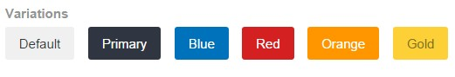  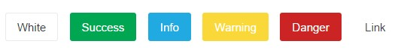  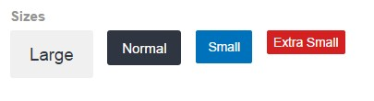  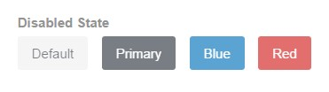
Text | - Must show full of a word (does not break it if it is at the end of a line)  - With space: exceed width of box will use “...” to shorten the text  - Just use … for unimportant field and can be view full data in another place: as tool tip or go to detailed view  - No white-space: wrap the text  - *** in email: must keep domain  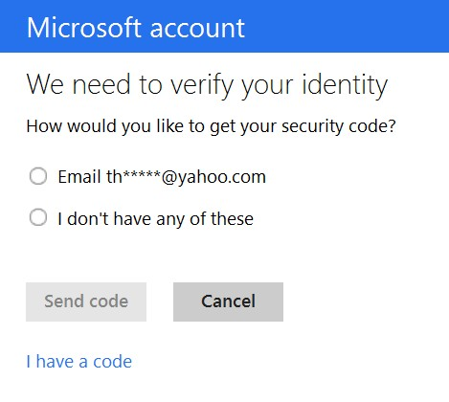  - Name is long: must set rule or “truncate”: hide Last Name/Middle Name (optional)
Alignment | - Text: left  - Number: right  - Date: Right  - Currency: right  - Values that have the same length: center (optional)  - Header of table  - Left (default)  - Center  - Based on the content
Tables | - Table Header: capitalize the first character of each main word  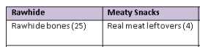  - Common related functions:  - Sort  - Ascending sort in the first column as default  - Note: Data within a table in database  - Data that must join n tables in database (take more effort)  - Paging: there are 2 types:  - Infinity (endless)  - Traditional paging – show 20 items per page as default  - Filter (optional)  - Search (optional)  - Re-size width of each column (optional)  - Relationship between functions:  - Sort function always are kept if there are filter or search  - If there are both filter and search: search will be applied on filtered records  - Delete an item in table: must not refresh page, just reload the table  - Responsive table  - Hide some columns and show some important columns  - Add scroll-bar within table (default)  - Each line will be broken to a new table  - Should not show # columns
Paging (Traditional) | - 20 items/page  - User can select number of items in a page (optional)  - User can go to:  - First page  - Last page  - Next  - Previous  - A particular page (optional)  - Must:  - Have button for each page and … section  - Focus on current page | As requirement
Sort | - Sort all table except for No. column & action column (Ex: Delete, Edit, View, Download, Export)
Disabled item | - Show this item with light color | In-active
Attachment | - Maximum per file: 2MB  - Have confirm message to inform when deleting file  - Need guideline for end user  - Size  - Format  - Drag & Drop (Optional)  - Progress bar (Optional)
Search | - Must have a placeholder as a guideline  - Keyword: from 1 to 255 characters  - Highlight words which matches keyword (optional)  - Should not highlight by using bold text  - Should change color for highlighting  - Or should highlight by an text background color  - Must have Button or Icon search, can press Enter key to search  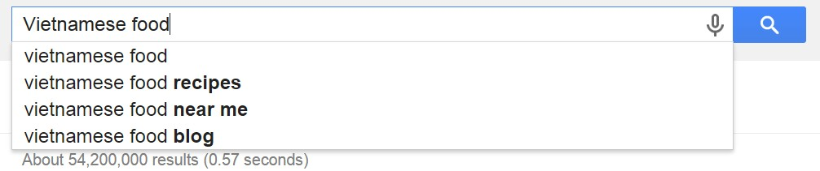  - Field to search: all columns in the table expect No. column, action  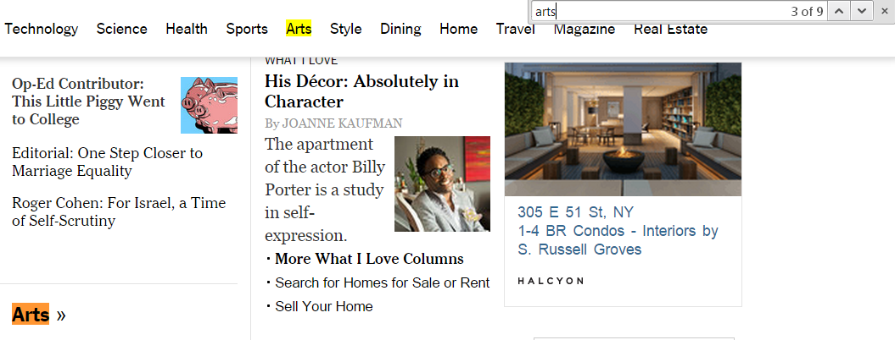  - Some special cases:  - Auto-suggestion  - Start auto-suggestion by 1 or 2 or 3 keyword based on how big of data, solution of search function and requirement  - Pre-action with keyword (as requirement): Remove blank space at the end and the beginning of keyword before proceed searching progress  - Trim left (Blank space at the beginning)  - Trim right (Blank space at the end) | Only search string / text  Search techniques to be refered:  - Full text search  - Keyword search  - Partial search
Table 4: Common Rules

Some Special Elements

Item | Rules | Notes
Checkbox | - Can be checked by clicking on text  - Check/uncheck by pressing on Space key  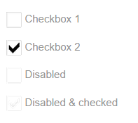
Radio button | - Can be checked by clicking on text  - Can be blank at beginning (optional)  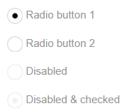
Text area | - Can be enlarged vertically  - Should not be enlarged horizontally  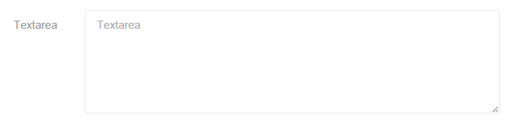
Drop-down list | - Content in box must be ordered meaningfully  - User can search to find a value if there are more than 10 values in box  - Closed view:  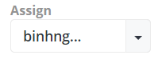  - If text is longer than box: put truncate and put “...” at the end of text as default  - Opened view:  - If text is longer than box: put truncate and put “...” at the end of text  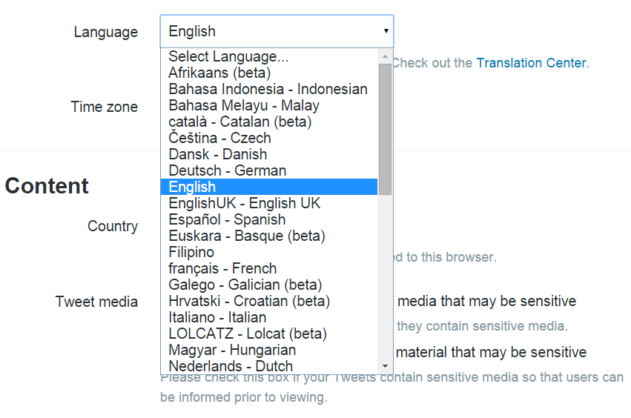  - Or: increase with of box to right side (or left side).
Date picker | - Date and Time: must be in a Timezone  - Use the right type based on purpose of picker  - Default view:  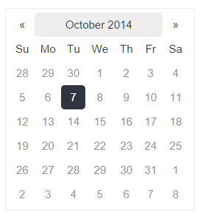  - Optional view  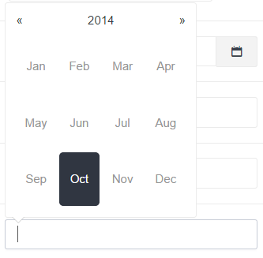  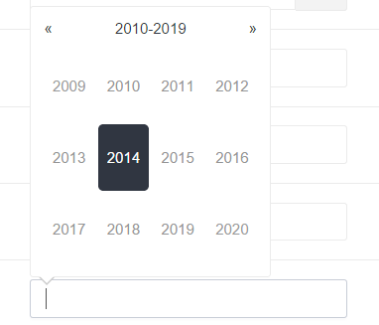  - Show at bellow/right/left/above of input box based on the position of this box in screen
Time picker | - Time: must be in a Time Zone  - Default format view: HH:MM AM/PM (Ex: 11:25 AM)
Slider | - Must show current chosen value  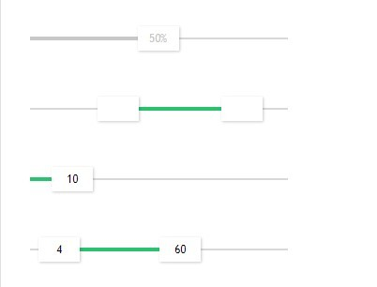
Tag | - Type and press Enter to enter new value  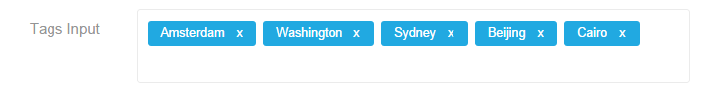
Table 5: Input Controls

Item | Rules | Notes
Breadcrumb | 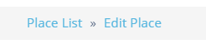  - Default: show the 'tree' of features/function
Icon | - All icons in app must be consistent
Table 6: Navigational Components

Item | Rules | Notes
Tooltip | - Must have tooltip for all icon/action text  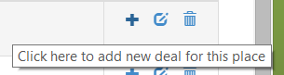
Progress bar | 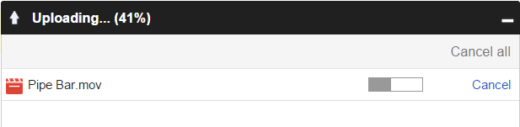  - Must show % complete
Notification/Flash message/Alert notification | - Color of notification must be the same to the guideline below | There is x icon to close message as default
Message | - Confirmation: Are you sure you want to [do] something?  - Warning Message: A sentence describes the error. Ex: To continue printing, add more paper to the printer and press OK  - Error Message: A sentence describes the error and a sentence guides what users should do. Ex: Cannot delete. E:\: Access is denied. Make sure the disk is not full or write-protected and the file is not currently in use.
Table 7: Informational Components

