Y3. Các yêu cầu về chức năng

## Thêm thông tin vào các bảng: ……..

1. **Truy vấn thông tin a, ……….**

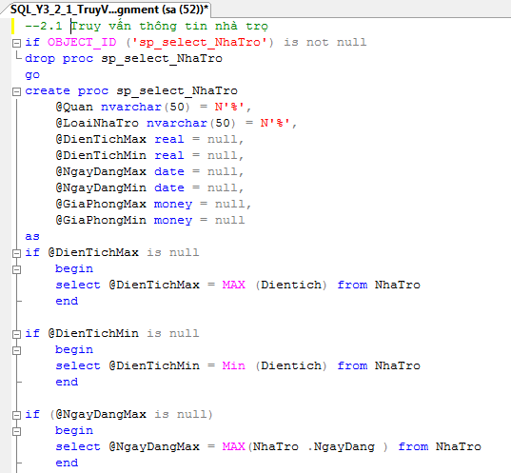



* if (@NgayDaogHio is



* begin

#### select @NgayDaogHio = Nin(NbaTro .Ngay0aog + from NbaTro

end

#### if @GiaP&oogHaa is

* begin

#### select @GiaPboogHaa NAX(NbaTro .GiaP&oog from NbaTro

* end

#### if GGiaP&oogHio is ’all

begin

#### select GGiaPboogHio = Nin(NbaTro .GiaP&oog i from NbaTro

end

-j select (N ' Cho thue phñng t at ' - EthaI co . Di aChi - ' , ' - lIhaI zo . Quan i as ' D ia Chi ' , ( REP LACE ( fOlIV€ RR (varchar, Di end i ct, IO3 i , ' . ' , ' , ' i - ' m2 ' as ' Die•n T i ch ' ,

(srPLRCE rd cONVE RI (vazchaz, GiaPhong , 1 i , I.EN ( CONVERT (varchar, GiaPhong , 1 i i - 3 i , ' , ' , ' '; - N' VND'; as 'Gié Phong', NRaTro .J&oogTioNRaTro as 'Thong Tin Nhâ Trg',

#### CONVERT(varchar,Ngay0aog ,105+ as 'Ngây Dâng',

case NguoiDuog .GioiTioA

when 1 when 'A. ' - NguoiDuog .IeoNguoiDuog when 0 then 'C. ' - NguoiDuog .TeoNguoiDuog end as N'Ngudi dang',

OieoThoai as N'Dien thoai lién he', (NguoiDuog .DiaCbi - ', ' - NguoiDuog .Quao 1 as N'Dia chi lién he'

#### from N&aJro 'ciz LoaiNRa on NRaIro .HaLoaiNRa = LoaiNRa .HaLoaiNRa 'cis NguoiDuog on N&aTro .HaNguoiDuog = NguoiDuog .HaNguoiDuog where (OieoTicA C= @0ieoTicRHaa+ and (DieoIicA >= @DieoIinbXio; azd (Ngay0aog <= @Ngay0aogHaa+ and

(Ngay0aog >= @NgayDaogHioi and (GiaPRoog <= @GiaP&oogHaxi and (GiaPRoog >= @GiaPRoogHioi

&xd (MRRJrO.Quam ?2<i @Quaot &i3 (LORiNhR.ienLORiNhR l?.< @LORiNhRJrO+

#### order by Ngay0aog

--Truy v/in

exec sp select NRaTro

exec sp_select_NRaTro @LoaiNRaTro=N'%nguyén cân%'

exec sp_select_NRaTro @Quao=N'%Quan l%',@DieoTicbHaa=60,@GiaPfloogHaa=4000000

exec sp select NRaTro @NgayDaogHax='7/30/2013',@NgayDaogHio='l/1/2013'

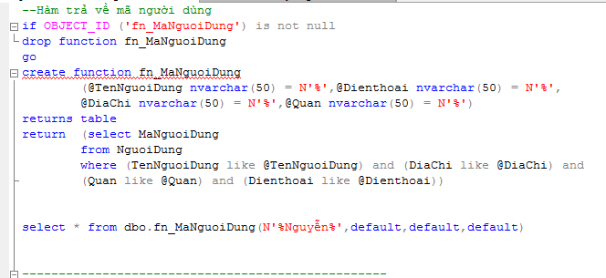b, …….

Tham khao them cac lau lenh duoi

--Truy v/in nhñng nhâ tro co nguoi dâng co ho tén chña chuoi ’Nguyén’ select HaNbaTro as N'Hâ Nhâ Tro',

TeoLoaiNba as N'Tén Loai Nhâ',

'.',','i - ' as 'Dién Tich',

(REPLACE(lZFT(CONVERT(varchar,GiaPRoog i-3i,',','. - N' as 'Giâ Phong', (NbaTro.DiaCbi - ', ' - as N'Dia Chi Nhâ Tro',

TRoogTioNbaTro as N'Thong Tin Nhâ Tro', NgayDaog as N'Ngây &âng', NguoiDuog.TeoNguoiDuog as 'Ngudi Dâng'

from NbaTro -c c NguoiDuog on NbaTro.HdNguoiDuog = NguoiDuog.HaNguoiDuog -c c LoaiNba on NbaTro.HaLoaiNba = LoaiNba.HaLoaiNba where NbaTro.HaNguoiDuog c (select HaNguoiDuog from dbo.fo_HaNguoiDuog(N'BNguyenB',default,default,defaulti i

--Truy van nhñng nhâ tro co nguoi lién hé co dia chi lién hé o Quân 1 select HaNbaTro as N'Hâ Nhâ Tro',

TeoLoaiNba as N'Tén Loai Nhâ',

'.',','i - ' as 'Dién Tich',

(REPLACE(lZFT(CONVERT(varchar,GiaPRoog i-3i,',','. - N' as 'Giâ Phong', (NbaTro.DiaCbi - ', ' - as N'Dia Chi Nhâ Tro',

TRoogTioNbaTro as N'Thong Tin Nhâ Tro', NgayDaog as N'Ngây &âng', NguoiDuog.TeoNguoiDuog as 'Ngudi Dâng',

(NguoiDuog.DiaCbi - ', ' - as N'Dia Chi Lién Hé'

from NbaTro -c c NguoiDuog on NbaTro.HdNguoiDuog = NguoiDuog.HaNguoiDuog -c c LoaiNba on NbaTro.HaLoaiNba = LoaiNba.HaLoaiNba where NbaTro.HaNguoiDuog c (select HaNguoiDuog from dbo.fo_HaNguoiDuog(default,default,default,N'BQuâ

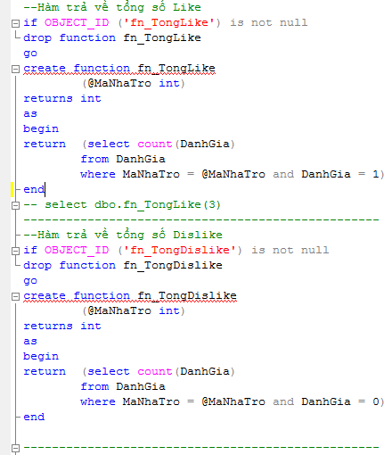C, ……..

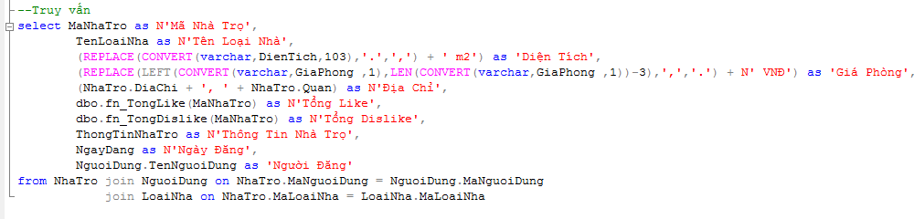

D, …..

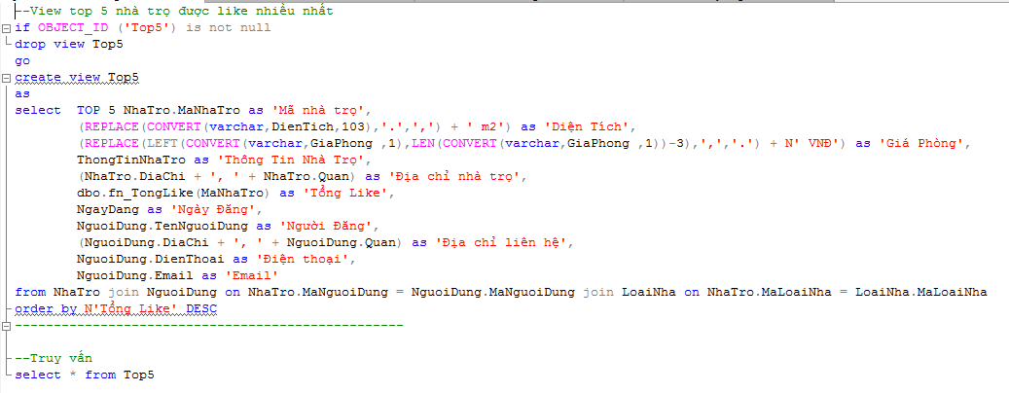

E, …..

-Truy van thong tin dânh giâ nhâ tro

|:jif O]CZtT ID ('sp select s act L bloc sp select DanhGiaNhaTro

'J°

[:jcreate proc sp select DanhGiaNhaTro

@MaNhaTro int

gif act exists (select * from NhaTro where MaNhaTro = begin

print N'Nhâ tro nây khong ton tai'

else



end

### begin

if act exists (select * from DanhGia where MaNhaTro = begin

else

end

print N'Nhâ tro nây chua

dânh giâ'

begin

select DanhGia.MaNhaTro as 'Mâ nhâ tro', NguoiDung.TenNguoiDung as 'Ngudi dânh giâ', case DanhGia.DanhGia

when 1 then 'Like' when 0 then 'Dislike'

end as N'Dânh giâ',

DanhGia.ThongTinDanhGia as 'Noi dung dânh giâ'

from DanhGia -c z NguoiDung on DanhGia.MaNguoiDung = NguoiDung.MaNguoiDung where DanhGia.MaNhaTro = @MaNhaTro

end

end

--Truy v/in

|  |  |  |  |  |
| --- | --- | --- | --- | --- |
| exec | sp | select | DanhGiaNhaTro | @MaNhaTro=l |
| exec | sp | select | DanhGiaNhaTro | @MaNhaTro=2 |
| exec | sp | select | DanhGiaNhaTro | @MaNhaTro=3 |
| exec | sp | select | DanhGiaNhaTro | @MaNhaTro=9 |
| exec | sp | select | DanhGiaNhaTro | @MaNhaTro=5 |
| exec | sp | select | DanhGiaNhaTro | @MaNhaTro=6 |
| exec | sp | select | DanhGiaNhaTro | @MaNhaTro=7 |
| exec | sp | select | DanhGiaNhaTro | @MaNhaTro=8 |
| exec | sp | select | DanhGiaNhaTro | @MaNhaTro=9 |
| exec | sp | select | DanhGiaNhaTro | @MaNhaTro=l0 |



exec sp select



exec sp select

tro chua co dânh giâ DanhGiaNhaTro @MaNhaTro=ll

tro khong ton tai

# DanhGiaNhaTro @MaNhaTro=l3