**SRS LITTLE ANGEL MILK**

**1.ERD:**

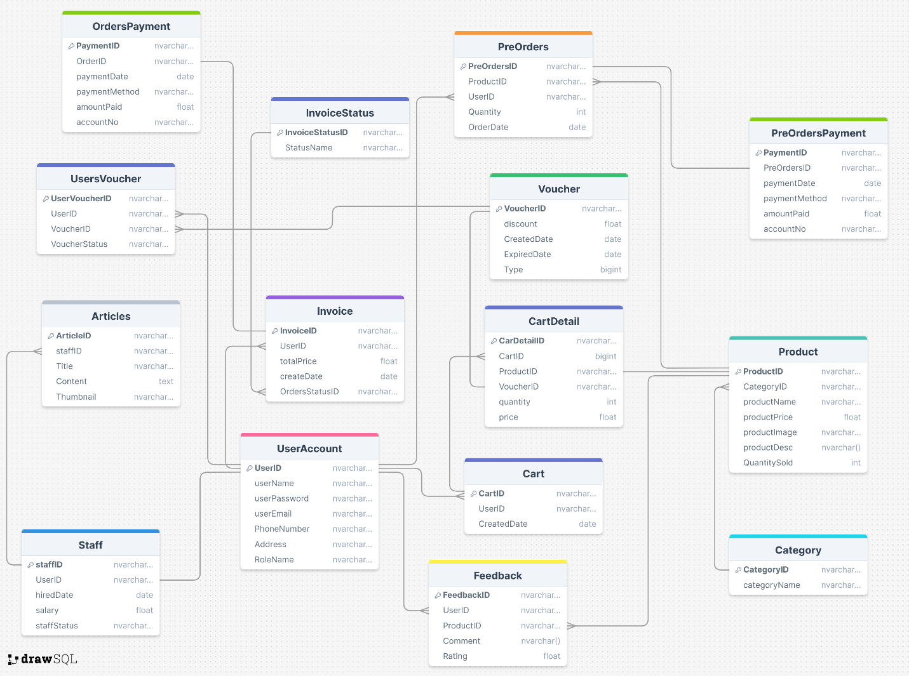

**2. Functional Requirement:**

- Guest   
+ Xem thông tin, xem đánh giá, tìm kiếm các sản phẩm về sữa và mua hàng.   
+ Xem các bài viết về chăm sóc sức khỏe cho mẹ bầu và em bé, mua hàng trực tiếp từ các sản phẩm được gợi ý từ các bài viết.  
- Member   
+ Mua hàng bằng các hình thức chuyển khoản, thanh toán trực tuyến  
+ Sử dụng voucher, tích lũy điểm thành viên, đổi quà hoặc sản phẩm tương ứng từ cửa hàng  
+ Đánh giá, feedback sản phẩm.   
+ Đăng ký tư vấn chọn và mua sữa online thông qua chức năng chat.   
+ Đặt hàng trước khi chưa có sẵn sản phẩm.  
- Staff   
+ Xác nhận các đơn hàng, quản lý hàng hóa, người dùng, tạo các mã voucher, xử lý report, tracking đơn hàng.   
+ Quản lý các bài viết.  
- Admin   
+ Quản lý account, thống kê doanh thu, sản phẩm...

**3. USECASE LIST:**

* Guest: View Product Information, View Reviews, Search Products, Purchase Products, View Health Articles.
* User: Purchase with Bank Transfer, Purchase with Online Payment, Use Vouchers, Accumulate Points, Exchange Points for Gifts/Products, Review Products, Provide Feedback, Register for Online Consultation, Pre-order Products.
* Staff: Confirm Orders, Manage Users, Create Voucher Codes, Handle Reports, Track Orders, Manage Articles.
* Admin: Manage Accounts, Revenue Statistics, Manage Products.

**4.UI(Front-End):**

Link Figma:

<https://www.figma.com/design/eTy2O8KonNGbo7n1ncCV9v/CuaHangSua?node-id=0-1&t=G382YireVEUmiGDB-0>

[www.figma.com](http://www.figma.com)

**5.TECHNICAL REQUIREMENT**  
Guest

* View Product Information
  + T1 Product ID - Product ID is required
  + T2 Product ID - Valid product ID must exist in the database
  + T3 Product Details - Product details must be retrieved from the database
* View Reviews
  + T4 Product ID - Product ID is required
  + T5 Product ID - Valid product ID must exist in the database
  + T6 Review Details - Review details must be retrieved from the database
* Search Products
  + T7 Search Query - Search query is required
  + T8 Search Query - Search query must be a valid string
  + T9 Search Results - Search results must be retrieved from the database
* Purchase Products
  + T10 Product ID - Product ID is required
  + T11 Product ID - Valid product ID must exist in the database
  + T12 Order Details - Order details must be stored in the database
* View Health Articles
  + T13 Article ID - Article ID is required
  + T14 Article ID - Valid article ID must exist in the database
  + T15 Article Details - Article details must be retrieved from the database

User

* Purchase with Bank Transfer
  + T16 Payment Method - Payment method is required
  + T17 Payment Method - Payment method must be "Bank Transfer"
  + T18 Order Details - Order details must be updated in the database
* Purchase with Online Payment
  + T19 Payment Method - Payment method is required
  + T20 Payment Method - Payment method must be "Online Payment"
  + T21 Order Details - Order details must be updated in the database
* Use Vouchers
  + T22 Voucher Code - Voucher code is required
  + T23 Voucher Code - Voucher code must be valid
  + T24 Order Details - Order details must be updated in the database
* Accumulate Points
  + T25 User ID - User ID is required
  + T26 User ID - Valid user ID must exist in the database
  + T27 Points - Points must be updated in the database
* Exchange Points for Gifts/Products
  + T28 Points - Points are required
  + T29 Points - Points must be sufficient for redemption
  + T30 Redemption Details - Redemption details must be stored in the database
* Review Products
  + T31 Product ID - Product ID is required
  + T32 Product ID - Valid product ID must exist in the database
  + T33 Review Details - Review details must be stored in the database
* Provide Feedback
  + T34 Feedback - Feedback is required
  + T35 Feedback - Feedback must be a valid string
  + T36 Feedback Details - Feedback details must be stored in the database
* Register for Online Consultation
  + T37 User ID - User ID is required
  + T38 User ID - Valid user ID must exist in the database
  + T39 Consultation Details - Consultation details must be stored in the database
* Pre-order Products
  + T40 Product ID - Product ID is required
  + T41 Product ID - Valid product ID must exist in the database
  + T42 Pre-order Details - Pre-order details must be stored in the database

Staff

* Confirm Orders
  + T43 Order ID - Order ID is required
  + T44 Order ID - Valid order ID must exist in the database
  + T45 Order Status - Order status must be updated in the database
* Manage Users
  + T46 User ID - User ID is required
  + T47 User ID - Valid user ID must exist in the database
  + T48 User Details - User details must be updated in the database
* Create Voucher Codes
  + T49 Voucher Code - Voucher code is required
  + T50 Voucher Code - Voucher code must be unique
  + T51 Voucher Details - Voucher details must be stored in the database
* Handle Reports
  + T52 Report Type - Report type is required
  + T53 Report Type - Report type must be valid
  + T54 Report Details - Report details must be generated
* Track Orders
  + T55 Order ID - Order ID is required
  + T56 Order ID - Valid order ID must exist in the database
  + T57 Order Status - Order status must be updated in the database
* Manage Articles
* T58 ArticleID - Article ID is required
  + T59 Article ID - Valid article ID must exist in the database
  + T60 Article Details - Article details must be updated in the database

Admin

* Manage Accounts
  + T61 User ID - User ID is required
  + T62 User ID - Valid user ID must exist in the database
  + T63 User Details - User details must be updated in the database
* Revenue Statistics
  + T64 Date Range - Date range is required
  + T65 Date Range - Date range must be valid
  + T66 Revenue Details - Revenue details must be generated
* Manage Products
  + T67 Product ID - Product ID is required
  + T68 Product ID - Valid product ID must exist in the database
  + T69 Product Details - Product details must be updated in the database

[**6. SCREEN FLOW:**   
Guest:](https://anhbd.atlassian.net/jira/projects)

1. [View Product Information:](https://anhbd.atlassian.net/jira/projects)
   * [Guest browses the product catalog.](https://anhbd.atlassian.net/jira/projects)
   * [Guest selects a product to view details like name, price, description, images, and reviews.](https://anhbd.atlassian.net/jira/projects)
2. [View Reviews:](https://anhbd.atlassian.net/jira/projects)
   * [Guest navigates to the product details page.](https://anhbd.atlassian.net/jira/projects)
   * [Guest can see all user reviews for that product.](https://anhbd.atlassian.net/jira/projects)
3. [Search Products:](https://anhbd.atlassian.net/jira/projects)
   * [Guest uses the search bar to input keywords related to the desired product.](https://anhbd.atlassian.net/jira/projects)
   * [Results are displayed based on the search terms.](https://anhbd.atlassian.net/jira/projects)
4. [Purchase Products:](https://anhbd.atlassian.net/jira/projects)
   * [Guest adds desired products to the cart.](https://anhbd.atlassian.net/jira/projects)
   * [Guest proceeds to checkout, selecting the desired payment method (e.g., online payment or bank transfer).](https://anhbd.atlassian.net/jira/projects)
   * [Guest enters delivery details and confirms the order.](https://anhbd.atlassian.net/jira/projects)
5. [View Health Articles:](https://anhbd.atlassian.net/jira/projects)
   * [Guest navigates to the "Health Articles" section.](https://anhbd.atlassian.net/jira/projects)
   * [Guest can browse and view available articles.](https://anhbd.atlassian.net/jira/projects)

[User:](https://anhbd.atlassian.net/jira/projects)

1. [Purchase with Bank Transfer:](https://anhbd.atlassian.net/jira/projects)
   * [User follows the purchase flow (same as guest) but selects "Bank Transfer" as the payment method.](https://anhbd.atlassian.net/jira/projects)
   * [User receives payment instructions with account details.](https://anhbd.atlassian.net/jira/projects)
2. [Purchase with Online Payment:](https://anhbd.atlassian.net/jira/projects)
   * [User follows the purchase flow (same as guest) but selects "Online Payment" as the payment method.](https://anhbd.atlassian.net/jira/projects)
   * [User enters payment details and completes the transaction.](https://anhbd.atlassian.net/jira/projects)
3. [Use Vouchers:](https://anhbd.atlassian.net/jira/projects)
   * [User enters the voucher code during the checkout process.](https://anhbd.atlassian.net/jira/projects)
   * [The system applies the voucher discount and updates the total price.](https://anhbd.atlassian.net/jira/projects)
4. [Accumulate Points:](https://anhbd.atlassian.net/jira/projects)
   * [User earns points for each successful purchase or other activities (e.g., reviews).](https://anhbd.atlassian.net/jira/projects)
   * [The system tracks accumulated points in the user profile.](https://anhbd.atlassian.net/jira/projects)
5. [Exchange Points for Gifts/Products:](https://anhbd.atlassian.net/jira/projects)
   * [User navigates to the "Points Exchange" section.](https://anhbd.atlassian.net/jira/projects)
   * [User selects the desired gift/product and redeems their points.](https://anhbd.atlassian.net/jira/projects)
6. [Review Products:](https://anhbd.atlassian.net/jira/projects)
   * [User navigates to the product details page.](https://anhbd.atlassian.net/jira/projects)
   * [User writes a review and submits it for approval.](https://anhbd.atlassian.net/jira/projects)
7. [Provide Feedback:](https://anhbd.atlassian.net/jira/projects)
   * [User submits feedback through a dedicated feedback form.](https://anhbd.atlassian.net/jira/projects)
   * [The system records the feedback for review.](https://anhbd.atlassian.net/jira/projects)
8. [Register for Online Consultation:](https://anhbd.atlassian.net/jira/projects)
   * [User navigates to the "Consultations" section.](https://anhbd.atlassian.net/jira/projects)
   * [User selects the desired consultation type and books a slot.](https://anhbd.atlassian.net/jira/projects)
9. [Pre-order Products:](https://anhbd.atlassian.net/jira/projects)
   * [User identifies products with the "Pre-order" option.](https://anhbd.atlassian.net/jira/projects)
   * [User places the pre-order, providing estimated delivery details.](https://anhbd.atlassian.net/jira/projects)

[Staff:](https://anhbd.atlassian.net/jira/projects)

1. [Confirm Orders:](https://anhbd.atlassian.net/jira/projects)
   * [Staff reviews pending orders in the "Order Management" section.](https://anhbd.atlassian.net/jira/projects)
   * [Staff confirms orders based on available stock and payment verification.](https://anhbd.atlassian.net/jira/projects)
2. [Manage Users:](https://anhbd.atlassian.net/jira/projects)
   * [Staff accesses the "User Management" section.](https://anhbd.atlassian.net/jira/projects)
   * [Staff can view user profiles, update user details, and manage user access permissions.](https://anhbd.atlassian.net/jira/projects)
3. [Create Voucher Codes:](https://anhbd.atlassian.net/jira/projects)
   * [Staff navigates to the "Voucher Management" section.](https://anhbd.atlassian.net/jira/projects)
   * [Staff creates voucher codes with specific discounts and expiration dates.](https://anhbd.atlassian.net/jira/projects)
4. [Handle Reports:](https://anhbd.atlassian.net/jira/projects)
   * [Staff accesses reports related to orders, sales, users, and other relevant metrics.](https://anhbd.atlassian.net/jira/projects)
   * [Staff analyzes data and identifies trends or issues.](https://anhbd.atlassian.net/jira/projects)
5. [Track Orders:](https://anhbd.atlassian.net/jira/projects)
   * [Staff tracks order progress from placement to delivery.](https://anhbd.atlassian.net/jira/projects)
   * [Staff manages order updates, shipping information, and customer communication.](https://anhbd.atlassian.net/jira/projects)
6. [Manage Articles:](https://anhbd.atlassian.net/jira/projects)
   * [Staff accesses the "Article Management" section.](https://anhbd.atlassian.net/jira/projects)
   * [Staff creates, edits, and publishes health articles.](https://anhbd.atlassian.net/jira/projects)

[Admin:](https://anhbd.atlassian.net/jira/projects)

1. [Manage Accounts:](https://anhbd.atlassian.net/jira/projects)
   * [Admin accesses the "Account Management" section.](https://anhbd.atlassian.net/jira/projects)
   * [Admin creates, modifies, and deletes user accounts.](https://anhbd.atlassian.net/jira/projects)
   * [Admin sets user permissions and manages user roles.](https://anhbd.atlassian.net/jira/projects)
2. [Revenue Statistics:](https://anhbd.atlassian.net/jira/projects)
   * [Admin accesses detailed reports on revenue, sales, and profit margins.](https://anhbd.atlassian.net/jira/projects)
   * [Admin analyzes data to monitor performance and identify growth opportunities.](https://anhbd.atlassian.net/jira/projects)
3. [Manage Products:](https://anhbd.atlassian.net/jira/projects)
   * [Admin accesses the "Product Management" section.](https://anhbd.atlassian.net/jira/projects)
   * [Admin creates, edits, and deletes products.](https://anhbd.atlassian.net/jira/projects)
   * [Admin manages product inventory, prices, and availability.](https://anhbd.atlassian.net/jira/projects)
   * [Admin sets product attributes and categories.](https://anhbd.atlassian.net/jira/projects)

**7.Bussiness rules :**

**Business Rules for Guest Users**

1. Product Information Access:

- Guests can view product details and reviews for dairy products.

- Guests can search for dairy products using specific criteria.

2. Health Articles Access:

- Guests can read articles related to health care for pregnant women and babies.

- Guests can purchase products directly recommended in the health articles.

**Business Rules for Member Users**

1. Payment Methods :

- Members can purchase products using bank transfers or online payment methods.

2. Voucher and Points System :

- Members can use vouchers to

get discounts on purchases.

- Members can accumulate points from purchases and use them to redeem gifts or products from the store.

3. Product Reviews and Feedback :

- Members are allowed to rate and provide feedback on products they have purchased.

4. Consultation and Pre-ordering :

- Members can register for online consultations for selecting and purchasing dairy products through a chat function.

- Members can place pre-orders for products that are currently out of stock.

**Business Rules for Staff**

1. Order Management :

- Staff must confirm and process customer orders.

2. Inventory and User Management :

- Staff are responsible for managing the inventory, including updating stock levels and product details.

- Staff manage user accounts and handle user-related issues.

3. Voucher and Report Handling :

- Staff can create and distribute voucher codes.

- Staff handle and process reports related to product issues or customer feedback.

4. Content Management :

- Staff manage the content of health-related articles on the platform.

5. Order Tracking :

- Staff track the status of orders and ensure timely delivery.

**Business Rules for Admin**

1. Account Management :

- Admins manage all user accounts, including staff and member accounts.

2. Revenue Statistics :

- Admins are responsible for generating and analyzing revenue reports.

3. Product Management :

- Admins oversee the entire product catalog, including adding, updating, and removing products.