

“Make the Internet change Vietnamese lives”

Guideline

NIKKISEA DIAGRAM

**10.11.2016**

RECORD OF CHANGE

*A - Added M - Modified D - Deleted

|  |  |  |  |  |
| --- | --- | --- | --- | --- |
| Effective Date | Changed Items |  | Change Description | New Version |
| 10.11.2016 | QuangTD2 |  | New Document | 1.0 |
|  |  |  |  |  |
|  |  |  |  |  |
|  |  |  |  |  |
|  |  |  |  |  |
|  |  |  |  |  |
|  |  |  |  |  |
|  |  |  |  |  |
|  |  |  |  |  |
|  |  |  |  |  |
|  |  |  |  |  |
|  |  |  |  |  |
|  |  |  |  |  |
|  |  |  |  |  |
|  |  |  |  |  |
|  |  |  |  |  |
|  |  |  |  |  |
|  |  |  |  |  |
|  |  |  |  |  |
|  |  |  |  |  |

TABLE OF CONTENTS

I. Tổng quan 4

II. Kiến trúc hệ thống 5

1. Application diagram 5

2. Network diagram 6

3. Login flow and process 7

a. Login Flow: 7

b. Game Login Process 8

4. Payment flow 10

# Tổng quan

● Thể loại game: Mobile

● OS: GameServer sử dụng CentOS 6.5 64bits

● DB: GameDB sử dụng MYSQL

# Kiến trúc hệ thống

## Application diagram

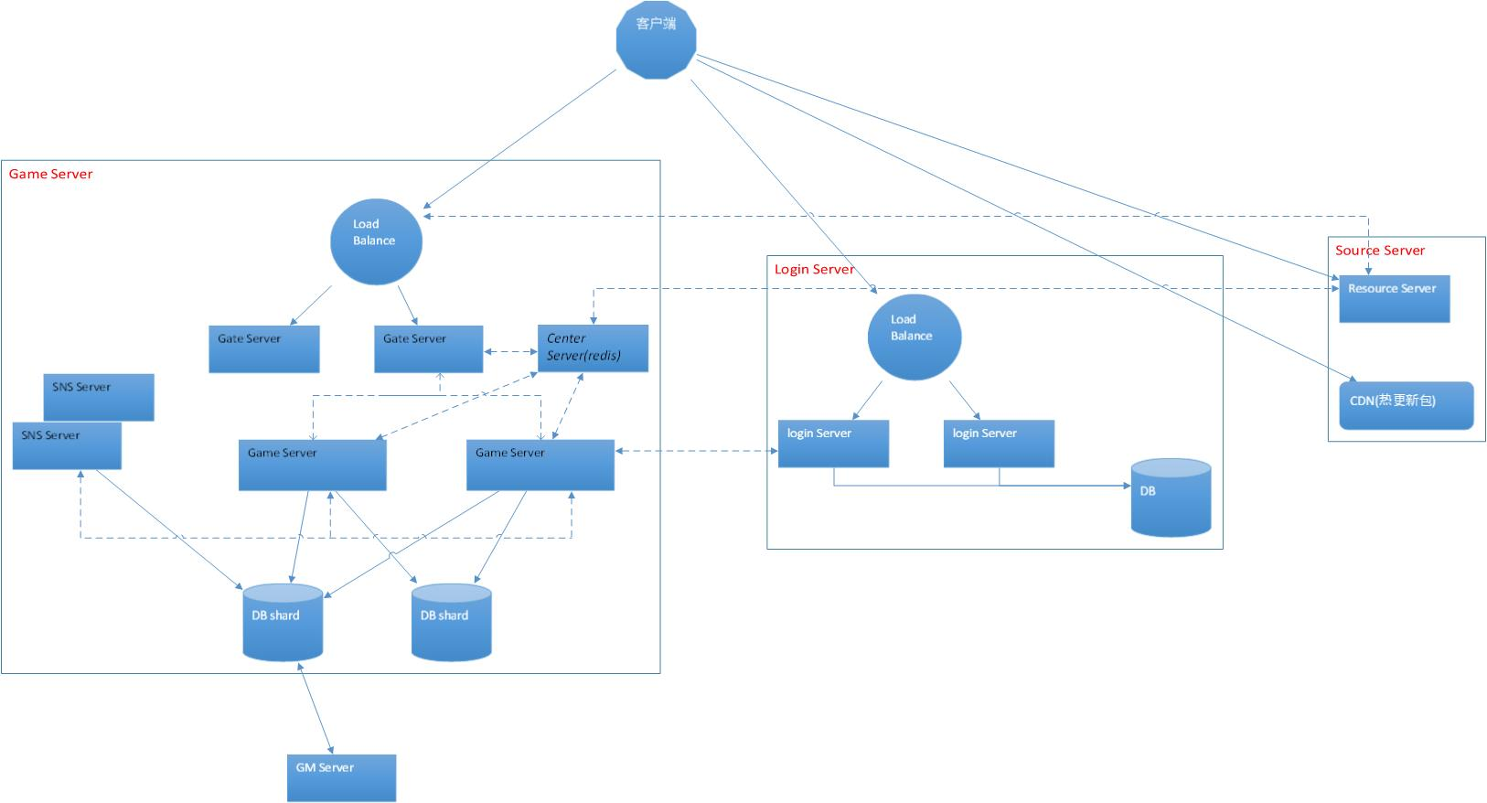

Server resource: phụ trách upload download source, gamer load server list

Server gamesvr: phụ trách xử lý request của client và các vấn đề logical khác, backend connect DB, 1 số request sẽ thông qua server này chuyển đến các server logical khác như server bảng xếp hạng …, định kì viết cache của gamer vào kho DB

Server login: phụ trách kiểm chứng token thân phận của user, user mới đăng kí acc

Server snsserver: phụ trách các request sns của thông tin bảng xếp hạng 。

Gate Server(Portal Server) : Server hứng request từ Server LoadBalance đẩy request của client tới GameServer.

## Network diagram

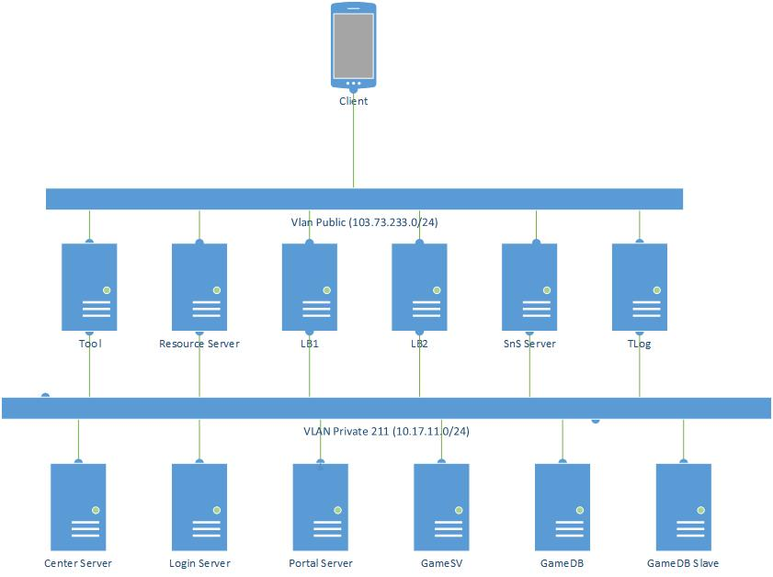

## Login flow and process

### *a. Login Flow:*

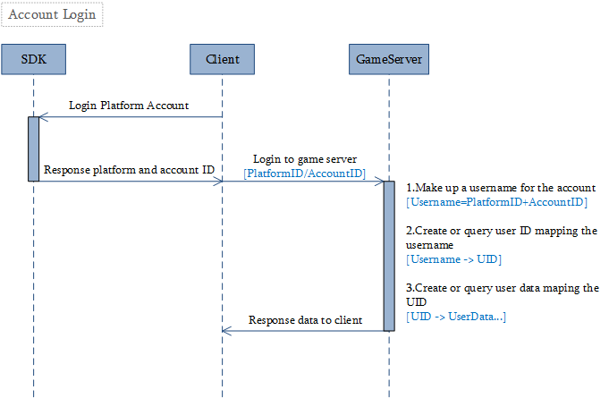

### *b. Game Login Process*

- Client connects static entry resource server (this ip ,port , version and channel is written in the client package), send the first protocol (/x/3/resource/selentry), which parameters contains current version and channel.

- Resource Server use the version and channel to find the entry_ip and entry_port from the version_channel_data (this data table contains the available entry point of resource server, which like the following)

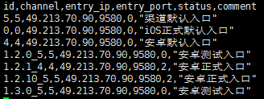

The match rule is get the id (version + “_” + channel, which like “1.3.0_5”) first, if found this line, then will send this resource server entry info back to client, or if can’t found this id, the server will found the default line, which id equals the channel sent by client (the Vietnam version’s channel is 5).

- Now the client get a new resource server’s entry point, then client will send protocol (/x/3/resource/entry) to get the server’s version info.

- Resource handle the (/x/3/resource/entry) protocol, then will response with the login server’s ip and port, the cdn server’s URL, the client’s patch data’s md5 checksum, and so on.

- When the client find it needs to download the new path, it will download the new patch from cdn server if necessary.

- If client patch data is same as server’s md5, it will request the protocol (/x/3/resource/servers), in this protocol, server will response the portal server’s ip and port (or the balance’s ip and port), finally, client will request the SDK to login and use SDK’s token to login gamesvr.

- When login server received the client’s login request (/x/3/account/tplogin), it will authenticate the client’s token from the third platform(VNG SDK checksession), then check the user from DB_login and return the client.

- After all, the client will send the request to portal (/x/3/account/entergame), this request gamesvr will load the client’s user info from DB_game, and return all info to client, then the login process finished.

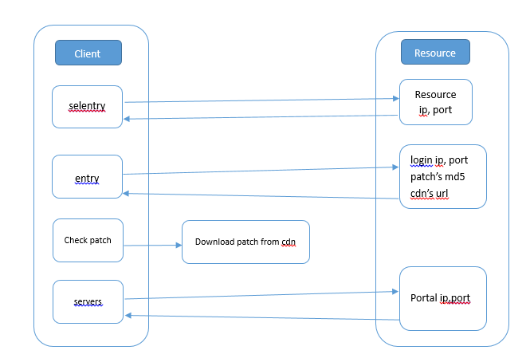

## Payment flow

