《功夫少林服务器部署文档》

Version | Date | Author | Memo
1.0 | 20151218 | Dominic
1.1 | 20151228 | Dominic | Add. Description of Program Logic Function(yellow bg)
1.2 | 20151228 | Dominic | Add.

1 set up Database
Software requirements
System: MySql 5.1 or 5.5

S1. Set up Database
Make sure all the Database character set is UTF-8
Install scripts:
dbscripts.zip
>>gamestart.sh
>>db
>>create_com.sh
>>create_gamedb.sh
>>sql

Gamestart.sh is a start tool, you can use it for start our executive program.
and you can set up db schema and table by create_com.sh and create_gamedb.sh

2 set up Game Center Server
Software requirements
System: CentOS 6.4-6.7 64bit

S1. Set up library
yum -y install debuginfo boost-python boost-regex boost-system boost-thread glibc libgcc libicu libstdc++ libuuid ncurses-libs python python-libs readline gdb* gdb
yum -y install zip unzip tar gcc

S2. Set up dir && open port
~mkdir -p /opt/Applications/Common/
~mkdir -p /opt/Applications/Common/Nginx/
~mkdir -p /opt/Applications/Common/Redis/
~mkdir -p /home/cmge/shaolin/

Ensure the following ports are opened
8080, 8081, 8089

S2.1 set up Redis
Function: WebSite and GameSite use Redis as DB
Files:
redis-3.0.2.tar.gz
Install:
~make && make test
~cp ./src/redis-cli ./src/redis-server ./src/redis-benchmark redis.conf /opt/Applications/Common/Redis/
Modify Config:
~vi redis.conf
daemonize no => yes
bind 127.0.0.1

Run:
~cd /opt/Applications/Common/Redis/
~./redis-server redis.conf
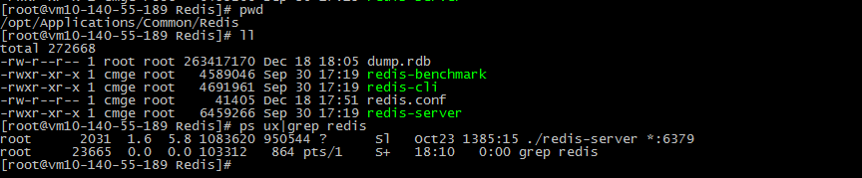

S2.2 set up Reids-py
Function: Debug Redis
Files:
redis-py-master.zip
Install:
~python setup.py install

S2.3 set up Nginx
Function: We use Nginx as Load Balancing
Files:
nginx-1.9.2.tar.gz
Install:
~./configure --prefix=/opt/Applications/Common/Nginx --sbin-path=/opt/Applications/Common/Nginx --conf-path=/opt/Applications/Common/Nginx/nginx.conf --pid-path=/opt/Applications/Common/Nginx/nginx.pid

~make && make install
Modify Config:
Replace /opt/Applications/Nginx/nginx.conf using nginx.conf in sourcefile

Run:
~/opt/Applications/Common/Nginx/nginx -c /opt/Applications/Common/Nginx/nginx.conf
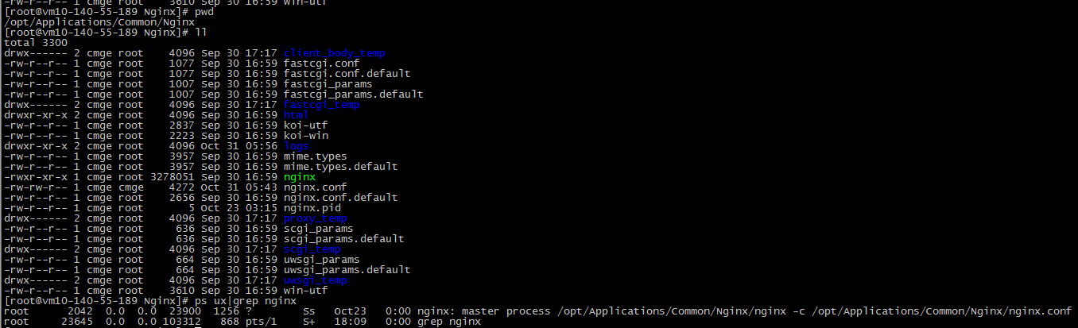

S2.4 set up WebSite
Function: as http server ,collection ,analyze and show player data ,
File:
Website.zip
Install:
Decompress the Website.zip to /opt/Applications/Common/WebSite/
Run:
~cd /opt/Applications/Common/WebSite/
~./startup.sh

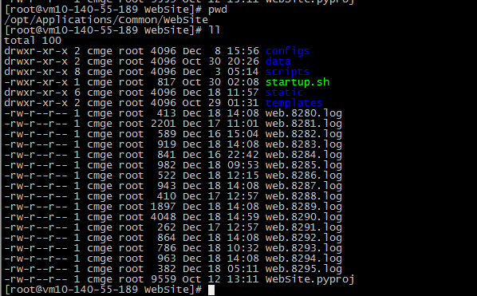

S2.5 set up GameSite
Function: as internal account sign
File:
GameSite.zip
Install:
Decompress the GameSite.zip to /opt/Applications/Common/GameSite/
Run:
~cd /opt/Applications/Common/GameSite/
~./startup.sh

S2.6 set up PayServer & GMServer
Function: PayServerd is a payment server, GMServerd provides all interface of game manager tool
File:
centerServer.zip
Install:
Decompress zip file to /home/cmge/shaolin/
Run:
~nohup ./PayServerd > nohup.out_ps 2>&1 &
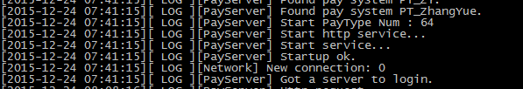
~nohup ./GMServerd > nohup.out_gm 2>&1 &
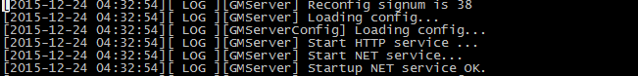

3 set up Game Logic Server
Software requirements
System: CentOS 6.4-6.7 64bit

S1. Set up library
yum -y install debuginfo boost-python boost-regex boost-system boost-thread glibc libgcc libicu libstdc++ libuuid ncurses-libs python python-libs readline gdb* gdb
yum -y install zip unzip tar gcc

S2. Set up dir && open port
~mkdir -p /home/cmge/shaolin/

Ensure the following ports are opened
8899, 18899

S2.1 set up logic server
Function: there are four execute program
AuthServerd for account verification
BattleManagerd is used to manage the battle server
BattleServerd is used to calculate and synchronous player’s battle data

GameServerd is a logic server, it deals with other logical protocols, except for battle

File:
logicServer.zip
Install:
Decompress zip file to /home/cmge/shaolin/
Run:

~nohup ./AuthServerd> nohup.out_ps 2>&1 &
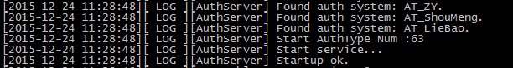
~nohup ./BattleManagerd> nohup.out_gm 2>&1 &
~nohup ./BattleServerd> nohup.out_gm 2>&1 &
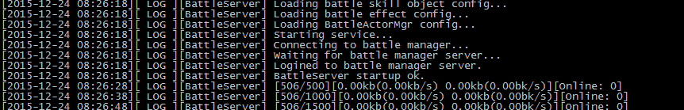
Ensure the success of these starts and then start up logic server

~nohup ./GameServerd> nohup.out_gm 2>&1 &
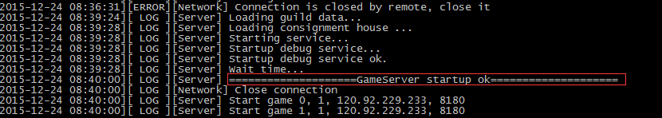

4 ServerList
File:
serverlist.txt
Just put serverlist.txt into /opt/Applications/Common/WebSite/static/

5 Config
File:
All program configurations are packaged with execute program together. And then
You need to adjust these configurations. And make sure all databases and tables have been created successfully before you adjust.

E.g.
One Redis and Three MySql databases are usually required.
- for game Center [comm, gmdb, pay, web]
B.for game logic [GameSL_data_xx]
C.for game log [GameSl_log_xx]
D.redis for game Center
And B. C appear in pairs

Now, you need to adjust these configurations:
1. Modify GameServerd’s configuration gs.config

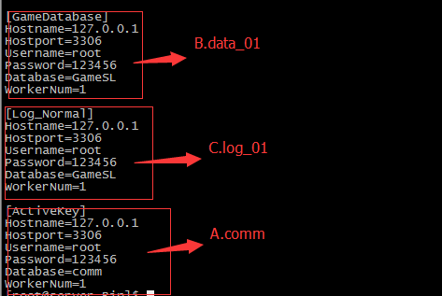

2. Modify WebSite’s configuration
/opt/Applications/Common/WebSite/configs/main.json
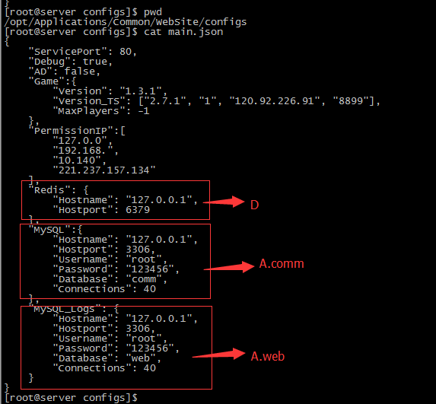

3.Modify Pay Server’s configuration ps.json
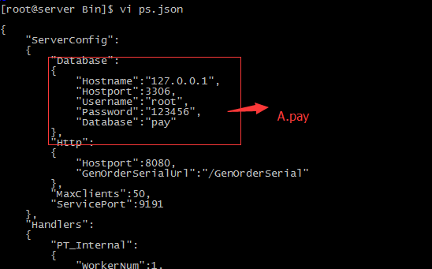

4. Modify GMServerd’s configuration ps.json
