

**ONLINE TECH SHOPPING**

**Software Requirement Specification**

**Group 3**

– Can Tho, January 2023 –

**Table of Contents**

**I. Overview 2**

**1. Introduction 2**

**2. System Functions 2**

a. Screen Flow 2

b. Screen Details 3

c. User Authorization 10

d. Non-Screen Functions 12

**3. Common Requirements 13**

**II. Functional Requirements 13**

1. Public Feature 13

a. Home page 13

b. Blog list 13

c. Blog detail 14

d. Products List 15

e. Products Details 16

f. Feedback 17

2. Customer Feature 18

a. My Order 18

b. Order Information 19

3. Common Feature 23

a.User login 23

b. User register 25

c. Change Password 26

d. Forgot Password 26

e. User Profile 27

4. Marketing Feature 28

a.Dashboard 28

b.Slider List 28

c. Product List 29

d. Post List 30

e. Feedback List 31

# **I. Overview**

## **1. Introduction**

*The commercial shop system is the new system to manage and keep tracking of all trading actions online. The system is expected to allow customers to view, search or filter, buying what products they need in the most convenient way, the sale can list, keep tracking of all orders and products that they sell, admin can view, add or edit the statistic of setting, customer, marketing role can view, search, edit products, sliders, posts and keep track of information all customers buying their own goods.*

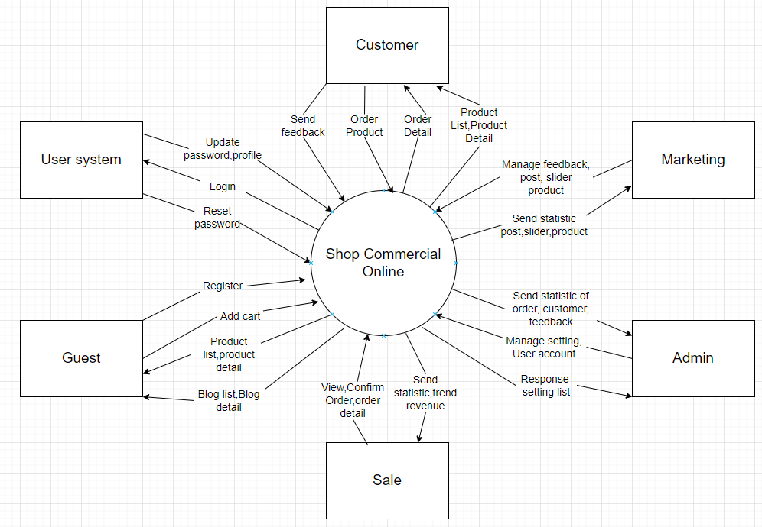

## **2. System Functions**

#### ***a. Screen Flow***

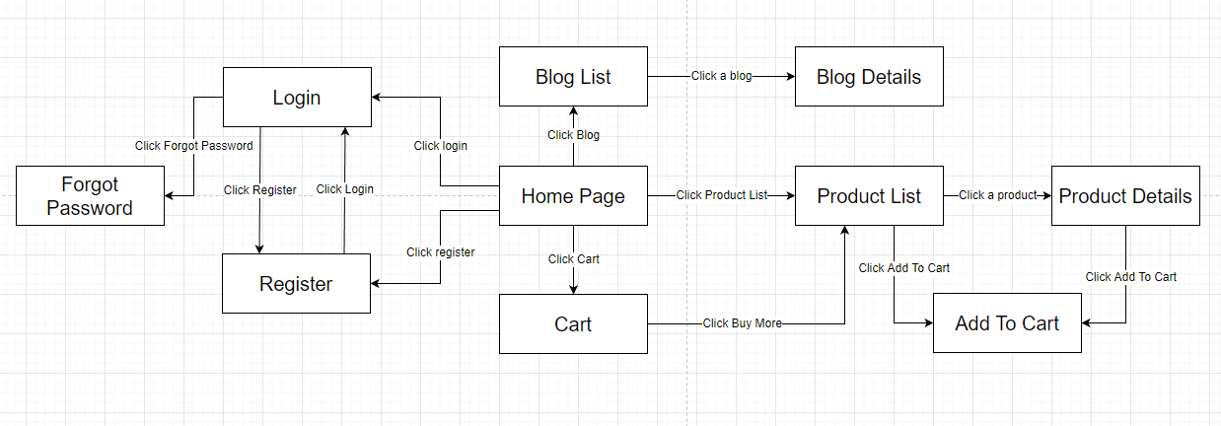Figure 2-1: Screen Flow for Guest

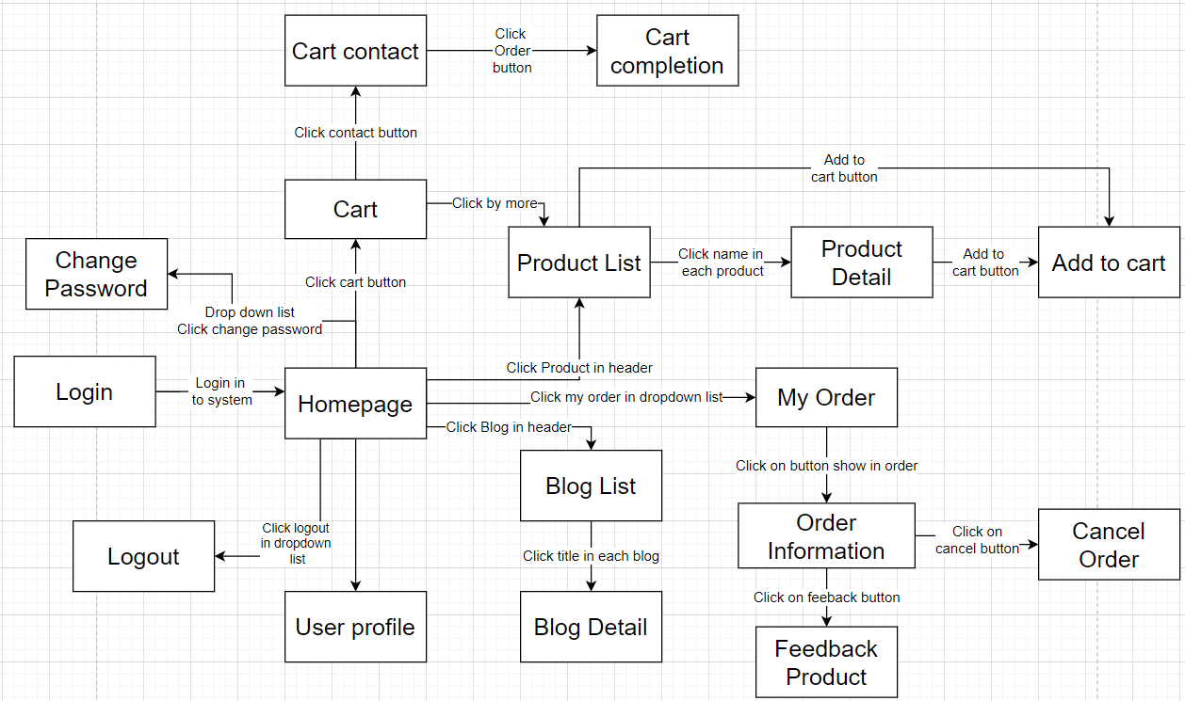Figure 2-2: Screen Flow for Customer

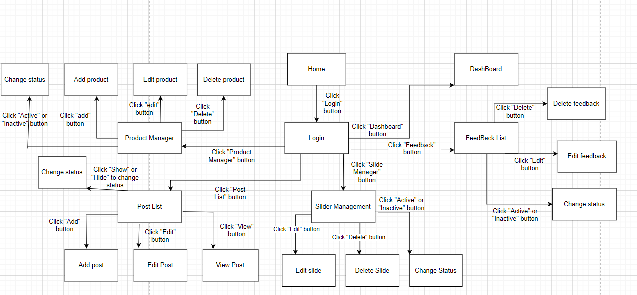

Figure 2-2: Screen Flow for Marketing

#### ***b. Screen Details***

|  |  |  |  |
| --- | --- | --- | --- |
| **#** | **Feature** | **Screen** | **Description** |
| 1 | Public Feature | Home Page | Show sliders, hot posts, featured products + the sider with the latest posts, static contacts/links  - Shown slider information includes its image and title; the user is redirected to the slider's backlink on his/her clicking  - Shown post information includes its thumbnail, title, brief-info; the user is redirected to the post's details on his/her clicking  - Shown product information includes its thumbnail, title, brief information; the user is redirected to the product's details on his/her clicking |
| Blogs List | Show the posts paginatedly (sorted by updated date, paginated) + the slider with the post search box, post categories, the latest posts, and static contacts/links; Shown post information includes its thumbnail, title, brief-info; the user is redirected to the post's details on his/her clicking |
| Blogs Details | Show post details (including title, author, updated date, category, and post details) + the side with the post search box, post categories, static contacts/links |
| Products List | Show the products paginatedly (sorted by updated date) + the sider with the product search box, product categories, the latest products, and static contacts/links;  - Shown product information includes its thumbnail, title, brief information, original price, and sale price;  - The user is redirected to the product's details on his/her clicking on the product  - The user can choose to add the product to the cart or to feedback on the product by clicking the product's Buy & Feedback buttons responsively |
| Product Details | Show product details (including title, category, images, original price, sale price, and product details) + the sider with the product search box, product categories, the latest products, and static contacts/links |
| Cart Details | Show the cart details with list of the user's chosen products (including Id, title, price, quantity, total cost) and the total order price + the sider with the product search box, product categories, the latest products, and static contacts/links; The user can  - Change the quantity of each product: the total cost is automatically adjusted  - Choose to delete/remove product by clicking on the deleting icon  - Click the Choose More Product button to go to Products List page  - Click the Check Out button to go to the Cart Contact page  Please notes: the user's chosen products from the last browsing session are remained in his/her cart until s/he submit the cart. However, the product prices are updated with the latest prices in the system |
| Cart Contact | Display orders and status of orders so far. Allows users to edit, change, delete orders while the order is still in the processing state. |
| Cart Completion | This page show the cart completion notes + the sider with the product search box, product categories, the latest products, and static contacts/links; Before this page is shown:  - The Order status is changed to submitted;  - The product's available quantities are updated accordingly  - The submitted order is assigned automatically to the active salers rotatedly  - If the receiver information (name, email, mobile, gender) is new or changed (checking via the email0, the latest receiver information is stored in the system as latest & historical system contact information (for the marketing's reference later)  - The customer/user would be received the order confirmation & payment guides via his/her email. Those information is shown on the page also. The payment information (banking account,...) are taken from the system configuration file |
| Feedbacks | On receiving the bought products successfully, the receiver would receive a confirmation email with the guides to feedback on each of the received product; Beside, the user/receive could also give the feedback (on a specific product or general feedback) via the website; The user also call this screen from the system menu on the header;  The feedback information includes contact information (full name, gender, email, mobile), rated star, the attached images and the contact's free-format feedback  The page sider is also shown with the product search box, product categories, static contacts/links; |
| 2 | Common | User Login | 'This is a pop-up screen which allows the user to enter phone number & password to login; on this page, there are also options for user to register new information or reset the password for the case she forget it |
| User Register: | 'This is a pop-up screen which allows the user to register himself/herself to the system by inputing following information: full name, gender, email, mobile, and address; User then need to verify by clicking the link sent via email to him/her before being able to access the system |
| Reset Password: | 'The user to input his/her email to receive the reset password link. This link is sent to the user's email for his/her password resetting.  - On clicking the link, the user is redirected to the password resetting page in which s/he input new password (twice) for the system access  - Note that the link is only available for a specific time duration as configured in the system config file. |
| Change Password: | 'This is a pop-up screen which allows the user to change his/her password by inputting his current password as well as new password (twice) |
| User Profile: | 'This is a pop-up screen which allows the user to edit his/her profile information, including the registered ones & the avatar image. Please note that s/he is not allowed to change the email |
| 3 | Customer Feature | My Orders | 'Show the list of user's orders paginatedly + the sider with the product search box, product categories, the latest products, and static contacts/links  - Each order include below information: id, ordered date, product (first product name & number of other products if any), total cost, status;  - On clicking the link under the order id, user would be redirected to the Order Information page |
| Order Information | 'Show the order details, including the information as below + the sider with the product search box, product categories, the latest products, and static contacts/links  - The order id, order date, total cost, status  - The receiver information: full name, gendar, email, mobile  - This list of ordered products, each product include following information & the links/buttons that allow the user to re-buy or feedback: thumbnail, name, category, unit price, quantity, total cost  For the submitted orders, the user can choose to update (redirect the user to the Cart Details page for that) or cancel the order |
| 4 | Marketing Feature | MKT Dashboard | 'Show statistics of posts, products, customers, feedbacks & the trend of new customers by day for the last 7 days (the start date & end date can be adjustable) |
| Posts List | 'Show the paginated list of posts (include posts' id, thumbnail, title, category, author, featured, and status information):  - The user can filter the post by category, author, status or search by title  - Sortable by title, category, author, featured, or status  - From each post, the user can choose to hide, show, view, edit it  - The page also have the button/link that allows the user to add new post |
| Post Details | 'Show detailed post information (thumbnail, category, title, brief information, description, flag to turn the featurning on/off, status), from that allow the user to input, view or edit them |
| Sliders List | 'Show the paginated list of sliders (including sliders' id, title, image, backlink, status)  - The user can filter the sliders by the status + search by title or backlink  - For each slider, the user can choose to hide, show, edit it |
| Slider Details | 'Show detailed slider information (image, title, backlink, status, notes) |
| Products List | 'Show the paginated list of products (include products' id, thumbnail, title, category, list price, sale price, featured, and status information):  - The user can filter the product by category, status or search by title, brief info  - Sortable by title, category, list price, sale price, featured, or status  - From each product, the user can choose to hide, show, view, edit it  - The page also have the button/link that allows the user to add new product |
| Product Details | 'Show detailed product information (thumbnail, category, title, brief information, attached images, description, quantity, list price, sale price, flag to turn the featurning on/off, status), from that allow the user to input, view or edit them |
| Customers List | 'Show the list of customers / contacts paginatedly (include contacts' id, full name, gender, email, mobile, status):  - The user can filter the customers by status + search by full name, email, mobile  - Sortable by full name, email, mobile, status  - From each customer, the user can choose to add new, view or edit it |
| Customer Details | 'Show detailed customer/contact information (full name, gender, email, mobile, address, status), from that allow the user to input, view or edit them (excep for the status which is generated automatically - contact, potential or customer)  Besides, the screen also shows the list of customer/contact changes history in the form of a table which includes following columns: email, full-name, gender, mobile, address, updated by, updated date |
| Feedbacks List | 'Show the list of feedbacks paginatedly (include feedbacks' contact full name, product name, rated star, status):  - The user can filter the feedbacks by status, product, rated star + search by full name, feedback content  - Sortable by full name, product name, rated star, status  - From each feedback, the user can choose to view or change it's status |
| Feedback Detail | 'Show the feedback details (contact full name, email, mobile, product, rated star, feedback, images status) from that allow the user to change its status |
| 5 | Sales Feature | Sales Dashboard | 'Show the trend of success/total orders, and the revenues trends by day for the last 7 days for all or a specific sale person (the start date, end date, sale, order status can be adjustable) |
| Orders List | 'Show the list of orders paginatedly  - The list can be shorted by the order date, customer name, total cost, status  - Each order include below information: id, ordered date, customer name, product (first product name & number of other products if any), total cost, status;  - Allow the users to filter the order by the order date (from, to), sale name, status  - Allow the user to search the orders by order id, customer name  - On clicking the link under the order id, user would be redirected to the Order Details page |
| Order Details | 'Show the order details, including the following information:  - Basic order information: order id, customer full name, email, mobile, order date, total cost, sale name, status  - The receiver information: full name, gendar, email, mobile, address  - This list of ordered products, each product include following information: thumbnail, name, category, unit price, quantity, total cost  Sale Manager & the assigned Sale can change the order status & the sale notes  Sale Manager can assign the order to other sale |
| 6 | Admin Feature | Admin Dashboard | 'Show statistics of new orders (success, cancelled, submitted), revenues (total, by product categories), customers (newly registered, newly bought), feedbacks (average star: total, by product categories) & the trend of order counts (success, all) by day for the last 7 days (the start date & end date can be adjustable) |
| Users List | 'Show the paginated list of registered users (include users' id, full name, gender, email, mobile, role, status):  - The admin can filter the users by gender, role, status  - Allow the admin to seach users by full name, email, mobile  - The list is sortable by id, fullname, gender, email, mobile, role, status  - From each user, the admin can choose to view or edit it  - The page also have the button/link that allows the admin to add new user |
| User Details | 'Show detailed user information (avatar, full name, gender, email, mobile, role, address, status), from that allow the user to add new, view or edit user information  - After adding, new generated login password would be email to the new user  - The admin can only edit/update the role and status of the user |
| Settings List | 'Show the paginated list of settings (include settings' id, type, value, order, status):  - The admin can filter the setting by type, status  - Allow the admin to seach settings by value  - The list is sortable by id, type, value, order, status  - From each setting, the admin can choose to view, activate/deactivate, or edit it  - The page also have the button/link that allows the admin to add new setting |
| Settings Details | 'Show detailed user information (type, value, order, description, status), from that allow the user to add new, view or edit setting information |

#### ***c. User Authorization***

|  |  |  |  |  |  |
| --- | --- | --- | --- | --- | --- |
| **Screen** | **Guest** | **Customer** | **MKT** | **Sale** | **Admin** |
| Home Page | V | V | V | V | V |
| Blogs List | V | V | V | V | V |
| Blogs Details | V | V | V | V | V |
| Products List | V | V | V | V | V |
| Product Details | V | V | V | V | V |
| Cart Details | V | V | V | V | V |
| Cart Contact |  | V | V | V | V |
| Cart Completion |  | V | V | V | V |
| Feedbacks |  | V | V | V | V |
| User Login | V | V | V | V | V |
| User Register: | V | V |  |  |  |
| Reset Password: | V | V | V | V | V |
| Change Password: |  | V | V | V | V |
| User Profile: |  | V | V | V | V |
| My Orders |  | V | V | V | V |
| Order Information |  | V | V | V | V |
| MKT Dashboard |  |  | V |  |  |
| Posts List |  |  | V |  |  |
| Post Details |  |  | V |  |  |
| Sliders List |  |  | V |  |  |
| Slider Details |  |  | V |  |  |
| Products List |  |  | V |  |  |
| Product Details |  |  | V |  |  |
| Customers List |  |  | V |  |  |
| Customer Details |  |  | V |  |  |
| Feedbacks List |  |  | V |  |  |
| Feedback Detail |  |  | V |  |  |
| Sales Dashboard |  |  |  | V |  |
| Orders List |  |  |  | V |  |
| Order Details |  |  |  | V |  |
| Admin Dashboard |  |  |  |  | V |
| Users List |  |  |  |  | V |
| User Details |  |  |  |  | V |
| Settings List |  |  |  |  | V |
| Settings Details |  |  |  |  | V |

In which:

* Guest: are customers who have not registered an account or have not logged in. They only have access to the shop to view and search for products, but do not have the right to order, feedback and many other rights.
* Customer: are users who, after being logged in, can use all functions such as order, feedback, ...
* Marketing: These are the park staff responsible for making slides or creating feedback highlighting products on the website.
* Sale: They are sales people, each user here acts as a small shop. They can add or edit their own products.
* Admin: They are the site managers. They will have the right to change and edit the overview of the website and manage the users who are using the application.

#### ***d. Non-Screen Functions***

|  |  |  |  |
| --- | --- | --- | --- |
| **#** | **Feature** | **System Function** | **Description** |
| 1 | Usability | Design simple | Design based on UI UX, easy to use and view information. |
| 2 | Authorization | System authorization every roles in system | Implementation of authorization mechanism in the system, including the specify the role of logged-in user, his/her authorized page links (building the displayed menu items (in the front end) and preventing unauthorized access via enter the links directly) |
| 3 | Efficiency | Minimize users' actions on the screen so that they complete a task on the system as quickly as possible. | Helps minimize users' actions on the screen so that they complete a task on the system as quickly as possible.  For example, from 5 touches, down to 3 touches, you can order 1 product |

## **3. Common Requirements**

The common functions/screens used for all types of users, as listed below

- User Login: authenticate the user to give him/her to access authorized features later on

- Register: You will register with your account then it will be verified by gmail

- Forgot Password: In case you forget your password, you can forget it with your gmail account

- Profile: edit information such as email, password, add or delete a delivery address

# **II. Functional Requirements**

## **1. Public Feature**

### **a. Home page**

* **Function: Home page.**
* **Function Description:**

Show sliders, hot posts, new features + the sider with the latest posts, static contacts/links.

* **Screen Layout:**

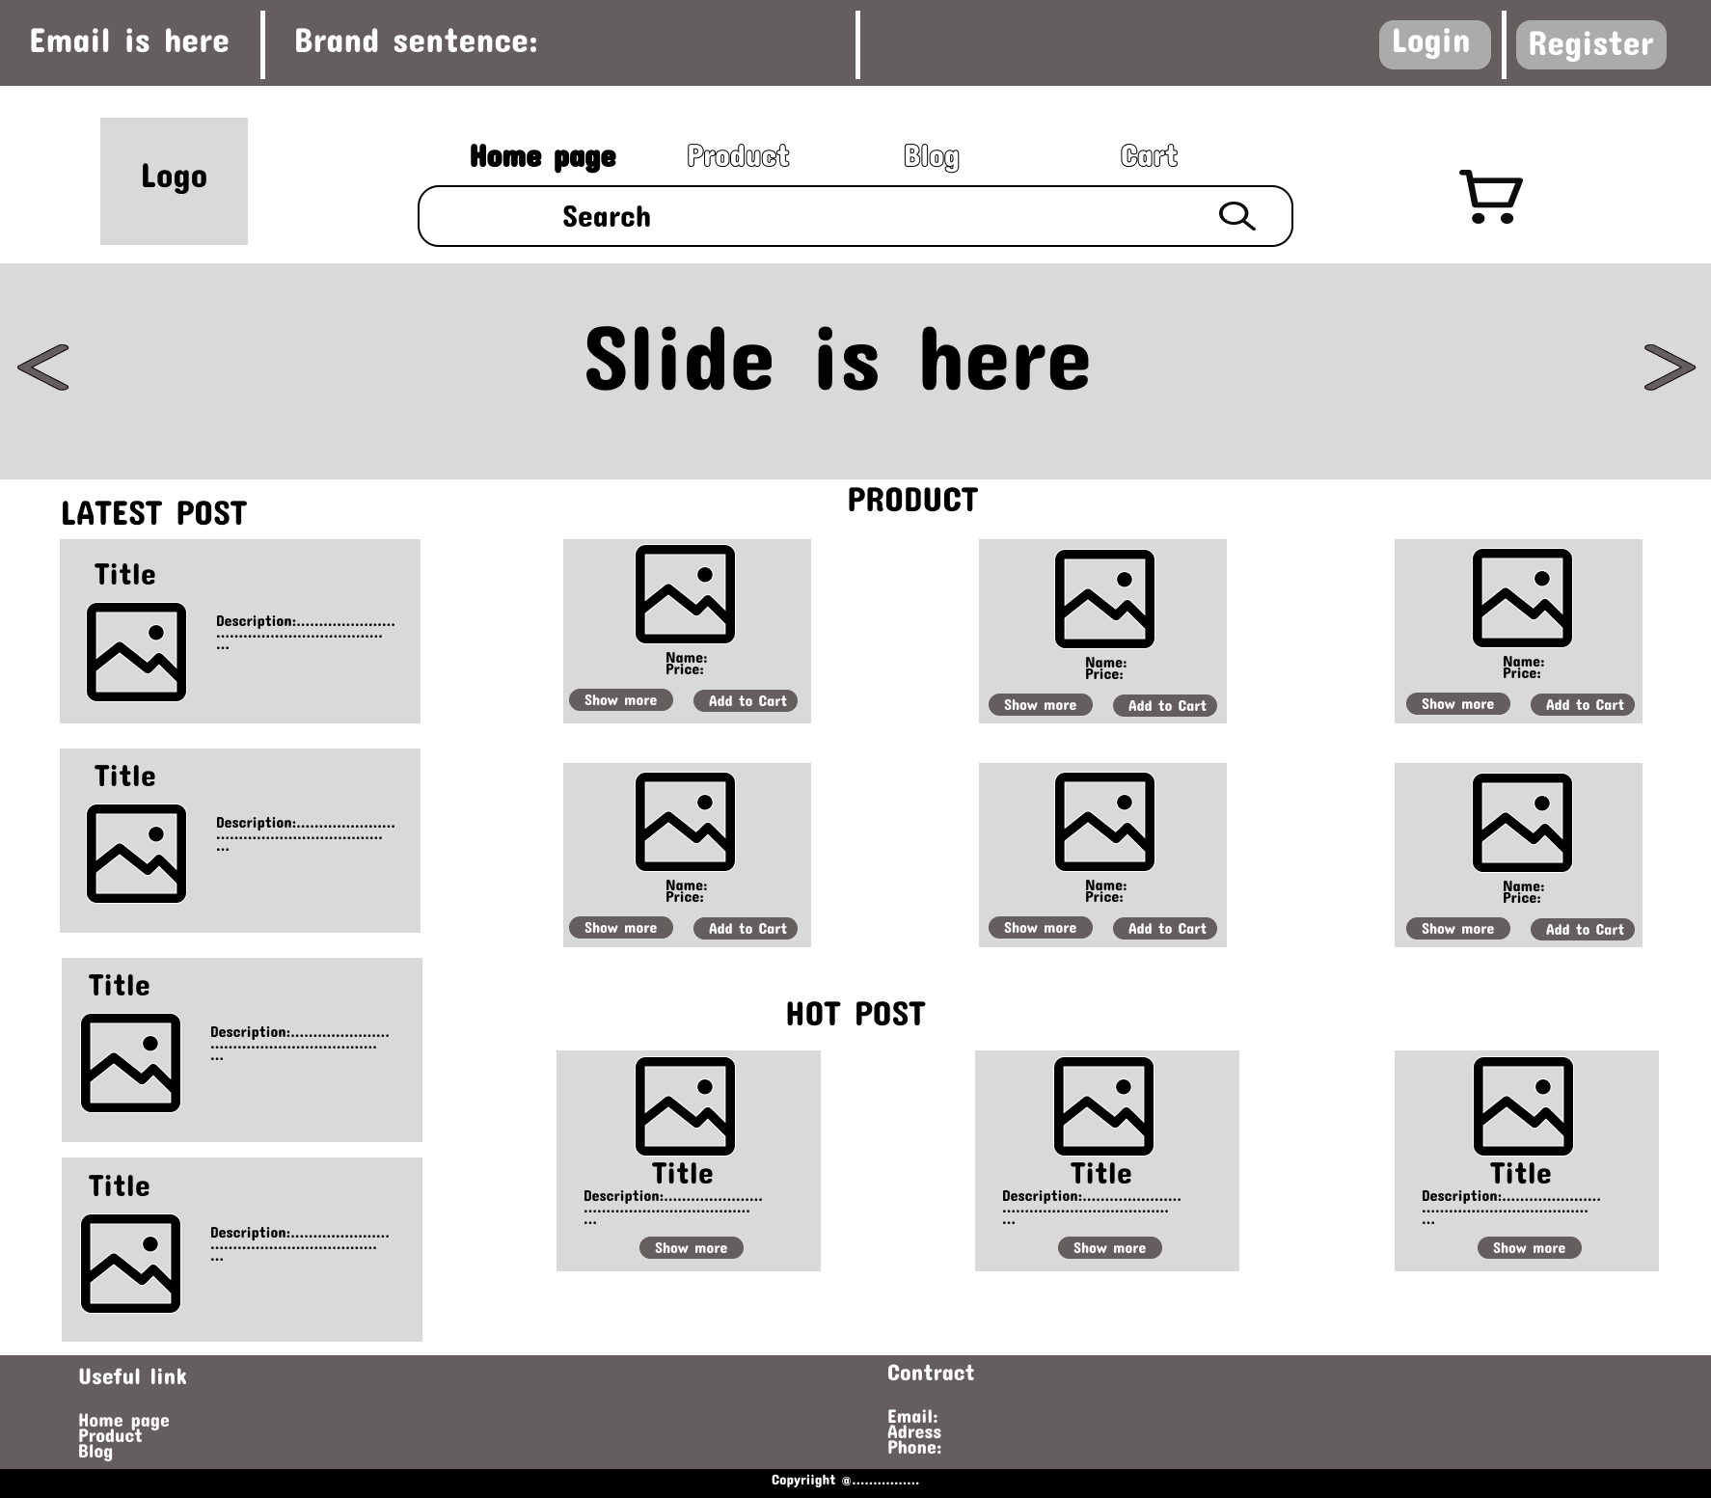

* **Function details on the screen :** To redirect to home page we click on Home in header, in home page we have a slide in top, Below of slide is list of category. And below the category is Hot Product, Feature Product and All Product. All of them is show the product, thumbnail, name, price.

### **b.** [**Blog list**](https://docs.google.com/document/d/1kCRVpEawTf359X6wvjCen9UjhcyBTsEFwCF6lDQPKzo/edit?fbclid=IwAR0UQ9VfgnyQEUQNyCgW-xAGqmgMIjF3jd83a7OHuq4zuUcrwWVzaSRy0JU#heading=h.ufcbvtigrx79)

* **Function:** List all existing blogs
* **Function Description:** Shown post information includes its thumbnail, title, brief-info; the user is redirected to the post's details on his/her clicking.
* **Screen Layout:**

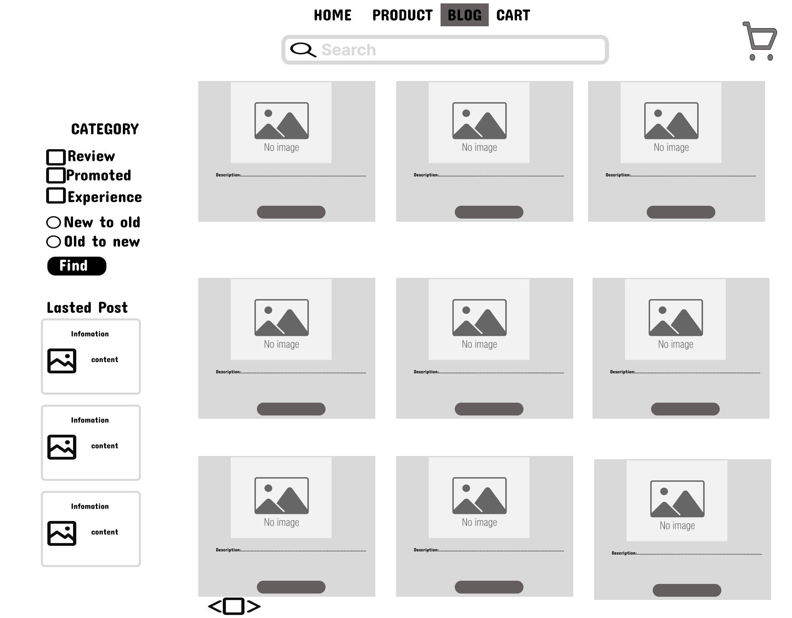

* **Function details on the screen:** This page shows the title, author’s post, date, summary content,.... If we click in title of the page will redirect to blog detail

### **[c. Blog detail](https://docs.google.com/document/d/1kCRVpEawTf359X6wvjCen9UjhcyBTsEFwCF6lDQPKzo/edit?fbclid=IwAR0UQ9VfgnyQEUQNyCgW-xAGqmgMIjF3jd83a7OHuq4zuUcrwWVzaSRy0JU#heading=h.3pr6wlich15c)**

* **Function: Show all information of blog**
* **Function Description:**

Show post details (including title, author, updated date, category, and post details) + the sider with the post search box, post categories.

* **Screen Layout:**

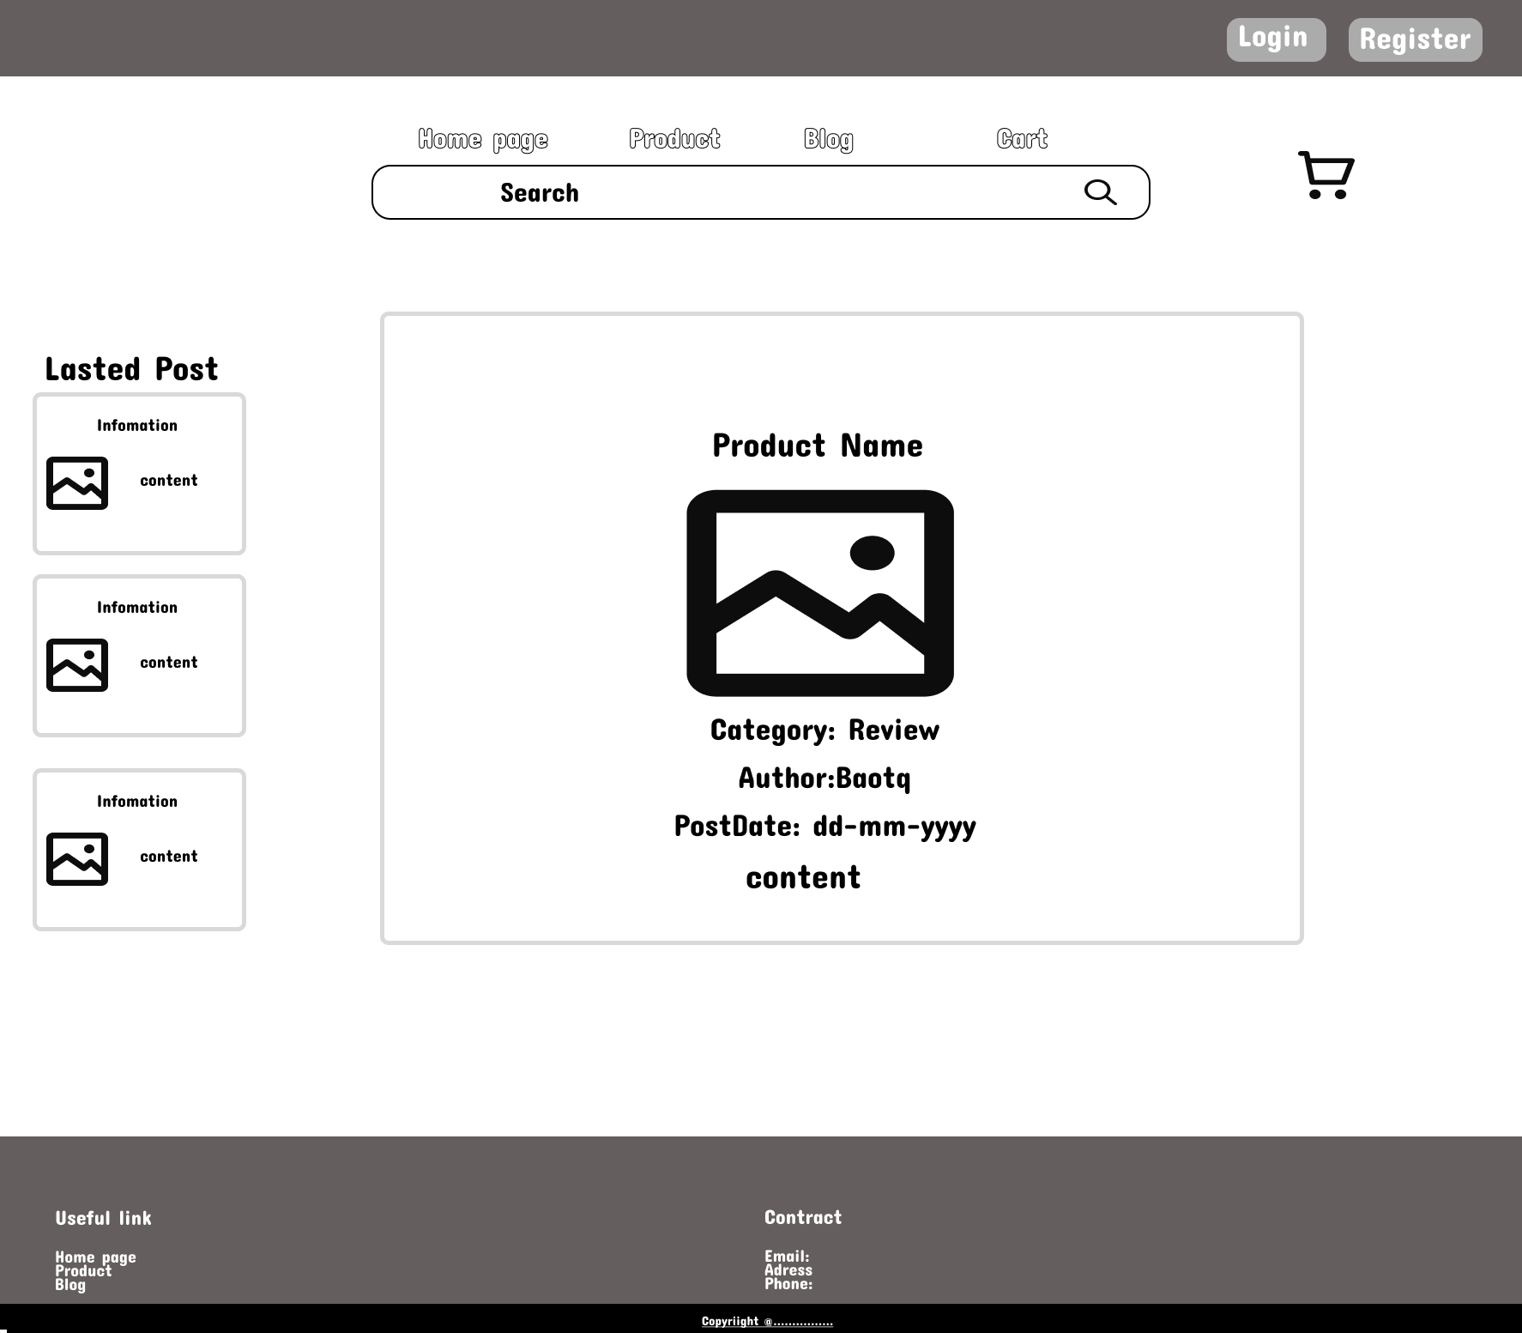

* **Function details on the screen:** This page shows the descriptions of blogs when users are redirected when they clicked on a title of a blog list. It includes the title, whole content of the author's post, date and some images. When users want to back to the blog list, they will click on “Blog” in header, the page will redirect to blogs list.

### **[d. Products List](https://docs.google.com/document/d/1kCRVpEawTf359X6wvjCen9UjhcyBTsEFwCF6lDQPKzo/edit?fbclid=IwAR0UQ9VfgnyQEUQNyCgW-xAGqmgMIjF3jd83a7OHuq4zuUcrwWVzaSRy0JU" \l "heading=h.jve45lyxvlfi)**

* **Function: Show all product**
* **Function Description:**

Show all product by category

* **Screen Layout:**
* 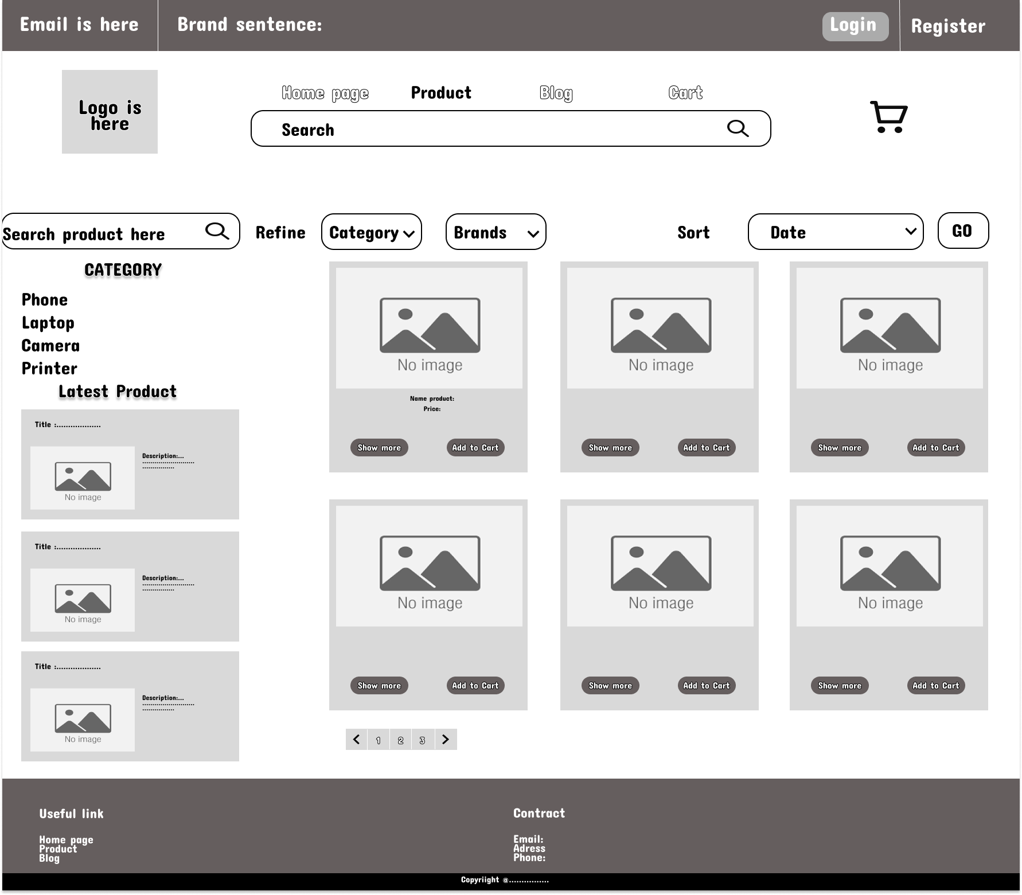
* **Function details on the screen:**This page shows a list of products when users click on a “Product” in the header. Users can filter their products they want to buy based on ”Price”,”Brand”, and can sort the list through the “Sorting” button. The list below shows title, attributes and price of products paginated(before/after sort).

### **[e.](https://docs.google.com/document/d/1kCRVpEawTf359X6wvjCen9UjhcyBTsEFwCF6lDQPKzo/edit?fbclid=IwAR0UQ9VfgnyQEUQNyCgW-xAGqmgMIjF3jd83a7OHuq4zuUcrwWVzaSRy0JU" \l "heading=h.49eoeo311hmx)** [**Products**](https://docs.google.com/document/d/1kCRVpEawTf359X6wvjCen9UjhcyBTsEFwCF6lDQPKzo/edit?fbclid=IwAR0UQ9VfgnyQEUQNyCgW-xAGqmgMIjF3jd83a7OHuq4zuUcrwWVzaSRy0JU#heading=h.jve45lyxvlfi) [**Details**](https://docs.google.com/document/d/1kCRVpEawTf359X6wvjCen9UjhcyBTsEFwCF6lDQPKzo/edit?fbclid=IwAR0UQ9VfgnyQEUQNyCgW-xAGqmgMIjF3jd83a7OHuq4zuUcrwWVzaSRy0JU#heading=h.49eoeo311hmx)

* **Function: Show all information of product**
* **Function Description:**

Show the products paginatedly (sorted by updated date) + the sider with the product search box, product categories, the latest products.

* **Screen Layout:**

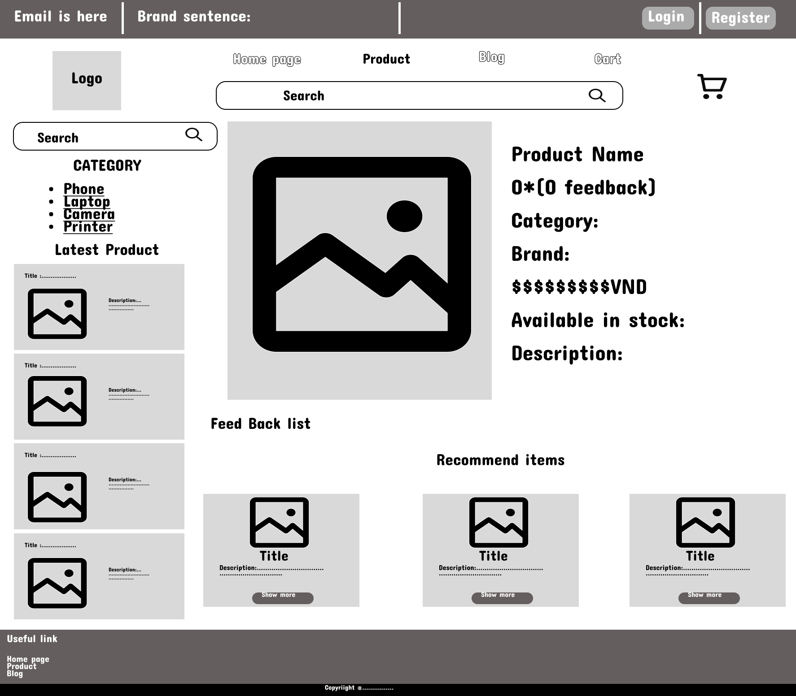

* **Function details on the screen:** This page shows the descriptions of products when users click on a product of a products list. It includes the product’s name, some images of the product, sizing chart for men or women when choosing size,quantity of product that users want to buy, add to cart button when users decide to buy these products,detailed description of these products and recommend similar products. When users want to back to the products list, they will click on “Product” in header, the page will redirect to Products list

### **f**[**.**](https://docs.google.com/document/d/1kCRVpEawTf359X6wvjCen9UjhcyBTsEFwCF6lDQPKzo/edit?fbclid=IwAR0UQ9VfgnyQEUQNyCgW-xAGqmgMIjF3jd83a7OHuq4zuUcrwWVzaSRy0JU#heading=h.ijb8z2nqazl0) **Feedback**

* **Function: User input the feedback for product**
* **Function Description:**

On receiving the bought products successfully, the receiver would receive a confirmation email with the guides to feedback on each of the received product; Beside, the user/receive could also give the feedback (on a specific product or general feedback) via the website; The user also call this screen from the system menu on the header;

* The feedback information includes contact information (full name, gender, email, mobile), rated star, the attached images and the contact's free-format feedback
* The page sider is also shown with the product search box, product categories, static contacts/links;
* **Screen Layout :**

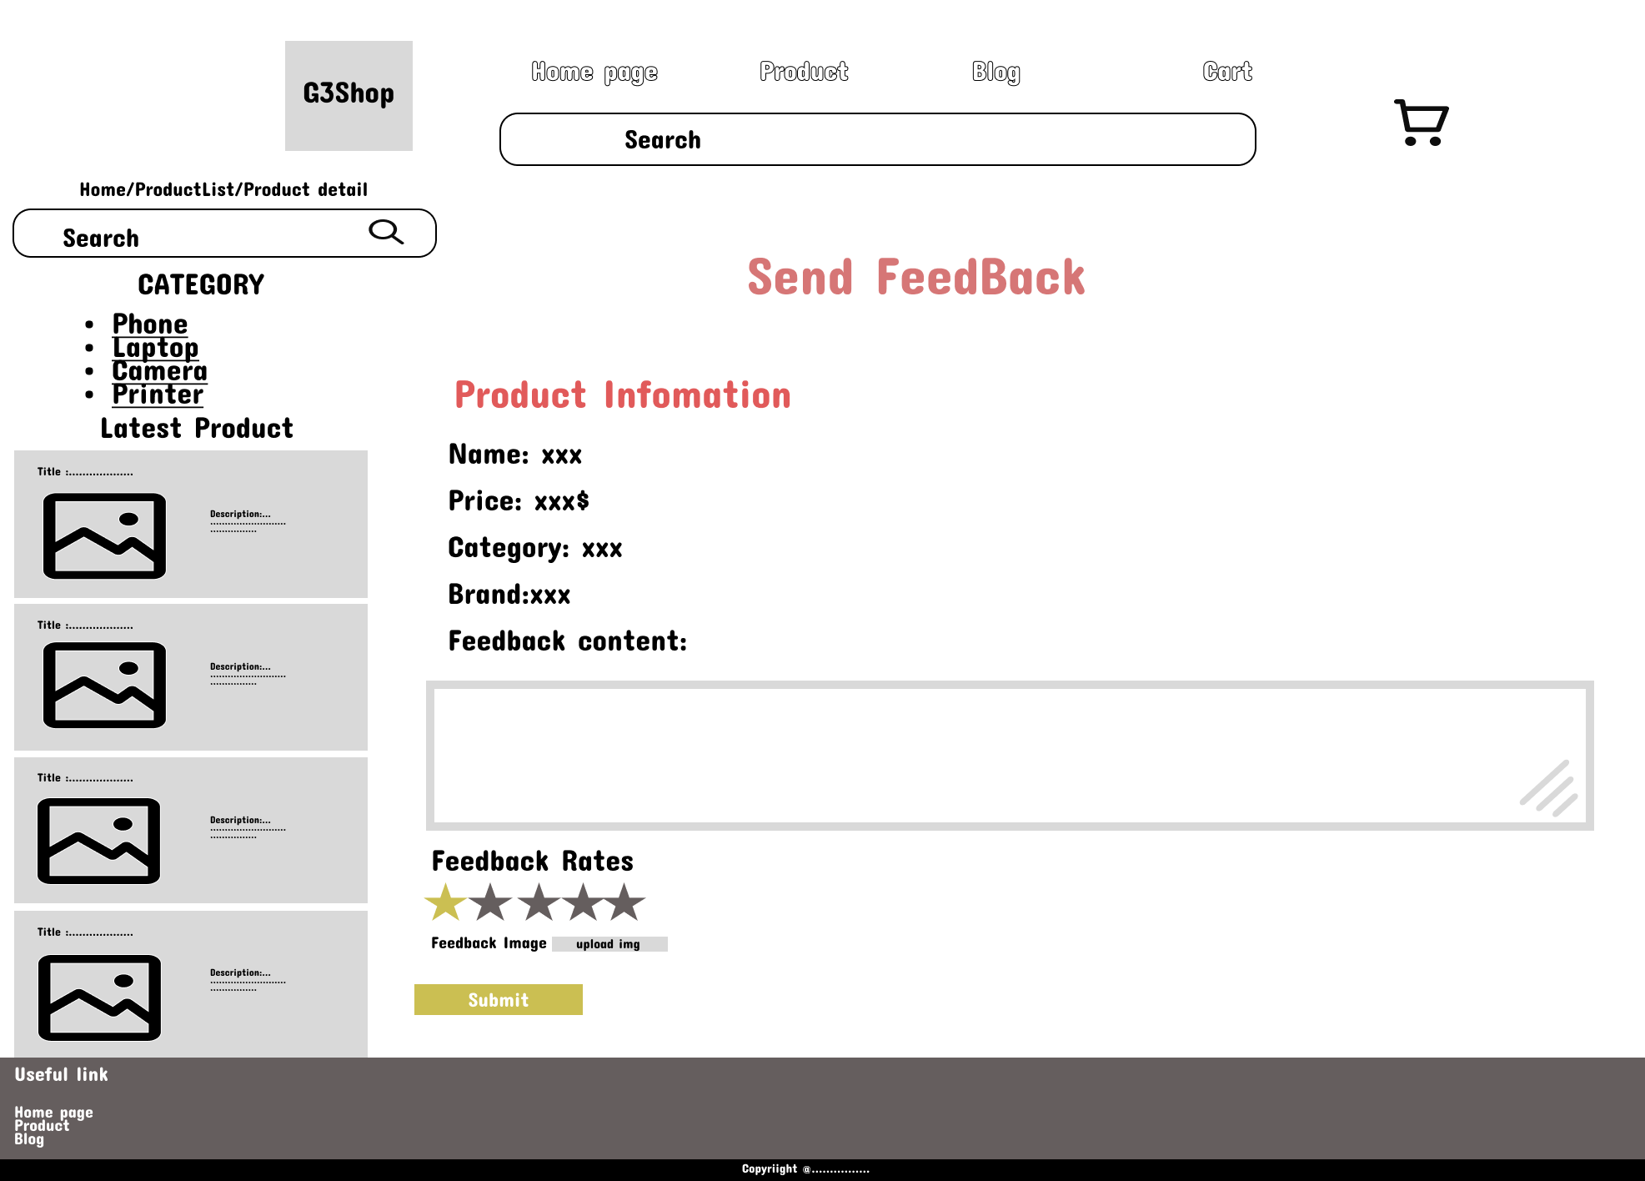

* **Function details on the screen :** This screen user can access when they Received Product then click button feedback in Order Information. User input all fields to send feedback.

## **[2. Customer Feature](https://docs.google.com/document/d/1kCRVpEawTf359X6wvjCen9UjhcyBTsEFwCF6lDQPKzo/edit?fbclid=IwAR0UQ9VfgnyQEUQNyCgW-xAGqmgMIjF3jd83a7OHuq4zuUcrwWVzaSRy0JU#heading=h.htgntpn3ne3x)**

### **a**[**.**](https://docs.google.com/document/d/1kCRVpEawTf359X6wvjCen9UjhcyBTsEFwCF6lDQPKzo/edit?fbclid=IwAR0UQ9VfgnyQEUQNyCgW-xAGqmgMIjF3jd83a7OHuq4zuUcrwWVzaSRy0JU#heading=h.ijb8z2nqazl0) **My Order**

* **Function: Show my order**
* **Function Description:** Show the list of user's orders paginatedly + the slider with the product search box, product categories, the latest products, and static contacts/links

Each order include below information: id, ordered date, product (first product name & number of other products if any), total cost, status;

On clicking the link under the order id, user would be redirected to the Order Information page

* **Screen Layout:**

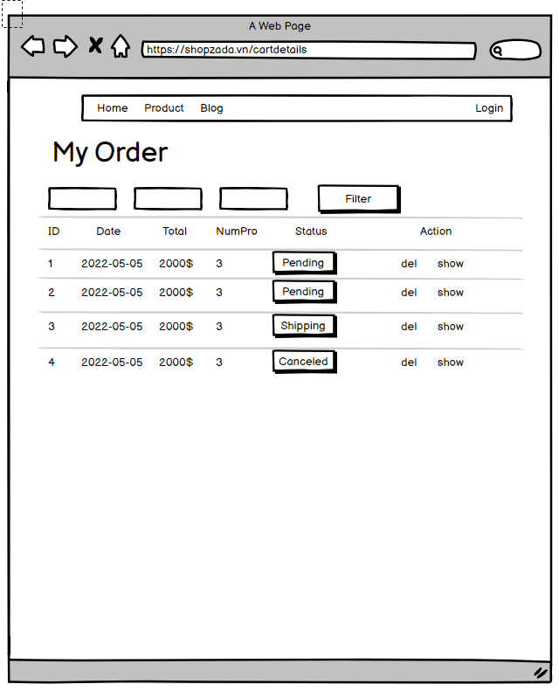

* **Function details on the screen:** Show the list of user's orders paginatedly + the slider with the product search box, product categories, the latest products, and static contacts/links

### **b**[**.**](https://docs.google.com/document/d/1kCRVpEawTf359X6wvjCen9UjhcyBTsEFwCF6lDQPKzo/edit?fbclid=IwAR0UQ9VfgnyQEUQNyCgW-xAGqmgMIjF3jd83a7OHuq4zuUcrwWVzaSRy0JU#heading=h.ijb8z2nqazl0) **Order Information**

* **Function: show order details**
* **Function Description:**

Show the order details, including the information as below + the sider with the product search box, product categories, the latest products, and static contacts/links

The order id, order date, total cost, status

The receiver information: full name, gender, email, mobile

This list of ordered products, each product include following information & the links/buttons that allow the user to re-buy or feedback: thumbnail, name, category, unit price, quantity, total cost

For the submitted orders, the user can choose to update (redirect the user to the Cart Details page for that) or cancel the order

* **Screen Layout:**

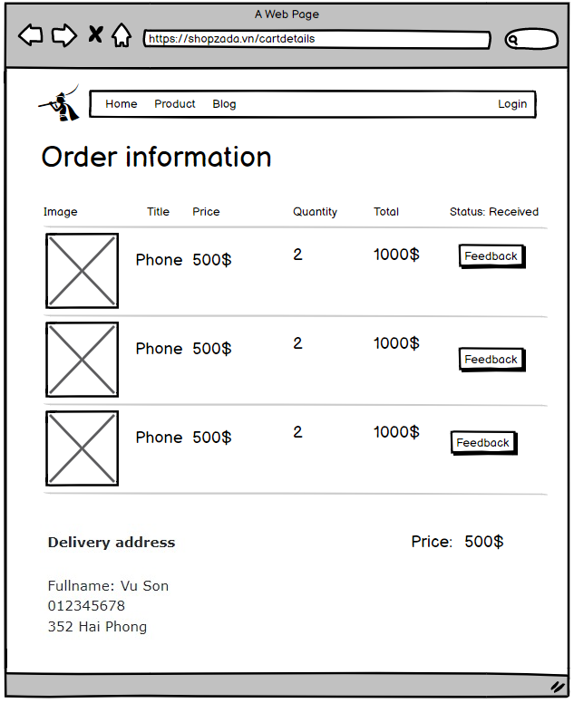

* **Function details on the screen:** This screen displays when user click show in MyOrder page and it show the detail of order is address, phone number, name, price, product

**c. Cart Detail**

* **Function: Use for buying cart**
* **Function Description:**

Show the cart details with list of the user's chosen products (including Id, title, price, quantity, total cost) and the total order price + the sider with the product search box, product categories, the latest products, and static contacts/links; The user can:

- Change the quantity of each product: the total cost is automatically adjusted

- Choose to delete/remove product by clicking on the deleting icon

- Click the Choose More Product button to go to Products List page

- Click the Check Out button to go to the Cart Contact page

Please notes: the user's chosen products from the last browsing session are remained in his/her cart until s/he submit the cart. However, the product prices are updated with the latest prices in the system

**-Screen Layout:**

|  |
| --- |
|  |
|  |

* **Function details on the screen:** This page is shown the cart contains list of product with that own quantity, user can delete, update quantity and the total price automatically update, user can choose buy more to select more item, click cart contact to connect to the shipping.

**d. Cart Contact**

* **Function: Use for contact for shipping**
* **Function Description:**

Show the cart details with list of the user's chosen products (including Id, title, price, quantity, total cost) and the total order price + the sider with the product search box, product categories, the latest products, and static contacts/links; The user can

- Change the quantity of each product: the total cost is automatically adjusted

- Choose to delete/remove product by clicking on the deleting icon

- Click the Choose More Product button to go to Products List page

- Click the Check Out button to go to the Cart Contact page

Please notes: the user's chosen products from the last browsing session are remained in his/her cart until s/he submit the cart. However, the product prices are updated with the latest prices in the system

**-Screen Layout:**

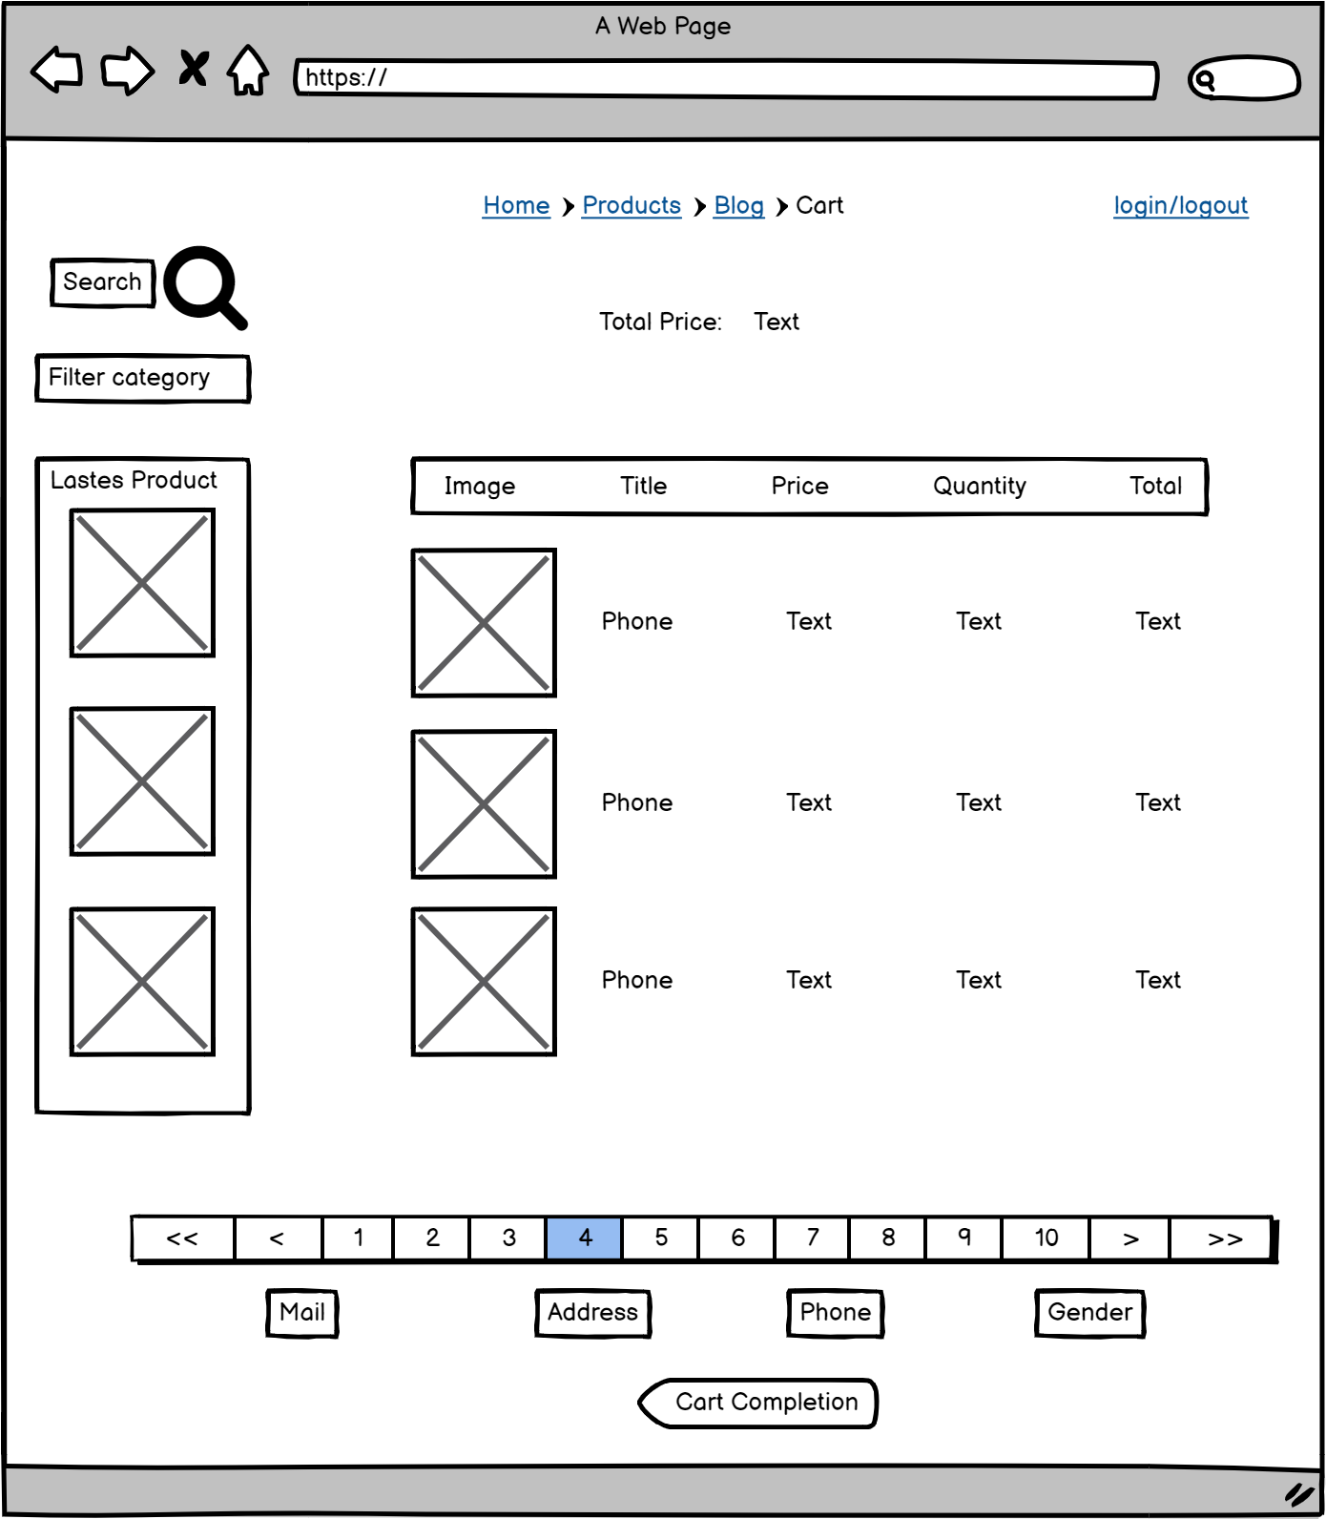

**-Functional detail:** This page show the contact information of user for shipping, if the user login, the information is automatically generated, else the information in text is empty, user can see the order and can change cart by clicking on change cart button to redirect to cart page

|  |
| --- |
|  |

## **3**[**. Common Feature**](https://docs.google.com/document/d/1kCRVpEawTf359X6wvjCen9UjhcyBTsEFwCF6lDQPKzo/edit?fbclid=IwAR0UQ9VfgnyQEUQNyCgW-xAGqmgMIjF3jd83a7OHuq4zuUcrwWVzaSRy0JU#heading=h.htgntpn3ne3x)

### **[User login](https://docs.google.com/document/d/1kCRVpEawTf359X6wvjCen9UjhcyBTsEFwCF6lDQPKzo/edit?fbclid=IwAR0UQ9VfgnyQEUQNyCgW-xAGqmgMIjF3jd83a7OHuq4zuUcrwWVzaSRy0JU#heading=h.ig9jhdabnrwq)**

* **Function: Use for login**
* **Function Description:**

This is a pop-up screen which allows the user to enter email & password to login; on this page, there are also options for user to register new information or reset the password for the case s/he forget it.

* **Screen Layout:**

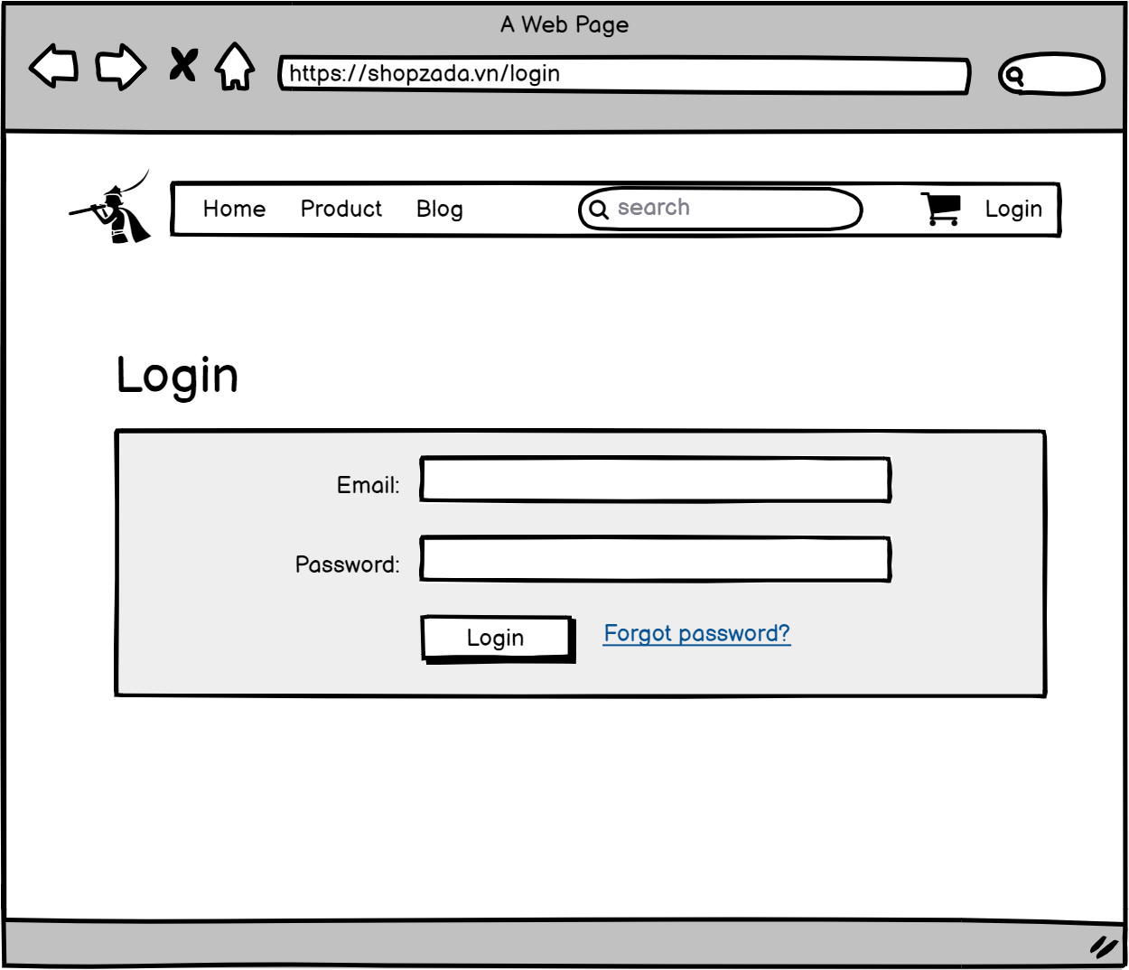

* **Function details on the screen:** This page shows the login form that includes email and password and if you are a new member/user you can click on register, users will be sent to the register page. Become our member that will make everything more convenient for buying products on our web. If users login successfully they will be redirected to the home page. Users don’t have any account, they can’t login in and they must register their account if they want to become our members. When users forget their password, users need to click “Forgot password?” which will redirect users to reset password page.

### **[b. User register](https://docs.google.com/document/d/1kCRVpEawTf359X6wvjCen9UjhcyBTsEFwCF6lDQPKzo/edit?fbclid=IwAR0UQ9VfgnyQEUQNyCgW-xAGqmgMIjF3jd83a7OHuq4zuUcrwWVzaSRy0JU" \l "heading=h.x4nfu9tmdirw)**

* **Function: Use for register**
* **Function Description:**

This is a pop-up screen which allows the user to register himself/herself to the system by input following information: full name, gender, email, mobile, and address; User then need to verify by clicking the link sent via email to him/her before being able to access the system.

* **Screen Layout:**
* 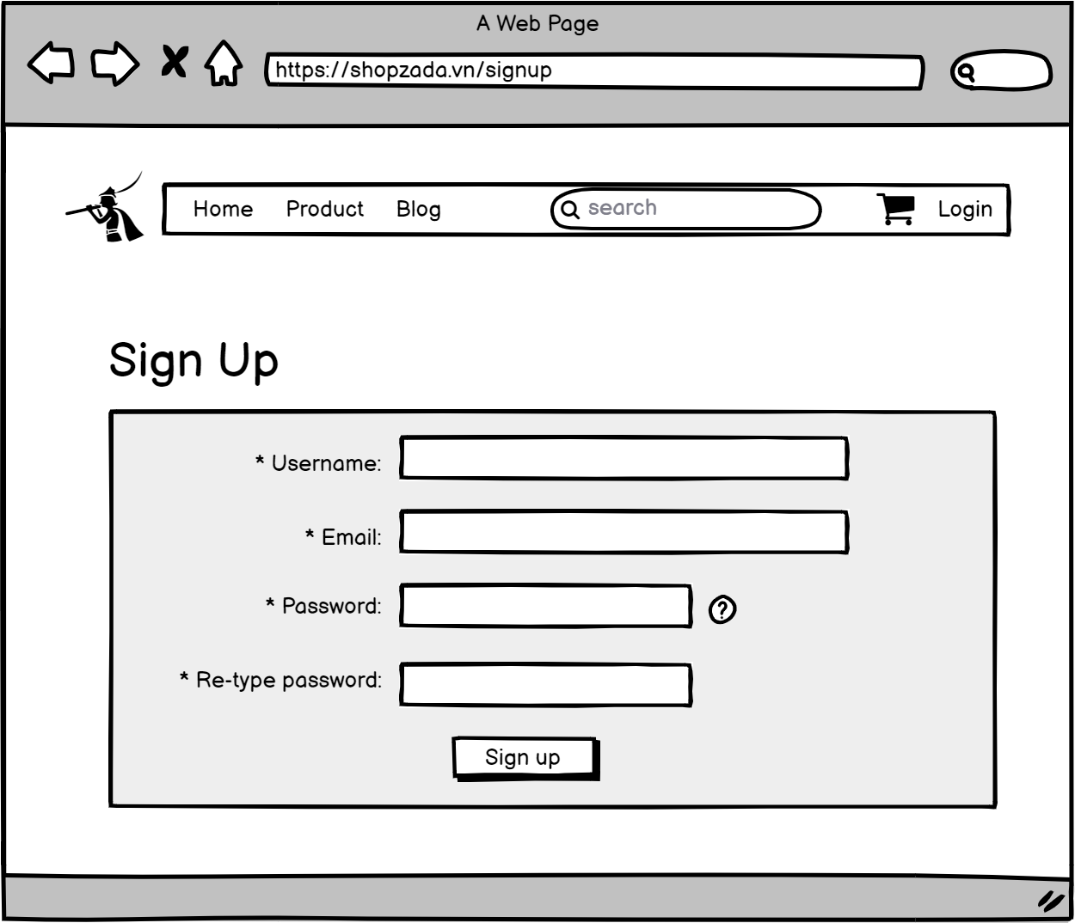
* 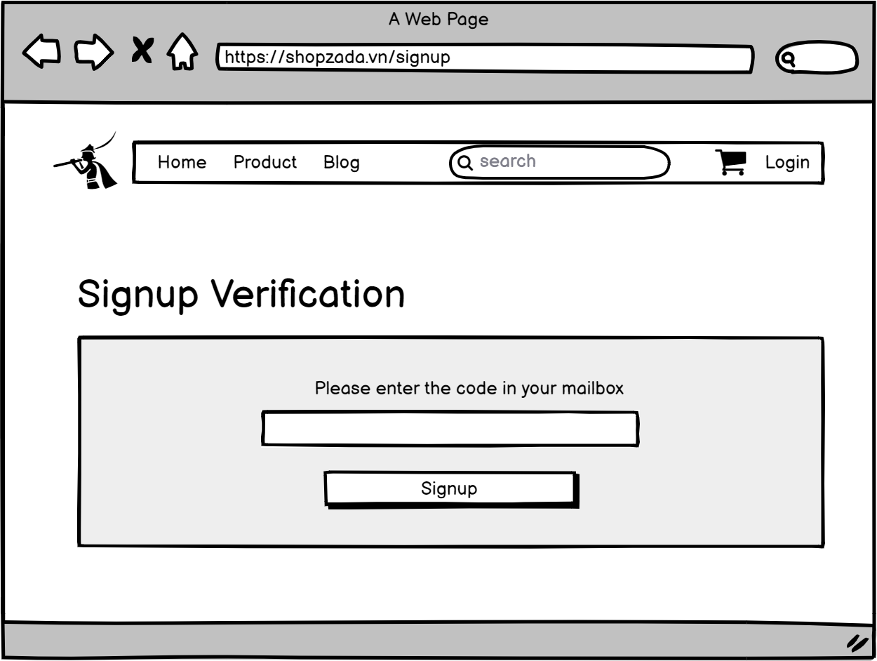
* **Function details on the screen:** This page shows the register/sign up form that includes username, email, password and retype password. When users fill out all the fields, our system will check your information and ensure that it is correct then send an email to the user's email which is filled above. User will enter the code that they receive through the email in the ”Signup Verification” screen . If sign up/register successful, users will be sent to the login page to sign in/login. If your information is not correct, please refill the field that’s not correct.

### **c**[**. Change Password**](https://docs.google.com/document/d/1kCRVpEawTf359X6wvjCen9UjhcyBTsEFwCF6lDQPKzo/edit?fbclid=IwAR0UQ9VfgnyQEUQNyCgW-xAGqmgMIjF3jd83a7OHuq4zuUcrwWVzaSRy0JU#heading=h.ijb8z2nqazl0)

* **Function: Use for reset password**
* **Function Description:**

This is a pop-up screen which allows the user to change his/her password by inputting his current password as well as new password (twice)

* **Screen Layout:**

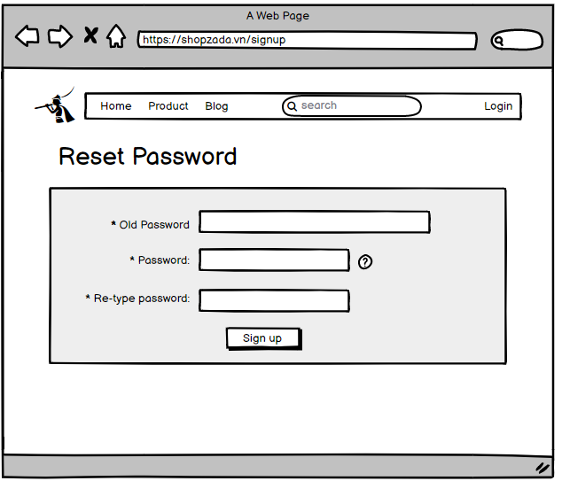

* **Function details on the screen:** This page shows the reset password form that requests users enter their username, our system will send an email to these users, then users will be redirected to the next screen which requires the code through the user's email to reset password.

### **d**[**. Forgot Password**](https://docs.google.com/document/d/1kCRVpEawTf359X6wvjCen9UjhcyBTsEFwCF6lDQPKzo/edit?fbclid=IwAR0UQ9VfgnyQEUQNyCgW-xAGqmgMIjF3jd83a7OHuq4zuUcrwWVzaSRy0JU#heading=h.ijb8z2nqazl0)

* **Function: use for resetting passwords when user forgot it**
* **Function Description:**

The user to input his/her email to receive the reset password link. This link is sent to the user's email for his/her password resetting.

On clicking the link, the user is redirected to the password resetting page in which s/he input new password (twice) for the system access

Note that the link is only available for a specific time duration as configured in the system config file.

* **Screen Layout:**

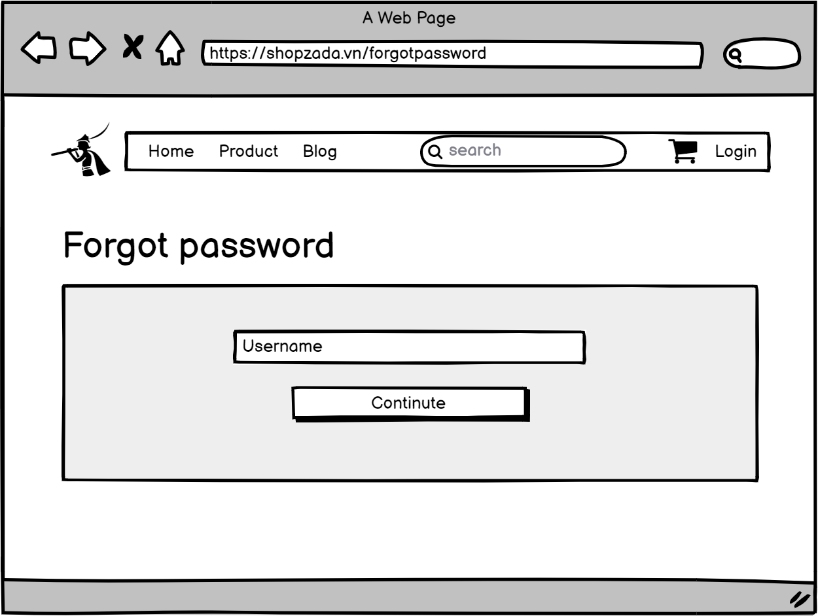

* **Function details on the screen:** when user forgot password user can click forgot password in login site and it send a verification mail to user verifi code and then allow user to set new password

### **e**[**.**](https://docs.google.com/document/d/1kCRVpEawTf359X6wvjCen9UjhcyBTsEFwCF6lDQPKzo/edit?fbclid=IwAR0UQ9VfgnyQEUQNyCgW-xAGqmgMIjF3jd83a7OHuq4zuUcrwWVzaSRy0JU#heading=h.ijb8z2nqazl0) **User Profile**

* **Function: show profile of user and user can edit profile**
* **Function Description:**

This is a pop-up screen which allows the user to edit his/her profile information, including the registered ones & the avatar image. Please note that s/he is not allowed to change the email

* **Screen Layout:**

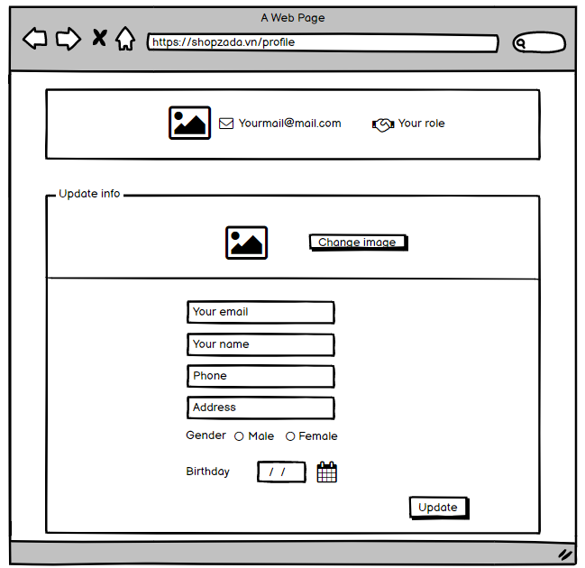

* **Function details on the screen:** This site to show information about user and allows the user to edit his/her profile information

## **4**[**. Marketing Feature**](https://docs.google.com/document/d/1kCRVpEawTf359X6wvjCen9UjhcyBTsEFwCF6lDQPKzo/edit?fbclid=IwAR0UQ9VfgnyQEUQNyCgW-xAGqmgMIjF3jd83a7OHuq4zuUcrwWVzaSRy0JU#heading=h.htgntpn3ne3x)

### **Dashboard**

* **Function: Show the statistic of all information in system**
* **Function Description:** 'Show statistics of posts, products, customers, feedbacks & the trend of new customers by day for the last 7 days (the start date & end date can be adjustable)
* **Screen Layout:**

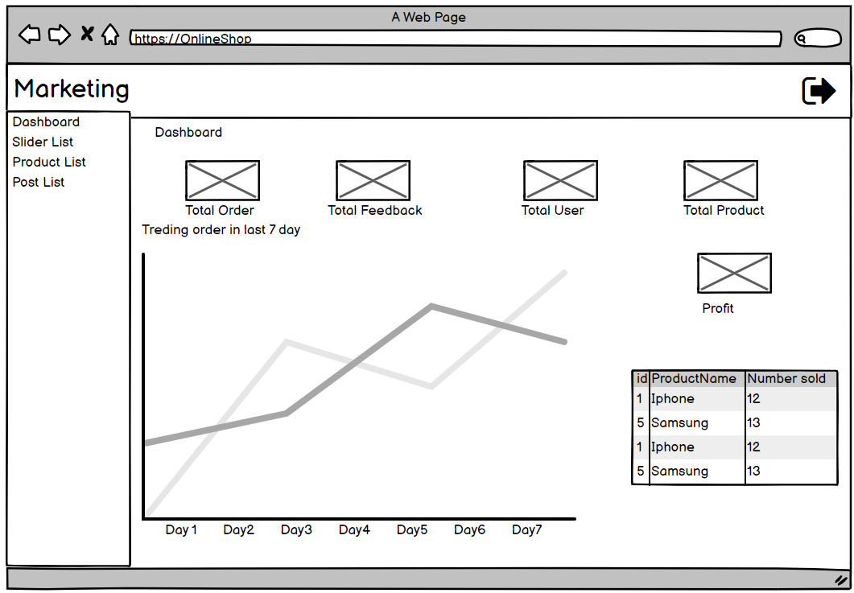

* **Function details on the screen:** This site to show statistics of product, total order, total profit, total feedback, top selling products.

### **Slider List**

* **Function: show list of slide in system**
* **Function Description:**

Show the paginated list of sliders (including sliders' id, title, image, backlink, status)

The user can filter the sliders by the status + search by title or backlink for each slider, the user can choose to hide, show, edit it

* **Screen Layout:**

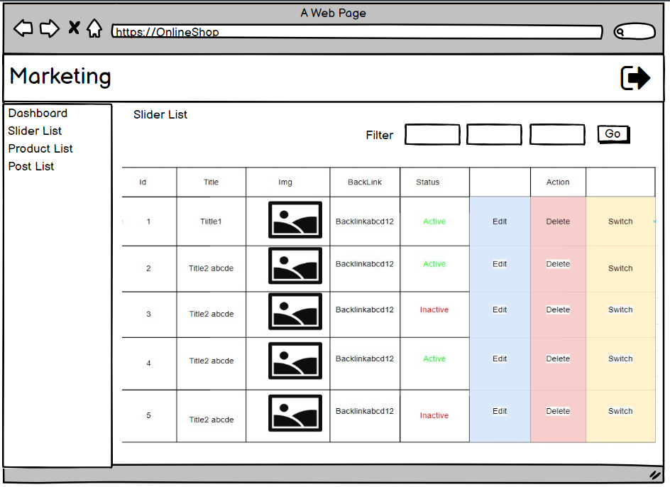

* **Function details on the screen:** This site to show List of slide and manages them. Admin can edit, delete and switch the status of slide. It have filter to filter and search product

### **c. Product List**

* **Function: show list of product**
* **Function Description:**

Show the paginated list of products (include products' id, thumbnail, title, category, list price, sale price, featured, and status information): The user can filter the product by category, status or search by title, brief info

Sortable by title, category, list price, sale price, featured, or status

From each product, the user can choose to hide, show, view, edit it

The page also have the button/link that allows the user to add new product

* **Screen Layout:**

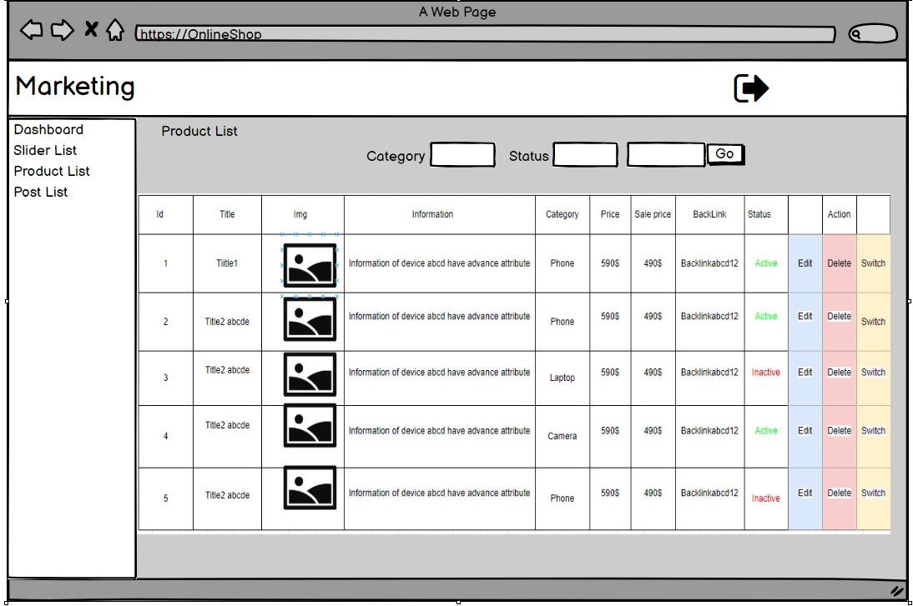

* **Function details on the screen:** This site to show information about Product and can delete, edit and switch status and add new product. Moreover it cant filter product by category, status and search by title or information

### **d. Post List**

* **Function : show list of post**
* **Function Description :**

Display a paginated list of post (including id, user, title, img, description, category, status, action): Admin can filter post by category, status or search by title.

From each post, user can choose to hide, show, view, edit it

The page also has a button/link that allows admin to add new post

* **Screen Layout :**

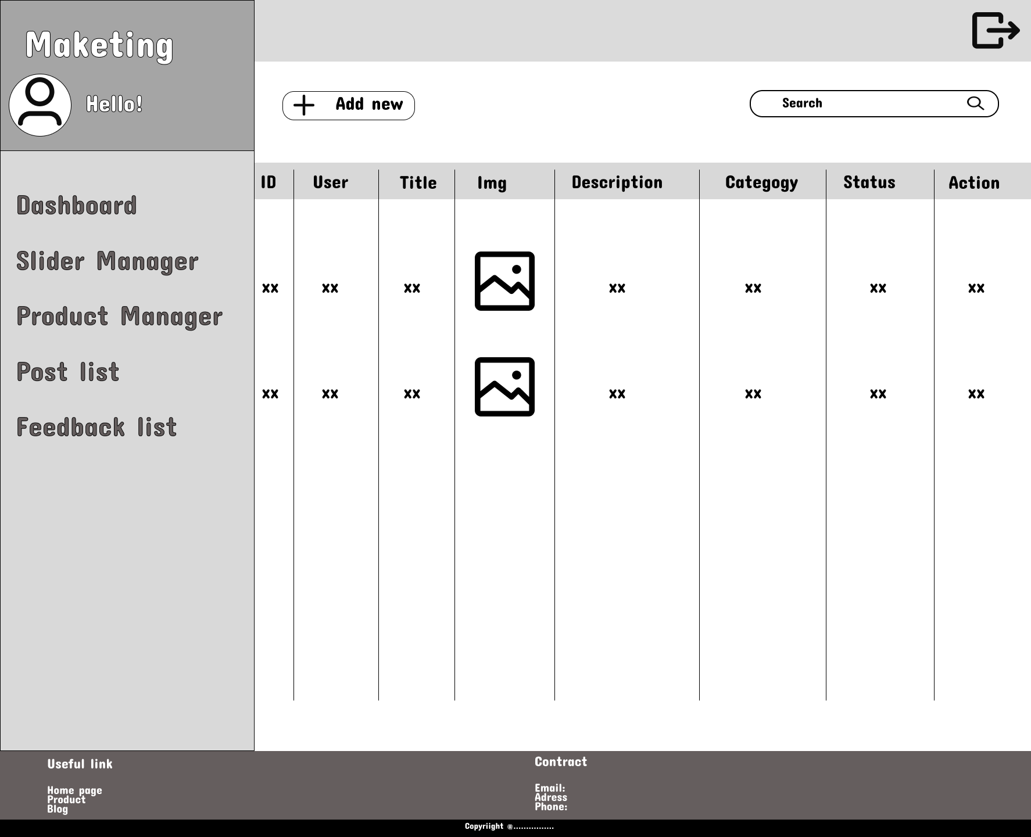

* **Function details on the screen :** This site to show information about Post and can delete, edit and switch status and add new post. Moreover it cant filter post by category, status, title and seach by title or information.

### **e. Feedback List**

* **Function : show list of feedback**
* **Function Description :**

Show the paginated list of feedback (id, full name, img, product, rated star, status, action): The admin can filter the product by star, name or search by title

From each list, the user can choose to hide, show, view

* **Screen Layout :**

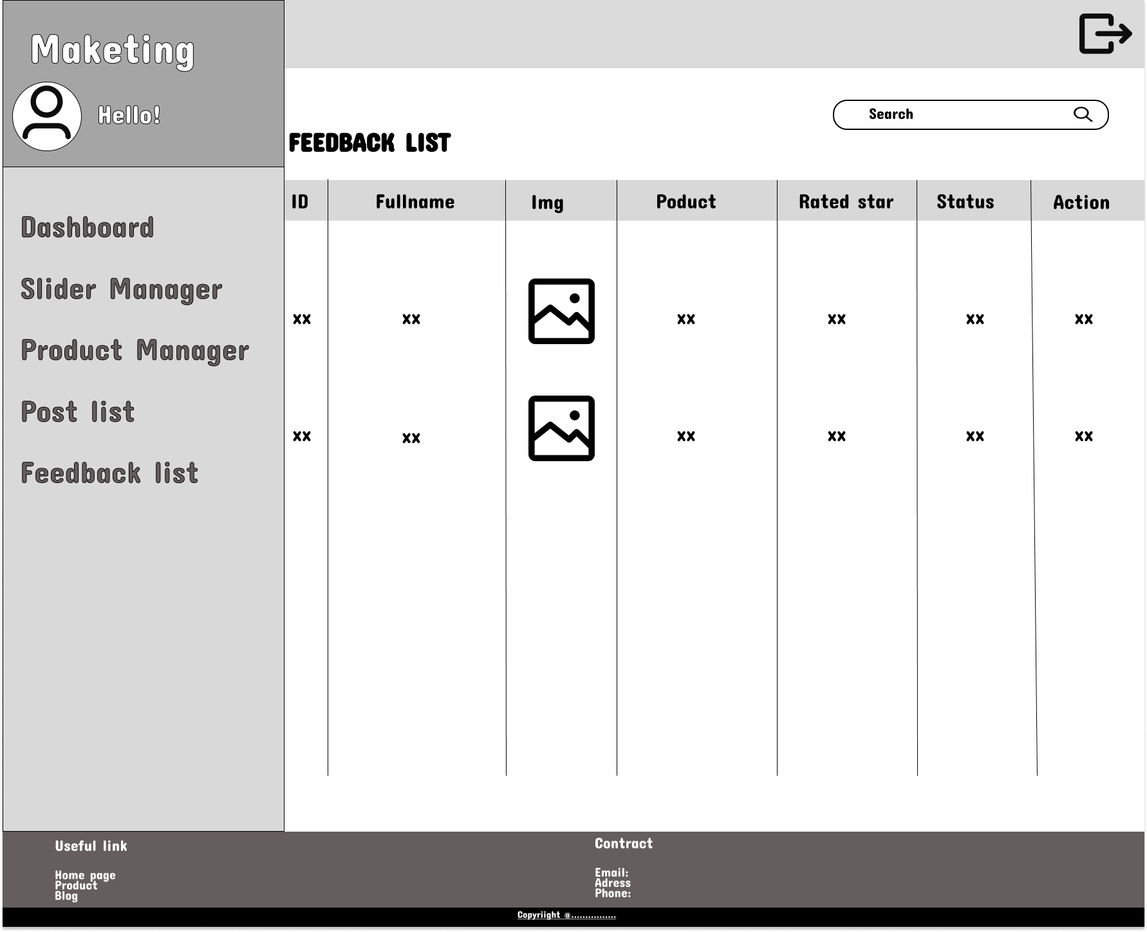

* **Function details on the screen :** This site to show information about feedback and can delete and switch.