EDTRONAUT
AI-POWERED WORKFORCE DEVELOPMENT & PLACEMENT

BUSINESS ANALYST / PRODUCT OWNER INTERN
TAKE-HOME ASSIGNMENT — SUBMISSION
Enterprise Recruitment & Onboarding Suite — B2B Transition

Document Title | BA/PO Intern Deliverables — Edtronaut B2B Enterprise Suite
Document ID | BRD-SRS-EDTRONAUT-B2B-v1.0
Project | Edtronaut B2B Enterprise Transition
Version | v1.0
Status | Draft — Submitted for Assessment
Author | IT BA / Product Owner Intern Candidate
Date Submitted | 01 June 2026
Confidentiality | Internal Confidential

PART A: USER RESEARCH & PERSONA DEFINITION
This section profiles the six primary user personas in the Edtronaut B2B ecosystem, covering three functional modules: Hiring, Onboarding, and Upskilling. For each persona, the analysis identifies the top three pain points experienced under current processes, key objections and risk concerns that must be addressed during product adoption, and the primary motivations driving their engagement with the platform.
User Stories are written for the Hiring module, as this constitutes the core focus of Phase 2 and directly drives the PRD and Dashboard design in Part C.

A.1 Hiring Module Personas

Persona 1: TA Lead / Recruiter (Primary Buyer and User)
Name: Le Minh Tri, 32 years old
Title: Talent Acquisition Lead, Technology & Finance company, 500 headcount
Context: Manages multiple open roles simultaneously. Receives a high volume of CVs daily (approximately 100-150 CVs per day) across LinkedIn, TopCV, and VietnamWorks. The majority of working time is consumed by manual CV screening, candidate outreach, and interview scheduling.
Top 3 Pain Points:
- CV-to-performance mismatch: Spends a significant portion of the day screening CVs, yet experiences a noticeable mismatch between CV quality and actual on-the-job performance, because candidates who present well on paper consistently underperform in practical assessments.
- Time-to-hire pressure: KPI requires filling roles within 20 days. Traditional competency testing takes 7–10 days, leaving insufficient time for the remainder of the hiring funnel.
- Candidate experience degradation: Workload prevents individual feedback delivery, damaging employer brand reputation and increasing candidate drop-off rates.
Key Objections and Risks:
- AI bias: Concern that automated scoring algorithms may incorrectly eliminate strong candidates who do not match specific keyword patterns in their CVs.
- Data privacy and compliance: Apprehension about candidate PII being exposed or mishandled, particularly regarding PDPA obligations when transferring data to a third-party platform.
Motivations:
- Fill critical roles within 20 business days (Time-to-Hire target).
- Reduce manual screening time by at least 50% through automated Job Simulation scoring.
- Achieve a post-simulation interview pass rate of > 60%, showing high pre-qualification accuracy.

Persona 2: Candidate / Simulation Taker
Name: Nguyen Thao Vy, 22 years old
Title: Final-year Information Systems student, applying for BA Intern positions
Context: Actively applying to multiple internships simultaneously. Has received a Job Simulation invitation from an Edtronaut-powered hiring process as part of initial screening.
Top 3 Pain Points:
- Abstract assessments: Existing tests are theory-based and multiple choice, failing to reflect real problem-solving ability or practical judgment.
- Opaque AI scoring: Automated grading systems feel rigid and appear unable to recognize creative or non-linear reasoning approaches.
- Absence of feedback: After completing assessments, candidates receive no substantive response beyond automated rejection emails.
Key Objections and Risks:
- Time burden: Simulations lasting 2–3 hours are demanding when a candidate is simultaneously completing assessments for multiple employers.
- Intellectual property concern: Candidates worry that solutions submitted in simulations may be used by the company without compensation or hiring.
Motivations:
- Obtain clear assessment expectations and detailed system requirements before starting.
- Receive a transparent, structured Skill Feedback Report within 48 hours of submission.
- Complete the simulation within 90 minutes without experiencing UI/UX friction.

A.2 Onboarding Module Personas

Persona 3: New Hire
Name: Pham Hoang Nam, 24 years old
Title: Junior Business Analyst, 3 days into onboarding
Context: Has just joined the company and is absorbing a high volume of information: organisational structure, internal processes, technology systems, and company culture. Has no clear map of what is expected in the first 30–60 days.
Top 3 Pain Points:
- Information overload: Required to read hundreds of pages of unstructured documents stored across Google Drive, email, and internal wikis, with no contextual guidance.
- Fear of asking: Mentors and managers are overscheduled; Nam hesitates to ask basic questions for fear of appearing incompetent or passive.
- Progress ambiguity: No visibility into what percentage of the probationary milestones have been completed or what standard must be met to pass probation.
Key Objections and Risks:
- Assessment anxiety: Onboarding simulations feel evaluative rather than developmental, creating a test-taking mindset rather than a learning mindset.
- Tool complexity: Time spent learning a new platform reduces focus on substantive role-specific content.
Motivations:
- Complete assigned onboarding tasks and micro-simulations within target dates.
- Achieve a score of >= 80% on all core onboarding competency modules.
- Report 100% clarity on company standards and job expectations by Day 30.

Persona 4: People Ops / HR Onboarding Owner
Name: Do Thanh Hai, 29 years old
Title: HR Operations Specialist
Context: Manages onboarding for 15–20 new hires per month across departments. Must coordinate with line managers in each business unit to assign materials and track probationary assessments.
Top 3 Pain Points:
- Manual tracking overhead: Onboarding progress is managed in a shared Google Sheet, which is error-prone, frequently outdated, and unscalable beyond 20 concurrent hires.
- Manager non-compliance: Line managers consistently deprioritise reviewing new hire simulation outputs, creating bottlenecks in the feedback cycle that HR cannot resolve.
- Stale content: Onboarding materials are scattered across multiple repositories; updating them consistently when processes change is operationally intensive.
Key Objections and Risks:
- Change resistance: HR staff and department heads are accustomed to email and chat-based coordination; migrating to a dedicated platform faces cultural friction.
- Customisation effort: Each department requires a distinct onboarding path; configuring role-specific content for every position is time-consuming.
Motivations:
- Establish a single automated dashboard, eliminating manual Google Sheets tracking.
- Reduce time-to-productivity for new hires by 30% through structured sandbox learning.
- Achieve 100% compliance from department managers in reviewing outputs within 5 business days.

A.3 Upskilling Module Personas

Persona 5: L&D Manager / HRBP / Line Manager
Name: Tran Duc Manh, 38 years old
Title: L&D Manager and HR Business Partner (HRBP)
Context: Responsible for long-term workforce capability planning. Organises internal training programmes but lacks objective data to measure actual skill development outcomes.
Top 3 Pain Points:
- Subjective skills assessment: No systematic tool to measure skill gaps. Training nominations rely predominantly on anecdotal input from line managers rather than evidence-based gap analysis.
- Low training ROI: Significant budget allocated to theoretical external courses, yet post-training evaluations show minimal improvement in on-the-job performance metrics.
- Fragmented data: No consolidated skill matrix covering the entire workforce; capability data required for succession planning does not exist in a usable form.
Key Objections and Risks:
- Completion rates: Concern that employees will abandon simulation-based training mid-way due to competing project deadlines.
- Recommendation accuracy: Scepticism that AI-generated training recommendations will suggest skills irrelevant to each employee's actual current work context.
Motivations:
- Establish a dynamic skill matrix updated in real time for 100% of employees.
- Achieve a training path completion rate of >= 85% on continuous learning loops.
- Demonstrate a measured 25% average performance improvement in post-training evaluations.

Persona 6: Employee (Simulation Taker — Upskilling)
Name: Bui Anh Tuan, 27 years old
Title: Business Analyst Level 1, 1.5 years of experience
Context: Working on an outsourced project. Motivated to reach Senior BA level and achieve a salary increase in the next performance review cycle.
Top 3 Pain Points:
- Theory-practice gap: Company-sponsored training is heavily theoretical and does not help resolve the complex, ambiguous problems encountered in live projects.
- Absence of specific feedback: No structured, objective feedback identifying which specific competencies (for example, requirements specification writing or stakeholder negotiation) require improvement.
- Opaque promotion criteria: Unclear what specific skills must be demonstrated, and to what standard, in order to qualify for the next career level.
Key Objections and Risks:
- Performance penalty fear: Concerned that a low simulation score will be used against him in the annual KPI evaluation rather than treated as a developmental signal.
- Capacity and burnout: Project workload leaves insufficient time and energy to engage meaningfully with additional simulation tasks.
Motivations:
- Gain a transparent learning path leading to the next promotion target.
- Practice on high-fidelity simulation challenges that match real-world project complexity.
- Receive continuous, actionable feedback to systematically close skill gaps.

A.4 User Stories — Hiring Module
The following nine User Stories represent the high-priority requirements for the core Hiring module, demonstrating a complete understanding of the end-to-end recruitment ecosystem. Stories are defined for the Recruiter, Candidate, and Hiring Manager personas (3 stories each) to cover all major touchpoints, written to conform with INVEST criteria.

US-HIR-001: Filter and Rank Candidates by AI Simulation Score (Recruiter)
User Story: As a TA Recruiter, I want to filter the candidate list by a defined simulation score range and AI Rank classification (A, B, C, D), so that I can immediately identify the top-performing candidates (top 10–20%) and prioritise them for interview outreach, eliminating 80% of time spent reviewing non-qualifying profiles.
Acceptance Criteria:
Scenario: Recruiter successfully filters candidates by score threshold
Given the Recruiter is logged in and viewing the Recruitment Pipeline for job 'BA Intern'
And the list currently displays all 150 applicants
When the Recruiter sets the simulation score slider to a range of 80 to 100
And selects AI Rank filters 'Rank A (Excellent)' and 'Rank B (Good)'
And clicks 'Apply Filters'
Then the system displays filtered candidates.
And the filter criteria are correctly applied to the list.
And the record count indicator updates correctly.
And a 'Clear Filters' button MUST appear to restore the full unfiltered list
Out of Scope (MVP v1): Compound filtering by individual soft-skill sub-scores. This capability is deferred to Phase 2.

US-HIR-002: Configure Hiring Flow Order per Job Description (Recruiter)
User Story: As a TA Recruiter, I want to toggle the order of the 'Simulation Assessment' and 'Direct Interview' stages for each specific Job Description, so that I can apply the most appropriate process for each seniority level — for example, Simulation First for high-volume junior roles, and Interview First for senior roles where initial rapport matters.
Acceptance Criteria:
Scenario: Recruiter successfully changes flow configuration to Interview First
Given the Recruiter is on the 'Job Configuration' page for job 'Senior BA'
And the current flow setting is 'Simulation First'
When the Recruiter clicks the toggle to switch to 'Interview First'
And clicks 'Save Changes'
Then the system MUST display a success notification: 'Flow updated to: Interview First'
And the system MUST persist this configuration to the database for this Job ID
And for all new applicants to 'Senior BA', the system MUST NOT auto-send a simulation link
And the Candidate Detail View for this job MUST display a 'Send Simulation' button
that becomes active only after the Direct Interview stage is marked complete
Out of Scope (MVP v1): Free-form drag-and-drop workflow builder with unlimited custom stages. MVP supports only a binary toggle between two pre-defined flows.

US-HIR-003: Bulk Send Simulation Invitations (Recruiter)
User Story: As a TA Recruiter, I want to select multiple candidates (up to 50) from the candidate list and send simulation invitations to all of them simultaneously with a single shared deadline, so that I do not have to perform the same action 50 times individually, and all candidates in a given cohort work to the same timeline.
Acceptance Criteria:
Scenario: Recruiter successfully sends bulk simulation invitations
Given the Recruiter is viewing the candidate list in stage 'Applied' for job 'BA Intern'
And the Recruiter has selected 25 candidates using row checkboxes
When the Recruiter clicks 'Bulk Send Simulation' in the action toolbar
And sets the deadline to '5 days from today'
And clicks 'Confirm Send'
Then the system MUST display a loading indicator with message 'Sending invitations to 25 candidates...'
And successfully dispatches invitations to the selected candidates
And MUST display success notification: 'Successfully sent 25 simulation invitations'
And the stage of all 25 candidates MUST update immediately from 'Applied' to 'Simulation Sent'
And the system MUST log 'Bulk Invite Sent — Deadline: DD/MM/YYYY' in each candidate's Audit Trail
Out of Scope (MVP v1): Custom email template editor per send batch. MVP v1 uses a single system-defined default template.

US-HIR-004: View Simulation Deadline and Instructions (Candidate)
User Story: As a Candidate, I want to view my simulation assessment deadline, estimated time duration, and explicit instructions on a pre-simulation landing page, so that I can prepare my working environment and allocate uninterrupted time to complete the test before the link expires.
Acceptance Criteria:
Scenario: Candidate successfully views assessment landing page
Given the Candidate clicks the unique assessment link from their invitation email
When the assessment landing page loads
Then the system MUST display the target job title 'BA Intern' and company logo
And MUST prominently display the simulation deadline (e.g., 'Before DD/MM/YYYY, HH:MM')
And MUST show the estimated time to complete (e.g., 'Estimated duration: 90 minutes')
And MUST display a bulleted list of rules and technical requirements
And MUST display a 'Start Simulation' button that triggers the countdown timer.

US-HIR-005: Submit Job Simulation Assessment (Candidate)
User Story: As a Candidate, I want to submit my completed simulation assessment, so that the AI Simulation Engine can analyze and score my technical outputs.
Acceptance Criteria:
Scenario: Candidate successfully submits simulation assessment
Given the Candidate has completed all tasks in the simulation portal
When the Candidate clicks 'Submit Assessment'
And confirms the submission in the warning dialogue
Then the system displays a confirmation screen: 'Submission Successful'
And updates the candidate status in the database to 'Simulation Completed'
And locks editing of candidate answers in the simulation portal

US-HIR-006: Receive Structured Skill Feedback Report (Candidate)
User Story: As a Candidate, I want to receive an automated, structured Skill Feedback Report via email after my simulation is scored, so that I understand my strengths and growth areas, ensuring a transparent and valuable candidate experience regardless of the final hiring decision.
Acceptance Criteria:
Scenario: Candidate receives automated feedback report upon scoring
Given the Candidate has submitted their simulation
And the AI Engine and Recruiter have completed the scoring process
When the system updates the candidate status to 'Simulation Evaluated'
Then the system MUST automatically generate a PDF Skill Feedback Report
And MUST dispatch an email to the Candidate containing a secure download link
And the report MUST present scores across 3 primary areas: Accuracy, Communication, and Logical Thinking
And MUST include AI-generated constructive feedback on improvement areas without revealing proprietary test answers.

US-HIR-007: Review Shortlisted Candidates (Hiring Manager)
User Story: As a Hiring Manager, I want to view a dashboard listing shortlisted candidates for my open roles, so that I can focus only on qualified applicants.
Acceptance Criteria:
Scenario: Hiring Manager views shortlisted candidates
Given the Hiring Manager is logged in and viewing their department pipeline
When the system loads the page
Then the system displays only candidates who are in 'Shortlist' or 'Interviewing' stage
And hides candidates from other departments

US-HIR-008: Add Detailed Evaluation Notes (Hiring Manager)
User Story: As a Hiring Manager, I want to add detailed evaluation notes to a candidate profile, so that I can document my feedback and share it with the Recruiter.
Acceptance Criteria:
Scenario: Hiring Manager adds evaluation notes
Given the Hiring Manager is viewing a candidate's detail page
When the Hiring Manager types feedback in the 'Reviewer Notes' field
And clicks 'Save Note'
Then the system displays the saved note with the Hiring Manager's name and timestamp
And the note is appended to the Candidate Activity Timeline

US-HIR-009: Approve/Reject Candidate for Interview (Hiring Manager)
User Story: As a Hiring Manager, I want to approve or reject a candidate for the direct interview round, so that the Recruiter knows who to schedule or notify.
Acceptance Criteria:
Scenario: Hiring Manager approves a candidate
Given the Hiring Manager is viewing candidate Nguyen Thao Vy's detail page
When the Hiring Manager clicks the 'Approve to Interview' button
Then the system updates the candidate status to 'Interview Scheduled'
And triggers a notification email to the assigned Recruiter

PART B: WORKFLOW DEFINITION
This section defines three end-to-end business process workflows corresponding to the three B2B modules. Each workflow is specified as a Cross-Functional Swimlane diagram following ISO 5807 notation standards for Flowcharts and BPMN 2.0 notation for the Hiring flow. Diagrams are provided as separate image files and referenced below.

B.1 Workflow 1 — Hiring Automation (BPMN 2.0 Swimlane)
Diagram type: BPMN 2.0 Swimlane with Pools and Lanes
Rationale: The Hiring workflow involves multiple interacting actors (Candidate, Recruiter, AI System, Hiring Manager), complex conditional branching including the Flow Manager toggle, and cross-department approval gates. BPMN 2.0 with explicit Pools and Lanes provides the most precise representation of responsibility boundaries, message flows, and decision logic required for this process.
Lanes: Recruiter / TA | AI System / Platform | Candidate | Hiring Manager
Key process elements covered:
- JD creation and publication
- CV ingestion and initial recruiter screening
- Flow Manager decision gate: Simulation First versus Interview First
- Automated simulation invitation dispatch
- Candidate simulation completion and AI scoring
- Recruiter review of AI Score Report and shortlist decision
- Hiring Manager approval of shortlist
- Interview scheduling and outcome decision
- Offer extension or rejection notification
Edge cases explicitly modelled:
- Candidate does not open simulation invitation within 3 days: auto-reminder triggered; if no response after a further 2 days, simulation link expires and status updates to 'Expired'
- AI score falls below threshold: candidate status moves to 'AI Recommend Reject'; recruiter receives flag and retains manual override authority
- Recruiter overrides AI recommendation: manual review path activated; override action is recorded in Audit Trail with reviewer ID and timestamp
- Hiring Manager rejects shortlist: returned to recruiter with reviewer notes; recruiter can re-evaluate or escalate
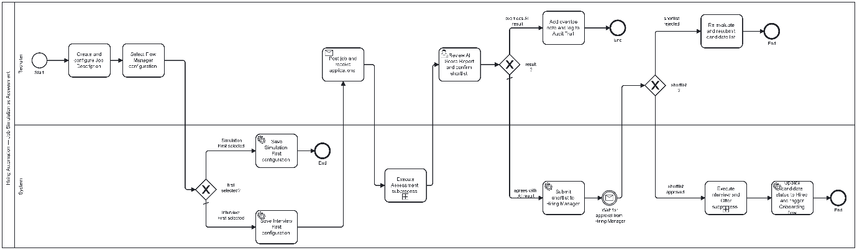
Figure B.1: Hiring Automation — BPMN 2.0 Swimlane Diagram
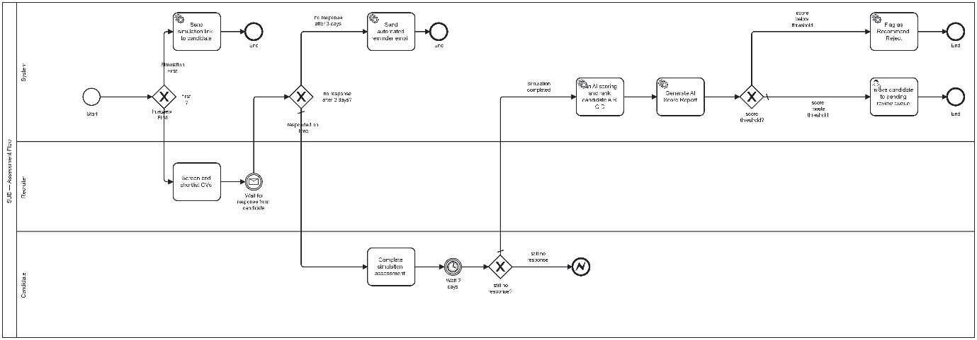
Figure B.1.1: SUB — Assessment Flow— BPMN 2.0 Swimlane Diagram
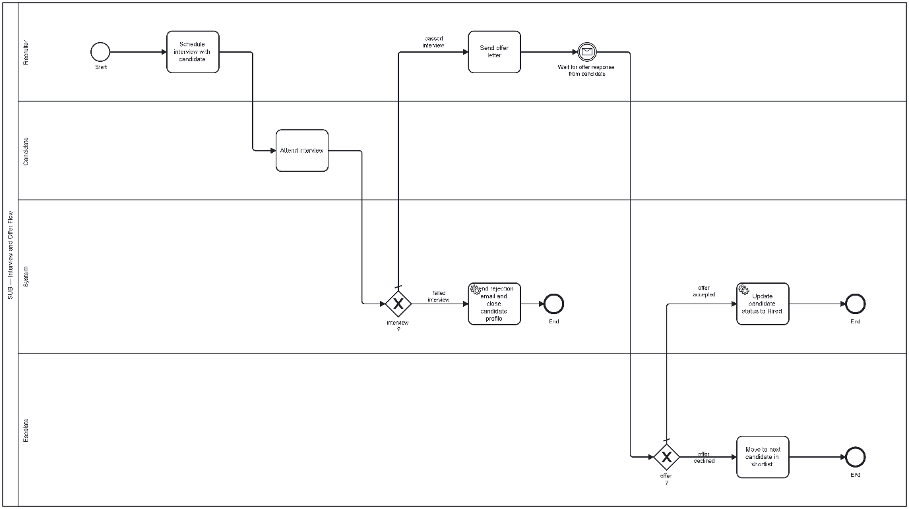
Figure B.1.2: SUB — Interview and Offer Flow— BPMN 2.0 Swimlane Diagram

B.2 Workflow 2 — New Hire Onboarding (Cross-Functional Swimlane Flowchart)
Diagram type: Cross-Functional Swimlane Flowchart, ISO 5807 notation
Rationale: The Onboarding workflow follows a predominantly sequential path with a defined feedback loop. Four actors participate — HR/People Ops, the Platform System, the New Hire, and the Line Manager — each with clearly delimited responsibilities. The Swimlane Flowchart format most efficiently communicates handoff points, the distinction between automated and human-approved steps, and the cyclic correction loop when simulation output requires revision.
Lanes: HR / People Ops | System / Platform | New Hire | Line Manager
Key process elements covered:
- Offer acceptance trigger: system auto-creates onboarding profile for new hire
- HR configures role-specific onboarding simulation plan
- System auto-assigns micro-simulations with defined completion deadlines
- New hire receives task notification and completes simulation
- Line Manager reviews simulation output and provides structured feedback
- Feedback loop: if output requires revision, new hire revises and resubmits
- Completion: all simulations passed, completion certificate issued, HR dashboard updated
- Automated 30-day and 60-day check-in reminders dispatched by system
Edge cases explicitly modelled:
- New hire does not complete simulation before deadline: system sends automated reminder at T-2 days; if still incomplete at deadline, HR receives escalation alert
- Line Manager does not review output within 5 business days: system sends reminder to manager; if unresolved after 3 further days, HR is notified and escalation path activates
- New hire repeatedly fails simulation after two revision cycles: flag raised to HR for manual intervention and possible extension of probation period

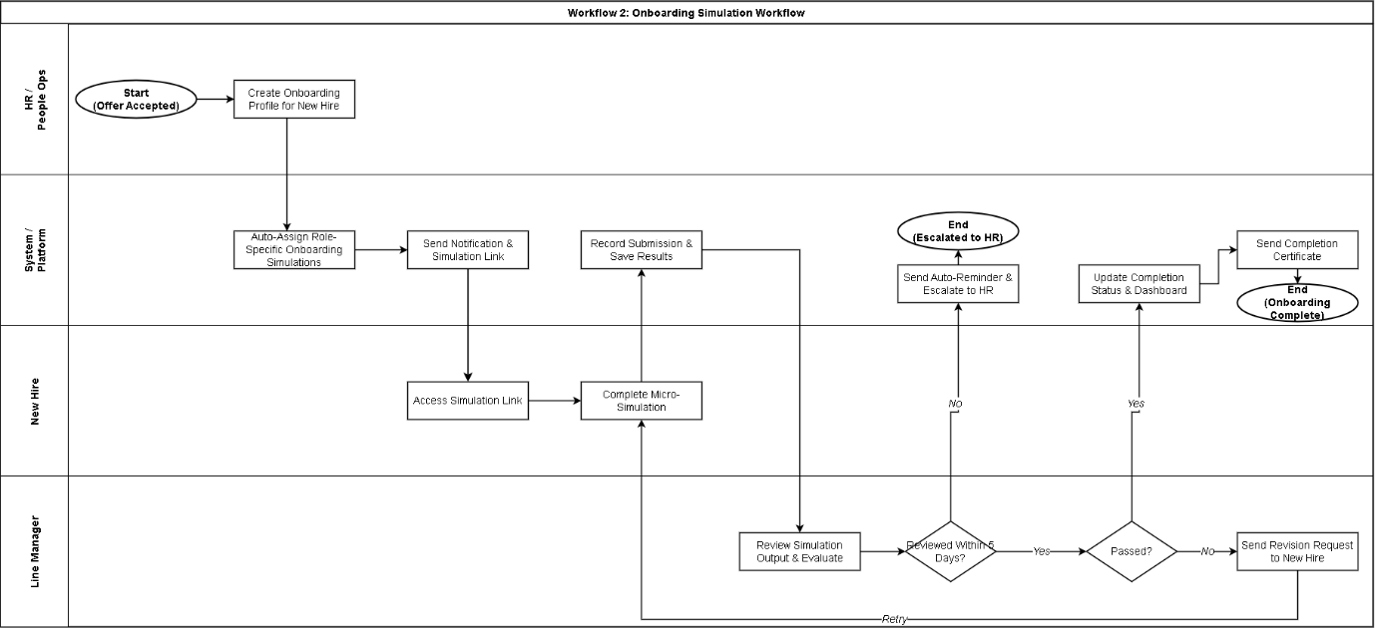
Figure B.2: New Hire Onboarding — Cross-Functional Swimlane Flowchart

B.3 Workflow 3 — Upskilling / Reskilling (Closed-Loop Swimlane Flowchart)
Diagram type: Closed-Loop Cross-Functional Swimlane Flowchart, ISO 5807 notation
Rationale: Upskilling is an ongoing, cyclical process rather than a one-time linear flow. The Closed-Loop Swimlane Flowchart captures the continuous cycle of gap detection, simulation assignment, completion, re-assessment, and escalation to promotion decision gates. The loop-back structure is central to representing the iterative nature of capability development.
Lanes: L&D Manager | System / Platform | Employee | Line Manager
Key process elements covered:
- L&D Manager defines competency framework and skill benchmarks per role level
- System runs periodic automated skill gap analysis against current employee scores
- If gap detected: system auto-recommends simulation from library; L&D reviews and approves assignment
- Employee receives simulation assignment notification
- Employee completes simulation; AI generates score and skill report
- Score checked against benchmark: if below threshold, remediation loop triggers new simulation recommendation
- If benchmark met: skill matrix updated; system checks promotion readiness criteria
- If promotion-ready: promotion signal dispatched to Line Manager and HRBP for review
- Manager approves or defers promotion; system updates role level and loads new competency framework for next cycle
Edge cases explicitly modelled:
- Employee does not complete assigned simulation within defined period: auto-reminder at T-3 days; escalation to L&D Manager if still overdue
- Employee score regresses across consecutive simulation attempts: system flags to L&D Manager for review and possible intervention
- Line Manager defers promotion after signal: decision and deferral reason recorded; system schedules reassessment for next review cycle

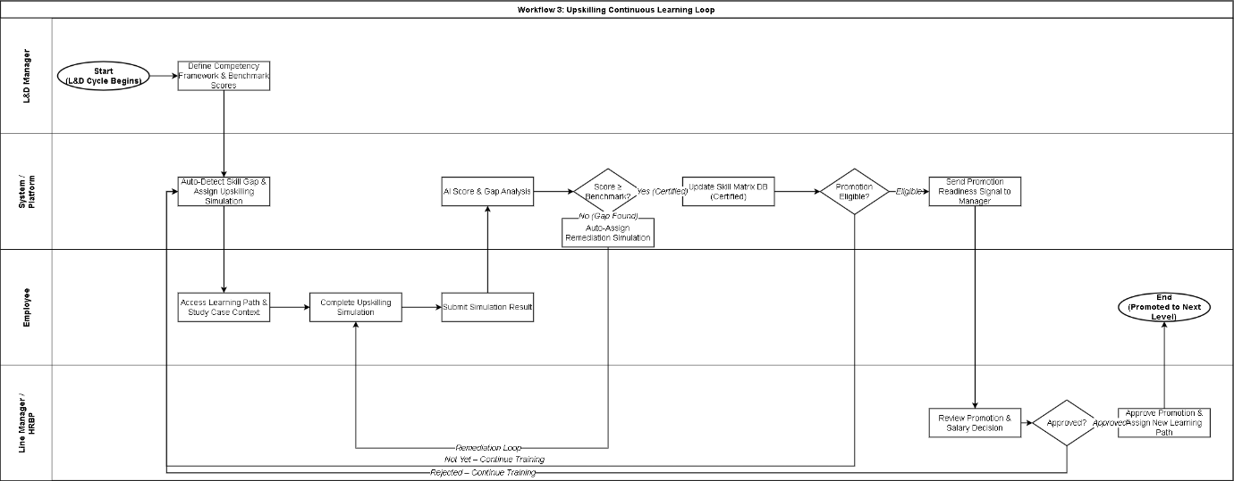
Figure B.3: Upskilling — Closed-Loop Swimlane Flowchart

PART C: PRODUCT REQUIREMENTS DOCUMENT — RECRUITMENT DASHBOARD
This section constitutes the engineering-ready PRD for the Recruitment Dashboard (Scope 1). It defines the problem being solved, the product goals and non-goals, MVP phasing, functional and non-functional requirements, data model, integration points, and dashboard UX specifications, followed by Gherkin-format Acceptance Criteria.

C.1 Problem Statement
Enterprise recruitment teams currently operate a fragmented, manual process. CVs are stored across email inboxes and basic ATS tools. Skill assessments are distributed via Google Forms or PDF attachments. Interview notes are recorded in shared Word documents. These disconnected systems produce three compounding problems:
- Mismatch between CV quality and job performance: Without a standardised, objective skill verification mechanism, candidate self-presentation in CVs is the primary basis for shortlisting. Candidates with strong CVs but weak practical skills regularly advance to late-stage interviews.
- Operational inefficiency: Recruiters spend significant time per candidate profile — reading, dispatching test materials, collecting responses, and coordinating scoring with Hiring Managers — work that is largely reducible through automation.
- Absence of a single source of truth: No centralised view consolidates candidate profiles, simulation outcomes, scores, and reviewer commentary in one place. Decision-making is slow and inconsistent across hiring teams.

C.2 Product Goals
- Build a centralised Recruitment Dashboard that serves as the Single Source of Truth for all candidate pipeline activity within the enterprise.
- Surface AI Simulation Engine scores and competency data directly on the recruiter's candidate list, eliminating the need to access external systems or manually compile score data.
- Accelerate hiring decisions through automated AI ranking, smart filters, and bulk action tools that reduce manual candidate review time and streamline coordination.

C.3 Non-Goals
- The system does not replace existing enterprise ATS software (such as Workable or Greenhouse). It integrates alongside those tools via API export.
- The system does not make final rejection or offer decisions autonomously. All terminal decisions require explicit confirmation from a human Recruiter or Hiring Manager (Human-in-the-loop principle).
- Real-time bi-directional ATS synchronisation via Webhooks is deferred to Phase 2.

C.4 MVP Scope versus Phase 2+ Scope
Feature scope is explicitly phased to minimise development risk and ensure delivery within the six-week timeline.

Module | In Scope — MVP v1 | Deferred — Phase 2+
Candidate Management | Centralised candidate list with columns: Name, Score, AI Rank, Stage, Last Updated. Pagination at 20 records per page. Search by name, email, phone. | Real-time sync from external ATS platforms via Webhooks.
Flow Configuration | Binary toggle per Job: Simulation First vs Interview First. Configuration persists per Job ID. | Free-form drag-and-drop workflow builder with unlimited custom stages.
Bulk Actions | Bulk simulation invite (up to 50 candidates) using default system email template. | Custom email template editor. Scheduled send at optimal delivery windows.
AI Assessment | AI Score display with Rank badge (A/B/C/D) on list and detail view. AI Narrative Summary on candidate detail. | Automated benchmark comparison with spider chart visualisation. AI-generated interview question suggestions.
Reporting | Export filtered shortlist to flat CSV file. | PDF report with evidence attachments formatted for presentation in hiring review meetings.

C.4.1 Feature Prioritization (MoSCoW Matrix)
To demonstrate strong product management and prioritization mindset, the following matrix defines P0 (Core MVP), P1 (High value MVP), and P2 (Deferred Phase 2) features based on business value and complexity mapping:

Feature Name | Description | Priority | Phase Target
Candidate List & Search | Centralised view with text search for rapid navigation. | P0 (Must) | MVP v1
AI Score & Rank Badge | Direct display of core metrics derived from the simulation engine. | P0 (Must) | MVP v1
Candidate Detail View | 3-tab modal with CV, AI report, and historical activity. | P0 (Must) | MVP v1
Hiring Flow Configuration | Binary toggle for process ordering (Sim First vs. Interview First). | P0 (Must) | MVP v1
Bulk Simulation Invite | Select and send invitations up to 50 candidates in a batch. | P1 (Should) | MVP v1
Shortlist CSV Export | One-way tabular data export for ATS integration. | P1 (Should) | MVP v1
Google Calendar Sync | Automated scheduling sync for recruiter and hiring manager. | P2 (Could) | Phase 2
Enterprise SSO | SAML 2.0 integration for enterprise identity provider access. | P2 (Could) | Phase 2

C.4.2 Core Product Assumptions
Decision Topic | MVP Chosen Path | Alternative Considered | Product / Technical Rationale
ATS Integration Method | Flat CSV Export | Direct Webhook/API Sync | Faster time-to-market. Avoids custom synchronization mappings per ATS provider in MVP.
Workflow Builder | Binary Flow Toggle (Toggle Switch) | Drag-and-drop Stages Canvas | Saves 3 weeks of frontend development effort. Binary config covers 95% of enterprise requirements.
Simulation Email Template | Fixed System Template with dynamic placeholders | Rich Text Email Editor (WYSIWYG) | Ensures brand consistency and strict format of tokenized link dispatch, preventing user-error during setup.
Defining the underlying operational environment reduces engineering ambiguity and aligns cross-functional expectations:
- Assumption 1: The AI Job Simulation Engine already exists and exposes functional REST endpoints for scoring and report payload retrieval.
- Assumption 2: Enterprise recruiters are provisioned with directory accounts in the corporate system; authentication relies on internal session management prior to Phase 2 SSO.
- Assumption 3: The outgoing email service is handled by a transactional provider (e.g., SendGrid or Amazon SES) using an approved enterprise domain.
- Assumption 4: A candidate belongs to exactly one active hiring pipeline at any given time, preventing duplicate simulation invitations for overlapping positions.

C.4.3 Product Trade-off Decisions
To ensure rapid time-to-market while managing architectural integrity, the following business-focused trade-offs were consciously made for the MVP v1:

C.5 Functional Requirements
All functional requirements below are specified using RFC 2119 priority language. Requirements marked MUST are mandatory for MVP v1 delivery.

ID | Module | Requirement Description | Priority
FR-DASH-001 | Dashboard | The system MUST display a Recruitment Funnel widget showing candidate counts at each pipeline stage: Applied → Simulation Sent → Simulation Completed → Interviewing → Offered → Hired. | MUST
FR-DASH-002 | Dashboard | The system MUST display a prominent 'Action Required' alert listing candidates who completed simulation more than 48 hours ago and have not yet been reviewed. | MUST
FR-LIST-001 | Candidate List | The candidate table MUST support pagination at a default of 20 records per page and text search by candidate name, email address, or phone number. | MUST
FR-LIST-002 | Candidate List | The Recruiter MUST be able to filter the candidate list by: job title, simulation score range (slider), AI Rank classification, and pipeline stage. | MUST
FR-ACT-001 | Bulk Actions | The system MUST allow the Recruiter to select multiple candidates via checkboxes and execute bulk actions: Send Simulation Invitation, Advance Stage, or Reject. | MUST
FR-DETAIL-001 | Candidate Detail | On selecting a candidate, the system MUST display a detail view containing three tabs: (1) CV and candidate profile; (2) Simulation Score Report including accuracy score, soft-skill score, time taken, and AI Narrative Summary; (3) Activity history and Reviewer Notes. | MUST
FR-DETAIL-002 | Candidate Detail | The Recruiter MUST be able to add Reviewer Notes and record a disposition decision: 'Approve to Interview' or 'Reject Candidate'. | MUST
FR-RBAC-001 | Access Control | The system MUST enforce role-based access: TA Recruiter has full edit, send, and decision rights; Hiring Manager has read-only access to their department's candidates and may write Reviewer Notes but cannot alter system configuration. | MUST

C.6 Non-Functional Requirements
NFR-PERF-001 — Page Load Performance: The Recruitment Dashboard main view MUST load within 1.5 seconds with a dataset of up to 1,000 concurrent candidates under standard network conditions.
NFR-PERF-002 — API Latency: The API endpoint delivering simulation score data from the AI Engine to the Dashboard MUST respond within 1.0 second to ensure data freshness at time of recruiter review.
NFR-SEC-001 — PII Data Encryption: All candidate personally identifiable information (name, email, phone number, CV content, and simulation scores) MUST be encrypted at rest using AES-256 standard.
NFR-COMP-001 — Right to Erasure (PDPA): The system MUST support a 'Right to Erasure' mechanism. Upon receipt of a valid candidate deletion request, the system MUST permanently remove all associated data — CV, simulation attempts, scores, and reviewer notes — within 72 hours, and MUST generate a deletion confirmation log entry.
NFR-AUD-001 — Audit Logging: The system MUST automatically record an immutable audit log entry for every sensitive operation, including: candidate data access, score modification, flow configuration change, and bulk action execution. Each log entry MUST contain: User ID, IP Address, Action Type, Timestamp, and Old Value versus New Value. Audit logs MUST NOT be editable or deletable by any user role and MUST be retained for a minimum of two years.

C.7 Data Model
The following logical data model defines the core entities required to support Recruitment Dashboard functionality. Relationships are expressed as one-to-many unless otherwise noted.

Entity | Key Attributes | Description
User | id (PK), email, name, role [RECRUITER | MANAGER | ADMIN], department, status, created_at | Stores system user profiles, role assignments, and organizational metadata.
Job | id (PK), title, department, status, flow_config [SIM_FIRST | INT_FIRST], created_at | Stores job description metadata and per-job hiring flow configuration.
Candidate | id (PK), job_id (FK), name, email, phone, cv_url, stage, created_at | Stores candidate profile and current pipeline stage.
Invitation | id (PK), candidate_id (FK), token (Unique), deadline, status [SENT | COMPLETED | EXPIRED], sent_at, reminder_sent_at | Tracks tokenised simulation assessment links, expiration status, and automated email reminders.
Simulation_Attempt | id (PK), candidate_id (FK), job_id (FK), started_at, submitted_at, status | Records each individual simulation session, including timing data.
Score_Report | id (PK), attempt_id (FK), accuracy_score, soft_skill_score, time_taken_seconds, ai_rank, ai_summary | Stores AI-generated scores and narrative summary per simulation attempt.
Reviewer_Note | id (PK), candidate_id (FK), reviewer_id (FK), note_text, decision [PASS | REJECT | HOLD], created_at | Stores human reviewer commentary and disposition decisions.
Audit_Log | id (PK), user_id (FK), ip_address, action_type, entity_id, old_value, new_value, timestamp | Immutable record of all sensitive system operations.

C.8 Integration Points
Integration | Type | Description
Email Delivery Service | API (MVP v1) | SendGrid or Amazon SES integration for dispatching simulation invitation emails with unique per-candidate tokenised links.
AI Simulation Engine | REST API (MVP v1) | REST API call to retrieve Score_Report payload upon simulation completion. Mock API used in Sprints 1–2; live API connected in Week 6.
ATS Export | CSV Export (MVP v1) | One-way flat CSV export of filtered shortlist for manual import into client ATS systems.
Single Sign-On (SSO) | Phase 2 | SAML 2.0 or OAuth 2.0 SSO integration with enterprise identity providers (Okta, Azure AD). Deferred post-MVP.
Calendar Integration | Phase 2 | Google Calendar and Microsoft Outlook integration for automated interview scheduling. Deferred post-MVP.

C.9 Data Points Required from the Job Simulation Engine
The Recruitment Dashboard must receive the following data points from the AI Simulation Engine upon simulation completion. These are the minimum fields required for the dashboard to render the Candidate Detail View and AI scoring columns:
- attempt_id: Unique identifier linking the score to the specific simulation attempt record.
- accuracy_score (integer, 0–100): Assessment of the correctness and completeness of the candidate's task outputs against the defined marking rubric.
- soft_skill_score (integer, 0–100): AI-evaluated score measuring communication quality, structuring logic, and stakeholder awareness as demonstrated in written or simulated interaction outputs.
- time_taken_seconds (integer): Total elapsed time from simulation start to final submission.
- ai_rank (enum: A | B | C | D): Composite rank classification derived from accuracy score, soft-skill score, and time efficiency relative to the benchmark cohort for the role.
- ai_summary (text, max 500 characters): AI-generated narrative identifying two or three specific strengths and one or two specific development areas observed in the candidate's simulation output.
- completion_status (enum: COMPLETED | EXPIRED | ABANDONED): Final state of the simulation attempt, required for pipeline stage automation.

C.10 Recruitment Dashboard Mockup — Screen Specifications
The following screen specifications define the information architecture and interaction design requirements for the two primary dashboard views. Detailed visual mockups are provided as separate image files referenced below.

Screen 1: Main Recruitment Dashboard
- Header area: breadcrumb navigation showing Jobs / [Job Title] / Candidate Pipeline. Primary action button: '+ Add Candidate'. Secondary action button: 'Job Settings'.
- KPI tiles (four tiles, horizontal row): Total Applicants with week-on-week change; Simulation Completion Rate with average completion time; Average Simulation Score; Time-to-Hire with target indicator.
- Recruitment Funnel widget: horizontal funnel showing candidate counts at each stage — Applied, Simulation Sent, Simulation Completed, Interviewing, Offered — with percentage conversion rates between stages.
- Action Required banner: persistent alert displaying count and list of candidates who completed simulation more than 48 hours ago without recruiter review. Includes direct link to filtered view.
- Filter and search bar: text search field; dropdown filters for Role, Score Range (slider), and AI Rank; active filter tags displayed as dismissible chips.
- Candidate data table columns: Checkbox (bulk select), Candidate Name (link to detail), Applied Role, Simulation Score (progress bar visualisation), AI Rank (colour-coded badge), Pipeline Stage (status badge), Last Updated, Actions (overflow menu).
- Bulk action toolbar: appears at page bottom when one or more candidates are selected. Displays selected count. Actions: Bulk Send Simulation, Bulk Advance Stage, Bulk Reject, Export CSV.

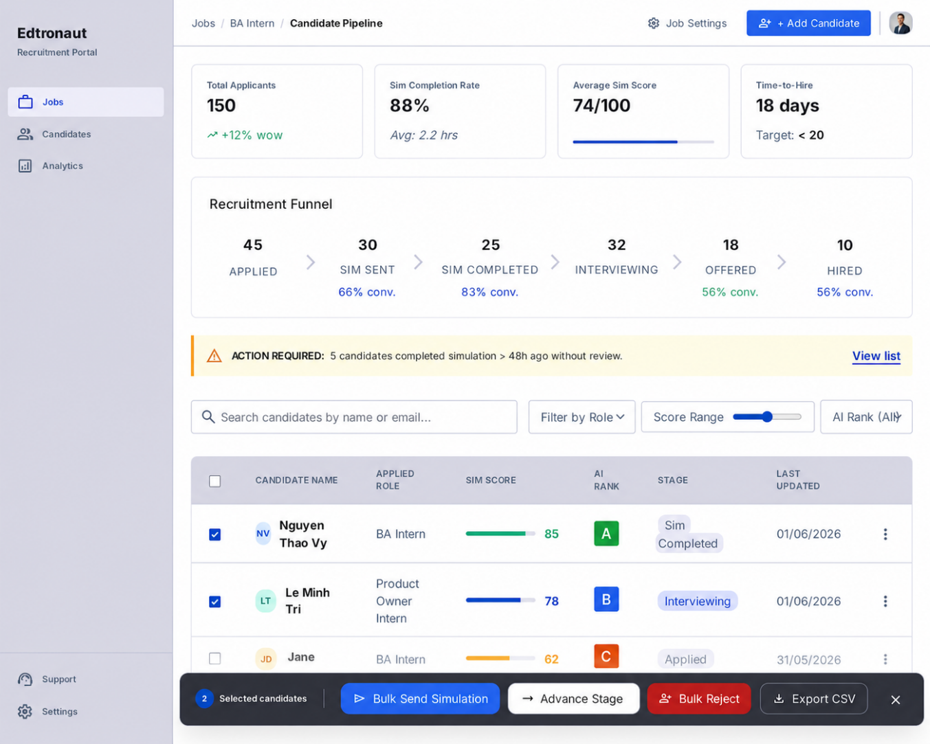
Figure C.1: Recruitment Dashboard — Main View

Screen 2: Candidate Detail View
- Layout: two-column asymmetric layout. Left column (65% width): analysis content. Right column (35% width): decision panel and activity log.
- Left column — Section 1: Candidate summary header with name, avatar, applied role, and embedded CV PDF viewer.
- Left column — Section 2: Simulation Score Report. Accuracy Score displayed as bar chart (0–100). Soft Skill Score displayed as bar chart (0–100). Time taken displayed with comparison to role benchmark average.
- Left column — Section 3: AI Narrative Summary. Text block containing AI-generated assessment of demonstrated strengths and identified development areas. Presented in a visually distinct callout box.
- Right column — Section 1: Decision action panel. Primary button: 'Approve to Interview'. Secondary button: 'Reject Candidate'. Conditional button: 'Send Simulation Link' (visible only for Interview First flow, when simulation not yet sent).
- Right column — Section 2: Reviewer Notes input area. Free-text field for recruiter or manager commentary. Existing notes displayed in chronological order with author attribution.
- Right column — Section 3: Activity Timeline. Chronological log of all actions taken on this candidate record, including system-generated events and human actions, with timestamp and actor identification.

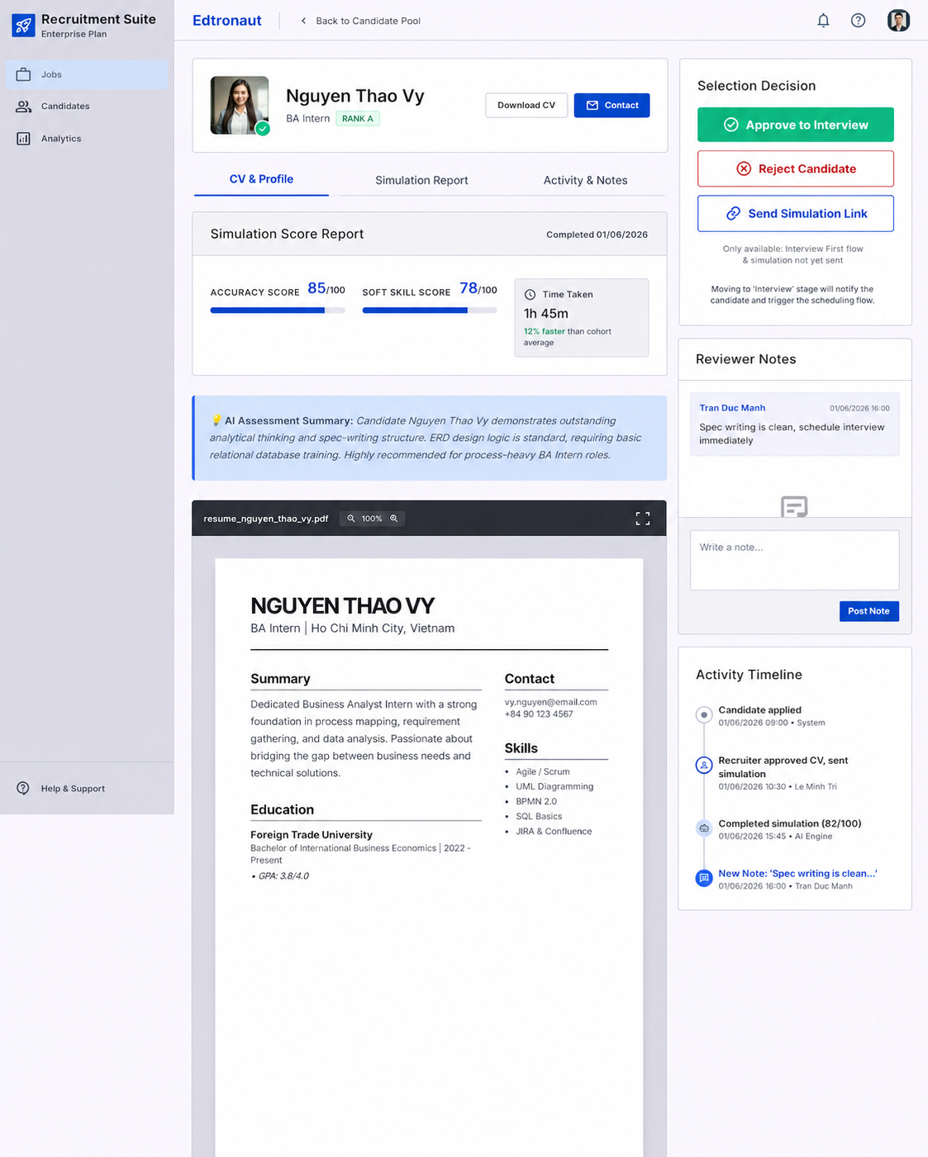
Figure C.2: Candidate Detail View

C.11 Acceptance Criteria — Recruitment Dashboard (Gherkin Format)

AC-01: View Candidate Pipeline by Role
Scenario: Recruiter views filtered pipeline for a specific job role
Given the Recruiter is logged in and on the main Recruitment Dashboard
And multiple job roles are active in the system
When the Recruiter selects 'BA Intern' from the 'Filter by Role' dropdown
Then the Funnel Widget MUST update to display stage counts for 'BA Intern' candidates only
And the Candidate Table MUST display only candidates who applied for 'BA Intern'
And the active filter tag 'Role: BA Intern' MUST appear above the table
And a 'Clear' button MUST be available to remove the role filter

AC-02: Filter Candidates by Simulation Score
Scenario: Recruiter filters candidates to display only those with scores in a specified range
Given the Recruiter is viewing the candidate list for job 'Product Owner Intern'
And the list contains 80 candidates with varying simulation scores
When the Recruiter sets the Simulation Score slider to a range of 75 to 100
And clicks 'Apply Filters'
Then the table MUST display only candidates with a simulation score >= 75
And the record count MUST reflect the filtered number: 'Showing N of 80 candidates'
And candidates who have not yet completed their simulation MUST NOT appear in the filtered results

AC-03: Send Simulation Invitation to Individual Candidate
Scenario: Recruiter sends a simulation invitation to a single candidate
Given the Recruiter is viewing the Candidate Detail page for candidate 'Nguyen Thao Vy'
And the candidate's current stage is 'Applied'
And the job flow configuration is set to 'Simulation First'
When the Recruiter clicks 'Send Simulation Link'
And confirms the action in the confirmation dialogue
Then the system MUST dispatch an invitation email to the candidate's registered email address within 5 seconds
And the email MUST contain a unique tokenised simulation link valid for 5 days
And the candidate's pipeline stage MUST update from 'Applied' to 'Simulation Sent'
And the Activity Timeline MUST record: 'Simulation invitation sent by [Recruiter Name] — [Timestamp]'

AC-04: Export Shortlist to CSV
Scenario: Recruiter exports a filtered candidate shortlist as a CSV file
Given the Recruiter has applied filters: Role = 'BA Intern', Score Range = 75–100, Stage = 'Simulation Completed'
And the filtered list contains 18 candidates
When the Recruiter clicks 'Export CSV' in the Bulk Action toolbar
Then the system MUST generate and download a CSV file within 3 seconds
And the CSV MUST contain columns: Candidate Name, Email, Applied Role, Simulation Score, AI Rank, Stage, Last Updated
And the CSV MUST contain exactly 18 data rows corresponding to the filtered results
And the filename MUST follow the pattern: 'Shortlist_[JobTitle]_[ExportDate].csv'

AC-05: Role-Based Access Control — TA Recruiter versus Hiring Manager
Scenario: Hiring Manager is restricted from accessing system configuration
Given user 'Tran Duc Manh' is logged in with the role 'Hiring Manager'
When the Hiring Manager navigates to the Recruitment Dashboard for his department
Then the Hiring Manager MUST be able to view all candidate profiles in his department
And the Hiring Manager MUST be able to add Reviewer Notes on candidate detail pages
But the 'Job Settings' button MUST NOT be visible or accessible to the Hiring Manager
And the 'Flow Configuration' toggle MUST NOT be visible or accessible to the Hiring Manager
And the 'Bulk Send Simulation' action MUST NOT be available to the Hiring Manager

AC-06: Candidate Detail View — Complete Information Display
Scenario: Recruiter reviews complete simulation results for a candidate who has completed assessment
Given the Recruiter is logged in
And candidate 'Nguyen Thao Vy' has completed the simulation with the following scores:
accuracy_score = 85, soft_skill_score = 78, time_taken = 6300 seconds, ai_rank = A
When the Recruiter clicks on 'Nguyen Thao Vy' in the candidate list
Then the Candidate Detail page MUST load within 1.5 seconds
And Tab 2 'Simulation Score Report' MUST display: Accuracy Score bar at 85/100, Soft Skill Score bar at 78/100
And the time taken MUST display as '1 hour 45 minutes'
And the AI Rank badge MUST display 'Rank A' in the appropriate visual style
And the AI Narrative Summary section MUST display the AI-generated assessment text
And the 'Approve to Interview' and 'Reject Candidate' buttons MUST be visible and active

PART D: PROJECT PLAN

D.1 MVP Definition
MVP v1 scope is bounded to the Recruitment Dashboard (Scope 1), targeting the TA Recruiter persona. The MVP delivers a single, centralised interface integrating AI Simulation Engine output with candidate pipeline management, enabling the recruiter to filter, rank, review, and action candidates without switching between multiple disconnected systems.
In-scope for MVP v1: All functional requirements marked MUST in Section C.5 (FR-DASH-001, FR-DASH-002, FR-LIST-001, FR-LIST-002, FR-ACT-001, FR-DETAIL-001, FR-DETAIL-002, FR-RBAC-001) and all non-functional requirements in Section C.6.
Out of scope for MVP v1: Real-time ATS synchronisation, custom email template editor, PDF report generation, SSO integration, calendar scheduling integration, and spider chart competency visualisation. These are explicitly deferred to Phase 2.

D.2 Timeline and Milestones — 6-Week Delivery Plan

Week | Sprint | Deliverable | Owner | Milestone
1 | Sprint 1 | Environment setup. Database schema deployed to staging. Swagger API Spec document approved. | BE Dev, BA/PO
2 | Sprint 1 | Main Dashboard UI implemented: candidate list, filters, pagination, KPI tiles, funnel widget. Mock data connected. | FE Dev, BE Dev
3 | Sprint 1 | Candidate Detail View UI implemented. Mock API integration for Score Report and AI Summary. Internal demo preparation. | FE Dev, BE Dev | Milestone 1: Internal Demo — recruiter can view list, filter candidates, open detail view, add reviewer notes.
4 | Sprint 2 | Bulk Action toolbar implemented. Email dispatch integration (SendGrid/SES). Tokenised simulation links generated and tested. | BE Dev, FE Dev
5 | Sprint 2 | RBAC enforcement implemented and tested. Audit log module developed. Recruiter training sessions conducted. | BE Dev, QA, BA/PO
6 | Sprint 2 | Live AI Simulation Engine API connected. Performance optimisation (NFR-PERF-001, NFR-PERF-002). UAT with client TA team. Bug fixes. Production deployment. | Full Team | Milestone 2: Go-Live — system available to 20 pilot recruiters.

D.3 Team Structure and Responsibilities

Role | Responsibilities
BA / PO (1 person) | Requirements ownership, PRD maintenance, backlog grooming, sprint planning, UAT coordination, stakeholder communication.
Frontend Engineer (2 people) | Dashboard UI implementation, component development, responsive layout, integration with Backend APIs.
AI Engineer (1 + 1 support) | AI Simulation Engine API development, score calculation model, narrative summary generation, mock API for development use.
Backend Engineer (1 person) | Database schema, REST API development, RBAC implementation, audit log module, email service integration, performance optimisation.

D.4 Dependencies and Risks

Risk ID | Description | Probability | Impact | Mitigation Strategy
RSK-001 | AI Simulation Engine API not ready on schedule: AI team does not deliver live API by Week 6, blocking final integration. | High | High | Design a Mock Data Layer conforming to the agreed API contract in Week 1. All dashboard features develop against the mock. Live API swap in Week 6 requires only endpoint reconfiguration, not code changes.
RSK-002 | PDPA compliance review delays go-live: Legal review of PII handling and data retention policies extends beyond planned timeline. | Medium | High | Engage Legal team from Week 1 in PRD review. Ensure AES-256 encryption and Right to Erasure mechanism are designed and approved on paper before development begins in Week 2.
RSK-003 | Recruiter adoption resistance: TA team continues using existing Excel and email workflows rather than migrating to the platform. | High | Medium | Nominate a TA Champion user in Week 3 to use the system during development and provide feedback. Conduct two hands-on training sessions in Week 5 before go-live.
RSK-004 | AI score schema volatility: AI Engine changes the structure of the score response payload mid-development, breaking dashboard data display. | Low | High | Store score data as JSONB in PostgreSQL with a flexible schema. Dashboard UI reads field configuration dynamically, ensuring schema changes do not require frontend code modifications.

D.5 Product Success Metrics & North Star
To prove long-term product efficacy and ROI, progress is measured using a core hierarchical metrics system, anchored by a singular North Star Metric:
NORTH STAR METRIC: Qualified Candidate Conversion Rate
Definition: The percentage of candidates who pass the AI Simulation screening stage and subsequently pass the subsequent technical face-to-face interview. Target: >= 65% (an increase from the current baseline of 25% under subjective CV screening).
Why this is the North Star: This metric directly measures the predictive validity and business value of the Job Simulation. A high conversion rate indicates the system is successfully filtering out 'CV-fluff' and only delivering highly-capable talent to hiring managers, saving expensive interview hours.

First 30 Days Post Go-Live KPI Matrix

Metric Category | Metric Name | Definition and Target | Measurement Method
North Star | Qualified Candidate Conversion Rate | Target: >= 65% of simulation-passed candidates successfully clear the technical interview. | Funnel outcome logs: [Interview Passed] / [Simulation Passed] * 100
Adoption | System Adoption Rate | Target: >= 85% of active recruiters using the dashboard at least 3 sessions per week. | User session tracking, clickstream analytics.
Efficiency | Review Cycle Time Reduction | Target: >= 45% reduction in average time from simulation completion to recruiter decision (from 4 hours to < 20 minutes). | Timestamp delta: simulation_submitted_at vs. reviewer_note.created_at
Experience | Candidate Experience Score | Target: >= 4.2 / 5.0 satisfaction score from post-simulation surveys. | Automated feedback survey triggered 24h post-simulation.

D.6 Strategic Product Vision and Future Roadmap
To prove robust product ownership and vision beyond the MVP v1, the product transition from Recruitment Dashboard to a holistic Enterprise Talent Suite is structured across three logical horizons:

Horizon | Focus Area | Key Deliverables | Target Window
Phase 1 (MVP) | Recruitment Dashboard & AI Screening Core | Centralised candidate pipeline, score rendering, bulk invitations, Gherkin compliance, Flat CSV export. | Weeks 1 - 6
Phase 2 | ATS Integrations & Calendar Scheduling | Bi-directional webhook sync with Greenhouse/Workable, SAML 2.0 SSO, Google/Outlook Calendar scheduling integration, spider skill matrix visualization. | Months 2 - 4
Phase 3 | Onboarding & continuous Upskilling suite | Micro-simulation onboarding plans, dynamic skillMatrix database, adaptive learning path assignments, automated promotion recommendation loops. | Months 5 - 8

