ASSIGNMENT 1

Web Application Development

Student name: Duy Thuc Pham
Student number: 101767225
COS80021

Table of Contents
Project Structure 3
CSS 3
SQL 3
PHP files 3
How To Use 5
Database 5
Using System 6

Project Structure
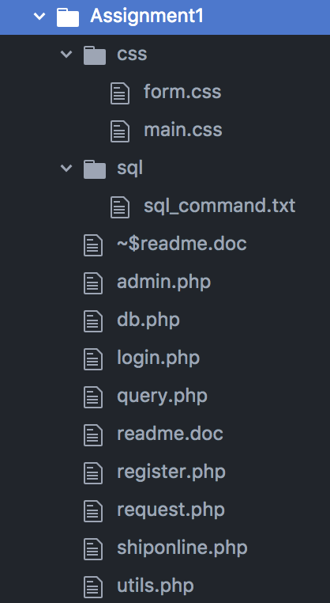

CSS
This folder includes two files form.css and main.css which use to support the UI of project.
Main.css
This file uses to set background color and text color for the whole project.
Form.css
This file is used to set up the UI for elements in a form.

SQL
This folder includes file sql_command.txt which contains the sql command to create table customer and request for this project.

PHP files
admin.php
This file includes the HTML script which help to display the UI, draw a table. It also contains the logical code to allow users to view requests by pickup date or request date.
db.php
This file uses to configure the Mysql information and connect to Mysql.
login.php
This file includes the HTML script which help to display the UI and the logical code in php to manage the login feature.

query.php
This file includes all queries that use in the project such as insert new customer, create new request, login, retrieve list of request by request date etc.
register.php
This file has the HTLM script to display the interface and the php code to allow users to register their information.
request.php
This file uses to create a request by having a form to allow users enter request information.
shiponline.php
This file is the main page of the web page, including three main features: login, registration and administration
utils.php
The Utils class which help reduce the code duplication and easy to call in other files.

How To Use

Database
Two table customer and request have been created in my Swinburne mysql.
https://feenix-mariadb-web.swin.edu.au
In order to create a new one, just simply using the code from the file sql_command.txt. Typing the command mysql –u [username] –p and enter the password. Next create the customer table first as the request table includes the foreign key with it.
Customer
CREATE TABLE customer (
customer_number int(10) UNSIGNED PRIMARY KEY AUTO_INCREMENT,
customer_name varchar(30) NOT NULL,
customer_email varchar(50) NOT NULL,
customer_password varchar(30) NOT NULL,
customer_phone varchar(10) NOT NULL
);
Request
CREATE TABLE request (
request_number int(10) UNSIGNED PRIMARY KEY AUTO_INCREMENT,
customer_number int(10) UNSIGNED NOT NULL,
request_date timestamp NOT NULL DEFAULT CURRENT_TIMESTAMP ON UPDATE CURRENT_TIMESTAMP,
item_description varchar(50) NOT NULL,
weight int(11) NOT NULL,
pickup_address varchar(50) NOT NULL,
pickup_suburb varchar(10) NOT NULL,
pickup_date_time datetime NOT NULL,
receiver_name varchar(30) NOT NULL,
receiver_address varchar(50) NOT NULL,
receiver_suburb varchar(10) NOT NULL,
receiver_state varchar(10) NOT NULL,
FOREIGN KEY (customer_number) REFERENCES customer(customer_number) ON DELETE CASCADE
);

Using System
To start the system the user must go to this home page
https://mercury.swin.edu.au/cos80021/s101767225/Assignment1/shiponline.php
There are three main features registration, login and administration in this page. There are several accounts that have been registered to login in the project, which help to login the project.
User 1:
Customer number: 1
Password: 123
User 2:
Customer number: 3
Password: 123

If users want to create a new account, they can manually register by themselves at Registration page.
https://mercury.swin.edu.au/cos80021/s101767225/Assignment1/register.php
Registration
Users use this page to create their account. After users provide all information, they click register button to create an account. Note that the password and confirmed password must match, the email must be valid and unique and the phone number must be more than 6 digits. If the registration is successful, the system displays a message like the image below, containing the customer number which uses to login.
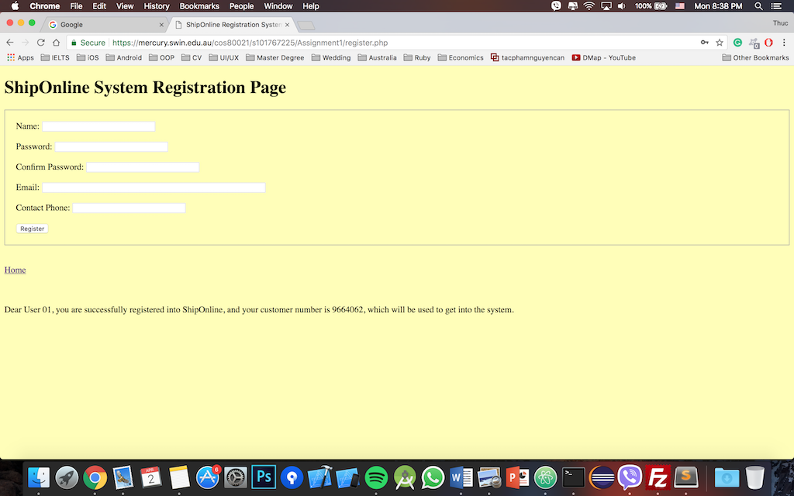
Login
Now the user can use the customer number to login to the system by selecting login button in home screen or by using this link.
https://mercury.swin.edu.au/cos80021/s101767225/Assignment1/login.php
If the user provides the correct customer number and password, they will go to Request Page, in which they can create a delivery request. Otherwise, the error message will show to let the user know what an error is.
Request
https://mercury.swin.edu.au/cos80021/s101767225/Assignment1/request.php
The user can request a delivery by providing sufficient data in this page. After successfully creating a request, the cost and delivery information will be displayed like the image. Also, an email is sent to the email that the user uses to create the account.
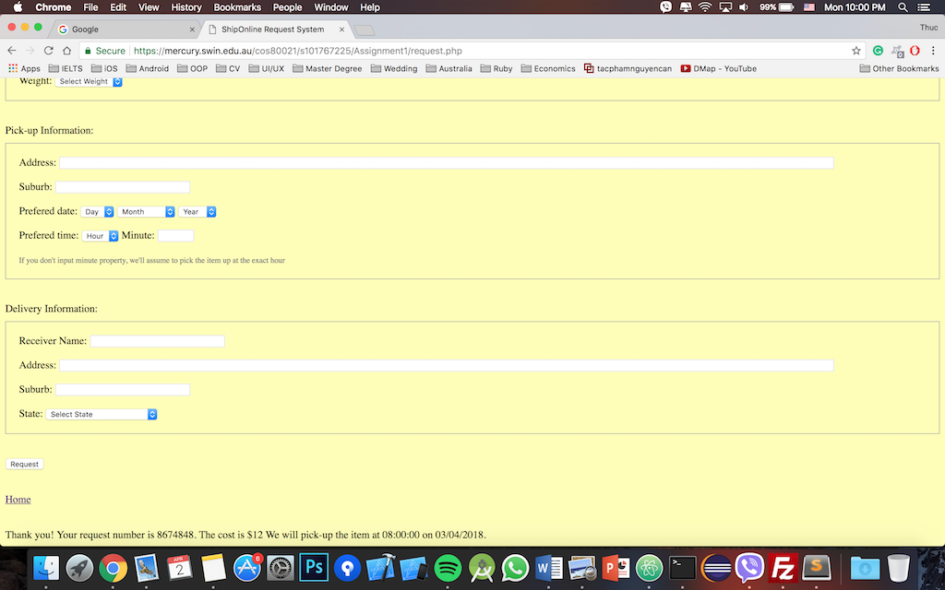

Administration
This page uses to view request based on the request date and pick up date.
https://mercury.swin.edu.au/cos80021/s101767225/Assignment1/admin.php

