Name: Huynh Chung Duy Thuc
ID: ITCSIU22284

Exe5:
Search and highlight
Main query: “SELECT * FROM students WHERE full_name LIKE ? OR student_code LIKE ? ORDER BY id DESC”

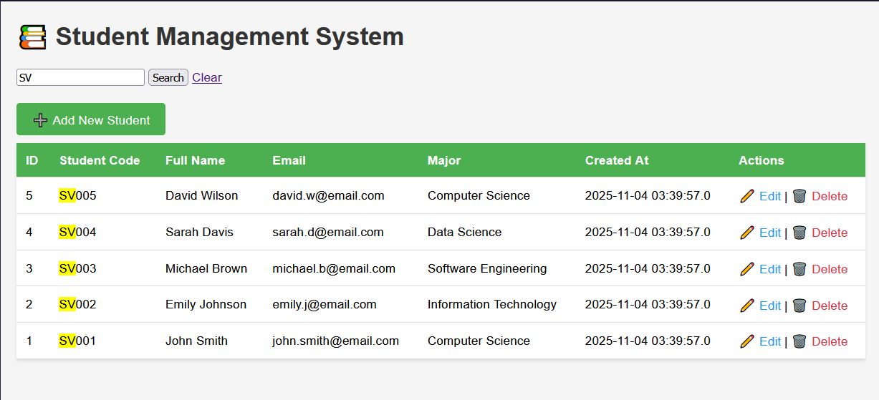

Exe6:
Exe7:
