Name: Huynh Chung Duy Thuc
Id: ITCSIU22284

Docker Usage to start Datavase and tomcat web server
docker-compose up -d

build app maven
mvn clean package

restart
docker-compose restart tomcat

List students
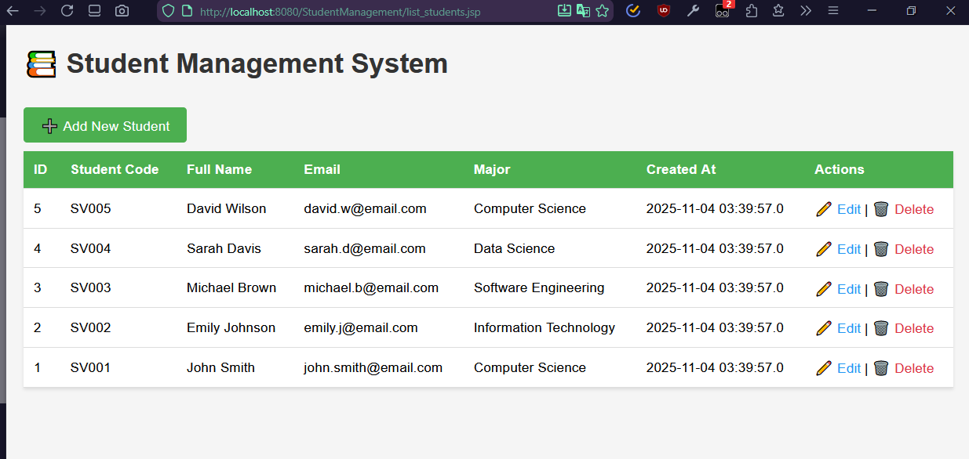

Add student
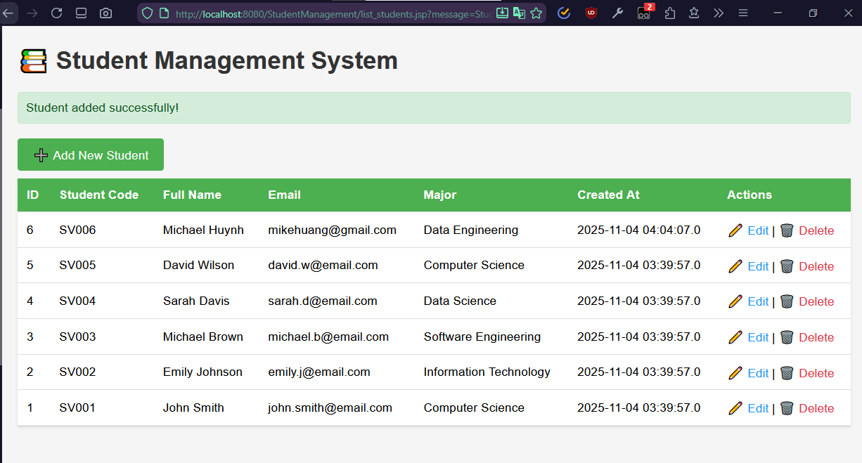
Edit Student
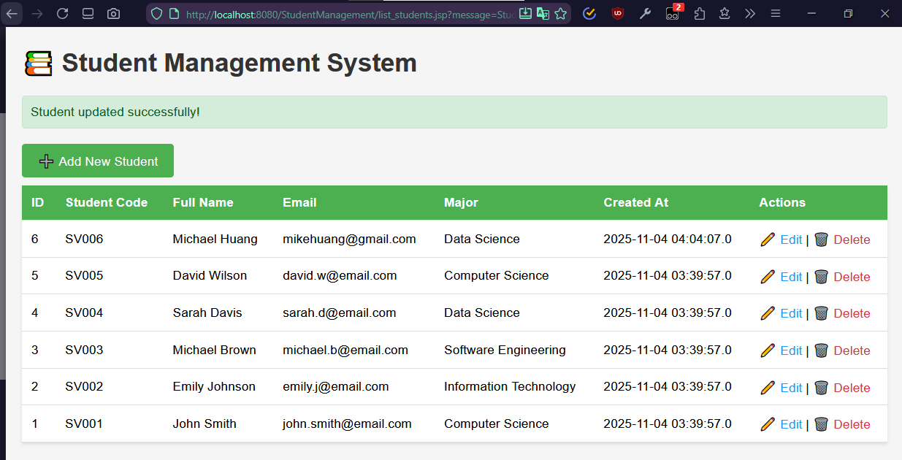
Delete Student
