1. Input: Hình ảnh kích thước 240p

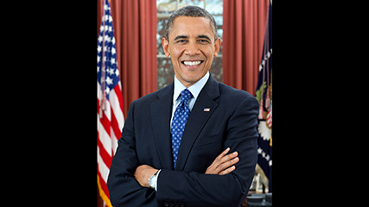

*obama-240p*

Output: Timings at 240p:

- Face locations: 0.0659s (15.18 fps)

- Face landmarks: 0.0032s (317.25 fps)

- Encode face (inc. landmarks): 0.0699s (14.30 fps)

- End-to-end: 0.1366s (7.32 fps)

1. Input: Hình ảnh kích thước 480p

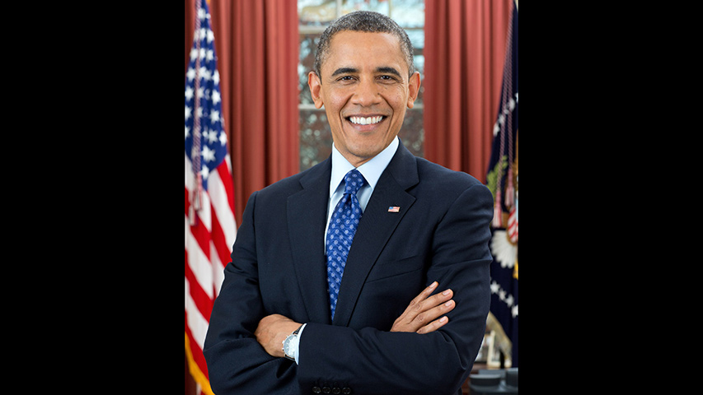

*obama-480p*

Output: Timings at 480p:

- Face locations: 0.2618s (3.82 fps)

- Face landmarks: 0.0030s (332.99 fps)

- Encode face (inc. landmarks): 0.0934s (10.71 fps)

- End-to-end: 0.3541s (2.82 fps)

1. Input: Hình ảnh kích thước 720p

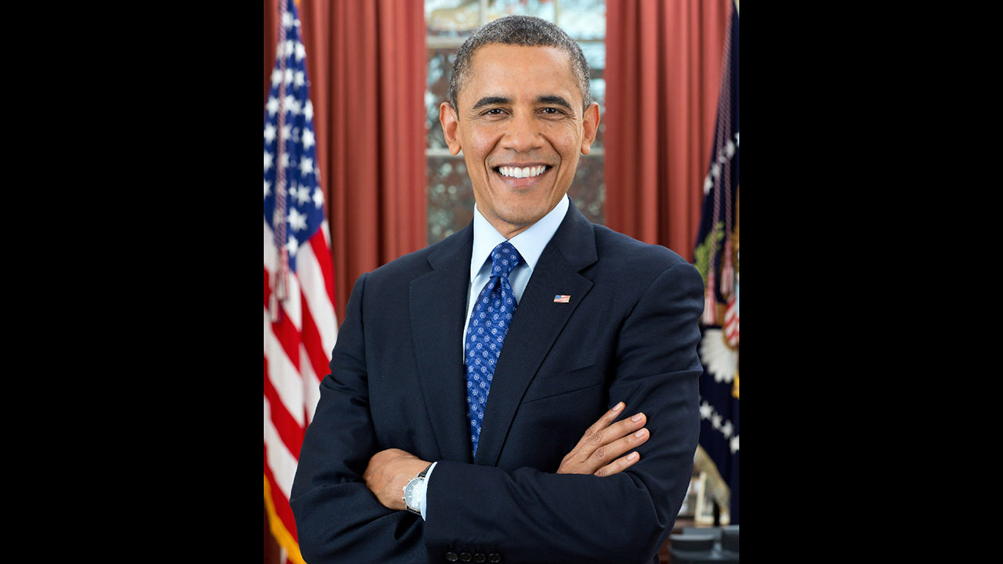

*obama-720p*

Output: Timings at 720p:

- Face locations: 0.5993s (1.67 fps)

- Face landmarks: 0.0032s (314.03 fps)

- Encode face (inc. landmarks): 0.0933s (10.72 fps)

- End-to-end: 0.6861s (1.46 fps)

1. Input: Hình ảnh kích thước 1080p

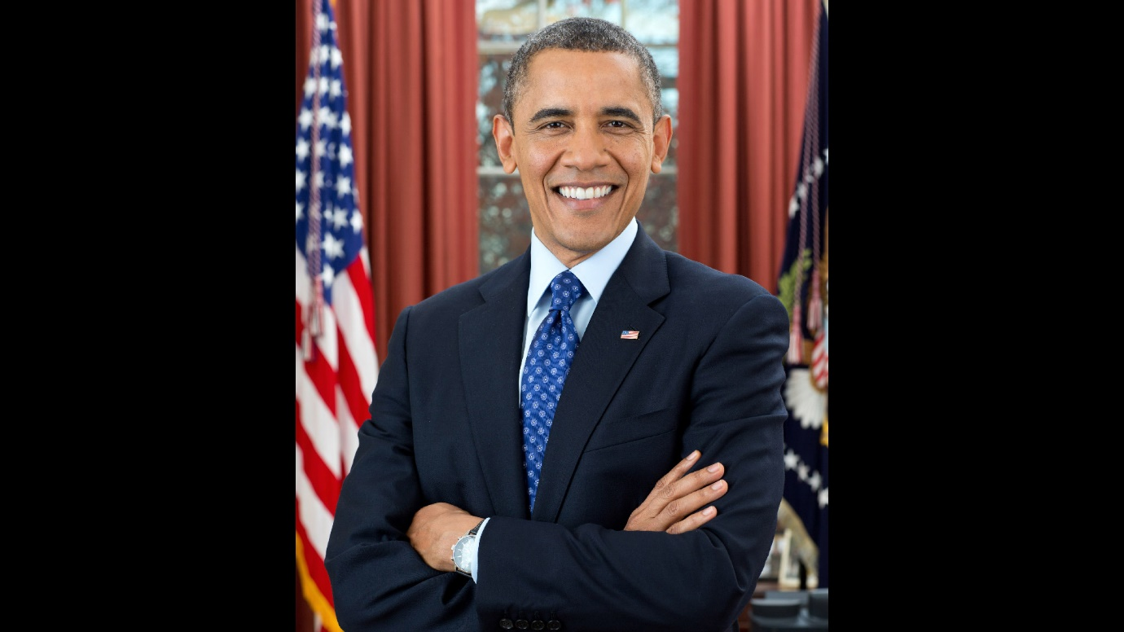

*obama-1080p*

Output: Timings at 1080p:

- Face locations: 1.3327s (0.75 fps)

- Face landmarks: 0.0032s (309.59 fps)

- Encode face (inc. landmarks): 0.0783s (12.77 fps)

- End-to-end: 1.4766s (0.68 fps)