**Ảnh đã biết (The known images)**

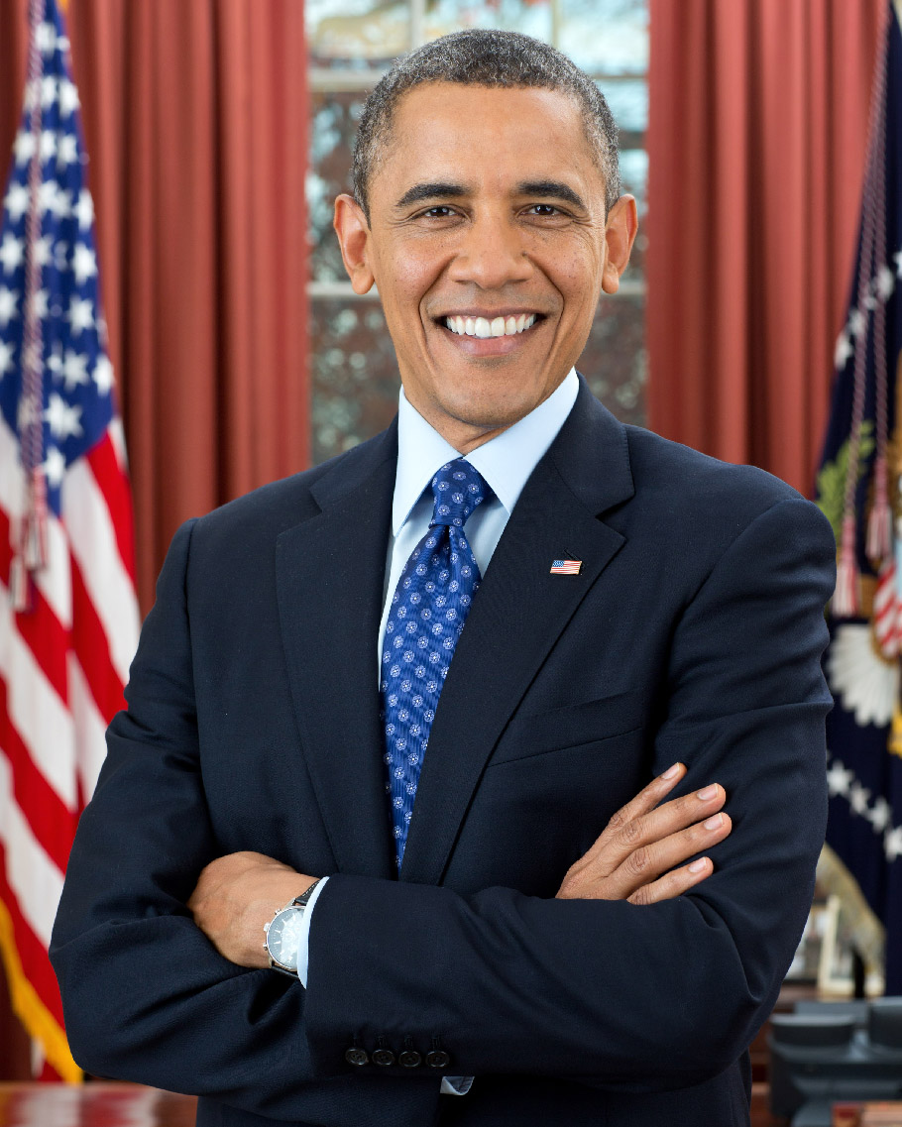

obama.jpg

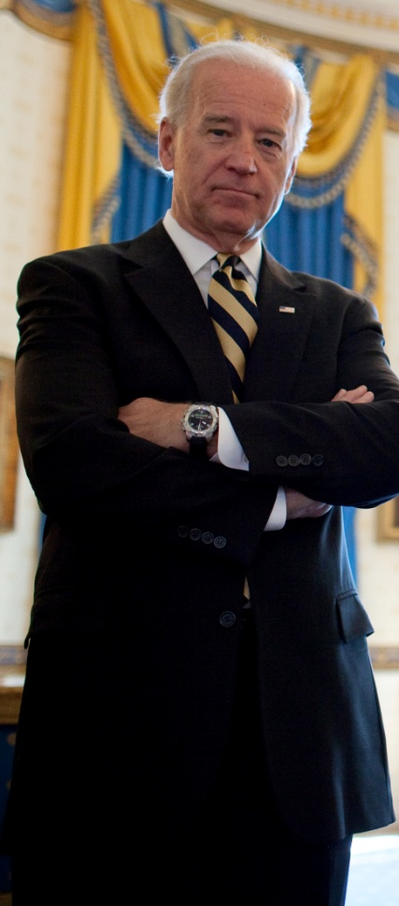

biden.jpg

**Ảnh test**

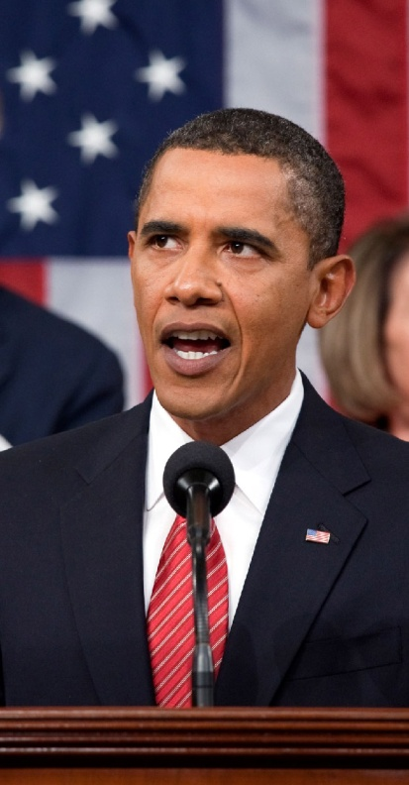

obama2.jpg

**Kết quả sau khi chạy face_distance.py**

The test image has a distance of 0.35 from known image #0 (obama.jpg)

- With a normal cutoff of 0.6, would the test image match the known image? True

- With a very strict cutoff of 0.5, would the test image match the known image? True

The test image has a distance of 0.82 from known image #1 (biden.jpg)

- With a normal cutoff of 0.6, would the test image match the known image? False

- With a very strict cutoff of 0.5, would the test image match the known image? False