* Input:

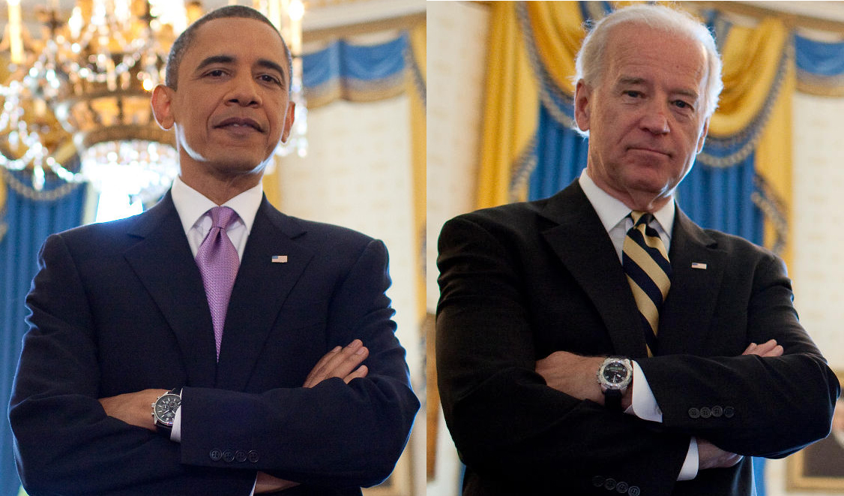

* Output: Tìm và đánh dấu các đặc trưng có trên khuôn mặt bằng các đường thẳng

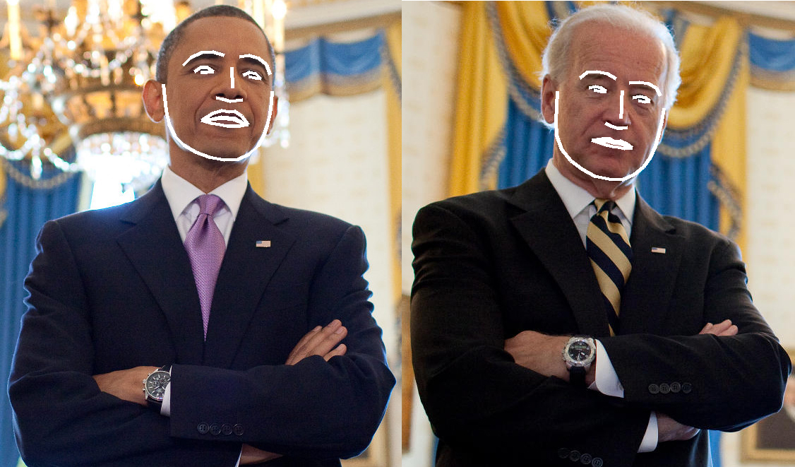

In ra vị trí của các đặc trưng tìm được:

I found 2 face(s) in this photograph.

* Face 1:
* The chin in this face has the following points: [(231, 119), (233, 138), (235, 156), (239, 175), (247, 192), (260, 205), (277, 215), (296, 222), (317, 226), (337, 225), (352, 218), (365, 206), (373, 192), (378, 177), (382, 161), (384, 144), (385, 129)]
* The left_eyebrow in this face has the following points: [(259, 92), (270, 81), (285, 74), (301, 73), (317, 78)]
* The right_eyebrow in this face has the following points: [(339, 80), (352, 78), (366, 82), (377, 91), (382, 105)]
* The nose_bridge in this face has the following points: [(328, 95), (328, 105), (329, 114), (329, 124)]
* The nose_tip in this face has the following points: [(306, 138), (315, 140), (326, 143), (334, 142), (343, 141)]
* The left_eye in this face has the following points: [(275, 101), (284, 95), (293, 95), (302, 101), (293, 102), (284, 102)]
* The right_eye in this face has the following points: [(344, 106), (353, 102), (362, 104), (369, 111), (361, 110), (352, 108)]
* The top_lip in this face has the following points: [(285, 170), (301, 160), (314, 156), (324, 158), (332, 157), (342, 164), (351, 176), (346, 175), (332, 167), (323, 166), (313, 165), (291, 170)]
* The bottom_lip in this face has the following points: [(351, 176), (340, 178), (330, 178), (321, 178), (311, 176), (299, 174), (285, 170), (291, 170), (313, 167), (322, 168), (331, 169), (346, 175)]
* Face 2:
* The chin in this face has the following points: [(789, 129), (788, 150), (787, 171), (788, 191), (795, 211), (808, 227), (824, 239), (842, 249), (862, 253), (881, 254), (897, 247), (911, 236), (921, 222), (928, 206), (933, 188), (937, 171), (940, 153)]
* The left_eyebrow in this face has the following points: [(821, 110), (831, 102), (845, 101), (860, 104), (872, 111)]
* The right_eyebrow in this face has the following points: [(891, 117), (905, 116), (918, 118), (929, 124), (935, 135)]
* The nose_bridge in this face has the following points: [(881, 128), (880, 141), (880, 154), (879, 167)]
* The nose_tip in this face has the following points: [(857, 174), (865, 178), (874, 181), (881, 181), (888, 180)]
* The left_eye in this face has the following points: [(834, 124), (843, 122), (851, 124), (858, 129), (850, 129), (841, 127)]
* The right_eye in this face has the following points: [(896, 138), (906, 136), (914, 138), (920, 143), (913, 144), (904, 142)]
* The top_lip in this face has the following points: [(838, 198), (852, 196), (863, 196), (870, 200), (878, 199), (887, 203), (895, 209), (891, 207), (877, 203), (869, 202), (862, 200), (842, 198)]
* The bottom_lip in this face has the following points: [(895, 209), (884, 210), (875, 208), (867, 207), (859, 205), (850, 202), (838, 198), (842, 198), (861, 199), (869, 201), (877, 202), (891, 207)]

