**Ảnh đã biết (The known images)**

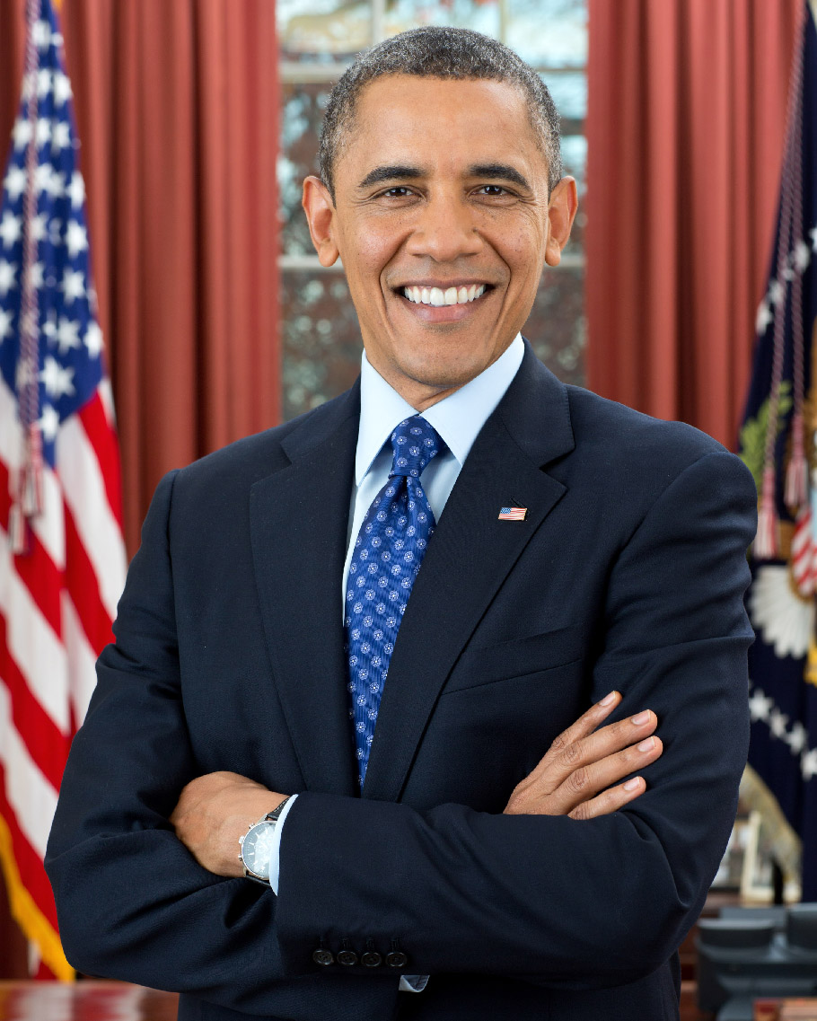

obama.jpg

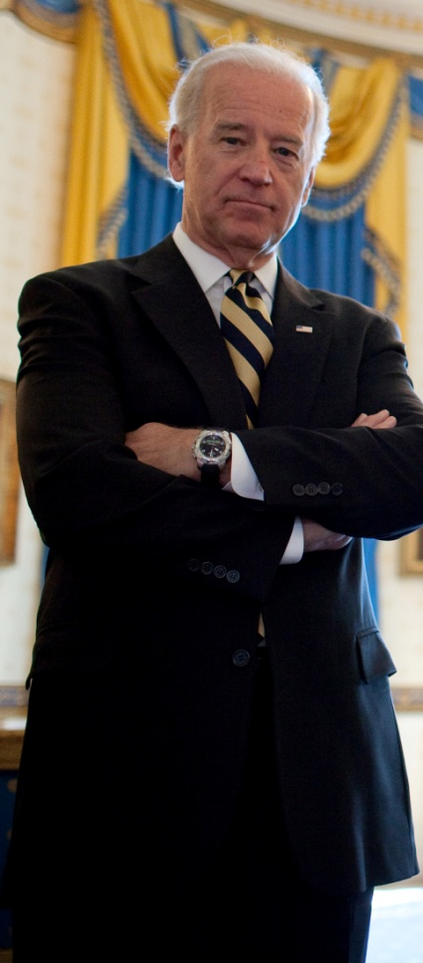

biden.jpg

**Ảnh test**

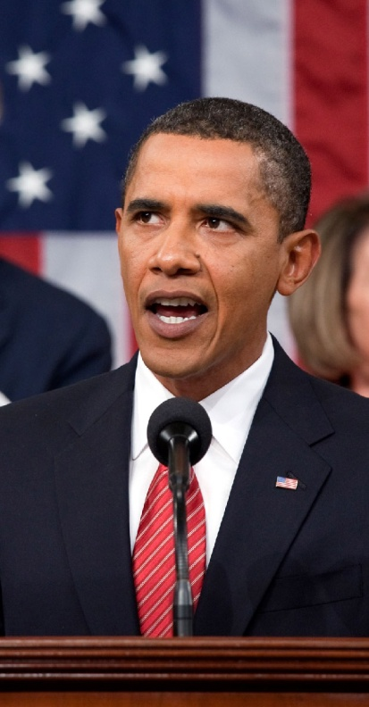

obama2.jpg

**Kết quả sau khi chạy recognize_faces_in_pictures.py**

Is the unknown face a picture of Biden? False

Is the unknown face a picture of Obama? True

Is the unknown face a new person that we've never seen before? False