# Milestone 1: Environment Setup

Task: Install VMware Workstation and create a new VM.

Objective: Prepare a VM environment on your local system.

Expected Outcome: Successfully install and configure VMware Workstation and launch a VM instance.

# Milestone 2: OS Installation

Task: Install Windows Server OS on the VM.

Objective: Set up a Windows Server instance as the primary VM environment for migration.

Expected Outcome: A running Windows Server OS with initial configurations complete.

# Milestone 3: Application Deployment

Task: Deploy a “Hello World” web application on the Windows Server.

Objective: Test basic server and network functionality.

Expected Outcome: The “Hello World” application should be accessible via a web browser within the VM network.

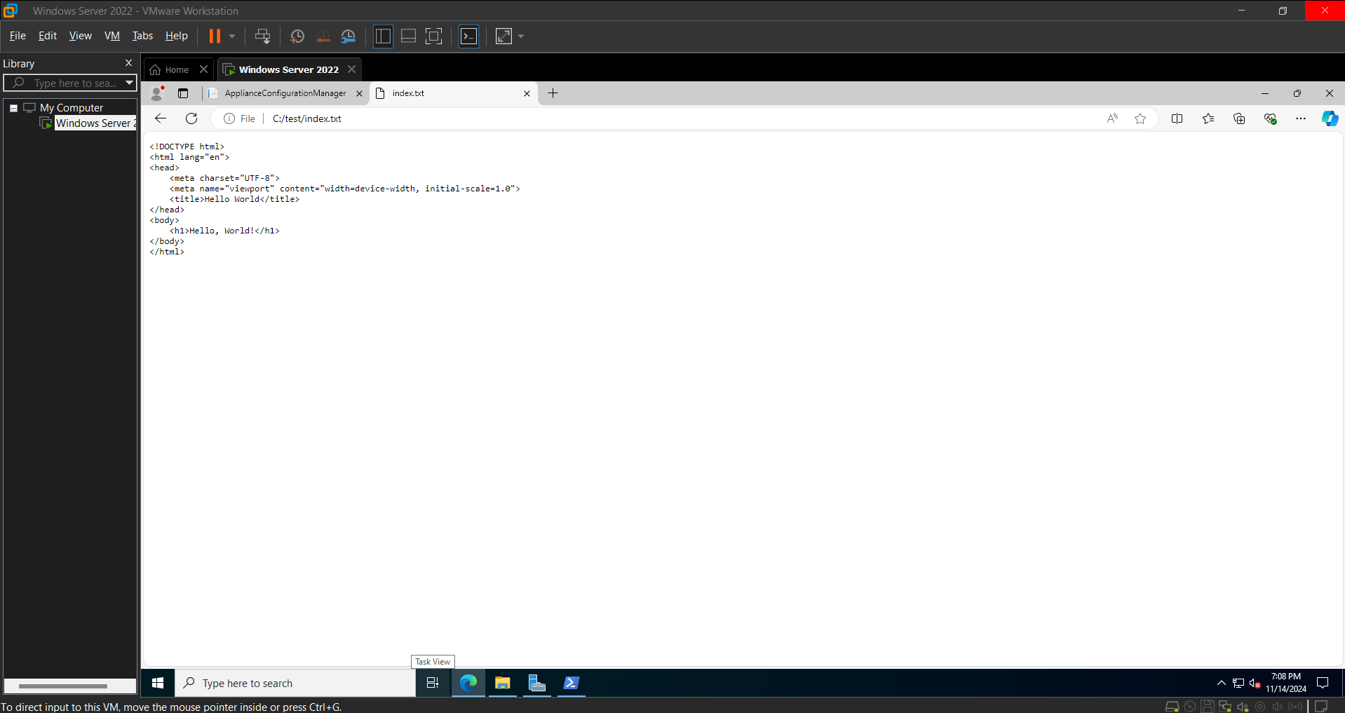

# Milestone 4: Migration Assessment

Task: Use Azure Migrate to perform an assessment of the VM for migration readiness.

Objective: Evaluate the VM’s compatibility with Azure and note any necessary adjustments.

Expected Outcome: A complete migration readiness assessment report, identifying compatibility issues and recommendations.

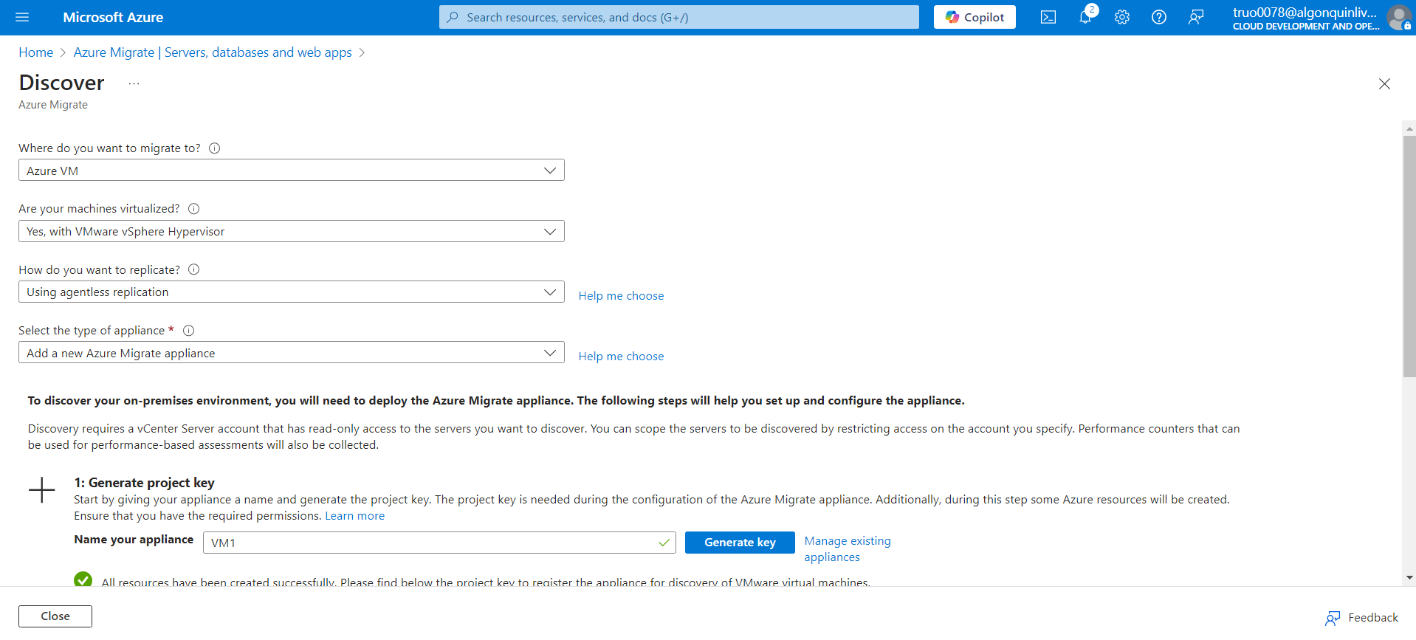

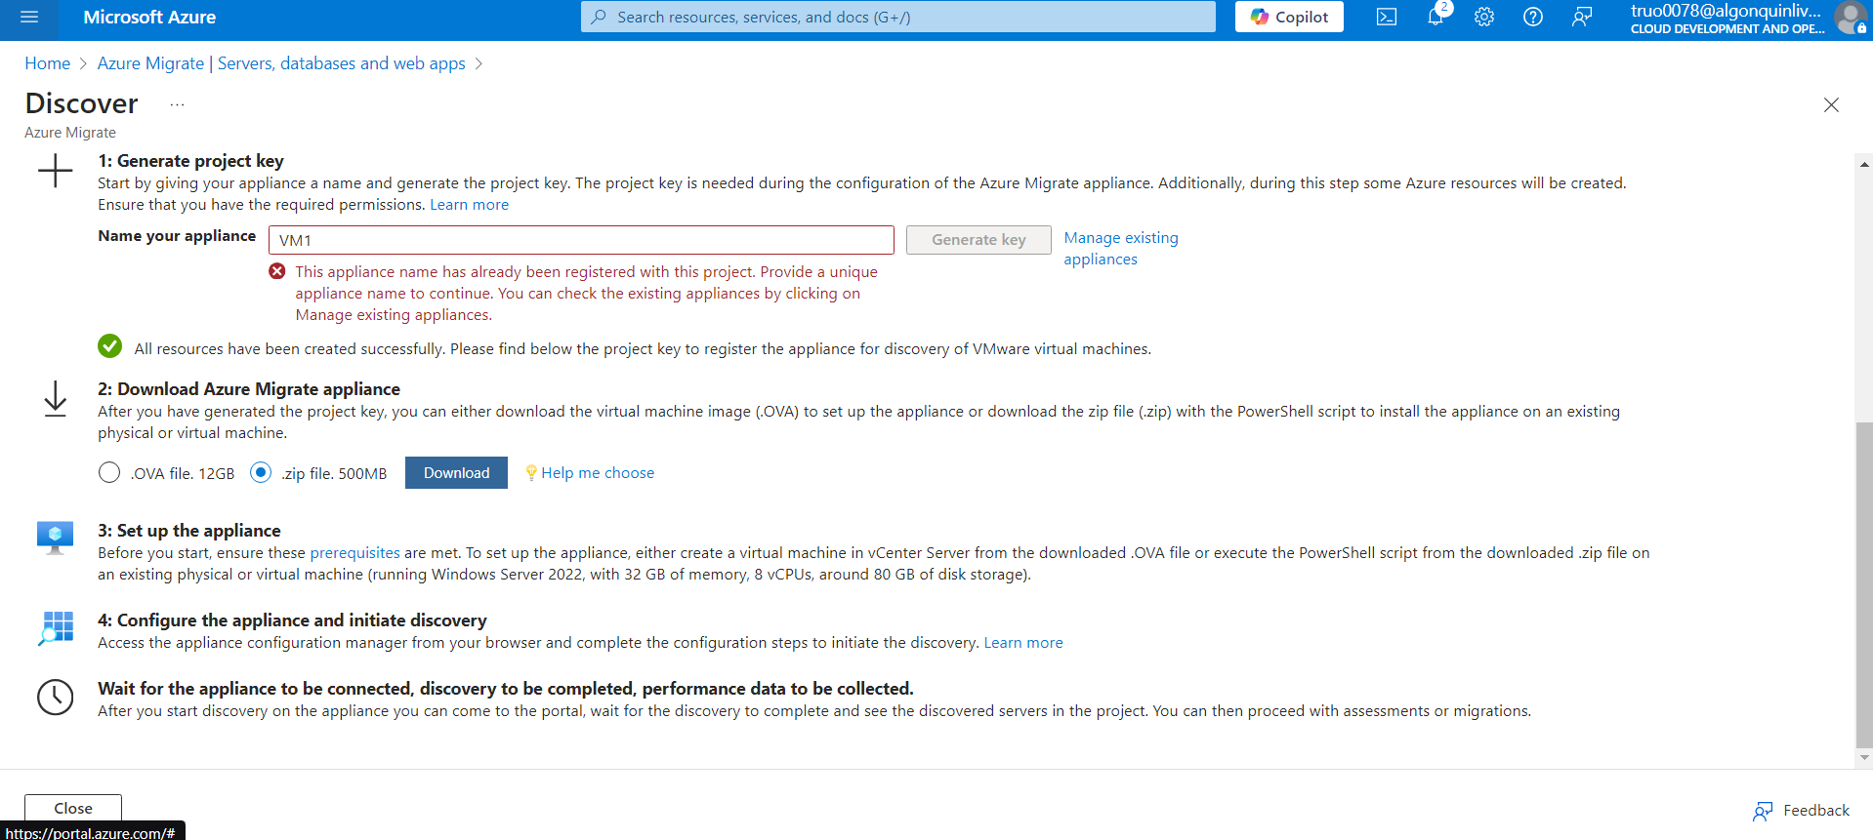

# Milestone 5: VM Migration Execution

Task: Migrate the VM to Azure using Azure Migrate tools.

Objective: Complete the VM migration to Azure and set up the necessary resources for it to run in the cloud.

Expected Outcome: The VM instance should be successfully migrated to Azure, with all required configurations applied.

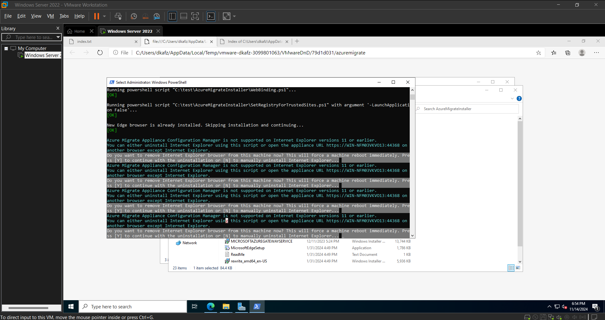

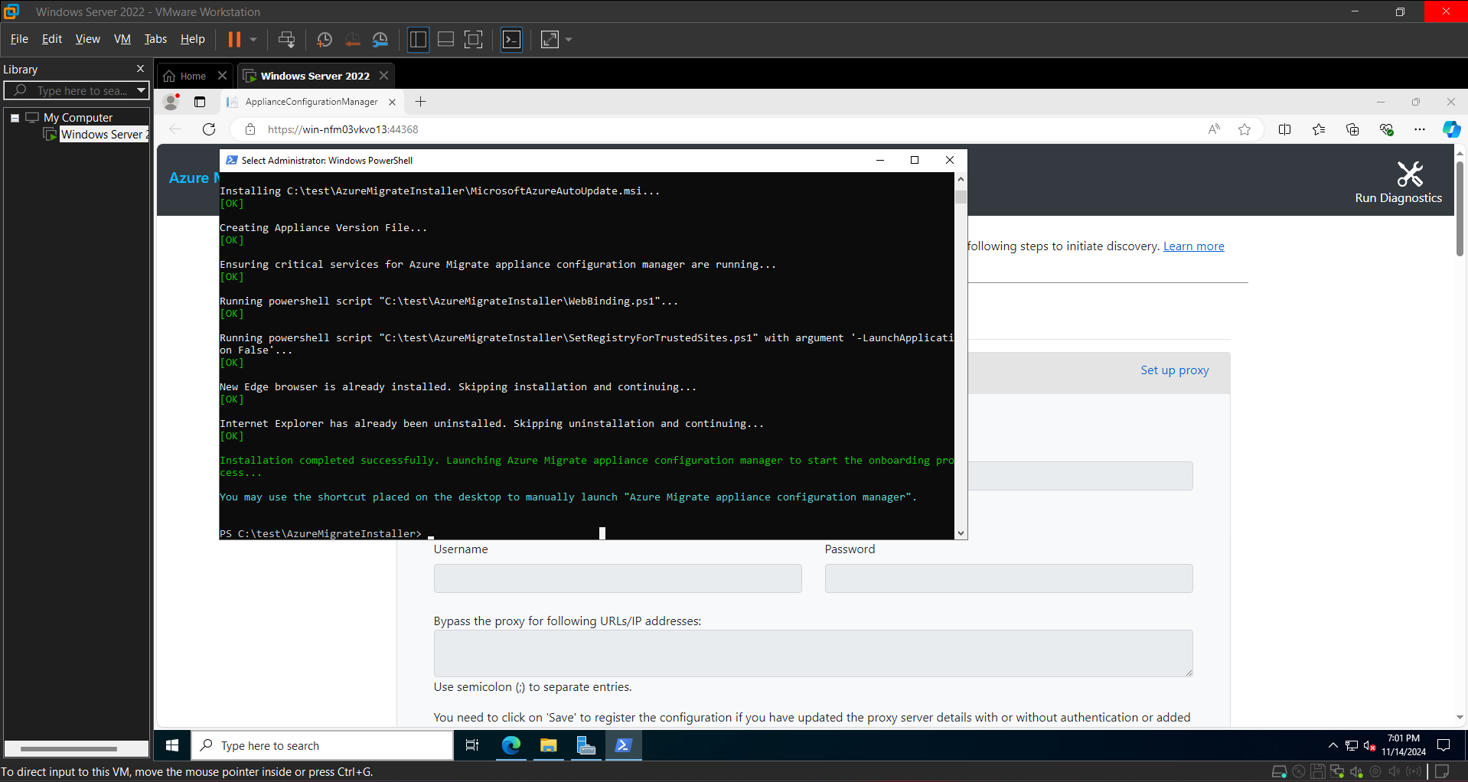

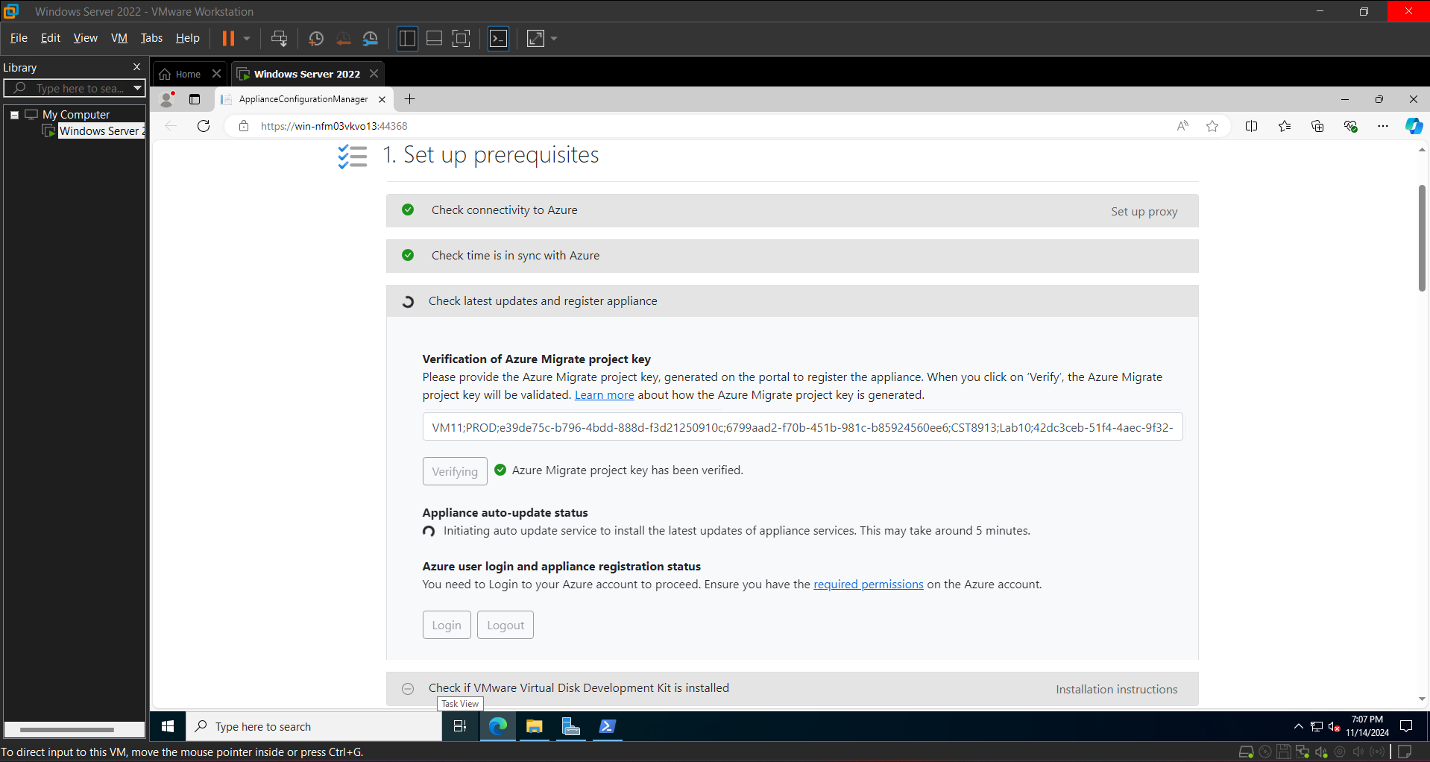

# Milestone 6: Validation and Failover Testing

Task: Validate the migrated VM's functionality by accessing the “Hello World” application in Azure. Then, conduct a failover test.

Objective: Ensure the application runs as expected post-migration and that failover mechanisms work effectively.

Expected Outcome: Verification that the “Hello World” application is functional in Azure and resilient to failover scenarios.