

Requirement & Design Specification
Laptop Website
Version: 1.0

Record of Changes
Version | Date | A*  M, D | In charge | Change Description
V1.0 | 11/5 | A | duytkce180366 | Initialise the document
v1.1 | 16/5 | M | duytkce180366 | - Develop a use case diagram and provide a detailed description of the use cases for the "User" and "Customer" roles.  - Create an Entity-Relationship Diagram (ERD) for the system.
v1.1 | 16/5 | M | TrinhLTKCE190422 | - Develop a use case diagram and provide a detailed description of the use cases for the “Staff” and “Customer” roles
v1.1 | 16/5 | M | AnhVLTCE200360 | Design a screen flow for the "Customer" interface
v1.1 | 16/5 | M | KhangNLCE200063 | Design a screen flow for the “Guest” and “Admin” interface
v1.1 | 16/5 | M | HaoVKCE200157 | Create a code package diagram for the project
v1.1 | 16/5 | M | AnhVLTCE200360 | Design and document the database schema for the system
v1.1 | 16/5 | M | HaoVKCE200157 | Design a screen flow for the “Staff” interface
v1.2 | 23/5 | M | DuyTKCE180366 | Develop the requirement specification and design specification for the use case:
*A - Added M - Modified D - Deleted

INTRODUCTION
This Test Plan outlines the Scope, Approach, Resources, and Schedule for testing the Laptop E-commerce Website Project. It includes key Testing Components such as Features to be Evaluated, Types of Tests, Responsible Personnel, Required Resources, and the Testing Timeline. Additionally, it identifies Potential Risks and Mitigation Strategies to ensure a Smooth Testing Process.
The Laptop E-commerce Website is an Online Shopping System designed specifically for retailing laptops, computer components, and tech accessories. The Platform allows Customers to easily Search for Products, Compare Specifications, Place Orders, and Track Deliveries Anytime, Anywhere. At the same time, Store Owners and Staff can Manage Inventory, Process Orders, Track Customer Preferences, and Optimize Operational Efficiency.
The Goal of the Laptop E-commerce Website is to Replace Traditional Retail Methods or Outdated Systems with a Modern Platform that Reduces Errors, Saves Time, and Enhances User Experience. The System also Helps Stores Expand their Customer Base, Optimize Revenue, and Drive Growth in the Tech Retail Industry.

Vision
Our vision is to revolutionise the tech shopping experience by providing a smart, modern, and flexible e-commerce solution dedicated to the laptop market. This system not only allows customers to conveniently and securely find and own the perfect laptop anytime, anywhere, but also helps retailers optimise supply chain management, minimise losses, and enhance business efficiency. We aim to build a comprehensive platform where users enjoy a premium tech shopping experience while businesses achieve sustainable growth and breakthrough sales in the digital era.

I. Overview

1. User Requirements

1.1 Actors

# | Actor | Description
1 | Guest | An unregistered visitor who browses the website to explore products and compare options before making a purchase decision.
2 | Customer | A registered user who has a personal account on the platform allows them to perform full purchasing activities and manage their shopping history.
3 | Staff | An internal user responsible for daily operational tasks, stock management, and assisting customers with their orders.
4 | Admin | The highest-level user with full control over the website's configuration, security, user management, and business analytics

1.2 Use Cases

a. Diagram(s)
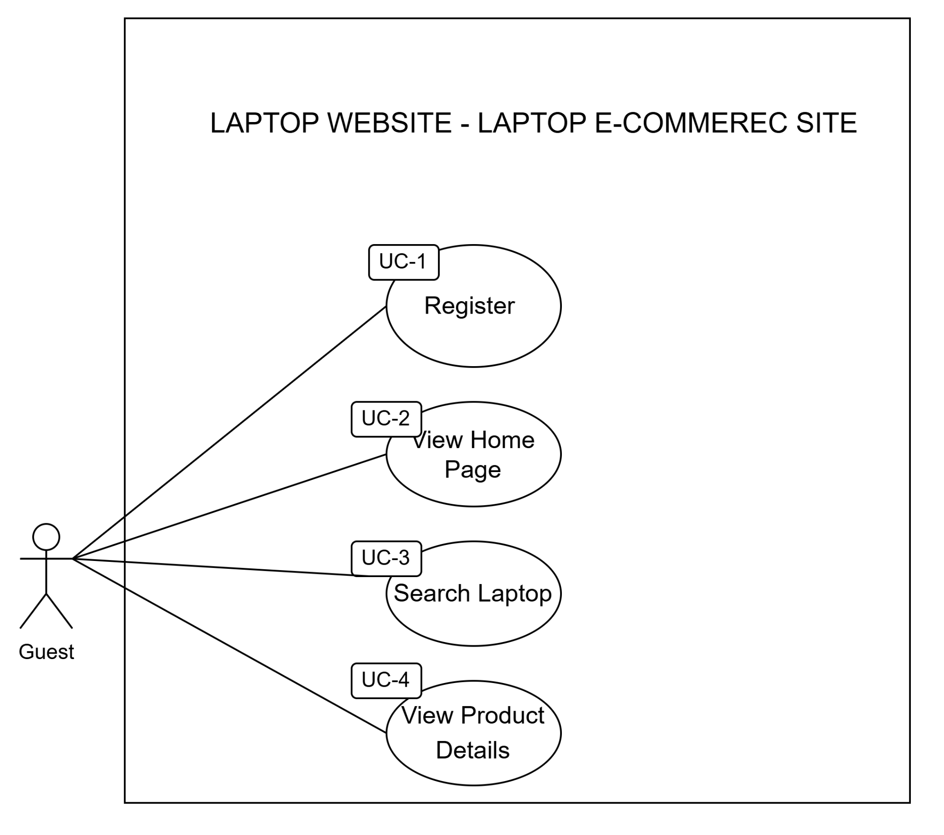
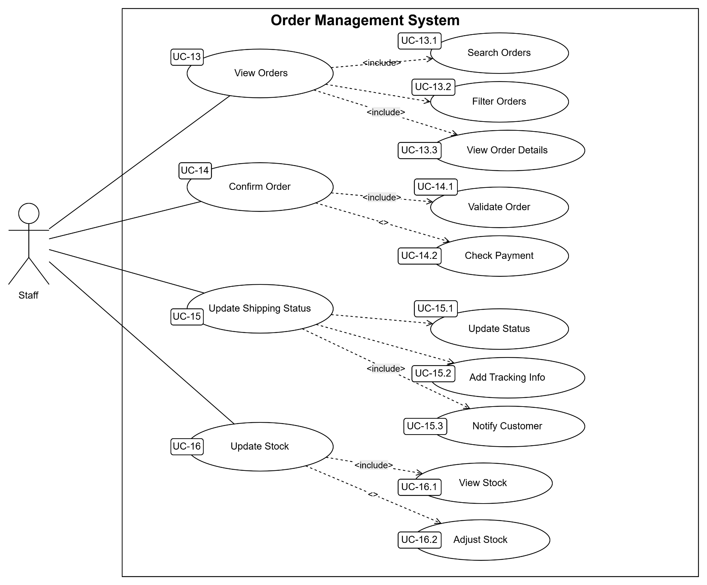
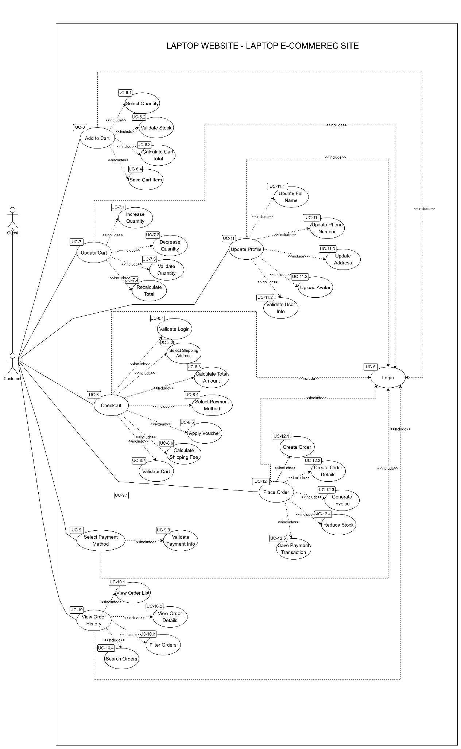
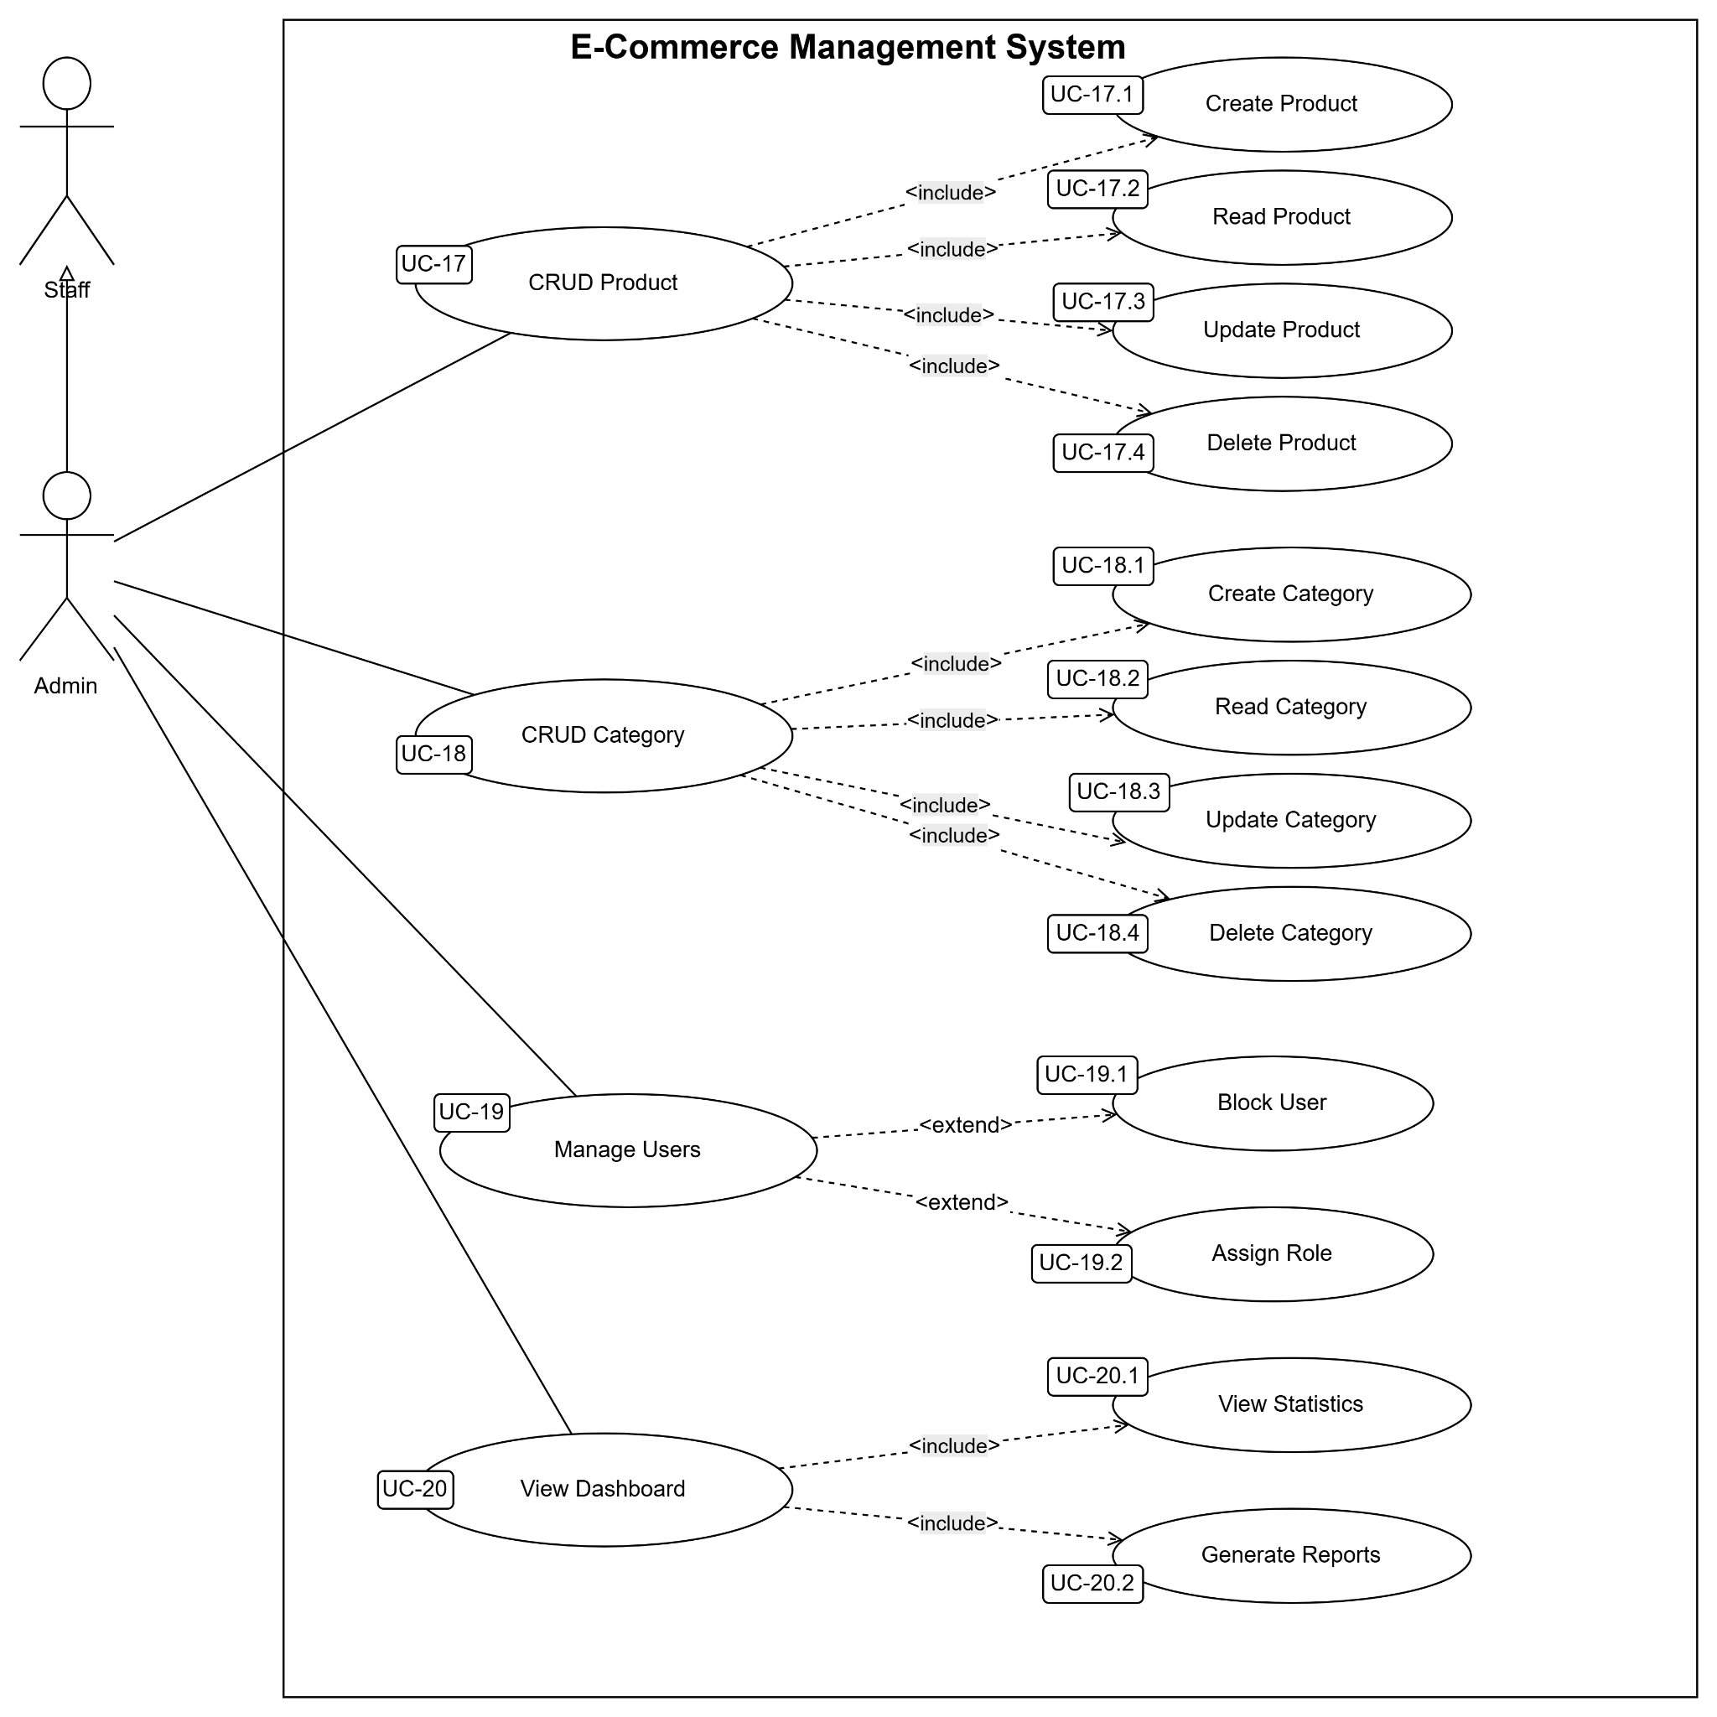

b. Descriptions

ID | Feature | Use Case | Use Case Description
UC-1 | Register | Register | Users can register for a new account by providing an email.
UC-2 | View Home Page | View Home Page | Allows users to access the website's main landing page to view promotional banners, featured laptop categories, and top-selling products.
UC-3 | Search Laptop | Search Laptop | Enables users to look for specific laptops by entering keywords in the search bar or applying advanced filters such as brand, price, CPU, and RAM specifications.
UC-4 | View Product Details | View Product Details | Allows users to view comprehensive information about a specific laptop, including detailed technical specifications, high-quality images, warranty policies, and customer reviews.
UC-5 | Login | Login | Allow the user to log in to the system.
UC-6 | Add to Cart | Add to Cart | Enables users to select the desired quantity of a laptop, triggers the system to validate real-time stock availability, and successfully saves the selected item to their shopping cart.
UC-6.1 | Select Quantity | Add to Cart | Allows users to manually adjust or enter the specific number of units they wish to purchase for a selected laptop model before adding it to the cart.
UC-6.2 | Validate Stock | Add to Cart | Triggers an automated system check to verify if the requested quantity is available in the inventory and ensures it does not exceed the current real-time stock limits.
UC-6.3 | Calculate Cart Total | Add to Cart | Stores the selected laptop details, chosen specifications, and quantity into the user's active session (for guests) or database (for registered customers).
UC-6.4 | Save Cart Item | Add to Cart | Contains the core data structure of an added product, including the product ID, laptop name, selected variant (CPU/RAM/Color), unit price, chosen quantity, and total price
UC-7 | Update Cart | Update Cart | Allows users to modify their active shopping cart by changing product quantities, removing items, or preparing the cart for the final checkout process
UC-7.1 | Increase Quantity | Update Cart | Enables users to add more units of a specific laptop model in the cart, instantly triggering a stock re-validation for the new total.
UC-7.2 | Decrease Quantity | Update Cart | Enables users to reduce the number of units for a specific laptop model in the cart, automatically removing the item if the quantity drops to zero.
UC-7.3 | Validate Quantity | Update Cart | Automatically checks that the updated quantity is a valid positive integer, is within the allowed purchase limits, and does not exceed available warehouse stock.
UC-7.4 | Recalculate Total | Update Cart | Instantly updates and displays the new line-item totals, applicable discounts, tax amounts, and the final total for the entire cart after any modification
UC-8 | Checkout | Checkout | Allows the customer to proceed with the purchasing process by validating the cart, selecting shipping information, calculating the total amount, and choosing a payment method before placing the order.
UC-8.1 | Validate Login | Checkout | Checks whether the customer is authenticated before accessing the checkout process.
UC-8.2 | Select Shipping Address | Checkout | Allows the customer to choose or enter a shipping address for delivery.
UC-8.3 | Calculate Total Amount | Checkout | Calculates the final order amount, including product subtotal, discounts, and shipping fee.
UC-8.4 | Validate Cart | Checkout | Verifies that: (1) the cart is not empty; (2) product quantities are valid; (3) products are still available in stock.
UC-8.5 | Select Payment Method | Checkout | Allows the customer to choose a payment option such as COD or online payment.
UC-8.6 | Apply Voucher | Checkout | Calculates the shipping fee based on the delivery location and shipping method.
UC-8.7 | Calculate Shipping Fee | Checkout | Allows the customer to apply a discount voucher at checkout if it is valid.
UC-9 | Select Payment Method | Select Payment Method | Allows the customer to choose how the payment will be processed for the order.
UC-9.1 | Choose COD | Select Payment Method | Allows the customer to select Cash on Delivery as the payment method.
UC-9.2 | Choose Online Payment | Select Payment Method | Allows the customer to select an online payment gateway such as VNPay or MoMo.
UC-9.3 | Validate Payment Info | Select Payment Method | Checks whether the payment information and transaction details are valid before processing the payment.
UC-10 | Place Order | Place Order | Allows the customer to confirm the purchase and create an official order in the system.
UC-10.1 | Create Order | Place Order | Creates a new order record containing customer and payment information.
UC-10.2 | Create Order Details | Place Order | Stores all purchased products and quantities associated with the order.
UC-10.3 | Reduce Stock | Place Order | Updates product inventory by reducing stock quantities after the order is successfully placed.
UC-10.4 | Generate Invoice | Place Order | Generates an invoice containing the order summary and payment information.
UC-10.5 | Save Payment Transaction | Place Order | Stores payment transaction details for tracking and verification purposes.
UC-11 | View Order History | View Order History | Allows the customer to view all previously placed orders and their statuses.
UC-11.1 | View Order List | View Order History | Displays a list of all orders associated with the customer account.
UC-11.2 | View Order Details | View Order History | Displays detailed information about a selected order, including purchased products and payment status.
UC-11.3 | Filter Orders | View Order History | Allows the customer to filter orders based on status, date, or payment method.
UC-11.4 | Search Orders | View Order History | Allows the customer to search for specific orders using order ID or keywords.
UC-12 | Update Profile | Update Profile | Allows the customer to manage and update personal account information.
UC-12.1 | Update Full Name | Update Profile | Allows the customer to modify their full name.
UC-12.2 | Update Phone Number | Update Profile | Allows the customer to update their contact phone number.
UC-12.3 | Update Address | Update Profile | Allows the customer to modify saved address information.
UC-12.4 | Upload Avatar | Update Profile | Allows the customer to upload or change their profile picture.
UC-12.5 | Validate User Info | Update Profile | Checks whether updated user information is valid and follows system rules before saving changes.
UC-13 | View Orders | Order Management | Allows staff to view and manage customer orders in the system.
UC-13.1 | Search Orders | View Orders | Allows staff to search orders by order ID, customer name, or date.
UC-13.2 | Filter Orders | View Orders | Allows staff to filter orders based on status, payment method, or shipping status.
UC-13.3 | View Order Details | View Orders | Allows staff to view detailed information of a selected order.
UC-14 | Confirm Order | Order Management | Allows staff to confirm valid customer orders before processing shipment.
UC-14.1 | Validate Order | Confirm Order | Checks whether the order information is complete and valid before confirmation.
UC-14.2 | Check Payment | Confirm Order | Verifies whether the payment has been completed successfully before confirming the order.
UC-15 | Update Shipping Status | Order Management | Allows staff to update the delivery progress of customer orders.
UC-15.1 | Update Status | Update Shipping Status | Allows staff to change the shipping status of an order.
UC-15.2 | Add Tracking Info | Update Shipping Status | Allows staff to add or update shipment tracking information.
UC-15.3 | Notify Customer | Update Shipping Status | Sends notifications to customers when the shipping status changes.
UC-16 | Update Stock | Order Management | Allows staff to manage and update product inventory quantities.
UC-16.1 | View Stock | Update Stock | Allows staff to check the current inventory quantity of products.
UC-16.2 | Adjust Stock | Update Stock | Allows staff to increase or decrease product stock quantities after inventory changes.
UC-17 | CRUD Product | Product Management | Allows admin or staff to manage product information in the system.
UC-17.1 | Create Product | CRUD Product | Allows admin or staff to add a new product to the system.
UC-17.2 | Read Product | CRUD Product | Allows admin or staff to view product details and product information.
UC-17.3 | Update Product | CRUD Product | Allows admin or staff to modify existing product information such as price, description, stock, or specifications.
UC-17.4 | Delete Product | CRUD Product | Allows admin or staff to remove a product from the system.
UC-18 | CRUD Category | Category Management | Allows the admin to manage product categories in the system.
UC-18.1 | Create Category | CRUD Category | Allows the admin to create a new product category.
UC-18.2 | Read Category | CRUD Category | Allows admin to view category information and related products.
UC-18.3 | Update Category | CRUD Category | Allows the admin to edit category information, such as category name or description.
UC-18.4 | Delete Category | CRUD Category | Allows the admin to remove a category from the system.
UC-19 | Manage Users | User Management | Allows admin to manage customer and staff accounts in the system.
UC-19.1 | Block User | Manage Users | Allows the admin to block or disable a user account that violates system policies.
UC-19.2 | Assign Role | Manage Users | Allows admin to assign or update roles for system users.
UC-20 | View Statistics | View Dashboard | Allows admin to monitor overall business activities and system performance.
UC-20.1 | View Statistics | View Dashboard | Allows the admin to view statistical information, including sales, orders, revenue, and users.
UC-20.2 | Generate Reports | View Dashboard | Allows admin to generate business reports for analysis and management purposes.

2. Overall Functionalities

2.1 Screens Flow
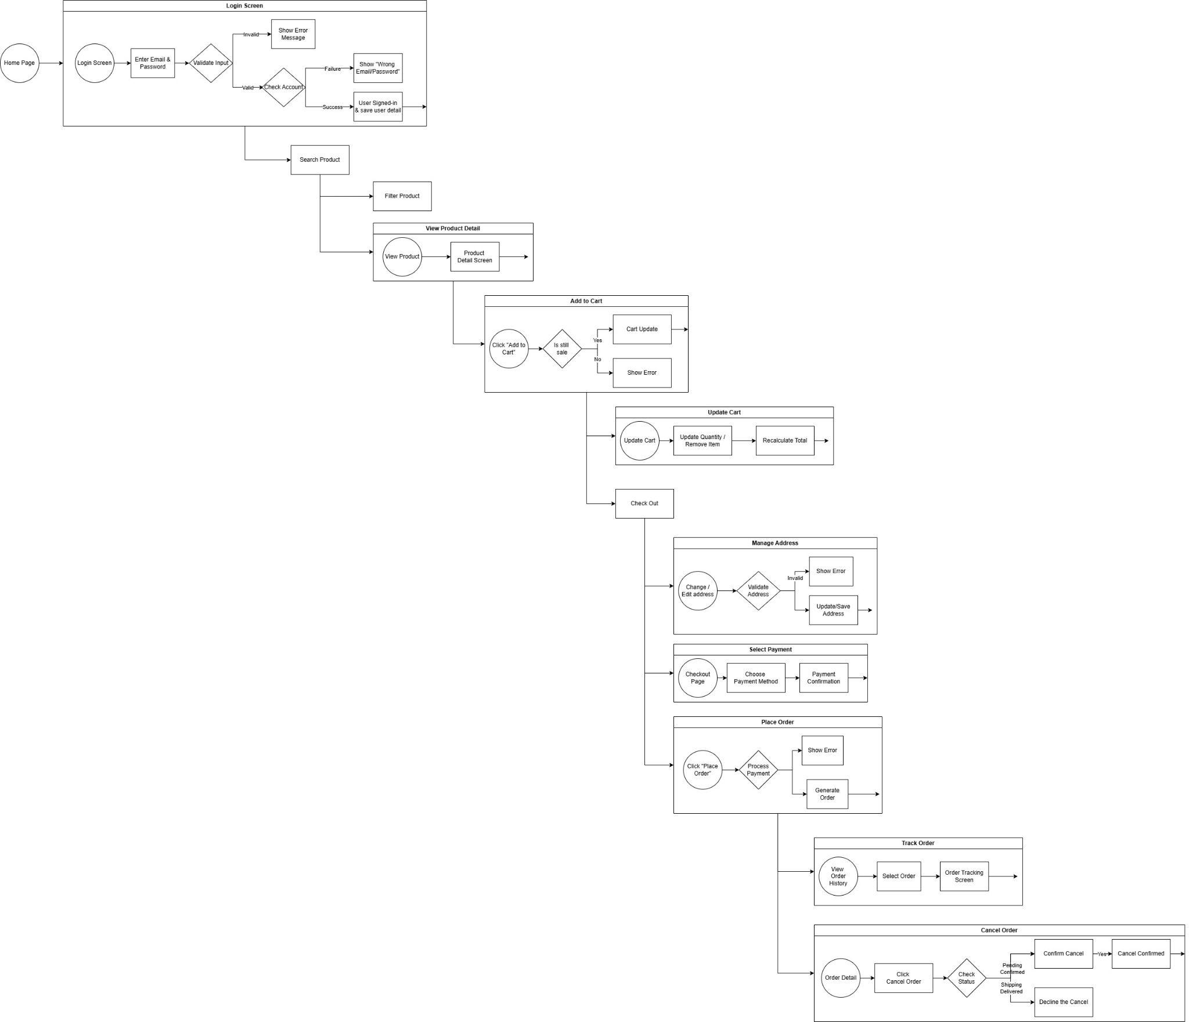
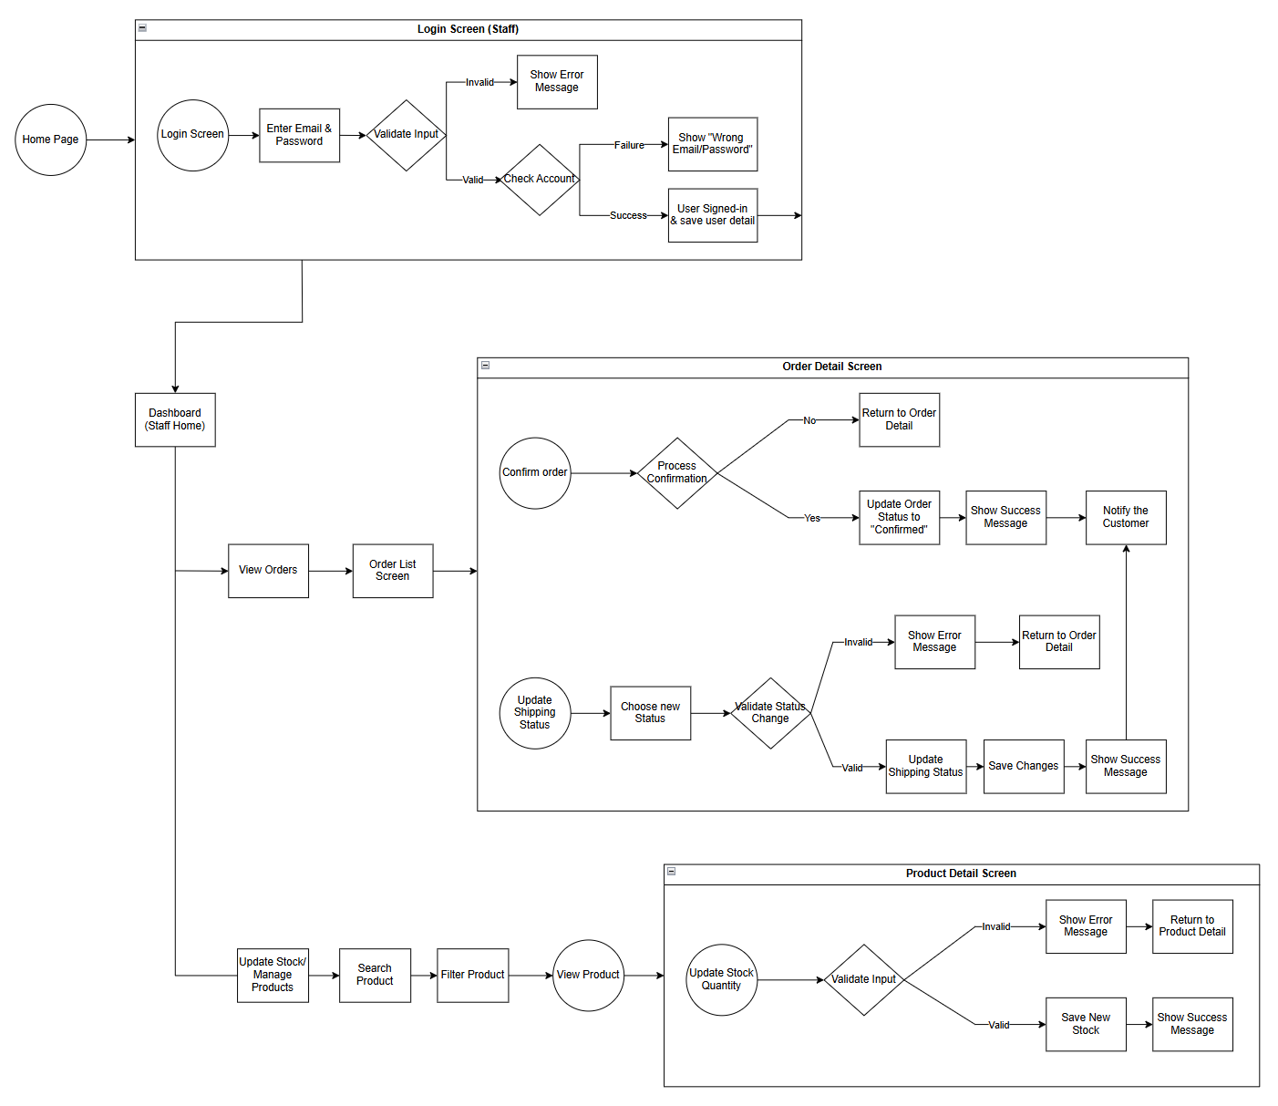
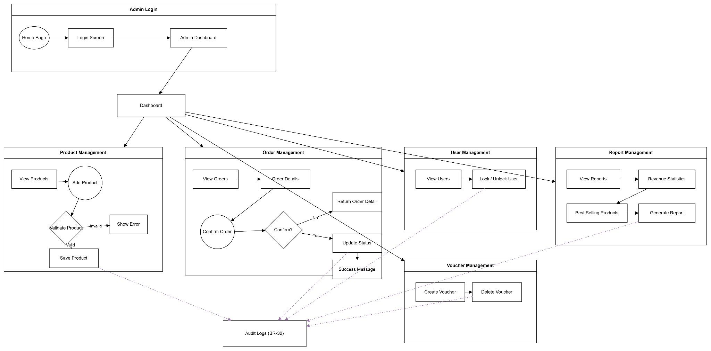
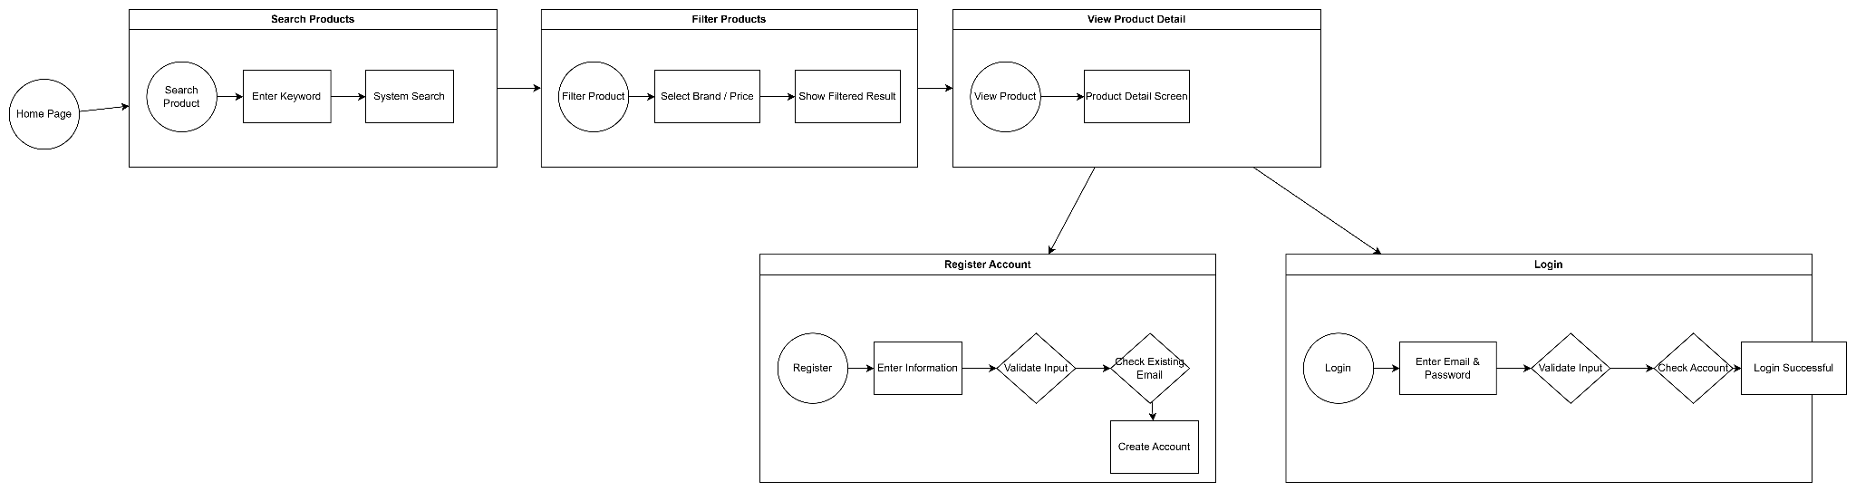

2.2 Screen Descriptions

# | Feature | Screen | Description
1 | Login (staff) | Login Screen | Allow staff to login into the system
2 | Dashboard (staff) | Dashboard Screen | Display staff dashboard
3 | View Orders (staff) | Order List Screen | Display customer orders
4 | Confirm Order (staff) | Order Detail Screen | Allow staff to confirm orders
5 | Update Shipping (staff) | Order Detail Screen | Allow staff to update shipping status
6 | Manage Stock (staff) | Stock Page | Allow staff to manage product stock
7 | Search Product (staff) | Search Product Screen | Allow staff to search products
8 | Filter Product (staff) | Filter Product Screen | Allow staff to filter products
9 | View Product (staff) | Product Detail Screen | Display product details
10 | Update Stock (staff) | Product Detail Screen | Allow staff to update stock quantity
11 | Login (admin) | Login Screen | Allow the admin to login into management system
12 | Dashboard (admin) | Dashboard Screen | Display management overview for admin
13 | Product Management (admin) | Product Management Screen | Allow admin to add and manage products
14 | Order Management (admin) | Order Management Screen | Allow admin to confirm and update orders
15 | User Management (admin) | User Management Screen | Allow admin to manage user accounts
16 | Voucher Management (admin) | Voucher Management Screen | Allow admin to create or delete vouchers
17 | Audit Log (admin) | Audit Log Screen | Store and track admin activity history
18 | Home | Home Page | Display homepage for guest users
19 | Search Product | Search Product Screen | Allow users to search products by keyword
20 | Filter Product | Filter Product Screen | Allow users to filter products by brand or price
21 | View Product Detail | Product Detail Screen | Display detailed information of the selected product
22 | Register Account | Register Screen | Allow guests to create a new account
23 | Login | Login Screen | Allow users to log in with email and password

2.3 Screen Authorization

Screen | Guest | Customer | Staff | Admin
Home Page | X | X | X | X
Register | X
Login | X | X | X | X
View Product Details | X | X | X | X
Add to Cart |  | X
Update Cart |  | X
Checkout |  | X
Place Order |  | X
View Order History |  | X
Update Profile |  | X
Apply Voucher |  | X
Track Order |  | X
Cancel Order |  | X
Manage Address |  | X
Review Product |  | X
Rate Product |  | X
View Orders |  |  | X | X
Confirm Order |  |  | X | X
Update Shipping Status |  |  | X
Update Stock |  |  | X | X
CRUD Product |  |  |  | X
CRUD Category |  |  |  | X
Manage Users |  |  |  | X
View Dashboard |  |  |  | X
Manage Voucher |  |  |  | X
View Reports |  |  |  | X
Reply to Customer Issues |  |  | X | X
Process Returns |  |  | X | X
Manage Banner |  |  |  | X
Configure System |  |  |  | X
Audit Logs |  |  |  | X
Assign Staff Role |  |  |  | X

2.4 Non-UI Functions

3. System High-Level Design

3.1 Database Design

a. Database Schema
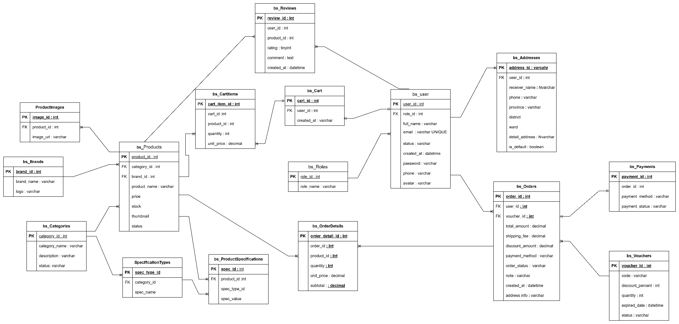

b. Table Descriptions

No | Table | Description
1 | bs_Categories | - Purpose: Stores product categories  - PK: category_id  - FK: None  - Main fields: category_name, description, status
2 | bs_Brands | - Purpose: Stores brand master data for products  - PK: brand_id  - FK: None  - Main fields: brand_name, logo
3 | bs_Products | - Purpose: Stores the main product catalogue  - PK: product_id  - FK: (1) category_id -> bs_Categories.category_id; (2) brand_id -> bs_Brands.brand_id  - Main fields: product_name, description, price, stock, thumbnail, status.
4 | bs_ProductImages | - Purpose: Stores multiple images for each product  - PK: image_id  - FK: product_id -> bs_Products.product_id  - Main fields: image_url.
5 | bs_ProductSpecifications | - Purpose: Stores technical specifications of products  - PK: spec_id  - FK: product_id -> bs_Products.product_id  - Main fields: cpu, gpu, screen, battery, ram, memory
6 | bs_Roles | - Purpose: Stores user roles such as admin/customer/staff  - PK: role_id  - FK: None  - Main fields: role_name
7 | bs_user | - Purpose: Stores user account information  - PK: user_id  - FK: role_id -> bs_Roles.role_id  - Main fields: full_name, email, status, created_at, password, phone, avatar
8 | bs_Addresses | - Purpose: Stores shipping/contact addresses for users  - PK: address_id  - FK: user_id -> bs_user.user_id  - Main fields: receiver_name, phone, province, district, ward, detail_address, is_default
9 | bs_Cart | - Purpose: Stores cart header information for a user  - PK: cart_id  - FK: user_id -> bs_user.user_id  - Main fields: created_at
10 | bs_CartItems | - Purpose: Stores items inside a shopping cart  - PK: cart_item_id  - FKs: (1)cart_id -> bs_Cart.cart_id; (2) product_id -> bs_Products.product_id  - Main fields: quantity, unit_price
11 | bs_Orders | - Purpose: Stores order header/checkout information  - PK: order_id  - FKs: (1) user_id -> bs_user.user_id; (2) voucher_id -> bs_Vouchers.voucher_id  - Main fields: total_amount, shipping_fee, discount_amount, payment_method, order_status, note, created_at, address_info
12 | bs_OrderDetails | - Purpose: Stores each product line inside an order  - PK: order_detail_id  - FKs: (1) order_id -> bs_Orders.order_id; (2) product_id -> bs_Products.product_id  - Main fields: quantity, unit_price, subtotal
13 | bs_Payments | - Purpose: Stores payment information for orders  - PK: payment_id  - FK: order_id -> bs_Orders.order_id  - Main fields: payment_method, payment_status
14 | bs_Vouchers | - Purpose: Stores discount/promo voucher data  - PK: voucher_id  - FK: None  - Main fields: code, discount_percent, quantity, expired_date, status
15 | bs_Reviews | - Purpose: Stores product reviews from users  - PK: review_id  - FKs: (1) user_id -> bs_user.user_id; (2) product_id -> bs_Products.product_id  - Main fields: rating, comment, created_at
16 | bs_Review | - Purpose: Secondary review-related table shown in ERD  - PK: review_id  - FKs: user_id, product_id  - Main fields: description, comment

3.2 Code Packages

a. Diagram
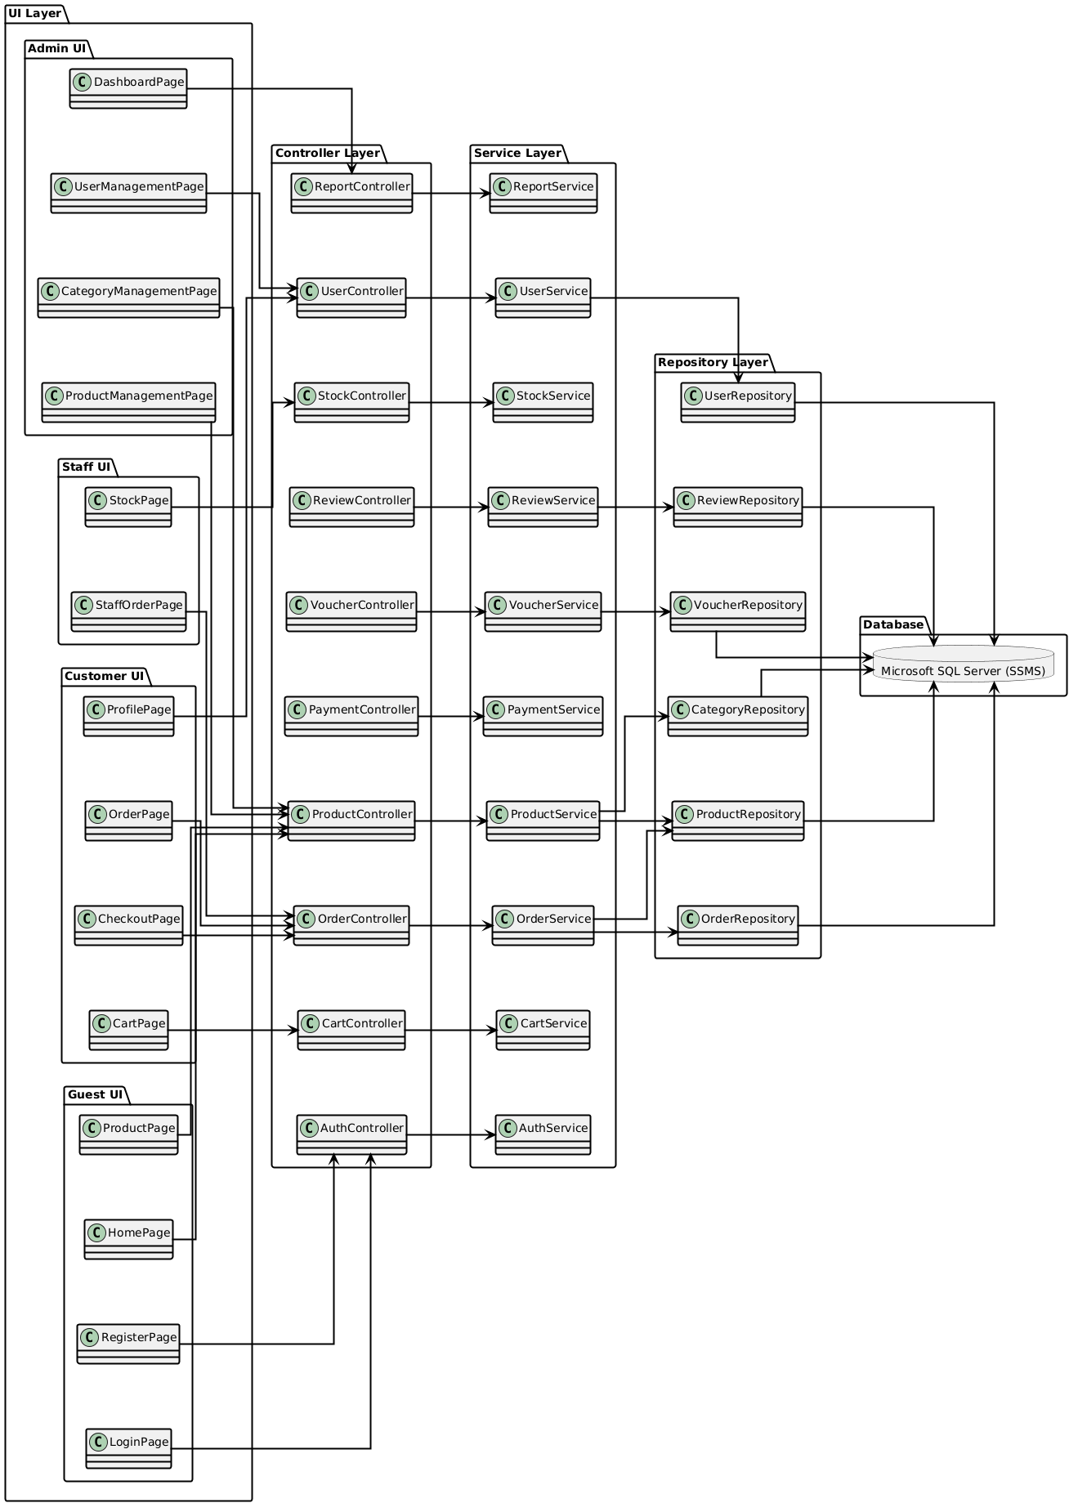

b. Package descriptions
No | Package | Description
01 | UI Layer | Contains all user interface pages for Admin, Staff, Customer, and Guest users. Responsible for displaying information and receiving user input.
02 | Admin UI Package | Provides interfaces for administrators to manage the dashboard, users, categories, and products.
03 | Staff UI Package | Provides interfaces for staff to manage stock and customer orders.
04 | Customer UI Package | Provides interfaces for customers to manage their profiles, carts, checkout, and orders.
05 | Guest UI Package | Provides interfaces for guests to browse products, register accounts, and log in.
06 | DashboardPage | Displays business statistics and system overview for administrators.
07 | UserManagementPage | Allows admin to manage user accounts and permissions.
08 | CategoryManagementPage | Allows admin to create, update, and delete product categories.
09 | ProductManagementPage | Allows admin to manage laptop product information and inventory details.
10 | StockPage | Allows staff to monitor and update stock quantity.
11 | StaffOrderPage | Allows staff to confirm and process customer orders.
12 | ProfilePage | Allows customers to view and update profile information.
13 | OrderPage | Displays customer order history and order details.
14 | CheckoutPage | Handles checkout process, shipping information, and payment selection.
15 | CartPage | Displays selected products and manages cart operations.
16 | ProductPage | Displays laptop product listings and product details for guests.
17 | HomePage | Displays homepage content and featured products.
18 | RegisterPage | Allows guests to create new customer accounts.
19 | LoginPage | Allows users to authenticate and access the system.
20 | Controller Layer | Handles requests from UI layer and coordinates business logic processing.
21 | AuthController | Handles login, registration, and authentication requests.
22 | ProductController | Handles product browsing, searching, and product detail requests.
23 | CartController | Handles add-to-cart, update-cart, and remove-cart operations.
24 | OrderController | Handles order creation, order tracking, and order management requests.
25 | PaymentController | Handles payment processing and payment validation requests.
26 | VoucherController | Handles voucher validation and discount application requests.
27 | ReviewController | Handles customer review and rating requests.
28 | StockController | Handles stock management and inventory update requests.
29 | UserController | Handles user account management requests.
30 | ReportController | Handles report generation and dashboard statistics requests.
31 | Service Layer | Contains business logic and system processing rules.
32 | AuthService | Processes authentication, authorization, and password validation logic.
33 | ProductService | Processes product management and product information logic.
34 | CartService | Processes cart calculation and cart validation logic.
35 | OrderService | Processes order creation, status management, and order validation logic.
36 | PaymentService | Processes online payment and transaction validation logic.
37 | VoucherService | Processes voucher validation and discount calculation logic.
38 | ReviewService | Processes customer reviews and ratings logic.
39 | StockService | Processes stock quantity updates and inventory validation logic.
40 | UserService | Processes user account and profile management logic.
41 | ReportService | Processes report generation and sales statistics logic.
42 | Repository Layer | Handles data access and communication with the database.
43 | UserRepository | Performs CRUD operations for user data.
44 | ProductRepository | Performs CRUD operations for laptop product data.
45 | CategoryRepository | Performs CRUD operations for category data.
46 | OrderRepository | Performs CRUD operations for order data.
47 | VoucherRepository | Performs CRUD operations for voucher data.
48 | ReviewRepository | Performs CRUD operations for review data.
49 | Database | Stores all system data using Microsoft SQL Server (SSMS).

II. Requirement Specifications

1. Register

a. Functionalities

UC ID and Name: | UC-1_Register
Created By: | DuyTK | Date Created: | 22/5/2026
Primary Actor: | Guest | Secondary Actors: | None
Trigger: | - User clicks the "Register" button from the Home Page, or  - User accesses the "Register" page via a link
Description: | As a user, I want to be able to register for a new account by providing my email, or by using my Google account so that I can access the system and use its features.
Preconditions: | The user has not already registered with the system.  The user is on the registration screen.
Postconditions: | - The user is successfully registered in the system.  - The system sends a verification email.  - The system logs the registration activity.  - The user is redirected to the login screen or homepage.
Normal Flow | 1.0 Register Account  1. The user accesses the "Register" page.  2. User selects their preferred registration method:  - Email  - Google credentials  3. The user enters the required registration details.  4. The user clicks the "Register" button.  5. The system validates the registration details.  6. If the registration details are valid, the system creates a new account for the user.  7. System redirects the user to the login page or Home Page.
Alternative Flows: | 1.0.A1 Google Registration  1. Users choose to register with their Google account.  2. The system redirects the user to Google’s registration/authorization page.  3. The user enters their Google credentials and chooses to register.  4. Google validates user’s information and redirects the user back to the system.  5. Return to step 6 of the normal flow.
Exceptions: | 1.0.E1 Phone Number/Email Already Exists  1. If the provided phone number or email is already registered, the system displays an error message indicating the conflict.  2. User can choose to:  - Click "Login" to log into the existing account.  - Choose a different phone number/email and proceed with registration.  1.0.E2 Google Already Registered  1. If the Google account is already registered, the system shows a message that the account is already linked to an existing user.  2. User can choose to:  - Click "Login" to log into the existing account.  - Use a different Google/Facebook account or another registration method.  1.0.E3 Invalid Registration Details  1. If the registration details provided (phone/email) are invalid (e.g., format errors), the system displays an error message prompting the user to correct the input.  2. Users can retry the registration process.
Priority: | Must Have
Frequency of Use: | High
Business Rules: | BR-01, BR-02, BR-03
Other Information: | None
Assumptions: | 1. The system supports registration via email and social login (Google).  2. The necessary APIs and OAuth integrations for Google registration are already set up.  3. The system is configured to send verification links.

b. Business Rules

ID | Business Rule | Business Rule Description
BR-01 | Unique Email | The user's email must be unique across the system.
BR-02 | Password Encoding | User’s password must be encoded with MD5 hashing

2. Login

a. Functionalities
UC ID and Name: | UC-5_Login
Created By: | DuyTK | Date Created: | 22/5/2026
Primary Actor: | User | Secondary Actors: | Manager, Admin
Trigger: | User clicks Login button from the page header, or  User accesses an authenticated feature (from a link or type the page URL directly into the address bar)
Description: | As a user, I want to be able to log into the system by providing my phone number, email, or Google credentials so that I can access the system’s authenticated features and my personalized account.
Preconditions: | User account has been created and authorized
Postconditions: | - User logs into the system successfully  - The system tracks successful login into the Activity Log  - User is redirected to the Home Page or the previous page they were on before logging in
Normal Flow | 4.0 Login System  1. User accesses the User Login screen.  2. User selects their preferred login method:  - Phone number  - Email  - Google credentials  3. The user enters the login details (either phone number/email or Google credentials).  4. The user clicks the Login button.  5. System validates the login details  6. The system allows the user access upon successful authentication.  7. Show login success message.  8. The system redirects the user to the Home Page (or the previous calling page if any).
Alternative Flows: | 4.0.A1 Google Login  1. The user chooses to log in with their Google account.  2. The system redirects the user to Google’s Login screen.  3. The user enters their Google credentials and chooses to log in.  4. Google validates user’s login information successfully and redirects the user back to the system.  5. Return to step 5 of the normal flow.
Exceptions: | 4.0.E1 System Can’t Authenticate the User  1. The system shows an error message indicating the login failure.  2. User can choose to:  - Cancel logging in and return to the Home Page.  - Click the "Forgot Password?" link to trigger.  - Click the "Register" link to trigger.
Priority: | Must Have
Frequency of Use: | High
Business Rules: | BR-02
Other Information: | Users are redirected to their previously accessed page after successful login.  Login form must support both manual login (email/phone) and social logins (Google).
Assumptions: | The system supports authentication through both manual (phone/email) and social login methods (Google).  The necessary APIs and OAuth integrations are already set up for Google.

b. Business Rules

ID | Business Rule | Business Rule Description
BR-02 | Password Encoding | User’s password must be encoded with MD5 hashing

3. Search Laptop

a. Functionalities

UC ID and Name: | UC-3_SearchLaptop
Created By: | DuyTK | Date Created: | 22/5/2026
Primary Actor: | Guest, Customer | Secondary Actors: | System
Trigger: | The user enters keywords or filtering criteria into the search bar or product filter section.
Description: | This use case allows customers or guests to search for laptops and other products by entering keywords, selecting categories, brands, price ranges, or product specifications.
Preconditions: | - The system is running normally.  - Product data exists in the database.  - The user is accessing the website.
Postconditions: | - A list of matching products is displayed.  - Search results are filtered based on the entered criteria.
Normal Flow: | - The user accesses the product search page or homepage.  - The user enters a keyword or selects filtering options.  - The system validates the search input.  - The system searches products based on the entered criteria.  - The system retrieves matching products from the database.  - The system displays the search results to the user.  - The user may select a product to view detailed information.
Alternative Flows: | A1. Search by Category  - The user selects a product category such as Laptop, Mouse, SSD, or RAM.  - The system displays products belonging to the selected category.  A2. Search by Brand  - The user selects a brand.  - The system filters products by the selected brand.  A3. Filter by Specifications  The user selects product specifications such as:  - RAM  - CPU  - Storage  - GPU  - The system displays products matching the selected specifications.  A4. Filter by Price Range  - The user selects a minimum and maximum price.  - The system displays products within the selected price range.
Exceptions: | E1. Invalid Search Input  - The system displays an error message if the search input contains invalid characters.  E2. No Matching Products Found  - The system displays a message indicating that no products match the search criteria.  E3. System Error  - The system displays an error notification if the search process fails.
Priority: | Must Have
Frequency of Use: | Very High-Searching products are one of the core functionalities of the ecommerce system.
Business Rules: | BR-03, BR-07, BR-08, BR-09
Other Information: | The search function may support pagination and sorting.  Sorting options may include:  The search function may support pagination and sorting.  Sorting options may include:  - price ascending  - price descending  - newest products  - best-selling products
Assumptions: | Product data is already stored in the database.  Internet connection is stable.  Product specifications are properly configured in the system.

b. Business Rules

ID | Business Rule | Business Rule Description
BR-03 | Authentication & Authorization Rules | Only logged-in users can place orders. Guests can only view products.
BR-07 | Product Rules | Products in the system shall have one of the following statuses: Active, Out of Stock, Inactive
BR-08 | The SKU/Product code | Each product must have a unique SKU or product code. The system may use Identity Keys or UUIDv4 for uniqueness.
BR-09 | Products specifications | Each laptop must have complete basic specifications.

4. View Product Detail

a. Functionalities
UC ID and Name: | UC-04 – View Product Details
Created By: | HaoVK | Date Created: | 25/05/2026
Primary Actor: | Guest, Customer | Secondary Actors: | Database Server
Trigger: | User clicks on a laptop product from product list/search result
Description: | The system displays detailed information about the selected laptop product.
Preconditions: | User is accessing the website; Product exists in database
Postconditions: | Product details are shown to the user
Normal Flow: | 1. User selects a laptop product.  2. System retrieves product information from database.  3. System displays product image, specifications, price, stock status, and description.  4. User can choose to add product to cart.
Alternative Flows: | 1. Product has discount → system displays discounted price.  2. Product is out of stock → system displays “Out of Stock” status.
Exceptions: | 1. Product does not exist.  2. Database connection fails.
Priority: | High, Must Have
Frequency of Use: | Very Frequent
Business Rules: | BR-05, BR-06, BR-07, BR-08, BR-09, BR-13, BR-35
Other Information: | Product images should load within acceptable response time.
Assumptions: | Internet connection is stable.

b. Business Rules

ID | Business Rule | Business Rule Description
BR-05 | Product Rules | Every product must be assigned to at least one category.
BR-06 | Product Rules | Product price must be greater than 0.
BR-07 | Product Rules | Product status determines whether the laptop can be displayed or purchased.
BR-08 | Product Rules | Each laptop must have a unique SKU/Product Code.
BR-09 | Product Rules | Every laptop must include CPU, RAM, Storage, GPU, Display, Battery, and Operating System information.
BR-13 | Inventory / Stock Rules | Products that are out of stock must display “Out of Stock”.
BR-35 | Non-functional Business Rules | Product search and display response time must not exceed 3 seconds.

5. Add to Cart

a. Functionalities
UC ID and Name: | UC-05 – Add to Cart
Created By: | HaoVK | Date Created: | 25/05/2026
Primary Actor: | Customer | Secondary Actors: | Shopping Cart System
Trigger: | Customer clicks “Add to Cart” button
Description: | The system adds the selected laptop product into the customer’s shopping cart.
Preconditions: | Customer is logged in; Product is available in stock
Postconditions: | Selected product is stored in customer cart
Normal Flow: | 1. Customer selects a laptop product.  2. Customer clicks “Add to Cart”.  3. System checks product stock quantity.  4. System adds product to cart.  5. System updates cart total and quantity.  6. System displays confirmation message.
Alternative Flows: | 1. Customer changes quantity before adding to cart.  2. Product already exists in cart → system updates quantity.
Exceptions: | 1. Product is out of stock.  2. Requested quantity exceeds available stock.  3. Customer session expires.
Priority: | High, Must Have
Frequency of Use: | Very Frequent
Business Rules: | BR-03, BR-04 , BR-10, BR-14, BR-15, BR-16, BR-17, BR-18
Other Information: | Cart data should be saved during user session.
Assumptions: | Customer account is active and valid.

b. Business Rules

ID | Business Rule | Business Rule Description
BR-03 | Authentication & Authorization | Only logged-in users can add products to cart and place orders.
BR-04 | Authentication & Authorization | Admin accounts are not allowed to use customer purchasing functions such as adding products to cart or placing orders.
BR-10 | Inventory / Stock Rules | Users cannot add quantity greater than available stock.
BR-14 | Inventory / Stock Rules | Product stock quantity must never be negative.
BR-15 | Cart Rules | Each laptop must have a unique SKU/Product Code.
BR-16 | Cart Rules | Minimum quantity of a product in cart is 1.
BR-17 | Cart Rules | Cart quantity cannot exceed available inventory quantity.
BR-18 | Cart Rules | If a product becomes out of stock after being added to cart, the system must block checkout and display an out-of-stock message.

6. Checkout

a. Functionalities
UC ID and Name: | UC-06 – Checkout
Created By: | HaoVK | Date Created: | 25/05/2026
Primary Actor: | Customer | Secondary Actors: | Payment Gateway
Trigger: | Customer clicks “Checkout” button
Description: | The system processes customer order and payment information to complete purchase.
Preconditions: | Customer is logged in; Cart contains at least one product
Postconditions: | Order is created and stored successfully
Normal Flow: | 1. Customer opens checkout page.  2. System displays cart summary and total amount.  3. Customer enters shipping information.  4. Customer selects payment method.  5. System validates entered information.  6. System processes payment.  7. System creates order record.  8. System sends order confirmation to customer.
Alternative Flows: | 1. Customer selects Cash on Delivery instead of online payment.  2. Customer edits shipping information before confirming order.
Exceptions: | 1. Payment transaction fails.  2. Invalid shipping information.  3. Product becomes out of stock during checkout.
Priority: | High, Must Have
Frequency of Use: | Very Frequent
Business Rules: | BR-19, BR-20, BR-21, BR-22,BR-23, BR-24, BR-25, BR-26, BR-27, BR-31, BR-34, BR-38, BR-39
Other Information: | Order summary is shown before final confirmation.
Assumptions: | Payment gateway service is operational.

b. Business Rules

ID | Business Rule | Business Rule Description
BR-19 | Order Rules | An order must contain at least one product.
BR-20 | Order Rules | Total order amount must equal product subtotal plus shipping fee minus discounts.
BR-21 | Order Rules | Order status must follow: Pending → Confirmed → Shipping → Delivered.
BR-22 | Order Rules | Only Admin or Staff accounts are allowed to confirm orders.
BR-23 | Order Rules | Users can only cancel orders before shipping starts.
BR-24 | Payment Rules | Orders using online payment remain Pending until payment is completed.
BR-25 | Payment Rules | COD orders are created with Pending status and require staff/admin confirmation.
BR-26 | Payment Rules | Failed online payments will move order to Payment Failed status or auto-cancel after a period of time.
BR-27 | Payment Rules | Paid orders cannot be paid again.
BR-31 | Security Rules | User session expires after 24 hours of inactivity.
BR-34 | Security Rules | HTTPS connection is mandatory during checkout and payment processing.
BR-38 | Shipping Rules | Shipping address is required during checkout.
BR-39 | Shipping Rules | Shipping fee is calculated based on delivery area.

7. Place Order

a. Functionalities

UC ID and Name: | UC-07: Place Order
Created By: | KhangNL | Date Created: | 25-05-2026
Primary Actor: | Customer | Secondary Actors: | System
Trigger: | Customer clicks Checkout
Description: | Customer places an order for selected products
Preconditions: | Customer has logged in and cart is not empty
Postconditions: | Order is successfully created
Normal Flow: | 1. Customer opens Shopping Cart  2. Customer clicks Checkout  3. Customer selects payment method  4. System validates order information  5. Customer confirms order  6. System creates order successfully
Alternative Flows: | Customer applies voucher before checkout
Exceptions: | Payment failed or product out of stock
Priority: | High, Must Have
Frequency of Use: | Frequently
Business Rules: | Order cannot be placed with empty cart
Other Information: | Order information stored in database
Assumptions: | Internet connection is stable

b. Business Rules

ID | Business Rule | Business Rule Description
BR-03 | Authentication & Authorization | Only authenticated users are allowed to place orders.
BR-10 | Inventory / Stock Rules | Customers are not allowed to order quantities greater than available stock quantity.
BR-11 | Inventory / Stock Rules | The system shall automatically reduce product stock when an order is confirmed.
BR-14 | Inventory / Stock Rules | Stock quantity must never be negative.
BR-17 | Cart Rules | Cart quantity must not exceed available stock quantity.
BR-18 | Cart Rules | System prevents checkout if product becomes out of stock.
BR-19 | Order Rules | An order must contain at least one product.
BR-20 | Order Rules | Total amount calculation rule.
BR-21 | Order Rules | Order status must follow defined sequence.
BR-24 | Payment Rules | Online payment keeps order in Pending until completed.
BR-25 | Payment Rules | COD orders remain Pending until confirmed.
BR-26 | Payment Rules | Failed payment handling rule.
BR-27 | Payment Rules | Prevent duplicate payment processing.
BR-38 | Shipping Rules | Shipping address is required.
BR-39 | Shipping Rules | Shipping fee calculated by location.

8.View Order History

a. Functionalities

UC ID and Name: | UC-08: View Order History
Created By: | KhangNL | Date Created: | 25-06-2026
Primary Actor: | Customer | Secondary Actors: | System
Trigger: | Customer selects Order History
Description: | Customer views previous orders
Preconditions: | Customer has logged in
Postconditions: | Order history is displayed
Normal Flow: | 1. Customer opens Profile  2. Customer selects Order History  3. System retrieves order data  4. System displays order list
Alternative Flows: | Customer views order details
Exceptions: | No order history found
Priority: | Medium, Must Have
Frequency of Use: | Frequently
Business Rules: | Customers can only view their own orders
Other Information: | Orders sorted by latest date
Assumptions: | Database connection is active

b. Business Rules

ID | Business Rule | Business Rule Description
BR-03 | Authentication & Authorization | Only authenticated users can view order history.
BR-21 | Order Rules | Orders follow predefined status sequence.
BR-23 | Order Rules | Customers can only cancel orders before Shipping status.
BR-31 | Security Rules | User session automatically expires after inactivity.

9.Update Profile

a. Functionalities

UC ID and Name: | UC-09: Update Profile
Created By: | KhangNL | Date Created: | 25-05-2026
Primary Actor: | Customer | Secondary Actors: | System
Trigger: | Customer selects Update Profile
Description: | Customer updates personal information
Preconditions: | Customer has logged in
Postconditions: | Profile information updated successfully
Normal Flow: | 1. Customer opens Profile Screen  2. Customer edits personal information  3. System validates input  4. Customer saves changes  5. System updates profile successfully
Alternative Flows: | Customer changes password
Exceptions: | Invalid information entered
Priority: | Medium, Must Have
Frequency of Use: | Occasionally
Business Rules: | Email must remain unique
Other Information: | Updated data stored in database
Assumptions: | Customer account exists

b. Business Rules

ID | Business Rule | Business Rule Description
BR-01 | Authentication & Authorization | Email address must be unique.
BR-02 | Authentication & Authorization | Password must satisfy security requirements.
BR-31 | Security Rules | Session expiration rule.
BR-32 | Security Rules | System prevents SQL Injection and XSS attacks.
BR-33 | Security Rules | Passwords must be encrypted using BCrypt.

10. Confirm Order

a. Functionalities

UC ID and Name: | UC-14 – Confirm Order
Created By: | TrinhLTK | Date Created: | 22/5/2026
Primary Actor: | Staff | Secondary Actors: | Payment System, Notification System
Trigger: | The staff selects a pending order and clicks the “Confirm Order” button.
Description: | This use case allows staff to confirm customer orders before shipment processing after validating order information and payment status.
Preconditions: | - Staff has logged into the system.  - Order exists in the system.  - Order status is Pending.
Postconditions: | - Order status is updated to Confirmed.  - Customer receives confirmation notification.  - Order is ready for shipping process.
Normal Flow: | - The staff accesses the Order Management page.  - The staff selects a pending order.  - The system displays order details.  - The system validates order information.  - The system checks payment status.  - The staff confirms the order.  - The system updates order status to Confirmed.  - The system sends confirmation notification to the customer.
Alternative Flows: | A1. Validate Order Information  - The system verifies customer information, shipping address, and ordered products.  - The system allows the staff to continue confirmation if all information is valid.  A2. Search by Brand  - The system checks payment transaction status.  - The system allows confirmation only if payment is successful
Exceptions: | E1. Invalid Order Information  - The system displays validation error messages.  - The confirmation process is stopped.  E2. Payment Failed or Unpaid  - The system rejects the confirmation request.  - The staff receives a payment issue notification.  E3. System Error  - The system displays an error notification if the confirmation process fails.
Priority: | Must Have
Frequency of Use: | High – Order confirmation is a core workflow before shipping.
Business Rules: | BR-03, BR-10, BR-11
Other Information: | The system may automatically record confirmation timestamps and staff information for audit tracking.
Assumptions: | Payment information is synchronized correctly.  Notification service is available.  Orders cannot be confirmed twice.

b. Business Rules

ID | Business Rule | Business Rule Description
BR-03 | Authentication & Authorization Rules | Only authorized staff members can confirm customer orders.
BR-10 | Order Confirmation Rules | Only orders with Pending status and successful payment can be confirmed.
BR-11 | Notification Rules | Customers shall receive a confirmation notification after the order is confirmed successfully.

11. Update Shipping Status

a. Functionalities

UC ID and Name: | UC-15 – Update Shipping Status
Created By: | TrinhLTK | Date Created: | 22/5/2026
Primary Actor: | Staff | Secondary Actors: | Shipping Service, Notification System
Trigger: | The staff selects an order and updates its shipping status.
Description: | This use case allows staff to update shipping progress and tracking information for customer orders.
Preconditions: | - Staff has logged into the system.  - Order has been confirmed.  - Shipping information exists.
Postconditions: | - Shipping status is updated.  - Tracking information is saved.  - Customer receives shipping notification.
Normal Flow: | - The staff opens the Order Management page.  - The staff selects an order.  - The system displays current shipping information.  - The staff updates shipping status.  - The staff enters tracking information.  - The system validates tracking data.  - The system saves updated shipping information.  - The system sends notification to the customer.
Alternative Flows: | A1. Update Tracking Information  - The staff updates the tracking code or carrier information.  - The system stores the updated tracking information.  A2. Update Shipping Progress  - The staff changes shipping status, such as Shipping, Delivered, or Cancelled.  - The system updates the order shipping progress accordingly.
Exceptions: | E1. Invalid Tracking Number  - The system displays an error message.  - The staff must re-enter tracking information.  E2. Order Not Confirmed  - The system prevents shipping updates.  - The staff receives a warning message.  E3. System Error  - The system displays an error notification if the shipping update fails.
Priority: | Must Have
Frequency of Use: | High – Shipping status updates are performed frequently during order processing.
Business Rules: | BR-10, BR-12, BR-13
Other Information: | The system may support integration with third-party shipping providers for automatic tracking updates.
Assumptions: | Shipping carrier service is available.  Tracking codes are generated correctly.  Notification service is functioning normally.

b. Business Rules

ID | Business Rule | Business Rule Description
BR-03 | Authentication & Authorization Rules | Only authorized staff members can update shipping status.
BR-12 | Shipping Status Rules | Shipping status must follow the valid workflow: Pending → Shipping → Delivered.
BR-13 | Tracking Information Rules Rules | Each shipment must contain a valid tracking number before updating shipping status.

12. Update Stock

a. Functionalities

UC ID and Name: | UC-16 – Update Stock
Created By: | TrinhLTK | Date Created: | 22/5/2026
Primary Actor: | Staff | Secondary Actors: | Inventory Database
Trigger: | The staff submits a stock quantity adjustment request.
Description: | This use case allows staff to manage inventory quantity for products in the system.
Preconditions: | - Staff has logged into the system.  - Product exists in inventory.
Postconditions: | - Product stock quantity is updated.  - Inventory records are saved successfully.
Normal Flow: | - The staff opens the Inventory Management page.  - The staff searches for a product.  - The system displays current stock quantity.  - The staff adjusts stock quantity.  - The staff submits stock update request.  - The system validates stock value.  - The system updates inventory quantity.  - The system saves inventory changes.
Alternative Flows: | A1. Increase Stock Quantity  - The staff adds additional stock quantity for a product.  - The system updates inventory records.  A2. Decrease Stock Quantity  - The staff reduces stock quantity due to sales or damaged products.  - The system updates inventory records accordingly.
Exceptions: | E1. Invalid Stock Quantity  - The system displays validation error.  - The update process is cancelled.  E2. Product Not Found  - The system displays “Product Not Found”.  - The staff returns to inventory page.  E3. Database Update Failed  - The system displays an error notification if inventory data cannot be saved.
Priority: | Must Have
Frequency of Use: | High – Inventory management is a core operational activity of the ecommerce system.
Business Rules: | BR-07, BR-08, BR-14
Other Information: | The system may automatically log inventory update history including staff ID and timestamp.
Assumptions: | Inventory database is synchronized correctly.  Product information already exists in the system.  Stock quantities cannot be negative.

b. Business Rules

ID | Business Rule | Business Rule Description
BR-03 | Authentication & Authorization Rules | Only authorized staff members can update inventory information.
BR-07 | Product Rules | Products in the system shall have valid statuses such as Active, Out of Stock, or Inactive.
BR-14 | Inventory Rules | Product stock quantity cannot be negative after inventory updates.

III. Design Specifications

1. <<Feature Name>>

1.1 <<SubFeature Name>>

IV. Appendix

1. Assumptions & Dependencies
AS-01: The system assumes that users have a stable internet connection while accessing the website.
AS-02: The database server is available and operational during system usage.
AS-03: Product information, prices, stock quantities, and specifications are maintained and updated by administrators.
AS-04: All products have valid categories, brands, and specification data configured in the system.
AS-05: Payment gateway services are available and functioning properly during online payment transactions.
DP-01: The system depends on the Authentication Module for user login and authorisation
DP-02: The system depends on the Product Management Module for retrieving product information and specifications.
DP-03: The Checkout Module depends on the Cart Management Module to retrieve selected products and quantities.
DP-04: The Order Management Module depends on the Inventory Management Module to validate and update stock quantities.

2. Limitations & Exclusions
LM-01: The system supports web platforms only and does not provide a mobile application version.
LM-02: The system supports a limited number of concurrent users (minimum 100 CCU).
LM-03: The online payment feature depends on third-party payment gateway availability.
LM-04: The system does not support real-time inventory synchronisation across multiple warehouses.
LM-05: The search function may not support advanced AI-based recommendations or semantic search.
EX-01: The system does not support international shipping.
EX-02: The system does not support cryptocurrency payments.
EX-03: The system does not include an AI chatbot or virtual shopping assistant.
EX-04: The system does not support multi-vendor marketplace functionality. Example:
- multiple independent sellers
- seller dashboards
- commission management

3. Business Rules

ID | Category | Rule Definition
BR-01 | Authentication & Authorization | Each account must be registered with a unique email address. Duplicate email registrations are not allowed.
BR-02 | Authentication & Authorization | User passwords must contain at least 8 characters, including at least one uppercase letter and one numeric character and password must be hashcode MD5.
BR-03 | Authentication & Authorization | Only authenticated users are allowed to place orders. Guest users can only browse and view products.
BR-04 | Authentication & Authorization | Admin accounts are not allowed to use customer purchasing functions such as adding products to cart or placing orders.
BR-05 | Product Rules | Every product must be assigned to at least one category.
BR-06 | Product Rules | The product price must be greater than zero.
BR-07 | Product Rules | Products shall have one of the following statuses: Active, Out of Stock, Hidden, or Inactive.
BR-08 | Product Rules | Each product must have a unique SKU or product code.
BR-09 | Product Rules | Every laptop product must contain required specifications including CPU, RAM, Storage, GPU, Display, Battery, and Operating System.
BR-10 | Inventory / Stock Rules | Customers are not allowed to order quantities greater than the available stock quantity.
BR-11 | Inventory / Stock Rules | The system shall automatically reduce product stock when an order is confirmed.
BR-12 | Inventory / Stock Rules | If an order is cancelled before shipping, the system shall restore the product stock quantity.
BR-13 | Inventory / Stock Rules | Products with zero stock quantity must display an 'Out of Stock' status.
BR-14 | Inventory / Stock Rules | Stock quantity must never be negative under any circumstance.
BR-15 | Cart Rules | A product cannot appear multiple times in the cart. If the same product is added again, the system shall increase the quantity of the existing cart item.
BR-16 | Cart Rules | The minimum quantity of a product in the cart is 1.
BR-17 | Cart Rules | The quantity of a cart item must not exceed the available stock quantity.
BR-18 | Cart Rules | If a product becomes out of stock after being added to the cart, the system shall prevent checkout and display an 'Out of Stock' notification.
BR-19 | Order Rules | An order must contain at least one product.
BR-20 | Order Rules | The total order amount must equal the sum of product prices multiplied by quantities, plus shipping fee, minus discounts or promotions.
BR-21 | Order Rules | Order status transitions must follow this sequence: Pending → Confirmed → Shipping → Delivered.
BR-22 | Order Rules | Only Admin or Staff accounts are allowed to confirm orders.
BR-23 | Order Rules | Customers are only allowed to cancel orders before the order reaches the Shipping status.
BR-24 | Payment Rules | If online payment is selected, the order shall remain in Pending status until payment is completed.
BR-25 | Payment Rules | If COD is selected, online payment confirmation is not required and the order will remain Pending until confirmed by Admin or Staff.
BR-26 | Payment Rules | If online payment fails, the order shall be marked as 'Payment Failed' or automatically cancelled after a predefined timeout period.
BR-27 | Payment Rules | The system shall not allow payment processing for orders that have already been paid or completed.
BR-28 | Admin Rules | Only Admin accounts are allowed to manage products, categories, and users.
BR-29 | Admin Rules | Completed orders cannot be permanently deleted. The system shall only allow soft delete or archive operations.
BR-30 | Admin Rules | The system shall log important admin activities for auditing purposes.
BR-31 | Security Rules | User sessions shall automatically expire after 24 hours (86400 seconds) of inactivity.
BR-32 | Security Rules | The system must prevent SQL Injection and Cross-Site Scripting (XSS) attacks.
BR-33 | Security Rules | All passwords must be encrypted using BCrypt before being stored in the database.
BR-34 | Security Rules | HTTPS protocol is mandatory for all payment-related transactions.
BR-35 | Non-functional Business Rules | The system shall return search results within a maximum of 3 seconds.
BR-36 | Non-functional Business Rules | The system shall support at least 100 concurrent users (CCU).
BR-37 | Non-functional Business Rules | The database must be backed up daily.
BR-38 | Shipping Rules | A shipping address is required during the checkout process.
BR-39 | Shipping Rules | Shipping fees shall be calculated based on the delivery region or location.

