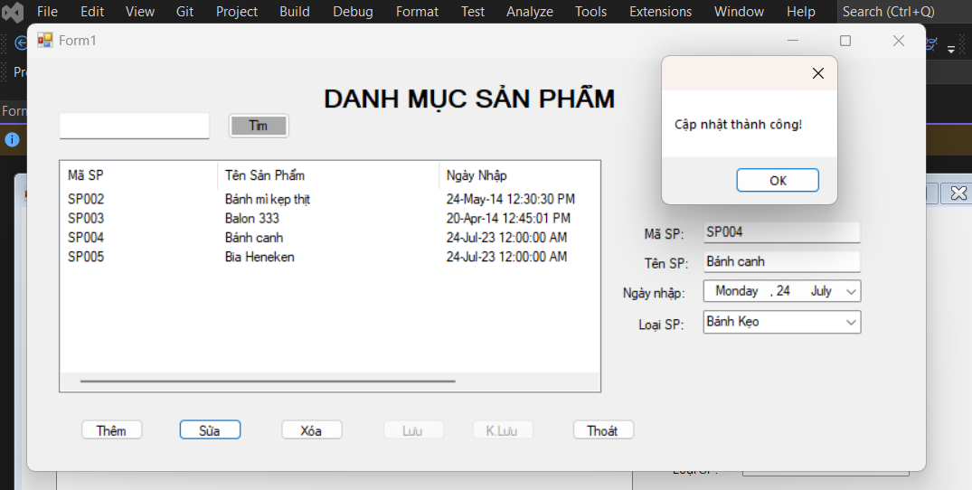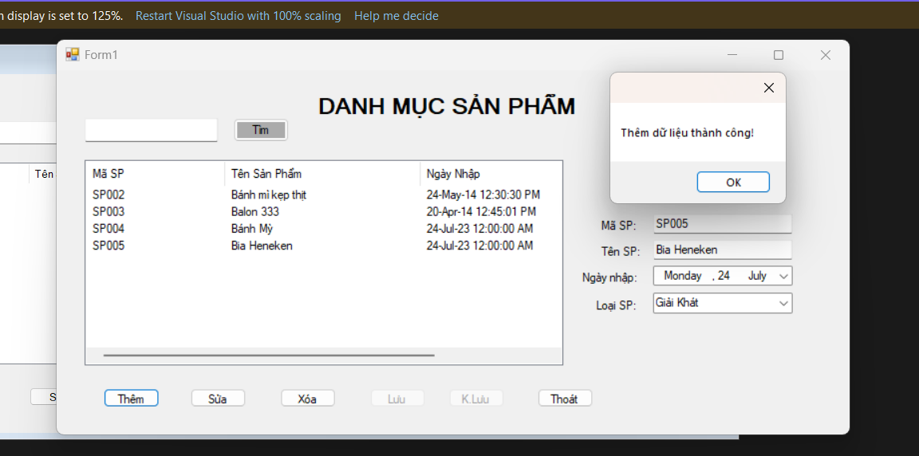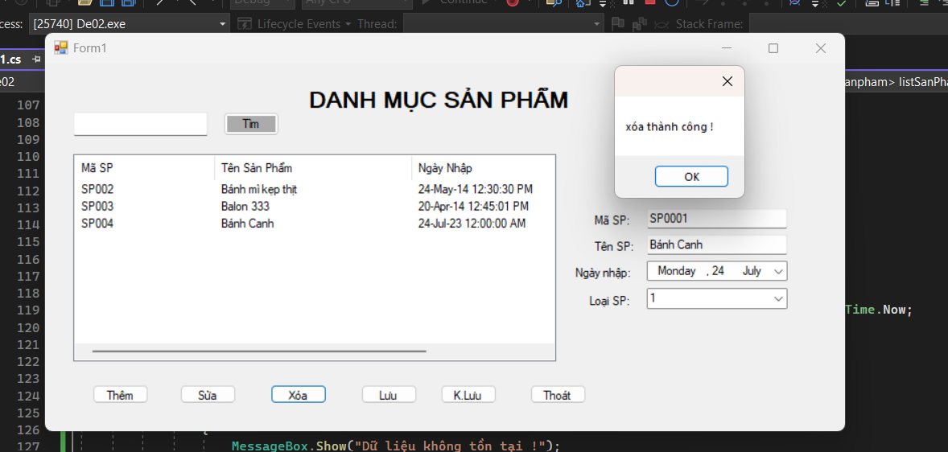

Phan Võ Duy Trinh : 8đ

https://drive.google.com/drive/folders/1uu32KSuG6Lx9Bxz8wzFZz77EUZ_dKBti?usp=sharing