Q1:

1. TCP Reno. Because it has fast recovery at time 09.
2. 16 MSS
3. time 4 to 8, time 9 to time 13, time 17 to time 19
4. time 0 to time 4, time 14 to time 17
5. 3-dups Acks
6. timeout
7. cwnd at time 17 is wrong. cwnd at time 13 is 14, ssthresh is half of cwnd at time 13 should be 14/2=7 MSS not 8 MSS

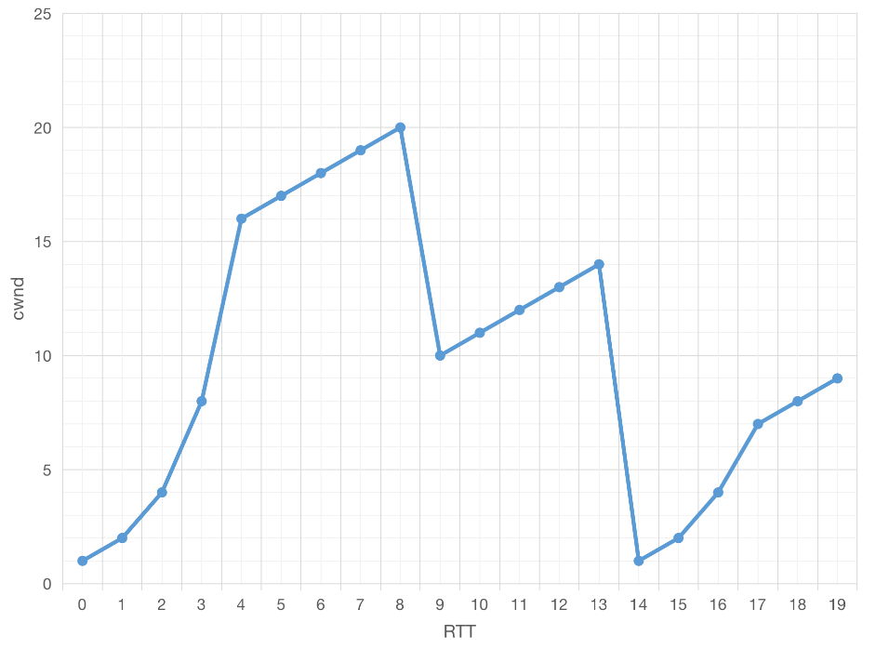

1. At time 5: 1+2+4+8+16+17>32

Q2

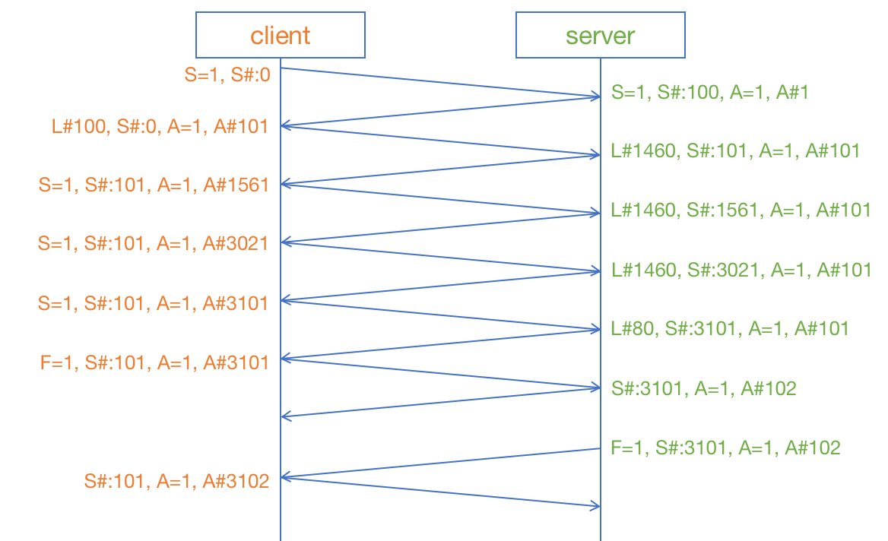

Q3



Q4

can’t figure out the answer.

Practical Exercises

Because I’m in China Mainland, destination IP address is different from IP address in *tcp-ethereal-trace-1*

3.

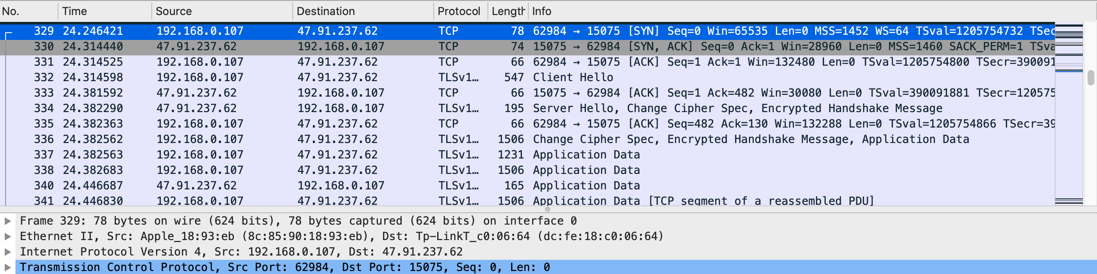

IP address: 192.168.0.107

port: 62984

1. the sequence number of the TCP SYN segment that is used to initiate the TCP connection from client: Seq=0

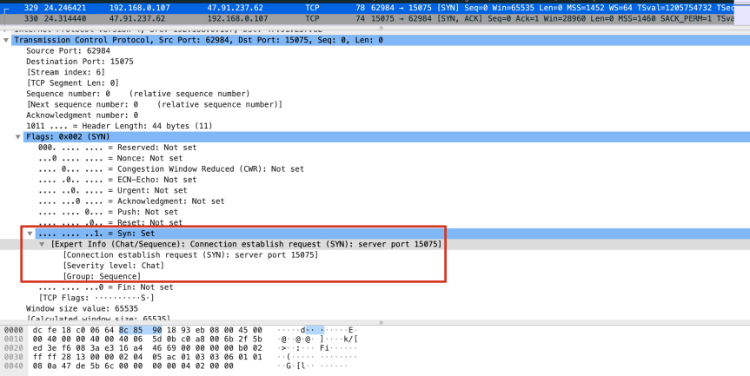

5. the sequence number of the SYNACK segment sent by gaia.cs.umass.edu is Seq=0, the value of the Acknowledgement field in the SYNACK segment is Ack=1. Server determines Ack by Seq value of client SYN segment.

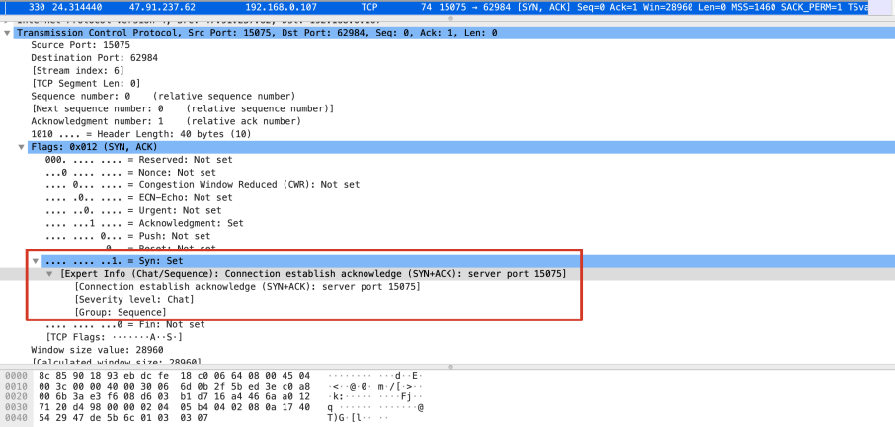

1. It’s difficult to find which segment containing HTTP POST when data is encrypted.

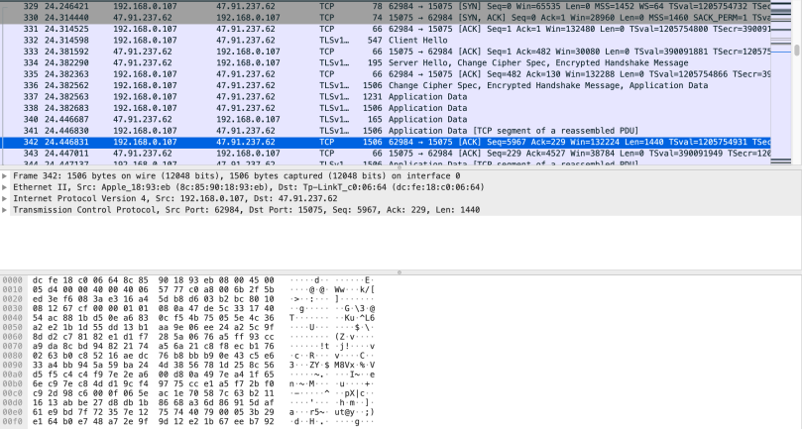

Using *tcp-ethereal-trace-1* to answer this question:

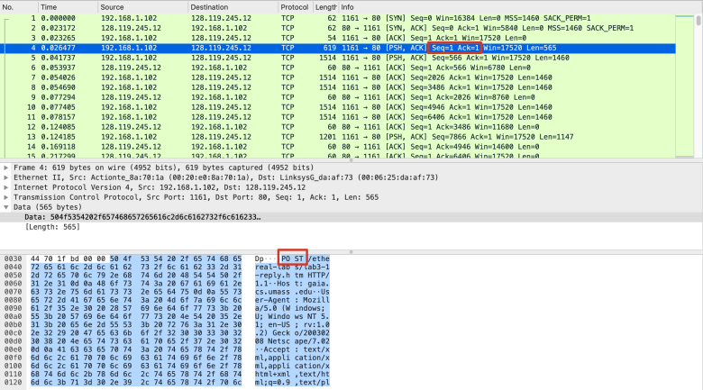

Seq=1