Q1:

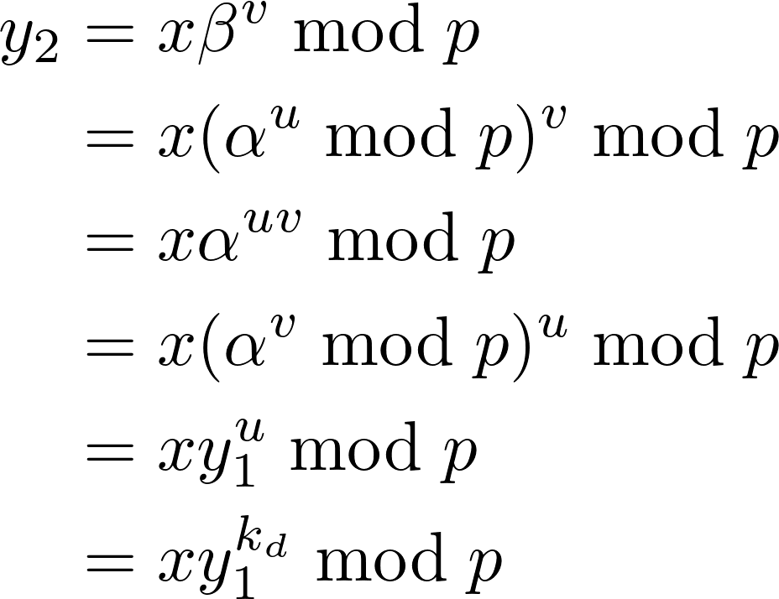

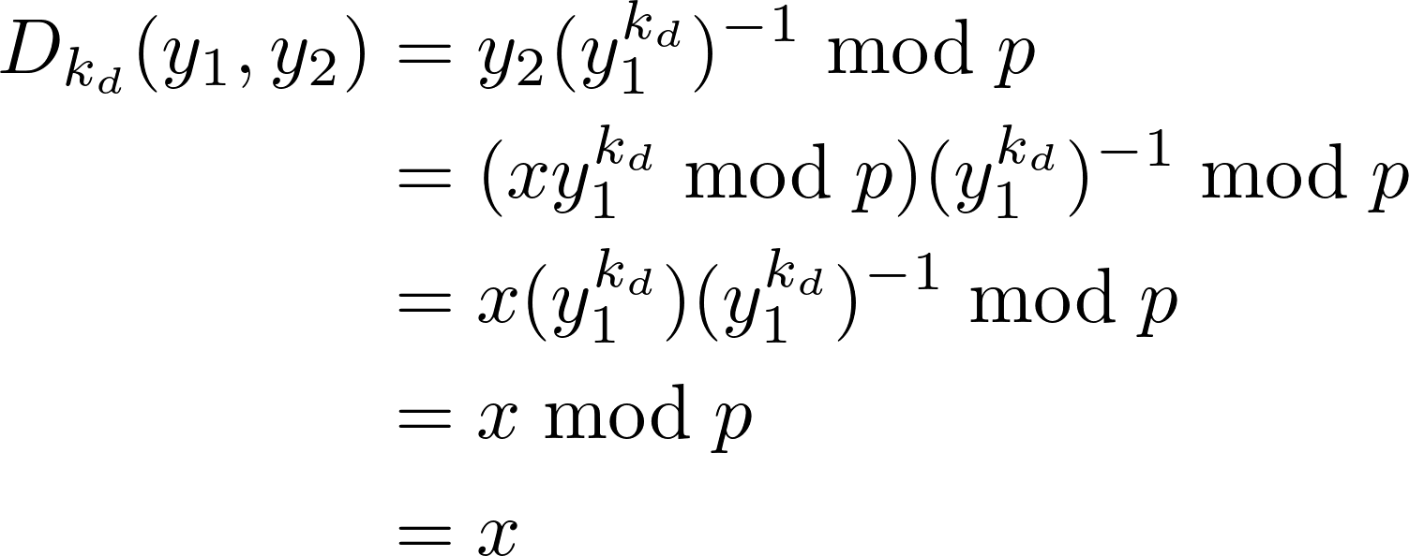

Q2:

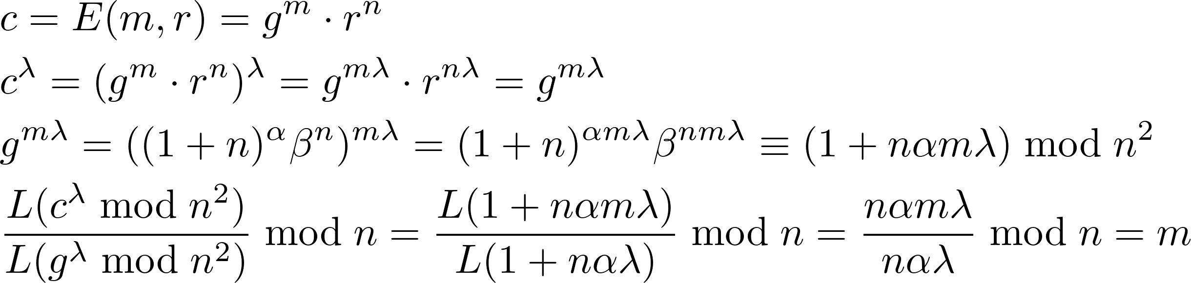

Q3:

No. Hash function is required. When hash function is well designed, it helps the signature verification logic doesn't pay any more attention to the message, then protects the origin message.

Q4:

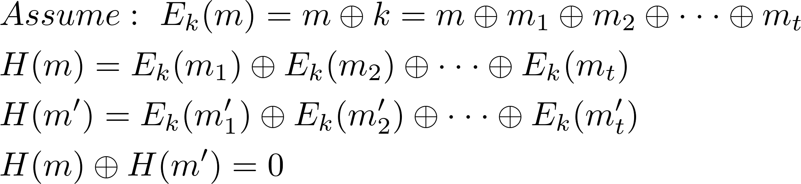

Q5:

