This file includes all staffs to reproduce the dashboard.

If you just want to see the dashboard, go to

<https://share.streamlit.io/duyufrank/duyufrank/main/stream_conservation.py>

If you want to reproduce the dashboard follow the following steps:

**1.Make sure your computer has python, and make sure add this directory’s address to your environment path.**

**2.Make sure you have installed the following packages:**

|  |
| --- |
| streamlit |
| matplotlib |
| numpy |
| pandas |
| PIL |
| plotly |
| datetime |

If you have not installed them, you can do the followings:

Open cmd (Windows)/terminal (Mac), and execute:

“pip install packagenames”



**3. In the cmd, go to the directory root, then run “streamlit run filename”, and the app will be opened in your browser.**

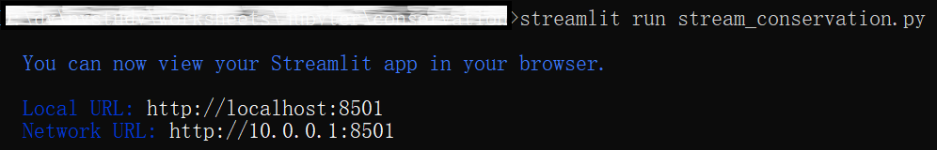

***Note****: I include all process in the streamlit_conservation.py including data processing for the convenience of reproducing. Since the data we have is very small, we can do it without considering speed. However, in you full data, if data amount is very large, it will be unwise to do data processing in streamlit file. Instead,* ***you should process your data in other program and only feed processed data to streamlit file,*** *which will make your app much faster.*