Homework 03
IB DP2 Computer Science
Due: 2026-Oct-07
Time allowed: 60 minutes
Total: 100 marks

Question 1 — The ALU and the system buses (A1.1 Computer organization) [8 marks]
(a) Describe the role of the arithmetic logic unit (ALU) within the CPU. [ 4 ]
The ALU performs arithmetic calculations and logical operations inside the CPU, such as
addition, subtraction, comparisons and Boolean operations.

(b) Name the three buses in a computer system and state what each one carries. Give ONE reason why a bus architecture is used rather than connecting every device directly to the CPU. [ 4 ]
Address bus: carries the address of the memory location or device being accessed.
Data bus: carries data and instructions between components.
Control bus: carries control signals, such as read and write signals.

A bus architecture is used because it reduces the number of separate connections required
between the CPU and other components, making the system simpler and more efficient.

Question 2 — Cache memory (A1.1 Computer organization) [12 marks]
(a) Explain why a cache is used in a computer system. Refer to the relative speeds of the CPU and RAM. [ 4 ]

A bus architecture is used because it reduces the number of separate connections required
between the CPU and other components, making the system simpler and more efficient.

(b) Explain the difference between a cache hit and a cache miss, and state what is meant by the hit rate. [ 4 ]
A cache hit occurs when the required data is found in the cache.
A cache miss occurs when the required data is not in the cache and must be fetched from RAM.
The hit rate is the percentage of memory accesses where the required data is found in the
cache.

(c) Explain what is meant by temporal locality and spatial locality, and state how each helps a cache to improve performance. [ 4 ]
Temporal locality: Data or instructions that have been used recently are likely to be used again
soon. Keeping them in the cache improves access speed.
Spatial locality: Data stored near recently accessed data is likely to be needed soon. Loading
nearby data into the cache can therefore improve performance.

Question 3 — Primary and secondary storage (A1.1 Computer organization) [10 marks]
(a) State TWO differences between RAM and ROM. [ 4 ]
RAM is volatile, so its contents are lost when the power is turned off; ROM is non-volatile, so its
contents are retained.
RAM can normally be read from and written to, while ROM is mainly read-only and stores
permanent instructions.

(b) Explain why a computer needs secondary storage as well as primary memory (RAM). [ 2 ]
A computer needs secondary storage because RAM is temporary and volatile. Secondary
storage keeps programs and data permanently even when the computer is switched off.

(c) Compare a solid-state drive (SSD) with a hard-disk drive (HDD) under TWO headings, and state ONE situation in which each is the better choice. [ 4 ]
Speed: SSD is faster than HDD.
Durability: SSD is more durable because it has no moving parts, while HDD has moving parts.
SSD better choice: A laptop where speed and durability are important.
HDD better choice: Large-capacity backup storage where low cost is important.

Question 4 — Number systems (A1.2 Data representation) [10 marks]
Show your working where asked.
(a) Convert the binary number 1101 1010₂ into hexadecimal. [ 3 ]

(b) Convert the hexadecimal number 2C7₁₆ into denary. Show your working. [ 4 ]

(c) Convert the hexadecimal number F5₁₆ into an 8-bit binary number. [ 3 ]

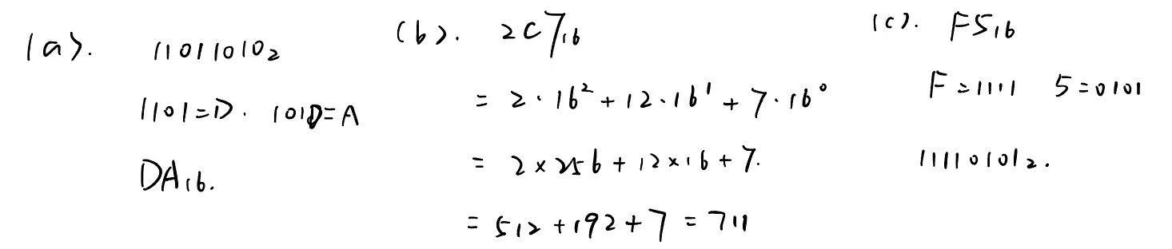

Question 5 — Characters, compression and images (A1.2 Data representation) [14 marks]
(a) Explain why Unicode is used in addition to ASCII. [ 4 ]

Unicode is used in addition to ASCII because ASCII can represent only a limited number of
characters, mainly English letters, numbers and symbols. Unicode can represent characters f
rom many different languages and writing systems.

(b) The character string AAABBBCCCDDDDD is to be compressed using run-length encoding (RLE). (i) Write the RLE output for this string. (ii) Calculate the compression ratio. [ 4 ]

(c) A bitmap image has a resolution of 800 × 600 pixels and a colour depth of 24 bits. Calculate the file size of this image in MiB. Show your working. (1 MiB = 1024 × 1024 bytes) [ 6 ]

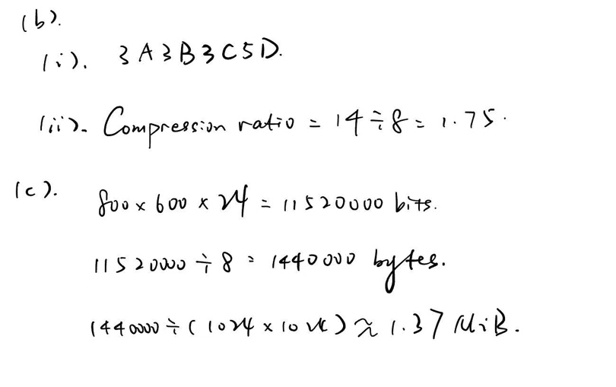

Question 6 — Linear search — implementation and tracing (B2.4 Algorithms) [14 marks]
Write your Java method in the box, then complete the trace.
(a) Write a Java method int linearSearch(int[] data, int target) that searches the array for the target and returns the index of its FIRST occurrence. If the target is not present in the array, the method must return -1. [ 8 ]
public static int linearSearch(int[] data, int target) {
for (int i = 0; i < data.length; i++) {
if (data[i] == target) {
return i;
}
}
return -1;
}

Index | 0 | 1 | 2 | 3 | 4 | 5
data[index] | 17 | 8 | 42 | 23 | 42 | 5

(b) The method is called with the array below and target = 42. Complete the trace table, then state the value that the method returns. [ 3 ]
Index i | data[i] | Is data[i] == 42 ? | Action
0 | 17 | No | Continue
1 | 8 | NO | continue
2 | 42 | Yes | Return 2
Return Value: 2
(c) Using the same array, state how many comparisons are needed to search for the value 99, and state the value that the method returns. Explain your answer. [ 3 ]

There are 6 comparisons because 99 is not in the array, so every element must be checked.
Return value = -1

Question 7 — Classes and encapsulation (B3.1 Object-oriented programming) [14 marks]
Write your Java class in the box.
(a) Explain the difference between a constructor and a normal method. [ 4 ]
A constructor is a special method used to initialize a new object when it is created. It has the
same name as the class and has no return type.
A normal method is used to perform an action or operation after the object has been created,
and it may return a value.

(b) Write a Java class BankAccount with private fields accountHolder (String) and balance (double), a constructor, and a getter for balance. Add a method deposit(double amount) that adds the amount to the balance only if the amount is greater than zero, and a method withdraw(double amount) that subtracts the amount only if it is greater than zero and does not exceed the current balance. Then in main() create an account with a balance of 100.0, deposit 50.0, withdraw 30.0, attempt to withdraw 500.0, and print the final balance. [ 10 ]
public class BankAccount {
private String accountHolder;
private double balance;
public BankAccount(String accountHolder, double balance) {
this.accountHolder = accountHolder;
this.balance = balance;
}
public double getBalance() {
return balance;
}
public void deposit(double amount) {
if (amount > 0) {
balance = balance + amount;
}
}
public void withdraw(double amount) {
if (amount > 0 && amount <= balance) {
balance = balance - amount;
}
}
public static void main(String[] args) {
BankAccount account = new BankAccount("Tina", 100.0);
account.deposit(50.0);
account.withdraw(30.0);
account.withdraw(500.0);
System.out.println(account.getBalance());
}
}

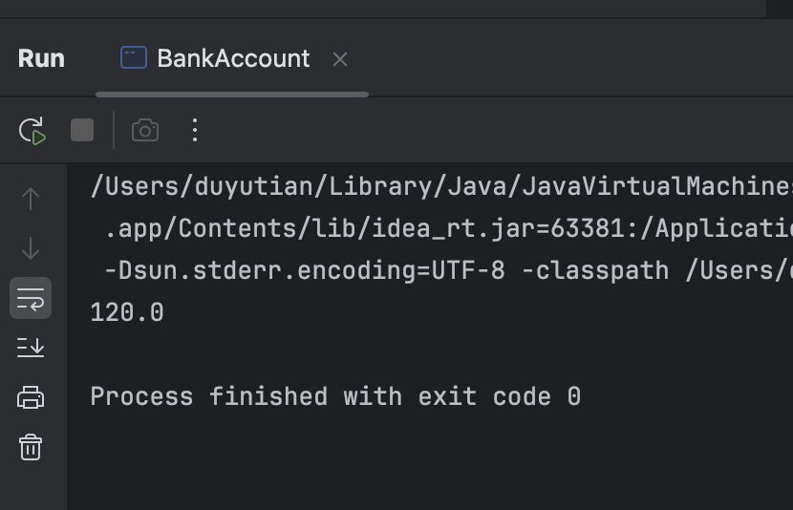

Question 8 — The machine cycle — a register trace (A1.1 Computer organization) [8 marks]
Use the memory layout below. The first instruction is held at address 100.
Address | Content
100 | LOAD 200
101 | ADD 201
102 | STORE 202
103 | HALT
200 | 6
201 | 9
202 | 0

(a) Immediately after the first instruction (LOAD 200) has been fetched but before it is executed, state the contents of: (i) the program counter (PC) (ii) the memory address register (MAR) (iii) the memory data register (MDR) (iv) the instruction register (IR). [ 4 ]
PC = 101
MAR = 100
MDR = LOAD 200
IR = LOAD 200

(b) The instruction LOAD 200 is now executed. State the contents of the MAR and the MDR at the end of the execute stage, state the value held in the accumulator (ACC) afterwards, and explain why. [ 4 ]
MAR = 200
MDR = 6
ACC = 6
This is because LOAD 200 loads the value stored at memory address 200 into the accumulator.

Question 9 — Two's complement arithmetic (challenging) (A1.2 Data representation) [10 marks]
Work in 8-bit two's complement throughout. Show all working.
(a) Write the denary number −45 as an 8-bit two's complement binary number. Show your working. [ 3 ]

(b) Using 8-bit two's complement, calculate 61 + (−45). Show your working and state the denary value of the result. [ 4 ]

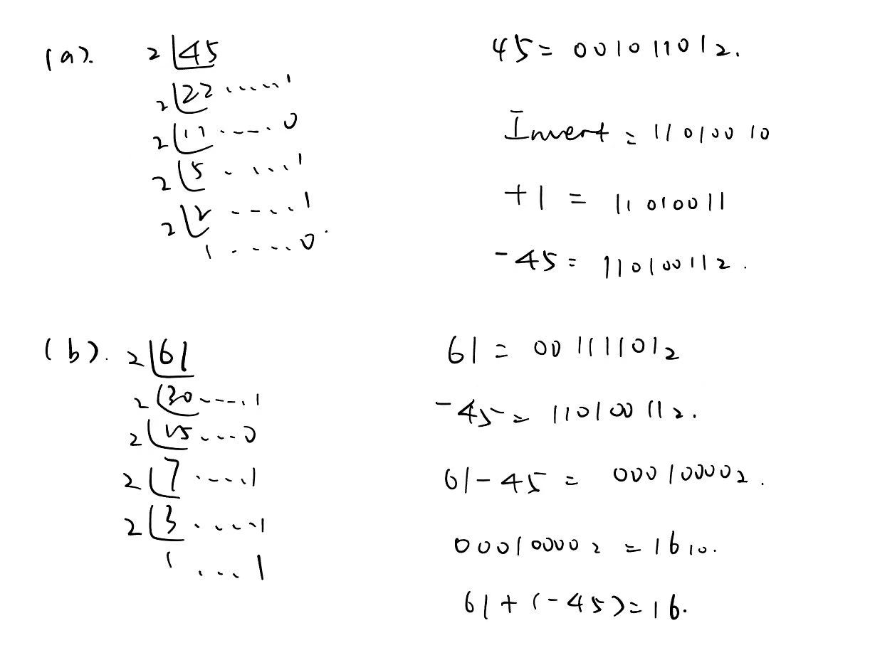
(c) Explain how a computer can detect that overflow has occurred when it adds two 8-bit two's complement numbers. [ 3 ]
Overflow occurs when two numbers with the same sign are added but the result has the
opposite sign.
For example, adding two positive 8-bit numbers and getting a negative result indicates overflow.

