Homework 01
IB DP2 Computer Science
Due: 2026-Sept-16
Time allowed: 60 minutes
Total: 100 marks

Question 1 — Decomposition, abstraction & algorithms (B1.1 Computational thinking) [8 marks]

(a) Define each of the following: (i) decomposition (ii) abstraction (iii) an algorithm. [ 4 ]
Decomposition: breaking a complex problem into smaller, more manageable parts.
Abstraction: removing unnecessary details and focusing only on the important information
needed to solve a problem.
Algorithm: A finite sequence of clear, ordered steps used to solve a problem.

(b) A school wants a program that decides whether a student may join the sports team: a student is eligible if they are aged 14 or over AND are at least 150 cm tall. Complete the problem specification by stating the input(s), the processing, and the output. [ 4 ]
Inputs: student’s age, student’s height (cm)
Processing: age >= 14 AND height >= 150
Output: eligible if both true; not eligible otherwise

Question 2 — Binary conversions (A1.2 Data representation) [8 marks]
Show all working for full marks.
(a) Convert the binary number 10110110₂ into denary. Show your working. [ 4 ]
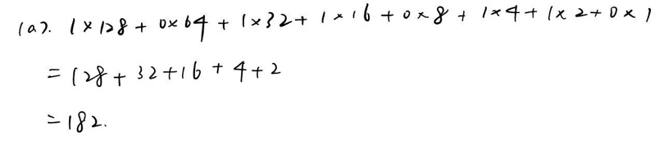
(b) Convert the denary number 177 into an 8-bit binary number. Show your working. [ 4 ]
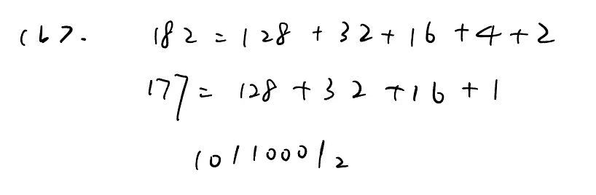
Question 3 — CPU components & fetch-decode-execute (A1.1 Computer hardware) [8 marks]

(a) Describe the role of the Control Unit and the Program Counter (PC) within the CPU. [ 4 ]
Control Unit (CU): controls and coordinates the operations of the CPU. It sends control signals
to other components and manages the execution of instructions.
Program Counter (PC): stores the address of the next instruction to be fetched from memory.

(b) Describe the three stages of the fetch–decode–execute cycle. [ 4 ]
Fetch: The CPU fetches the next instruction from memory using the address stored in the
Program counter.
Decode: The Control Unit decodes the instruction to determine what operation needs to be
performed.
Execute: The CPU carries out the instruction, for example by performing a calculation, moving
data, or storing a result.

Question 4 — Logic gates & operating systems (A1.2 & A1.3) [8 marks]

(a) Complete the truth table for the Boolean expression X = A AND (NOT B). [ 4 ]
A | B | NOT B | X = A AND (NOT B)
0 | 0 | 1 | 0
0 | 1 | 0 | 0
1 | 0 | 1 | 1
1 | 1 | 0 | 0
(b) State TWO functions of an operating system. [ 4 ]
First, manage the allocation and use of main memory.
Second, organize, store, retrieve, and manage files and folders.

Question 5 — Programming: selection, loops, file processing (B2.3 / B2.1 / B2.5) [16 marks]
Write your Java program in the box. (a) is the main task — do it first.
(a) Write a complete Java program that reads a class of N students (N ≤ 30) and a mark (0–100) for each. For every mark it must print the grade, then after the loop print the class average and the number of grade-A marks. Grades: ≥90 → “Grade A”; 80–89 → “Grade B”; 70–79 → “Grade C”; <70 → “Study harder”. [ 9 ]
import java.util.*;
public class Main {
public static void main(String[] args) {
Scanner input = new Scanner(System.in);
int N = input.nextInt();
int total = 0;
int gradeACount = 0;
for (int i = 0; i < N; i++) {
int mark = input.nextInt();
total += mark;
if (mark >= 90) {
System.out.println("Grade A");
gradeACount++;
} else if (mark >= 80) {
System.out.println("Grade B");
} else if (mark >= 70) {
System.out.println("Grade C");
} else {
System.out.println("Study harder");
}
}
double average = (double) total / N;
System.out.println("Average: " + average);
System.out.println("Grade A marks: " + gradeACount);
}
}

(b) The 30 marks are stored in a text file called marks.txt, one per line. Write the Java code that opens and reads this file, and handles the situation where the file does not exist. [ 3 ]
import java.util.*;
try {
File file = new File("marks.txt");
Scanner reader = new Scanner(file);
while (reader.hasNextInt()) {
int mark = reader.nextInt();
System.out.println(mark);
}
reader.close();
} catch (FileNotFoundException e) {
System.out.println("File not found.");
}

(c) State ONE advantage of using a loop here instead of writing the same statements 30 times. [ 2 ]
A loop reduces repeated code and makes the program shorter and easier to maintain.

(d) Trace your program with the five marks 90, 85, 95, 60, 78. State the two values it prints. [ 2 ]
Average = 81.6
Number of Grade A marks = 2

Question 6 — Linear & binary search, Big-O (B2.4 Algorithms) [18 marks]
Part (b) gives a sorted array to trace by hand.
(a) A linear search is made for a value in an array containing 15 elements. Explain how a linear search works, and state the best-case and worst-case number of comparisons. [ 6 ]
A linear search checks each element in the array one by one from the beginning until the target
value is found or the end of the array is reached.
Best: 1 comparison Worst: 15 comparisons

A[1..15] = { 3, 7, 12, 18, 25, 31, 39, 44, 52, 60, 68, 73, 81, 90, 97 } (target = 90)

(b) The sorted array is given. Complete the trace table to find the value 90 using a binary search, showing low/high/mid/A[mid] each step. [ 9 ]
Step | Low | High | Mid | A[mid] | Result
1 | 1 | 15 | 8 | 44 | 90>44, search in the right half
2 | 9 | 15 | 12 | 73 | 90>73, search is in the right half
3 | 13 | 15 | 14 | 90 | Found
(c) State the Big-O efficiency of a linear search and of a binary search, and state which is more appropriate for a large, already-sorted dataset. [ 3 ]
Linear search: O(n)
Binary search: O(log n)
For a large, already-sorted dataset, binary search is more appropriate because it is more
efficient.

Question 7 — Classes, objects & encapsulation (B3.1 OOP (single class)) [14 marks]
Write the class in Java in the box.
(a) Explain the difference between a class and an object. [ 4 ]
A class is a blueprint or template that defines the data and methods of a type of object.

An object is an instance of a class created from that blueprint.

(b) Explain what is meant by encapsulation / information hiding, and give ONE benefit of using it. [ 4 ]
Encapsulation means keeping data private inside a class and controlling access to it through
methods such as getters and setters.
One benefit is that it protects data from being changed directly in an unsafe or incorrect way.

(c) Write a Java class Book with private fields title, author and price, a constructor, and getter/setter methods. Then in main(), create two Book objects and display their details. [ 6 ]
public class Book {
private String title;
private String author;
private double price;
public Book(String title, String author, double price) {
this.title = title;
this.author = author;
this.price = price;
}
public String getTitle() {
return title;
}
public void setTitle(String title) {
this.title = title;
}
public String getAuthor() {
return author;
}
public void setAuthor(String author) {
this.author = author;
}
public double getPrice() {
return price;
}
public void setPrice(double price) {
this.price = price;
}
public static void main(String[] args) {
Book book1 = new Book("Book A", "Author A", 20.0);
Book book2 = new Book("Book B", "Author B", 25.0);
System.out.println(book1.getTitle() + " " + book1.getAuthor() + " " + book1.getPrice());
System.out.println(book2.getTitle() + " " + book2.getAuthor() + " " + book2.getPrice());
}
}

Question 8 — Arrays/Lists, stack & queue (B2.2 Data structures) [8 marks]

(a) Give TWO differences between a static array and a dynamic List. [ 4 ]
First, a static array has a fixed size, while a dynamic List can grow or shrink during program
execution.
Second, an array usually stores elements in fixed indexed positions, while a List provides built-
in methods such as adding and removing elements.

(b) Explain the difference between a stack (LIFO) and a queue (FIFO), and give a real-world use for each. [ 4 ]
A stack uses LIFO, meaning the last item added is the first one removed.
Real-world use: Undo function in a text editor.
A queue uses FIFO, meaning the first item added is the first one removed.
Real-world use: Print jobs waiting to be processed by a printer.

Question 9 — Selection sort — tracing & efficiency (challenging) (B2.4 Algorithms) [12 marks]
Study the algorithm carefully before tracing. Take your time.
public class SelectionSort {
public static void main(String[] args) {
int[] a = {5, 3, 8, 1}; // indices 0..3
int n = a.length;

for (int i = 0; i < n - 1; i++) {
int minPos = i;
for (int j = i + 1; j < n; j++) {
if (a[j] < a[minPos]) { minPos = j; }
}
int temp = a[i];
a[i] = a[minPos];
a[minPos] = temp;
}
}
}
(a)(i) Complete the trace table below, showing the array after each iteration of the outer loop. [ 6 ]
Iteration (i) | Min index | Array after this pass
0 | 3 | {1, 3, 8, 5}
1 | 1 | {1, 3, 8, 5}
2 | 3 | {1, 3, 8, 5}
(a)(ii) State the final sorted array. [ 2 ]
{1, 3, 8, 5}

(b) State the Big-O efficiency of this sorting algorithm and justify briefly. [ 2 ]
O(n^2)
Selection sort uses nested loops, so the number of comparisons grows approximately with the
square of the number of elements.

(c) If the array size is doubled (from 4 to 8 elements), roughly how many more comparisons/operations are needed? [ 2 ]
2^2 = 4
So it needs approximately 4 times as many operations.

