Homework 04
IB DP2 Computer Science
Due: 2026-Oct-15
Time allowed: 60 minutes
Total: 100 marks

Question 1 — Multi-core processors and co-processors (A1.1 Computer organization) [8 marks]
(a) Explain the difference between multitasking on a single-core processor and parallel processing on a multi-core processor. [ 4 ]
A single-core processor switches rapidly between tasks using time slices, so they appear to
run together, but only one instruction stream executes at a time.
A multi-core processor has several cores that can execute different tasks or threads
simultaneously, providing true parallel processing.

(b) A GPU is described as a co-processor. Explain what is meant by a co-processor, and give ONE task for which a GPU is more suitable than a CPU. [ 4 ]
A co-processor is a specialised processor that assists the CPU with particular types of work.
A GPU is suitable for rendering 3D graphics because its many processing units can perform
similar calculations on many pixels or vertices in parallel.

Question 2 — The memory hierarchy and cache levels (A1.1 Computer organization) [12 marks]
(a) Describe the memory hierarchy of a computer, from inside the CPU outwards to secondary storage. Your answer should refer to speed, capacity and cost. [ 4 ]
Registers → L1 cache → L2 cache → L3 cache → RAM → secondary storage.
Moving outwards, access is generally slower, capacity increases and cost per bit decreases.
Registers hold values currently being processed; caches hold frequently needed data. RAM
holds running programs, while secondary storage retains programs and data without power.

(b) Explain the differences between the L1, L2 and L3 caches. [ 4 ]
L1 is the smallest and fastest cache, located closest to each core and normally private to it.
L2 is larger but slower than L1, and is usually dedicated to a core.
L3 is larger and slower than L2, and is commonly shared between the CPU cores.

(c) When the CPU needs a piece of data it looks in L1, then L2, then L3, and only then in RAM. Explain why this order is used, and why it improves performance. [ 4 ]
The CPU checks the fastest cache first, so an L1 hit supplies the data with minimal delay.
If it misses, the larger L2 and L3 caches may still contain the data before RAM is accessed.
Keeping frequently used data in caches reduces slow RAM accesses and CPU waiting time,
so instructions can execute more quickly.

Question 3 — Types of secondary storage (A1.1 Computer organization) [10 marks]
(a) State TWO differences between internal secondary storage and external secondary storage. [ 4 ]
Internal storage is fitted inside the computer; external storage is housed outside it.
Internal storage usually connects through an internal interface such as SATA or PCIe;
external storage typically connects through an external port such as USB and is easier
to disconnect and move between computers.

(b) State TWO examples of optical storage, and give ONE disadvantage of optical storage. [ 3 ]
Examples: CD and DVD.
Disadvantage: Optical discs have a much lower capacity than modern HDDs or SSDs.

(c) Explain why a business might use a network-attached storage (NAS) device. [ 3 ]
A NAS provides central file storage that several employees can access over a network.
Users can share the same files, while permissions control who can read or change them.
Centralised storage also makes it easier to manage backups.

Question 4 — Representing sound (A1.2 Data representation) [12 marks]
(a) Explain the difference between an analogue signal and a digital signal, and state why an analogue-to-digital converter (ADC) is needed when sound is recorded. [ 4 ]
An analogue signal varies continuously in amplitude and time. A digital signal represents
the sound using discrete binary values taken at separate sampling times.
An ADC samples the microphone’s analogue signal and quantises each sample into a binary
value so that a computer can store and process the recording.

(b) Explain what is meant by the sampling rate and the sampling resolution of a sound recording, and state how each affects the quality of the recording. [ 4 ]
Sampling rate is the number of samples taken per second, measured in Hz. A higher rate
captures more detail over time and allows higher sound frequencies to be represented.
Sampling resolution is the number of bits per sample. More bits give more amplitude levels,
reducing quantisation error and reproducing quieter sounds more accurately.

(c) A sound clip is recorded for 30 seconds at a sampling rate of 44 100 Hz with a sampling resolution of 16 bits. Calculate the file size in MiB. Show your working. (1 MiB = 1024 × 1024 bytes) [ 4 ]
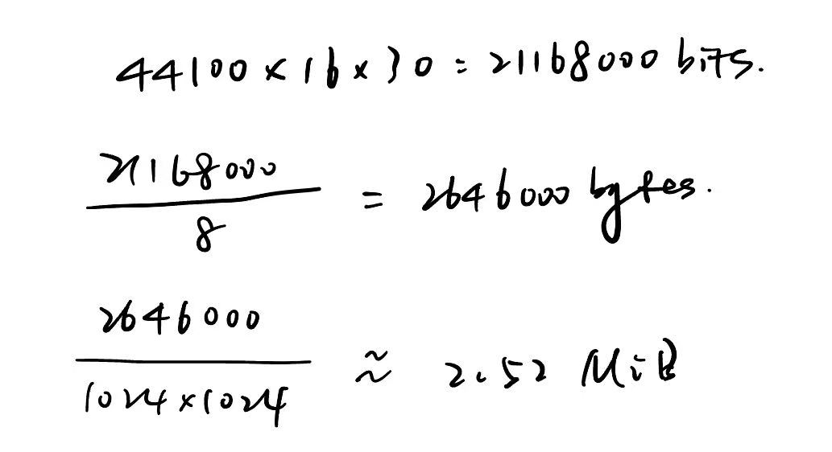

Question 5 — Colour depth and compression (A1.2 Data representation) [10 marks]
(a) Explain what is meant by the colour depth of a bitmap image, and state how many different colours an image with a colour depth of 8 bits can represent. [ 4 ]
Colour depth is the number of bits used to represent the colour of each pixel.
A greater depth allows more different colours and smoother colour changes.
With 8 bits: 2^8 = 256 different colours.

(b) Explain the difference between lossy and lossless compression, and give ONE file format that uses each. [ 4 ]
Lossy compression permanently removes some data, so the original cannot be restored
exactly and quality may decrease. Example: JPEG.
Lossless compression encodes data without discarding information, so the original can be
restored exactly. Example: PNG.

(c) A 24-bit colour photograph is saved twice: once as a JPEG and once as a PNG. Explain why the JPEG file is much smaller. [ 2 ]
JPEG uses lossy compression to discard less noticeable image detail, reducing the data stored.
PNG preserves all pixel data using lossless compression, so photographs usually stay larger.

Question 6 — Selection sort — implementation and tracing (B2.4 Algorithms) [14 marks]
Write your Java method in the box, then complete the trace.
(a) Write a Java method sortDescending(int[] data) that sorts the array into DESCENDING order using a selection sort. [ 8 ]
public static void sortDescending(int[] data) {
for (int i = 0; i < data.length - 1; i++) {
int maxPos = i;
for (int j = i + 1; j < data.length; j++) {
if (data[j] > data[maxPos]) {
maxPos = j;
}
}
int temp = data[i];
data[i] = data[maxPos];
data[maxPos] = temp;
}
}
(b) Trace your method on the array { 4, 9, 2, 7 }, showing the contents of the array after each iteration of the outer loop. [ 3 ]
Iteration (i) | Array after this pass
0 | {9, 4, 2, 7}
1 | {9, 7, 2, 4}
2 | {9, 7, 4, 2}
(c) Explain ONE way in which a selection sort is more efficient than a bubble sort in practice, and ONE advantage that a bubble sort has over a selection sort. [ 3 ]
Selection sort makes at most one swap per outer pass, so it usually needs fewer swaps
than bubble sort, which may swap adjacent elements many times in each pass.
An optimised bubble sort can stop after a pass with no swaps, making it faster for an
already-sorted array; standard selection sort still checks the remaining elements.

Question 7 — Classes and objects (B3.1 Object-oriented programming) [14 marks]
Write your Java class in the box.
(a) The statement Temperature t = new Temperature(25); is executed. Explain what happens, referring to the object, the reference variable and the constructor. [ 4 ]
A new Temperature object is allocated in memory. The constructor Temperature(double)
is called with 25 and initialises the object’s celsius field to 25.0.
The reference variable t stores a reference to this object, allowing its public methods
to be called through t.

(b) Write a Java class Temperature with a private field celsius (a double), a constructor, a getter and a setter, a method toFahrenheit() that returns the temperature in degrees Fahrenheit, and a method isFreezing() that returns true when the temperature is at or below 0 °C. Then in main() create a Temperature of 25, print its Celsius value, its Fahrenheit value and whether it is freezing; then change it to −5 using the setter and print the three values again. (F = C × 9 ÷ 5 + 32) [ 10 ]
public class Temperature {
private double celsius;
public Temperature(double celsius) {
this.celsius = celsius;
}
public double getCelsius() {
return celsius;
}
public void setCelsius(double celsius) {
this.celsius = celsius;
}
public double toFahrenheit() {
return celsius * 9.0 / 5.0 + 32;
}
public boolean isFreezing() {
return celsius <= 0;
}
public static void main(String[] args) {
Temperature t = new Temperature(25);
System.out.println(t.getCelsius());
System.out.println(t.toFahrenheit());
System.out.println(t.isFreezing());
t.setCelsius(-5);
System.out.println(t.getCelsius());
System.out.println(t.toFahrenheit());
System.out.println(t.isFreezing());
}
}

Question 8 — Pipelining (A1.1 Computer organization) [8 marks]
(a) Explain what is meant by pipelining in a CPU, and how it improves performance. [ 4 ]
Pipelining divides instruction processing into stages such as fetch, decode and execute.
Different instructions occupy different stages at the same time, so their execution overlaps.
Once the pipeline is full, ideally one instruction completes each cycle. This increases
instruction throughput, although a single instruction still passes through every stage.

(b) A program consists of 4 instructions. The CPU has a 3-stage pipeline (fetch, decode, execute), and each instruction takes 3 cycles to pass through it. State how many cycles are needed to complete the program (i) without pipelining and (ii) with a perfect 3-stage pipeline. Justify each answer. [ 4 ]
(i) Without pipelining: 4 × 3 = 12 cycles, since each instruction completes all three stages
before the next instruction starts.
(ii) With perfect pipelining: 3 + (4 − 1) = 6 cycles. The first instruction takes 3 cycles;
each of the remaining 3 instructions finishes one cycle later.

Question 9 — Signed and unsigned integers (challenging) (A1.2 Data representation) [12 marks]
Show all working. Signed numbers use two's complement.
(a) For an 8-bit binary number, state the range of values that can be represented when the number is interpreted as (i) an unsigned integer and (ii) a signed two's complement integer. [ 4 ]
(i) Unsigned: 0 to 2^8 − 1 = 255.
(ii) Signed two’s complement: −2^7 to 2^7 − 1 = −128 to 127.

(b) The 8-bit pattern 11011010 is held in a memory location. State the value it represents if it is interpreted as (i) an unsigned integer and (ii) a signed two's complement integer. Show your working for (ii). [ 4 ]
(i) Unsigned: 128 + 64 + 16 + 8 + 2 = 218.
(ii) Signed: −128 + 64 + 16 + 8 + 2 = −38.
The most significant bit has weight −128 in 8-bit two’s complement.

(c) A programmer writes the value 200 into a variable that is an 8-bit signed two's complement integer. Explain what happens and why. [ 4 ]
200 exceeds the signed 8-bit range of −128 to 127, so it cannot be represented correctly.
200 in unsigned binary is 11001000. If these low 8 bits are stored, the leading 1 indicates
a negative value: −128 + 64 + 8 = −56.
This is integer overflow; a language with range checking may reject the assignment instead.

