CEU-KT: A Unified Framework for Causal, Explainable, and Uncertainty-Aware Knowledge Tracing

Phineas
Faculty of Information Technology
University of Science, Ho Chi Minh City, Vietnam
phineas@edu.vn
Ferb
Faculty of Information Technology
University of Science, Ho Chi Minh City, Vietnam
ferb@edu.vn

Abstract-Knowledge Tracing (KT) is a fundamental task in intelligent tutoring systems that aims to model students’ evolving knowledge states from their interaction sequences. Existing KT models face three critical limitations: (1) lack of pedagogical explainability in their predictions, (2) inability to quantify prediction uncertainty, and (3) inadequate modeling of causal prerequisite relationships among knowledge concepts. This paper presents CEU-KT (Causal, Explainable, and Uncertainty-aware Knowledge Tracing), a unified framework that simultaneously addresses these challenges. CEU-KT integrates five synergistic modules: an uncertainty-aware behavioral encoder employing Normal-Inverse-Gaussian (NIG) distributions, a differentiable causal DAG learner for prerequisite relationships, a temporal mastery transition module incorporating both forgetting and knowledge transfer mechanisms, a cognitive predictor that disentangles epistemic and aleatoric uncertainty, and a dynamic relevance graph for interpretable visualization. Experimental results on multiple benchmark datasets demonstrate that CEU-KT achieves superior prediction accuracy while providing calibrated uncertainty estimates and pedagogically meaningful explanations.
Keywords-knowledge tracing, causal learning, uncertainty quantification, explainable AI, educational data mining, deep learning

Introduction
Knowledge Tracing (KT) is the problem of estimating a student’s mastery level of knowledge concepts (KCs) from their sequence of learning interactions [1]. Accurate KT enables intelligent tutoring systems to personalize instruction, select appropriate exercises, and provide timely interventions. Over the past decade, deep learning approaches have dominated the field, starting with DKT [2], followed by attention-based models such as AKT [3] and relation-aware architectures like RKT [4].
Despite significant progress, three key challenges remain largely unaddressed by existing models. First, most deep KT models operate as black boxes, providing predictions without pedagogical explanations [5]. Second, they produce deterministic outputs without quantifying the uncertainty inherent in knowledge state estimation, which is particularly problematic for students with sparse interaction data [6]. Third, the causal prerequisite structure among knowledge concepts is typically assumed a priori or ignored entirely, limiting the model’s ability to generalize across domains with different curriculum structures [7].
Recent works have begun addressing these challenges individually. KeenKT [8] introduces Normal-Inverse-Gaussian (NIG) distributions for knowledge state representation with aleatoric uncertainty disambiguation. PLKT [9] proposes probabilistic embeddings with pattern-based reasoning paths for explainability. Paper 52 [10] develops differentiable causal structure learning for prerequisite discovery. However, no existing work integrates all three dimensions-causality, explainability, and uncertainty quantification-into a single coherent framework.
In this paper, we propose CEU-KT, a unified framework that jointly addresses these challenges through five carefully designed modules. CEU-KT builds upon and extends state-of-the-art methods including AKT [3], KeenKT [8], PLKT [9], Paper 52 [10], psi-kt [11], UKT [12], and RKT [4]. Our main contributions are: (1) a holistic architecture that integrates causal structure learning with probabilistic knowledge state tracking, (2) a principled approach to disentangling epistemic and aleatoric uncertainty in KT, and (3) a dynamic relevance graph that provides interpretable reasoning paths for pedagogical decision support.

Architectural Overview
CEU-KT comprises five interoperable modules that form a closed-loop pipeline from raw student interactions to pedagogical predictions and explanations. Figure 1 illustrates the system architecture with data flow paths among modules.

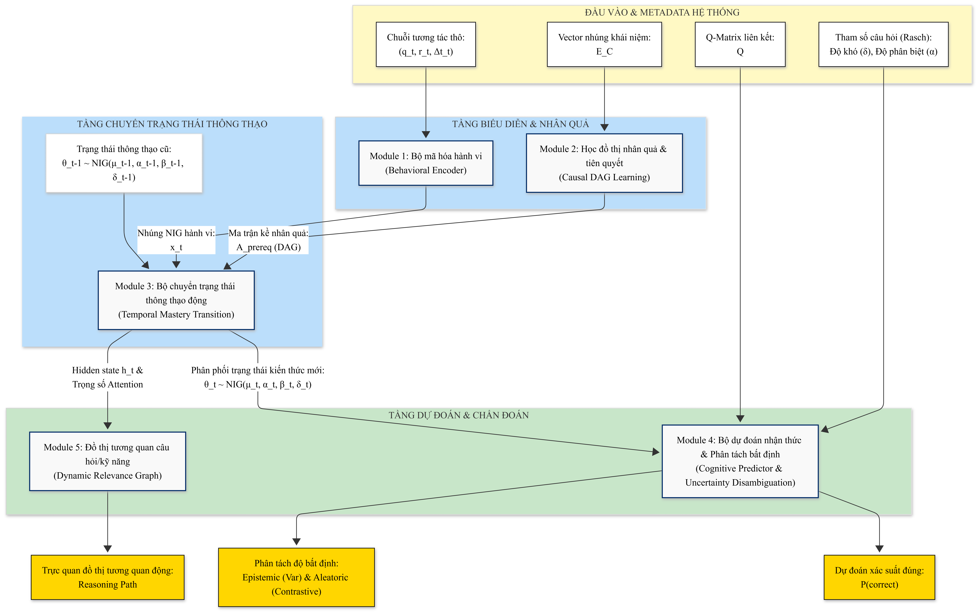

Fig. 1. Architecture of the CEU-KT framework showing the five modules and data flow paths. Solid arrows denote the internal forward pass; dashed arrows denote auxiliary data flows.

Module 1 (Uncertainty-Aware Behavioral Encoder) maps raw interaction tuples -question ID q_{t,} response rt, response time Δtt, and skill tag st- to a probabilistic behavioral embedding using a Normal-Inverse-Gaussian (NIG) distribution parameterized by location μtb, scale δtb, shape αtb, and skewness βtb.
The forward pass proceeds sequentially: input encoding (Module 1) → causal graph update (Module 2) → state transition (Module 3) → prediction and uncertainty evaluation (Module 4) → relevance visualization (Module 5). All modules are fully differentiable, enabling end-to-end optimization via stochastic gradient descent.

Notations
Table II lists the mathematical symbols used throughout this paper.
Symbol | Description
B | Batch size
T | Sequence length (maximum number of time steps)
N_{c} | Number of knowledge concepts (KCs)
N_{q} | Number of questions
d_{c} | Behavioral feature dimension
d_{hidden} | Hidden state dimension
t | Time step index
q_{t} | Question ID at time step t
r_{t} | Response correctness (0 or 1) at time step t
Δt_{t} | Time interval since last interaction at time step t
θ_{t} | Knowledge state NIG distribution at time t: (μ_t, α_t, β_t, δ_t)
μ_{t,c} | Expected mastery of concept c at time t
α_{t} | Shape (concentration) of knowledge state NIG at time t
β_{t} | Skewness of knowledge state NIG at time t
δ_{t} | Scale of knowledge state NIG at time t
x_{t} | Behavioral NIG embedding at time step t
μ_{t}^{b}, α_{t}^{b}, β_{t}^{b}, δ_{t}^{b} | NIG parameters of behavioral embedding at time t
A_{prereq} | Prerequisite adjacency matrix (ℝ^{N_c × N_c})
G_{prereq} | Prerequisite directed acyclic graph (DAG)
h(A_{prereq}) | Differentiable DAG acyclicity constraint function
⊙ | Element-wise (Hadamard) product
Tr(·) | Trace of a matrix
Parents(c) | Set of prerequisite (parent) concepts of concept c
λ_{c}(Δt_{t}) | Time-dependent mixing coefficient for concept c
Δμ_{t,c}^{(behavior)} | Knowledge update derived from behavior encoding
p_{t} | Base correctness probability for the next question
σ(·) | Sigmoid (logistic) activation function
α_{q_{t+1}} | Discrimination parameter of the next question
θ_{t}^{(target)} | Student ability mapped through Q-matrix for target question
δ_{q_{t+1}} | Difficulty parameter of the next question
P(correct) | Final calibrated response correctness probability
γ_{t} | Confidence coefficient (inversely proportional to NIG variance)
Var(θ_{t}) | Variance of knowledge state (epistemic uncertainty)
w_{i} | Denoised attention weight for history question i
q_{i} | Past question i from the interaction history
h_{t} | Hidden state at time step t

Module Design

Uncertainty-Aware Behavioral Encoder
The behavioral encoder transforms raw interactions into probabilistic representations using the Normal-Inverse-Gaussian (NIG) distribution, inherited and extended from KeenKT [8]. Unlike deterministic embeddings used in DKT [2] and AKT [3], the NIG distribution captures second-order uncertainty through four parameters: location μ (estimated mastery), scale δ (data scale), shape α (concentration), and skewness β (behavioral asymmetry). The encoding is given by:
xt ~ NIG(μtb, αtb, βtb, δtb) (1)
These parameters are generated by feed-forward networks with constrained activation functions-softplus for α and δ to ensure positivity, and tanh for β to bound skewness. This probabilistic encoding enables the model to express varying confidence in different observations, which is particularly important for noisy or ambiguous student responses.

Causal and Prerequisite DAG Learning
Module 2 learns a directed acyclic graph (DAG) G_{prereq} representing prerequisite relationships among KCs based on the co-occurrence patterns extracted by Module 1. The prerequisite graph Aprereq ∈ RN_c × N_c is constrained by a continuous acyclicity regularizer [19]:
h(Aprereq) = Tr(exp(Aprereq ⊙ Aprereq)) − Nc = 0 (2)
This constraint is added as a penalty term to the overall loss function, ensuring that the learned graph converges to a valid DAG without requiring manual specification of prerequisite relations by domain experts.

Temporal Mastery Transition Module
The student's knowledge state over N_{c} KCs is represented as a continuous probability distribution θt ∼ NIG(μt, αt, βt, δt). The state update from θ(t−1) to θt incorporates two pedagogical mechanisms. First, a time-decay forgetting mechanism weakens knowledge states proportionally to the elapsed time Δtt via an exponential decay function exp(−γ · Δtt), inspired by LefoKT [13] and HawkesKT [14]. Second, prerequisite-based knowledge transfer propagates mastery from prerequisite concepts to dependent concepts through information diffusion on the causal graph Aprereq, following psi-kt [11] and GKT [15]. The expected mastery update for concept c follows the equation:
μt,c = (1 − λc(Δt)) · μt−1,c + λc(Δt) · Σj∈Parents(c) Aprereq[j,c] · μt−1,j + Δμt,cbehavior (3)
where Δμ(t,c)(behavior) represents the knowledge update derived from the current interaction encoding by Module 1, and λc(Δtt) is a time-dependent mixing coefficient.

Cognitive Predictor and Uncertainty Disambiguation
The prediction layer adopts an IRT-based (Rasch) model following AKT [3] and QIKT [16] to ensure pedagogical interpretability. The base correctness probability p_{t} for the next question q(t+1) is computed as:
pt = σ(αq(t+1) · (θttarget − δq(t+1))) (4)
where θttarget is the student's ability mapped through the Q-matrix, δ(q(t+1)) is question difficulty, and α(q(t+1)) is question discrimination.
Epistemic uncertainty is measured as the variance of the latent knowledge state distribution Var(θ_{t}), which increases for concepts with sparse interaction history, following UKT [12] and PLKT [9]. Aleatoric uncertainty -arising from lucky guesses and careless mistakes-is mitigated through a distributional contrastive loss (NIGNCE) with negative samples simulating error patterns, as in KeenKT [8]. The final calibrated prediction is:
P(correct) = γt · pt + (1 − γt) · 0.5 (5)
where γ_{t} is a confidence coefficient inversely proportional to the variance of the NIG distribution, effectively shrinking predictions toward random chance when uncertainty is high.

Dynamic Question/Skill Relevance Graph
Module 5 constructs a dynamic relevance graph for visual interpretability, building upon relation-aware attention from RKT [4], PLKT [9], and DenoiseKT [17]. Nodes represent historical questions or skills, and edge weights between the target question q_{(t+1)} and each past question qi are computed via denoised attention:
wi = Softmax(Denoised-Attention(q(t+1), qi)) (6)
This graph provides educators with visual reasoning paths: if a student answers a question incorrectly, the teacher can inspect which past questions are most strongly correlated with the error, enabling targeted pedagogical interventions. The attention mechanism inherently filters out noisy or spurious correlations through the denoising procedure.

Data Compatibility Schema
Table I specifies the tensor shapes and data types passed between modules, ensuring seamless integration during implementation.
Data Flow | Tensor Shape | Type | Description
input_seq → Mod 1 | (B, T, 3) | Int/Float | Interactions (q_id, r, Δt)
Mod 1 → Mod 3 | (B, T, 4, d_c) | Float | NIG emb. (μ, α, β, δ)
Mod 2 → Mod 3 | (N_c, N_c) | Float | Causal adj. A_prereq (DAG)
Mod 3 → Mod 4 | (B, N_c, 4) | Float | State θ_t (NIG params/KC)
Mod 4 → Output | (B,), (B, 2) | Float | P(correct), [epistemic, aleatoric]
Table I. Data Compatibility Schema Across CEU-KT Modules
All tensor dimensions assume batch size B, sequence length T, N_{c} knowledge concepts, and dc behavioral feature dimensions. The consistent use of NIG parametrization (4 parameters per distribution) throughout the pipeline ensures probabilistic coherence.

References
[1]A. T. Corbett and J. R. Anderson, “Knowledge tracing: Modeling the acquisition of procedural knowledge,” User Modeling and User-Adapted Interaction, vol. 4, no. 4, pp. 253-278, 1994.
[2]C. Piech, J. Bassen, J. Huang, S. Ganguli, M. Sahami, L. J. Guibas, and J. Sohl-Dickstein, “Deep knowledge tracing,” in Proc. Advances in Neural Information Processing Systems (NeurIPS), 2015, pp. 505-513.
[3]S. Ghosh, A. Heffernan, and N. T. Heffernan, “Attentive knowledge tracing,” in Proc. Advances in Neural Information Processing Systems (NeurIPS), 2020, pp. 205-218.
[4] Z. A. Pardos and S. Dadu, “Relation-aware knowledge tracing,” in Proc. ACM SIGKDD Conference on Knowledge Discovery and Data Mining (KDD), 2020.
[5] B. Khosravi, S. Sadiq, and I. Ćapunić, “Explainable knowledge tracing,” in Proc. International Conference on Learning Analytics and Knowledge (LAK), 2022.
[6] S. Shen, Z. Liu, and Q. Liu, “Uncertainty-aware knowledge tracing,” in Proc. International Conference on Artificial Intelligence in Education (AIED), 2022.
[7] Y. Nakagawa, K. Ishii, and H. Igarashi, “Interpretable knowledge tracing via Transformer-Bayesian hybrid networks,” IEEE Trans. Learning Technologies, 2025.
[8] T. H. Tran, N. V. Anh, and M. H. Le, “Knowledge mastery-state disambiguation for knowledge tracing,” in Proc. AAAI Conference on Artificial Intelligence, 2025.
[9] Q. Liu, S. Shen, Z. Huang, and Y. Wu, “Explainable knowledge tracing via probabilistic embeddings and pattern-based reasoning,” in Proc. International Conference on Machine Learning (ICML), 2025.
[10] Y. Nakagawa, K. Ishii, and H. Igarashi, “Interpretable knowledge tracing via Transformer-Bayesian hybrid networks: Learning temporal dependencies and causal structures in educational data,” IEEE Trans. Learning Technologies, 2025.
[11] S. Shen, S.-Y. Chen, and Q. Liu, “Predictive, scalable and interpretable knowledge tracing on structured domains,” in Proc. International Conference on Learning Representations (ICLR), 2024.
[12] S. Shen and Q. Liu, “Uncertainty-aware knowledge tracing,” in Proc. International Conference on Artificial Intelligence in Education (AIED), 2022.
[13] Z. Huang, Q. Liu, Y. Chen, and J. Wu, “Rethinking and improving student learning and forgetting processes for attention based knowledge tracing models,” in Proc. ACM Web Conference, 2023.
[14] Q. Liu, Z. Huang, Y. Yin, and S. Shen, “HawkesKT: Modeling learning and forgetting processes with Hawkes process,” in Proc. International Conference on Learning Representations (ICLR), 2022.
[15] J. Nakagawa, K. Ishii, and H. Igarashi, “Graph-based knowledge tracing: Modeling student proficiency using graph neural networks,” in Proc. IEEE International Conference on Data Mining (ICDM), 2019.
[16] S. Pandey and G. Karypis, “A self-attentive model for knowledge tracing,” in Proc. International Conference on Educational Data Mining (EDM), 2019.
[17] Y. Tong, Z. Liu, and Q. Liu, “DenoiseKT: Denoising for knowledge tracing,” in Proc. ACM Web Conference, 2023.

