1. What is Boolean? Write down 3 different expression that results a Boolean type (i.e. 5 == 6)

* A Boolean value is either true or false. It is named after the British mathematician, George Boole, who first formulated Boolean algebra — some rules for reasoning about and combining these values. This is the basis of all modern computer logic.
* i.e
* 1 == 1

True

* 1 == 2

False

* “Duy” = “Dep Trai”

True

1. What is a flow chart? Draw flow chart for the following code snippet: (you can draw on a paper, take a picture of it)

if name == “Dinh Quy":

   print(“Hand some")

elif name == “Tuan Anh":

   even_more_handsome = True

else:

   webbrowser.open(“<https://www.youtube.com/watch?v=04854XqcfCY>”)

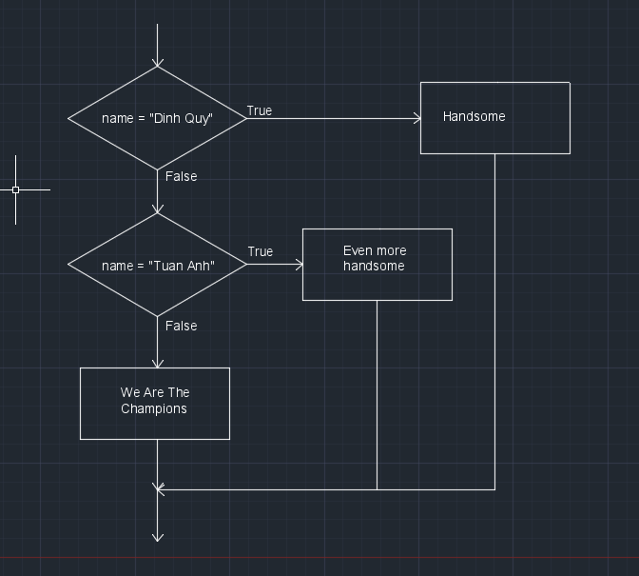

1. What is nested conditionals? Write a piece of code that uses nested conditionals

* One conditional nested within another is nested conditionals
* Code :

If mood < 30:

Print(“Pun`”)

Else:

If mood < 60:

Print(“Pinh` thuong`”)

Else:

Print(“Phe^ We’ ”)