**TERM PROJECT REPORT**

**CSI ESTIMATION FOR eMBB GUIDED BY URLLC USING DEEP LEARNING MODEL BASED ON ARTIFICIALLY** **GENERATED DATASET FOR TRAINING**

**Wireless communication**

**ECE(Dual), 3rd semester**



**UNDER THE GUIDANCE OF: DR. KRISHAN KUMAR**

**DEPARTMENT OF ELECTRONICS AND COMMUNICATON ENGINEERING**

**NATIONAL INSTITUTE OF TECHNOLOGY**

**HAMIRPUR- 177005 (HP)**

: SUBMITTED BY: DEEP RANJAN (17MI416)

HARIT YADAV (17MI418)

DIVYANSHU BHAI (17MI446)

**CERTIFICATE**

I hereby certify that the work which is being presented in the Report entitled **“CSI ESTIMATION FOR eMBB GUIDED BY URLLC USING DEEP LEARNING MODEL BASED ONARTIFICIALLY GENERATED DATASET FOR TRAINING”,** in partial fulfilment of the requirements for the award of the **Bachelor of Technology in Electronics & Communication Engineering** and submitted to the Department of Electronics & Communication Engineering of National Institute of Technology Hamirpur, HP is an authentic record of our own work carried out during a period from 25th June 2020 to 14th July 2020.

The matter presented in this thesis has not been submitted by us for the award of any other degree elsewhere**.**

Deep Ranjan (17MI416)

Harit Yadav (17MI418)

Divyanshu Bhaik (17MI446)

.

**ACKNOWLEDGEMENT**

This project has seen contributions from various individuals. It has been an honor to work under our guide, Dr. Krishan kumar. Department of Electronics and Communication Engineering, NIT Hamirpur. We are extremely thankful to her support and mentorship throughout the project. This project would not have had better supervisors than her. We would also like to thank Dr. Krishan kumar for giving us an opportunity to work under their guidance and blessing.

Lastly, we would like to thank our family and friends for their kind support. We feel grateful to Lord Almighty who has showered his graces upon me during this period

**TABLE OF CONTENTS**

Abstract…………………………………………………………......5

1. Introduction……………………………………………………....6

2. Related Work……………………………………………………..8

3. Mathematical Modeling…………………………………………..9-17

4.Proposed Scheme…………………………………………………18-33

5. Result and Analysis……………………………………………….34-38

6. Final Result……………………………………………………….39-41

7. Conclusion…………………………………………………...........42

References…………………………………………………………..43-44

**Abstract**

In the new era of 5G communication the technology of Multiple-input Multiple-output (MIMO) is the main lead which is not limited to only wireless communication but helps in gaining high spectrum efficiency, spatial gains, and energy efficiency. The benefits of the MIMO transmission can be fully harnessed only if the channel state information (CSI) is available at the transmitter side. But, the gathering of the CSI entails many challenges.

In this project report we have implemented a proposed deep learning assisted CSI estimation technique in highly mobile vehicular networks , based on the fact that the propagation environment (scatters, reﬂectors) is almost identical thereby allowing a data driven deep neural network (DNN) to learn the non-linear CSI relations with negligible overhead.

In this implementation a dynamic network slicing based resource allocation problem for vehicular user equipment (VUEs) requesting enhanced mobile broadband (eMBB) and ultra-reliable low latency (URLLC)trafﬁc slices is formulated and solved. We have realized the neural network which will infer the CSI of the eMBB channel based on the CSI of the URLLC channel.

The main project implementation focusses on training the neural network which will be used for the prediction of the CSI of the eMBB channel in the same cell and hence resulting in the overhead reduction and increase in the threshold violations. The Convergence if the Loss function in the paper is the main aim of this project implementation.

The trained neural network is similar to the instructed network in the paper which is implemented using TensorFlow 2.0 framework in python 3.5.0. using the Nvidia 1050ti graphic Card with CUDA and CUDNN support.

**Introduction**

The newly growing smart devices and the exponential growth in the new technologies in the field of medical science, industry automation, transport and space technology require highly efficient transmission techniques which should be ultra-reliable and efficient at the same time. Initial 5G use cases are expected to support enhanced mobile broadband (eMBB) and ultra-reliable and low latency (<1ms) (URLLC). Were the requirements of high peak Data rate and low-latency both are of same importance and respectively mentioned in above field of study.

The fundamental requirement fir the safer transportation is Vehicle-to-everything (V2X) communication. V2X use cases range from platooning, autonomous driving, collision avoidance, and infotainment services [3]. The critical application of autonomous vehicles requires highly reliable and low latency communication services. Also, in the field of medical science the remote operations performed by doctors requires very high precision and fast responses which can be achieved by the ultrareliable and low latency communication, similar with the entertainment services which can fall under eMBB use case, centered on the Gbps data transmission rate [4].

Channel state information (CSI) is of paramount importance to maximize the performance of 5G systems relying on spatial diversity harnessing multiple-input multiple-output (MIMO) transmission. The knowledge of CSI enables designing efﬁcient transmission, scheduling, and user-association schemes. CSI brings extra degree of freedom (DoF) by providing spatial multiplexing and robustness against channel impairments. Moreover, the integration of AI or advanced Deep Learning technology with the Communication technology will lead the field of wireless communication into another new level, the complex relationships/ correlations and the function estimations by the deep-learning models will allow the human race to realize and implement some of the complex systems easily which are very difficult to mathematically formulate and make models of.

Also, 5G technology relies on the high frequency bands beyond 6Ghz and beyond (millimeter 5G waves) which are difficult to work with because as the frequency of the communication channel increases its properties changes and interacts differently with the environment (more like the light rays interact) i.e., incapable of bending around the large structures and just reflecting back from them just like a light ray which in return reduces the field of coverage. So, there must be successful beam alignments for successful communication. For this the beam formations from the transmitting antennas must be very precise/ accurate and faster than previous technology. And the beam formation can be enhanced if we know about the CSI and accordingly the beamforming weights of the antenna be changed.

The timely and accurate acquisition of CSI is a major hurdle and is becoming more challenging with the next generation of mobile systems. Acquisition of CSI entails radio resource overhead either in the uplink or downlink whose overhead scales with the channel DoF [5].

**The main contribution of the paper is as follows:**

• Introduction of a deep learning-based CSI inference framework for radio resource overhead reduction in vehicular networks. The data driven based Deep neural network (DNN) learns the non-linear relationship between the CSI of geographically separated VUEs.

• A sliced vehicular network with URLLC and eMBB slices is considered and the resource allocation scenario as a rate reliability maximization problem taking into account the error due to CSI inference is formulated.

• The performance of the proposed CSI inference-based resource allocation algorithm is also evaluated.

**The implementation of the paper as the project includes the following:**

• Generation of the training data for the Deep Neural Network using the conventional approaches which is a total estimation-based approach.

• Training of the neural network based on the generated data based on TensorFlow 2.0 framework based on the generated data and trying to reduce converge the given Loss Function.

The implementation of project majorly focusses on the way to generate the data for the training of the model which in turn is very difficult to generate keeping in mind that there are two different receivers whose CSI need to be generated and inferred which is based on some kind of non-linear relation. Due to the presence of this nonlinear kind of relationship it is not possible to drive a direct mathematical model or any kind of equation for the relation between the two, the use of neural networks or the deep learning model in the research paper was also done because it is capable of copying that non-linear relationship between the two quantities where as it is close to impossible to define any proper mathematical model for that relationship.

The Deep Learning is special kind of branch of AI which deals with such kind of tasks majorly, not only in the field of wireless communication but also in the field of Digital Signal Processing, Natural Language Processing, Image Processing, Computer Vision, Space Industry, Medical Science and many more.

The implemented model was made on TensorFlow 2.0 framework as it is the best framework which supports the GPU running on the local host, the model was trained on the local host with self-generated data as the training dataset.

**Related Work**

In the conventional method the overhead reduction of CSI, the exploitation of linear structures in frequency, spatial, or time domains is involved. The main idea of overhead reduction lies in determining signal sparsity or exploiting linear correlation in the transform domain i.e., angular domain [6]-[7], time domain [8], and frequency domain [9]. Furthermore, CSI can also harness non-linear structures (CSI relation between geographically separated users), which are studied using a data driven approach [10]-[11]. The deep learning approach which is implemented in this project achieve an overhead reduction by exploiting the non-linear structures of CSIs at the base-station also it performs the CSI inference at a remote base-station by assuming the network has the common scatters. According to the paper there is one common limitation of the linear CSI inference which is its reliance on instantaneous CSI in the transform domain (which is not possible with the self-generated data under per assumed conditions, but the frame work for the given dataset works perfectly fine) and the non-linear CSI overhead reduction work involves the CSI estimation at a control base-station also. In the real world, obtaining accurate CSI is challenging due to channel estimation errors, thereby inevitably leading to system performance degradation. Also, with the no involvement of any measurement devices it becomes compulsory to use the conventional channel estimation techniques and programs which degrades the performances as mentioned earlier. Moreover, estimating the CSI becomes increasingly difﬁcult when considering mobility. On the other hand, [12] studies the fundamental blocks of machine learning i.e., neural network architectures, training and inference operation, and communication scenarios for several use cases pertaining to various mission critical applications in 5G and beyond. Similarly, several works focus on the resource management of URLLC [13], [14], and eMBB slices [15]. In [13], there is the study on the joint design of transmission power and resource allocation for URLLC traffic in vehicular network with distributed learning, and [14] studies the active learning approach for maximizing the knowledge of network dynamics. Resource allocation of multiple slice network (URLLC, eMBB) with chance constrained optimization is studied in [15]. Towards this end, the existing resource allocation assume perfect CSI knowledge without considering the inherent challenges of CSI acquisition. So, the proposed work in the paper which has been implemented is a deep learning based CSI inference framework, also a resource allocation algorithm for mobile vehicular users (VUEs) requesting eMBB and URLLC traffic slices is also proposed, which will be written later but it is only possible to physically implement and simulation is not possible without the proper data availability for training the neural network which is the core of the working algorithm.

**Mathematical Modeling**

In the paper, the study of downlink orthogonal frequency-division multiplexing access (OFDMA) system with MIMO transmission consisting the set S of road side units (RSU’s) and set V of vehicles. Vehicles in the network can request the services from the eMBB or the URLLC slice, which share the available bandwidth B. In this view, the set of vehicles are partitioned into {VE, VU}, where VE represents the vehicles requesting for eMBB services and the vehicles requiring URLLC services are denoted as VU and shown in figure below.

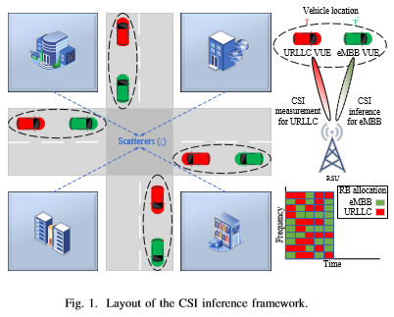

Also, the assumption is made the RSUs are equipped with Nt (we have considered as 4) number of uniform linear array (ULA) antennas, which are spaced at a distance of half wavelength and each vehicle has Nr (which we have assumed as 4) receive antennas. The discrete Fourier transform (DFT)based codebook, where the size of codebook is equal to the number of transmit antennas (where as we have utilized the conventional approach to determine the antenna beamforming weights, which is more sensible with self-generated dataset). The available bandwidth B at the RSU is divided into resource blocks (RB) and the assignment of RB to a vehicle is denoted with a resource indicator variable Ωbs,v ∈ {0,1}, where Ωbs,v = 1 indicates that the RB b of RSU s is allocated to vehicle v and Ωbs,v = 0 otherwise. The received signal by vehicle v ∈V transmitted by RSU s ∈ S on RB b at time t is given as:



where xb,ts,v is the transmitted data, hb,ts,v ∈ CNr x Nt is the communication channel from RSU s to vehicle v, wb,ts,v ∈C Nr x Nt is the beamforming vector from the RSU to vehicle,



Here Ib,ts,v is the interference from the neighboring RSUs using the same frequency resources, and zb,ts,v ∼ CN(0,σ2) is the additive noise with zero mean and variance σ2. The wireless downlink channel from the RSU to vehicle is modelled using the geometry-based stochastic channel model (GCSM) [16] given as:

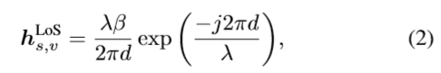

where d is the distance (km) of the direct path between the RSU s and vehicle v, λ is the wavelength, and β corresponds to the complex antenna amplitude. The vehicles are associated to the RSU based on maximum received signal strength (max RSSI) using the LoS channel model (2) and the distance dependent path loss model: PLdB = 100.7 + 23.5log(d) [17]. The network is mapped using a system level simulator, which uses the link-to-system (L2S) interface for modelling radio links and require channel state information (CSI) as an input. Maximal ratio combining (MRC) is used at the vehicular devices to exploit spatial diversity and signal-to interference-plus-noise (SINR) calculations are performed for every RB. Hybrid automatic repeat request (HARQ) mechanism is employed for the re-transmission of failed packets. The achievable rate Rt v by each vehicle depends upon the allocated resources and the downlink beamformer i.e.,

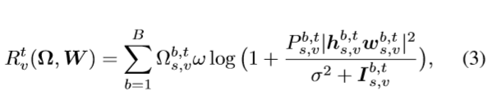

where Ω represents the resource allocation vector, ω is the bandwidth of RB, wb,ts,v ∈ W is the transmit beamformer from RSU s to vehicle v.

Based on this mode following policies and algorithms are drawn in paper 🡪

**Joint eMBB-URLLC Resource Allocation Policy:**

From the paper it is also found that, the focus of work is to allocate RBs to serve eMBB and URLLC VUEs. Towards URLLC, the goal is to ensure the services are provided within the maximum allowed delay to achieve the threshold rate



Here,



is the time average rate of vehicle. ϵ is very small threshold violation probability. For eMBB service, it is essential to guarantee the threshold rate by adopting best effort threshold violation probability minimization, i.e., to



In this view, a heuristic resource allocation policy presented in Algorithm 1. Therein, RSUs orthogonally allocate RBs among VUEs with the priority towards URLLC and the remaining resources are scheduled over eMBB VUEs. CSI is an important input parameter for the L2S interface and it is mapped to the corresponding mutual information curves for the computation of error probability. The rationale in the proposed algorithm is that the URLLC VUEs need to ensure a target reliability, while the eMBB VUEs are minimizing the maximum threshold violation probability using the remaining resources.

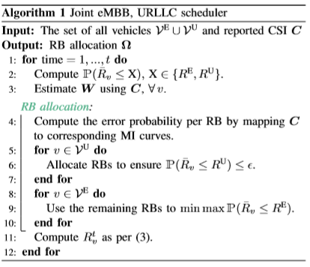

**Resource Allocation Using CSI Inference:**

There is a non-linear CSI relationship between geographically separated VUEs which can be used by the DNN for CSI inference. The aim is to enable low CSI overhead wireless connectivity in a sliced vehicular network via resource slicing. To perform radio resource scheduling of eMBB and URLLC slices we need an estimate of the channel statistics. However, acquiring the accurate CSI entails many challenges especially when the users are mobile and the overhead of CSI estimation may deplete the available radio resources. In this regard, the estimate of URLLC users CSI is done due to their strict reliability requirement while the CSI of eMBB users are inferred to avoid resource scarcity.

Later the non-linear relation between the CSI of geographically separated VUEs is described, which can emerge due to the existence of some location based components or common scatters as shown in Fig1 (this relation ship is due to natural environment and hence the real-time data will be able to converge the Loss Function effectively instead of artificially generated data). It is well known that a linear correlation exists among co-located antennas that are the order of the wavelength apart from each other [18] and there exist a region of stationary within which the CSI can be treated as wide sense stationary (WSS) process. To prove the non-linear relationship for geographically separated VUEs, mutual information (MI) is used, that is a measure of mutual dependency between the two random variables. Fig. 2 shows the MI and canonical correlation coefﬁcient (measure of the association/correlation among two sets of variables) as a function of angular resolution, where the canonical correlation between the two CSIs is almost zero and the MI is non-zero, hereby validating the point that there exists some non-linear relation.

Moreover, the proposed approach given in the research paper is different from the works done in paper [10]-[11], in this the CSI of a neighboring vehicle is inferred where as in these work studies the inference problem is for the neighboring base-station as shown in Fig. 2.The works [9]-[10] infer the CSI of the same user at a remote base station, while here the CSI of remote user for the same base station is inferred.

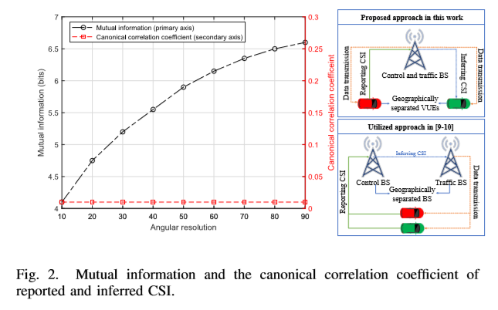

**CSI Inference and RB allocation:**

CSI inference of a remote vehicle given the reported CSI of another neighboring vehicle is proposed in the given research paper whose implementation is to be done. In the proposed scheme CSI at the RSU enable the design of the downlink beamformers, which are used for spatial diversity and multiple spatial access. In particular, here consideration of a communication system consisting of mobile vehicles is taken, which have the common scatterers.

For the sake proposed algorithm in the paper let’s consider a URLLC vehicle v whose CSI cv is reported and corresponding downlink beamformer wv is estimated by the RSU i.e.,



Furthermore, let there be a neighboring eMBB vehicle v0 whose CSI ^cv0 and the corresponding downlink beamformers ˆ wv0 are inferred i.e.,



The aim of the work in paper and the implementation of this paper in this project, is to infer ˆ wv0(ˆ cv0) given the knowledge of wv(cv) to reduce the overhead of CSI estimation in the network.

Mathematically, the downlink beamformer inference problem can be casted down as a function mapping of user location and the environment geometry i.e., obstacles, reﬂection and attenuation coefﬁcients as follows:



where f(·) denotes the function mapping of downlink beamformer, (Γ, ˆ Γ) denote the terminal locations of URLLC and eMBB vehicle respectively, and ζ speciﬁes the common propagation environment.

But the beamformer mapping model presented in (4) is indirect and infeasible (since there is no linear relation) for theoretical analysis, therefore in the paper a deep learning based function mapping approach is adopted at the expense of large training data which is also realized in the implementation of the paper in this project (the valid data for training is though is the main issue of concern). Training the NN in ofﬂine manner helps to efﬁciently solve user scheduling and resource allocation problems with less overhead. The DNN is trained using the beamforming loss function L deﬁned as [11]:

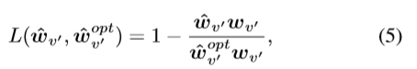

where ˆ wv0 is the inferred beamformer of vehicle v0 from the DFT codebook (whereas in the implementation the DFT Codebook utilization was not doe because the data was not real-time and authentic enough to generate the accurate results so the conventional way was adopted), ˆwoptv’ is the optimal beamforming vector in the DFT codebook (which was also obtained using conventional way and using the generated downlink channel), and wv0 is the beamforming label. After the training has converged to an acceptable loss rate, the low CSI overhead resource allocation follows Algorithm 2.

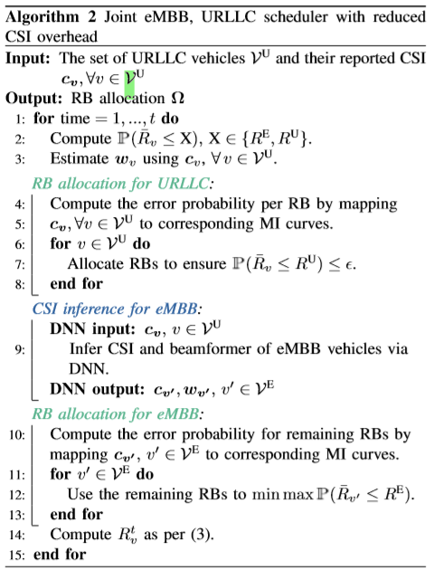

**DNN Implementation:**

The non-linear CSI structure exploitation problem is solved with deep neural networks (DNNs) based on a data-driven approach, since it does not require any explicit model of the propagation environment. In the paper and the implementation project, the training data for the DNN consist of the CSI of the geographically separated users which is obtained through pilot aided channel estimation in the ofﬂine training phase (We in our implementation used the MMSE channel estimate for generating the reported CSI information which is then converted into angular form for the input to the neural network training). The input data is further transformed into the angular domain followed by quantization to enable feature extraction, which represents the large-scale fading properties of the wireless channel [20]. The CSI angular domain representation exhibits sparsity which improves the training of the DNN by lowering the inference error in (5). Once the ofﬂine training has converged to an acceptable inference error, we proceed with the prediction phase. The low complexity online prediction phase uses the estimated beamformer of URLLC vehicle and infers the beamforming vector of the neighboring eMBB vehicle based on the learned policy. In the online phase the output of the DNN is a soft decision which indicates the probability of downlink beamformers ˆ wv0(ˆcv0) in the DFT codebook (but there is no use of DFT Codebook in the implementation, instead the conventional methods are utilized). In this way, the non-linear CSI exploitation helps to enhance the performance of cellular network by reducing the overhead of CSI estimation i.e., given the estimate of beamformer of one user we can infer the beamformer of another. The inference problem per vehicle and per training sample can be mathematically written as:



The DNN deployed in the RSU utilizes four fully connected layers as shown in Fig. 3. Below:

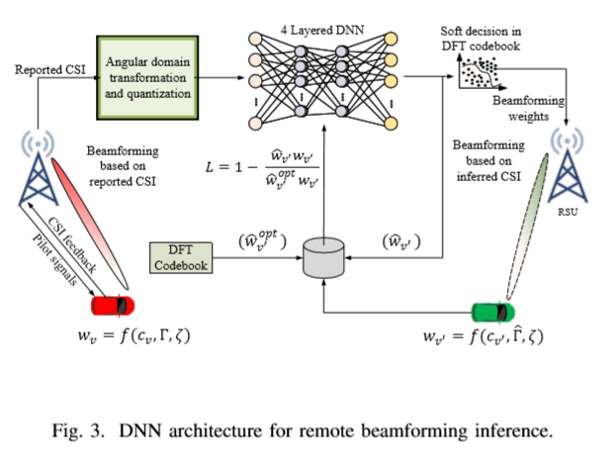

All the layers use rectiﬁed linear activation units (ReLU) activation except the output layer. The transformed and quantized CSI data from input layer is aggregated at a fully connected hidden layer that is composed of 128 neurons and the aggregated data is passed on to the output layer, which applies a SoftMax activation function. The training of the DNN uses Adam optimizer and rest of the DNN parameters are listed in Table. I



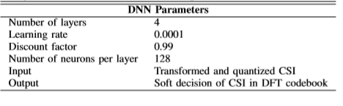

**Proposed Scheme**

While realizing the project from the paper we faced the main difficulty to gather the dataset for training of the model so we decided to make artificial data based on some assumptions, derivations and programs which is explained below:

In the paper the DFT-codebook was used for the beamforming weights which requires the real-time data and many simulations which was not available for releasing the project so we utilized the classical approach for determining the optimal weights for the beam formation of the communication channel of eMBB, which in turn also reduced the non-linear correlation between the CSI of eMBB and URLLC channels in the same cell. Also, the beamforming weights from the mobile vehicles which is obtained during real-time operation by various equipment at base station or with the observer were also not present so we also had to generate them with respect to the communication channel from the base station which is not as effective as the real-time data.

As there is no availability of real-time operating data due to many factors such as non-availability of resources and links, we have to implement the training of the network based on the self-generated data which is made by using various assumptions and lastly generating the data from the MATLAB program.

For the CSI of the URLLC we have implemented the MMSE channel estimate technique under the M-PSK channel encoding technique, and, for the channel model of the eMBB communication we have used the predefined MATLAB MIMOChannel model.

Since the data used for the training purpose was not based on real-time operations so many assumptions were taken during the data generation such as Pilot Energy, Pilot Frequency, Constellation Order, etc., which in result reduced the non-linear correlation between the CSI of the URLLC channel and eMBB channel in the same cell and hence the loss-function is not properly converged in the end.

The implementation of the neural network model with real-time will result in the perfect convergence of the loss function of the model and hence a proper estimate of the CSI can be done from the trained neural network in the project.

In the research the angular domain transformation is used which will be more logical with the real-time data as the data is already in complex number form so, to make some similarity we used the angular forms the given complex data while ignoring the amplitude of the complex data generated because in the operations performed and interactions involved with the environment there is changes in the information which are only related to the angular properties of the information and the amplitude data information remains preserved and is only affected by attenuation like process which can be boosted, also the operation with the amplitude properties and angular properties of the data is beyond the scope of the project implementation.

Previously explained mathematical model was proposed in the given paper [1] which is perfect in accordance with the availability of resources and real-time dataset, but as there is no available resources for measurements and operations for real time data collection some change in the model was made based on some assumptions.

* First of all, the wireless downlink channel from the RSU to vehicle is modelled using the geometry-based stochastic channel model (GCSM) was changed to the pre-defined MATLAB MIMOChannel which is further used for the beamforming weights estimation w.

**The MATLAB code for the channel model is given in the figure below:**

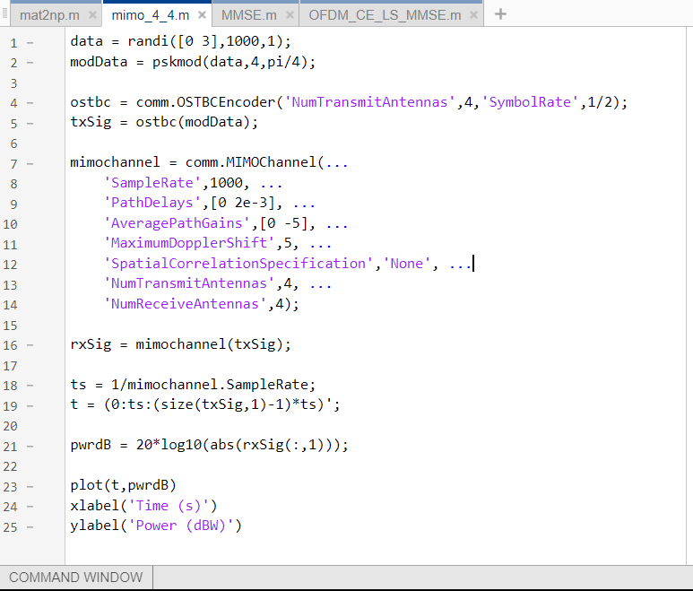

The above code was simulated on online MATLAB environment. The variables generated by running the above code is then downloaded and then converted to NumPy variable so that we can use them to train the model. The used procedure will be shown later.

The channel formation includes some estimations which can be clearly seen in the code above and majorly the use of 4 transmitting and 4 receiving antennas was preferred here. From which we considered the single antenna to single antenna communication so 4 receiving channels are chosen. From this the fading 4 channel coefficients h is obtained. The power (in dB) plot of the rxSig with respect to time is given below:

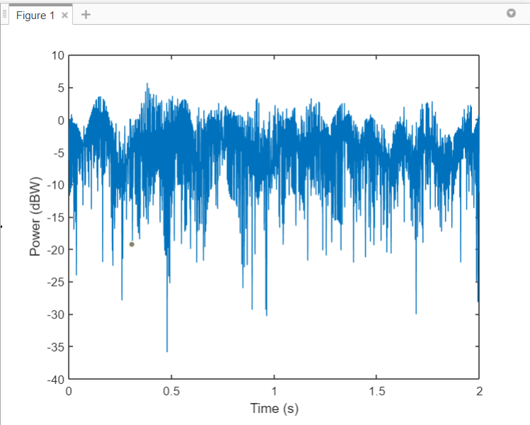

* Secondly, the beamforming vector in paper is obtained using DFT codebook which requires antennas number from the linear array as one of the factor which is possible when there is the device available for capturing the real-time data, so we instead used the conventional approach to get the optimal beamforming vector w opt.

**The derivation for the w_opt is given below which is also based on some assumptions:**

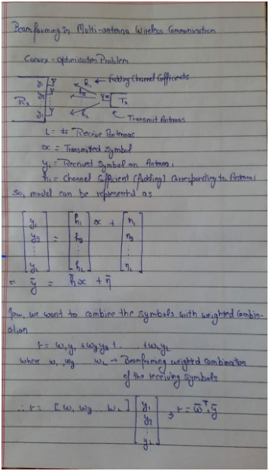

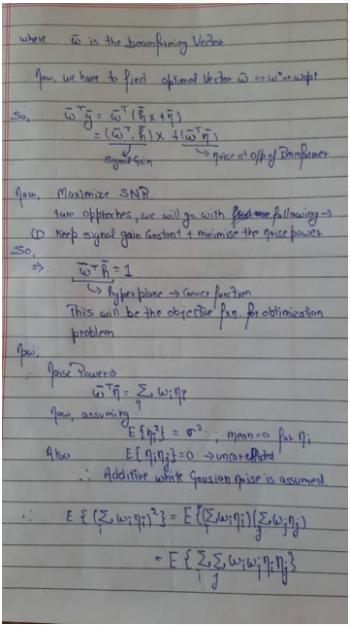

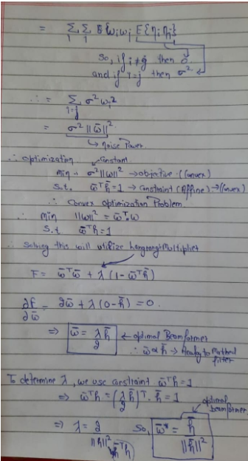

So, from the above derivation we obtained the optimal beamformer, and also used the constraint in making the w_label for the loss function as there will be the maximum gain in the direction of the beamformer. Which is also suggested in the paper and the mathematical model part.

* Third, there was no data available for the CSI of the URLLC, so we have to use the channel estimated MMSE and LS to obtain the CSI training data for the DL model.

**The MATLAB Script/programs used for this is shown below:**

In the Fig. below is the interpolate function (credits is specified in the function itself)

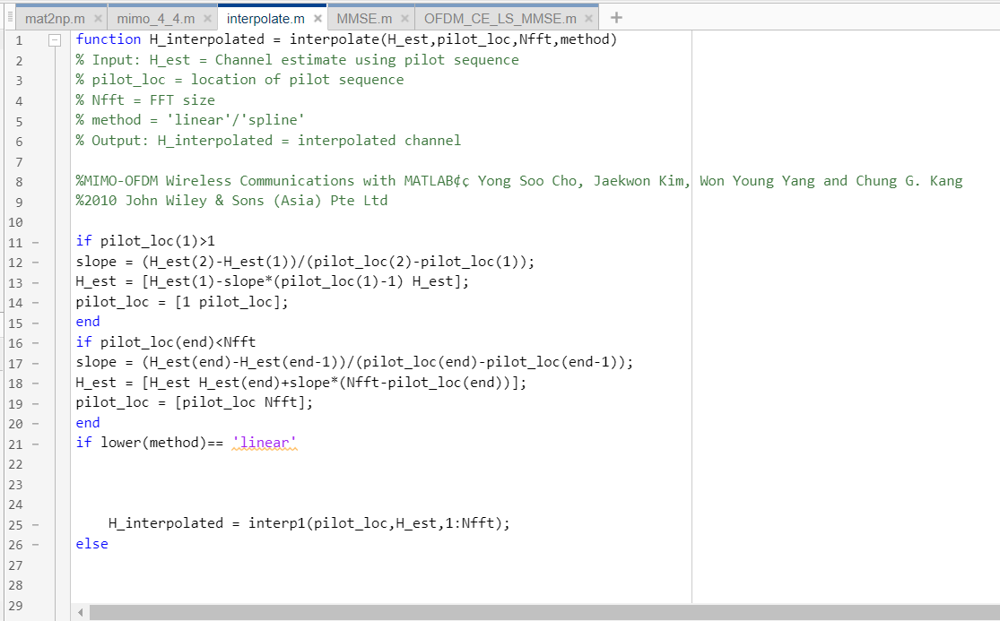

In the Fig. shown is the MMSE function which is itself used in the main function to generate the channel estimate which is then used for the CSI of URLLC Channel.

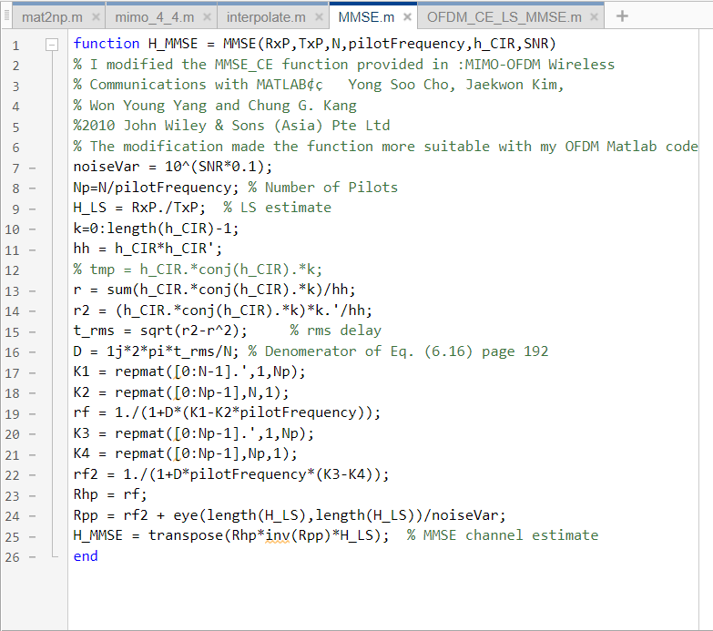

In the Figs. Below the main function us displayed which uses the information stated in column 2 [4:12] for the generation of the MMSE and LS channel estimate, we the download variables generated in the MATLAB work space ant later convert them to NumPy data so that we can use that data to train the model in python TensorFlow 2.0, the procedure used will be displayed later.

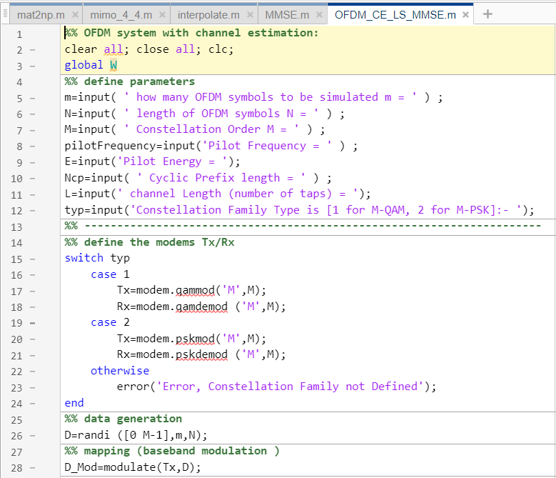

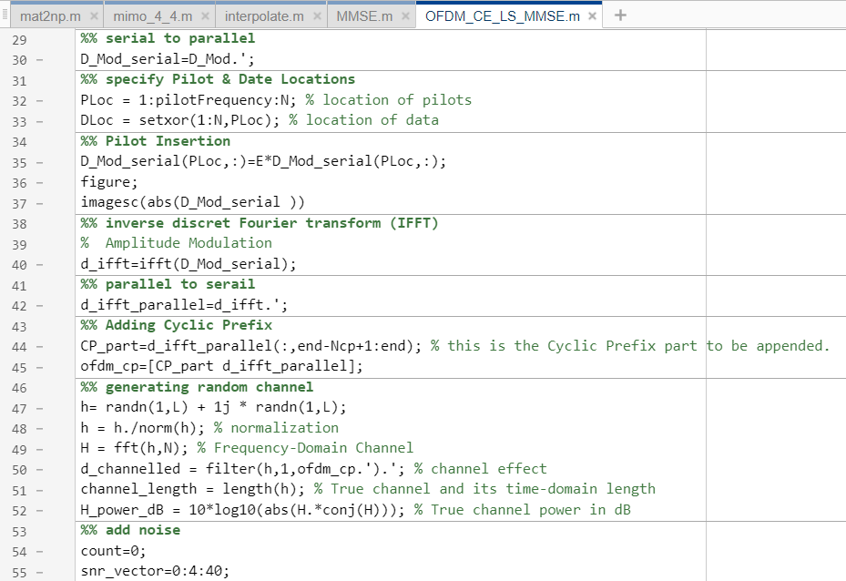

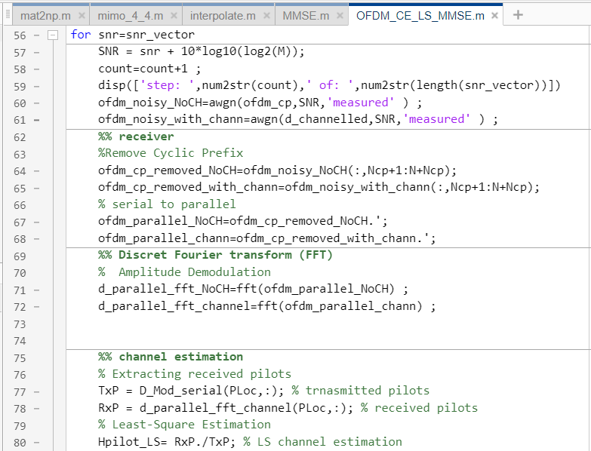

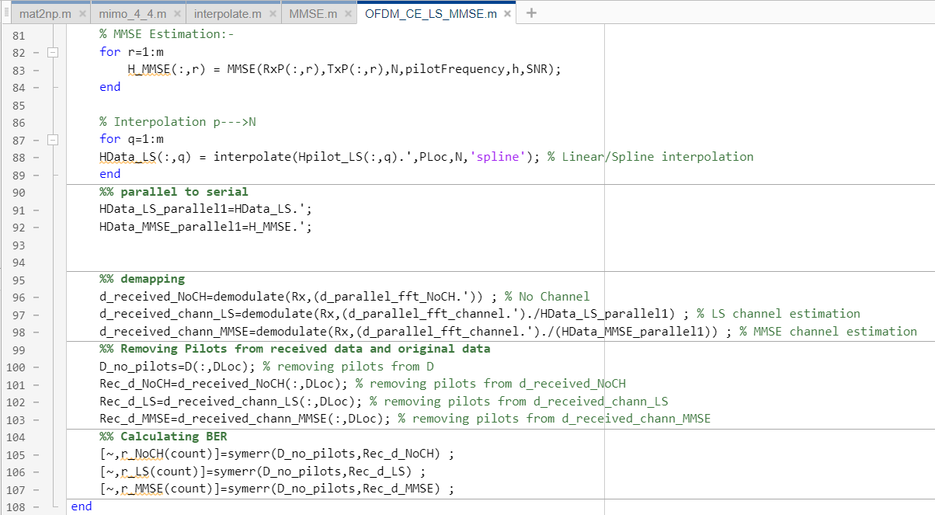

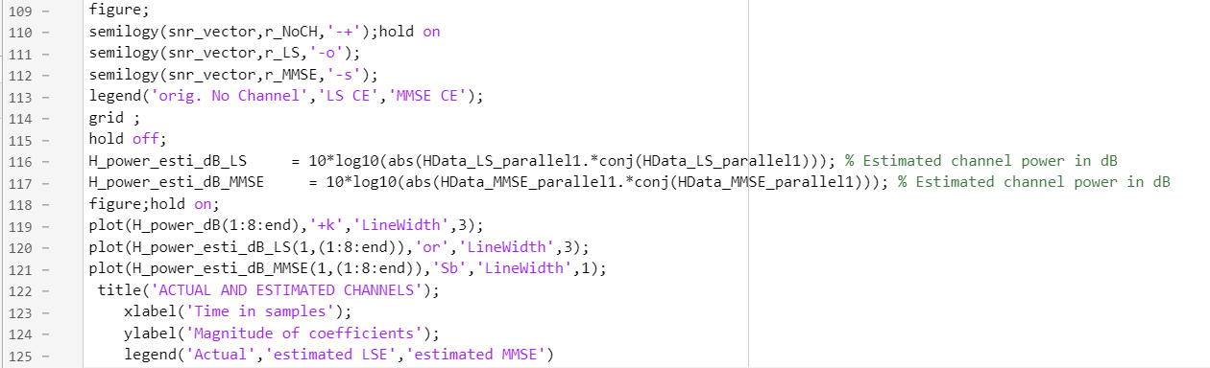

The information given to the above program when we ran it was:

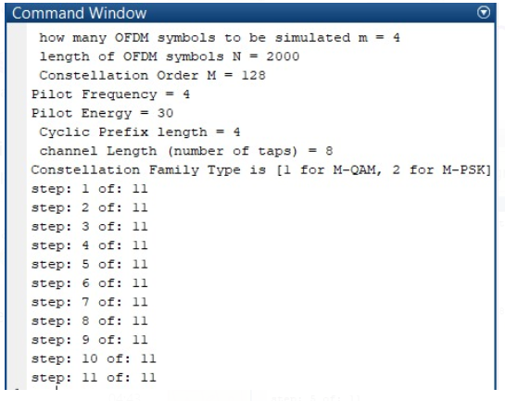

**The output Graphs Generated from the above program are given below:**

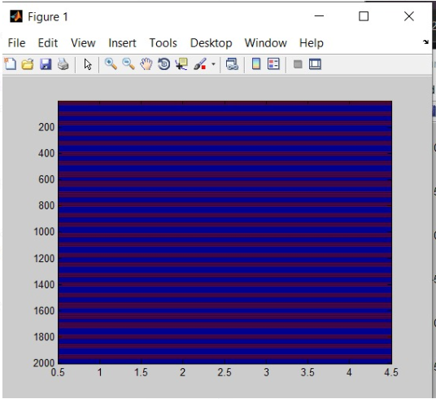

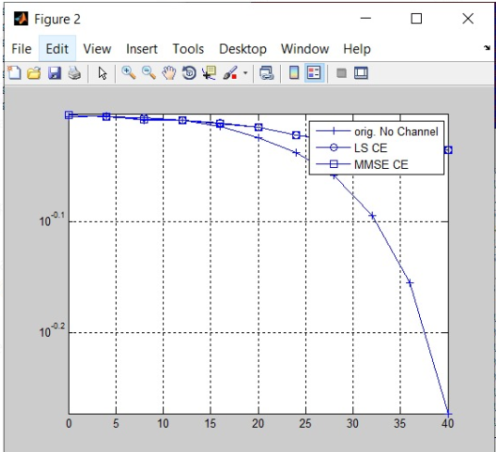

The main plot from the program is shown below which gives the similarity between the channel estimate by MMSE, LS and actual channel itself, since the data generated is large in sample for training purpose so difference can not be seen properly but the MMSE estimates are better than LS estimates generally.

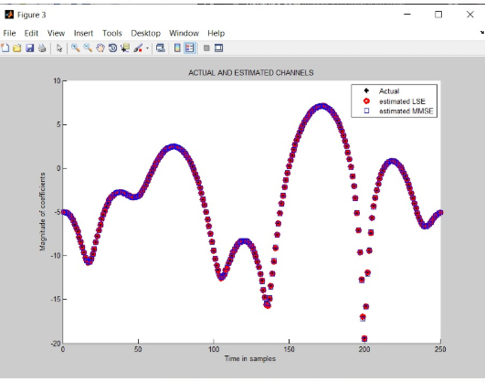

On the basis of above derivations, MIMO fading channel presumption and the MMSE Channel estimate values specifications which were based on some assumptions we generated the dataset for training of the model the variables and MATLAB programs were saved and downloaded to local host from the online MATLAB platform for further analysis. The further analysis and the final model were done and made on python 3.5.0

**The saved MATLAB variables and programs are:**

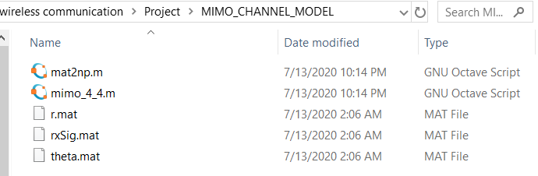

**The mat2np.m is the MATLAB program which converts the MATLAB variables to NumPy format and then saves as pickle.**

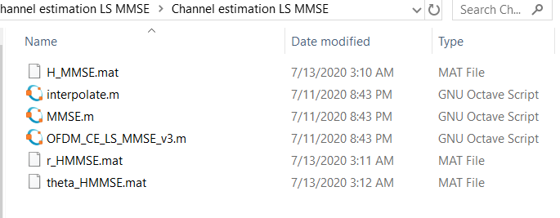

The above program is the MATLAB official LS MMSE channel estimate program.

**Note: all the programs used for the project are uploaded on the google drive whose sharable link (only with NITH email ids) will be provided at the end of the report.**

**Results and Analysis**

The further analysis of the saved MATLAB variables was done on python which was used to first convert the MATLAB variables to the NumPy variables.

Note: We the analysis part wholly on python so we added the comments as the explanation of the context of the code for analysis purpose in the script directly.

**The script for the conversion is shown below**:

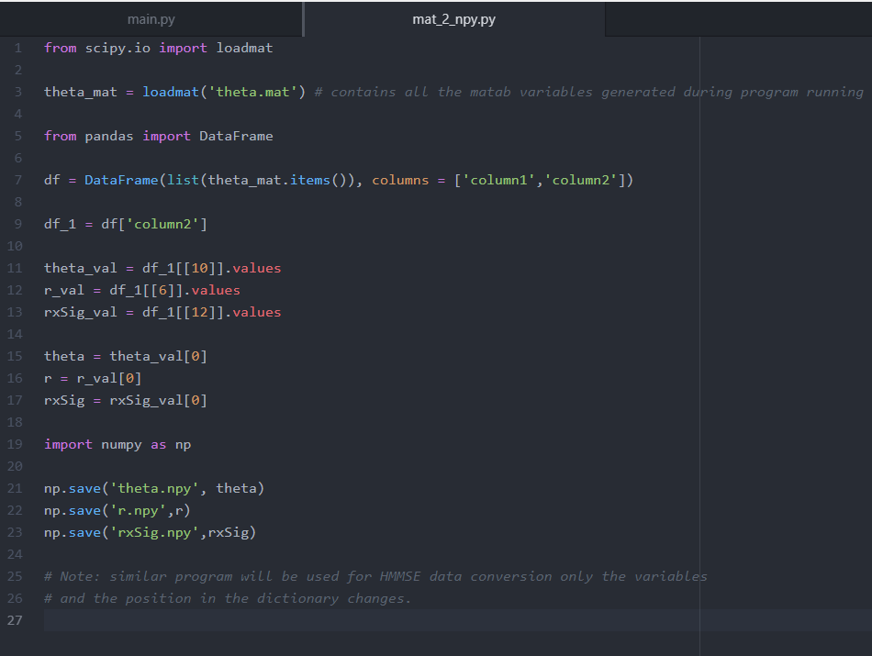

**The Command-prompt execution with all details is shown below:**

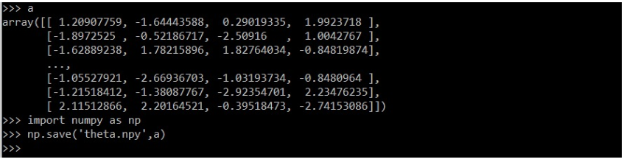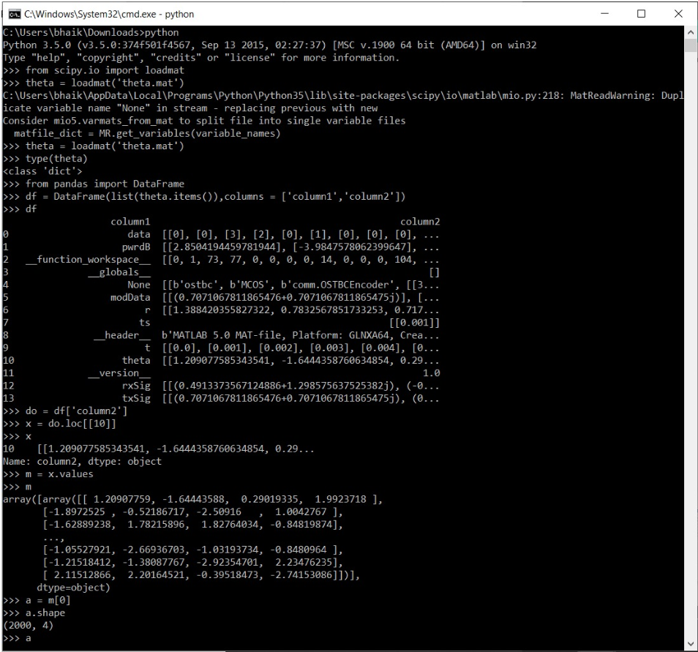

The further processing of the data and the training of the model is done on the second python script which is shown below:

**Note: Explanation of the code is done within the code itself which is hash tagged as comments.**

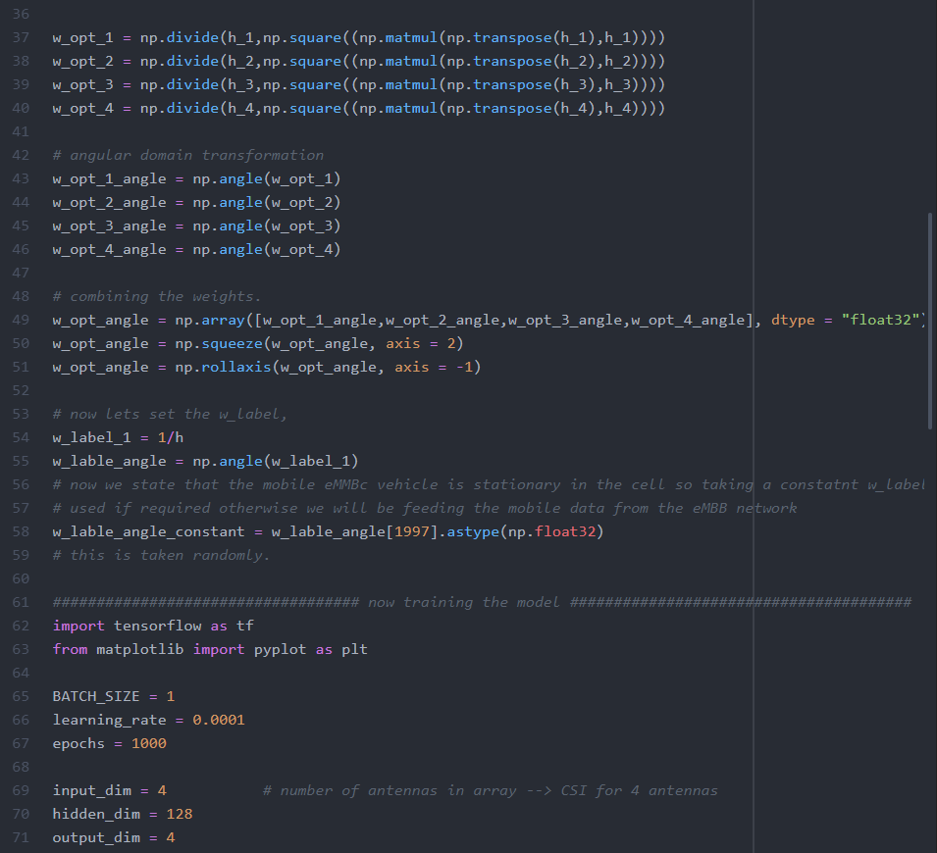

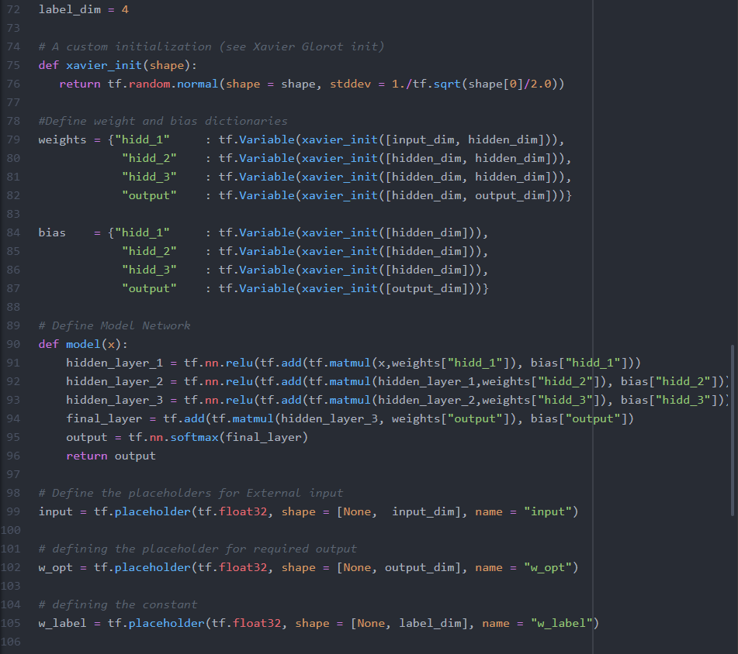

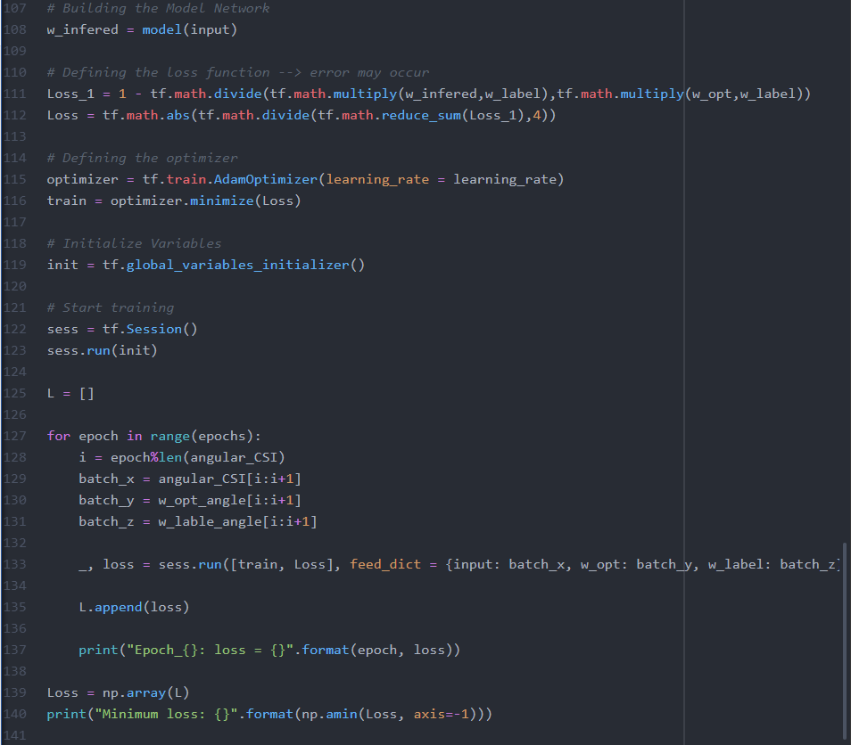

**Result:**

On running the above python script on 1000 epochs we get the following result.

**Note: some of the epoch runs are shown below.**

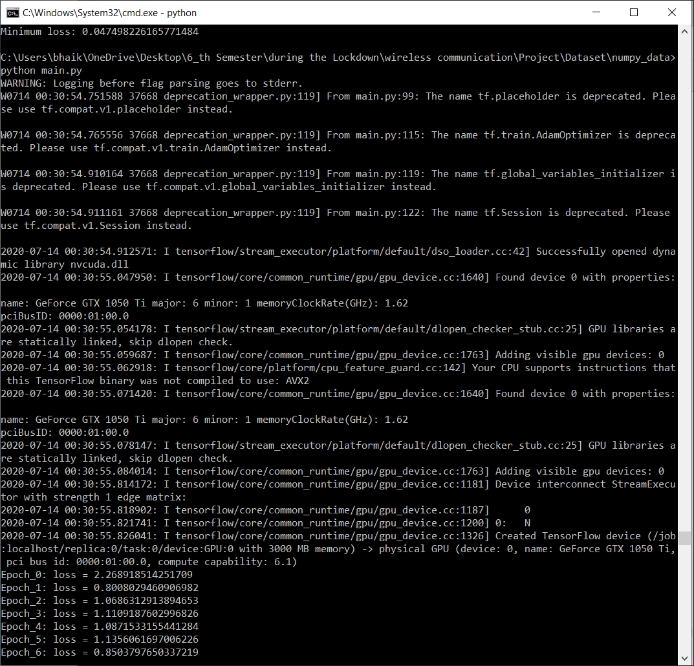

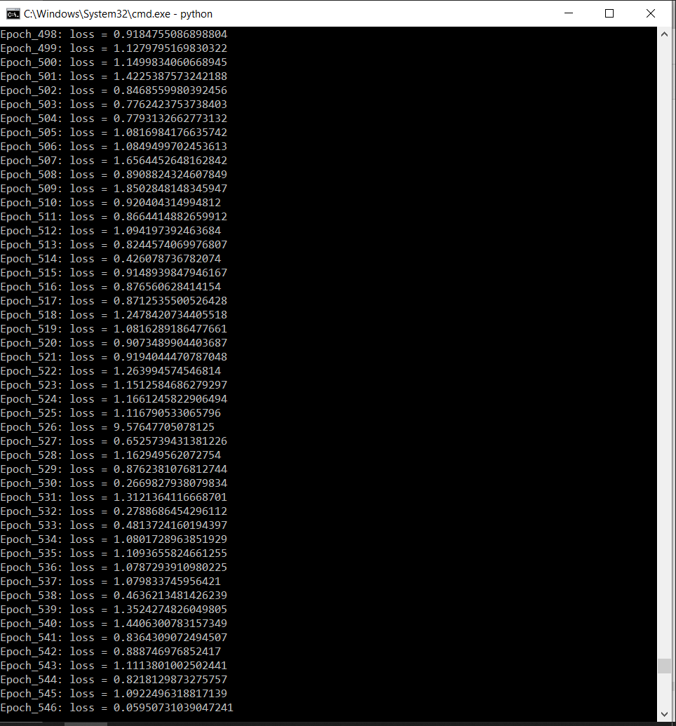

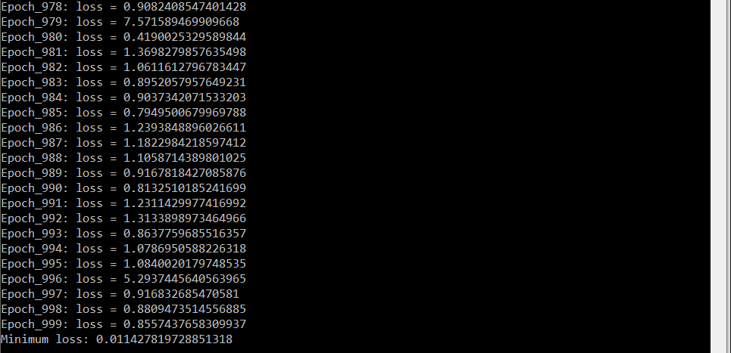

As we can see from the training the minimum loss achieved was 0.0114278….

But if we follow the previous training trend through the whole training of 1000 epochs then we can see that the loss function was not converging properly which was majorly due to not appreciable and enough amount of data fed to the model for training.

**Conclusion**

So, the realization of the given research paper [1] was done by the help of MATLAB and Python. As there was no training data available so some conventional methods were used to make the dataset for training using MATLAB programs and after then the generated data was saved and further analyzed and processed in Python, after data-preprocessing is completed the processed data was the ready to be fed to the DNN model, the DNN Network was wade similar to the Network described in the research paper, the Loss function for the training model was also made similar to that described in the research paper. And at last compiled and run.

After the run of 1000 epoch was complete, we were able to converge the loss function with the help of artificially generated dataset, but the convergence was not proper. So, we can conclude that the artificially generated CSI and channel model data can be used to train described Deep Neural Network and if the data can be improved with some less assumptions and more efficient and related MATLAB programs the Network can be trained more properly, moreover the network’s main purpose in the research paper was to find and model the relationship between the two CSIs of the physically separated mobile devises, given on the condition that they both share the same kind of environment and hence there is some non-linear relationship between there CSIs which is due to the presence of that similar kind of environment.

Hence, if we somehow are able to generate the data with that similar kind of environment simulation then the model will be trained well but again this is impossible, so we conclude that for the best training of the DNN model we need the real-time data from the real measuring devices so that we can use there specifications to preprocess the collected data which is then given to the network for the training and proper convergence of the Loss function and in the end will result in the reduction of CSI overhead of eMBB vehicles due to the realization of that not-linear CSI relationship by the DNN model.

**Google Drive Link to the project files 🡪**

<https://drive.google.com/drive/folders/1UDz2t-5_oThnxnd8i8uP2AccdDr692RZ?usp=sharing>

**Note: only assessable by NITH email id**

**References:**

[1] Deep Learning Assisted CSI Estimation for Joint URLLC and eMBB Resource Allocation, 2020 [Online]. Available: <https://arxiv.org/abs/2003.05685>

[2] NGMN, “5 x 5G Five things you need to know about 5G and what it delivers,” 2018. [Online].

[3] A. E. Fernandez and M. Fallgren, “5GCAR scenarios, use cases, requirements and kpis,” Fifth Generation Communication Automotive Research and Innovation, 2017.

[4] “METIS deliverable D7.3 Final 5G visualization,” 2017.

[5] Z. Jiang, A. F. Molisch, G. Caire, and Z. Niu, “On the achievable rates of FDD massive MIMO systems with spatial channel correlation,” in 2014 IEEE/CIC International Conference on Communications in China (ICCC), Oct 2014, pp. 276–280.

[6] J. Brady, N. Behdad, and A. M. Sayeed, “Beamspace MIMO for Millimeter-Wave Communications: System Architecture, Modeling, Analysis, and Measurements,” IEEE Transactions on Antennas and Propagation, vol. 61, no. 7, pp. 3814–3827, Jul 2013.

[7] X. Rao and V. K. N. Lau, “Distributed Compressive CSIT Estimation and Feedback for FDD Multi-User Massive MIMO Systems,” IEEE Transactions on Signal Processing, vol. 62, no. 12, pp. 3261–3271, Jun 2014.

[8] R. Hadani, S. Rakib, M. Tsatsanis, A. Monk, A. J. Goldsmith, A. F. Molisch, and R. Calderbank, “Orthogonal Time Frequency Space Modulation,” in 2017 IEEE Wireless Communications and Networking Conference (WCNC), Mar 2017, pp. 1–6.

[9] L. You, X. Gao, A. L. Swindlehurst, and W. Zhong, “Channel Acquisition for Massive MIMO-OFDM With Adjustable Phase Shift Pilots,” IEEE Transactions on Signal Processing, vol. 64, no. 6, pp. 1461–1476, 2016.

[10] Z. Jiang, S. Chen, A. F. Molisch, R. Vannithamby, S. Zhou, and Z. Niu, “Exploiting Wireless Channel State Information Structures Beyond Linear Correlations: A Deep Learning Approach,” IEEE Communications Magazine, vol. 57, no. 3, pp. 28–34, 2019.

[11] Z. Jiang, Z. He, S. Chen, A. F. Molisch, S. Zhou, and Z. Niu, “Inferring remote channel state information: Cram´er-Rae lower bound and deep learning implementation,” in 2018 IEEE Global Communications Conference (GLOBECOM). IEEE, 2018, pp. 1–7.

[12] J. Park, S. Samarakoon, M. Bennis, and M. Debbah, “Wireless Network Intelligence at the Edge,” Proceedings of the IEEE, vol. 107, no. 11, p. 22042239, Nov 2019.

[13] S. Samarakoon, M. Bennis, W. Saad, and M. Debbah, “Federated Learning for Ultra-Reliable Low-Latency V2V Communications,” 2018 IEEE Global Communications Conference (GLOBECOM), Dec 2018.

[14] M. K. Abdel-Aziz, S. Samarakoon, M. Bennis, and W. Saad, “Ultra-Reliable and Low-Latency Vehicular Communication: An Active Learning Approach,” IEEE Communications Letters, p. 11, 2019.

[15] M. Alsenwi, N. H. Tran, M. Bennis, A. Kumar Bairagi, and C. S. Hong, “eMBB-URLLC Resource Slicing: A Risk-Sensitive Approach,” IEEE Communications Letters, vol. 23, no. 4, p. 740743, Apr 2019.

[16] P. Kyasti, J. Meinila, L. Hentila, X. Zhao, T. Jamsa, C. Schneider, M. Narandzic, M. Milojevia, A. Hong, J. Ylitalo, V.-M. Holappa, M. Alatossava, R. Bultitude, Y. Jong, and T. Rautiainen, “WINNER II channel models,” IST-4-027756 WINNER II D1.1.2 V1.2, Feb 2008.

[17] 3GPP, “TR 36.814 V9.0.0: Further advancements for E-UTRA physical layer spects (Release 9),” Mar 2010.

[18] A. Adhikary, J. Nam, J. Ahn, and G. Caire, “Joint Spatial Division and MultiplexingThe Large-Scale Array Regime,” IEEE Transactions on Information Theory, vol. 59, no. 10, pp. 6441–6463, Oct 2013.

[19] C. Studer, S. Medjkouh, E. G¨on¨ultas¸, T. Goldstein, and O. Tirkkonen, “Channel charting: Locating users within the radio environment using channel state information,” IEEE Access, vol. 6, pp. 47682–47698, 2018.

[20] D. Kingma and J. Ba, “Adam: A Method for Stochastic Optimization,” International Conference on Learning Representations, Dec 2014.

……………………………………………XXXXXX……………………………………………