

| **Guide Name** | | **Panel Head** |
| --- | --- | --- |
|  | Dr. Vaissnave V | Dr. Nagendra Prabhu |
|  |  |  |
|  | **Faculty Advisor** | **Project Domain** |
|  | Dr. Nagendra Prabhu | Research Based- SDG8 |
| M |  |  |
|  | **Student(s) Details: Name** | **Passport size photo(s)** |
|  | 1. Balaji Sasank Chaganti 2. Ananya Parasrampuria |  |
|  |  |  |

Registration Number(s)



**Email ID(s)&Mobile Number(s)**

| 1: bc0985@srmist.edu.in | 6382955615 |
| --- | --- |
| 2: ap5746@srmist.edu.in | 7618910999 |

**Abstract Architecture Diagram**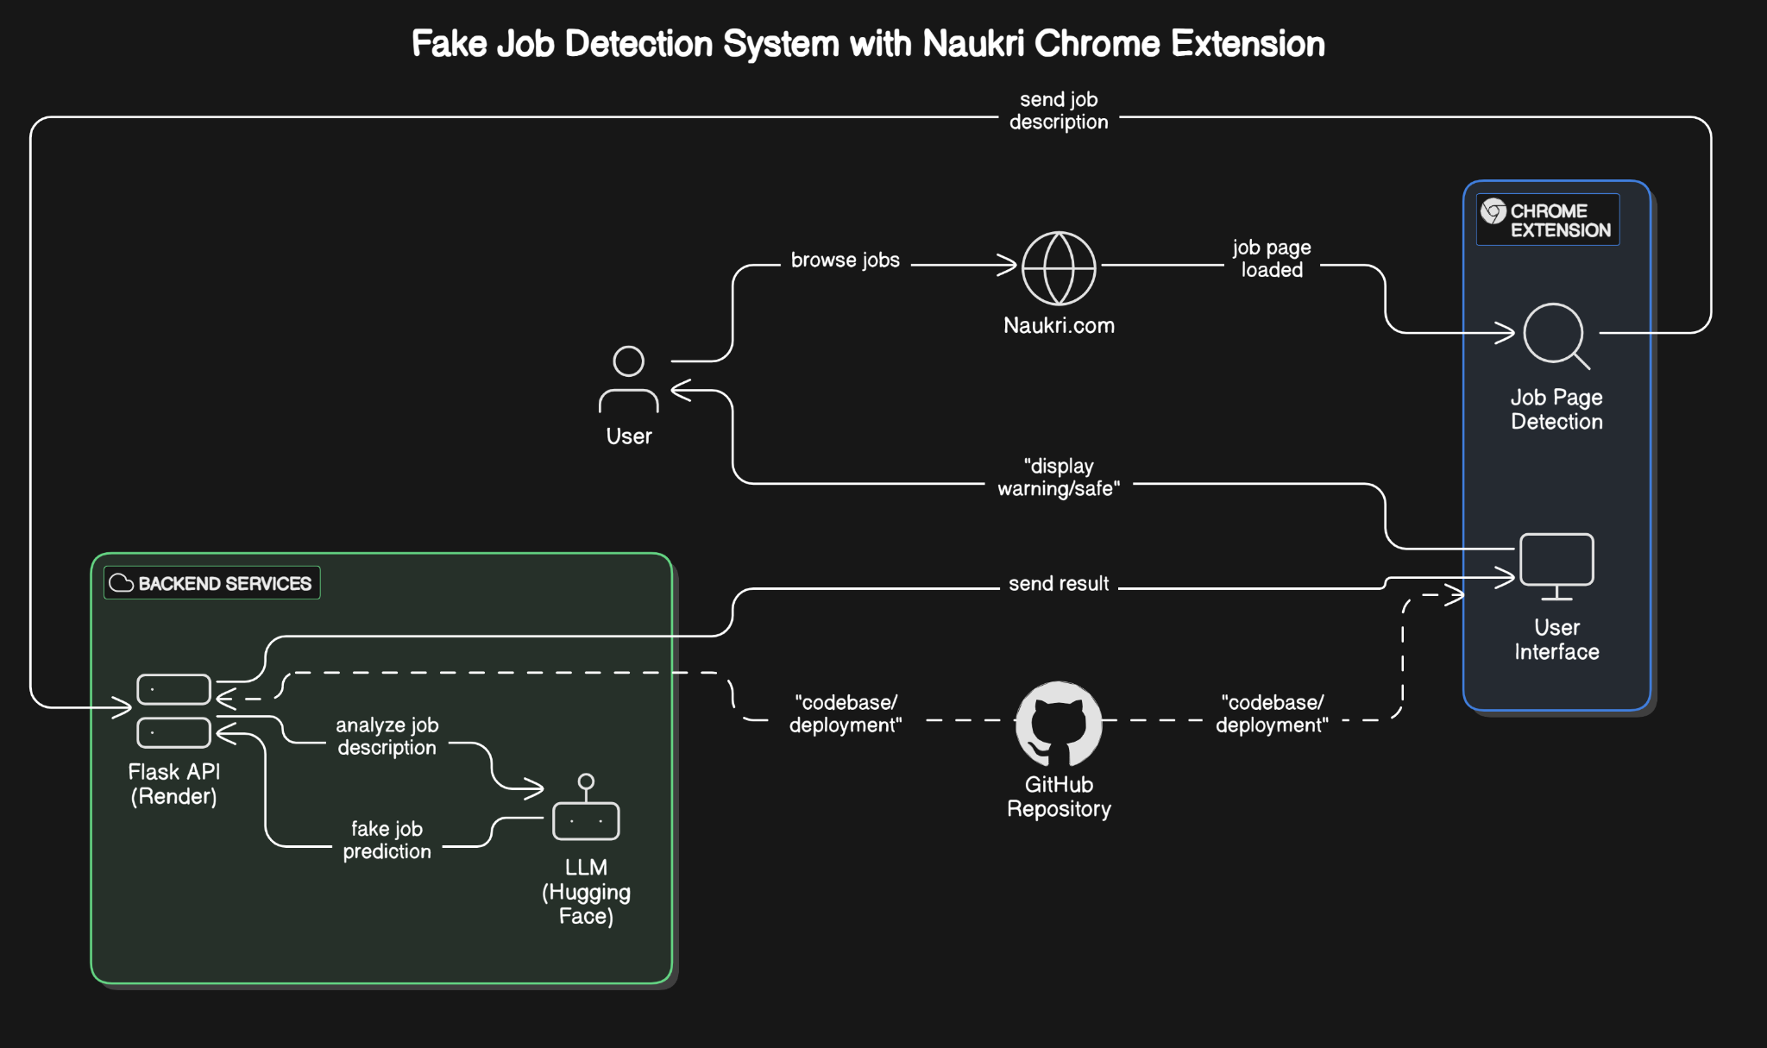



**Significance of the Project Conclusion**



**Conference/Journal Publication Details (Mandatory)**