**Tested GW against analytical solution of GW level pinned by two rivers.**

Test = passed (converging on analytical solution)

**Setup**

River 1 = 22m

River 2 = 16m

Rech = 1mm/d

k=2.5

size = 250*125

cell = 10m

sy = 0.002 (set low to speed up steady state)

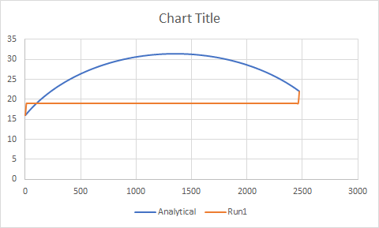

initialisation

**10 days**

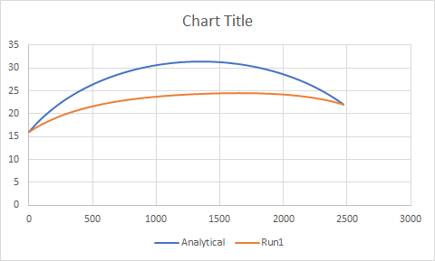

**20 days**

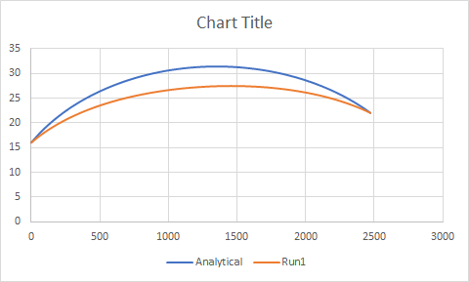

**40 days**

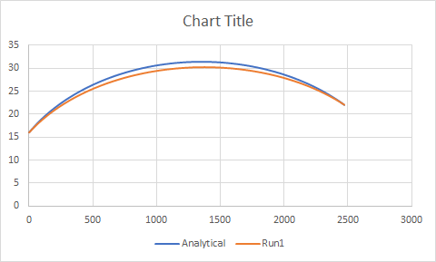

50 days

