A Primer on fundamental types of animal spatial orientation and stimulus localization.

In the study of Animal Behavior scientists have created a behavior classification system in order to provide an organizing principle or theme on which the many different behaviors we observe may be thought of as variations. The set of behaviors that are involved in Spatial Orientation, that is, behaviors devoted to locating and then moving relative to a stimulus, have thus been classified into two broad categories. One is the very basic Kinesis, and the other is the more varied, complex and common Taxis. The primary difference between these two categories is the use of any sort of directional information – Taxes use it, Kineses do not. Within these two basic categories are sub-categories, defined by the details of how the Kinesis or Taxis are performed within the confines of the “rules” that define them. Below is an outline of what Kineses and Taxes are and how they work.

Kinesis: un-directed movement (that nevertheless approaches a stimulus).
      - Stimulus does not attract or repel organisms.
- Changes in activity level, that is, in speed of movement or frequency of rotations (aka “tumbles”) that depend on the intensity of environmental stimulation (e.g. light, chemical, sound, temperature, humidity, pressure).
      - Self-referenced Rotation angles and straight Run velocities/distances.
      - Self-initiated based on presence or intensity of stimulus.
- Neither positive nor negative.
Main types of Kinesis:
- Klinokinesis: Stimulus induces more or less frequent Tumbles.
- Orthokinesis: Stimulus induces increased or decreased velocity of Runs.
Taxis: directed movement (uses sensors to gain information about, and act on, the direction of the stimulus).
- Oriented movement in response to environmental stimulus
- Can be positive or negative.
      - Positive if organism moves toward stimulus
      - Negative if organism moves away from stimulus

Main types of Taxis:
- Klinotaxis: Sequential sampling by one sensor – requires memory to compare stimulus intensity between one sample (at Time 1) and a second sample taken later (at Time 2).

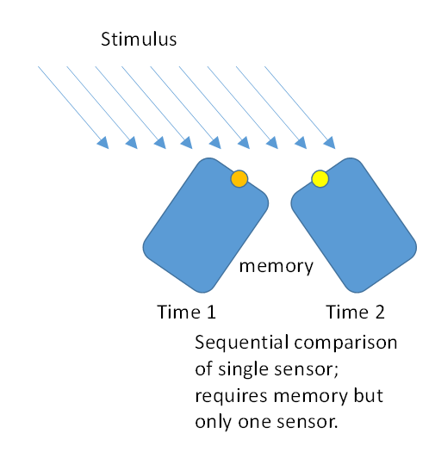

- Tropotaxis: Simultaneous sampling by two or more sensors – requires no memory but does require at least two sensors and the neural capacity to instantly compare their current values.

