**TEST CASE 1**: GetOpenTechIncidents(0) *\*zero value passed*

**RESULT**: Success (Expected Result returned)

* returned 0 records

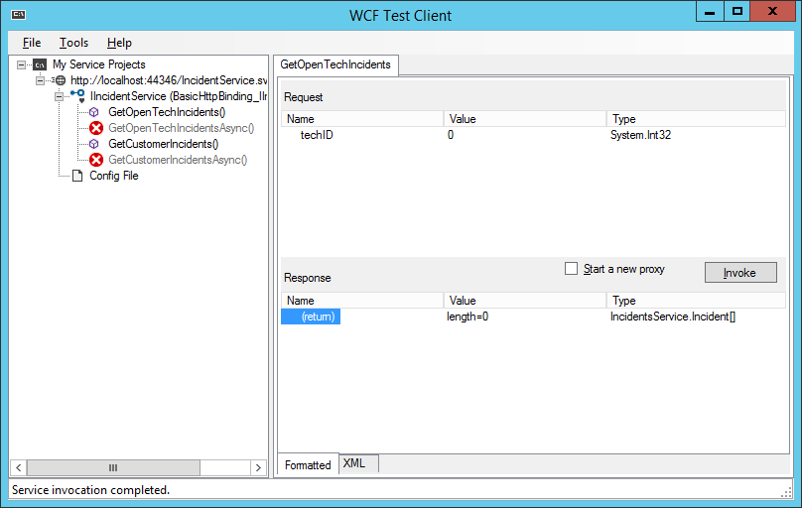

**TEST CASE 2**: GetOpenTechIncidents(1) *\*a value that is not in list*

**RESULT**: Success (Expected Result returned)

* returned 0 records

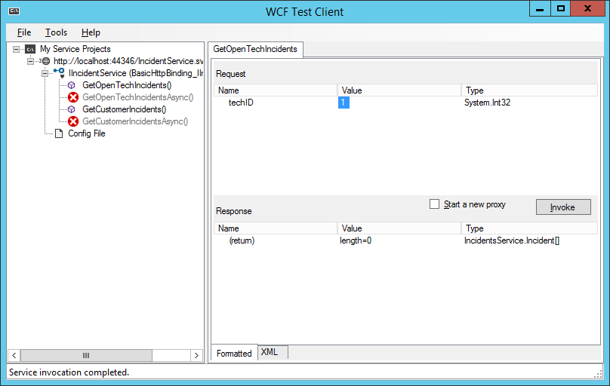

**TEST CASE 3**: GetOpenTechIncidents(12) *\*a value that is in the list*

**RESULT**: Success (Expected Result returned)

* returned 2 records with null DateClosed value as expected

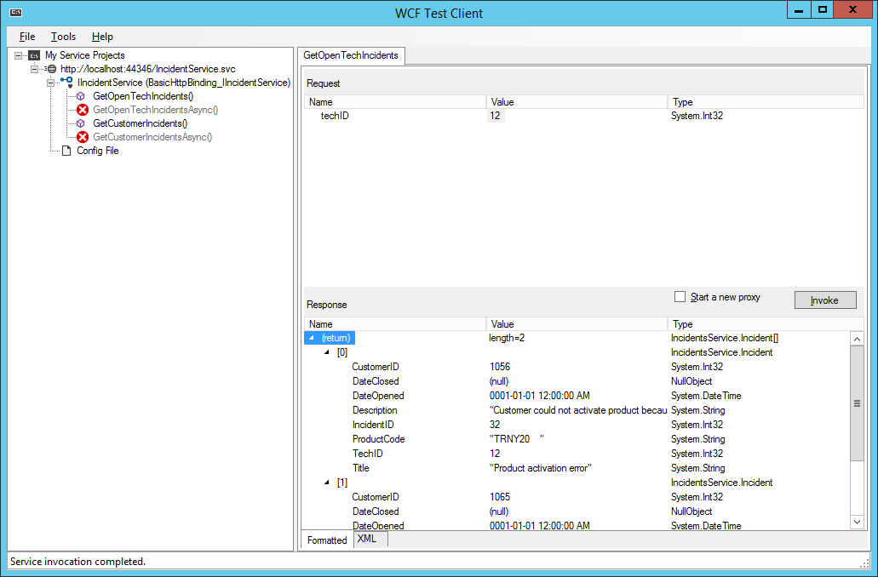

**TEST CASE 4**: GetOpenTechIncidents(a) *\*non-integer type passed*

**RESULT**: Success (Expected Result returned)

* Invalid value error

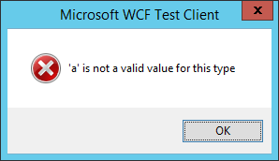

**TEST CASE 5**: GetCustomerIncidents(0) *\*zero value passed*

**RESULT**: Success (Expected Result returned)

* returned 0 records

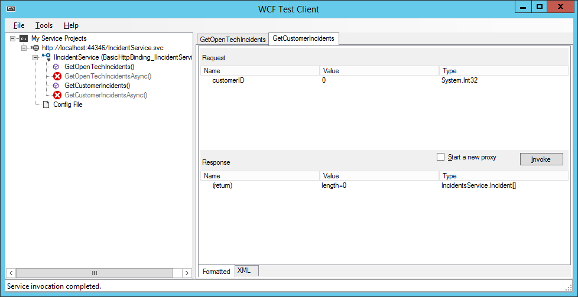

**TEST CASE 6**: GetCustomerIncidents(1) *\*a value that is not in list*

**RESULT**: Success (Expected Result returned)

* returned 0 records

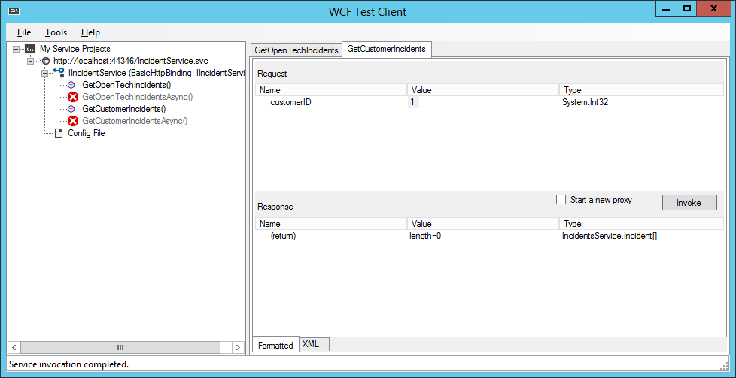

**TEST CASE 7**: GetCustomerIncidents(1116) *\*a value that is in the list*

**RESULT**: Success (Expected Result returned)

* returned 2 records as expected

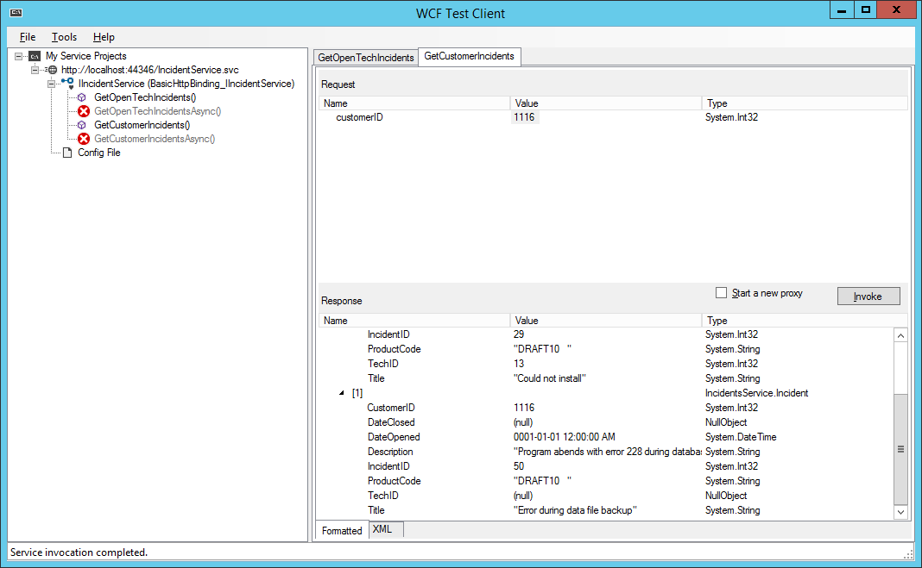

**TEST CASE 8**: GetCustomerIncidents(a) *\*non-integer type passed*

**RESULT**: Success (Expected Result returned)

* Invalid value error

