BMI Program Test Plan
Denys Vasiutyn

Testing Technology
I used Jest to test my BMI program. Jest is a JavaScript testing framework used to run automated tests. I chose Jest because my BMI program is written in JavaScript and Jest is simple to install and use. It also clearly shows whether each test passes or fails.
Test Case 1 – Weight Conversion
Description: Tests if the program correctly converts pounds to kilograms.
Input: 150 pounds
Expected Output: Approximately 68.04 kilograms
Result: Passed
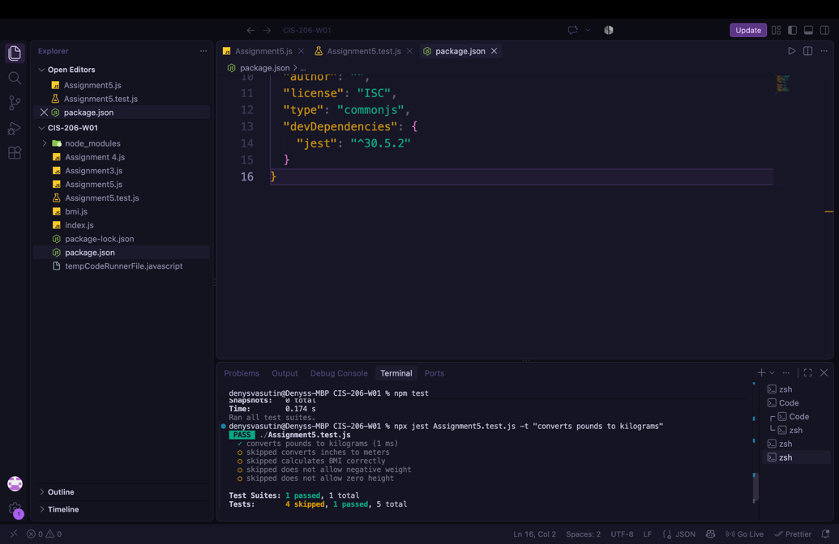

Test Case 2 – Height Conversion
Description: Tests if the program correctly converts inches to meters.
Input: 70 inches
Expected Output: Approximately 1.78 meters
Result: Passed
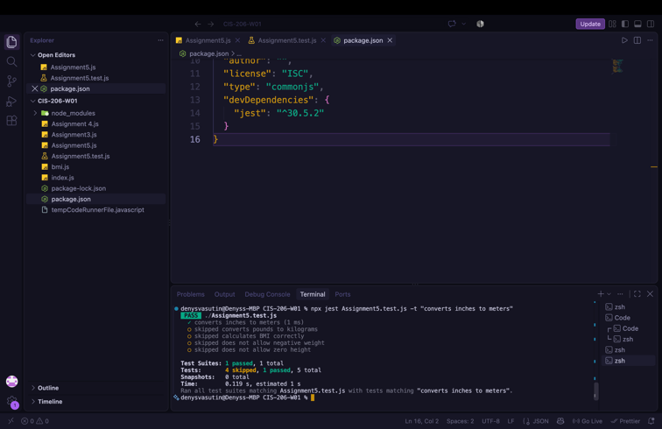

Test Case 3 – BMI Calculation
Description: Tests if the program calculates BMI correctly using valid weight and height values.
Input: 68 kg and 1.75 meters
Expected Output: Approximately 22.2 BMI
Result: Passed
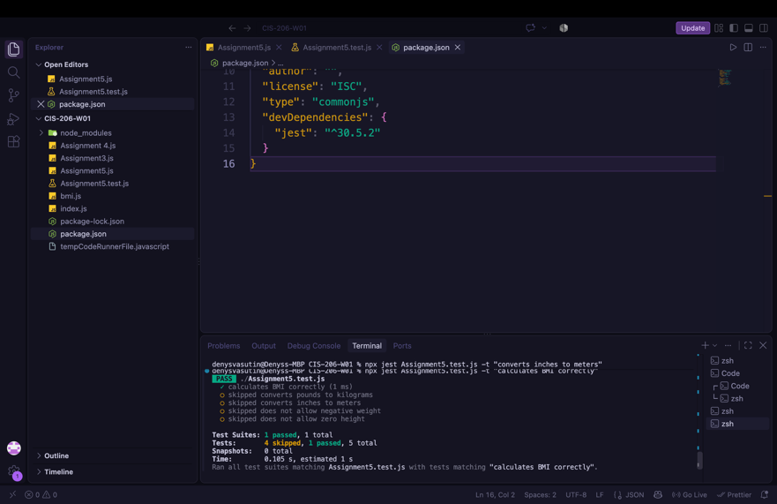

Test Case 4 – Negative Weight (Failed Condition)
Description: Tests how the program handles an invalid negative weight. A negative weight should not be accepted.
Input: -100 pounds
Expected Output: Invalid weight
Result: Passed
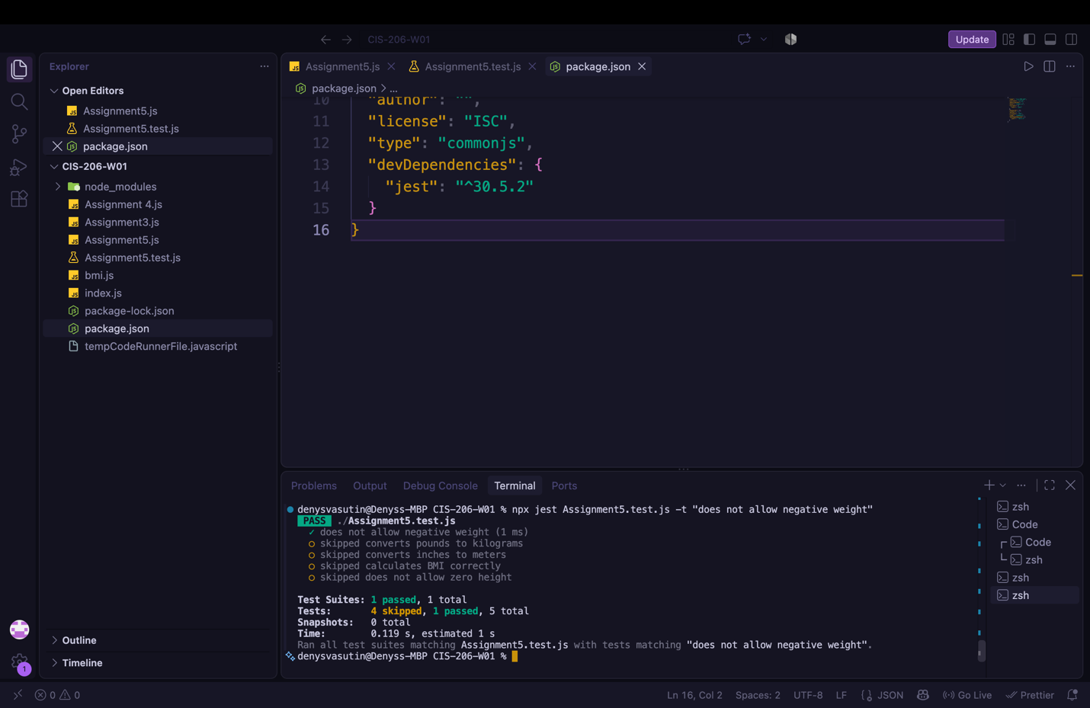

Test Case 5 – Zero Height (Failed Condition)
Description: Tests how the program handles a height of zero. Zero height should not be accepted.
Input: 0 inches
Expected Output: Invalid height
Result: Passed
