**MP3 – Design Document**

**Code Structure**

The code is organized into a C++ class named PageTable, which encapsulates various memory management functions. Here is a breakdown of the major components:

* current_page_table: A static member variable used to keep track of the active page table.
* paging_enabled: A static member variable indicating whether paging is enabled.
* kernel_mem_pool: A static member variable representing a memory pool for kernel memory.
* process_mem_pool: A static member variable representing a memory pool for process-specific memory.
* shared_size: A static member variable indicating the size of shared memory.-> 4MB

The init_paging function initializes the memory pools and shared memory size. This function is called at the beginning to set up the memory management system.

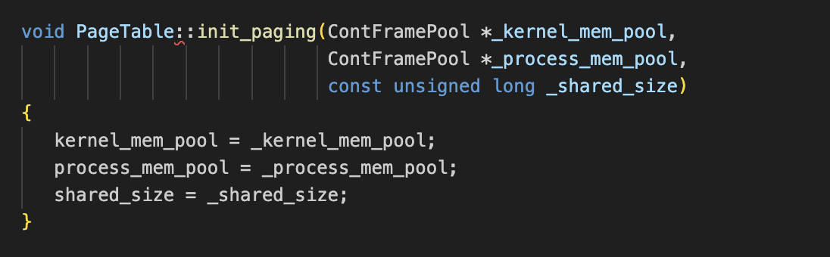

The constructor for the PageTable class sets up the initial page tables. It allocates memory for the page directory and page table for first 4MB of memory, shared_size -> direct mapping   
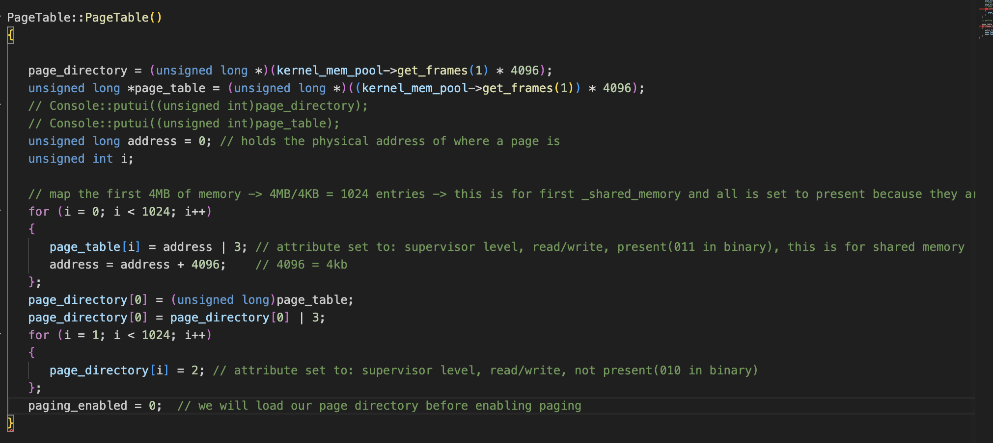

load **Function**

The load function is responsible for loading the current page directory into the control register CR3 and setting up current_page_table, static value. This function is used to switch between page tables as needed.

enable_paging **Function**

The enable_paging function enables paging by modifying the CR0 control register. This is done after initialising page tables

handle_fault **Function**

The handle_fault function is invoked when a page fault occurs. It determines the cause of the fault

**Final Test result :**

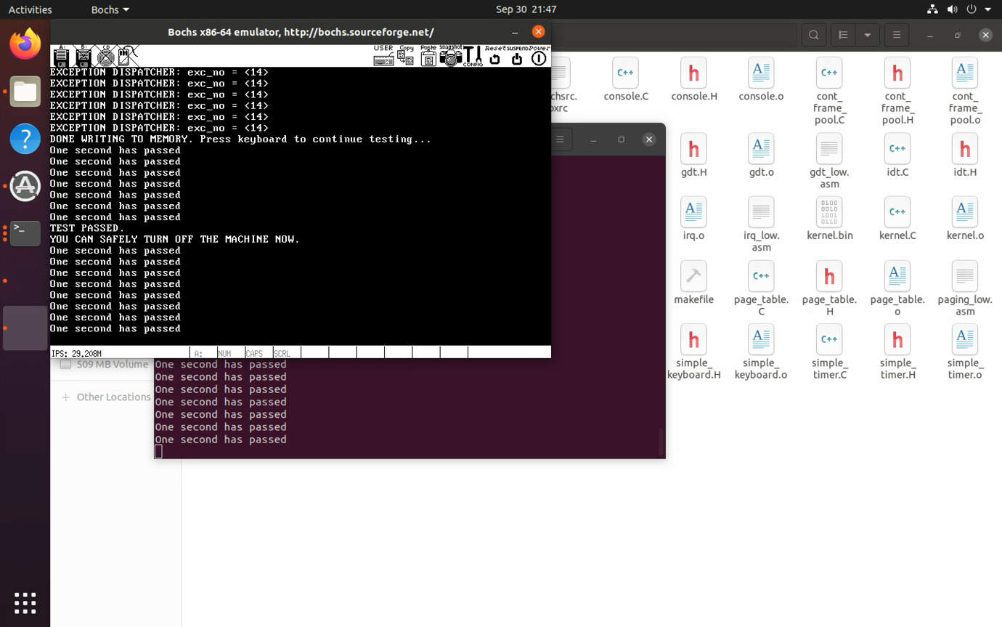

**Changes**

1. page_table.C -> to implement above code
2. cont_frame_pool.C -> to manage frame pools
3. makefile -> to add simple_frame_pool.C compilation and link 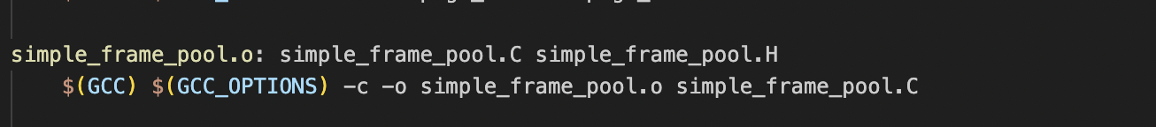A screen shot of a computer code

   Description automatically generated