**SMART IRRIGATION SYSTEM**

**A Project submitted to**

University of Mumbai for partial completion of the degree

of BACHELOR OF SCIENCE (INFORMATION TECHNOLOGY)

Under the faculty of science

By

___NAME__

Seat No.: -

Under the esteemed guidance of **Mr. Manish Singh**



KANDIVLI EDUCATION SOCIETY’S BK SHROFF COLLEGE OF ARTS AND MH SHROFF COLLEGE OF COMMERCE

Bhulabhai Desai Road, Kandivali (West), Mumbai-400067

NAAC Reaccredited ‘A’ Grade (CGPA 3.27) and ISO 9001:2015 Certified

April 2019



KANDIVALI EDUCATION SOCIETY’S

B.K. Shroff College of Arts & M.H. Shroff College of Commerce

Bhulabhai Desai Road, Kandivali (West), Mumbai-400067

NAAC Reaccredited ‘A’ Grade (CGPA 3.27) and ISO 9001:2015 Certified

CERTIFICATE

This is to certify that Ms._____ has worked and duly completed her project work for the Degree of Bachelor in Science (Information Technology) under the Faculty of Commerce and her project is entitled, “PROF MANISH SINGH” under my guidance and that no part of it has been submitted previously

for any Degree or Diploma of any University.

It is her own work and facts are reported by her personal findings and investigations.

PROF MANISH SINGH

Date of submission:

**DECLARATION BY LEARNER**

I, the undersigned, Miss hereby declare that the work embodied in this project work titled “SMART IRRIGATION SYSTEM”, forms my own contribution to the research work carried out under the guidance of PROF MANISH SINGH and is a result of my own research work. It has not been previously submitted to this or any other University for any other Degree/Diploma.

Whenever reference has been made to previous works of others, it has been clearly indicated as such and included in the bibliography.

I, hereby further declare that all information of this document has been obtained and presented in accordance with academic rules and ethical conduct.

--------------NAME----

Certified by

PROF MANISH SINGH

**ACKNOWLEDGEMENT**

To list who all have helped me is difficult because they are so numerous and the depth is so enormous.

I would like to acknowledge the following as being idealistic channels and fresh dimensions in the completion of this project.

I take this opportunity to thank the University of Mumbai for giving me chance to do this project.

I would like to thank my Principal, Dr. Lily Bhushan for providing the necessary facilities required for completion of this project.

I take this opportunity to thank our Coordinator, prof Vishesh Shrivastav for his moral support and guidance.

I would also like to express my sincere gratitude towards my project guide whose guidance and care made the project successful.

I would also like to express my gratitude to my College Library, for having provided various reference books and magazines related to my project.

Lastly, I would like thank each and every person who directly or indirectly helped me in the completion of the project especially my Parents and Peers who supported me throughout my project.

**ABSTRACT**

Embracing an upgraded water system framework has turned into a need due to the absence of the world water asset. The framework has a dirt dampness sensor. This task centers around a savvy water system framework which is financially savvy. Mechanization enables us to control different machines consequently. The goal of this task is to control the water supply to each plant naturally relying upon estimations of soil dampness sensors. System is done with the end goal that dirt dampness sensor anodes are embedded in soil. Programmed water system planning reliably has appeared to be profitable in water utilize effectiveness as for manual water system dependent on direct soil water estimations. The point of the usage is to show that the programmed water system can be utilized to lessen water utilize. The execution is an mechanized water system framework that comprises of a dirt dampness sensors which faculties the dirt stickiness and consequently waters the field.

**LIST OF CONTENT**

|  |  |  |
| --- | --- | --- |
| Sr. no. | Content | Page no. |
| **1** | **INTRODUCTION** | **1-9** |
| 1.1 | Introduction | 1-2 |
| 1.2 | Objectives | 2 |
| 1.3 | Purpose | 2-3 |
| 1.4 | Scope | 4-5 |
| 1.5 | Organization of Report | 6 |
| 1.6 | Overview | 6-7 |
| 1.7 | Proposed System | 7-9 |
| **2** | **SURVEY OF TECHNOLOGY** | **10-21** |
| 2.1 | Existing System | 13-14 |
| 2.2 | Proposed System | 14-15 |
| 2.3 | Technology Used | 15-21 |
| **3** | **REQUIREMENT ANALYSIS** | **22-38** |
| 3.1 | Problem definition | 22-23 |
| 3.2 | Requirement specification | 23-24 |
| 3.3 | Planning & scheduling | 25-27 |
| 3.4 | Software & hardware requirement | 27-32 |
| 3.5 | Preliminary product description | 32-33 |
| 3.6 | Conceptual model | 34-38 |
| **4** | **SYSTEM DESIGN** | **39-51** |
| 4.1 | Basic module | 39-40 |
| 4.2 | Data design | 41 |
| 4.2.1 | Schema design | 41 |
| 4.2.2 | Data integrity | 42-43 |
| 4.3 | Procedural design | 44 |
| 4.3.1 | Logic diagram | 44-46 |
| 4.3.2 | Algorithm design | 46 |
| 4.4 | User interface design | 47-48 |
| 4.5 | Security issues | 49 |
| 4.6 | Test cases design | 49-51 |
| **5** | **IMPLEMENTATION APPROACH** | **52-61** |
| 5.1 | Implementation Approach | 52-53 |
| 5.2 | Code efficiency | 53-55 |
| 5.3 | Testing Approach | 55 |
| 5.3.1 | Unit Testing | 55-56 |
| 5.3.2 | Integration Testing | 56-58 |
| 5.3.3 | Beta Testing | 58 |
| 5.4 | Modification and Improvements | 58 |
| 5.5 | Test Cases | 59-61 |
| **6** | **RESULT AND DISCUSSION** | **62-72** |
| 6.1 | Test report | 62 |
| 6.2 | User documentation | 62-72 |
| **7** | **CONCLUSION** | **73-75** |
| 7.1 | Conclusion | 73 |
| 7.1.1 | Significance of the system | 73-74 |
| 7.2 | Limitation of system | 74 |
| 7.3 | Future scope of project | 74 |
| **8** | **REFERENCE** | 76 |

**LIST OF TABLES**

|  |  |  |
| --- | --- | --- |
| **Sr no.** | **Table name** | **Pg no.** |
| 4.6 | Test Design | 50-51 |
| 5.3.1 | Unit Testing | 56 |
| 5.3.2 | Integration Testing | 57-58 |
| 5.5 | Test Cases | 59-61 |

**LIST OF FIGURES**

|  |  |  |
| --- | --- | --- |
| **Sr no.** | **Figure name** | **Page no** |
| 3.5 | Product Description | 32 & 34 |
| 3.6 | Data Flow Diagram | 35 & 36 |
|  | Sequence Diagram | 37 |
|  | ER diagram | 38 |
| 4.2.1 | Schema Diagram | 41 |
| 4.3.1 | Logic Diagram | 45 |
| 4.4 | User Interface Design | 47-48 |
| 5.1 | Implementation Approach | 53 |
| 5.3 | Testing Approach | 55 |

**CHAPTER 1: INTRODUCTION**

**1.1INTRODUCTION**

In this day and age, everything is about "smart" innovation. You can deck your home and life out in brilliant gadgets that range from shrewd indoor regulators to keen watches to savvy shades. As innovation propels an ever-increasing number of procedures in the home, this will wind up mechanized and keen. This is for a valid justification – savvy gadgets tend to diminish waste and increment proficiency which amplifies abilities while limiting expense. One region numerous individuals may not understand that has progressed toward becoming "brilliant" is their water system framework. A water system framework is basic to any mortgage holder's scene since it keeps the scene appropriately flooded on a reliable calendar with the goal that a property holder does not need to endeavor to recollect when they last watered the patio grass or the flower hedges out front. Be that as it may, now water system has become considerably more complex with shrewd water system.

* In the United States, open air water utilizes alone midpoints in excess of 9 billion gallons of water every day, predominantly for scene water system.
* As much as half of this water is squandered because of overwatering caused by wasteful aspects in customary water system strategies and frameworks.
* Shrewd water system innovation is the appropriate response. Savvy water system frameworks tailor watering timetables and run times naturally to meet particular scene needs. These controllers altogether enhance outside water utilize efficiencies.
* Not at all like customary water system controllers that work on a preset modified timetable and clocks, savvy water system controllers screen climate, have soil conditions, dissipation and plant water used to consequently modify the watering calendar to genuine states of the site.
* For instance, as open-air temperatures increment or precipitation diminishes, savvy water system controllers consider nearby particular factors, for example, soil compose, sprinklers' application rate, and so on to modify the watering run times or timetables. There are a few choices for savvy water system controllers.

**Accuracy Agriculture:** The advancement of WSN applications in exactness agribusiness makes it conceivable to build efficiencies, profitability and benefit in numerous horticultural generation frameworks, while limiting unintended effects on untamed life and the earth. The ongoing data acquired from the fields can give a strong base to ranchers to alter procedures whenever. Rather than settling on choices situated in some speculative normal condition, which may not exist anyplace truly, an accuracy cultivating approach perceives contrasts and changes administration activities as needs be.

**1.2 OBJECTIVES**

* The targets of the task are to outline a keen trickle water system framework to water plants with the utilization of gadgets like raspberry pi, Arduino microcontrollers.
* Zigbee is utilized to control the framework remotely while Python programming dialect is utilized for robotization reason.
* This framework likewise contributes a proficient and genuinely shabby computerization water system framework. Framework once introduced has no support cost and is anything but difficult to utilize.
* Condition parameters checking framework in view of remote correspondence innovation has been created to control remotely, which understands the estimation of temperature, rain fall, soil parameters.
* Checking framework in light of remote correspondence innovation has been produced to control remotely, which understands the estimation of temperature, rain fall, soil parameters.

**1.3 PURPOSE**

1. Existing water system controllers depend on settled calendar. Agriculturists, Districts and business proprietors of green zones normally set a watering plan that includes particular run-times and days, and the controller executes a similar calendar paying little mind to the season or climate conditions. Now and again a specialist may physically alter the watering plan, however such changes are normally just made a couple of times amid the year, and are based upon the expert’s discernments as opposed to real watering needs. Brilliant water system control innovation depends on ordinary atmosphere foundation and real water need of plant. In this innovation water system happens when the water is required by plant. It supplies just that measure of water to the plant as plant needs.
2. In regular water system control innovation, water system is done in the path in which expansive measure of underground or surface water is squandered. In brilliant water system control innovation water system is done in a way in which there is next to no possibility of water wastage.
3. The basic water system control technology doesn’t consider the plant efficiency which did not depend on proficient water system. It depends on view of specialist. The keen water system control innovation considers every one of the parts of plants identified with water system. It depends on proficient water system.
4. Shrewd water system control innovation is effectively deployable and can be controlled physically or naturally without physical nearness at the framework or field. In existing innovation these sorts of offices are not effortlessly accessible.
5. Regarding highlights and life of keen water system controller the cost is satisfactory for each sort of ranchers, districts and business green territory experts.

The motivation behind this work is to create independent water system frameworks that can be utilized consistently on soil basis to adjust day by day water system profundities to plant needs. Criteria for example, the amount of water needed by plants can be estimated straightforwardly by SENSORS which at that point adjust the water system calendar to the watched conditions, prompting a sensible sparing in the measure of water system. Consequently, this work means to build up a financially savvy water system controller using Raspberrypi, that is versatile to every day atmosphere conditions, without the requirement for costly and expensive climate stations. It should likewise be solid and effortlessly deployable keeping in mind the end goal to work under cruel outside conditions without the requirement for supervision or consistent checking.

**WHY AUTOMATIC IRRIGATION SYSTEM?**

* Straightforward and simple to introduce and arrange.
* Saving vitality and assets, so it very well may be used in legitimate way.
* Farmers would have the capacity to spread the perfect measure of water at the ideal time.
* Avoiding water system at the wrong time of day.
* Automated water system framework utilizes valves to turn engine ON and OFF. Engines can be mechanized effortlessly by utilizing controllers and no need of work to turn engine ON and OFF.
* It is exact strategy for water system and a significant instrument for precise soil dampness control in exceptionally particular nursery vegetable generation.
* It is efficient, the human mistake disposal in changing accessible soil dampness levels.

**1.4 SCOPE**

* The brilliant water system framework executed is achievable and for improving water assets for rural creation.
* This water system framework permits development in places with water shortage along these lines enhancing maintainability.
* The keen water system framework created demonstrates that the utilization of water can be lessened for a given measure of crisp biomass creation.
* Continuous framework for water system is in light of GSM and ZigBee module.
* The framework is fantastically adaptable and conservative. It does not bother with people on obligation it is so natural and solid.

**FUTURE SCOPE**

* To give protection from the creepy insects and pests.

Concentrated on the counteractive action of yields from creepy insects which harms the harvest leaves and root so it consequently influences the product yield

* To watch different parameters for better yield.

Climatic conditions likewise influence the development of yields, similar to temperature builds the water necessity moreover increments so it can likewise be observed.

* To have prior information about the weather.

Our task can be ad libbed by including a Webscaper which can foresee the climate and water the plants/edits in like manner. On the off chance that rain is estimated, less water is let out for the plants.

* To control the system accordingly.

Additionally, a GSM module can be included so the client can control the framework by means of advanced cell.

* To measure the water utilized.

A water meter can be introduced to evaluate the measure of water utilized for water system and consequently giving a cost estimation.

* To create fluctuations in the volume.

A solenoid valve can be utilized for changing the volume of water stream. Besides, Wireless sensors can likewise be utilized.

* Use of wireless sensors.

In future we can update the system by using wireless sensors so that there is a ease of spreading them into large distances in order to provide equal and accurate amount of water throughout.

On the off chance that the proposed rural condition observing server framework is connected to a rural situation, natural and soil data could be checked even at a remote site, and it is normal this would add to expanded harvest yields and the change of value in the horticultural field by supporting makers' basic leadership about yield generation through the investigation on the gathered data.

**APPLICABILITY**

* This system can be utilized to quantify the loss of dampness in the dirt after some time because of vanishing and admission.
* Limits water squander and enhances plant development.
* The circuit is intended to work naturally and subsequently, there is no requirement for any human intercession.
* The venture is expected for little gardens and private condition. By utilizing propelled soil dampness sensor, a similar circuit can be extended to huge horticultural fields.

**1.5 ORGANIZATION OF THE PROJECT**

Section 1: Introduction

This section gives the diagram of the undertaking.

Section 2: Literature Survey

This section indicates about the related work and foundation works of this undertaking.

Section 3: Software Design

Necessity

The section condenses about the framework necessity particulars, utilitarian and nonfunctional prerequisites of this task.

Plan

This module connotes the plan portrayal, framework design and clarification of modules.

Part 4: Implementation

This module of the part comprises the task execution and the usefulness.

Testing: This module depicts the kinds of testing required for this task and the experiments outlined furthermore, executed.

Part 5: Results and Conclusion.

**1.6 OVERVIEW**

* At the present time, the ranchers have been utilizing water system procedure in India through the manual control in which the agriculturists flood the land every now and then. This procedure now and again expends more water. Programmed water system booking reliably has appeared to be important in water utilize effectiveness concerning manual water system in light of direct soil water estimations.
* Water system of plants is normally an exceptionally tedious movement which has to be done in a sensible measure of time; it requires a lot of HR. All the means were executed by people customarily.
* These days, a few frameworks utilize innovation to decrease the quantity of specialists and to lessen the time required to water the plants. With such frameworks, the control is extremely restricted furthermore, huge numbers of the assets are as yet squandered. Water is one of these assets which is utilized unreasonably. Mass water system is the technique which is utilized to water the plant. This strategy speaks to monstrous misfortunes since the measure of water given surpasses the plants' needs. The overabundance water gets released by the openings of the pots, or it permeates through the dirt in the fields. Notwithstanding the overabundance cost of water, work is winding up increasingly costly.
* It not just gives comfort yet in addition lessen vitality, effectiveness and efficiency. Presently the ventures are utilizing robotization and control machine which is high in cost and not appropriate as a part of a homestead field. So here it additionally outlines a brilliant water system innovation in ease which is usable by Indian ranchers.
* A microcontroller (which fills in as the 'data entryway') lies at the core of the robotized water system foundation. Soil dampness sensors and temperature sensors, which are put on the fields, send ongoing information to the microcontroller. For the most part, a 'dampness/temperature extend' is determined, and at whatever point the genuine qualities are out of this range, the microcontroller consequently switches on the water pump, which is mounted on it with yield pins. The microcontroller likewise has servo engines to ensure that the funnels are really watering the fields consistently so no zone gets obstructed or is left excessively dry. The whole framework can be overseen by the end-client through a devoted portable application.

**1.7 PROPOSED SYSTEM**

* The proposed water system framework makes the productive utilization of water. Water is bolstered to the plant at whatever point there is requirement.
* There as of now exist water system frameworks which water plants on the premise of soil stickiness, pH estimation of soil, temperature and light. Wherever these parameters are required in enormous rural fields their efficiency of the yield matters.
* The proposed water system framework will be extremely productive in territories like house gardens, office premises, structures and so forth where watering plants at normal interim issues.
* Taking after like motherboard, raspberry pi has every one of the parts to associate sources of info, yields and capacity
* This framework additionally shows a keen dribble water system framework to water plants utilizing gadgets like raspberry Pi.
* This is utilized to control the framework remotely. And furthermore, the client gets the status time to time.
* Raspberrypi is considered as the heart of the system. It is a minimal effort, Visa measured PC. It is able to do doing all that you'd anticipate that a PC will do, from perusing the web and playing superior quality video, making spreadsheets, and playing recreations.
* There are unique models of Raspberry Pi from Raspberry Pi 0 to Raspberry Pi 3. Raspberry pi is a pocket PC with Linux working framework on it.
* This is extraordinary shoddy to energize youngsters for picking up, programming, testing and for making advancement.
* Taking after like motherboard, raspberry pi has every one of the parts to associate sources of info, yields and capacity.

**Focal points:**

* Moisture inside the root zone can be kept up at field limit.
* Water dispersion is profoundly uniform.
* Labor cost is not as much as other water system strategies.
* Fertilization can without much of a stretch be incorporated with negligible misuse of manures.
* Consumption of water and additionally power is diminished to a huge sum.

**CHAPTER 2: SURVEY OF TECHNOLOGY**

**Bennis, H. Fouchal, O. Zytoune, D. Aboutajdine, "Driple Irrigation System utilizing Wireless Sensor Systems"** The Model incorporates soil dampness, temperature and weight sensors to screen the water system activities. In particular, we consider the situation where a framework breakdown happens, as when the channels burst or the producers square. Additionally, we separate two fundamental movement levels for the data transmitted by the WSAN, and we utilize a sufficient need based directing convention to accomplish high QoS execution. Recreations directed over the NS-2 test system indicate promising outcomes regarding deferral and Packet Delivery Ratio (PDR), essentially for need activity.

**Sneha Angal "Raspberry pi and Arduino Based Automated Irrigation System"**, This presents a home robotization framework which depends on Raspberry pi, Arduino microcontrollers, and ZigBee and transfer sheets to water plants. Raspberry pi goes about as the control hinder in the programmed water system framework to control the stream of engine. The directions from the Arduino are prepared at raspberry pi. Zigbee module is utilized for correspondence between the Raspberry pi and Arduino. This paper shows a proficient and genuinely shabby robotization water system framework. By utilizing dampness sensor, we will make the water system framework brilliant and computerized. Framework once introduced has no upkeep cost and is simple to use.

**Suprabha Jadhav1, Shailesh Hambarde,"Android based Automated Irrigation System utilizing Raspberry Pi”. Nowadays**, receiving an advanced water system framework has turned into a need because of the absence of the world water asset. The framework has a circulated remote system of soil-dampness and temperature sensors.

This venture centers around a keen water system framework which is financially savvy. As the innovation is developing and evolving quickly, Wireless detecting Network (WSN) redesigns the innovation where mechanization is assuming vital job in human life. Robotization permits us to control different machines consequently. DC engine-based vehicle is intended for water system reason.

**Joaquín Gutiérrez, Juan Francisco Villa-Medina et al:"Mechanized Irrigation System Using a Remote Sensor Network and GPRS Module”**: In this paper the System has a circulated remote system of soil-dampness and temperature sensors put in root zone of plants. Portal unit handles sensor data, triggers actuators, and transmits information to a web application. An calculation was created with limit estimations of sensors that was modified into a microcontroller-based portal to control water amount.

**Pravina B. Chikankar, Deepak Mehetre, Soumitra Das, "An Automatic Irrigation System utilizing ZigBee in Wireless Sensor Network":** In the exploration field of remote sensor arrange control effective time is significant issue which can be overwhelmed by utilizing ZigBee innovation. The primary thought is to see how information goes through remote medium transmission utilizing WSN and checking framework. Plan of a water system framework which is mechanized by utilizing controllable parameter, for example, temperature, soil dampness and air moistness since they are the essential elements to be controlled in PA(Precision Agriculture).

**Gajjala Ashok, Gogada Rajasekar, "Savvy Drip Irrigation System utilizing Raspberry Pi what's more, Arduino"** This paper proposes a plan for home robotization framework utilizing prepared to-utilize, financially savvy and vitality proficient gadgets including raspberry pi, arduino microcontrollers, xbee modules and transfer sheets. Utilization of these segments results in generally speaking financially savvy, adaptable and strong usage of framework.

The sensor information were transferred in to cloud by raspberry pi utilizing python programming dialect. Arduino microcontrollers used to transmit the sensor information to the raspberry pi utilizing zigbee convention. Star zigbee topology fills in as spine for the correspondence between raspberry pi and end gadgets. Raspberry pi acts a focal organizer and end gadgets go about as different switches. Ease and vitality proficient trickle water system framework fills in as a proof of idea.

The outline can be utilized in enormous agribusiness fields and also in little gardens and water plants. The utilization of ultrasound sensors and solenoid valves make a brilliant trickle water system framework. The paper clarifies the entire establishment of the framework including equipment and programming perspectives.

**CropX** is the most recent IoT-empowered brilliant water system gadget that is constructed consolidating the dirt sensor and cloud-based information investigation. CropX is reasonable and offers remarkable straightforwardness in everyday utilization by agriculturists with slightest specialized know-how. The gadget won't just help enhancing yields of products however will likewise add to lessening the expense of water assets.

**eBee Ag**:

The utilization of automaton or UAV has been extremely well known to screen the farmland remotely. Through the automaton caught pictures of the sections of land of farmland, the ranchers can get precise view and information about their yields, soil condition and water level. eBee Ag is a propelled ramble grew particularly for the rural reason. The automaton can give exact pictures of each meter of an extensive land even on a blurred day. In addition, the pictures given by this automaton are goals shrewd superior to those given by the satellites.

**GREENHOUSES**

* Robotization and productivity are significant in nursery condition observing and control. With the end goal to control and screen the natural elements, sensors and actuators are fundamental. Nursery harvests can profit a great deal from the utilization of WSNs, on the grounds that inside the nursery the yield conditions, for example, atmosphere and soil don't rely upon outside elements and the executions are hence less demanding than in open air applications.
* The principal utilization of WSN in a nursery was accounted for in the year 2003. It was a checking and control framework created by methods for Bluetooth.
* From that point forward, a few applications have been created, the greater part of them making utilization of IEEE 802.15.4/ZigBee. For instance, Gonda and Cugnasca exhibited a proposition of a circulated nursery control and observing framework utilizing ZigBee .
* Yoo et al. portrayed the consequences of genuine sending of a WSN IEEE 802.15.4 consistent framework to screen and control the earth in nurseries where melons and cabbages were being developed.
* Lea-Cox et al. built up a WSN in a nursery, that coordinates an assortment of sensors which can quantify substrate water, temperature, electrical conductivity, every day photosynthetic radiation and leaf wetness continuously. Advantages originated from an enhanced plant development, more productive water and manure applications, together with a decrease in sickness issues identified with over-watering.
* Liu et al. detailed a WSN model with a two-section system for nurseries. In the initial segment, a few sensor hubs were utilized to gauge temperature, light and soil dampness. The other part comprises of a GSM module and the administration programming dependent on a database running on the remote PC.
* Zhou et al. planned an observing framework dependent on ZigBee, utilizing a star arrange topology inside the nursery and a work topology for the association between the nurseries and the administration framework.
* Yang et al. detailed a multi-utilitarian remote detecting framework that coordinates RFID innovation with unearthly imaging and natural detecting in a nursery. The multi-unearthly Sensors 2010, 10 11193 imaging framework was utilized for remote detecting of the shelter of cabbage seedlings. Nursery temperature, relative stickiness, and lighting conditions were estimated over the harvest.

**2.1 EXISTING SYSTEM**

**1.SICCA**

* Alongside the assembling segment, Internet of Things (IoT) and associated gadgets currently would like to address a portion of the consuming issues identified with agribusiness too. Sense It Out Intelligent Solutions Private Limited, a Pune-based start-up, thought of an answer which intends to enhance water use utilizing sensors and on-field associated gadgets. Called Sensor-based Intelligent Crop Centric Automation (SICCA), this arrangement utilizes sensors to gauge soil dampness to improve water use on fields.
* Jasveer Singh, prime supporter of the organization which has built up the innovation, said on-field sensors will enable them to lessen the amount of water required for water system. "With the end goal to get the best yield per section of land, amend water use assumes an imperative job. Be that as it may, at present the greater part of the agriculturists have back-of-the-envelope estimations to control their water use amid the existence cycle of the product," he said.
* Singh referred to the case of sugarcane whose development, particularly in zones like Maharashtra, has frequently been condemned as a result of the colossal measures of water it requires. Most sugarcane ranchers, Singh stated, honed what is designated "dubuk" water system to water their harvests. "Ranchers toss an irregular stone at the remotest piece of their field. Just if the stone makes the average sound of hitting the water, showing adequate water levels, the water supply is turned off. A great deal of water gets squandered simultaneously," he said.
* Singh said SICCA tackles this issue by standard observing of the dirt dampness content through sensors which are introduced in the field. "Toward the beginning of the editing cycle, everything that the agriculturist needs to do is to choose the name of the product starting from the drop menu of the application. The application will in like manner ascertain the measure of water and interims when the product would require watering. In view of this information, the trickle water system framework will just enable the required measure of water to stream into the field," he said. As and when the sensors demonstrate dampness push, the pump will be "told" to run the watering cycle once more.
* This keen water system framework, Singh stated, enhances the yield per grounds by 1.2-2 times and decreases water wastage by very nearly 60-70 for each penny. "The information so acquired can be utilized for dry spell administration and manage the water utilization in times of extreme pressure," he said. This framework requires no human impedance and the introduced application will convey message just in the event of crises.
* The item, or, in other words old, had won a concede from the Center and was likewise one of the main 20 new companies under the Innovate for Digital India challenge. Alongside Singh, Dr Abhay Hake helped to establish the start-up and their working model is prepared for field preliminaries.

**2.2 PROPOSED SYSTEM**

* The proposed water system framework makes the productive utilization of water.
* Water is encouraged to the plant at whatever point there is require. There as of now exist water system frameworks which water plants on the premise of soil mugginess, pH estimation of soil, temperature and light.
* Wherever these parameters are required in huge agrarian fields their efficiency of the harvest matters.
* The proposed water system framework will be extremely productive in regions like house gardens, office premises, structures and so on where watering plants at customary interim issues.
* This framework likewise exhibits a shrewd trickle water system framework to water plants utilizing gadgets like raspberry pi, Arduino microcontrollers.
* Zigbee is utilized to control the framework remotely. And furthermore the client the status time to time.
* The framework arranged in this venture designs a robotized soil water system framework which will screen and keep the required soil dampness content through a programmed water system.
* Microcontroller on PIC stage is used to outline the control unit. The get together uses soil dampness sensors which recognize the right dampness content in the field.
* This information makes the framework to use legitimate required measure of water which counteracts over/under watering of the field. IOT is used to influence the ranchers to get refreshes identified with the state of sprinklers.

**2.3 TECHNOLOGY USED**

The following is the technology used for making this project:

**JAVA**

Java is a broadly useful, abnormal state programming language created by Sun Microsystems. The Java programming language was created by a little group of specialists, known as the Green Team, who started the language in 1991.

Initially called OAK, the Java language was intended for handheld gadgets and set-top boxes. Oak was ineffective and in 1995 Sun changed the name to Java and altered the language to exploit the blossoming World Wide Web.

Afterward, in 2009, Oracle Corporation obtained Sun Microsystems and took responsibility for key Sun programming resources: Java and Solaris.

Java stage is an accumulation of projects that assistance to create and run programs written in the Java programming language. Java stage incorporates an execution motor, a compiler, and a lot of libraries. JAVA is stage autonomous language. It isn't explicit to any processor or working framework.

It is simple for engineers to compose programs which utilize mainstream programming configuration examples and best works on utilizing the different parts found in Java EE. For instance, structures, for example, Struts and JavaServer Faces all utilization a Java servlet to actualize the front controller configuration design for bringing together demands.

A major piece of the Java environment is the extensive assortment of open source and network manufactured tasks, programming stages and APIs. For instance, the Apache Foundation has an assortment of ventures composed utilizing Java, including basic logging structures for Java (SLF4J), both Yarn and Hadoop handling systems, Microservices improvement stages and joining stages.

Java EE conditions can be utilized in the cloud also. Designers can fabricate, send, investigate and screen Java applications on Google Cloud at an adaptable dimension.

As far as versatile advancement, Java is normally utilized as the programming language for Android applications. Java will in general be favored by Android designers in light of Java's security, object-situated standards, consistently refreshed and kept up capabilities, utilization of JVM and systems for systems administration, IO and stringing.

Despite the fact that Java is generally utilized, regardless it has reasonable reactions. Java sentence structure is regularly reprimanded for being excessively verbose. Accordingly, a few fringe dialects have risen to address these issues, including Groovy. Because of the manner in which Java references protests inside, perplexing and simultaneous rundown based tasks moderate the JVM. The Scala language tends to a considerable lot of the deficiencies of the Java language that decrease its capacity to scale.

**REASON WHY I CHOSE JAVA?**

Here is my rundown of 10 reasons, which I inform any individual who asks my feeling regarding learning Java, and whether Java is the best programming language as far as circumstances, advancement and network support.

**1) Java is Easy to learn**

Many would be shocked to see this one of the top purpose behind learning Java or thinking about it as the best programming language, however it is. On the off chance that you have a precarious expectation to learn and adapt, it is hard to get profitable in a limited capacity to focus time, which is the situation with a large portion of the expert task.

Java has familiar English like grammar with least enchantment characters for example Generics point sections, which makes it simple to peruse Java program and adapt rapidly.

**2) Java is an Object Oriented Programming Language**

Another reason, which made Java well known is that it's an Object Oriented Programming language. Creating OOP application is a lot simpler, and it additionally keeps framework particular, adaptable and extensible.

When you know about key OOP ideas like Abstraction, Encapsulation, Polymorphism, and Inheritance, you can utilize each one of those with Java. Java itself epitomizes many accepted procedures and configuration design in its library.

Java is one of only a handful couple of near 100% OOP programming language. Java additionally advances the utilization of SOLID and Object-situated structure standards in type of open source ventures like spring, which ensure your item reliance is overseen well by utilizing Dependency Injection guideline.

**3) Java has Rich API**

One more explanation behind Java writing computer programs language's enormous achievement is it's Rich API and in particular it's very obvious in light of the fact that accompany Java establishment.

When I initially begun Java programming, I used to code Applets and those days Applets gives extraordinary activity ability, which astonishes new software engineer like us, who are utilized to code in Turbo C++ proofreader.

**4) Powerful improvement apparatuses for example Shroud, Netbeans**

Trust it or not, Eclipse and Netbeans have assumed a colossal job to make Java a standout amongst the best programming dialects. Coding in IDE is a joy, particularly on the off chance that you have coded in DOS Editor or Notepad.

They help in code culmination as well as gives a ground-breaking investigating capacity, which is basic for genuine improvement. Incorporated Development Environment (IDE) made Java improvement a lot simpler, quicker and familiar. It's anything but difficult to seek, refactor and read code utilizing IDEs.

**5) Great gathering of Open Source libraries**

Open source libraries guarantee that Java ought to be utilized all over the place. Apache, Google, and other association have contributed a ton of extraordinary libraries, which makes Java advancement simple, quicker and financially savvy.

There are structures like Spring, Struts, Maven, which guarantees that Java improvement pursues best practices of programming craftsmanship, advances the utilization of configuration designs and helped Java engineers to arrive work done.

**6) Wonderful Community Support**

A solid and flourishing network is the greatest quality of Java programming language and stage. Regardless, How great a language is, it wouldn't endure, if there is no network to help, help and offer their insight. Java has been fortunate, it has heaps of dynamic gatherings, Stack Overflow, open source associations and a few Java client gatherings to help everything.

**7) Java is FREE**

Individuals like FREE things, Don't you? So if a software engineer needs to get familiar with a programming language or an association needs to utilize innovation, COST is a critical factor. Since Java is free from the begin, for example you don't have to pay anything to make Java application.

**8) Excellent documentation support - Javadocs**

It's an extraordinary bit of documentation, which informs a great deal of things regarding Java API. I think without Javadoc documentation, Java wouldn't be as well known, and it's one of the primary reason,I think Java is the best programming language.

**9) Java is Platform Independent**

During the 1990s, this was the fundamental explanation behind Java's fame. The possibility of stage autonomy is extraordinary, and Java's slogan "compose once run anyplace" and abbreviation "WORA" was sufficiently alluring to draw in heaps of new advancement in Java.

**10) Java is Everywhere**

Truly, Java is all over, it's on the work area, it's on versatile, it's on the card, all over as is Java software engineers. I think Java developer dwarf some other programming language proficient.

**RASPBERRY PI PLATFORM and PYTHON PROGRAMMING:**

* Raspberry Pi is a minimal effort processing stage. The objective of the Raspberry Pi Foundation is to make figuring accessible to everybody all around to assist them with learning programming. Since its beginning discharge in 2012, the Raspberry Pi has seen a few improvements as far as the measure of RAM, CPU control, fringe support, and support for systems administration conventions; yet, it has figured out how to clutch its unique US$ 35 sticker price.
* The most recent rendition, Raspberry Pi 3, was declared in February 2016. It accompanies a 1.2GHz 64-bit quad-center ARMv8 CPU, 1GB RAM, worked in remote/Bluetooth support and much to program them utilizing an assortment of programming devices/situations. In this article, how about we get begun with programming on the Raspberry Pi utilizing a standout amongst the most prominent dialects in the world, Python.
* The Raspberry Pi has been downright an upset in presenting a large number of individuals over the world to processing and being one of the drivers behind acquainting PC programming with everybody. It has great enough equipment to begin with programming also, the US$ 35 sticker price is difficult to beat. The creators of Raspberry Pi have additionally given careful consideration to guaranteeing that obstructions to beginning are insignificant.
* The suggested Linux dissemination for Raspberry Pi, Raspbian, comes packaged with numerous programming dialects and IDEs so you are prepared to go from the time you control on the smaller than normal advancement load up. Python, then again, is a standout amongst the most mainstream dialects on the planet and has been around for over two decades. It is vigorously utilized in scholarly conditions and is a broadly bolstered stage in present day applications, particularly utilities, and work area and Web applications.
* Python is very prescribed as a dialect that is simple for newcomers to program. With its simple to-peruse linguistic structure, the presentation is delicate and the general understanding much better for an amateur. The most recent variant of the Raspbian OS comes packaged with both Python 3.3 and Python 2.x apparatuses. Python 3.x is the most recent variant of the Python dialect and is prescribed by the Raspberry Pi Foundation as well.
* Python uses dynamic typing, and a combination of reference counting and a cycle-detecting garbage collector for memory management. It also features dynamic name resolution (late binding), which binds method and variable names during program execution. Python is meant to be an easily readable language.
* Its formatting is visually uncluttered, and it often uses English keywords where other languages use punctuation. Unlike many other languages, it does not use curly brackets to delimit, blocks and semicolon after statements are optional. It has fewer syntactic exceptions and special cases than C or Pascal. Python's large standard library, commonly citedas one of its greatest strengths, provides tools suited to many tasks. For Internet-facing applications, many standard formats and protocols such as MIME and HTTP are supported.
* It includes modules for creating graphical user interfaces, connecting to relational databases, generating pseudo random numbers, arithmetic with arbitrary precision decimals, manipulating regular expressions, and unit testing. Most Python implementations (including CPython) include a read–eval–printloop (REPL), permitting the to function as a commandline interpreter for which the user enters statements sequentially and receives result immediately.Other shells, including IDLE and I Python, add further abilities such as auto- completion, sessions tateretention and syntax highlighting. As well as standard desktop integrated development environments, there are Web browser-based IDEs.
* Boo uses space, a comparative sentence structure, and a comparative protest model. Cobra uses space and a comparative linguistic structure, and its "Affirmations" report records Python first among dialects that affected it. However,Cobra specifically supports design-by-contract, unit tests, and optional static typing. Coffee Script, a programming dialect that cross-aggregates to JavaScript, has Python-roused syntax. ECMA Script borrowed it and generators from Python. Go is intended for the" speed of working in a dynamic dialect like Python" and has a similar grammar for cutting arrays. Groovy was persuaded by the craving to bring the Python out line logic to Java. Julia was planned" with true macros [...furthermore, to be] as usable for general programming as Python [and] ought to be as quick as C".
* Calling to or from Julia is conceivable; to with Call. Jlanda Python bundle pyjulia permits calling, in the other heading, from Python. Python mediators are accessible for many operating systems. C Python, the reference implementation of Python, is open source programming and has a network based improvement demonstrate, as do about the majority of Python's different usage. Python and C Python are overseen by the non-profit Python Software Foundation.

**CHAPTER 3: REQUIREMENTS AND ANALYSIS**

**3.1 PROBLEM DEFINITION**

**What problem actually exist**?

Plants getting untimely, insufficient water and crucial supplements which prompts undesirable life and development and plants may kick the bucket. Over water likewise prompts wastage of water and suffocate the plants.

**Who does it affect?**

Agriculturists and Plants men or Horticulturist who put time, cash and endeavors in dealing with them.

* The expense of giving water system have been expanding throughout the years from the initial multiyear plant to tenth multiyear plant.
* While only before Independence (1945-46) open water system plans demonstrated a surplus in the wake of meeting working costs and different charges, the position weakened extensively in the post autonomy period.
* Rainfall and Water accessibility in India has gigantic Regional Imbalance.
* There is a gigantic fleeting and spatial variety in precipitation and water accessibility in the nation. While normal yearly precipitation is 1170mm, a few sections of north east get around 10000 mm for each year, while parts of western Rajasthan get just 100 mm. The beneath designs demonstrates that that around 68% of aggregate net sown region fall under either lower or low precipitation.
* We experience the ill effects of Sub-ideal use of made facilities. Despite of such a large number of decades passed, the endeavors to tap the water system potential, the hole between the potential tapped and the potential conceivable is not only large but enlarging.
* The significant reasons for these holes are poor support of the channel framework, absence of participatory administration, changing area utilize design, deviation from the assigned trimming design, soil debasement and deferral in the advancement of the direction zone. Though the potential created for water system is 112 million ha, the gross inundated zone is only 93 million — the hole of 19 million is amazing. Competing interest for water is expanding quickly.
* The interest for water for different reasons for existing is expanding because of populace development, urbanization and industrialization. Directly, the horticulture segment is utilizing around 83 percent of accessible water resources, however request from different segments may decrease accessibility for agrarian use to 68 percent by 2050.

**3.2 REQUIREMENTS SPECIFICATION**

Framework prerequisite determination gives the total depiction of the conduct about the framework created by this venture. This incorporates determination of practical and not useful prerequisites of the application. The collaboration of the clients with the application is spoken to with the assistance of utilization cases and there investigation. This additionally incorporates the depiction about practicality, chance investigation and outside interface prerequisites to achieve this venture.

FUNCTIONAL REQUIREMENTS:

* It necessitates that the client legitimately maps the dirt dampness sensors to the water system valves.
* The focal control unit will highlight an outline demonstrating the coordinated connection between soil dampness sensor sources of info and water system valve inputs.
* The web application ought to be versatile and responsive in the majority of the most recent adaptations of Mozilla Firefox, Google Chrome, and Internet Explorer.
* The rain sensor must be put outside in an area where there are no obstructions specifically above it. The best arrangement for this sensor is on the top of the client’s home in an area where other water sources won't meddle with it.

NON-FUNCTIONAL REQUIREMENTS:

The non-Functional prerequisites characterize how the framework will do certain activity. Non-functional necessities are typically called as "quality traits". The framework ought to likewise meet the non-utilitarian prerequisites alongside the useful necessities.

Non-Functional prerequisites for this venture are:

* Security

It is the component of the framework which guarantees that framework must be shielded from the unexpected or dangerous damage.

* Performance

The manner by which the framework meets its execution targets is for it to be indicated plainly and expressly. The framework itself probably won't require anything particularly for its essential task, yet the entire framework alongside the parts associated may have some Performance prerequisite.

* User-accommodating

The graphical UI (GUI) is easy to understand.

* Usability

Ease of use decides that it is so hard to learn and utilize the framework.

* Availability

It implies for to what extent the framework is accessible for its clients and for to what extent the framework will be operational.

* Reliability

Unwavering quality decides how frequently the product comes up short. The estimation is communicated in Mean Time Between Failures (MTBF). The framework is totally tried for power before the sending. The module grew along these lines looks after information consistency.

**3.3 PLANNING AND SCHEDULING**

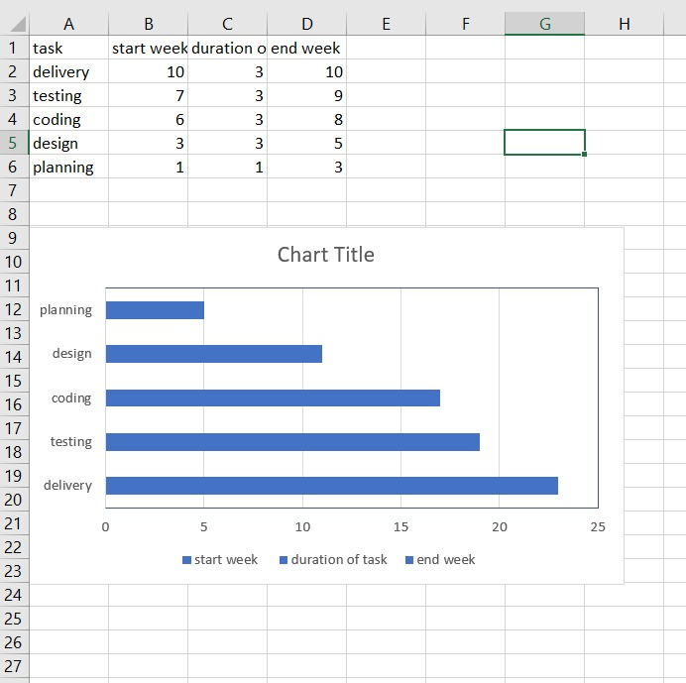

The above chart represents the number of days which are directly represented in the form of, months.

Starting from the June which includes the process of the selection of the topic, following the other procedures that are the discussion regarding the hardware and software that will be used.

Next regarding the language that will be used which took almost 10 days.

The planning of the project was more time consuming than the previous stages as it included the description of the overall architecture of the system.

Lastly was the Designing part of the system which included the modules to be used and how it must be implemented according to the time provided for the project?

To sufficiently plan and outline a water system framework, certain fundamental data is required. This information incorporates:

**1. Field Information**

This is best controlled by a visual assessment of the territory alongside a guide demonstrating field limits, water sources, common or artificial obstacles, and relative rise focuses.

After assessment of this fundamental field data, the most attractive water system framework might be chosen.

**2. Soil and Water Data**

This incorporates-

* Soil profile and surface arrangement
* Soil profundity
* Water consumption rate
* Soil water holding limit or accessible soil dampness.

**3. Plant Data**:

This incorporates-

* The sort of editing framework,
* Crop pivot designs, and
* Peak rate of water use by yields.

The pinnacle water utilize more often than not happens amid the most extreme development foliage cover period, especially amid hot, dry periods. This pinnacle water utilize rate or outline dampness withdrawal rate is utilized to decide the water system recurrence and greatest water necessities of the water system framework. Pinnacle water utilize rates change for various harvests yet as a rule run somewhere in the range of 0.15 and 0.30-inch every day.

**4. Water Availability:**

The water source must be assessed to decide whether satisfactory water is accessible to meet the necessities of the water system framework.

Water sources incorporate streams, lakes, stores, wells, and in addition water from trenches or water advancement ventures.

Various methods exist for estimating the accessible water supply.

The stream of water through a pipe that is streaming full can be assessed from the accompanying relationship. The pipe must be set flat. The separation can bemeasured with a woodworker's square.

**3.4 SOFTWARE AND HARDWARE REQUIREMENTS**

Equipment interface is a physical restricting which associates the general population and innovation. The framework will work together with the equipment assets. It trains the outline which shapes the association among client and the innovation.

1. Raspberry Pi:

Raspberry Pi: The Raspberry Pi is a minimal effort, Visa estimated PC. Its prepared to do doing all that you'd anticipate that a work station will do, from perusing the web and playing top quality video, making spreadsheets, and playing amusements. There are extraordinary models of Raspberry Pi from Raspberry Pi 0 to Raspberry Pi 3.

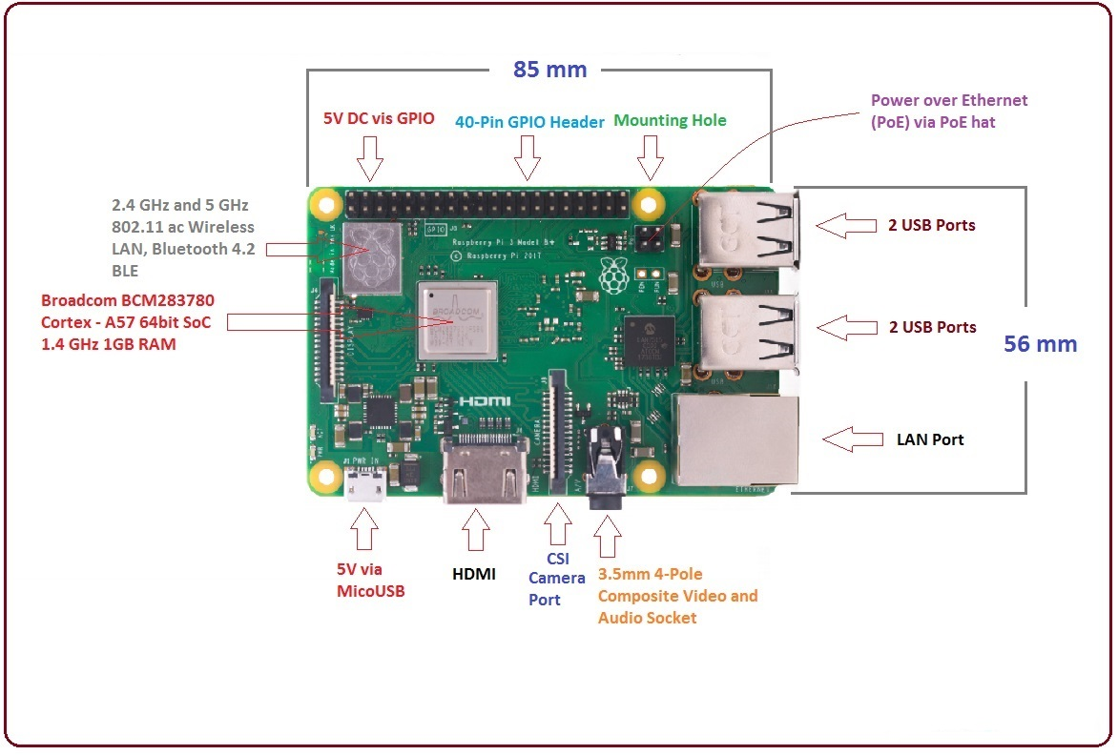

1. Jumper Wires

A JUMPER wire (otherwise called jumper, jumper wire, jumper link, DuPont wire, or DuPont link – named for one producer of them) is an electrical wire, or gathering of them in a link, with a connector or stick at each end (or in some cases without them – just "tinned"), or, in other words to interconnect the segments of a breadboard or other model or test circuit, inside or with other gear or parts, without soldering. Singular jumper wires are fitted by embedding’s their "end connectors" into the openings gave in a breadboard, the header connector of a circuit board, or a bit of test hardware. Here we have used to inter-connect the devices.

3. Motor driver

A Motor is a gadget which changes over electrical power into mechanical pivot utilizing the guideline of electromagnetism. Electro-attraction: A wire twisted on a ferrite center conveying electric current creates an attractive field; this guideline is called Electro-attraction.

4. 4-Channel Relay

The 4-Channel Relay Driver Module makes it basic and advantageous to drive loads, for example, 12V transfers from straightforward 5V advanced yields of your Arduino perfect board or other microcontroller. You can utilize any of the control channels autonomously, so just leave any unused channels disconnected. Relays are associated legitimately to each yield channel. In numerous instructional exercises about transfers you will see guidelines that you should incorporate an assurance diode over the hand-off terminals. You don't have to do that when utilizing the 4-Channel Relay Driver Module, in light of the fact that the insurance diodes are worked in to the module itself.

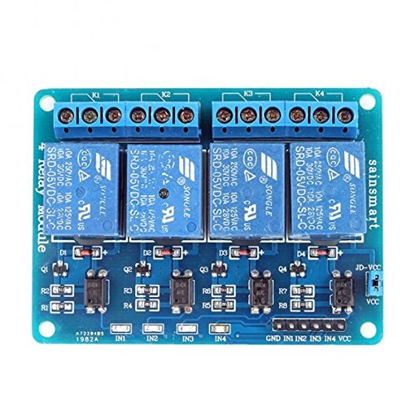

5. Soil-moisture sensor

The dirt dampness sensor comprises of two tests which are utilized to quantify the volumetric substance of water. The two tests enable the current to go through the dirt and afterward it gets the obstruction incentive to gauge the dampness esteem.

At the point when there is more water, the dirt will direct greater power which implies that there will be less opposition. Thusly, the dampness level will be higher. Dry soil conducts power inadequately, so when there will be less water, at that point the dirt will lead less power which implies that there will be more obstruction. Along these lines, the dampness level will be lower.

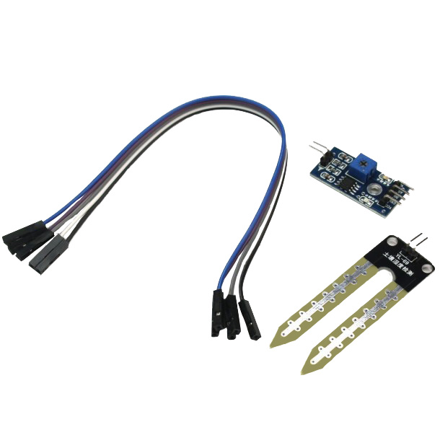

6. Laptop

**SOFTWARE REQUIREMENTS**

RASPBERRY PI PLATFORM & PYTHON PROGRAMMING:

* Raspberry Pi is a minimal effort registering stage. The objective of the Raspberry Pi Foundation is to make registering accessible to everybody all inclusive to assist them with learning programming. Since its underlying discharge in 2012, the Raspberry Pi has seen a few upgrades regarding the measure of RAM, CPU control, fringe support, and support for systems administration conventions; yet, it has figured out how to clutch its unique US$ 35 sticker price.
* The most recent variant, Raspberry Pi 3, was reported in February 2016. It accompanies a 1.2GHz 64-bit quad-center ARMv8 CPU, 1GB RAM, worked in remote/Bluetooth support and much to program them utilizing an assortment of programming instruments/conditions. In this article, we should begin with programming on the Raspberry Pi utilizing a standout amongst the most famous dialects on the planet, Python.
* The Raspberry Pi has been out and out a transformation in presenting a huge number of individuals over the world to processing and being one of the drivers behind acquainting computer programming with everybody.
* It has sufficiently intense equipment to begin with programming and the US$ 35 sticker price is difficult to beat. The producers of Raspberry Pi have additionally given careful consideration to guaranteeing that obstructions to beginning are insignificant.
* The prescribed Linux dispersion for Raspberry Pi, Raspbian, comes packaged with different programming dialects and IDEs so you are prepared to go from the time you control on the smaller than usual advancement load up.
* Python, then again, is a standout amongst the most prevalent dialects on the planet and has been around for over two decades. It is intensely utilized in scholastic situations and is a generally upheld stage in present day applications, particularly utilities, and work area and Web applications.
* Python is exceptionally suggested as a dialect that is simple for newcomers to program. With its simple to-peruse sentence structure, the presentation is delicate and the general experience much better for an amateur. The most recent form of the Raspbian OS comes packaged with both Python 3.3 and Python 2.x instruments. Python 3.x is the most recent variant of the Python dialect and is suggested by the Raspberry Pi Foundation as well.
* Raspbian Operating System: The Raspberry Pi fundamentally utilizes Raspbian, a Debian-based Linux working framework. Ubuntu MATE, Snappy Ubuntu Core, Windows 10 IoT Core, RISC OS and specific circulations for the Codi media focus and classroom administration. Working frameworks accessible by means of the official site of other outsider.

JAVA CODING:

* Java is a programming language that produces programming for different stages. At the point when a developer composes a Java application, the accumulated code (known as byte code) keeps running on most working frameworks (OS), including Windows, Linux and Mac OS. Java determines a lot of its punctuation from the C and C++ programming dialects.
* Java program advancement requires a Java programming improvement unit (SDK) that normally incorporates a compiler, mediator, documentation generator and different apparatuses used to deliver a total application.
* Improvement time might be quickened using coordinated advancement situations (IDE) -, for example, JBuilder, Netbeans, Eclipse or JCreator. IDEs encourage the advancement of GUIs, which incorporate catches, content boxes, boards, outlines, scrollbars and different articles by means of intuitive and point-and-snap activities.

**3.5 PRELIMINARY PRODUCT DESCRIPTION**

* Different plants have different requirements depending upon their features and characteristics. We need to keep the record of this to water them.
* This machinery system not only waters the plants according to the noted schedule but also keeps the complete information about the temperature and the amount of water it will be needing.
* This brilliant water system framework is a versatile system which checks the water content in the soil and then provides the required amount of water to the plant.
* The software will be running on a android mobile platform. Hence will be developed in android studio.
* The main and basic function would be to sense the water level in the soil of the crop/plant by using water sensors so as to compare it with the amount of water that would be needed.
* The data of the plant such as its moisture level and also the other data included like temperature will be accurate enough to inform us about the health of the plant. The data thus will be finished and accurate.
* Since the application which is designed will be android based, it will be quite easy for the customer to use it effectively.
* The sensors will be connected to raspberry pi so that it can transfer the complete information of the plant to the android application software so as to give the output accordingly.
* The application software will be consisting parameters like the number of times the plant needs to be watered, the switch to control the functioning of the motors, the present temperature around the plant and how many number of times the cycle of watering the plants should be done. This will thus be beneficial to know the field status accurately.
* The only thing required for the user is to update the schedules according to the plant’s condition and also follow them so as to keep the plant healthy and growing.
* The user must be able to maintain the operation of the motor accordingly.

WATER

MOTOR

RELAY

RASPBERRY PI

SOIL SENSOR

SOIL SENSOR

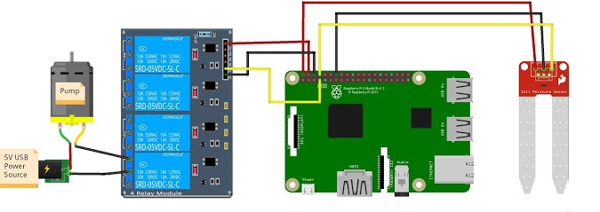

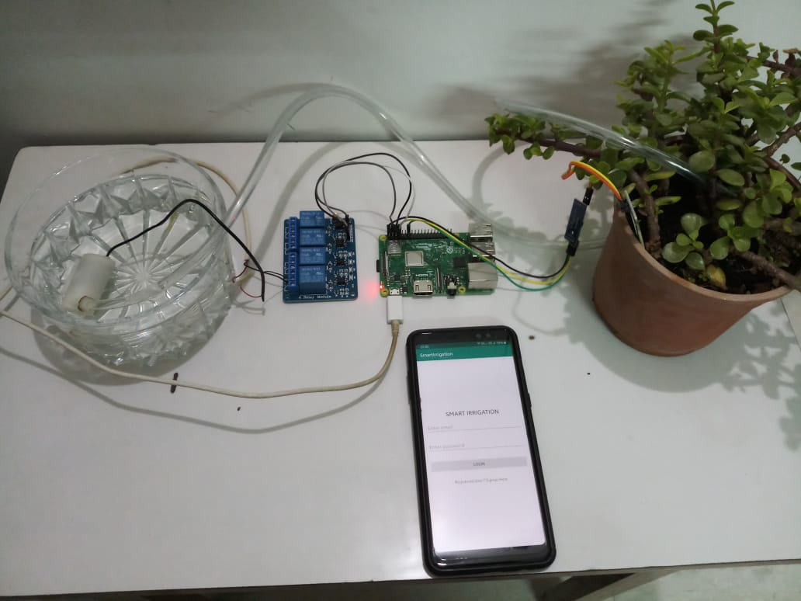

**3.6 CONCEPTUAL MODELS**

The Data Flow Diagram (DFD) is a method for speaking to a stream of an information of a procedure or a framework (for the most part a data framework)

The DFD additionally gives data about the yields and contributions of every element and the procedure itself. An information stream outline has no control stream, there are no choice guidelines and no circles. Explicit activities dependent on the information can be spoken to by a flowchart.

For every datum stream, somewhere around one of the endpoints (source and/or goal) must exist in a procedure. The refined portrayal of a procedure should be possible in another information stream graph, which subdivides this procedure into sub-forms

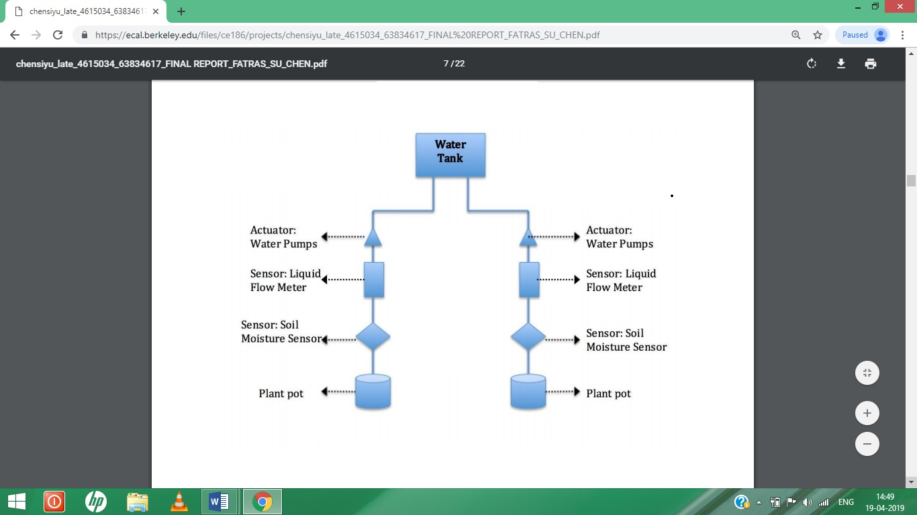

**1. DATA FLOW DIAGRAM:**

**RASPBERRY PI**

**Wi-Fi**

**MOBILE**

**MOTORS**

**SENSORS**

LOGIN PAGE

PASSES DATA TO THE

SERVER

READS SUBJECT FROM

SERVER THROUGH RASPBERRY PI

CHECKS PLANT IF NOT

CONDITION

IF DRY

SENDS DATA TO THE

SYSTEM

TURNS THE RELAY ON

WATERS PASSES

THROUGH MOTOR

Information stream chart delineates the working of Raspberry pi utilizing different sensors. The stream of information with the assistance of Wi-Fi module and versatile which advises the agriculturist about the dirt dampness.

The anticipated yield is then utilized for sending the control flag through the sequential correspondence to Raspberry pi for controlling water pump for watering the field as needs be.

Raspberry pi is the principle heart of the entire framework. A mechanized water system framework was created to advance water use for rural yields. Mechanization enables us to control machines automatically.

2. SEQUENCE DIAGRAM:

**SERVER**

**ALGORITHM**

**SENSOR**

**OUTPUT**

**USER**

1. Take values from user

2. Collect data

3. Send Data

6. Display data

5. Start the server

4. Send Analyzed data

A grouping graph demonstrates protest collaborations masterminded in time arrangement. It delineates the articles and classes associated with the situation and the succession of messages traded between the items expected to do the usefulness of the situation. Arrangement charts are normally connected with utilize case acknowledge in the Logical View of the framework a work in progress. Arrangement graphs are at times called occasion charts or occasion situations.

3. ENTITY-RELATIONSHIP DIAGRAM:

DEVICE

USER

Order

**CHAPTER FOUR: SYSTEM DESIGN**

Request

Viewing

**4.1 BASIC MODULES**

A module is an accumulation of source documents and construct settings that enable you to separate your venture into discrete units of usefulness. Your undertaking can have one or numerous modules and one module may utilize another module as a reliance. Every module can be autonomously constructed, tried, and repaired.

Extra modules are frequently helpful while making code libraries inside your own undertaking or when you need to make diverse arrangements of code and assets for various gadget composes, for example, telephones and wearable’s, however keep every one of the records checked inside a similar task and offer some code.

This software application consists of four basic modules that are given below:

**1.) USER AUTHENTICATION**

* The Login Module documentation portrays the interface that must be actualized by verification innovation suppliers. Login Module s are connected to under applications to give a specific sort of validation. A Configuration determines the Login to be utilized with a specific login application.
* Clients are demonstrated the primary entry tab. At the point when clients get to the framework through Portal Direct Entry, they are viewed as visitors until the point when they sign in. The Login Module is an entry module that enables clients to type a client name and secret key to sign in. This module can be put on any module tab to enable clients to sign in to the framework. For data about how to add a module to a tab, see Creating Module Tabs.
* On the off chance that a manager has enabled clients to make accounts and turned on Portal Direct Entry, a Create Account connect shows up in the Login Module. The module is never again accessible to clients after they have signed in.

**2.) CLIENT-SERVER COMMUNICATION THROUGH WI-FI**

* In this the system is connected to the server through the Wi-Fi
* Raspberry Pi will presently associate with WiFi organize consequently subsequent to booting. Presently, we can discover the IP address of Raspberry Pi utilizing Advance IP scanner.
* Advance IP scanner filters the system and gives rundown of associated gadget. In that we will get IP address of Raspberry Pi. To think about how to utilize Advance IP scanner, you can allude Access Raspberry Pi Home Screen on Laptop Display utilizing LAN.
* Once the raspberry pi is connected, you can now connect the software with the system by using the IP address of the system.

**3.) TIMING, AUTOWATERING AND SOIL STATUS**

* This is the most imperative module where the real working of the framework is appeared.
* The timing here means at what time we have watered the plant. So by this we will have the capacity to track the date and time of past watering and in like manner we can plan the following one. This will deal with the schedule openings and furthermore the normality of the activity.
* Next is the programmed arrangement of watering. In this the client has two options whether to keep it ON or OFF. If its ON that implies the framework will consequently water the plant in the given time schedules. This will the spare the client's energy.
* If it is in the OFF mode then the client himself needs to deal with the watering. Hence this 7relies on the circumstance the client is in. This module will likewise give the present
* Status of the soil. What is the wellbeing and to what rate it is great.
* Watering along these lines isn't the main thing that ought to be considered. The nature of the dirt likewise matters.

**4.) MODIFY AND DELETE USER REQUEST**

* Whatever subtle elements the client gives in regards to the dirt wellbeing and the plant can be altered and erased according to the client's convenience.
* This module subsequently deals with the altering and the progressions that should be possible in the application.
* Additionally the calendar and alternate settings identified with the watering activity on the plant can be changed by the plant's need.

**4.2 DATA DESIGN**

**4.2.1. SCHEMA DESIGN**

**Manage soil status**

**Manage autowatering**

+Erosion condition

+Percentage of nourishment.

+ON the automatic watering

+OFF the automatic watering

+Check-in/Login

+Password

+Settings

**Welcome**

+Last watered

+Date

+Time

**Manage Time**

+Update Profile

+Reset Password

**Profile**

+Water once

+Water according to schedule

**Manage Schedule**

The appreciated plan her demonstrates the login page where in the client needs to make his record which incorporates the username and the password. This is for the validation of the product inorder to keep it approved.

**Manage Soil Status** gives the flow wellbeing of the dirt in rate with the goal that the client can comprehend the extent in which watering must be finished.

**Manage Time** stores the time and the date of the past activity performed with the goal that the further timetable of the watering can be overseen and chosen in like manner.

In **Manage Schedule** the client can choose this mode to water the plant more than once.

**Profile** spares the profile of the client and the progressions that he needs to perform.The client can refresh its data and furthermore reset his secret word whenever required.

**The Manage Auto-watering** here has two choices whether to keep it in the ON mode or OFF. Once we instate this mode the framework will naturally begin watering the plant at whatever point the timetable is fixed. If not then the client needs to take care of the watering arrangement of the plant in a normal way.

**4.2.2Data Integrity and Constraints**

Data Integrity is the overseeing of the information in a fitting route in order to enable the client to refresh and erase the information as needs be.

There are different principles that ought to be pursued int Data Integrity. These are:

* Invalid Rule

An invalid govern is an administer characterized on a solitary section that permits or prohibits embeds or updates of lines containing an invalid (the nonattendance of an esteem) in that segment.

* Remarkable Column Values

A remarkable esteem run characterized on a section (or set of segments) permits the embed or refresh of a line just in the event that it contains an exceptional incentive in that segment (or set of segments).

* Essential Key Values

An essential key esteem manage characterized on a key (a segment or set of segments) indicates that each line in the table can be remarkably distinguished by the qualities in the key.

* Referential Integrity Rules

A referential respectability control is to govern characterized on a key (a segment or set of sections) in one table that ensures that the qualities in that key match the qualities in a key in a related table (the referenced esteem).

Referential respectability additionally incorporates the standards that manage what kinds of information control are permitted on referenced qualities and how these activities influence subordinate qualities. The guidelines related with referential trustworthiness are:

* Limit: Disallows the refresh or cancellation of referenced information.
* Set to Null: When referenced information is refreshed or erased, all related ward information is set to NULL.
* Set to Default: When referenced information is refreshed or erased, all related ward information is set to a default esteem.
* Course: When referenced information is refreshed, all related ward information is correspondingly refreshed. At the point when a referenced column is erased, all related ward lines are erased.
* No Action: Disallows the refresh or cancellation of referenced information. This contrasts from RESTRICT in that it is checked toward the finish of the announcement, or toward the finish of the exchange if the limitation is conceded. (Prophet utilizes No Action as its default activity.)

The next are the constraints for the proposed system:

1.) The structure ought to be available over the intranet either client ought to have the capacity to utilize it from anywhere. A determined separation must be allotted so the framework could work inside the given separation.

2.).For watering area into the system client ought to have the capacity to use login and passwords for getting to the structure.

3.) The client ought to have the capacity to change the secret word for the extended security. Also the subtle elements can be altered by the plant.

4.) The framework ought to be direct and created structurally.

5.) The customers ought to be in like manner to get contribution about any goofs that occur. There ought not to be any requirement about the hardware organize that will be used to run the structure.

6.) Whatever calendar made reference to in the database must work as needs be considering the plant’s wellbeing.

7.) In the planning area the date and time put away should be sufficiently precise specifying the am and pm.Also the month and the ought to be made reference to precisely.

8.) Using the programmed ON and OFF mode, the framework ought to have the capacity to consequently water the plant in exact proportion. Excess water can harm the dirt and less measure of water can leave the dirt dry. Hence it ought to be kept up precisely.

9.) The current status of the dirt ought to be considered entirely with the goal that the essential consideration could be given to the plant.

**4.3 PROCEDURAL DESIGN**

**4.3.1 LOGIC DIAGRAM**

Logical graphs have numerous employments. In the strong state industry, they are utilized as the important graph for the plan of strong state parts, for example, PC chips. They are utilized by mathematicians to help take care of sensible issues (called Boolean variable based math). The utilization of rationale symbology results in a chart that enables the client to decide the task of a given segment or framework as the different info signals change.

To peruse and translate rationale charts, the preuser must comprehend what every one of the specific images speak to. This part talks about the regular images utilized on rationale outlines. Whenever aced, this learning should empower the preuser to see most rationale charts.

.

**LOGIN**

**START**

NO

**USER NOT VALID**

YES

**WELCOME**

**CHECK THE DATE & TIME**

**MOISTURE SENSOR DETECTS THE SOIL**

**HEHE SOIL**

**CONVERSION FROM ANALOG TO DIGITAL**

**DIGITAL VALUE IS SEND TO RASPBERRY PI**

**IF DRY**

**RELAY OFF**

**RELAY ON**

**WATER PUMP OFF**

**WATER PUMP ON**

The rationales of the calculation help to distinguish whether there is need of water to plant. Further, rationales and basic leadership conditions help soil dampness state of the dirt and it generally keep up dampness and furthermore the client gets the status of the engine on the portable. First the dampness sensor detects the dirt.

The yield of the dampness is in the simple shape. The advanced esteem is then send to the Raspberry pi through RF module which chooses whether to soil is wet or dry and as indicated by that water the plant. On the off chance that the dirt is dry, Raspberry pi incites the hand-off and water pump begins which leads to water to stream. On the off chance that the dirt is wet, Raspberry pi turns the transfer of therefore water pump is off also, water stream stop.

**4.3.3ALGORITHM DESIGN**

1. START

2. IF VALID USERID GOTO STEP 3

ELSE CREATE NEW ID

3. HOME PAGE APPEARS

4. IF USER WANTS THE PREVIOUS HISTORY THEN CHECK DATE

ELSE GOTO STEP 5.

5. SENSOR DETECTS THE SOIL

6. CONVERTS DATA FROM ANALOG TO DIGITAL

7. RASPBERRY PI RECEIVES THE DATA.

8. IF SOIL IS DRY THEN GOTO STEP 9

ELSE OFF THE PUMP

9. RELAY STARTS WORKING

10. WATER PUMP STARTS WORKING

11. STOP

**4.4 USER INTERFACE DESIGN**

**VALVE CONTROL**

USER

**USER CONTROL**

USER

**CHECK STATUS**

USER

* The client opens the valve when he needs to water the plant. When the client needs to water the plant that is the point at which the dirt’s turns up dry, he gives the order to the system.
* This begins the transfer module which naturally opens up the valve. When the dirt isn't dry the valve gets shut.
* The client needs to make his account. For the capacity of the directions in the application, the client needs to sign in by utilizing his username and the password
* .As soon as the client signs in, he can set up the watering timetable of the plant. The framework will then work accordingly. The calendar can be refreshed and erased according to client's solace.
* To check the quality and state of the soil, the client needs to choose the CHECK SOIL STATUS MODE where the sensors will give the present status of the dirt.

**4.5 SECURITY ISSUES**

Once in the system, programmers can dispatch man-in-the-center (MitM) assaults and satire the contribution of the water system framework. Specialists found that assailants could parody the framework's setup, the climate conjecture, and different sensors (rain, water stream and soil dampness sensors) to control the sprinklers.

Notwithstanding mocking assaults, programmers can dispatch replay assaults, where they send subjective directions to the focused on gadget as genuine information. Uniquely created HTTP parcels containing watering plan refreshes are sent to the framework with the goal that the sprinklers are initiated as determined by the aggressor.

Replay assaults can likewise be utilized to open the valves of keen water system frameworks and start the watering procedure at whatever point the programmer wishes. In their tests, analysts got the ace valve of a framework to open and close at regular intervals**.**

**4.6 TEST CASE DESIGN**

* The client opens the valve when he needs to water the plant. When the System testing is the way toward checking the target and prerequisites. It is an exceptionally basic component of programming quality confirmation (SQA) and speaks to the survey of particular, outline and coding.
* Testing speaks to an intriguing abnormality i.e deviation from what is in reality required for the product. Subsequently, a progression of tests are performed for the proposed framework before the framework is prepared for client acknowledgment. A portion of the different experiments used to test the framework are as per the following
* The experiments are composed for testing against prerequisites of the unit being tried.
* If the unit changes the database, test for the respectability of the database after the task.
* Experiments for the way or branch inclusion ought to be finished.
* Test cases for information stream inclusion ought to be finished.
* Test cases dependent on the experience, for example, testing for limit conditions-least, and most extreme and off by one limit.

TEST CASES

|  |  |  |  |  |
| --- | --- | --- | --- | --- |
| **TEST CASE ID** | **TEST CASES** | **TEST CASE DESCRIPTION** | **STATUS** | **REMARK** |
| 01 | Login | Check whether the client can login to the applications  Effectively. | PASS | The clients are capable to login to the  applications  effectively with  checked username  Furthermore, secret word. |
| 02 | Water Pump | Water pump Check whether the engine pump accurately pumps  Water to the plants. | PASS | The engine pump  effectively draws the water to the plants by getting signals |
| 03 | Moisture Sensor | Moisture sensor Check whether the soil dampness  sensor detects the  Dampness in the dirt suitably. | PASS | The dirt dampness sensor detects the  dampness in the dirt what's more, sends adjust  messages and  signs to the  Raspberry pi and  the pump. |
| 04 | Raspberry pi | Check whether the raspberry pi  gets signals from  shows the  comparing  occasions on the  Workstation. | PASS | The Raspberry pi  gets signals  from what's more, shows suitable occasions on both the versatile what's more, PC |

**CHAPTER FIVE: IMPLEMENTATION AND TESTING**

**5.1 IMPLEMENTATION APPROACHES**

1. IDENTIFICATION

This stage begins with social occasion the business necessities in the pattern winding. In the resulting spirals as the item develops, recognizable proof of framework prerequisites, subsystem necessities and unit necessities are altogether done in this stage.

This stage likewise incorporates understanding the framework necessities by ceaseless correspondence between the client and the framework investigator. Toward the finish of the winding, the item is conveyed in the distinguished market.

1. DESIGN

The Design stage begins with the applied plan in the gauge winding and includes compositional structure, sensible plan of modules, physical item structure and the last structure in the resulting spirals.

1. CONSTRUCT AND BUILD

The Construct stage alludes to generation of the genuine programming item at each winding. In the pattern winding, when the item is simply thought of and the plan is being built up a POC (Proof of Concept) is created in this stage to get client input.

At that point in the resulting spirals with higher lucidity on necessities and configuration subtleties a working model of the product called assemble is delivered with a rendition number. These constructs are sent to the client for input.

1. EVALUATION AND RISK ANALYSIS

Hazard Analysis incorporates recognizing, evaluating and checking the specialized achievability and the executives dangers, for example, plan slippage and cost overwhelm. In the wake of testing the work, toward the finish of first emphasis, the client assesses the product and gives input.

In light of the client assessment, the product improvement process enters the following emphasis and therefore pursues the direct way to deal with execute the criticism proposed by the client. The procedure of cycles along the winding proceeds for the duration of the life of the product.

The upsides of the Spiral SDLC Model are as per the following −

* Changing prerequisites can be suited.
* Permits broad utilization of models.
* Necessities can be caught all the more precisely.
* Clients see the framework early.
* Advancement can be partitioned into littler parts and the hazardous parts can be grown before which helps in better hazard the executives.

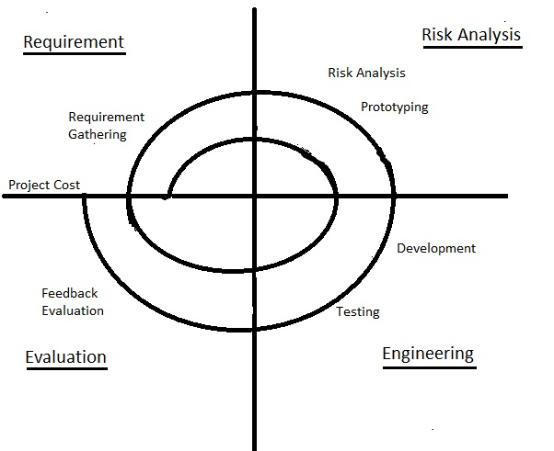

**5.2 CODE EFFICIENCY**

The following is the main raspberry pi code responsible for the important operations that are performed in the system.

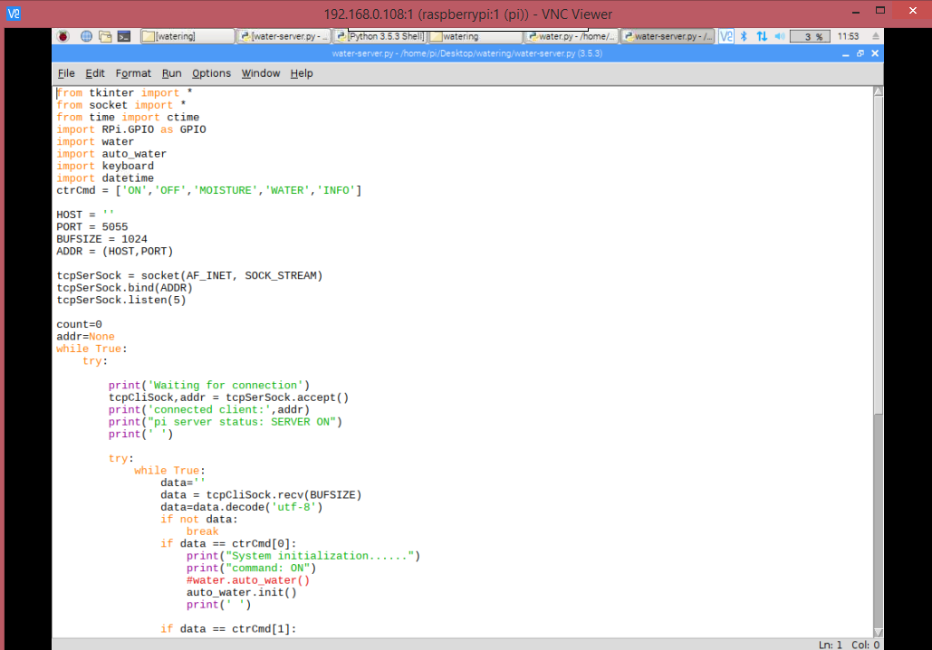

The above code is for the initialization process that is it connects the client to the server. The function “tcpCliSock” will create the socket to connect with the server. This function sends the command forward to the server.

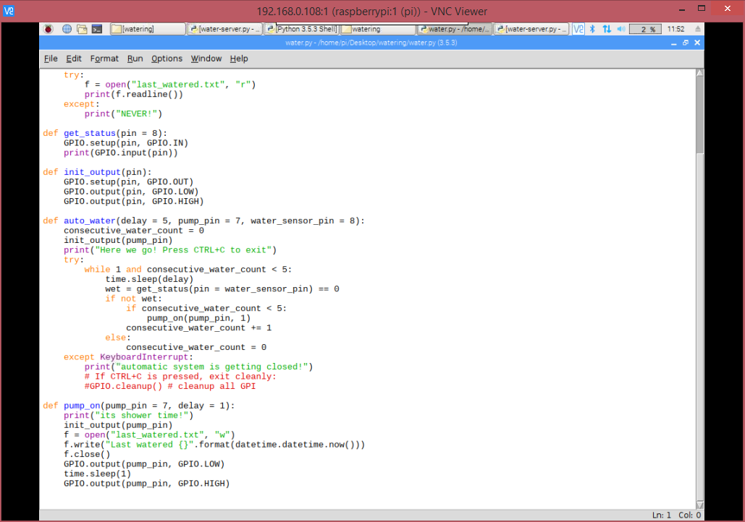

The above code is responsible for the checking the moisture continuously 5 times.If the output shows as 1 in the raspberry pi then the plant needs to be watered.Here the interpreter throws “KeyboardInterrupt” exception when the user tries to stop the process using keyboard.

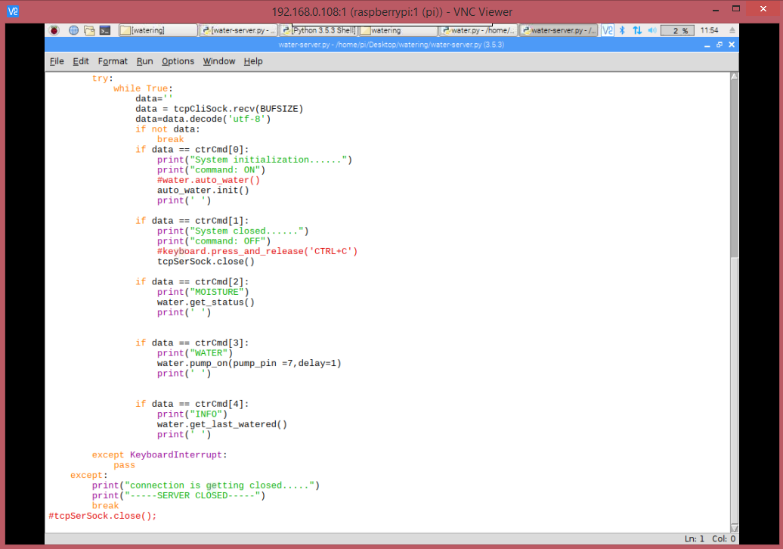

The above commands are responsible to show the moisture status of the plant. Also it prints the date and time of the last time the user watered the plant.

**5.3 TESTING APPROACH**

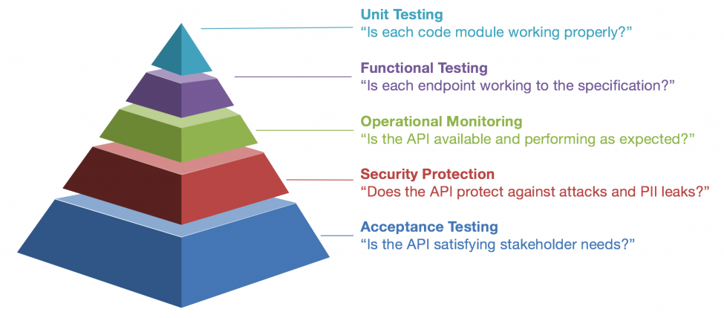

**5.3.1 Unit Testing**

Basically, a unit test is a technique that instantiates a little bit of our application and confirms its conduct freely from different parts. A common unit test contains 3 stages: First, it instates a little bit of an application it needs to test (otherwise called the framework under test, or SUT), at that point it applies some improvement to the framework under test (more often than not by calling a strategy on it), and lastly, it watches the subsequent conduct. On the off chance that the watched conduct is predictable with the desires, the unit test passes, else, it comes up short, demonstrating that there is an issue some place in the framework under test. These three unit test stages are otherwise called Arrange, Act and Assert, or essentially AAA.

A unit test can confirm distinctive social parts of the framework under test, however no doubt it will can be categorized as one of the accompanying two classes: state-based or collaboration based. Confirming that the framework under test produces right outcomes, or that its subsequent state is right, is called state-based unit testing, while at the same time checking that it legitimately summons certain techniques is called collaboration based unit testing.

|  |  |  |  |  |  |
| --- | --- | --- | --- | --- | --- |
| TEST ID | SOFTWARE TESTS | INPUT | OUTPUT | TESTS | PASS/FAIL |
| 1. | User Authentication | Enter the User ID and Password | It redirects to the main page. | To test the authorized user. | PASS |
| 2. | Last Update information | Click on the INFORMATION | Date and time of the last time we watered the plant. | To check the last date and time the plant was watered. | PASS |
| 3. | Client-Server Connection | Enter the IP address of the system. | Connects the system to Raspberry pi. | To check whether the application is connected to the server. | PASS |

**5.3.2 Integration Testing**

Reconciliation Testing is the way toward testing the availability or information exchange between the couple of unit tried modules. It is AKA I&T (Integration and Testing) or String Testing.

This procedure is completed by utilizing sham projects called Stubs and Drivers. Stubs and Drivers don't actualize the whole programming rationale of the product module however simply mimic information correspondence with the calling module.

It is done after Unit testing. Every single module associated with joining testing ought to be unit trying before mix testing. By doing unit testing before joining testing gives trust in performing programming combination testing.

It is done according to Test plan. By following the test plan before doing mix testing moderate the disarray and gives an unmistakable way in performing incorporation testing adequately.

The following table shows the tests related to client and server-side.

CLIENT-SIDE TESTS:

|  |  |  |  |  |  |
| --- | --- | --- | --- | --- | --- |
| TEST ID | SOFTWARE TESTS | INPUT | OUTPUT | TESTS | PASS/FAIL |
| 1. | Admin login | Entering the user id and password | Shows that login is successful and redirects to next page. | To check the login. | PASS |
| 2. | Client-server connection through Wi-Fi | Connect the raspberry pi through the Wi-Fi. | This will allow raspberry pi to the laptop so as to give the output. | In this the both client and raspberry pi are connected through Wi-Fi. | PASS |
| Enter the IP address of the system. | Redirects you to the main command page. | In this we enter the IP address of the system for the connection. | PASS |
| 3. | Multiple-client Inheritance | Enter the other registered user name. | Connects the other registered user to the system. | In this we check whether more than one client are allowed for usability. | PASS |

SERVER-SIDE TESTS:

|  |  |  |  |  |  |
| --- | --- | --- | --- | --- | --- |
| TEST ID | SOFTWARE TESTS | INPUT | OUTPUT | TESTS | PASS/FAIL |
| 1. | Automatic System | Check the moisture in the plant that whether it needs water or not. | Gives the status of the soil in the system. | To check whether plant needs water. | PASS |
| 2. | Last watered information | Click on the information. | Gives the date and time of last watered. | To get the date and time of last we watered the plant. | PASS |

**5.3.3 Beta Testing**

A beta test is the second period of programming testing in which an inspecting of the target group attempts the item out. (Beta is the second letter of the Greek letter set.) Originally, the term alpha testing implied the primary period of testing in a product advancement process. The primary stage incorporates unit testing, part testing, and framework testing. Beta testing can be considered "pre-discharge testing.

The objective of beta testing is to put your application in the hands of genuine clients outside of your own designing group to find any defects or issues from the client's point of view that you would not have any desire to have in your last, discharged variant of the application. Model: Microsoft and numerous different associations discharge beta renditions of their items to be tried by clients.

**5.4 MODIFICATIONS AND IMPROVEMENTS**

* Starting from the authentication module we first tried to use master login but it created the security and validation issues.
* We then switched to the Login and Registration module. This also provided us with multiple client system.
* More than one client can now use the application. So this gives the ease of operations as every member in the family can control the watering system of their gardens.
* Next we changed the client-server connection platform from Bluetooth to the Wi-Fi as Wi-Fi provides more exchange of the data over distance as compared to Bluetooth.
* Raspberry pi is not so easy to handle as it is more sensitive enough regarding the ports and pins.
* So every pin should be fixed properly and as this project is related to the irrigation, there are chances that the device might get damaged if in contact with the water.
* Hence all the hardware components are safely used and accordingly the setup is made.

**5.5 TEST CASES**

**HARDWARE TESTS**

|  |  |  |  |  |  |
| --- | --- | --- | --- | --- | --- |
| TEST ID | HARDWARE  TESTS | INPUT | OUTPUT | TESTS | PASS/FAIL |
| 1. | Raspberry Pi B+ | Response after sending request, sensor data | Commands through sensor data | Here we check the functionality of raspberry pi. | PASS |
| 2. | Soil Moisture Sensor | Soil moisture level | 0-No need to water  1-Dry | In this we check whether it senses the dry soil. | PASS |
| 3. | Relay Module | Commands Signals | Turn on the valve to water. | To check whether relay responds to pi. | PASS |
| 4. | Water Motor | Command Input | Turns the motor ON to water the plant. | To check whether the water passes through motor at right time. | PASS |

Framework Hardware approval is fundamental when the equipment is to be utilized in a procedure or undertaking that can have any impact on the quality, wellbeing, adequacy of the item or item ordered information.

Complex frameworks that are utilized in cost-basic and life-basic applications persuades the requirement for a precise way to deal with checking usefulness. Equipment confirmation multifaceted nature has expanded to the point that it can rule the expense of plan. So as to deal with the multifaceted nature of the issue, we need to research approval strategies, in which usefulness is confirmed by reproducing (or copying) a framework portrayal with a given test input succession.

Nonetheless, formal methods experience the ill effects of high unpredictability, so the confirmation of expansive structures utilizing formal systems alone is regularly obstinate.The table below shows the testing of the various modules of the software and the results obtained.

**SOFTWARE TESTS:**

|  |  |  |  |  |  |
| --- | --- | --- | --- | --- | --- |
| TEST ID | SOFTWARE TESTS | INPUT | OUTPUT | TESTS | PASS/FAIL |
| 1. | User Authentication | Enter the User ID and Password | It redirects to the main page. | To check allowance of user. | PASS |
|  |  | Enter Wrong User ID and Password. | Shows the message ‘Wrong info’ | To check allowance of the unauthorized user. | PASS |
| 2. | Registration | Enter NULL infields. | No data. Shows the message ‘Enter the data’ | To check whether it takes null inputs. | PASS |
| 3. | Client-Server Connection | Enter the IP address of the system. | Connects the system to Raspberry pi. | In this we enter the IP address of the system for the connection | PASS |
| 4. | Moisture Environment | Click on the MOISTURE | 0-No need to water  1-Moist | In this we check whether it senses the dry soil. | PASS |
| 5. | Last Update information | Click on the INFORMATION | Date and time of the last time we watered the plant. | To get the date and time of last we watered the plant. | PASS |

**CHAPTER SIX: RESULTS AND DISCUSSION**

**6.1 TEST REPORTS:**

By taking a look at the test cases above all the modules have been tested accordingly. Also the bugs and the errors were rectified and improved in a good way.

**6.2 User Documentation:**

1. USER AUTHENTICATION

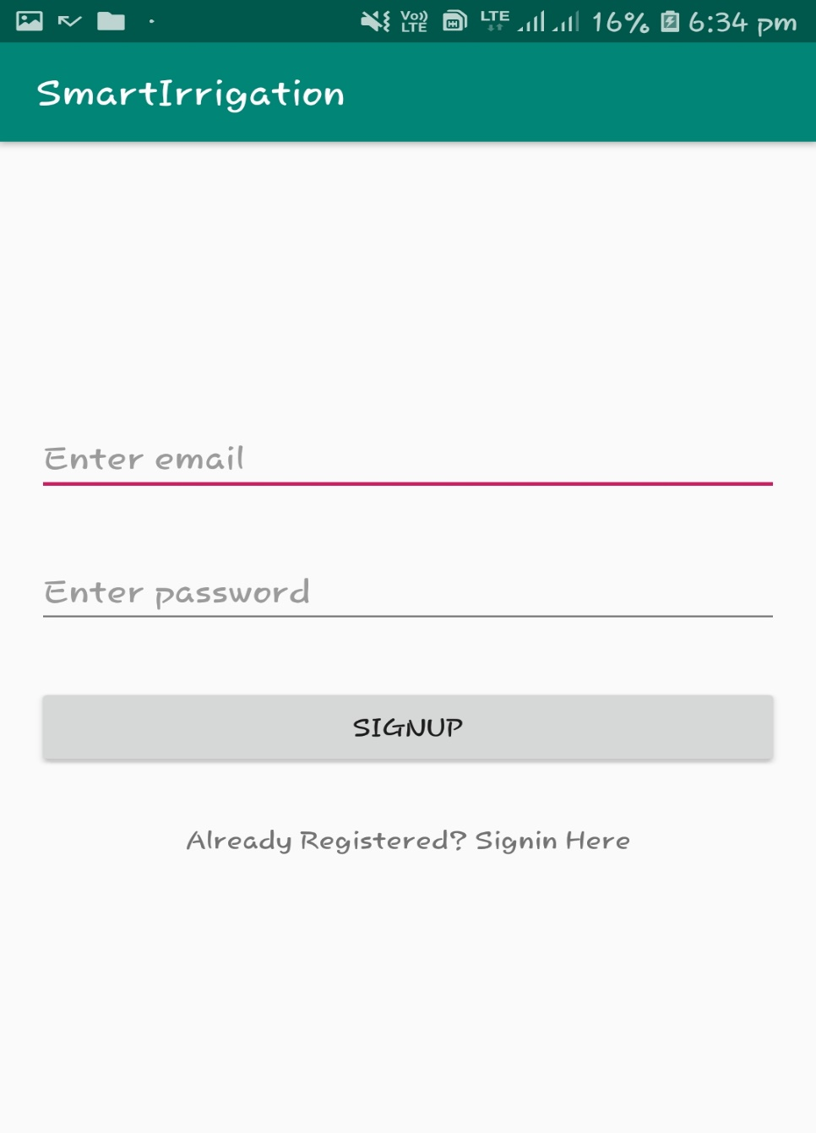

The user first needs to sign up by entering its email id and the password.

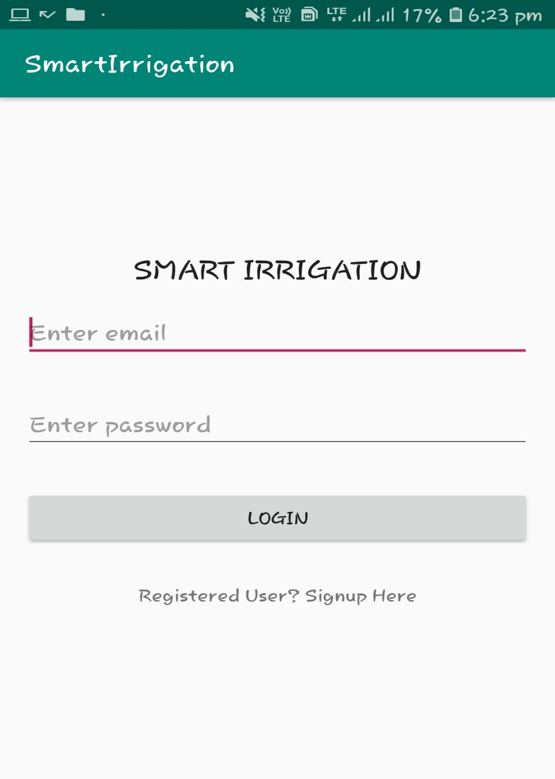

* This allows the user to log into the application by using its Username and Password. This is the first page of the software which redirects you to the commands for the system.
* Logins help for a few reasons, area form of the site they will in any case have their hunt history, top choices, and Steadiness of information, if the client changes telephones or goes on to the work so forth. Next is for the network and the control of the system.

2. CLIENT-SERVER CONNECTION

To connect the user to the system we need to enter the IP Address of the portal you are using for the network and the connection.

We use the application wNetwatcher for getting the IP address. It will give you the list of IP addresses of the around devices. Enter the IP address of the raspberry pi system.

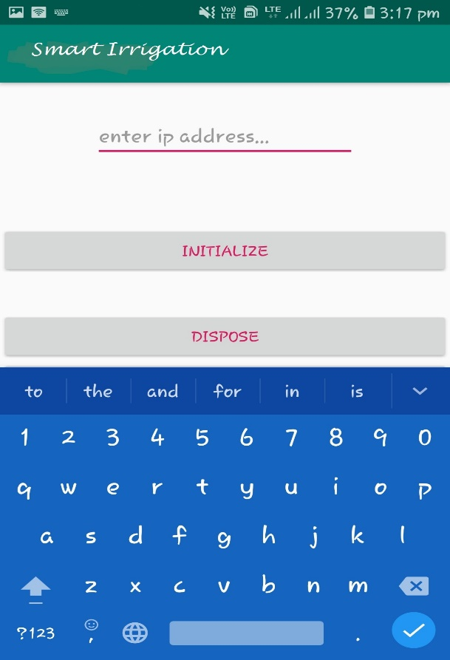

Enter the IP address of the raspberry pi system.

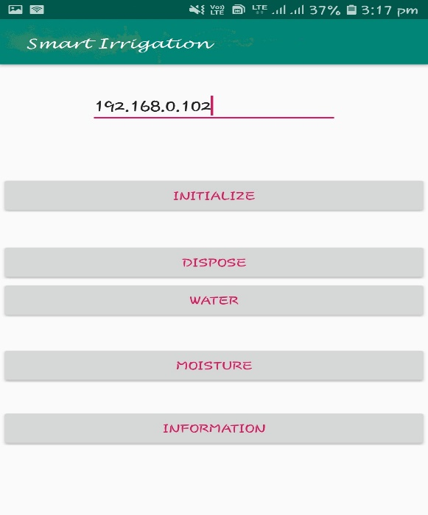

3. START THE SYSTEM

Now we start the implementation of the system by clicking the INITIALIZE button. This initializes the system and gives the output. It gives either 1 or 0 as the output. Here, 1 means that we need to water and 0 means no need to water. With the help of the moisture sensor it senses whether the soil is dry or not. If dry, it gives the message “Its shower time”.

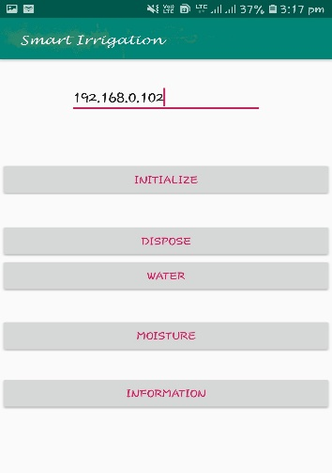

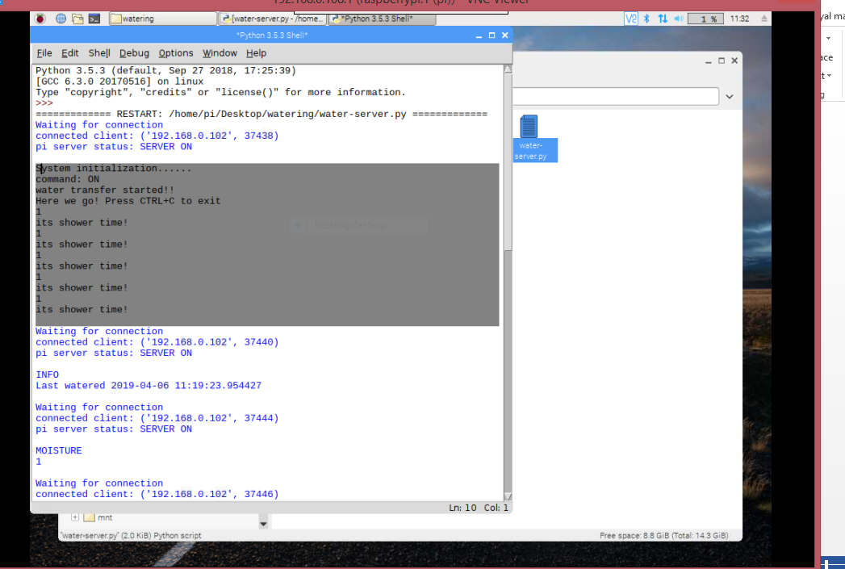

4. MOISTURE

Once initialized we will check whether the plant needs to be water or not. MOISTURE button helps you to know this by giving the output as 1.This means that the plant is dry and it needs to be watered. Hence we can then water it by referring the next given step.

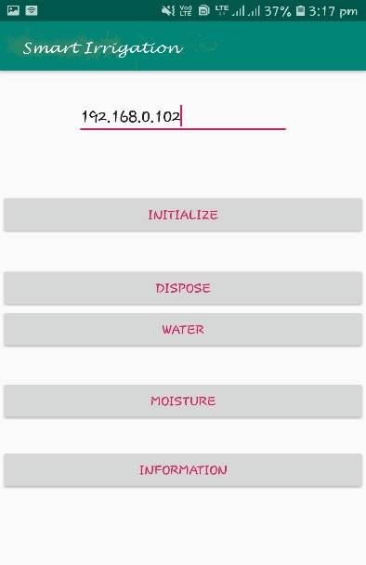

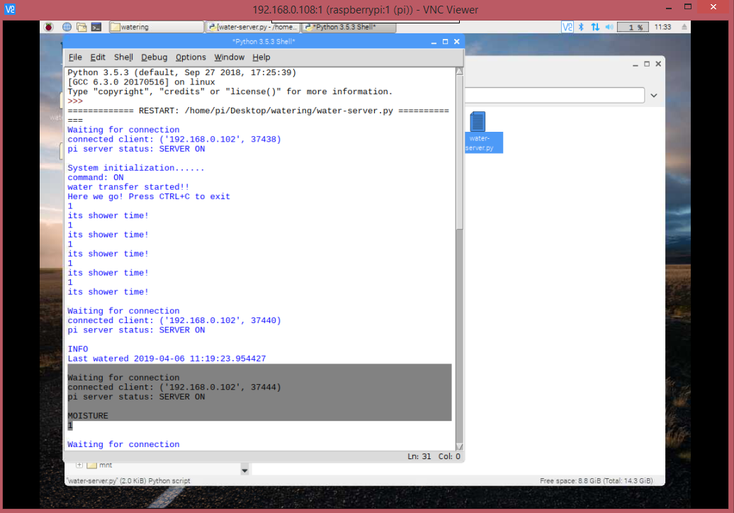

5. WATERING THE PLANT

As soon as the system tells us that it’s time to water the plant, we click on the next button that is WATER. By clicking on this the system will turn the relay on and will push the water into the pipe through the motor. This again displays the message “its shower time” and waters the plant.

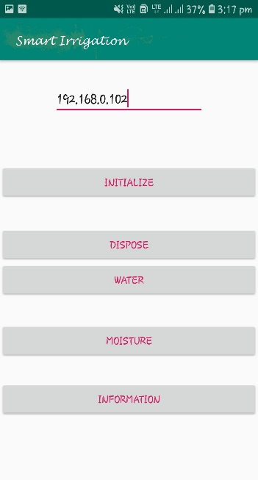



6. INFORMATION

This gives you the information regarding the last time you watered the plant. It displays the date and time of the last time we watered the plant. To get this we need to click on the INFORMATION button

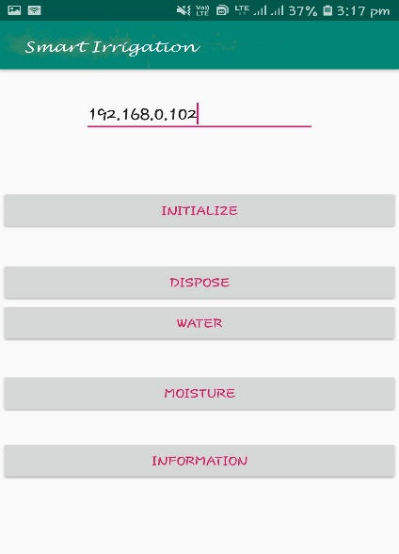

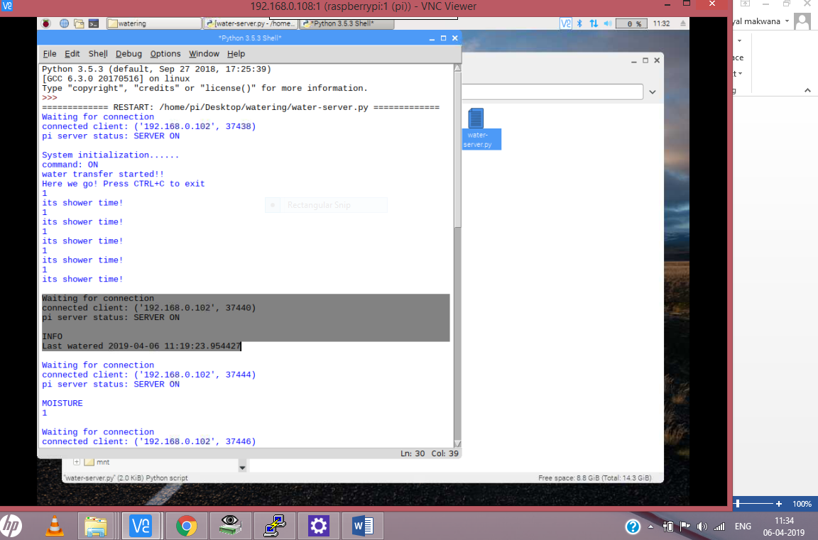

7. DISPOSE/TERMINATE THE SYSTEM

In this we will close the connection by clicking on the DISPOSE button. This will close the server connection once you are done with your work.

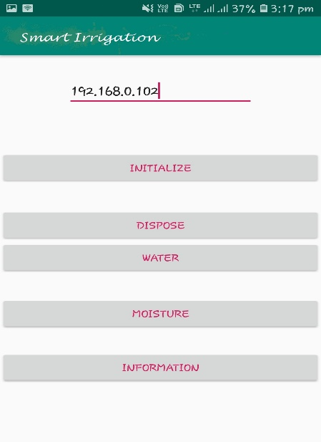

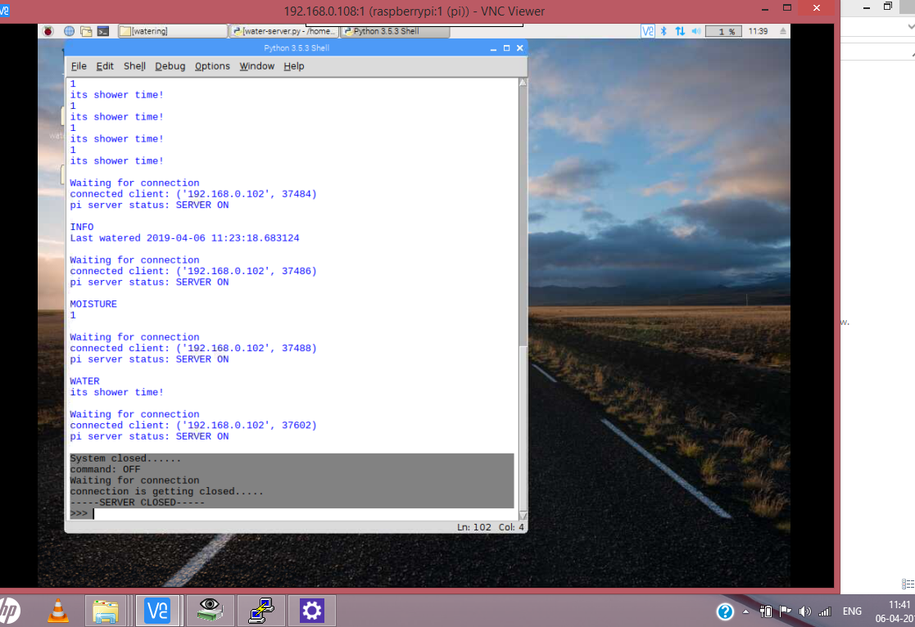

**CHAPTER 7: CONCLUSIONS**

**7.1 CONCLUSION**

* Utilizing this framework, one can spare labor, water to improve creation and at last increment benefit.
* The mechanized water system framework is plausible and financially savvy for advancing water assets for rural generation.
* The framework would give input control framework which will screen and control every one of the exercises of water system framework productively.
* In this proposed framework have introduced the new inventive water system framework. This framework contains the live spilling of harvests utilizing android telephones and programmed engine on/off framework, this two frameworks make the water system completely programmed.
* The whole framework is checked and constrained by the power full charge card estimated microcomputer called Raspberry Pi. Pi board is controlled by windows working framework.

**7.1.1 SIGNIFICANCE OF THE SYSTEM**

One of the best points of interest of a keen water system framework is its capacity to spare water.

As a rule, customary watering strategies can squander as much as half of the water utilized because of wasteful aspects in water system, vanishing and overwatering. Shrewd water system frameworks use sensors for ongoing or recorded information to educate watering schedules and alter watering calendars to improve proficiency.

Soil-based shrewd water system frameworks utilize nearby soil dampness information attracted from sensors the ground to help educated choices about watering plans. Clients can design these frameworks to oversee water system on interest, for instance, when a specific land territory is excessively dry and beginning a water system routine or to stop water system when a specific immersion point is met in light of the fact that a dirt dampness level has been come to. Controlling these two set focuses lessens the measure of water utilized by connecting it to the dampness level required in the dirt for a specific yield.

One of the other significant points of interest of a savvy water system framework is that accuracy watering in brilliant water system additionally manages efficiencies in the conveyance of the water. There are commonly four sorts of conveyance: surface, sprinklers, stream and subsurface techniques.

Smart water system is a key segment of accuracy farming. It causes ranchers to keep away from water wastage and improve the nature of harvest development in their fields by an

a) Inundating at the right occasions,

b) Limiting spillovers and different wastages, and

c)Deciding the dirt dampness levels precisely, accordingly, finding the water system prerequisites at wherever.

Supplanting manual water system with programmed valves and frameworks likewise gets rid of the human blunder component (for example neglecting to kill a valve in the wake of watering the field) and is instrumental in sparing vitality, time, and profitable assets. The establishment and setup of brilliant water system frameworks is, when all is said in done, genuinely direct, as well.

**7.2 LIMITATIONS OF THE SYSTEM**

While there are numerous benefits of the keen soil dampness sensors, they don't factor in the climate related factors in any capacity, and that remaining parts a restriction. Huge measures of dampness are lost because of evapotranspiration (ET; the all out water lost from the plant leaves by means of transpiration and the dirt through vanishing).

Small breaks and splits in conventional water system frameworks (in tanks, stores, and so on.) can prompt extensive water misfortune, adding to the previously mounting worldwide water emergency. Likewise, physically distinguishing the wellspring of these issues is regularly troublesome and can be a conceivably tedious undertaking. Introducing keen water system devices is an incredible method to keep such issues at an a safe distance. With IoT-support, these controllers can recognize existing issues in any water system unit continuously, which, thusly, makes it simple for clients to do the fundamental fixes right away. Basically, an Internet-empowered water system framework can 'direct' the state of the tanks, siphons, and different units – without the client remaining before a PC consistently.

**7.3 FUTURE SCOPE**

* To give protection from the creepy insects and pests.

Concerned on the counteractive action of yields from the creepy pests which harms the harvest leaves and root so it consequently influences the product yield.

* To watch different parameters for better yield.

Climatic conditions likewise influence the development of yields, similar to temperature builds the water necessity moreover increments so it can likewise be observed.

* To have prior information about the weather.

Our task can be added by including a Webscaper which can foresee the climate and water the plant in the likely manner. On the off chance that rain is estimated, less water is let out for the plants.

* To control the system accordingly.

Additionally, a GSM module can be included so that the client can control the framework by the means of advanced cell.

* To measure the water utilized.

A water meter can be introduced to evaluate the measure of water utilized for water system and consequently giving a cost estimation.

* To create fluctuations in the volume.

A solenoid valve can be utilized for changing the volume of water stream. Besides, wireless sensors can likewise be utilized.

REFERENCES:

<https://pdfs.semanticscholar.org/6f8e/68071f270e3203435fc517e65060459dfef9.pdf>

<http://ijcsit.com/docs/Volume%206/vol6issue06/ijcsit20150606104.pdf>

www.lucidchart.com%26from_login%3D1%26as%3DTKw3twrPWwx3SbDe5Oq2qQ&oauth=1&sarp=1&scc=1

Nikhil Agrawal, Smita Singhal, “Smart Drip Irrigation System using Raspberry pi and

Arduino” International Conference on Computing, Communication and Automation

(ICCCA2015) .

<http://ijcsit.com/docs/Volume%206/vol6issue06/ijcsit20150606104>.

Pravina B. Chikankar, Deepak Mehetre, Soumitra Das, “An Automatic Irrigation System

Using ZigBee in Wireless Sensor Network,” 2015 International Conference.